__________________________



**Title: Employee_Hierarchy_SSIS_DD**

**SSIS Detail Design Document**

__________________________

|  |  |  |
| --- | --- | --- |
| Last Revision | Last Review | Description |
| 01/28/2015 |  | Initial revision |

Prepared by: Susmitha Palacherla Date: 12/04/2013

Department, Location: Health Solutions Division

Approved by: Date:

**Change History Log**

| **Date** | **Change Description** | **Author** |
| --- | --- | --- |
| 12/04/2013 | Initial revision | Susmitha Palacherla |
| 06/30/2014 | Updated per scr 12982 to move the updates for migrated logs above the employee id to lanid process. | Susmitha Palacherla |
| 10/27/2014 | Updated per SCR 13624 to add step for Inactivating expired warnings logs. | Susmitha Palacherla |
| 01/19/2015 | Updated to import status and lanid from eWFM emp Info file to use in inactivation of ecls for employees in EA and Inactive status per scr 14072. | Susmitha Palacherla |
| 01/28/2015 | Additional update during SCR 14072. Adding a variable for eWFM info file directory to be able to use a test file from a test staging directory. | Susmitha Palacherla |
|  |  |  |
|  |  |  |

Contents

1. Overview 4

1.1 Project Description 4

1.2 Document Scope 4

1.3 Source Files 4

1.4 Module List 4

1.5 Software and Hardware Interfaces 4

1.5.1 Software 4

1.5.2 Hardware 4

1.6 Users 4

2. Details 5

2.1 Source Files 5

2.1.1 PS_Employee_Information_mmddyyyy.csv 5

2.1.2 Employee_Information_WithProgram.csv 5

2.2 Module Details 5

2.2.1 SQL agent job 5

2.2.2 SSIS Package 6

2.2.3 Tables 33

2.2.4 Procedures 33

# Overview

## Project Description

The eCoaching Log (eCL) is an internal Vangent process designed for the entry and storage of the coaching notes that supervisors, managers, Advanced Resolution Center (ARC) CSRs and quality leads make regarding CSR performance. These notes are gathered through escalations, floor walking, training, quality monitors. It also provides a repository of coaching notes to generate reports for management.

## Document Scope

This document describes the process for maintaining the Employee Hierarchy table. It describes the source files and the workflow to maintain the user table.

## Source Files

* PS_Employee_Information_mmddyyyy.csv
* Employee_Information_WithProgram.csv

## Module List

* SQL agent job
* SSIS Package
* Tables
* Procedures

## Software and Hardware Interfaces

### Software

* SQL Server 2008 R2 SP1 Suite

### Hardware

* VRIVFSSDBT02\SCORD01,1437 – Dev DB Instance
* VRIVFSSDBT02\SCORT01,1438 – Test DB Instance
* VDENSSDBP07\SCORP01 – Prod DB Instance
* \\VRIVSCORS01\BCC Scorecards\ - File staging share

## Users

* N/A

# Details



## Source Files

### PS_Employee_Information_mmddyyyy.csv

* Description: This is an Employee file from Peoplesoft.
* Used for capturing Employee attributes like Employee ID, Name, Lan ID, Location, Job Code and Manager(Supervisor’s supervisor) and last hire date and Active Flag.
* Source system: PeopleSoft
* Staging location: \\vrivscors01\BCC Scorecards\Coaching\HRInfo\
* File name: PS_Employee_Information_mmddyyyy.csv
* Frequency: Arrives daily at ~4:30 AM EST
* Load time: 8 PM EST (6:00 PM Database time)
* Destination Table: Employee_Hierarchy

### Employee_Information_WithProgram.csv

* Description: This is an Employee file from Aspect eWFM. Used to capture the Supervisor for employees having a CSR job code and the program value. The program value should be associated with the call or activity and will be input from the web interface or provided in the Coaching requests from Quality system and Outliers feeds. The program value based on the agents 1MULTI value from eWFM will only be sued when a program cannot be identified for the call activity for a specific coaching log.
* Source system: Aspect eWFM
* Staging location: \\vrivscors01\BCC Scorecards\Coaching\EmpInfo\
* File name: Employee_information_WithProgram.csv
* Frequency: Arrived daily at ~6:00 AM EST
* Load time: 8 PM EST (6:00 PM Database time)
* Destination Table: EmpID_To_SupID_Stage

## Module Details

### SQL agent job

* Production Instance : VDENSSDBP07\SCORP01
* Production Job: EmployeeHierarchyLoad
* Production Package: \\VDENSSDBP07\scorecard-ssis\Coaching\Employee_Hierarchy.dtsx
* Production Config File: Prod_Employee_Hierarchy.dtsConfig
* Owner: jobs_admin
* Run As: BccScrdSQLAgent
* Schedule: Daily 8:30 PM EST
* Destination File Location: N/A

### SSIS Package

* + - 1. **Variables**

|  |  |  |  |
| --- | --- | --- | --- |
| **Name** | **Scope** | **DataType** | **Value** |
| FileDir | Employee_Hierarchy | String | \\vrivscors01\BCC Scorecards\Coaching\HRInfo\ |
| WFMFileDir | Employee_Hierarchy | String | \\vrivscors01\BCC Scorecards\Coaching\EmpInfo\ |

* + - 1. **Connection Manager Entries**
         1. Destinationdb
* Dev - VRIVFSSDBT02\SCORD01,1437) DB – eCoachingdev
* Prod - VDENSSDBP07\SCORP01 DB – eCoaching

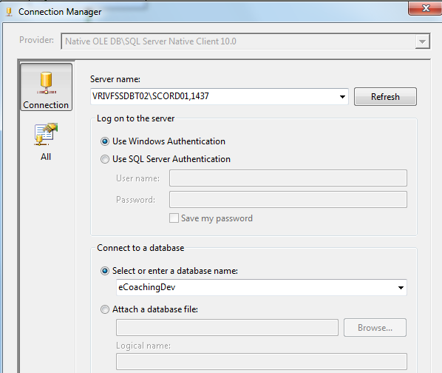

* + - * 1. EmpFile
* \\vrivscors01\bcc scorecards\Coaching\EmpInfo\Employee_Information_WithProgram.csv
* Expression: @[User::WFMFileDir]+"Employee_Information_WithProgram.csv"

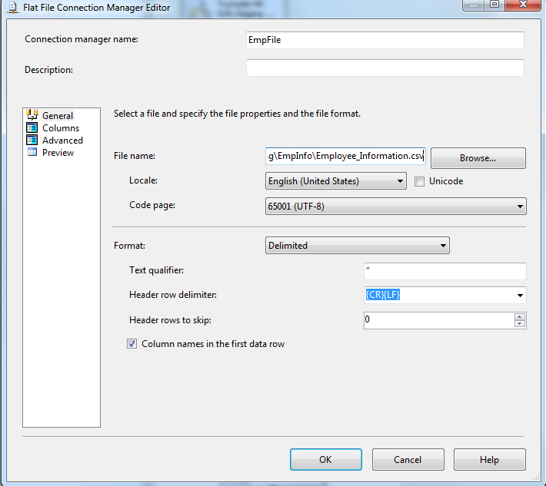

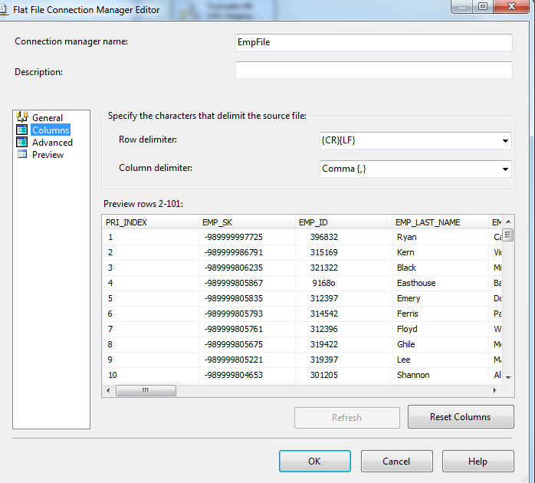

* + - * 1. PSFile
* \\VRIVSCORS01\BCC Scorecards\Coaching\HRInfo\PS_Employee_Information_mmddyyyy.csv
* Expression: @[User::FileDir] + "PS_Employee_Information_" +

Right("0" + (DT_STR,4,1252) DatePart("m",getdate()),2) +

Right("0" + (DT_STR,4,1252) DatePart("d",getdate()),2) +

(DT_STR,4,1252) DatePart("yyyy",getdate()) + ".csv"

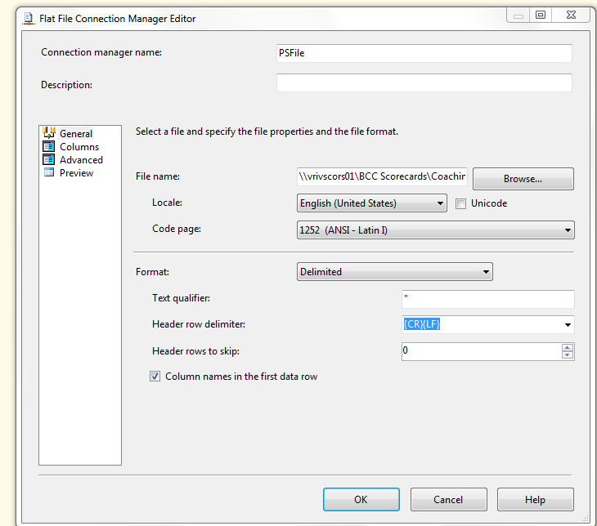

* + - 1. **Package Content**

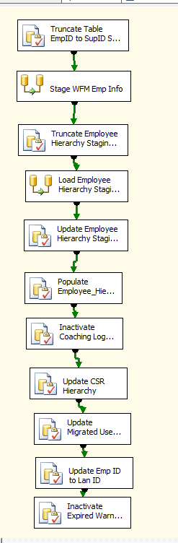

**Workflow**

**Summary of Steps**

1. SQL task – Truncate EmP ID To sup ID Staging Table
2. DFT – Stage WFM emp Info File data into Emp ID To Sup ID Table
3. SQL task – Truncate Employee Hierarchy Staging Table
4. DFT – Stage PeopleSoft HR File data into Employee Hierarchy Staging Table
5. SQL task – Update Employee Hierarchy Staging table.
6. SQL task – Populate Employee Hierarchy table
7. SQL task – Inactivate Coaching logs for termed users
8. SQL task – Update CSR Hierarchy Table
9. SQL task – Update Coaching Logs for migrated users
10. SQL task – Update Employee ID To Lan ID table
11. SQL task – Inactivate expired warning logs

**Details**

Step1: SQL task - Truncate Table EmpID to SupID Stage

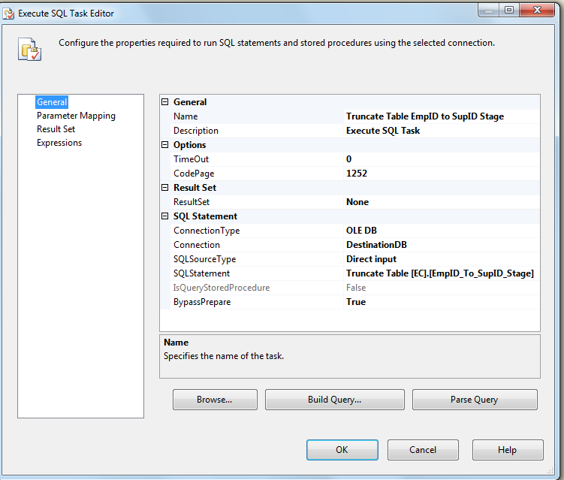

Step2: DFT - Stage WFM Emp Info

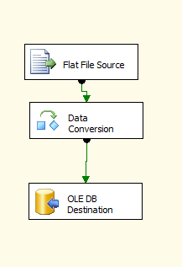

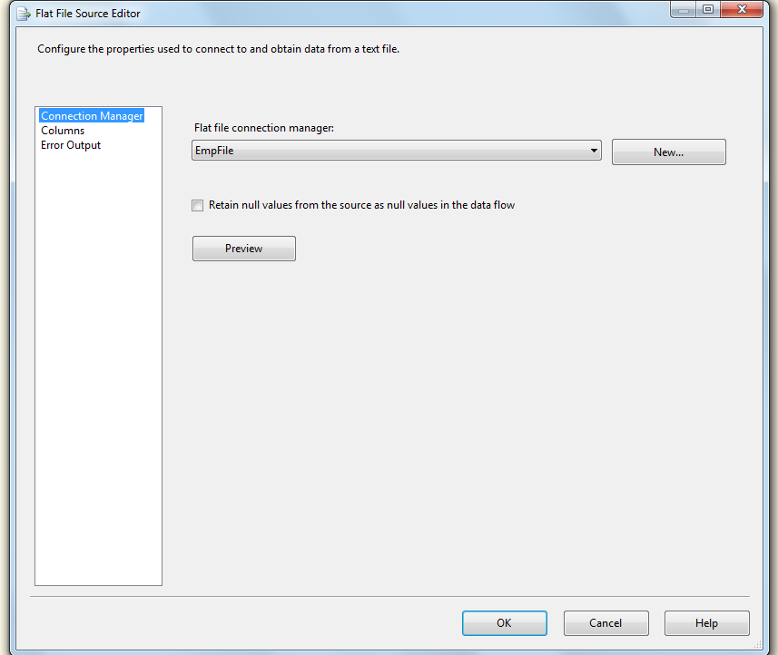

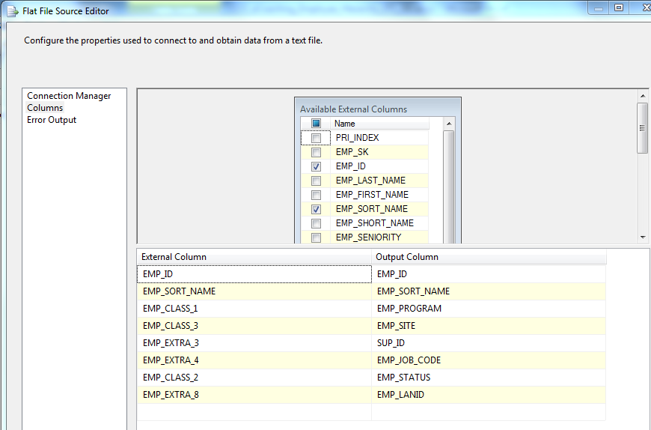

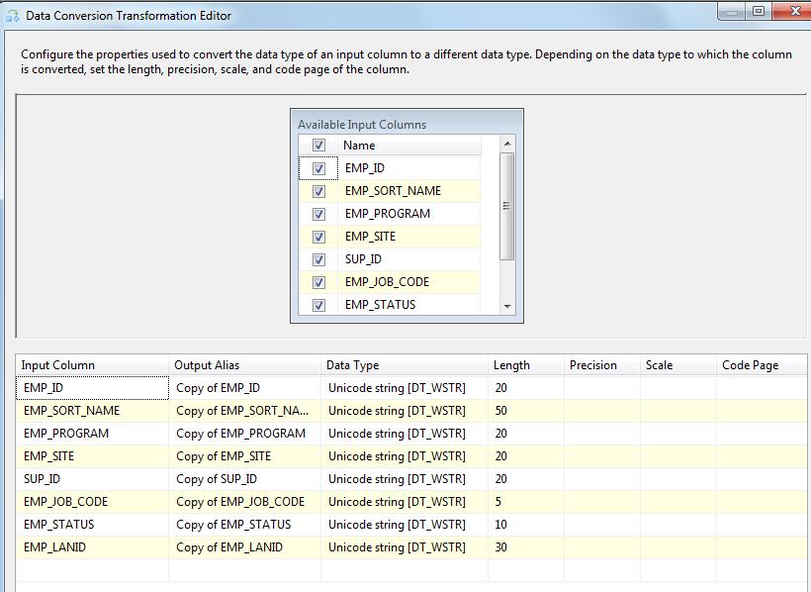

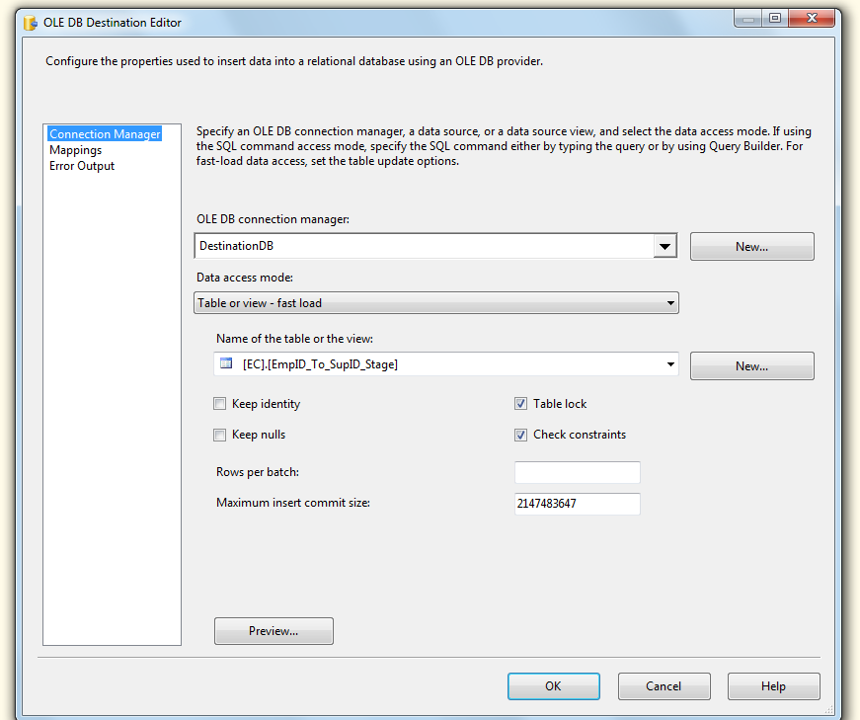

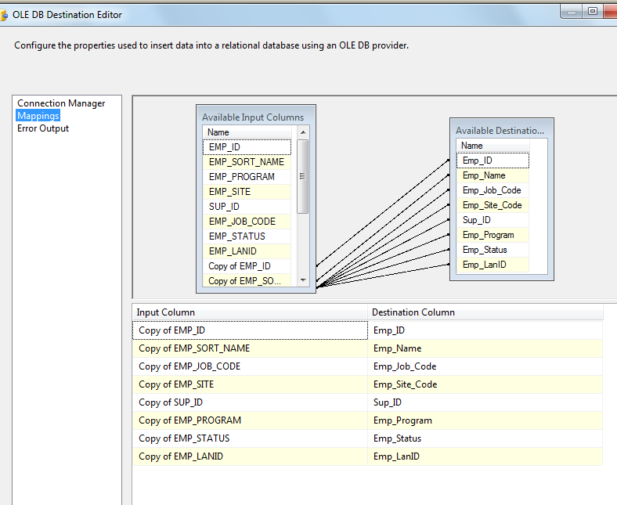

Step3: Truncate Employee Hierarchy Staging Table

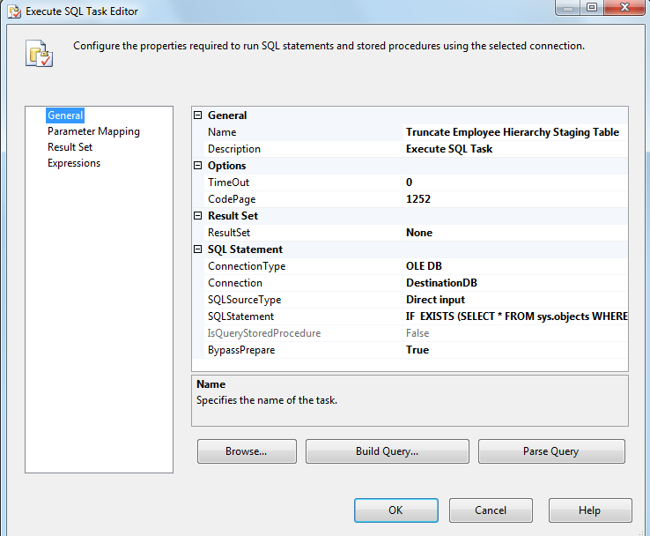

IF EXISTS (SELECT * FROM sys.objects WHERE object_id = OBJECT_ID(N'[EC].[Employee_Hierarchy_Stage]') AND type in (N'U'))

Truncate TABLE [EC].[Employee_Hierarchy_Stage]

Step4: Load Employee Hierarchy Staging Table

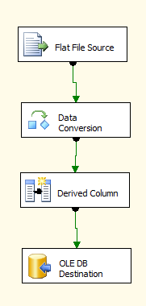

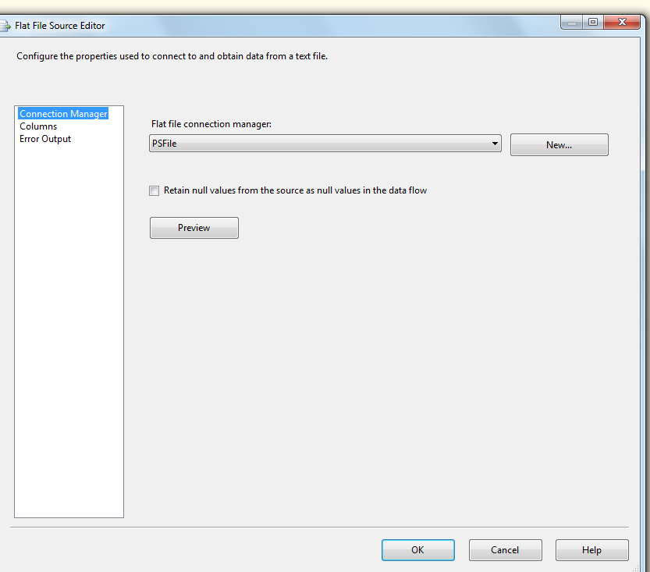

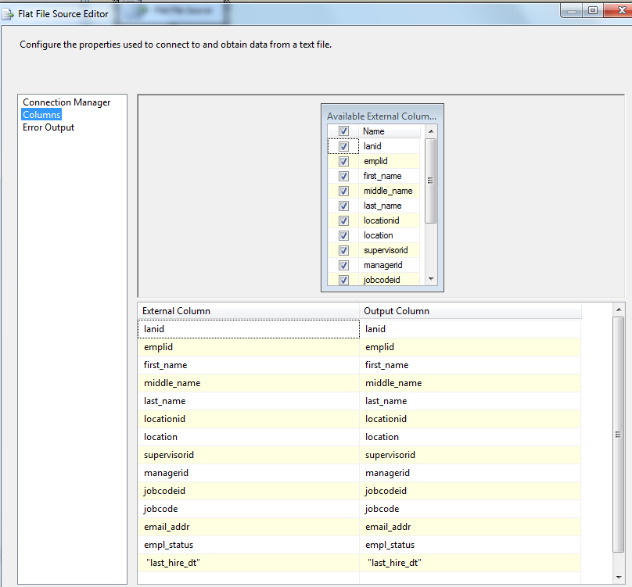

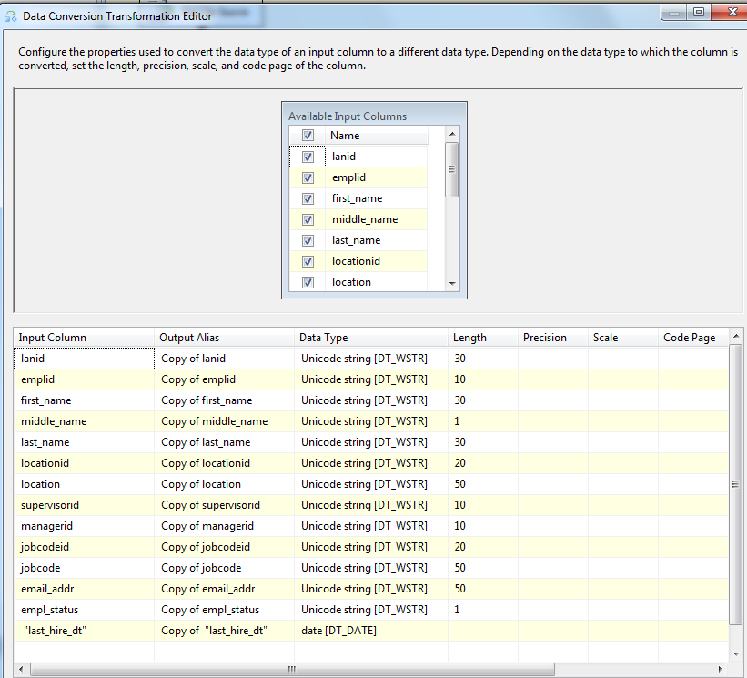

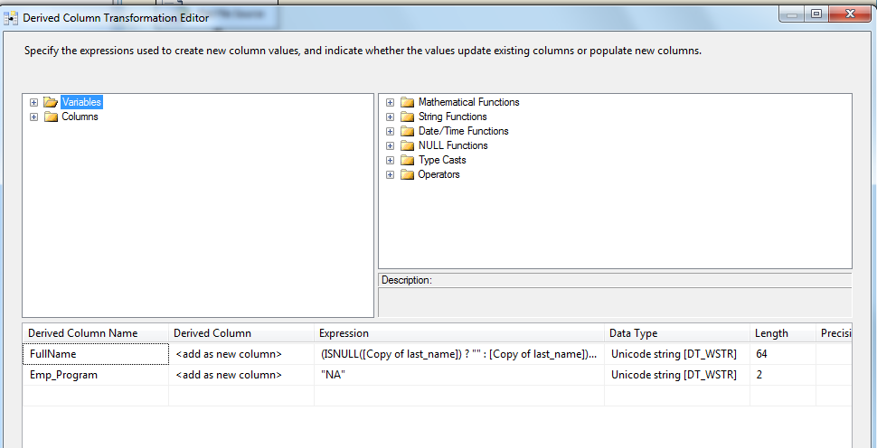

(ISNULL([Copy of last_name]) ? "" : [Copy of last_name]) + ", " + (ISNULL([Copy of first_name]) ? "" : [Copy of first_name]) + " " + (ISNULL([Copy of middle_name]) ? "" : [Copy of middle_name])

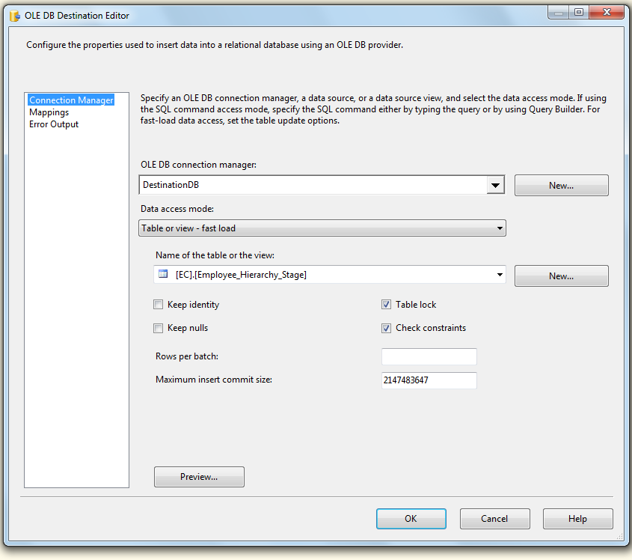

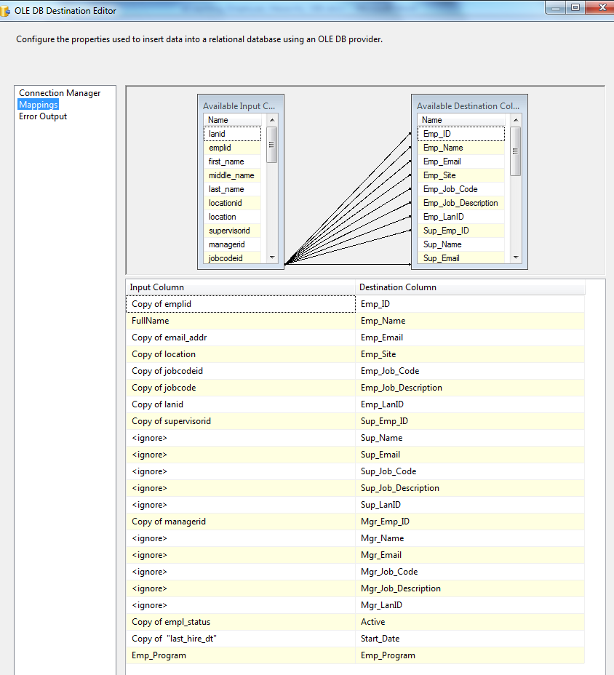

Step5: Update Employee Hierarchy Staging Table

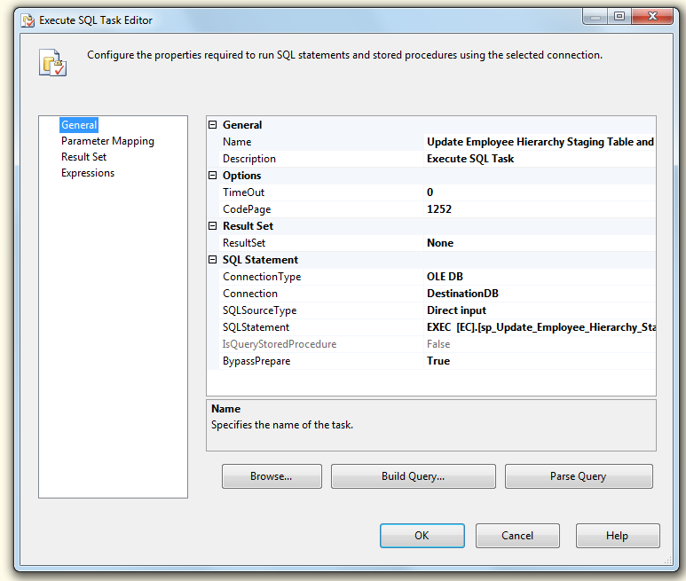

EXEC [EC].[sp_Update_Employee_Hierarchy_Stage]

Step6: Populate Employee_Hierarchy Table

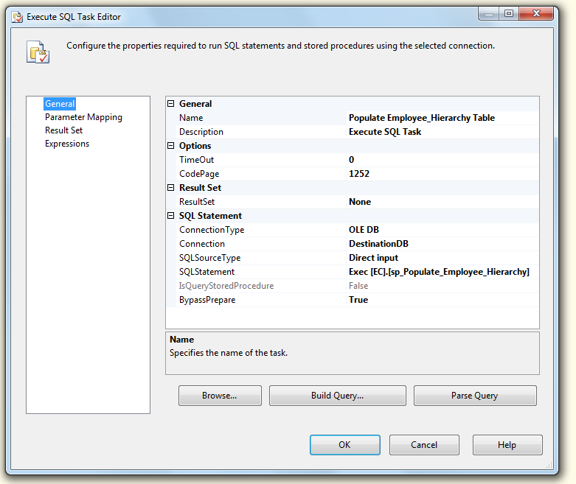

Exec [EC].[sp_Populate_Employee_Hierarchy]

Step7: Inactivate Coaching Logs for Terms

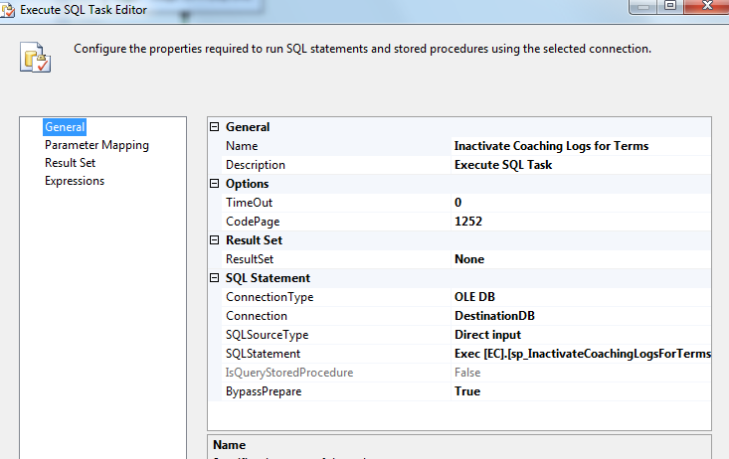

Exec [EC].[sp_InactivateCoachingLogsForTerms]

Step8: Update CSR Hierarchy Table

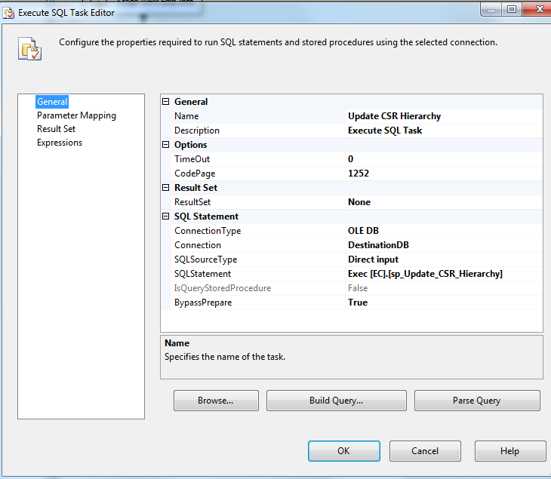

Exec [EC].[sp_Update_CSR_Hierarchy]

Step 9: SQL task – Update Coaching Logs for migrated users

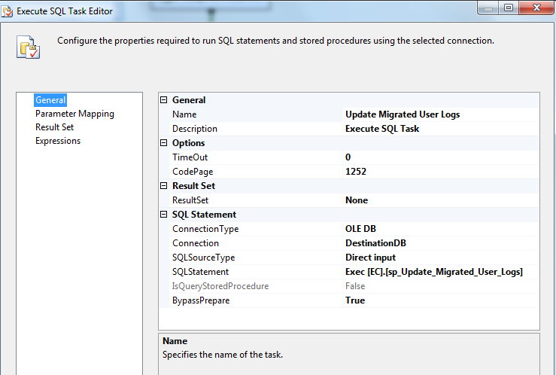

Step10: Update Employee ID To Lan ID Table

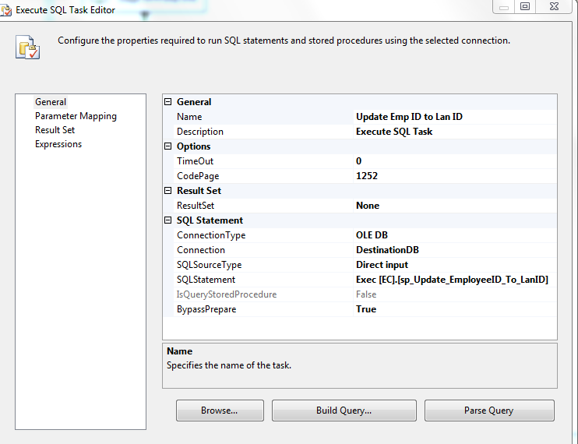

Exec [EC].[sp_Update_EmployeeID_To_LanID]

11. SQL task – Inactivate expired warning logs

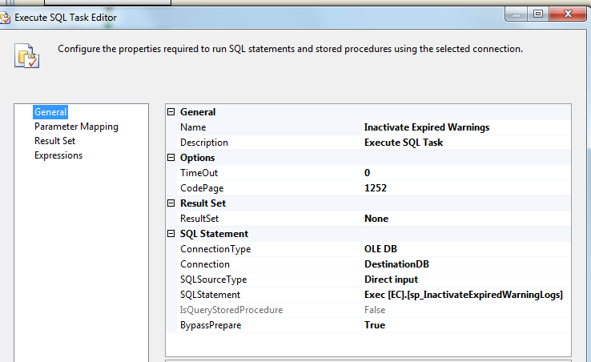

Exec [EC].[sp_InactivateExpiredWarningLogs]

### Tables

|  | **Table Name** | **Table Description** |
| --- | --- | --- |
| 1. | Employee_Hierarchy | Table for storing Employee Information. |
| 2. | Employee_Hierarchy_Stage | Table used for staging the Employee Information from PeopleSoft during the Employee Hierarchy load process. |
| 3. | EmpID_To_SupID_Stage | Table used for staging the Sup Ids from Aspect eWFM during the Employee Hierarchy load process. |
| 4. | EmployeeID_To_LanID | Table used for storing Employee ID to Lan ID links over time. |
| 5. | CSR_Hierarchy | Table used for storing CSR Hierarchy records over time. |

Table structure and details in document: eCoaching_Database_DD.docx

### Procedures

|  | **Procedure Name** | **Usage** |
| --- | --- | --- |
| 1. | sp_Populate_Employee_Hierarchy | Load: Employee Data |
| 2. | sp_Update_CSR_Hierarchy | Load: Employee Data |
| 3. | sp_Update_Employee_Hierarchy_Stage | Load: Employee Data |
| 4. | sp_Update_EmployeeID_To_LanID | Load: Employee Data |
| 6. | sp_Update_Migrated_User_Logs | Housekeeping: Migrated user log update |

Reference Document for Objects and Code: Coaching_PS_Employee_Hierarchy_Load.sql