__________________________



**Title: eCoaching_Generic_Load**

**SSIS Detail Design Document**

__________________________

|  |  |  |
| --- | --- | --- |
| Last Revision | Last Review | Description |
| 4/11/2016 |  | Initial revision. TFS 2470 |

Prepared by: Susmitha Palacherla Date: 4/11/2016

Department, Location: Health Solutions Division

Approved by: Date:

**Change History Log**

| **Date** | **Change Description** | **Author** |
| --- | --- | --- |
| 4/11/2016 | 1.0 Initial revision. TFS 2470 | Susmitha Palacherla |
|  |  |  |
|  |  |  |
|  |  |  |
|  |  |  |
|  |  |  |
|  |  |  |

Contents

1. Overview 4

1.1 Project Description 4

1.2 Document Scope 4

1.3 Source Files 4

1.4 Module List 6

1.5 Software and Hardware Interfaces 6

1.5.1 Software 6

1.5.2 Hardware 6

1.6 Users 6

2. Details 6

2.1 Source Files 6

2.2 Module Details 7

2.2.1 SQL agent job 7

2.2.2 SSIS Package 7

2.2.3 Tables 82

2.2.4 Procedures 82

2.2.5 Functions 82

# Overview

## Project Description

The coaching process is a standard process to facilitate consistent communication when a performance opportunity or reinforcement exists. It provides a method to make a determination of whether coaching is needed, when to initiate coaching and verification that the performance issue has been addressed. The Generic (General) feed(s) will be used for mass loading of general ecls that would have normally been submitted through the User Interface into the database. Utilizing the eCL work-flow, items can be tracked from start to finish to verify if items have been addressed.

## Document Scope

This document describes the load of the ‘Generic’ or general feeds that will be used to mass load ecls into the database. Once the reports are loaded into the database the logs are tracked through the workflow like any Coaching log entered from the web interface.

## Source Files

The table below shows the attributes for the ‘Generic’ reports.

Files have a naming convention eCL_Generic _Feed_**xxx**yyyymmdd.csv where xxx is the 3 letter Report code.

Files are staged at \\VRIVSCORS01\BCC Scorecards\Coaching\Generic\

|  |  |  |  |  |  |  |
| --- | --- | --- | --- | --- | --- | --- |
| **#** | **Metric/Report** | **Active Feed** | **Code** | **eCL Workflow** | **Entry** | **Coaching Reason** |
| 1 | Generic Report | Y | OTH | Direct Coach | Feed | Current Coaching Initiatives |

## Module List

* SQL agent job
* SSIS Package
* Tables
* Procedures

## Software and Hardware Interfaces

### Software

* SQL Server 2008 R2 SP1 Suite

### Hardware

* VRIVFSSDBT02\SCORD01,1437 – Dev DB Instance
* VRIVFSSDBT02\SCORT01,1438 – Test DB Instance
* VDENSSDBP07\SCORP01 – Prod DB Instance
* \\VRIVSCORS01\BCC Scorecards\ - File staging share

## Users

* The first set of users for the Generic records loaded into the eCL database are the CCO Supervisors as all records have default state of ‘Pending Supervisor Review’ at the time of the load.
* After a Supervisor reviews the log, the logs goes to Pending Employee review and the Employee becomes the user.
* CCO Supervisors and Managers and specific HR staff will be able to access the logs from the historical Dashboards.

# Details



## Source Files

eCL_Generic _Feed_xxxyyyymmdd.csv is the naming convention for the feed where xxx is the 3 letter Report code.

Source system: NA

* Staging location: \\vrivscors01\BCC Scorecards\Coaching\GenFeeds\
* File name eCL_Generic _Feed_xxxyyyymmdd.csv
* Frequency: Ad-hoc
* File arrival time: NA
* Destination Table: Coaching_Log and Coaching_Log_Reason

## Module Details

### SQL agent job

* Production Instance : VDENSSDBP07\SCORP01
* Production Job: GenericCoaching
* Production Package: \\VDENSSDBP07\scorecard-ssis\Coaching\Generic _Coaching.dtsx
* Production Config File: Prod_Generic_Coaching.dtsConfig
* Owner: jobs_admin
* Run As: BccScrdSQLAgent
* Schedule: Fridays On-demand
* Destination File Location: N/A

### SSIS Package

* + - 1. **Variables**

|  |  |  |  |
| --- | --- | --- | --- |
| **Name** | **Scope** | **DataType** | **Value** |
| FilebakPath | Generic_Coaching | String | \\vrivscors01\BCC Scorecards\Coaching\ Generic\Backups |
| FileNum | Generic_Coaching | Int32 | 0 |
| FilePath | Generic_Coaching | String | \\vrivscors01\BCC Scorecards\Coaching\Generic |
| varDBName | Generic_Coaching | String | Dev |
| varFileName | Generic_Coaching | String |  |
| FailMessage | Generic_Coaching | String | Generic Coaching Load failed in Dev |
| StagedCount | Generic_Coaching | Int32 | 0 |
| RejectedCount | Generic_Coaching | Int32 | 0 |
| LoadedCount | Generic_Coaching | Int32 | 0 |
|  |  |  |  |

* + - 1. **Connection Manager Entries**
         1. Destinationdb
* Dev - VRIVFSSDBT02\SCORD01,1437) DB – eCoachingdev
* Prod - VDENSSDBP07\SCORP01 DB – eCoaching

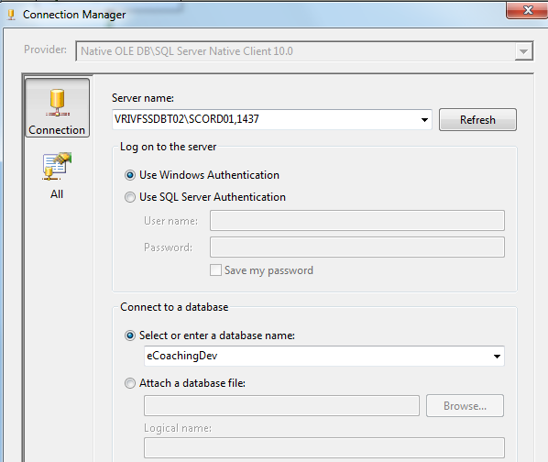

* + - * 1. Generic _File
* \\vrivscors01\bcc scorecards\Coaching\Generic\eCL_Generic _Feed_*.csv

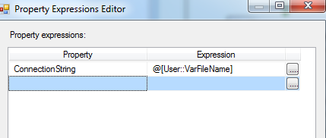

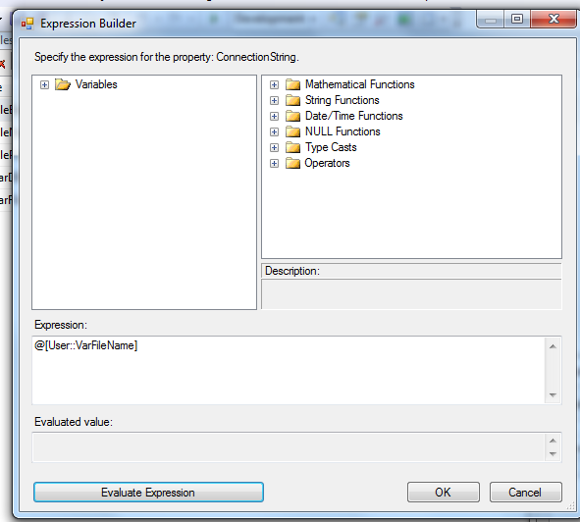

* + - * 1. SMTP Connection Manager

smtpout.gdit.com

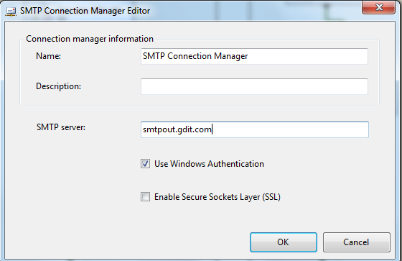

* + - 1. **Package Content(Control Flow)**

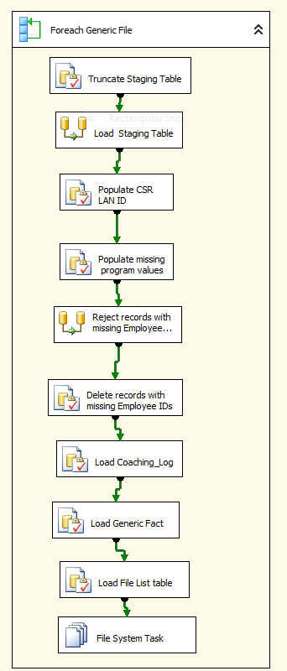

**Workflow**

* + - * 1. **For each Generic file in Staging directory Workflow**

Container: Foreach Loop

Folder: \\vrivscors01\BCC Scorecards\Coaching\Generic

Files: eCL_Generic _Feed_*.csv

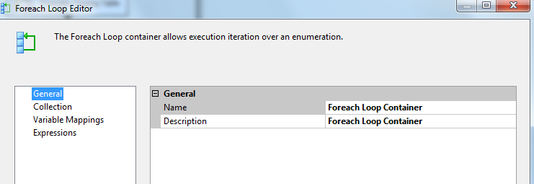

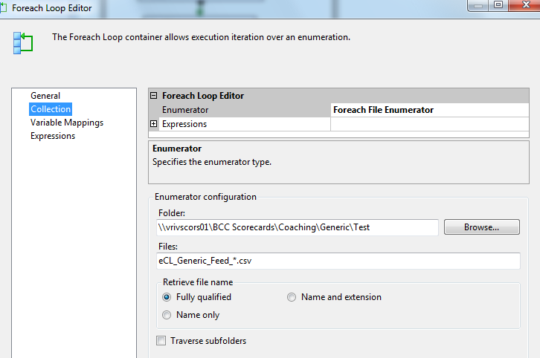

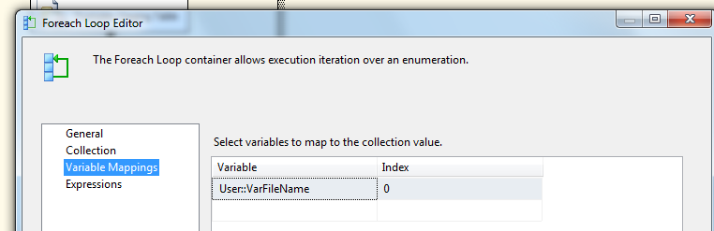

**Summary of Steps**

1. SQL task – Truncate Generic Staging table
2. DFT – Stage Generic Staging table
3. SQL task – Populate CSR LAN ID for LCS
4. SQL Task – Populate missing Program Values
5. DFT Rejected records with missing Employee attributes
6. SQL task – Delete records with missing employee ID from Staging table
7. SQL task Load coaching_Log and Coaching_Log_Reason tables
8. SQL task – Load Generic Fact table
9. SQL task – Load File list table
10. File system task – Backup files to Backups directory

**Details of Steps**

1. SQL task – Truncate Generic Staging table

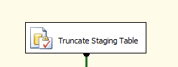

Executes Truncate Table [EC].[Generic_Coaching_Stage]

1. DFT: Load Generic staging table

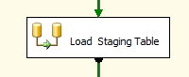

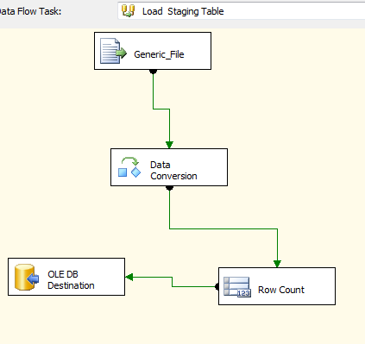

1. Flat File source

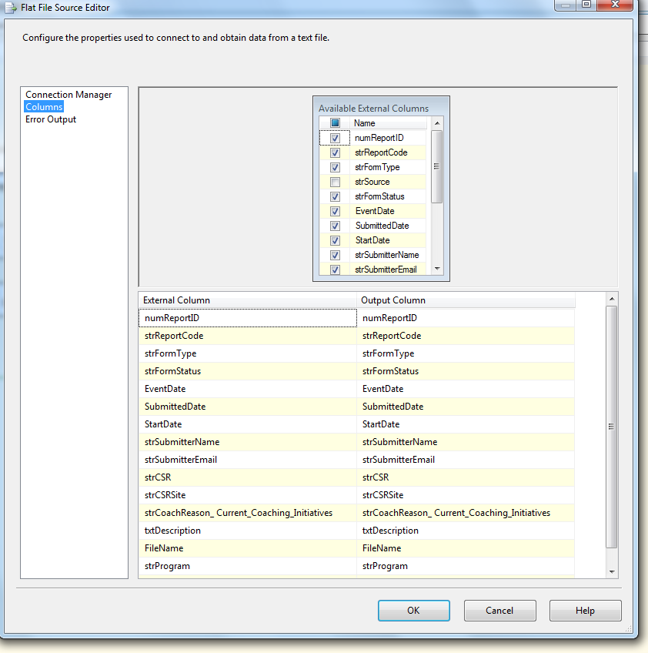

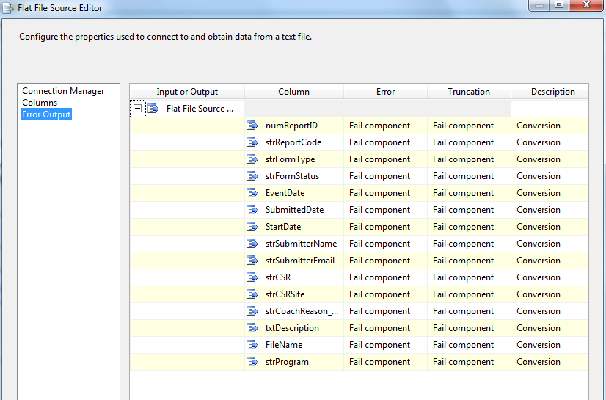

1. Data Conversion

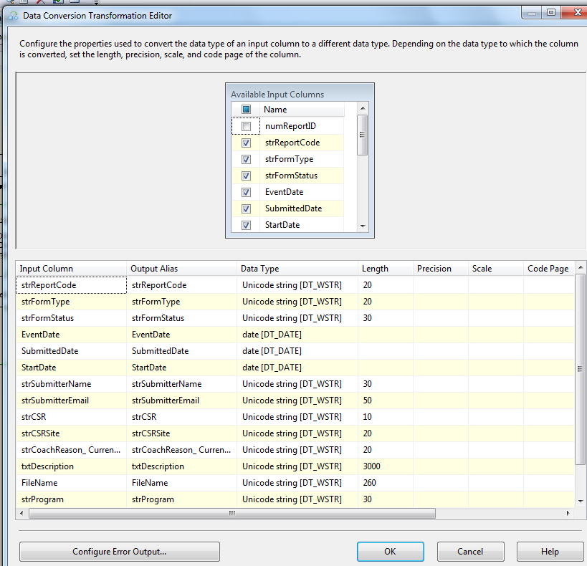

1. Derived Column

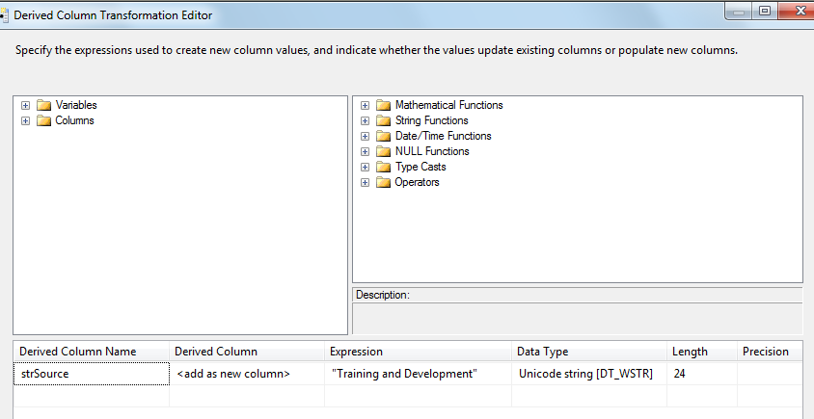

1. Row Count Transformation

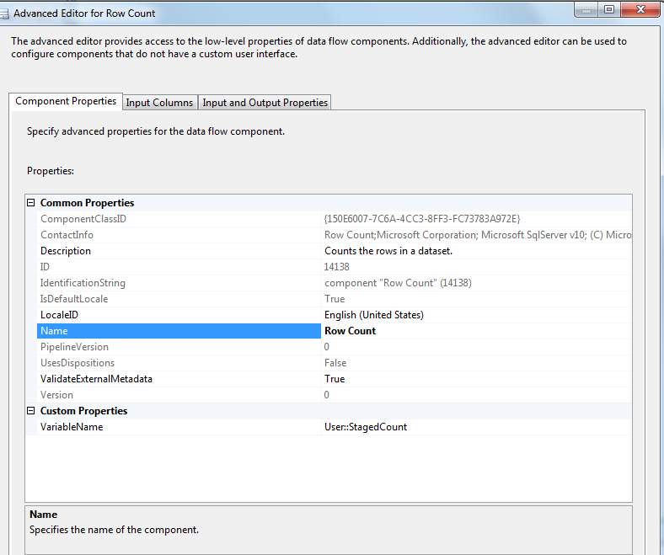

1. Oledb destination

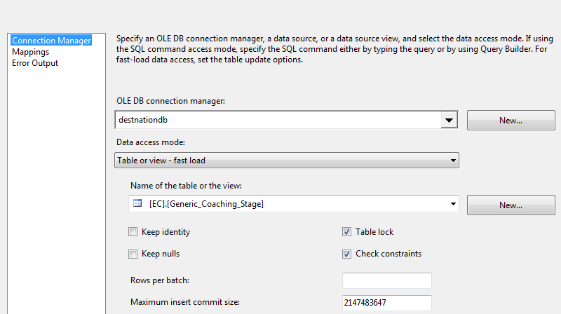

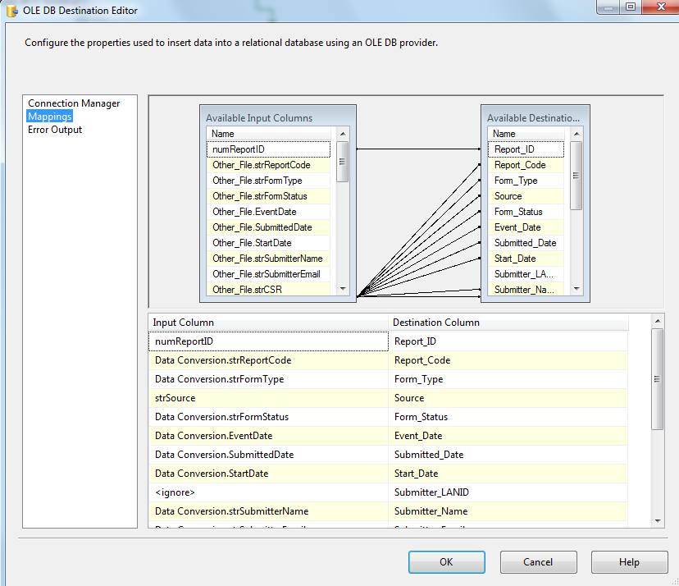

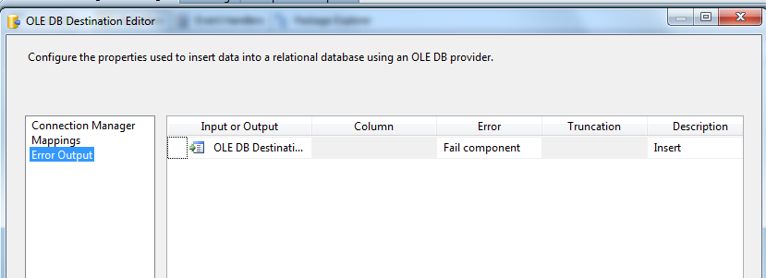

1. SQL Task: Populate CSR LAND ID

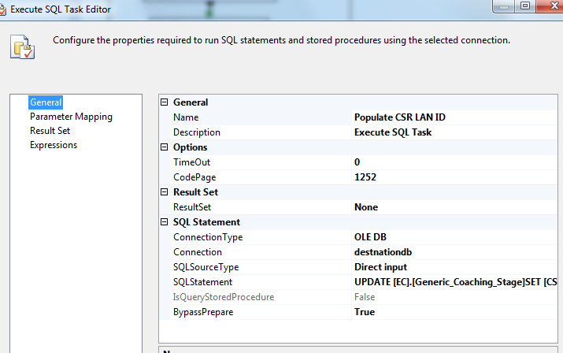

UPDATE [EC].[Generic_Coaching_Stage]

SET [CSR_LANID]= [EC].[fn_strEmpLanIDFromEmpID]([CSR_EMPID])

1. SQL Task: Populate site and program values

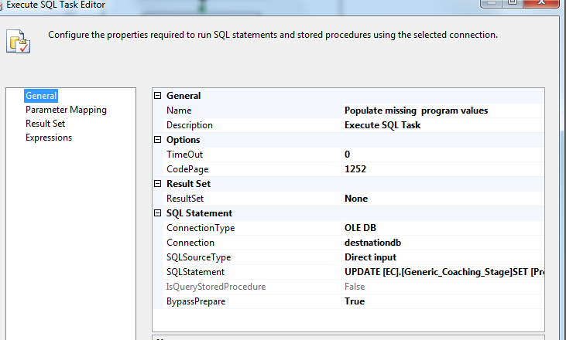

UPDATE [EC].[Generic_Coaching_Stage]

SET [Program]= H.[Emp_Program]

,[CSR_Site] = H.[Emp_Site]

FROM [EC].[Generic_Coaching_Stage]S JOIN [EC].[Employee_Hierarchy]H

ON S.[CSR_EMPID]=H.[Emp_ID]

1. DFT: Reject Records with Missing Employee ID

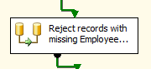

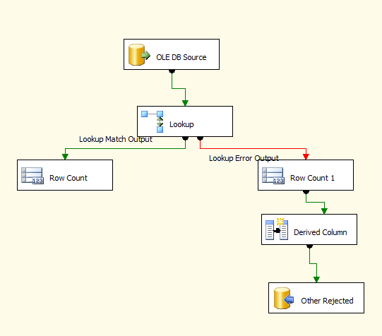

1. Oledb source

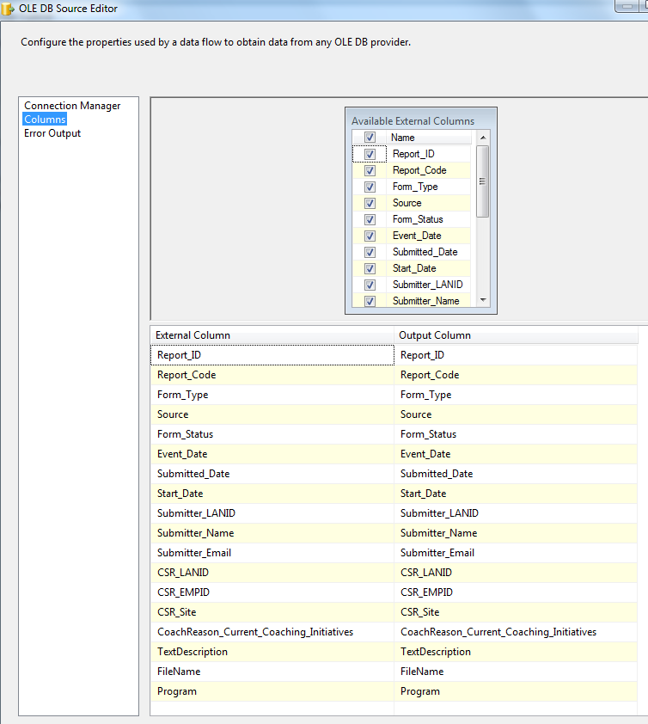

1. Lookup Transformation

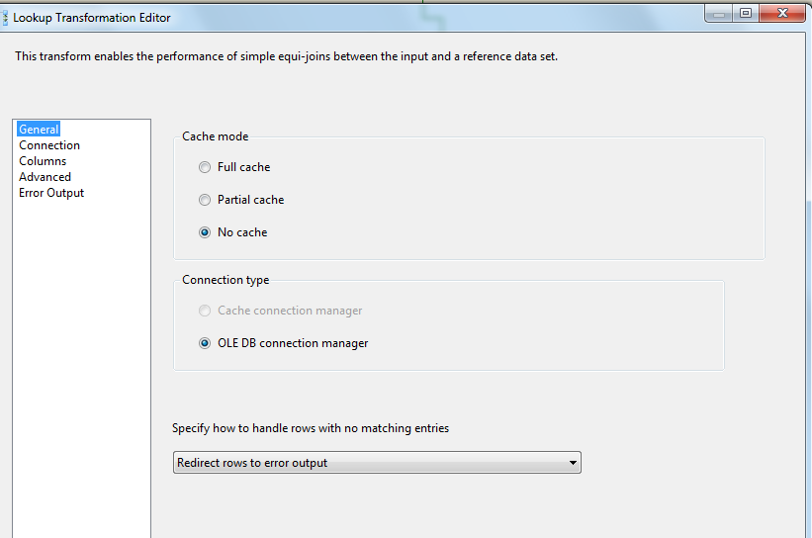

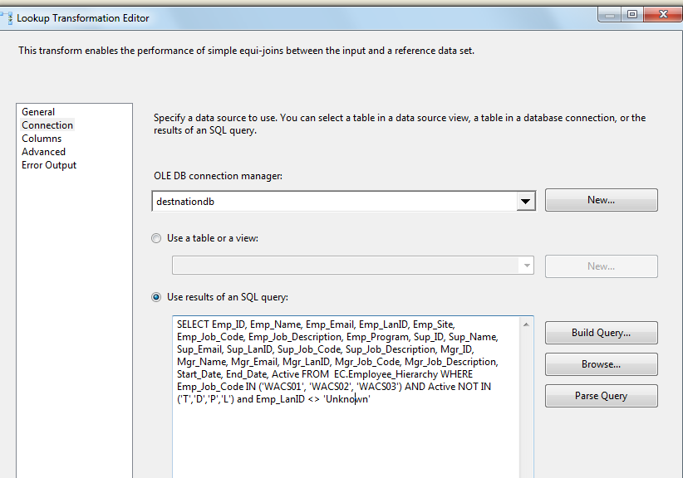

SELECT Emp_ID, Emp_Name, Emp_Email, Emp_LanID, Emp_Site, Emp_Job_Code, Emp_Job_Description,

Emp_Program, Sup_ID, Sup_Name, Sup_Email, Sup_LanID, Sup_Job_Code, Sup_Job_Description,

Mgr_ID, Mgr_Name, Mgr_Email, Mgr_LanID, Mgr_Job_Code, Mgr_Job_Description, Start_Date, End_Date, Active

FROM EC.Employee_Hierarchy

WHERE Emp_Job_Code IN ('WACS01', 'WACS02', 'WACS03')

AND Active NOT IN ('T','D','P','L') and Emp_LanID <> 'Unknown'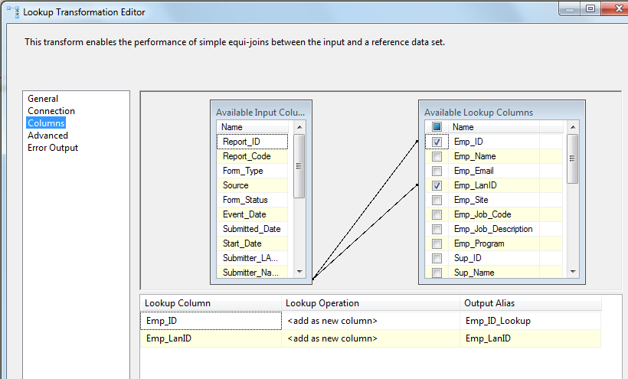

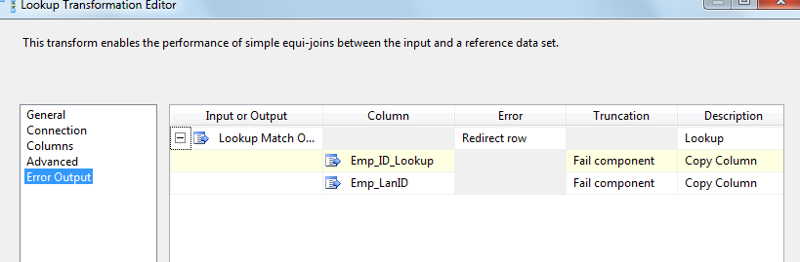

1. Lookup Match Output – Row Count Transformation to get Loaded Count

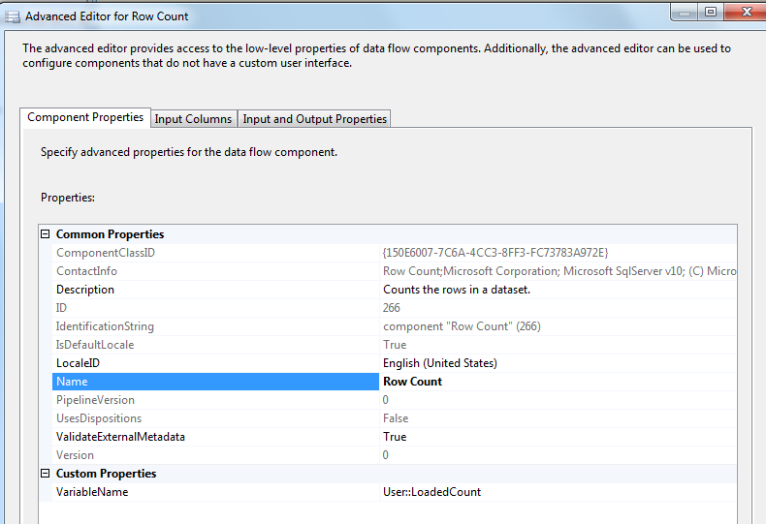

Lookup Transformation No Match Output – Row Count Transformation to get Rejected Count

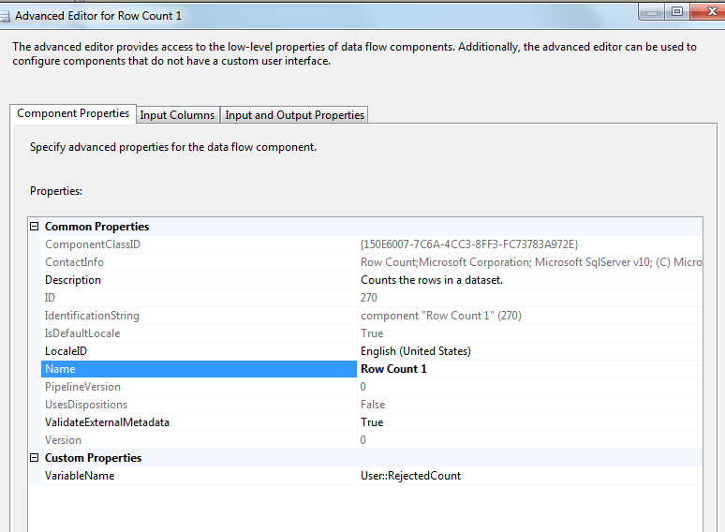

Derived Column – To get Reject Reason and Reject Date

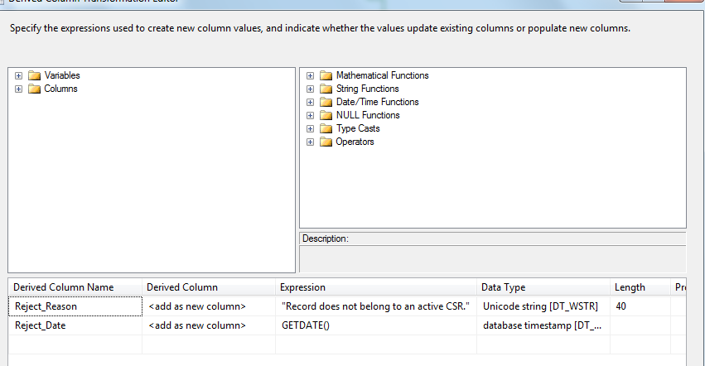

oledb destination – Write rejected records to Generic rejected table

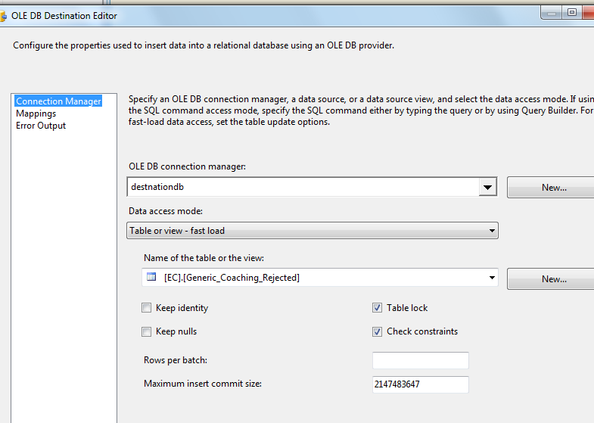

1. SQL Task: Delete records with missing Employee ID from Staging table

DELETE FROM [EC].[Generic_Coaching_Stage]

WHERE [CSR_EMPID] IS NULL OR [CSR_EMPID] ='' OR [CSR_LANID] = 'Unknown'

DELETE os FROM

[EC].[Generic_Coaching_Stage] os JOIN [EC].[Employee_Hierarchy] eh

ON os.CSR_EMPID = eh.Emp_ID

WHERE eh.Emp_Job_Code not in ('WACS01','WACS02','WACS03')

OR Active in ('T','D','L','P')

GO

1. SQL Task: Load Coaching_Log table

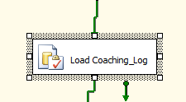

Executes Exec [EC].[sp_InsertInto_Coaching_Log_Generic]

1. SQl Task: Load Generic Fact table

INSERT INTO[EC].[Generic_Coaching_Fact]

([Report_ID]

,[Report_Code]

,[Form_Type]

,[Source]

,[Form_Status]

,[Event_Date]

,[Submitted_Date]

,[Start_Date]

,[Submitter_LANID]

,[Submitter_Name]

,[Submitter_Email]

,[CSR_LANID]

,[CSR_Site]

,[Program]

,[CoachReason_Current_Coaching_Initiatives]

,[TextDescription]

,[FileName]

)

SELECT S.[Report_ID]

,S.[Report_Code]

,S.[Form_Type]

,S.[Source]

,S.[Form_Status]

,S.[Event_Date]

,S.[Submitted_Date]

,S.[Start_Date]

,S.[Submitter_LANID]

,S.[Submitter_Name]

,S.[Submitter_Email]

,S.[CSR_LANID]

,S.[CSR_Site]

,S.[Program]

,S.[CoachReason_Current_Coaching_Initiatives]

,S.[TextDescription]

,S.[FileName]

FROM [EC].[Generic_Coaching_Stage]S LEFT OUTER JOIN [EC].[Generic_Coaching_Fact]F

ON S.[Report_ID]=F.[Report_ID]

AND S.Report_Code = F.Report_Code

WHERE F.[Report_ID] IS NULL AND F.Report_Code IS NULL

GO

1. SQL Task: Load Generic File List table

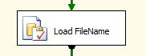

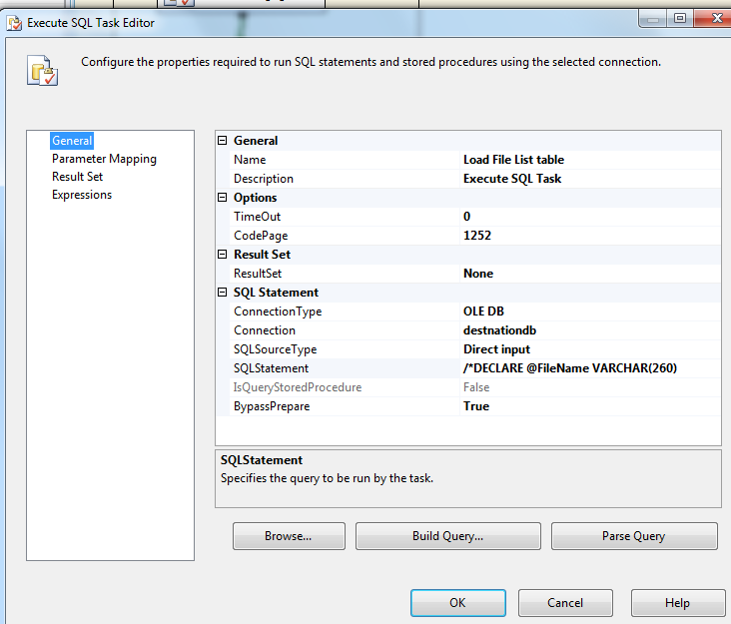

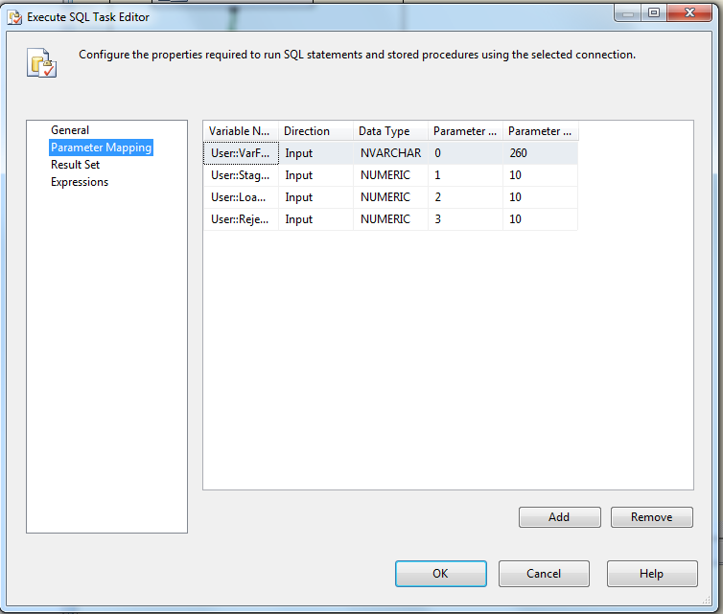

Executes the following sql

INSERT INTO [EC].[Generic_FileList]

([File_Name]

,[File_LoadDate]

,[Count_Staged]

,[Count_Loaded]

,[Count_Rejected])

VALUES (?,GetDate(), ?, ?,?)

1. File System Task: Move file to backup folder



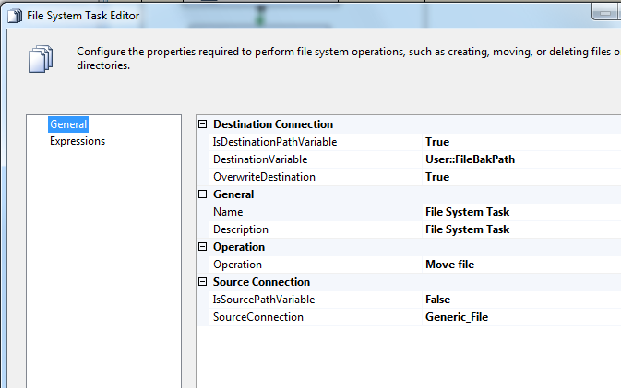

* + - 1. **Package Content(Event Handlers)**

Executables: Generic _Coaching

EventHandler: OntaskFailed

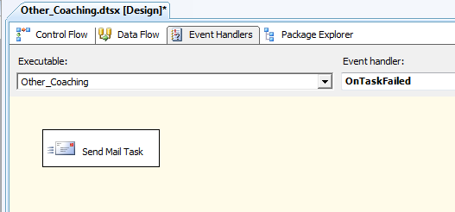

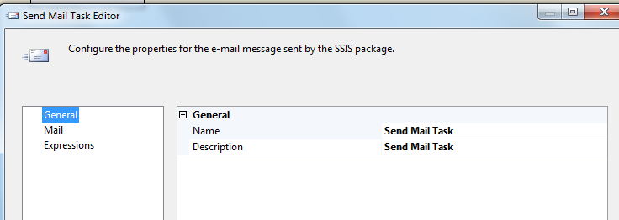

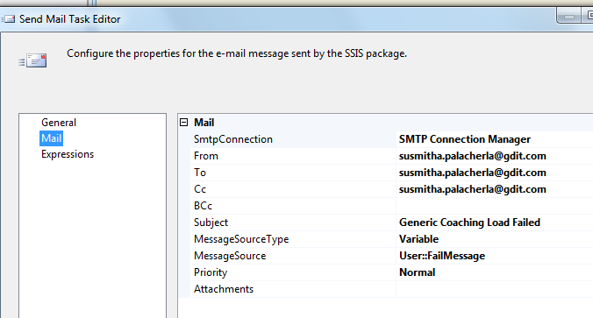

### Tables

|  | **Table Name** | **Table Description** |
| --- | --- | --- |
| 1. | Generic_Coaching_Stage | Table used for staging the Generic records during the insert into Coaching_Log table. |
| 2. | Generic_Coaching_Rejected | Table used for storing the rejected Generic records during the insert into Coaching_Log table. Logs are rejected when an incoming Lan ID does not exist in the Employee_Hierarchy table. |
| 3. | Generic_Coaching_Fact | Table used for storing Generic source records loaded into the Coaching Log table. |
| 4. | Generic_FileList | Table used for storing the Generic file names and Load dates. |

Table structure and details in document: eCoaching_Database_DD.docx

### Procedures

|  | **Procedure Name** | **Usage** |
| --- | --- | --- |
| 1. | sp_InsertInto_Coaching_Log_Generic | Load: Generic Data |

### Functions

|  | **FunctionName** | **Usage** |
| --- | --- | --- |
| 1. |  |  |

Reference Document for Objects and Code: eCoaching_Generic_Load_Create