__________________________



**Title: eCoaching_Inactivations_From_Feed**

**SSIS Detail Design Document**

__________________________

|  |  |  |
| --- | --- | --- |
| Last Revision | Last Review | Description |
| 04/23/2015 |  | Initial revision |

Prepared by: Susmitha Palacherla Date: 04/23/2015

Department, Location: Health Solutions Division

Approved by: Date:

**Change History Log**

| **Date** | **Version** | **Change Description** | **Author** |
| --- | --- | --- | --- |
| 04/23/2015 | 1.0 | Initial revision. Set up per SCR 14634 | Susmitha Palacherla |
|  |  |  |  |
|  |  |  |  |
|  |  |  |  |
|  |  |  |  |
|  |  |  |  |
|  |  |  |  |

Contents

1. Overview 4

1.1 Project Description 4

1.2 Document Scope 4

1.3 Source Files 4

1.4 Module List 5

1.5 Software and Hardware Interfaces 6

1.5.1 Software 6

1.5.2 Hardware 6

1.6 Users 6

2. Details 6

2.1 Source Files 6

2.2 Module Details 7

2.2.1 SQL agent job 7

2.2.2 SSIS Package 7

2.2.3 Tables 33

2.2.4 Procedures 33

# Overview

## Project Description

Currently program management forwards authorized inactivation requests to engineering via email and engineering inactivates the logs manually by running SQL in the database.   
This new process would automatically process a file every night to inactivate all standard requests that would normally be requested via email. In addition to saving time the automated process will reduce the risk associated with the manual in-activations.

## Document Scope

This document describes the processing of the Coaching and Warning Files that are posted by

program management on a daily basis.

## Source Files

There will be one Coaching and one warning file posted daily.

eCL_Coaching_mmddyyyy.csv

eCL_Warning_mmddyyyy.csv

Files are staged at \\VRIVSCORS01\BCC Scorecards\Coaching\Inactivations\

## Module List

* SQL agent job
* SSIS Package
* Tables
* Procedures

## Software and Hardware Interfaces

### Software

* SQL Server 2008 R2 SP1 Suite

### Hardware

* VRIVFSSDBT02\SCORD01,1437 – Dev DB Instance
* VRIVFSSDBT02\SCORT01,1438 – Test DB Instance
* VDENSSDBP07\SCORP01 – Prod DB Instance
* \\VRIVSCORS01\BCC Scorecards\ - File staging share

# Details



## Source Files

A file will be posted daily for Coachings and warning logs by Program Manager.

eCL_Coaching_mmddyyyy.csv

eCL_Warning_mmddyyyy.csv

* Description: Files will contain only one column which is the form name.
* Source system: NA – Requests are sent via email to program Manager who

Reviews the requests and consolidates approved requests into the files.

* Staging location: \\vrivscors01\BCC Scorecards\Coaching\Inactivations\
* Frequency: Once Daily
* File arrival time: Prior to 10:00 PM EST
* Processing table - [EC].[Inactivations_Stage]

## Module Details

### SQL agent job

* Production Instance : VDENSSDBP07\SCORP01
* Production Job: CoachingInactivations
* Production Package: \\VDENSSDBP07\scorecard-ssis\Coaching\eCL_Inactivations.dtsx
* Production Config File: Prod_eCL_Inactivations.dtsConfig
* Owner: jobs_admin
* Run As: BccScrdSQLAgent
* Schedule: 10:00 PM EST
* Destination File Location: N/A

### SSIS Package

* + - 1. **Variables**

|  |  |  |  |  |
| --- | --- | --- | --- | --- |
| **Name** | **Scope** | **DataType** | **Value** | **Evaluate As expression** |
| BakDir | eCL_Inactivations | String | \\vrivscors01\BCC Scorecards\Coaching\Inactivations\Bak\ | False |
| CoachFileIn | eCL_Inactivations | String | eCL_Coaching_mmddyyyy.csv | True |
| CoachFileOut | eCL_Inactivations | String | eCL_Coaching_Processed_mmddyyyy.csv | True |
| FileDir | eCL_Inactivations | String | \\vrivscors01\BCC Scorecards\Coaching\Inactivations\ | False |
| FileExists | eCL_Inactivations | Boolean | False | True |
| FromEmail | eCL_Inactivations | String | eCoaching_Notifications@GDIT.com | False |
| ProcessedDir | eCL_Inactivations | String | \\vrivscors01\BCC Scorecards\Coaching\Inactivations\Processed\ | False |
| ToEmailCC | eCL_Inactivations | String | susmitha.palacherla@GDIT.com | False |
| ToEmailExt | eCL_Inactivations | String | JohnEric.Tiongson@GDIT.com | False |
| ToEmailInt | eCL_Inactivations | String | susmitha.palacherla@GDIT.com | False |
| WarnFileIn | eCL_Inactivations | String | eCL_Warning_mmddyyyy.csv | True |
| WarnFileOut | eCL_Inactivations | String | eCL_Warning_Processed_mmddyyyy.csv | True |
|  |  |  |  |  |
|  |  |  |  |  |
|  |  |  |  |  |
|  |  |  |  |  |
|  |  |  |  |  |
|  |  |  |  |  |

* + - 1. **Connection Manager Entries**
         1. Destinationdb
* Dev - VRIVFSSDBT02\SCORD01,1437) DB – eCoachingdev
* Prod - VDENSSDBP07\SCORP01 DB – eCoaching
* Test- VRIVFSSDBT02\SCORT01,1438) DB – eCoachingTest

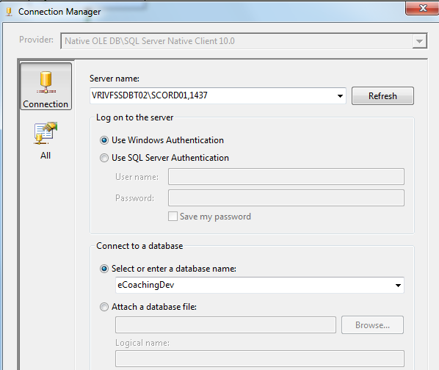

* + - * 1. CoachingsFileIn

\\vrivscors01\BCC Scorecards\Coaching\Inactivations\Test\eCL_Coaching_mmddyyyy.csv

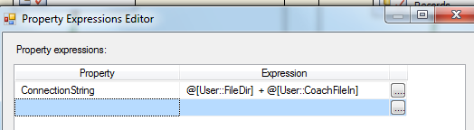

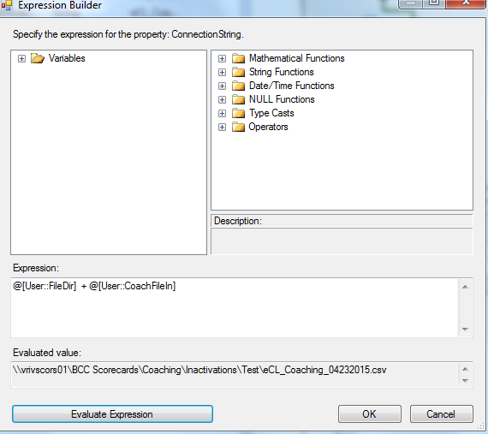

* + - * 1. CoachFileOut

\\vrivscors01\BCC Scorecards\Coaching\Inactivations\Test\Processed\eCL_Coaching_Processed_04232015.csv

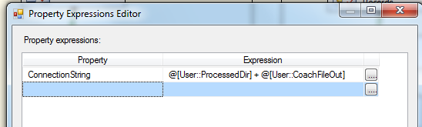

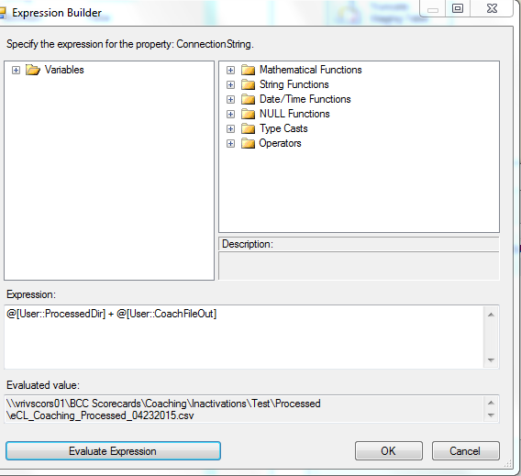

* + - * 1. WarningsFileIn

\\vrivscors01\BCC Scorecards\Coaching\Inactivations\Test\eCL_Warning_mmddyyyy.csv

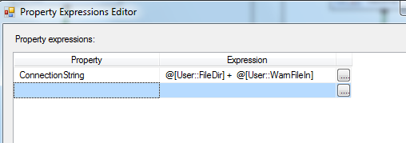

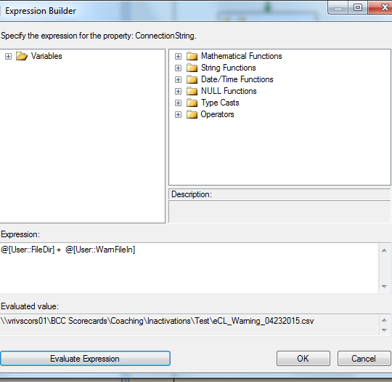

* + - * 1. WarningFileOut

\\vrivscors01\BCC Scorecards\Coaching\Inactivations\Test\Processed\eCL_Warning_mmddyyyy.csv

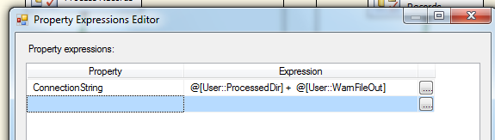

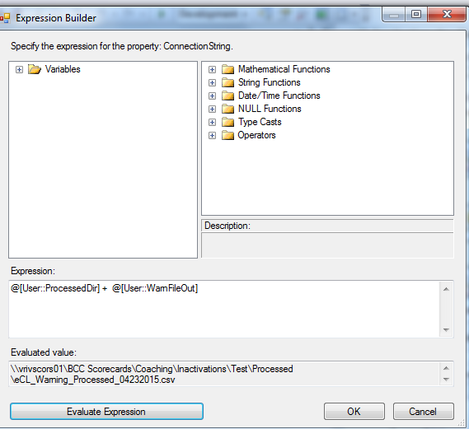

* + - * 1. SMTP Connection Manager

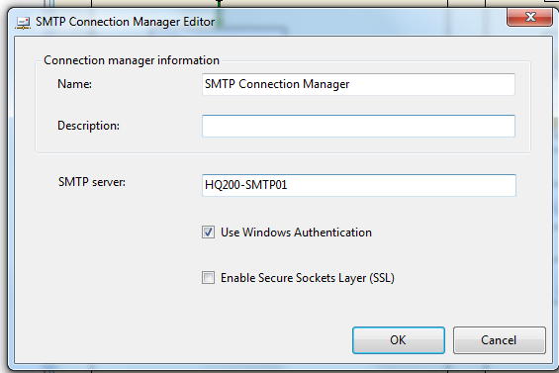

* + - 1. **Package Content**

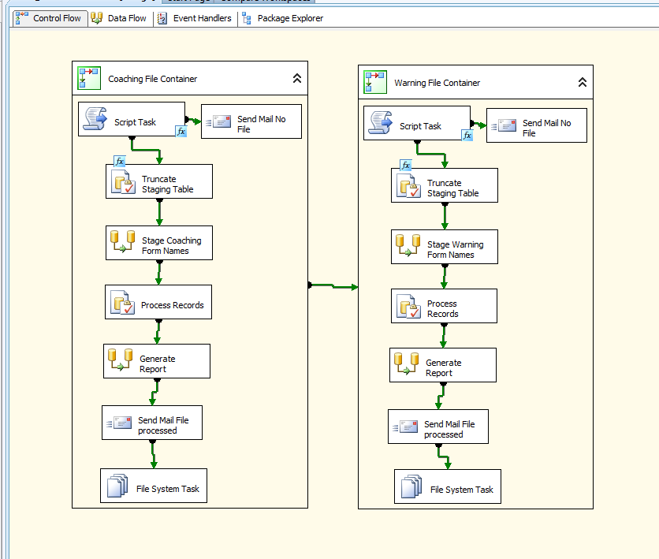

**Workflow**

**Summary of Steps**

1. Sequence Container – Coaching File container
2. Script task – Truncate WH Staging table
3. SQL task – Truncate WH Staging table
4. DFT – Stage Staging table
5. SQL task – Process Records
6. DFT – Generate Report
7. SMTP Task – Send Email
8. File System task – Backup file
9. Sequence Container – Warnings File File container
10. Script task – Truncate WH Staging table
11. SQL task – Truncate WH Staging table
12. DFT – Stage Staging table
13. SQL task – Process Records
14. DFT – Generate Report
15. SMTP Task – Send Email
16. File System task – Backup file
    * + - 1. **Sequence Container – Coaching File container**

Container: Coachings Sequence Container

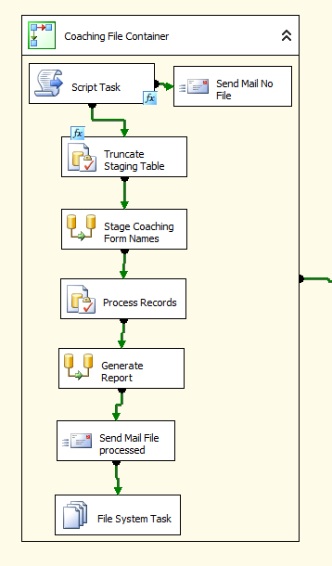

1. Script task – Check If File Exists

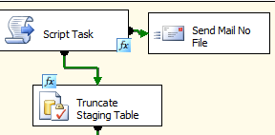

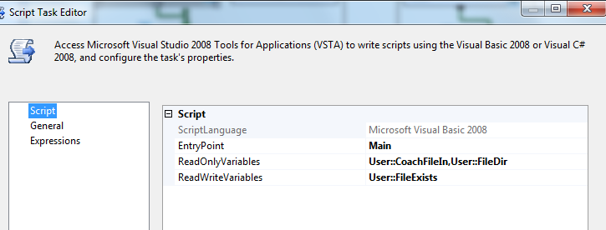

' Microsoft SQL Server Integration Services Script Task

' Write scripts using Microsoft Visual Basic 2008.

' The ScriptMain is the entry point class of the script.

Imports System

Imports System.Data

Imports System.Math

Imports System.IO

Imports Microsoft.SqlServer.Dts.Runtime

<System.AddIn.AddIn("ScriptMain", Version:="1.0", Publisher:="", Description:="")> _

<System.CLSCompliantAttribute(False)> _

Partial Public Class ScriptMain

Inherits Microsoft.SqlServer.Dts.Tasks.ScriptTask.VSTARTScriptObjectModelBase

Enum ScriptResults

Success = Microsoft.SqlServer.Dts.Runtime.DTSExecResult.Success

Failure = Microsoft.SqlServer.Dts.Runtime.DTSExecResult.Failure

End Enum

' The execution engine calls this method when the task executes.

' To access the object model, use the Dts property. Connections, variables, events,

' and logging features are available as members of the Dts property as shown in the following examples.

'

' To reference a variable, call Dts.Variables("MyCaseSensitiveVariableName").Value

' To post a log entry, call Dts.Log("This is my log text", 999, Nothing)

' To fire an event, call Dts.Events.FireInformation(99, "test", "hit the help message", "", 0, True)

'

' To use the connections collection use something like the following:

' ConnectionManager cm = Dts.Connections.Add("OLEDB")

' cm.ConnectionString = "Data Source=localhost;Initial Catalog=AdventureWorks;Provider=SQLNCLI10;Integrated Security=SSPI;Auto Translate=False;"

'

' Before returning from this method, set the value of Dts.TaskResult to indicate success or failure.

'

' To open Help, press F1.

Public Sub Main()

Dim fileLoc, CoachFile As String

If Dts.Variables.Contains("User::FileDir") = True AndAlso _

Dts.Variables.Contains("User::CoachFileIn") = True Then

fileLoc = CStr(Dts.Variables("User::FileDir").Value)

CoachFile = CStr(Dts.Variables.Item("User::CoachFileIn").Value)

'System.Windows.Forms.MessageBox.Show("FileDir:"+fileLoc+"CoachFileIn:" + CoachFile)

If File.Exists(fileLoc + CoachFile) Then

Dts.Variables.Item("User::FileExists").Value = True

'System.Windows.Forms.MessageBox.Show("File exists")

Else

Dts.Variables.Item("User::FileExists").Value = False

'System.Windows.Forms.MessageBox.Show("File not exists")

End If

Dts.TaskResult = ScriptResults.Success

Else

Dts.TaskResult = ScriptResults.Failure

End If

End Sub

End Class

1. If FileExists == TRUE SQL task – Truncate Staging Table

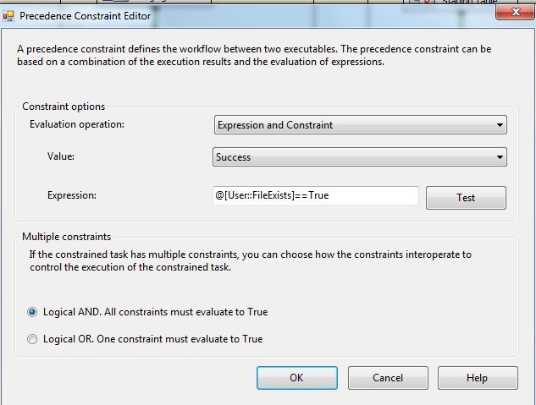

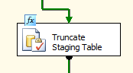

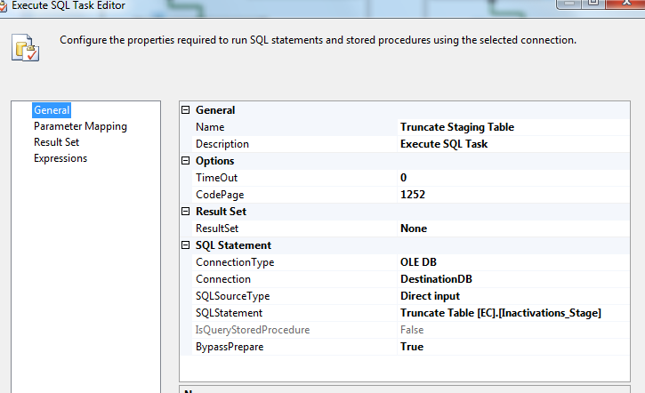

IF FileExists == False

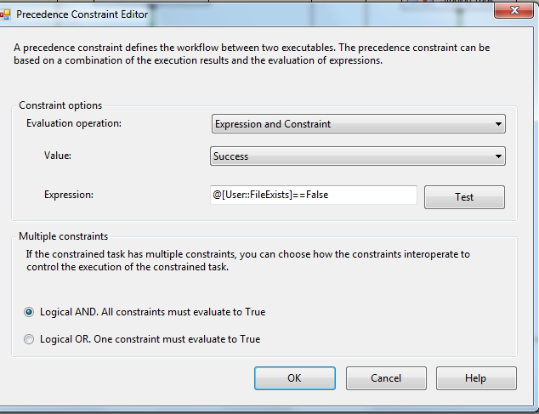

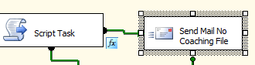

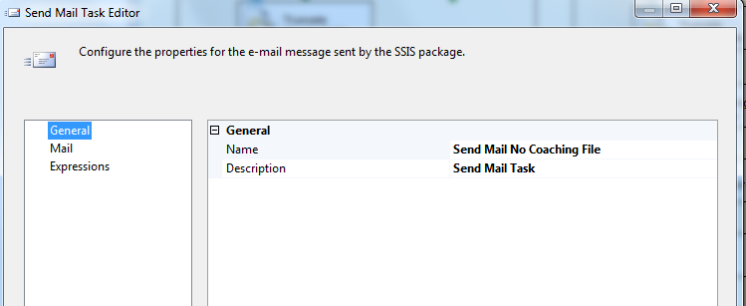

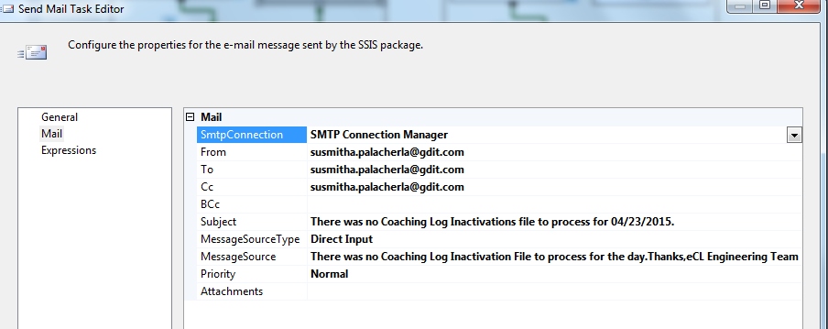

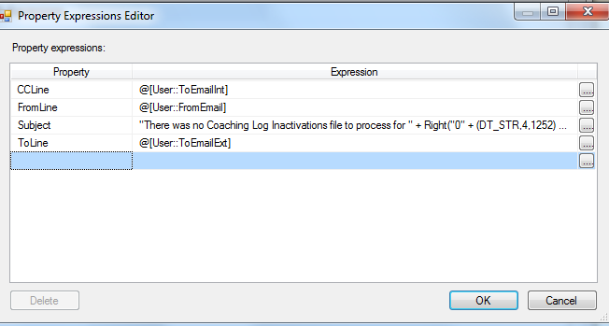Subject - "There was no Coaching Log Inactivations file to process for " + Right("0" + (DT_STR,4,1252) DatePart("m",getdate()),2) +

"/" + Right("0" + (DT_STR,4,1252) DatePart("d",getdate()),2) + "/" +

(DT_STR,4,1252) DatePart("yyyy",getdate())

+ "."

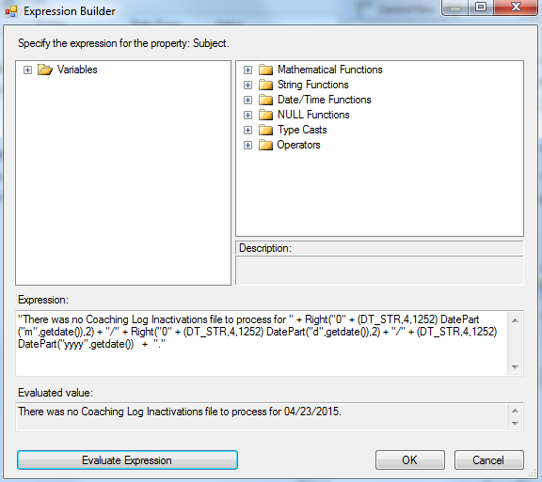

1. DFT: Load Staging Table

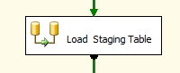

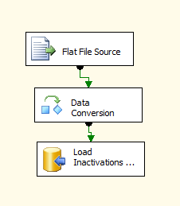

1. Flat File source

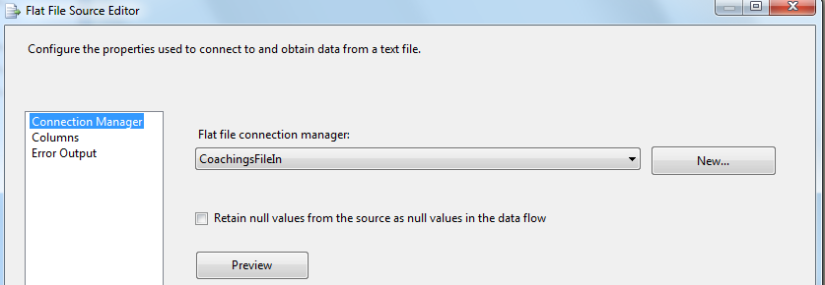

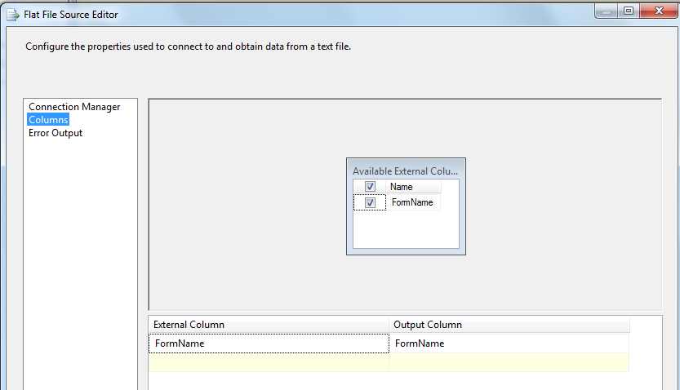

1. Data Conversion

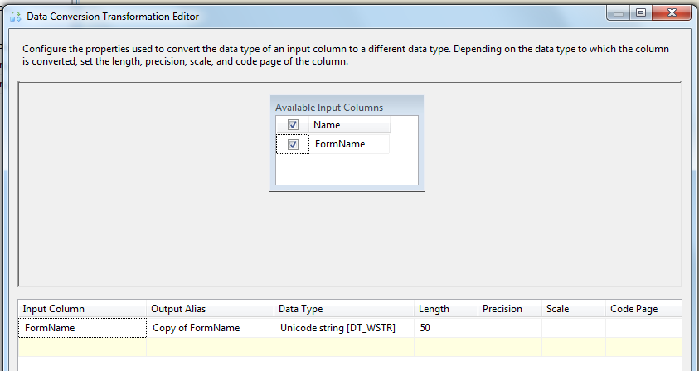

1. OLEDB Destination

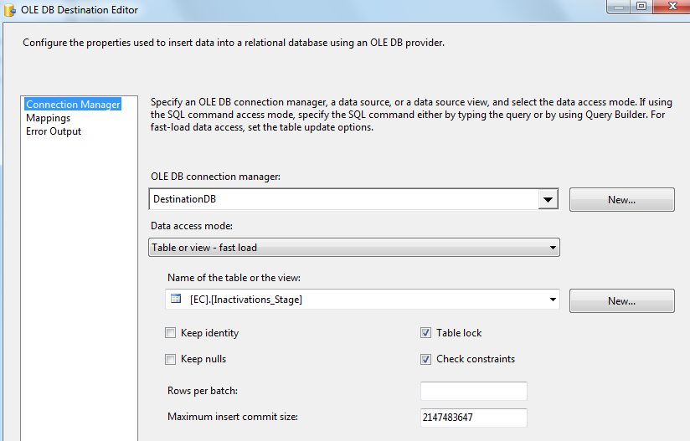

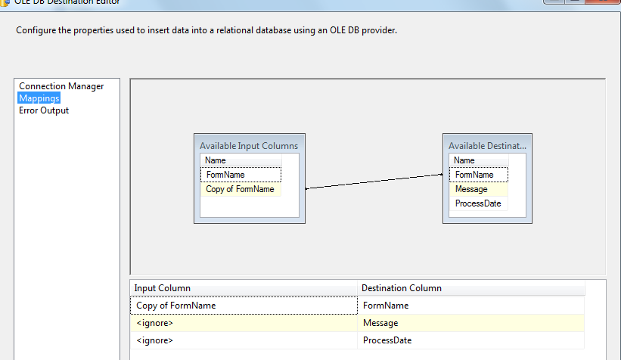

1. SQL task: Process Records

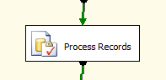

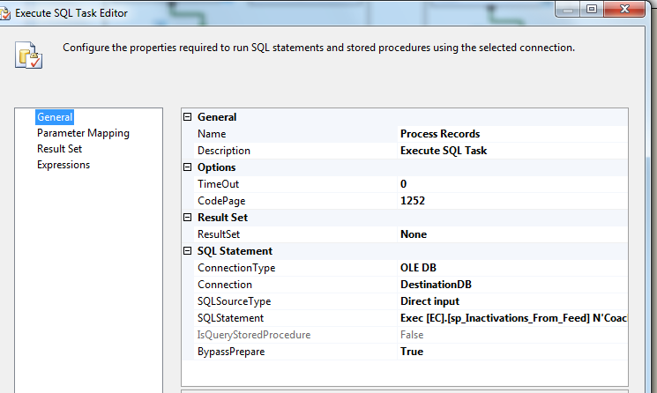

Executes Exec [EC].[sp_Inactivations_From_Feed] N'Coaching'

1. DFT: Generate Report

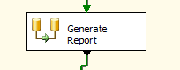

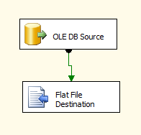

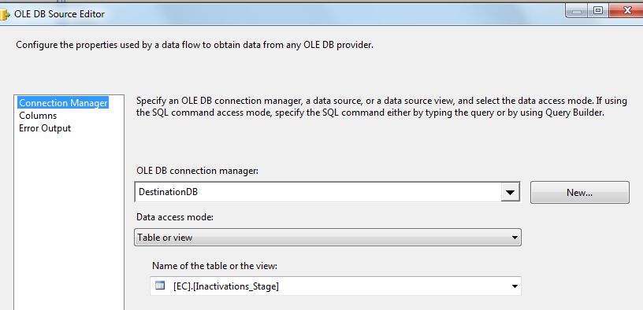

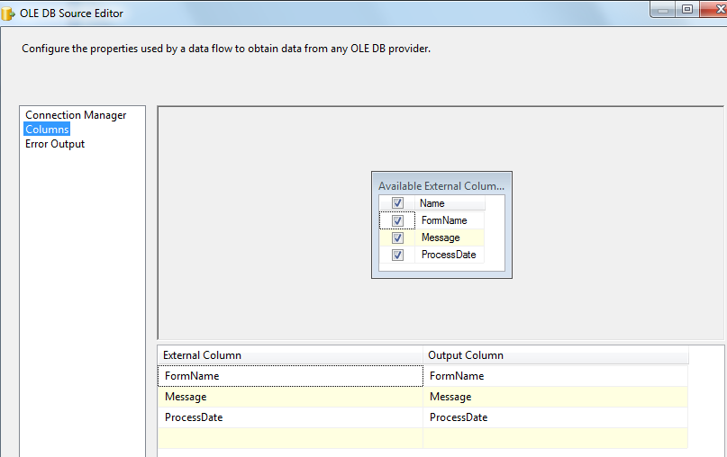

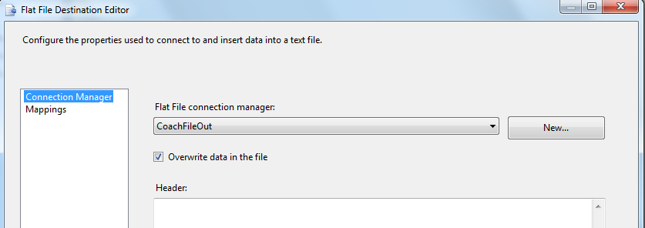

1. SMTP task: Send Mail Task

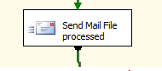

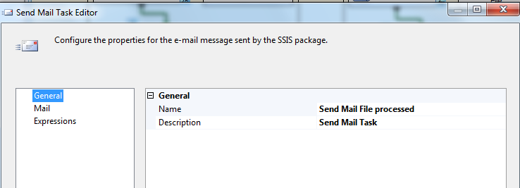

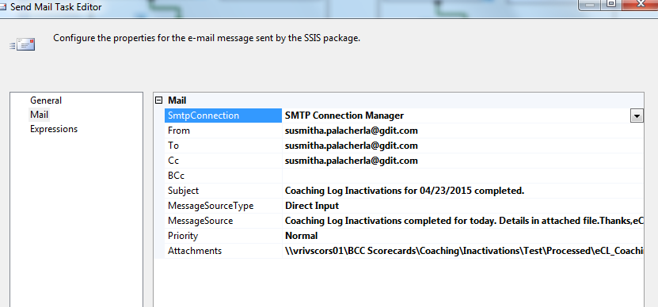

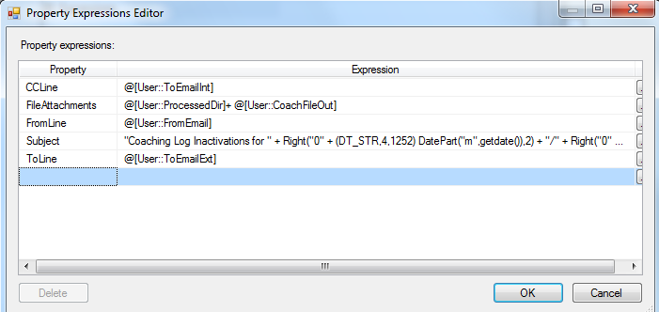

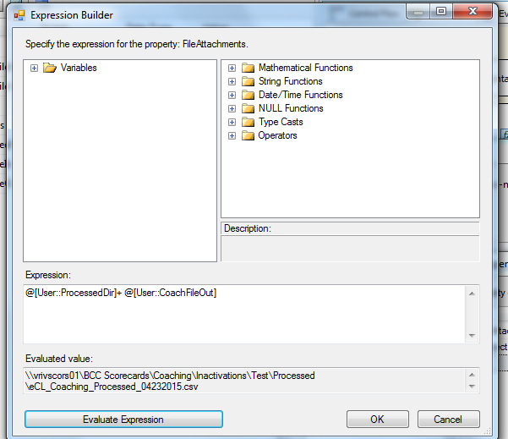

@[User::ProcessedDir]+ @[User::CoachFileOut]

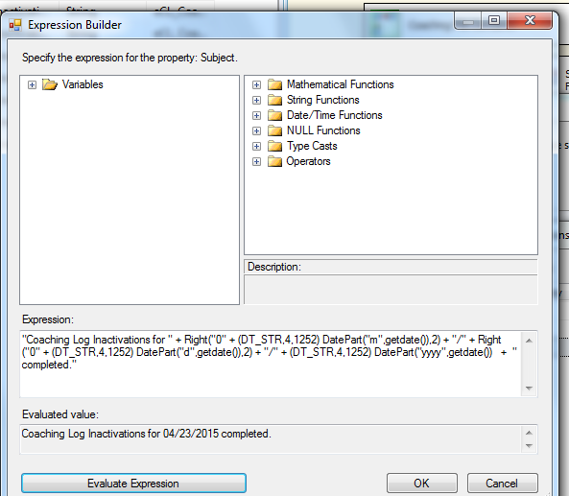

"Coaching Log Inactivations for " + Right("0" + (DT_STR,4,1252) DatePart("m",getdate()),2) +

"/" + Right("0" + (DT_STR,4,1252) DatePart("d",getdate()),2) + "/" +

(DT_STR,4,1252) DatePart("yyyy",getdate())

+ " completed."

1. File System Task: Move processed File

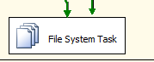

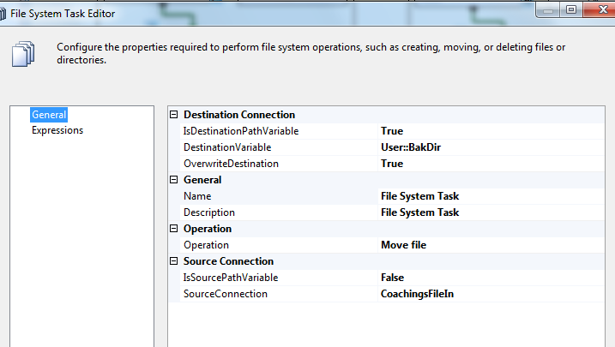

* + - * 1. **Sequence Container – Warnings File container**

1. Script task – Truncate WH Staging table
2. SQL task – Truncate WH Staging table
3. DFT – Stage Staging table
4. SQL task – Process Records
5. DFT – Generate Report
6. SMTP Task – Send Email
7. File System task – Backup file

Repeat above steps similar to Coachings File container in 2.2.2.3.1.

* + - 1. **Event Handlers**

Executables: Coaching File Container and Warning File container

EventHandler: OntaskFailed

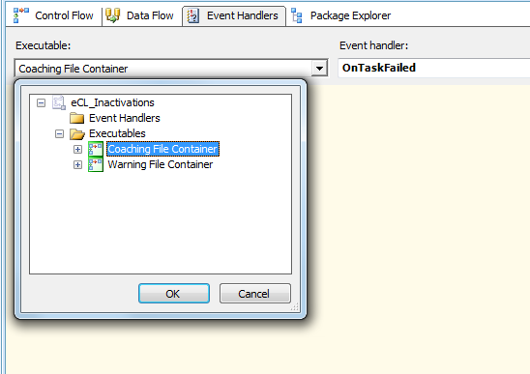

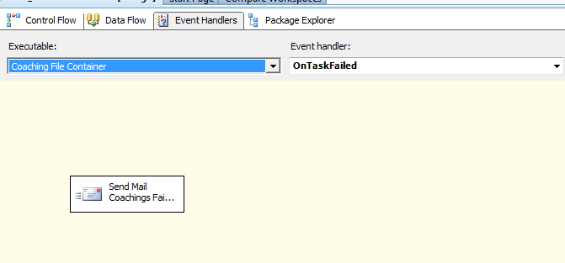

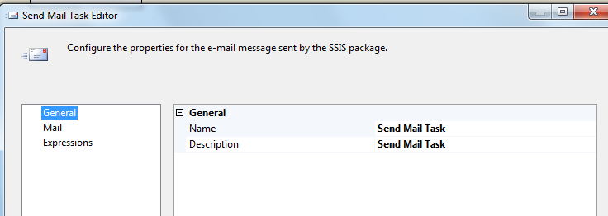

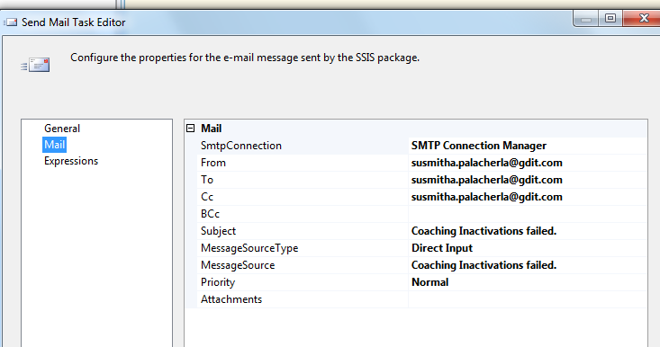

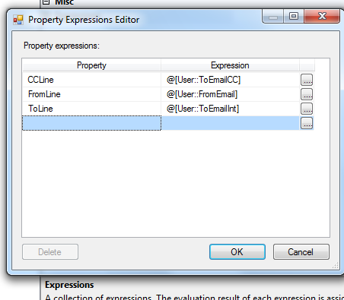

Similarly for warning File container.

### Tables

|  | **Table Name** | **Table Description** |
| --- | --- | --- |
| 1. | [EC].[Inactivations_Stage] | Table used for processing of the logs. Truncated for each file processed. |

Table structure and details in document: eCoaching_Database_DD.docx

### Procedures

|  | **Procedure Name** | **Usage** |
| --- | --- | --- |
| 1. | [EC].[sp_Inactivations_From_Feed] | Used for processing the in-activations. |

Table and procedure create code in CCO_eCoaching_Maintenance_Create.sql.