__________________________



**Title: eCoaching_Outliers_Load**

**SSIS Detail Design Document**

__________________________

|  |  |  |
| --- | --- | --- |
| Last Revision | Last Review | Description |
| 09/21/2015 |  | IAT and IAE feeds. TFS 644. |

Prepared by: Susmitha Palacherla Date: 12/04/2013

Department, Location: Health Solutions Division

Approved by: Date:

**Change History Log**

| **Date** | **Change Description** | **Author** |
| --- | --- | --- |
| 12/04/2013 | 1.0 Initial revision | Susmitha Palacherla |
| 05/01/2015 | 2.0 SMTP server change. SCR 14803. | Susmitha Palacherla |
| 05/26/2015 | 3.0 LSAT feed Addition. SCR 14818. | Susmitha Palacherla |
| 09/21/2015 | 4.0 IAT and IAE feed(s) Addition. TFS 644.  Added IAT file to Section 1.3 and checked IAE as Active.  Added Section 2.2.2.3.2  Added Section 2.2.5 (Functions)  General updates to LCS and General OMR workflow sections for consistency. | Susmitha Palacherla |
|  |  |  |
|  |  |  |
|  |  |  |

Contents

1. Overview 4

1.1 Project Description 4

1.2 Document Scope 4

1.3 Source Files 4

1.4 Module List 6

1.5 Software and Hardware Interfaces 6

1.5.1 Software 6

1.5.2 Hardware 6

1.6 Users 6

2. Details 6

2.1 Source Files 6

2.2 Module Details 7

2.2.1 SQL agent job 7

2.2.2 SSIS Package 7

2.2.3 Tables 82

2.2.4 Procedures 82

2.2.5 Functions 82

# Overview

## Project Description

The eCL outlier research and coaching process is a standard process to facilitate consistent communication when a performance opportunity exists. It provides a method to make a determination of whether coaching is needed, when to initiate coaching and verification that the performance issue has been addressed. Outlier reports are created by the CCO Analytics team which identifies thresholds and exceptions that require coaching or further research by Call Center Mangers (CCM). All items are entered into the eCL either through a Point of Contact (POC) via the standard entry form or through a data feed. Utilizing the eCL work-flow, items can be tracked from start to finish to verify if items have been addressed. The eCL will also provide reporting on the number of outliers entered into the system, the number coached, pending coaching, pending review or reasons why coaching was not required.

## Document Scope

This document describes the load of the Outliers reports provided by the Analytics team into the eCoaching database. Once the reports are loaded into the database the logs are tracked through the workflow like any Coaching log entered from the web interface.

## Source Files

The table below shows all of the outlier report types that can arrive as feeds. Currently active feeds are marked by an ‘X’ in the table below.

Files have a naming convention eCL_Outlier_Feed_XXXyyyymmdd.csv where XXX stands for the 3 letter acronym used by the report as shown in the ‘Code’ column below.

Files are staged at \\VRIVSCORS01\BCC Scorecards\Coaching\Outliers\

|  |  |  |  |  |  |  |
| --- | --- | --- | --- | --- | --- | --- |
| **#** | **Metric/Report** | **Active Feed** | **Code** | **eCL Workflow** | **Entry** | **Coaching Reason** |
| 1 | OMR: Inappropriate ACO Escalation |  | ACO | Direct Coach | POC | Current Coaching Initiatives |
| 2 | OMR: ACW |  | ACW | Direct Coach | POC | Current Coaching Initiatives |
| 3 | OMR: AHT |  | AHT | Direct Coach | POC | Current Coaching Initiatives |
| 4 | OMR: Cancelled Calls | X | CAN | Manager Review | Data Feed | Current Coaching Initiatives |
| 5 | OMR: Default Qualifiers | X | DFQ | Manager Review | Data Feed | Current Coaching Initiatives |
| 6 | OMR: Inappropriate ARC Escalation | X | IAE | Direct Coach | Data Feed | Current Coaching Initiatives |
| 7 | OMR: Inappropriate DME Escalation |  | IDE | Direct Coach | POC | Current Coaching Initiatives |
| 8 | OMR: Inappropriate EE/MM Escalation |  | IEE | Direct Coach | POC | Current Coaching Initiatives |
| 9 | OMR: Inappropriate NGD Feedback |  | INF | Direct Coach | POC | Current Coaching Initiatives |
| 10 | OMR: ISG Consults |  | ISG | Manager Review | Data Feed | Current Coaching Initiatives |
| 11 | OMR: Short Calls – Inbound | X | ISQ | Manager Review | Data Feed | Current Coaching Initiatives |
| 12 | OMR: Low CSAT | X | LCS | Direct Coach | Data Feed | Current Coaching Initiatives |
| 13 | OMR: Scripts Logged |  | SLG | Direct Coach | POC | Current Coaching Initiatives |
| 14 | OMR: NGD Inappropriate Transfer |  | NIT | Manager Review | Data Feed | Current Coaching Initiatives |
| 15 | OMR: Open Calls | X | OPN | Manager Review | Data Feed | Current Coaching Initiatives |
| 16 | OMR: Short Calls – Outbound | X | OSC | Manager Review | Data Feed | Current Coaching Initiatives |
| 17 | OMR: Returned MAC Escalation |  | RME | Direct Coach | POC | Current Coaching Initiatives |
| 18 | OMR: BCC Security and Privacy Incident Coaching |  | SPI | Direct Coach | POC | Current Coaching Initiatives |
| 19 | OMR: Transfers |  | TRN | Manager Review | Data Feed | Current Coaching Initiatives |
| 20 | OMR: Inappropriate ARC Transfer | X | IAT | Direct Coach | Data Feed | Current Coaching Initiatives |

## Module List

* SQL agent job
* SSIS Package
* Tables
* Procedures

## Software and Hardware Interfaces

### Software

* SQL Server 2008 R2 SP1 Suite

### Hardware

* VRIVFSSDBT02\SCORD01,1437 – Dev DB Instance
* VRIVFSSDBT02\SCORT01,1438 – Test DB Instance
* VDENSSDBP07\SCORP01 – Prod DB Instance
* \\VRIVSCORS01\BCC Scorecards\ - File staging share

## Users

* The first set of users for the OMR records loaded into the eCL database are the CCO Managers as all records have default state of ‘Pending Manager Review’ at the time of the load.
* After a Manager reviews the log and determines that a Coaching is required the log gets assigned to the CSRs and they become the users.
* CCO Supervisors will be able to access the logs from the historical Dashboards.

# Details



## Source Files

eCL_Outliers_Feed_XXXyyyymmdd.csv where XXX is the 3 letter acronym for the Report Type.

Description: A file containing records for agents that exceed a certain threshold for each of the identified metrics. The Analytics team captures records that meet the Outlier thresholds and generate a feed. Once the feed is loaded into eCL the Managers have the opportunity to determine if a Coaching is needed or additional research is needed.

Source system: CCO Analytics

* Staging location: \\vrivscors01\BCC Scorecards\Coaching\Outliers\
* File name eCL_Outliers_Feed_XXXyyyymmdd.csv
* Frequency: N/A No regular schedule. Files are sent at random intervals.
* File arrival time: NA
* Destination Table: Coaching_Log and Coaching_Log_Reason

## Module Details

### SQL agent job

* Production Instance : VDENSSDBP07\SCORP01
* Production Job: NewDailyCoaching
* Production Package: \\VDENSSDBP07\scorecard-ssis\Coaching\Outlier_Coaching.dtsx
* Production Config File: Prod_Outlier_Coaching.dtsConfig
* Owner: jobs_admin
* Run As: BccScrdSQLAgent
* Schedule: Daily 6:30 AM EST IF Files exist to be loaded
* Destination File Location: N/A

### SSIS Package

* + - 1. **Variables**

|  |  |  |  |
| --- | --- | --- | --- |
| **Name** | **Scope** | **DataType** | **Value** |
| FilebakPath | Outlier_Coaching | String | \\vrivscors01\BCC Scorecards\Coaching\Outliers\Backups |
| FileNum | Outlier_Coaching | Int32 | 0 |
| FilePath | Outlier_Coaching | String | \\vrivscors01\BCC Scorecards\Coaching\Outliers |
| varDBName | Outlier_Coaching | String | Dev |
| varFileName | Outlier_Coaching | String |  |
| FailMessage | Outlier_Coaching | String | Outliers Coaching Load failed in Dev |
| StagedCount | Outlier_Coaching | Int32 | 0 |
| RejectedCount | Outlier_Coaching | Int32 | 0 |
| LoadedCount | Outlier_Coaching | Int32 | 0 |
|  |  |  |  |

* + - 1. **Connection Manager Entries**
         1. Destinationdb
* Dev - VRIVFSSDBT02\SCORD01,1437) DB – eCoachingdev
* Prod - VDENSSDBP07\SCORP01 DB – eCoaching

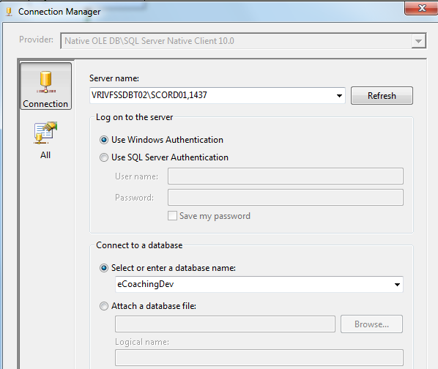

* + - * 1. Outlier_File
* \\vrivscors01\bcc scorecards\Coaching\Outliers\eCL_Outlier_feed*.csv

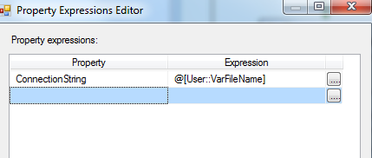

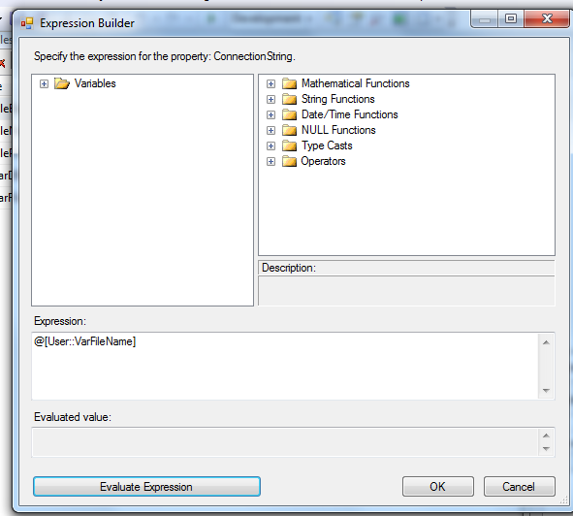

* + - * 1. SMTP Connection Manager

smtpout.gdit.com

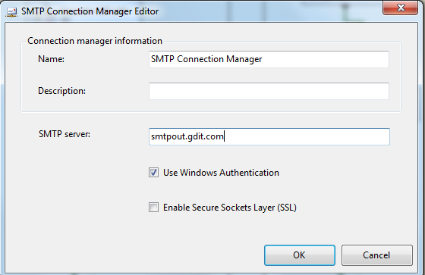

* + - * 1. LCS_File

\\vrivscors01\bcc scorecards\Coaching\Outliers\eCL_Outlier_Feed_LCS*.csv

* + - * 1. ARC_File

\\vrivscors01\bcc scorecards\Coaching\Outliers\eCL_Outlier_Feed_*.csv

*(Similar to Outlier_File. Will be distinguished using an expression in conditional

Flow during load process)







* + - 1. **Package Content(Control Flow)**

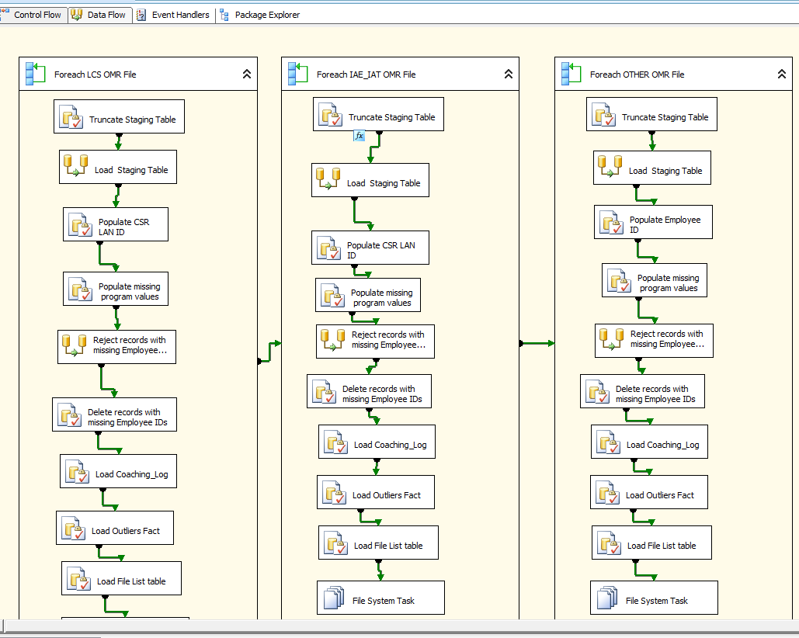

**Workflow**

* + - * 1. **For each LCS Outlier file in Staging directory Workflow**

Container: Foreach Loop

Folder: \\vrivscors01\BCC Scorecards\Coaching\Outliers

Files: eCL_Outlier_Feed_LCS*.csv

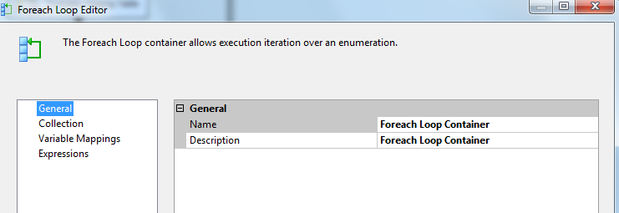

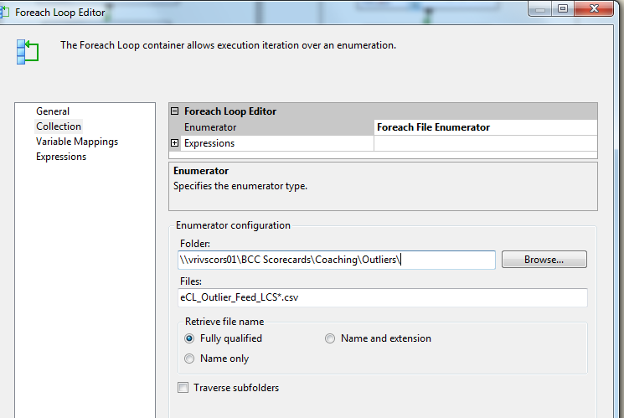

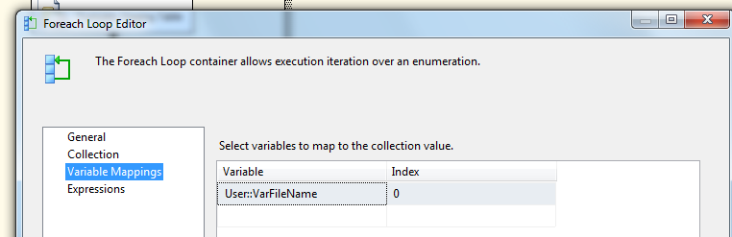

**Summary of Steps**

1. SQL task – Truncate Outliers Staging table
2. DFT – Stage Outliers Staging table
3. SQL task – Populate CSR LAN ID for LCS
4. SQL Task – Populate missing Program Values
5. DFT – Redirect rejected records to Reject table
6. SQL task – Delete records with missing employee ID from Staging table
7. SQL task Load coaching_Log and Coaching_Log_Reason tables
8. SQL task – Load Outliers Fact table
9. SQL task – Load File list table
10. File system task – Backup files to Backups directory

**Details of Steps**

1. SQL task – Truncate Outliers Staging table

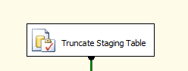

Executes Truncate Table [EC].[Outlier_Coaching_Stage]

1. DFT: Load Outliers staging table

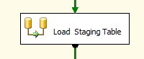

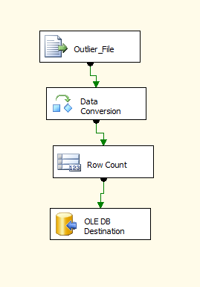

1. Flat File source

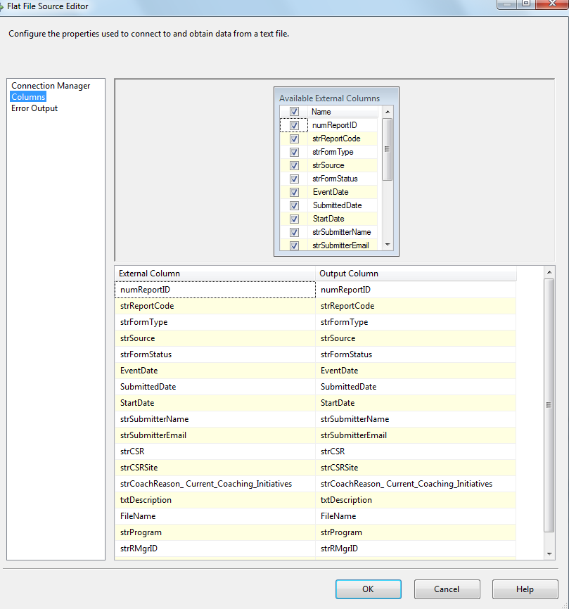

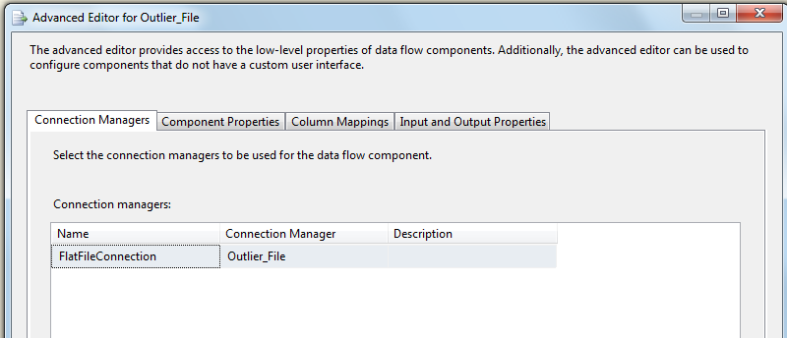

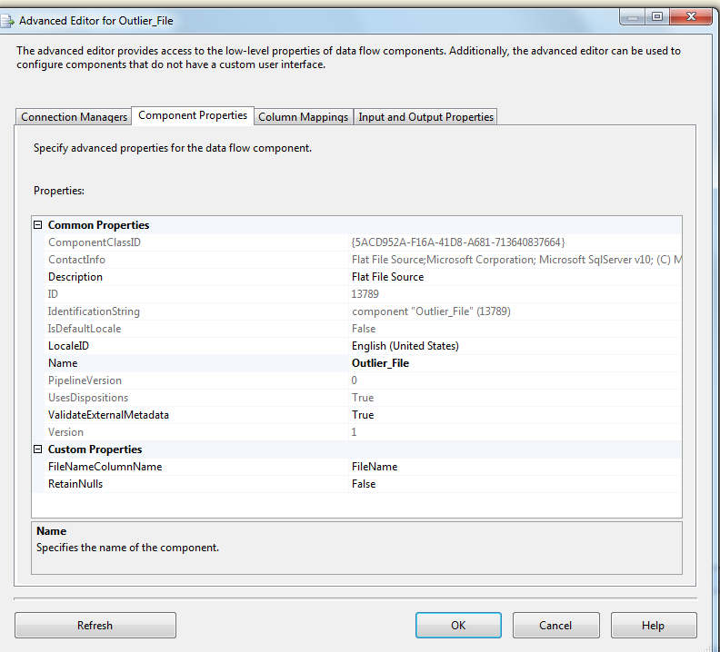

1. Data Conversion

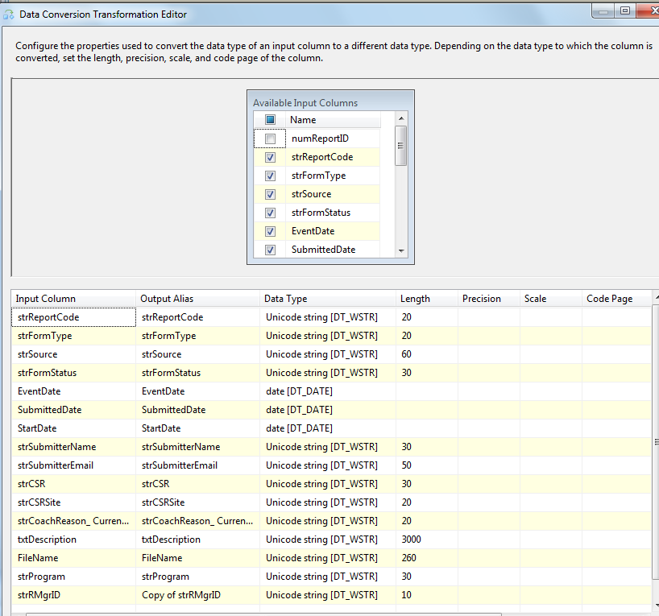

1. Row Count Transformation

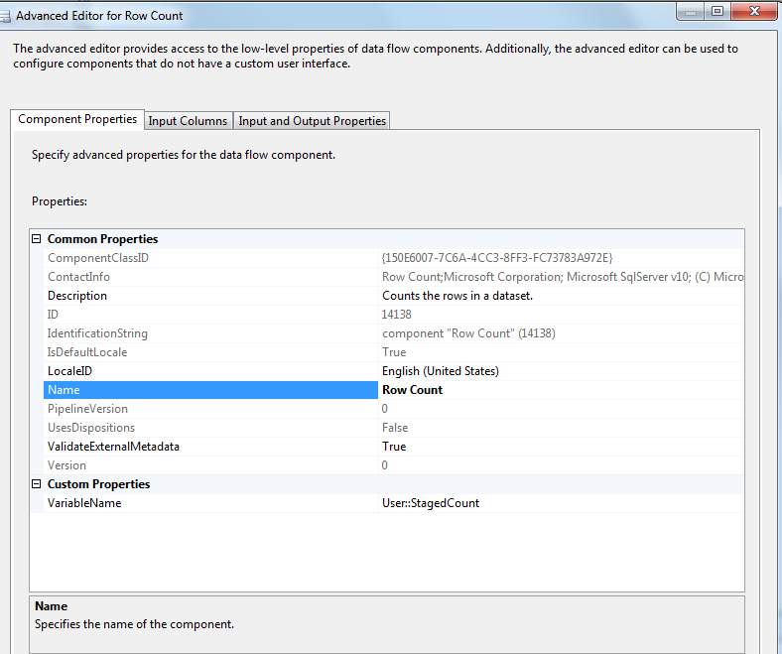

1. Oledb destination

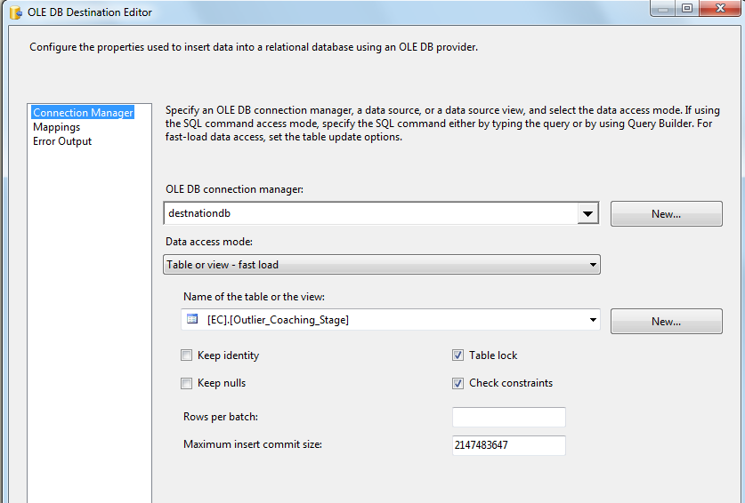

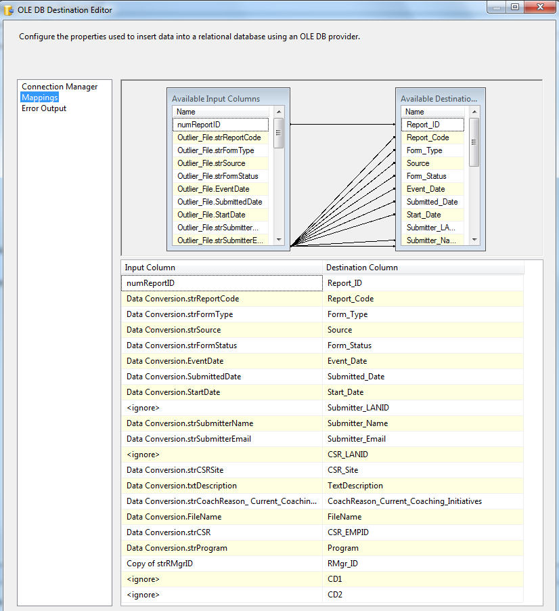

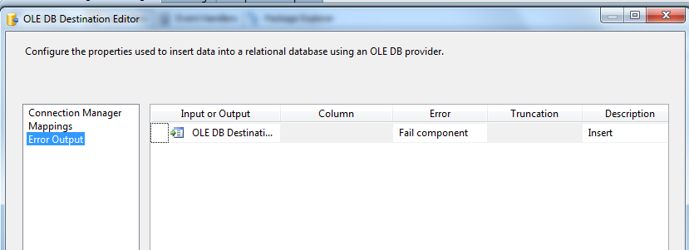

1. SQL Task: Populate CSR LAND ID

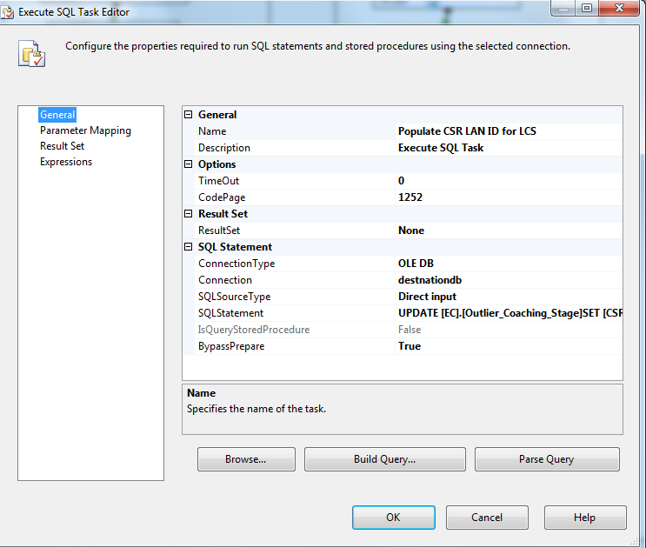

UPDATE [EC].[Outlier_Coaching_Stage]

SET [CSR_LANID]= [EC].[fn_strEmpLanIDFromEmpID]([CSR_EMPID])

1. SQL Task: Populate missing program values

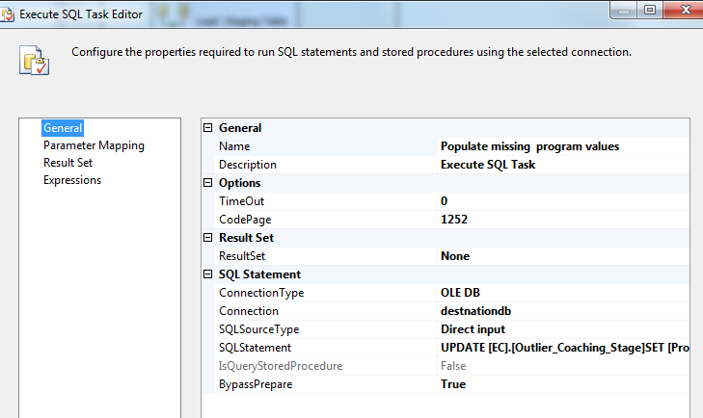

UPDATE [EC].[Outlier_Coaching_Stage]

SET [Program]= H.[Emp_Program]

FROM [EC].[Outlier_Coaching_Stage]S JOIN [EC].[Employee_Hierarchy]H

ON S.[CSR_EMPID]=H.[Emp_ID]

WHERE (S.Program IS NULL OR S.Program ='')

1. DFT: Reject Records with Missing Employee ID

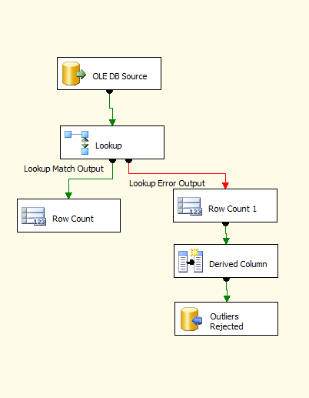

1. Oledb source

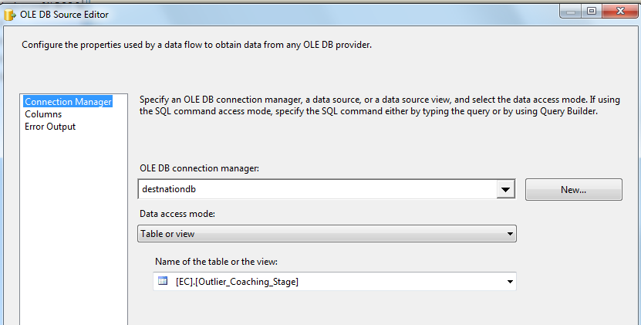

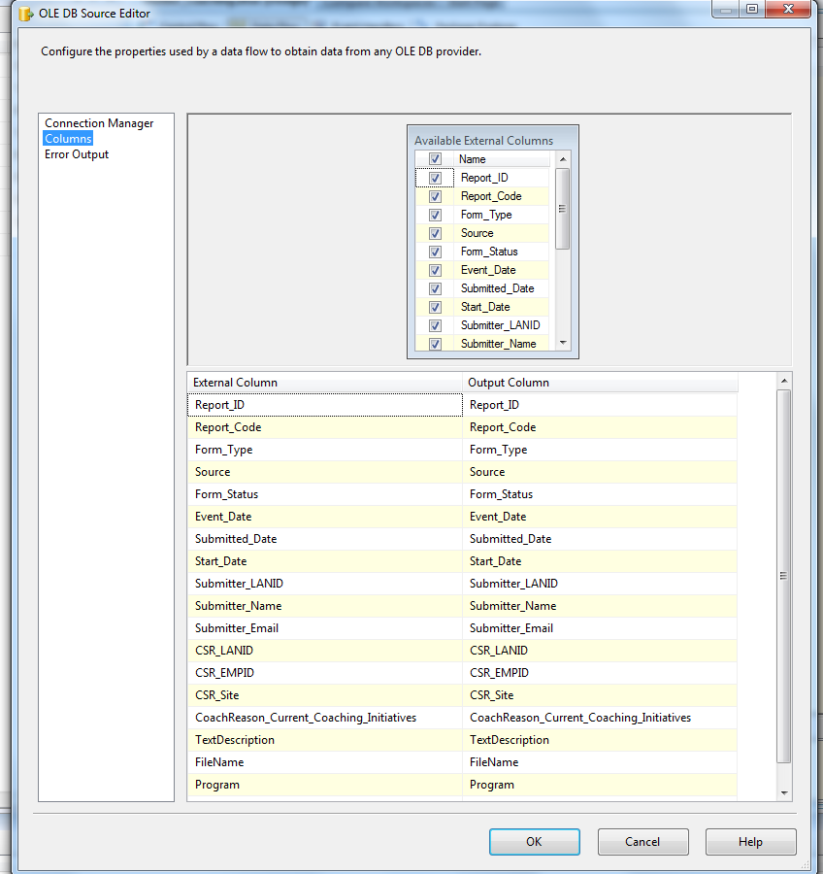

1. Lookup Transformation

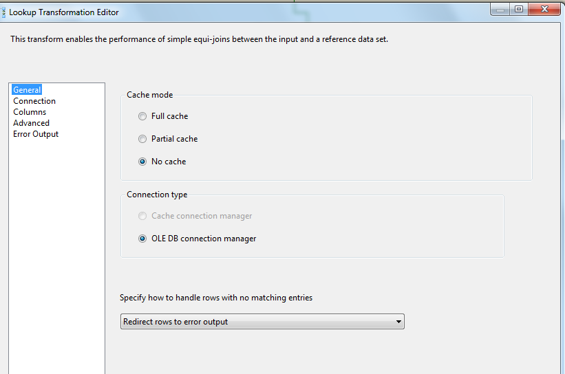

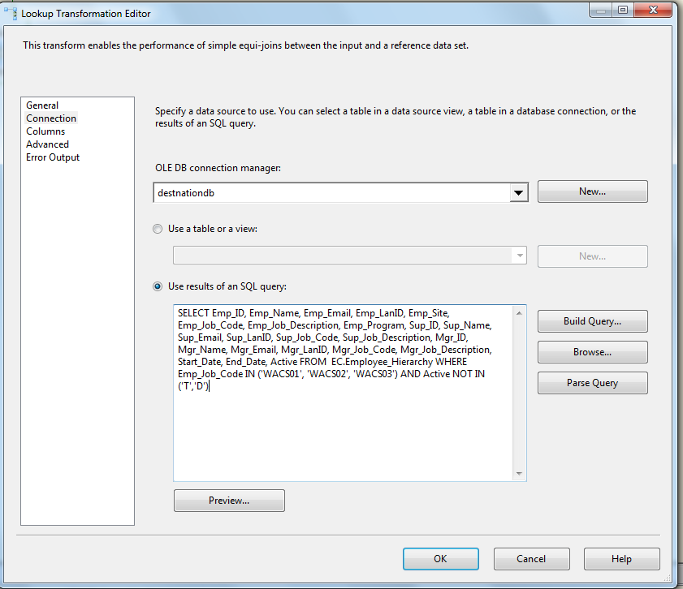

SELECT Emp_ID, Emp_Name, Emp_Email, Emp_LanID, Emp_Site, Emp_Job_Code, Emp_Job_Description,

Emp_Program, Sup_ID, Sup_Name, Sup_Email, Sup_LanID, Sup_Job_Code, Sup_Job_Description,

Mgr_ID, Mgr_Name, Mgr_Email, Mgr_LanID, Mgr_Job_Code, Mgr_Job_Description, Start_Date, End_Date, Active

FROM EC.Employee_Hierarchy

WHERE Emp_Job_Code IN ('WACS01', 'WACS02', 'WACS03')

AND Active NOT IN ('T','D')

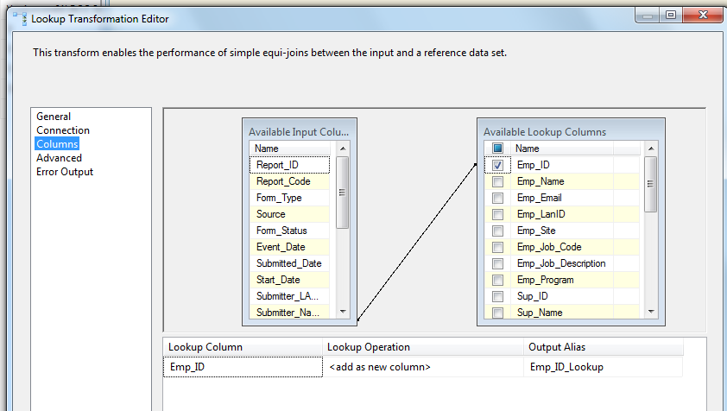

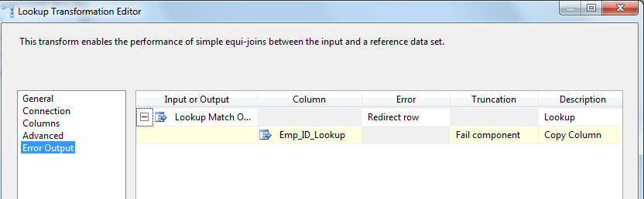

1. Lookup Match Output – Row Count Transformation to get Loaded Count

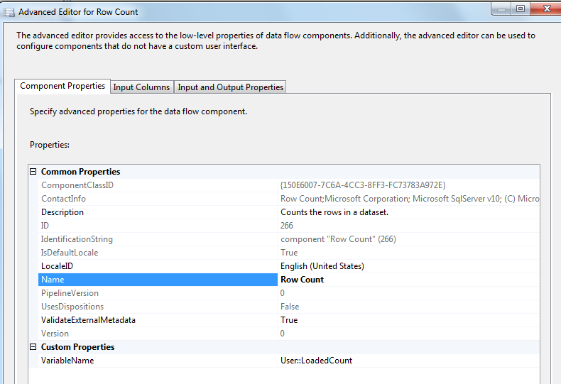

Lookup Transformation No Match Output – Row Count Transformation to get Rejected Count

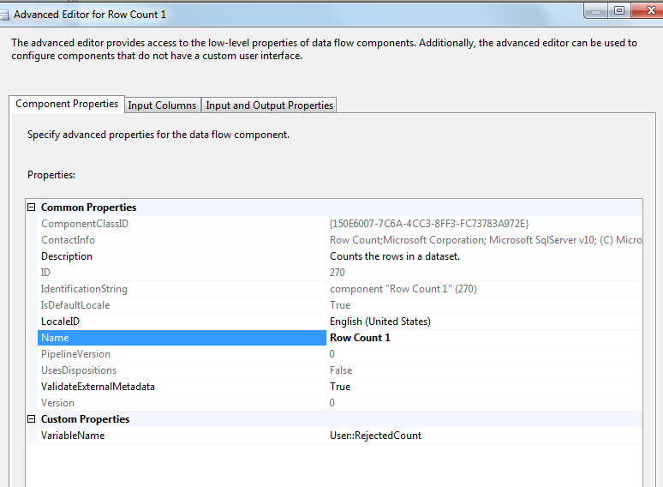

Derived Column – To get Reject Reason and Reject Date

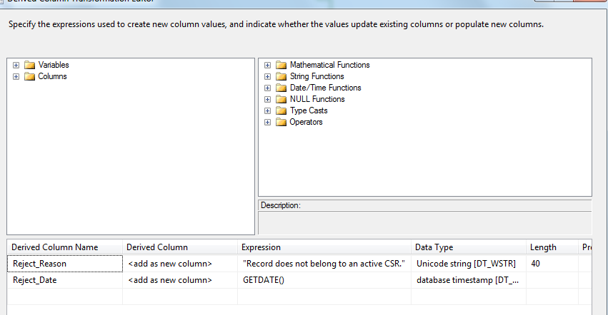

oledb destination – Write rejected records to Outliers rejected table

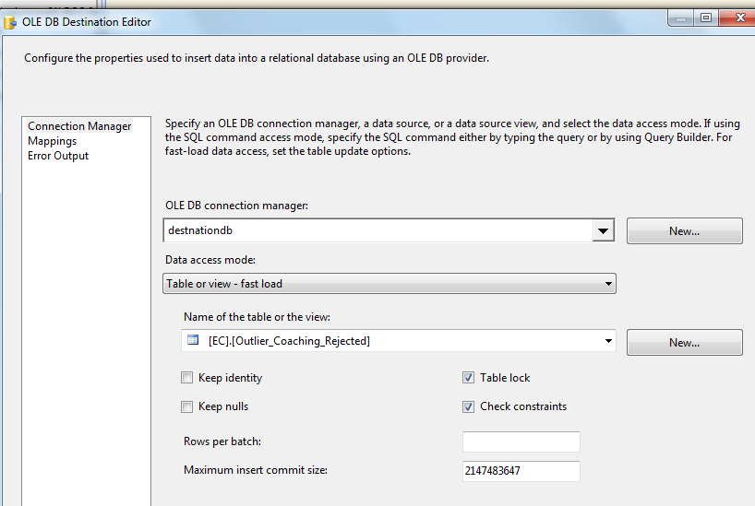

1. SQL Task: Delete records with missing Employee ID from Staging table

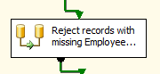

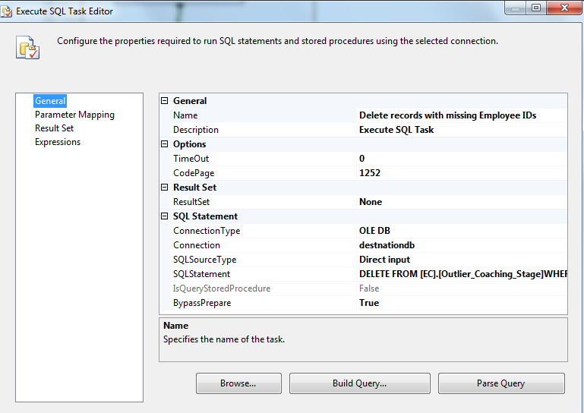

DELETE FROM [EC].[Outlier_Coaching_Stage]

WHERE [CSR_EMPID] IS NULL OR [CSR_EMPID] ='' OR [CSR_LANID] = 'Unknown'

DELETE os FROM

[EC].[Outlier_Coaching_Stage] os JOIN [EC].[Employee_Hierarchy] eh

ON os.CSR_EMPID = eh.Emp_ID

WHERE eh.Emp_Job_Code not in ('WACS01','WACS02','WACS03')

OR Active in ('T','D')

GO

1. SQL Task: Load Coaching_Log table

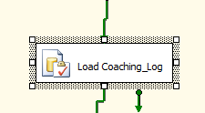

Executes Exec [EC].[sp_InsertInto_Coaching_Log_Outlier]

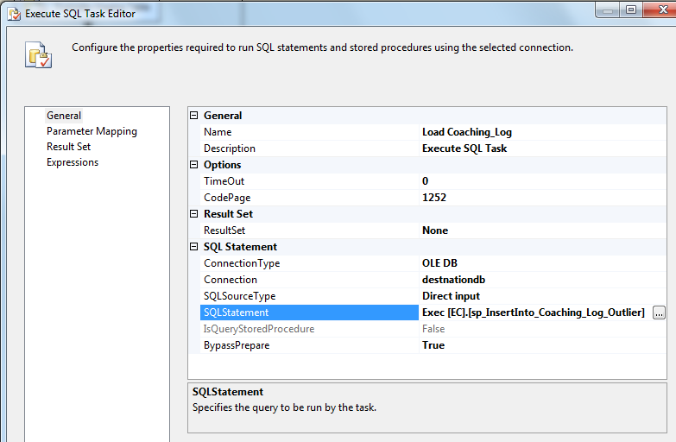

1. SQl Task: Load Outliers Fact table

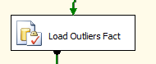

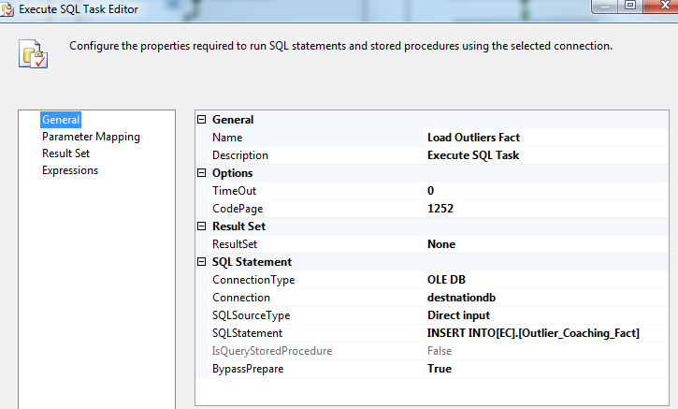

INSERT INTO[EC].[Outlier_Coaching_Fact]

([Report_ID]

,[Report_Code]

,[Form_Type]

,[Source]

,[Form_Status]

,[Event_Date]

,[Submitted_Date]

,[Start_Date]

,[Submitter_LANID]

,[Submitter_Name]

,[Submitter_Email]

,[CSR_LANID]

,[CSR_Site]

,[Program]

,[CoachReason_Current_Coaching_Initiatives]

,[TextDescription]

,[FileName]

,[RMgr_ID]

,[CD1]

,[CD2])

SELECT S.[Report_ID]

,S.[Report_Code]

,S.[Form_Type]

,S.[Source]

,S.[Form_Status]

,S.[Event_Date]

,S.[Submitted_Date]

,S.[Start_Date]

,S.[Submitter_LANID]

,S.[Submitter_Name]

,S.[Submitter_Email]

,S.[CSR_LANID]

,S.[CSR_Site]

,S.[Program]

,S.[CoachReason_Current_Coaching_Initiatives]

,S.[TextDescription]

,S.[FileName]

,S.[RMgr_ID]

,S.[CD1]

,S.[CD2]

FROM [EC].[Outlier_Coaching_Stage]S LEFT OUTER JOIN [EC].[Outlier_Coaching_Fact]F

ON S.[Report_ID]=F.[Report_ID]

AND S.Report_Code = F.Report_Code

WHERE F.[Report_ID] IS NULL AND F.Report_Code IS NULL

GO

1. SQL Task: Load Outliers File List table

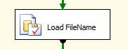

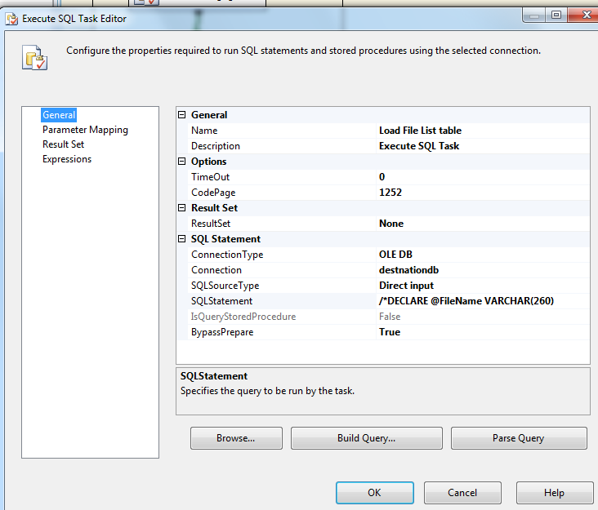

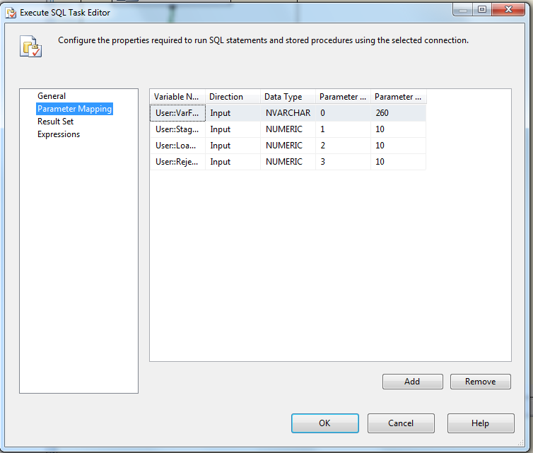

Executes the following sql

INSERT INTO [EC].[Outlier_FileList]

([File_Name]

,[File_LoadDate]

,[Count_Staged]

,[Count_Loaded]

,[Count_Rejected])

VALUES (?,GetDate(), ?, ?,?)

1. File System Task: Move file to backup folder

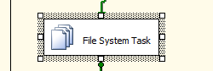

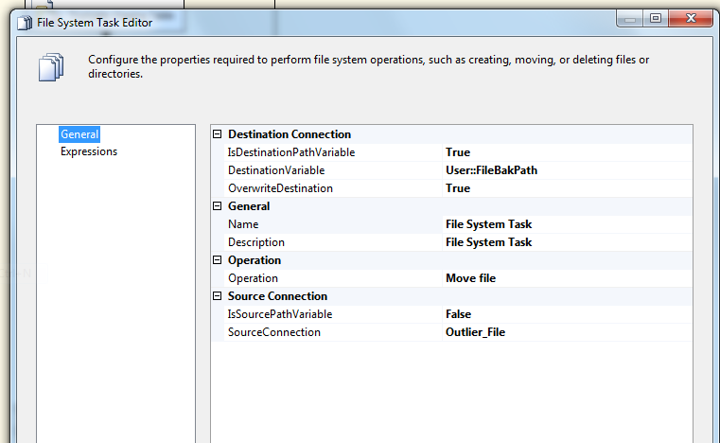



* + - * 1. **For each IAT and IAE Outlier file in Staging directory Workflow**

Container: Foreach Loop

Folder: \\vrivscors01\BCC Scorecards\Coaching\Outliers

Files: eCL_Outlier_Feed_*.csv

(*Expression used to distinguish from rest of non LCS OMR Files in conditional workflow)



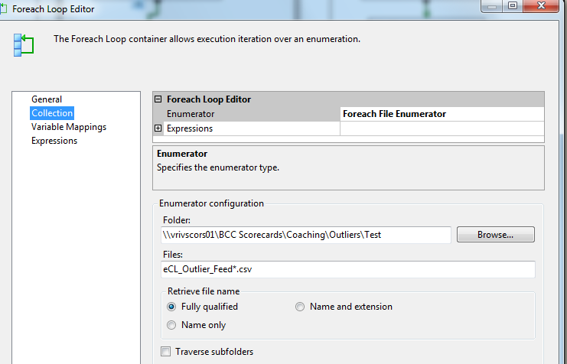



**Summary of Steps**

1. SQL task – Truncate Outliers Staging table
2. DFT – Stage Outliers Staging table
3. SQL task – Populate CSR LAN ID for LCS
4. SQL Task – Populate missing Program Values
5. DFT – Redirect rejected records to Reject table
6. SQL task – Delete records with missing employee ID from Staging table
7. SQL task Load coaching_Log and Coaching_Log_Reason tables
8. SQL task – Load Outliers Fact table
9. SQL task – Load File list table
10. File system task – Backup files to Backups directory

**Details of Steps**

1. SQL task – Truncate Outliers Staging table



Executes Truncate Table [EC].[Outlier_Coaching_Stage]

1. DFT: Load Outliers staging table

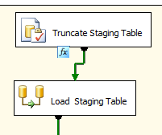

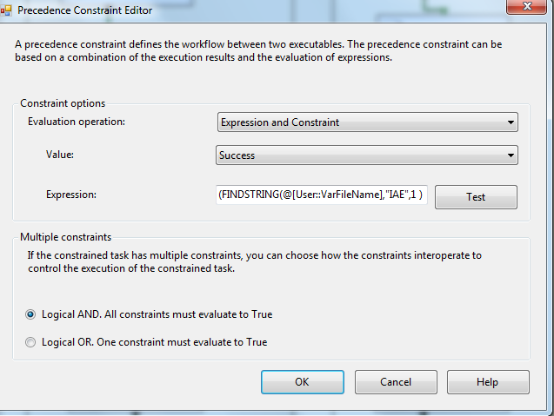

Expression: (FINDSTRING(@[User::VarFileName],"IAE",1 ) > 0 ) ||(FINDSTRING(@[User::VarFileName],"IAT",1 ) > 0 )

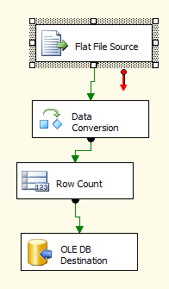

1. Flat File source

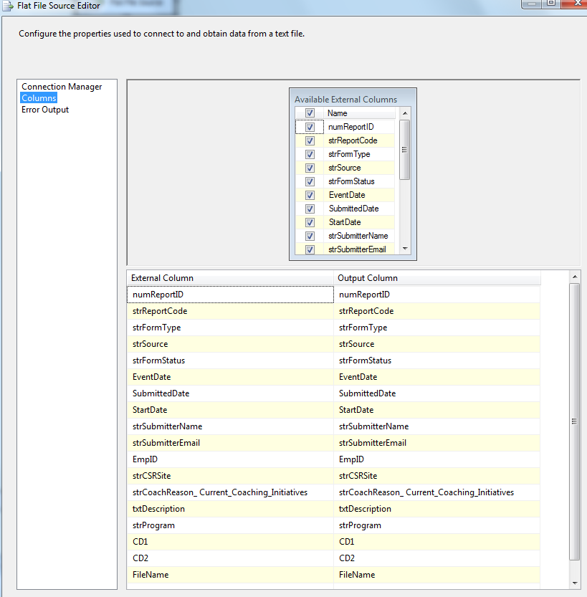

1. Data Conversion

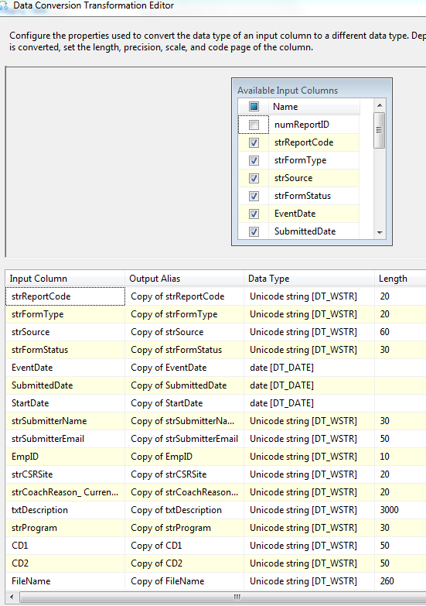

1. Row Count Transformation

Similar to LCS File

1. Oledb destination

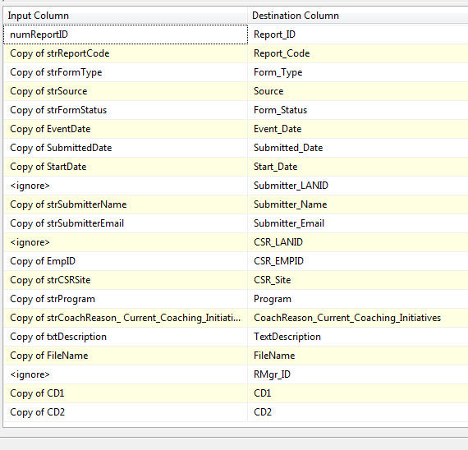

1. SQL Task: Populate CSR LAND ID

Same as LCS File

1. SQL Task: Populate missing program values

Same as LCS File

1. DFT: Reject Records with Missing Employee ID

Same as LCS File

1. SQL Task: Delete records with missing Employee ID from Staging table

Same as LCS File

1. SQL Task: Load Coaching_Log table

Same as LCS File

1. SQl Task: Load Outliers Fact table

Same as LCS File

1. SQL Task: Load Outliers File List table

Same as LCS File

1. File System Task: Move file to backup folder

Same as LCS File

* + - * 1. **For each NON LCS, IAT and IAE Outlier file in Staging directory Workflow**

Container: Foreach Loop

Folder: \\vrivscors01\BCC Scorecards\Coaching\Outliers

Files: eCL_Outlier_Feed_*.csv



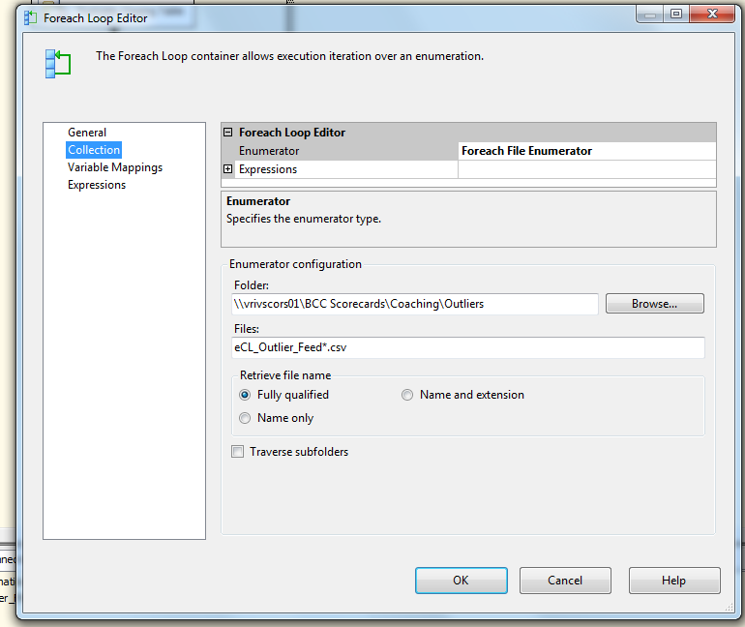



**Summary of Steps**

1. SQL task – Truncate Outliers Staging table
2. DFT – Stage Outliers Staging table
3. SQL task – Populate Employee IDs
4. SQL task – Update missing Program values
5. DFT – Redirect rejected records to Reject table
6. SQL task – Delete records with missing employee ID from Staging table
7. SQL task Load coaching_Log and Coaching_Log_Reason tables
8. SQL task – Load Outliers Fact table
9. SQL task – Load File list table
10. File system task – Backup files to Backups directory

**Details**

1. SQL task – Truncate Outliers Staging table



Executes Truncate Table [EC].[Outlier_Coaching_Stage]

1. DFT: Load Outliers staging table





1. Flat File source

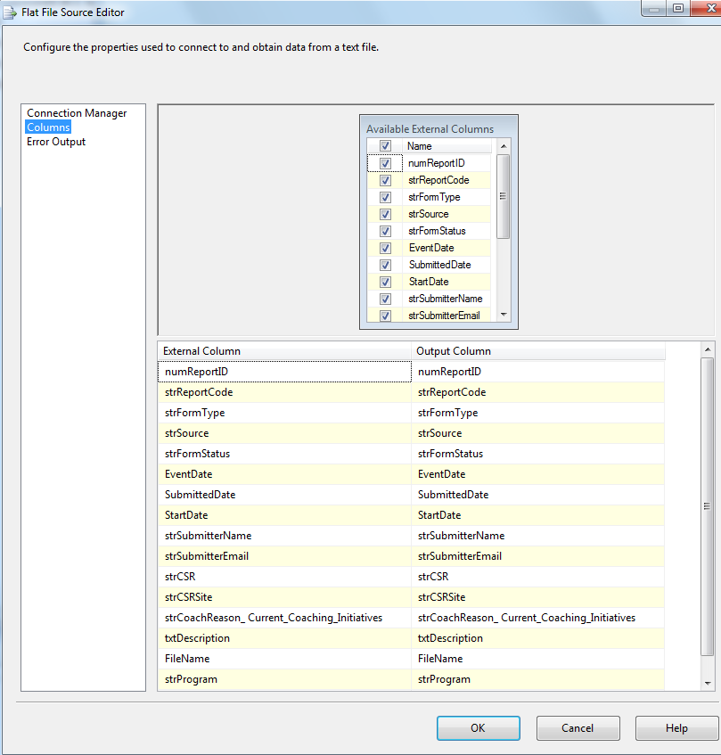





1. Data Conversion

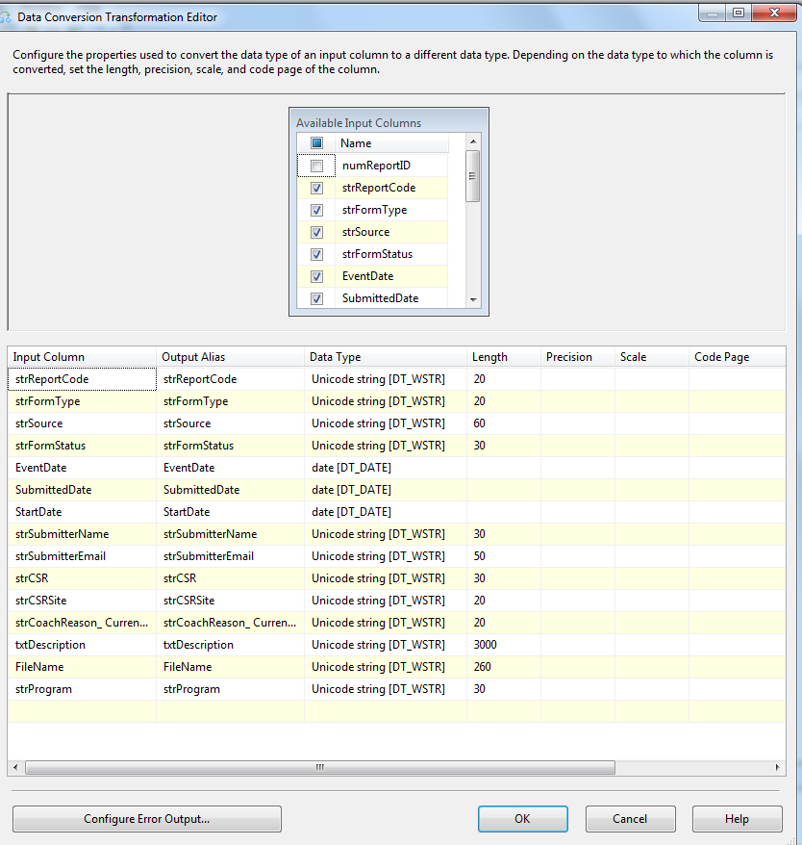

1. Row Count Transformation



1. Oledb destination



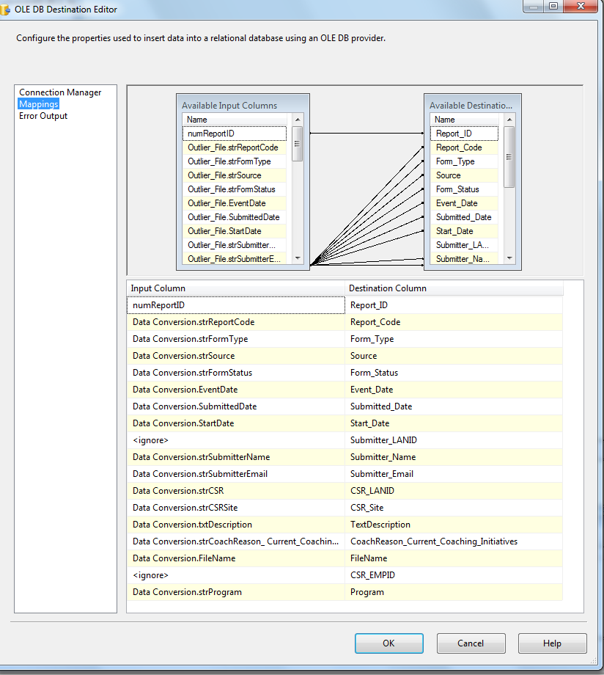



1. SQL Task: Populate Employee ID

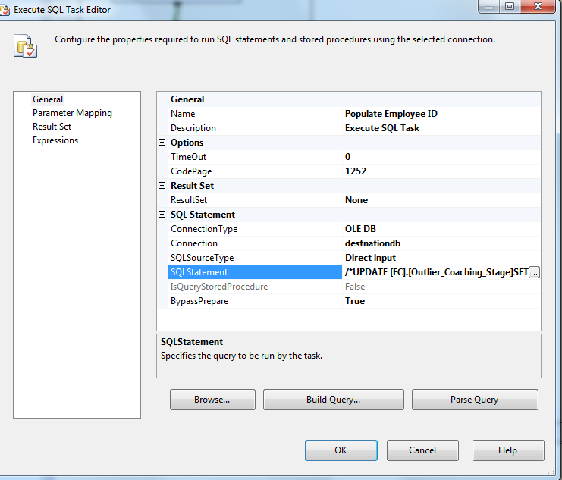

UPDATE [EC].[Outlier_Coaching_Stage]

SET [CSR_EMPID]= [EC].[fn_nvcGetEmpIdFromLanId] ([CSR_LANID],[Submitted_Date])

UPDATE [EC].[Outlier_Coaching_Stage]

SET [CSR_EMPID]= ''

WHERE [CSR_EMPID]='999999'

1. SQL Task: Populate missing Program values



UPDATE [EC].[Outlier_Coaching_Stage]

SET [Program]= H.[Emp_Program]

FROM [EC].[Outlier_Coaching_Stage]S JOIN [EC].[Employee_Hierarchy]H

ON S.[CSR_EMPID]=H.[Emp_ID]

WHERE (S.Program IS NULL OR S.Program =' ')

1. DFT: Reject Records with Missing Employee ID



1. Oledb source





1. Lookup Transformation

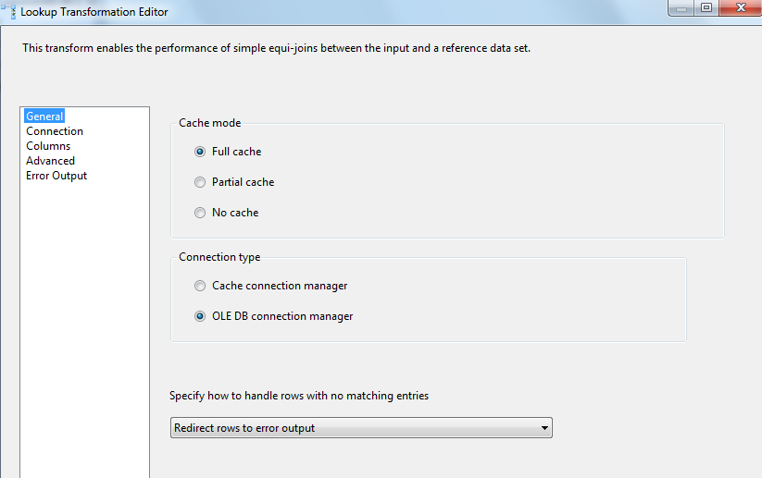

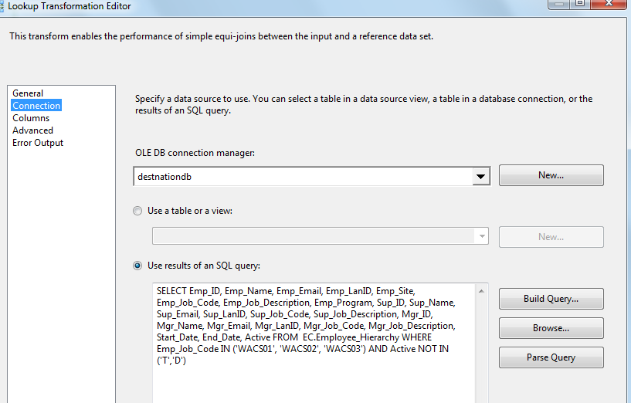





1. Lookup Match Output – Row Count Transformation to get Loaded Count



Lookup Transformation No Match Output – Row Count Transformation to get Rejected Count



Derived Column – To get Reject Reason and Reject Date

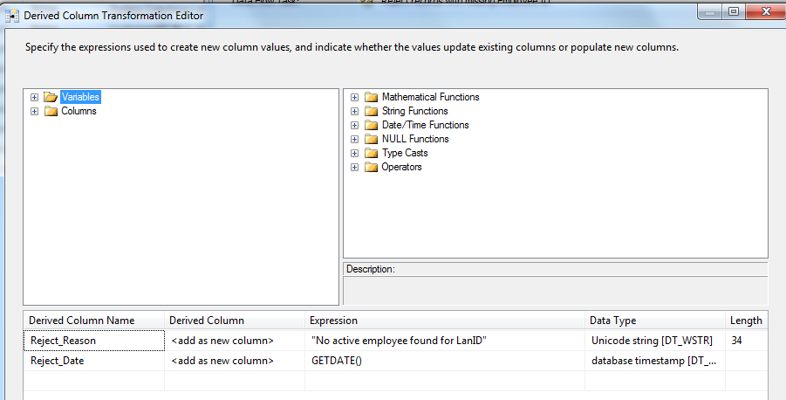

oledb destination – Write rejected records to Outliers rejected table



1. SQL Task: Delete records with missing Employee ID from Staging table





DELETE FROM [EC].[Outlier_Coaching_Stage]

WHERE [CSR_EMPID] IS NULL OR [CSR_EMPID]= ''

1. SQL Task: Load Coaching_Log table



Executes Exec [EC].[sp_InsertInto_Coaching_Log_Outlier]



1. SQl Task: Load Outliers Fact table



1. SQL Task: Load Outliers File List table







Executes the following sql

INSERT INTO [EC].[Outlier_FileList]

([File_Name]

,[File_LoadDate]

,[Count_Staged]

,[Count_Loaded]

,[Count_Rejected])

VALUES (?,GetDate(), ?, ?,?)

1. File System Task: Move file to backup folder





* + - 1. **Package Content(Event Handlers)**

Executables: Outlier_Coaching

EventHandler: OntaskFailed

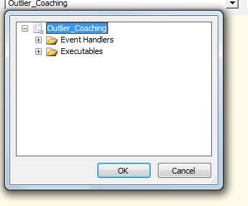

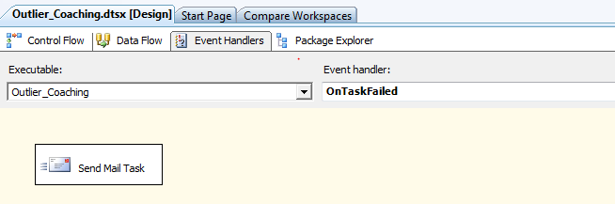

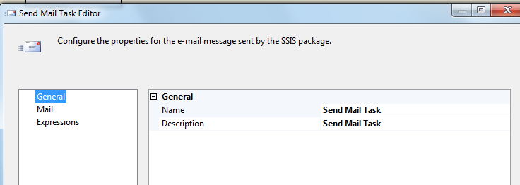

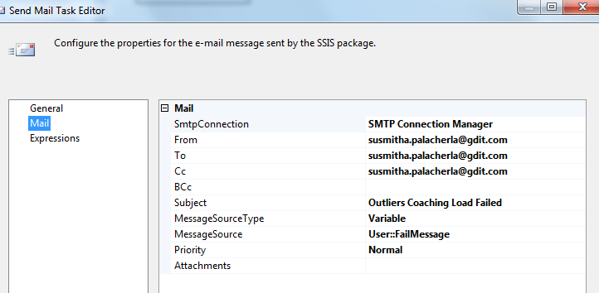

### Tables

|  | **Table Name** | **Table Description** |
| --- | --- | --- |
| 1. | Outlier_Coaching_Stage | Table used for staging the OMR records during the insert into Coaching_Log table. |
| 2. | Outlier_Coaching_Rejected | Table used for storing the rejected OMR records during the insert into Coaching_Log table. Logs are rejected when an incoming Lan ID does not exist in the Employee_Hierarchy table. |
| 3. | Outlier_Coaching_Fact | Table used for storing Outliers source records loaded into the Coaching Log table. |
| 4. | Outlier_FileList | Table used for storing the OMR file names and Load dates. |

Table structure and details in document: eCoaching_Database_DD.docx

### Procedures

|  | **Procedure Name** | **Usage** |
| --- | --- | --- |
| 1. | sp_InsertInto_Coaching_Log_Outlier | Load: Outliers Data |

### Functions

|  | **FunctionName** | **Usage** |
| --- | --- | --- |
| 1. | fn_intSubCoachReasonIDFromRptCode | Load: Outliers Data |

Reference Document for Objects and Code: eCoaching_Outliers_Create.sql