__________________________



**Title: eCoaching_Surveys**

**SSIS Detail Design Document**

__________________________

|  |  |  |
| --- | --- | --- |
| Last Revision | Last Review | Description |
| 09/30/2015 |  | Initial revision |

Prepared by: Susmitha Palacherla Date: 09/30/2015

Department, Location: Health Solutions Division

Approved by: Date:

**Change History Log**

| **Date** | **Version** | **Change Description** | **Author** |
| --- | --- | --- | --- |
| 09/30/2015 | 1.0 | Initial revision. Set up per TFS 549 | Susmitha Palacherla |
|  |  |  |  |
|  |  |  |  |
|  |  |  |  |
|  |  |  |  |
|  |  |  |  |
|  |  |  |  |

Contents

1. Overview 4

1.1 Project Description 4

1.2 Document Scope 4

1.3 Source Data 4

1.4 Module List 4

1.5 Software and Hardware Interfaces 4

1.5.1 Software 4

1.5.2 Hardware 4

2. Details 5

2.1 Source Data 5

2.2 Module Details 5

2.2.1 SQL agent job 5

2.2.2 SSIS Package 5

2.2.3 Tables 13

2.2.4 Procedures and Functions 14

# Overview

## Project Description

CCO Operations has requested to generate monthly eCoaching Log related Surveys for employees to provide feedback coaching experience.

## Document Scope

This document does not describe the logic or workflow of the actual Survey process.

It documents the call to database objects (Stored procedures) that will be used to automate

the generation or re-generation of the Surveys.

## Source Data

EC.Coaching_log table

## Module List

* SQL agent job
* SSIS Package
* Tables
* Procedures

## Software and Hardware Interfaces

### Software

* SQL Server 2008 R2 SP1 Suite

### Hardware

* VRIVFSSDBT02\SCORD01,1437 – Dev DB Instance
* VRIVFSSDBT02\SCORT01,1438 – Test DB Instance
* VDENSSDBP07\SCORP01 – Prod DB Instance

# Details



## Source Data

The source data for this package is Table EC.Coaching_log

## Module Details

### SQL agent job

* Production Instance : VDENSSDBP07\SCORP01
* Production Job: CoachingSurveys
* Production Package: \\VDENSSDBP07\scorecard-ssis\Coaching\eCL_Surveys.dtsx
* Production Config File: Prod_eCL_Surveys.dtsConfig
* Owner: jobs_admin
* Run As: BccScrdSQLAgent
* Schedule: 5:00 AM EST on the 8th, 15th and 22nd of the Month
* Destination File Location: N/A

### SSIS Package

* + - 1. **Variables**

|  |  |  |  |  |
| --- | --- | --- | --- | --- |
| **Name** | **Scope** | **DataType** | **Value** | **Evaluate As expression** |
| FailMessage | eCL_Surveys | String | Survey Generation failed in Dev. | False |
| Resend | eCL_Surveys | Boolean | eCL_Coaching_mmddyyyy.csv | False |
|  |  |  |  |  |
|  |  |  |  |  |
|  |  |  |  |  |
|  |  |  |  |  |

* + - 1. **Connection Manager Entries**
         1. Destinationdb
* Dev - VRIVFSSDBT02\SCORD01,1437) DB – eCoachingdev
* Prod - VDENSSDBP07\SCORP01 DB – eCoaching
* Test- VRIVFSSDBT02\SCORT01,1438) DB – eCoachingTest

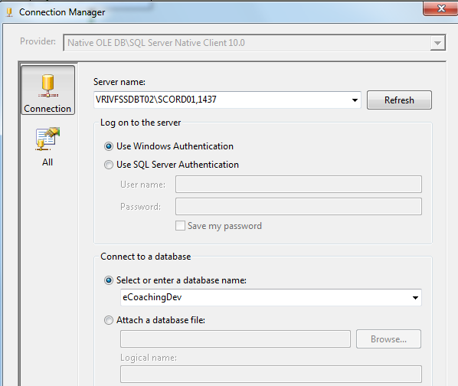

* + - * 1. SMTP Connection Manager

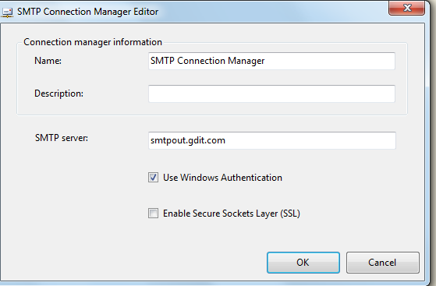

* + - 1. **Package Content**

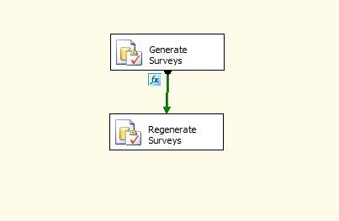

**Workflow**

* + - * 1. **SQL task – Generate Surveys**

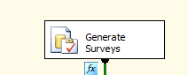

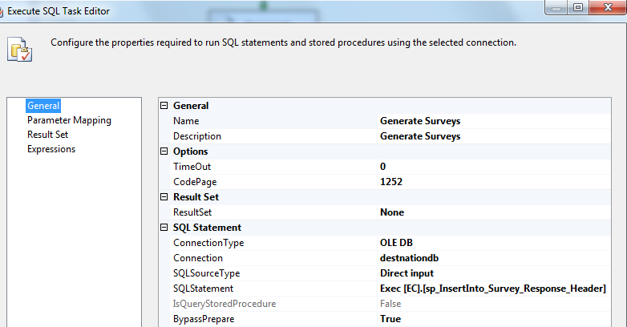

* + - * 1. **Flow – Precedence Constraint**

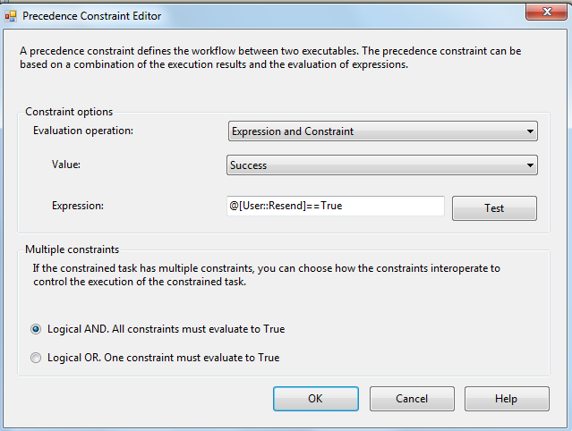

* + - * 1. **SQL task – Regenerate Surveys**

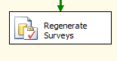

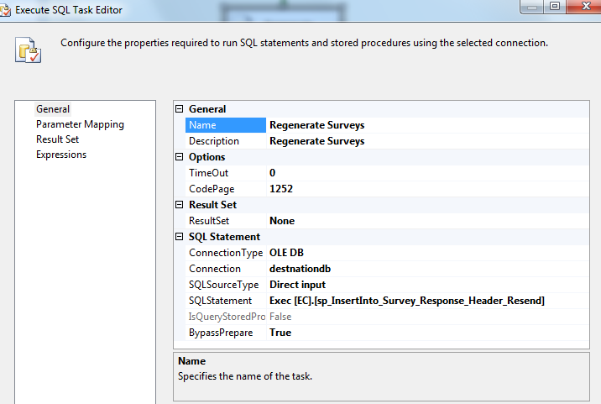

* + - 1. **Event Handlers**

Executables: eCL_Surveys

EventHandler: OntaskFailed

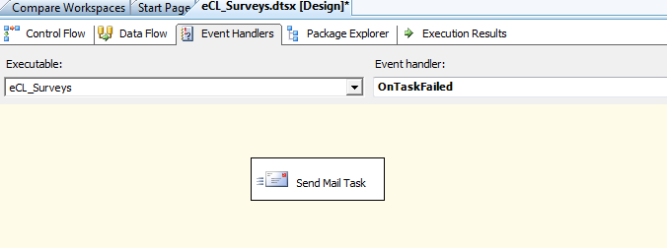

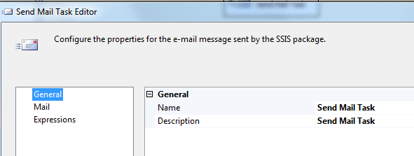

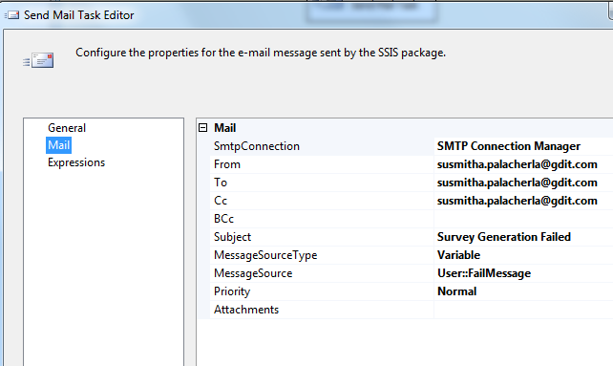

### Tables

|  | **Table Name** | **Table Description** |
| --- | --- | --- |
| 1. | [EC].[Coaching_Log] | Source Table. eCLS meeting certain criteria are picked for Survey. |
| 2. | [EC].[Survey_Response_Header] | Destination table. Header records for generated Surveys are inserted into this table. |
| 3. | [EC].[Survey_response_Detail] | Destination table – Details Table that is populated with employee responses on survey completion. |
| 4. | [EC].[Survey_Type_DIM] | Dimension table. |
| 5. | [EC].[Survey_Question_DIM] | Dimension table. |
| 6. | [EC].[Survey_Response_DIM] | Dimension table. |
| 7. | [EC].[Survey_QAnswer_DIM] | Dimension table. |

Table structure and details in document: eCoaching_Database_DD.docx

### Procedures and Functions

|  | **Procedure Name** | **Usage** |
| --- | --- | --- |
| 1. | [EC].[sp_InsertInto_Survey_Response_Header] | Initial Survey generation and Insert. |
| 2. | [EC].[sp_InsertInto_Survey_Response_Header_Resend] | Initial Survey generation and Insert for Survey Resend. |
| 3. | [EC].[sp_Update_Survey_Response] | Survey Response capture |
| 4. | [EC].[sp_SelectSurvey4Contact] | Select for Survey Notification. |
| 5. | [EC].[sp_UpdateSurveyMailSent] | Updating EmailSent flag after Notification. |
| 6. | [EC].[sp_Select_Questions_For_Survey] | Returns a list of Questions and their display order to be displayed in the UI. |
| 7. | [EC].[sp_Select_Responses_For_Survey] | Returns a list of all Active Responses and their Ids. |
| 8. | [EC].[sp_Select_Responses_By_Question] | Returns a list of Questions Ids and all their possible responses and their display order. |
| 9. | [EC].[sp_Select_SurveyDetails_By_SurveyID] | Given a Survey ID returns the details of the Survey like the Employee ID, eCL Form Name and whether or not a Hot Topic question is associated with this Survey. |
| 10. | [EC].[fn_isHotTopicFromSurveyTypeID] | Given a Survey Type ID returns a bit to indicate whether or not there is an Active Hot topic question associated with the Survey. |
| 11. | [EC].[fn_isHotTopicFromSurveyTypeID] | Given a Survey Type ID returns a bit to indicate whether or not there is an Active Hot topic question associated with the Survey. |
|  |  |  |

Table and procedure create code in CCO_eCoaching_Surveys_Create.sql