__________________________



**Title: Coaching Summary Report**

**SSIS Detail Design Document**

__________________________

|  |  |  |
| --- | --- | --- |
| Last Revision | Last Review | Description |
| 10/16/2017 |  | TFS 6066 – Schedule Coaching Summary Reports. Added delay before File copy. Updated destination and added schedule info. |

Prepared by: Susmitha Palacherla Date: 10/10/2017

Department, Location: Health Solutions Division

Approved by: Date:

**Change History Log**

| **Date** | **Change Description** | **Author** |
| --- | --- | --- |
| 10/10/2017 | TFS 6066 – Initial revision - Schedule Coaching Summary Reports | Susmitha Palacherla |
| 10/16/2017 | TFS 6066 – Schedule Coaching Summary Reports. Added delay before File copy. Updated destination and added schedule info | Susmitha Palacherla |
|  |  |  |
|  |  |  |
|  |  |  |
|  |  |  |
|  |  |  |
|  |  |  |
|  |  |  |
|  |  |  |
|  |  |  |

Contents

1. Overview 4

1.1 Project Description 4

1.2 Document Scope 4

1.3 Input 4

1.4 Output(s) 4

1.5 Module List 4

1.6 Software and Hardware Interfaces 4

1.6.1 Software 4

1.6.2 Hardware 5

1.7 Users 5

2. Details 5

2.1 Input 5

2.1.1 Stored Procedure [EC].[sp_rptCoachingSummaryForModule] 5

2.2 Output 5

2.2.1 Coaching Summary Report for CSR Module 5

2.2.2 Coaching Summary Report for Supervisor Module 5

2.2.3 Coaching Summary Report for Quality Module 6

2.2.4 Coaching Summary Report for LSA Module 6

2.2.5 Coaching Summary Report for Training Module 6

2.3 Module Details 6

2.3.1 SQL agent job 6

2.3.2 SSIS Package 7

2.3.2.1 Variables 7

2.3.2.2 Connection Manager Entries 9

2.3.2.3 Package Content 12

2.3.2.4 Event Handlers 25

2.3.2.5 Config File- Prod 26

2.3.2.6 Code Files 28

# Overview

## Project Description

The eCoaching Log (eCL) is an internal GDIT process designed for the entry and storage of the coaching notes that supervisors, managers, Advanced Resolution Center (ARC) CSRs and quality leads make regarding CSR performance. These notes are gathered through escalations, floor walking, training, quality monitors. It also provides a repository of coaching notes to generate reports for management.

## Document Scope

This document describes the process for generating and posting Coaching Summary reports by Module for the previous month for Program team to use.

## Input

* Procedure [EC].[sp_rptCoachingSummaryForModule] on eCoaching DB on F3420-ECLDBP01

## Output(s)

### Original Report Names

* eCL_CoachingSummary_CSR_YYYYMMDD_YYYYMMDDD.csv
* eCL_CoachingSummary_Supervisor_YYYYMMDD_YYYYMMDDD.csv
* eCL_CoachingSummary_Quality_YYYYMMDD_YYYYMMDDD.csv
* eCL_CoachingSummary_LSA_YYYYMMDD_YYYYMMDDD.csv
* eCL_CoachingSummary_Training_YYYYMMDD_YYYYMMDDD.csv

### Encrypted Report Names

* eCL_CoachingSummary_CSR_CCYYMMDD_CCYYMMDD.csv.zip.encrypt
* eCL_CoachingSummary_Supervisor_CCYYMMDD_CCYYMMDD.csv.zip.encrypt
* eCL_CoachingSummary_Quality_CCYYMMDD_CCYYMMDD.csv.zip.encrypt
* eCL_CoachingSummary_LSA_CCYYMMDD_CCYYMMDD.csv.zip.encrypt
* eCL_CoachingSummary_Training_CCYYMMDD_CCYYMMDD.csv.zip.encrypt

## Module List

* SQL agent job
* SSIS Package
* Procedures
* Functions

## Software and Hardware Interfaces

### Software

* SQL Server 2012 SP3 Suite

### Hardware

* F3420-ECLDBD01 – Dev DB Server
* F3420-ECLDBT01 – Test DB Server
* F3420-ECLDBP01 – Prod Server
* [\\F3420-ECLDBD01\Reports\](\\\\F3420-ECLDBD01\\Reports\\) - Dev File staging share
* \\F3420-ECLDBT01\Reports\ - Test File staging share
* [\\F3420-ECLDBP01\Reports\](\\\\F3420-ECLDBP01\\Reports\\) - Prod File staging share

## Users

* Program Team

# Details



## Input

### Stored Procedure [EC].[sp_rptCoachingSummaryForModule]

Procedure [EC].[sp_rptCoachingSummaryForModule]

(@intModulein, @intBeginDate,@intEndDate)

\eCoaching_V2\Code\DB\Stored Procedures\sp_rptCoachingSummaryForModule.sql

## Output

### Coaching Summary Report for CSR Module

* Description: Coaching Summary Report
* Module: CSR
* Status(es): All Except Inactive
* Date Range: Submitted in previous Month
* Delivery location: [\\F3420-ECLDBP01\Reports\](\\\\F3420-ECLDBP01\\Reports\\)
* File name: eCL_Coaching_Summary_CSR_YYYYMMDD_YYYYMMDD.csv
* Frequency: 2 AM 3rd of each Month

### Coaching Summary Report for Supervisor Module

* Description: Coaching Summary Report
* Module: Supervisor
* Status(es): All Except Inactive
* Date Range: Submitted in previous Month
* Delivery location: [\\F3420-ECLDBP01\Reports\](\\\\F3420-ECLDBP01\\Reports\\)
* File name: eCL_Coaching_Summary_Supervisor_YYYYMMDD_YYYYMMDD.csv
* Frequency: 2 AM 3rd of each Month

### Coaching Summary Report for Quality Module

* Description: Coaching Summary Report
* Module: Quality
* Status(es): All Except Inactive
* Date Range: Submitted in previous Month
* Delivery location: [\\F3420-ECLDBP01\Reports\](\\\\F3420-ECLDBP01\\Reports\\)
* File name: eCL_Coaching_Summary_Quality_YYYYMMDD_YYYYMMDD.csv
* Frequency: 2 AM 3rd of each Month

### Coaching Summary Report for LSA Module

* Description: Coaching Summary Report
* Module: LSA
* Status(es): All Except Inactive
* Date Range: Submitted in previous Month
* Delivery location: [\\F3420-ECLDBP01\Reports\](\\\\F3420-ECLDBP01\\Reports\\)
* File name: eCL_Coaching_Summary_LSA_YYYYMMDD_YYYYMMDD.csv
* Frequency: 2 AM 3rd of each Month

### Coaching Summary Report for Training Module

* Description: Coaching Summary Report
* Module: Training
* Status(es): All Except Inactive
* Date Range: Submitted in previous Month
* Delivery location: [\\F3420-ECLDBP01\Reports\](\\\\F3420-ECLDBP01\\Reports\\)
* File name: eCL_Coaching_Summary_Training_YYYYMMDD_YYYYMMDD.csv
* Frequency: 2 AM 3rd of each Month

## Module Details

### SQL agent job

* Production Instance : F3420-ECLDBP01
* Production Job: CoachingSummaryReport
* Production Package: \\F3420-ECLDBP01\ssis\Coaching\Packages\CoachingSummaryReport.dtsx
* Production Config File: Prod_CoachingSummaryReport.dtsConfig
* Owner: ecljobowner
* Run As: ECLProxy (ECL Credential using application service account VNGT\SVC-SQLECLP01
* Schedule: 2 AM 3rd of each Month
* Destination File Location: [\\F3420-ECLDBP01\Reports\](\\\\F3420-ECLDBP01\\Reports\\)

### SSIS Package

#### Variables

|  |  |  |  |
| --- | --- | --- | --- |
| **Name** | **DataType** | **Value** | **Evaluate as Expression** |
| Adhoc | Boolean | False |  |
| BackupsDir | String | [\\F3420-ECLDBP01\Reports\](\\\\F3420-ECLDBP01\\Reports\\)Backups\  *set from config file |  |
| BeginDate | Int32 | [0](mailto:Susmitha.palacherla@gdit.com)  *set from config file or fetched from SP depending on value of ‘Adhoc’ variable |  |
| CCEmail | String | [Susmitha.palacherla@gdit.com](mailto:Susmitha.palacherla@gdit.com)  *set from config file | False |
| CSRPull | String | Exec [EC].[sp_rptCoachingSummaryForModule]1,0,0 | "Exec [EC].[sp_rptCoachingSummaryForModule]1," +(DT_WSTR,20) @[User::BeginDate] + "," + (DT_WSTR,20) @[User::EndDate] |
| DecryptInDir | String | [\\F3420-ECLDBP01\Reports\](\\\\F3420-ECLDBP01\\Reports\\)Decrypt_In\ |  |
| DecryptOutDir | String | [\\F3420-ECLDBP01\Reports\](\\\\F3420-ECLDBP01\\Reports\\)Decrypt_Out\ |  |
| EncryptInDir | String | [\\F3420-ECLDBP01\Reports\](\\\\F3420-ECLDBP01\\Reports\\)Encrypt_In |  |
| EncryptOutDir | String | [\\F3420-ECLDBP01\Reports\](\\\\F3420-ECLDBP01\\Reports\\)Encrypt_Out |  |
| EndDate | Int32 | [0](mailto:Susmitha.palacherla@gdit.com)  *set from config file or fetched from SP depending on value of ‘Adhoc’ variable |  |
| Env | String | PROD |  |
| FromEmail | String | [Susmitha.palacherla@gdit.com](mailto:Susmitha.palacherla@gdit.com)  *set from config file |  |
| LSAPull | String | Exec [EC].[sp_rptCoachingSummaryForModule]4,0,0 | "Exec [EC].[sp_rptCoachingSummaryForModule]4," +(DT_WSTR,20) @[User::BeginDate] + "," + (DT_WSTR,20) @[User::EndDate] |
| MsgEmail | String | The Reports have been posted to \\f3420-ecldbp01\data\Coaching\Reports\      Thanks,  CCO Engineering General Dynamics Information Technology | "The Reports have been posted to " + @[User::ReportsDir] + "\r\n" +  " " + "\r\n" +  " " + "\r\n" +  "Thanks," + " " + "\r\n" +  "CCO Engineering" + " " + "\r\n" +  "General Dynamics Information Technology" |
| QualityPull | String | Exec [EC].[sp_rptCoachingSummaryForModule]3,0,0 | "Exec [EC].[sp_rptCoachingSummaryForModule]3," +(DT_WSTR,20) @[User::BeginDate] + "," + (DT_WSTR,20) @[User::EndDate] |
| ReportPeriod | String |  | (SUBSTRING((DT_WSTR,8)@[User::BeginDate],5,2) == "01" ? "January" :  SUBSTRING((DT_WSTR,8)@[User::BeginDate],5,2) == "02" ? "February" :  SUBSTRING((DT_WSTR,8)@[User::BeginDate],5,2) == "03" ? "March" :  SUBSTRING((DT_WSTR,8)@[User::BeginDate],5,2) == "04" ? "April" :  SUBSTRING((DT_WSTR,8)@[User::BeginDate],5,2) == "05" ? "May" :  SUBSTRING((DT_WSTR,8)@[User::BeginDate],5,2) == "06" ? "June" :  SUBSTRING((DT_WSTR,8)@[User::BeginDate],5,2) == "07" ? "July" :  SUBSTRING((DT_WSTR,8)@[User::BeginDate],5,2) == "08" ? "August" :  SUBSTRING((DT_WSTR,8)@[User::BeginDate],5,2) == "09" ? "September" :  SUBSTRING((DT_WSTR,8)@[User::BeginDate],5,2) == "10" ? "October" :  SUBSTRING((DT_WSTR,8)@[User::BeginDate],5,2) == "11" ? "November" :  SUBSTRING((DT_WSTR,8)@[User::BeginDate],5,2) == "12" ? "December" :  "Unknown") + ", " + SUBSTRING((DT_WSTR,8)@[User::BeginDate],1,4) |
| ReportsDir | String | \\F3420-MWBP11\Reports\eCL_Reports\ |  |
| SupervisorPull | String | Exec [EC].[sp_rptCoachingSummaryForModule]2,0,0 | "Exec [EC].[sp_rptCoachingSummaryForModule]2," +(DT_WSTR,20) @[User::BeginDate] + "," + (DT_WSTR,20) @[User::EndDate] |
| ToEmail | String | [Susmitha.palacherla@gdit.com](mailto:Susmitha.palacherla@gdit.com)  *set from config file |  |
| TrainingPull | String | Exec [EC].[sp_rptCoachingSummaryForModule]5,0,0 | "Exec [EC].[sp_rptCoachingSummaryForModule]5," +(DT_WSTR,20) @[User::BeginDate] + "," + (DT_WSTR,20) @[User::EndDate] |
| varFileName | String |  |  |
| varFilePath | String |  | @[User::EncryptOutDir] + @[User::varFileName] |
|  |  |  |  |
|  |  |  |  |
|  |  |  |  |
|  |  |  |  |

#### Connection Manager Entries

##### dbconn

* Dev – F3420-ECLDBD01 DB – eCoachingdev
* Test - F3420-ECLDBT01 DB – eCoachingtest
* Prod - F3420-ECLDBP01 – eCoaching

##### CSR_Report

* eCL_Coaching_Summary_CSR_YYYYMMDD_YYYYMMDD.csv
* Expression: @[User::EncryptInDir] + "eCL_CoachingSummary_CSR_" + (DT_WSTR,20) @[User::BeginDate] + "_" + (DT_WSTR,20) @[User::EndDate] + ".csv"

##### Supervisor_Report

* eCL_Coaching_Summary_Supervisor_YYYYMMDD_YYYYMMDD.csv
* Expression: @[User::EncryptInDir] + "eCL_CoachingSummary_Supervisor_" + (DT_WSTR,20) @[User::BeginDate] + "_" + (DT_WSTR,20) @[User::EndDate] + ".csv"

##### Quality_Report

* eCL_Coaching_Summary_Quality _YYYYMMDD_YYYYMMDD.csv
* Expression: @[User::EncryptInDir] + "eCL_CoachingSummary_Quality _" + (DT_WSTR,20) @[User::BeginDate] + "_" + (DT_WSTR,20) @[User::EndDate] + ".csv"

##### LSA_Report

* eCL_Coaching_Summary_LSA _YYYYMMDD_YYYYMMDD.csv
* Expression: @[User::EncryptInDir] + "eCL_CoachingSummary_LSA _" + (DT_WSTR,20) @[User::BeginDate] + "_" + (DT_WSTR,20) @[User::EndDate] + ".csv"

##### Training_Report

* eCL_Coaching_Summary_Training _YYYYMMDD_YYYYMMDD.csv
* Expression: @[User::EncryptInDir] + "eCL_CoachingSummary_Training _" + (DT_WSTR,20) @[User::BeginDate] + "_" + (DT_WSTR,20) @[User::EndDate] + ".csv"

##### fileconn

* Expression: @[User::varFilePath]

##### smtpconn

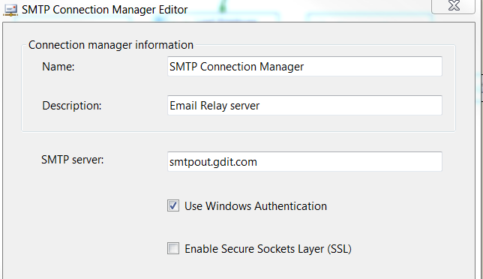

#### Package Content

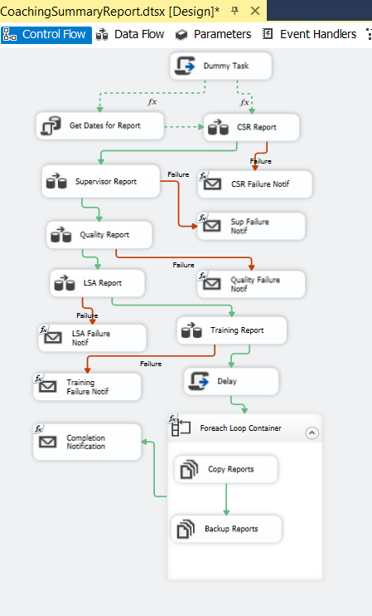

**Workflow of Steps**

|  |  |  |  |
| --- | --- | --- | --- |
| **Step #** | **Task** | **On Success** | **On Failure** |
| 1. | **Dummy Task to establish precedence constraint** |  |  |
|  | Expression and Constraint (Logical OR)  Expression: @[User::Adhoc] == False | Go to Step 2 | Stop execution. |
|  |  |  |  |
|  | Expression and Constraint (Logical OR)  Expression: @[User::Adhoc] == True | Go to Step 3 | Stop execution. |
|  |  |  |  |
|  |  |  |  |
| 2. | **Get dates for Report** | Go to next step | Stop execution. |
|  |  |  |  |
| 3. | **CSR Report** | Go to step 4 | Go to Step 3a |
|  |  |  |  |
| 3a. | **CSR Failure Notification** | Stop execution. | Stop execution. |
|  |  |  |  |
| 4. | **Supervisor Report** | Go to step 5 | Go to Step 4a |
|  |  |  |  |
| 4a. | **Supervisor Failure Notification** | Stop execution. | Stop execution. |
|  |  |  |  |
| 5. | **Quality Report** | Go to step 6 | Go to Step 5a |
|  |  |  |  |
| 5a. | **Quality Failure Notification** | Stop execution. | Stop execution. |
|  |  |  |  |
| 6. | **LSA Report** | Go to step 7 | Go to Step 6a |
|  |  |  |  |
| 6a. | **LSA Failure Notification** | Stop execution. | Stop execution. |
|  |  |  |  |
| 7. | **Training Report** | Go to step 8 | Go to Step 7a |
|  |  |  |  |
| 7a. | **Training Failure Notification** | Stop execution. | Stop execution. |
|  |  |  |  |
| 8. | **Delay** | Go to step 9 | Stop execution. |
|  |  |  |  |
| 9. | **Foreach Loop Container**   * Copy Reports to Reports folder * Backup encrypted reports | Go to step 10 | Stop execution. |
|  |  |  |  |
| 10. | **Completion Notification** | End of process. | Stop execution. |
|  |  |  |  |
|  |  |  |  |
|  |  |  |  |

**Details**

|  |  |
| --- | --- |
|  | **Task** |
|  | **Script Task: Dummy Task**  Does Nothing |
|  |  |
|  | **SQL Task: Get Dates for Report**  **Tab1: General**  **Result Set:** Single Row  **Connection type:** OLE DB  **Connection:** dbconn  **SQLSourceType:** Direct input  **SQLStatement:**  **--Begin**  DECLARE @intBeginDate int,  @intEndDate int  Exec [EC].[sp_Get_Dates_For_Previous_Month]  @intBeginDate OUTPUT,  @intEndDate OUTPUT  SELECT @intBeginDate as N'@intBeginDate',  @intEndDate as N'@intEndDate'  **--End**  **Tab2: Parameter Mapping: Nothing**  **Tab3: Result Set**  0-User::BeginDate  1-User::EndDate  **Tab4: Expressions: Nothing** |
|  |  |
| **3.** | **DFT: CSR Report**     1. **OLE DB Source**        1. **Data Conversion**      1. **Derived Column**      1. **File Destination**   Connection Manager    Mappings |
|  |  |
| **3a.** | **Send Mail Task** |
|  |  |
| **\*** | **4, 4a, 5, 5a, 6, 6a, 7. 7a similar to 3, 3a for respective Modules (Supervisor, Quality, LSA, Training)** |
|  |  |
| **8.** | **Script Task: Delay**  **(To allow time for all Reports to complete and not copy over incomplete Reports)**    public void Main()  {  // TODO: Add your code here  // Sleep for 90 seconds (*1000)  System.Threading.Thread.Sleep(90000);  Dts.TaskResult = (int)ScriptResults.Success;  } |
|  |  |
| **9.** | **Foreach Loop**     1. **Copy Reports**      1. **Backup Reports** |
|  |  |
| **10.** | **Send Mail Task: Completion Notification** |
|  |  |

#### Event Handlers

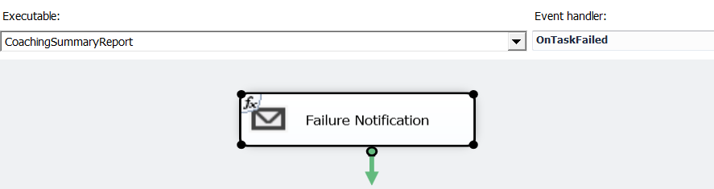

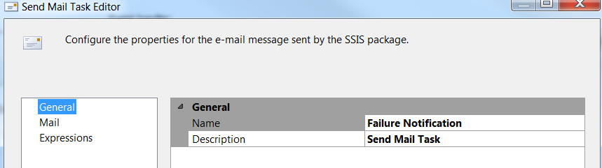

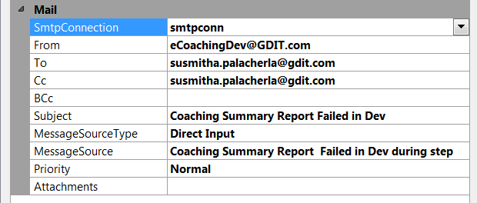

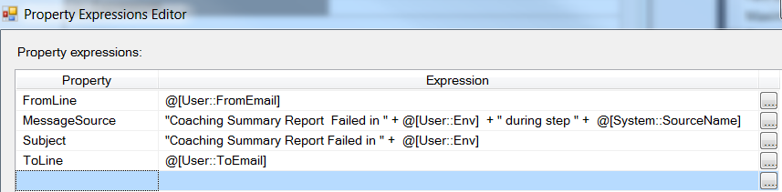

#### Config File- Prod

|  |
| --- |
| <?xml version="1.0"?><DTSConfiguration>  <DTSConfigurationHeading>  <DTSConfigurationFileInfo GeneratedBy="VNGT\211palasu" GeneratedFromPackageName="CoachingSummaryReport" GeneratedFromPackageID="{FA5D7D05-0867-40B4-84EF-DBE69724D26B}" GeneratedDate="10/6/2017 10:57:32 AM"/>  </DTSConfigurationHeading>  <Configuration ConfiguredType="Property" Path="\Package.Connections[dbconn].Properties[InitialCatalog]" ValueType="String"><ConfiguredValue>eCoaching</ConfiguredValue>  </Configuration><Configuration ConfiguredType="Property" Path="\Package.Connections[dbconn].Properties[ServerName]" ValueType="String"><ConfiguredValue>f3420-ecldbp01</ConfiguredValue>  </Configuration><Configuration ConfiguredType="Property" Path="\Package.Connections[smtpconn].Properties[SmtpServer]" ValueType="String"><ConfiguredValue>smtpout.gdit.com</ConfiguredValue>  </Configuration><Configuration ConfiguredType="Property" Path="\Package.Variables[User::Adhoc].Properties[Value]" ValueType="Boolean"><ConfiguredValue>0</ConfiguredValue>  </Configuration><Configuration ConfiguredType="Property" Path="\Package.Variables[User::BackupsDir].Properties[Value]" ValueType="String"><ConfiguredValue>\\f3420-ecldbp01\data\Coaching\Encryption\Backups\</ConfiguredValue>  </Configuration><Configuration ConfiguredType="Property" Path="\Package.Variables[User::BeginDate].Properties[Value]" ValueType="Int32"><ConfiguredValue>0</ConfiguredValue>  </Configuration><Configuration ConfiguredType="Property" Path="\Package.Variables[User::CCEmail].Properties[Value]" ValueType="String"><ConfiguredValue>susmitha.palacherla@gdit.com</ConfiguredValue>  </Configuration><Configuration ConfiguredType="Property" Path="\Package.Variables[User::CompletionCCEmail].Properties[Value]" ValueType="String"><ConfiguredValue>Douglas.Stearns@GDIT.com;susmitha.palacherla@gdit.com;lili.huang@GDIT.com;david.hinman@GDIT.com</ConfiguredValue>  </Configuration><Configuration ConfiguredType="Property" Path="\Package.Variables[User::CustomerEmail].Properties[Value]" ValueType="String"><ConfiguredValue>JohnEric.Tiongson@GDIT.com;Mark.Hackman@GDIT.com</ConfiguredValue>  </Configuration><Configuration ConfiguredType="Property" Path="\Package.Variables[User::DecryptInDir].Properties[Value]" ValueType="String"><ConfiguredValue>\\f3420-mwbp11\Apps\Encryption\Decrypt_In\</ConfiguredValue>  </Configuration><Configuration ConfiguredType="Property" Path="\Package.Variables[User::DecryptOutDir].Properties[Value]" ValueType="String"><ConfiguredValue>\\f3420-mwbp11\Apps\Encryption\Decrypt_Out\</ConfiguredValue>  </Configuration><Configuration ConfiguredType="Property" Path="\Package.Variables[User::EncryptInDir].Properties[Value]" ValueType="String"><ConfiguredValue>\\f3420-mwbp11\Apps\Encryption\Encrypt_In\</ConfiguredValue>  </Configuration><Configuration ConfiguredType="Property" Path="\Package.Variables[User::EncryptOutDir].Properties[Value]" ValueType="String"><ConfiguredValue>\\f3420-mwbp11\Apps\Encryption\Encrypt_Out\</ConfiguredValue>  </Configuration><Configuration ConfiguredType="Property" Path="\Package.Variables[User::EndDate].Properties[Value]" ValueType="Int32"><ConfiguredValue>0</ConfiguredValue>  </Configuration><Configuration ConfiguredType="Property" Path="\Package.Variables[User::Env].Properties[Value]" ValueType="String"><ConfiguredValue>Prod</ConfiguredValue>  </Configuration><Configuration ConfiguredType="Property" Path="\Package.Variables[User::FromEmail].Properties[Value]" ValueType="String"><ConfiguredValue>eCoaching@GDIT.com</ConfiguredValue>  </Configuration><Configuration ConfiguredType="Property" Path="\Package.Variables[User::ReportsDir].Properties[Value]" ValueType="String"><ConfiguredValue>\\f3420-mwbp11\Reports\CoachingSummary\</ConfiguredValue>  </Configuration><Configuration ConfiguredType="Property" Path="\Package.Variables[User::ToEmail].Properties[Value]" ValueType="String"><ConfiguredValue>susmitha.palacherla@gdit.com;lili.huang@GDIT.com;david.hinman@GDIT.com</ConfiguredValue>  </Configuration></DTSConfiguration> |

#### Code Files

|  |  |
| --- | --- |
| Procedures | \Code\DB\Stored Procedures\sp_Get_Dates_For_Previous_Month.sql  \Code\DB\Stored Procedures\sp_rptCoachingSummaryForModule.sql |
| SSIS Package | \Code\ETL\CoachingSummaryReport.dtsx |
| Config Files | \Code\ETL\Dev_CoachingSummaryReport.dtsConfig  \Code\ETL\Test_CoachingSummaryReport.dtsConfig  \Code\ETL\Prod_CoachingSummaryReport.dtsConfig |