__________________________



**Title: Employee_Hierarchy_SSIS_DD**

**SSIS Detail Design Document**

__________________________

|  |  |  |
| --- | --- | --- |
| Last Revision | Last Review | Description |
| 05/19/2017 |  | TFS 6623 - Checks for data in files. |

Prepared by: Susmitha Palacherla Date: 12/04/2013

Department, Location: Health Solutions Division

Approved by: Date:

**Change History Log**

| **Date** | **Change Description** | **Author** |
| --- | --- | --- |
| 12/04/2013 | Initial revision | Susmitha Palacherla |
| 06/30/2014 | Updated per scr 12982 to move the updates for migrated logs above the employee id to lanid process. | Susmitha Palacherla |
| 10/27/2014 | Updated per SCR 13624 to add step for Inactivating expired warnings logs. | Susmitha Palacherla |
| 01/19/2015 | Updated to import status and lanid from eWFM emp Info file to use in inactivation of ecls for employees in EA and Inactive status per scr 14072. | Susmitha Palacherla |
| 01/28/2015 | Additional update during SCR 14072. Adding a variable for eWFM info file directory to be able to use a test file from a test staging directory. | Susmitha Palacherla |
| 4/15/2016 | Added steps for integrating a supplementary file for HR employees per TFS 2332 | Susmitha Palacherla |
| 5/16/2016 | Added step to populate AT User Table per TFS 1709 | Susmitha Palacherla |
| 5/18/2017 | TFS 6623 – Check for data in files  2.1.1.1 –Variables – Added additional variables  2.1.1.2 – connection Manager – Added new SMTP connection  2.1.1.3 - Package content and workflow steps- Updated workflow diagram showing additional data checks  Updated Details section to reorder steps and add new steps | Susmitha Palacherla |
| 5/19/2017 | TFS 6623 – Check for data in files – Updates from V&V feedback. Replaced references to Vangent with GDIT. | Susmitha Palacherla |

Contents

1. Overview 4

1.1 Project Description 4

1.2 Document Scope 4

1.3 Source Files 4

1.4 Module List 4

1.5 Software and Hardware Interfaces 4

1.5.1 Software 4

1.5.2 Hardware 4

1.6 Users 4

2. Details 5

3.1 Source Files 5

3.1.1 PS_Employee_Information_mmddyyyy.csv 5

3.1.2 Employee_Information_WithProgram.csv 5

3.1.3 HR_Employee_Information.csv 5

3.2 Module Details 6

3.2.1 SQL agent job 6

3.2.2 SSIS Package 6

3.2.3 Tables 27

3.2.4 Procedures 27

# Overview

## Project Description

The eCoaching Log (eCL) is an internal GDIT process designed for the entry and storage of the coaching notes that supervisors, managers, Advanced Resolution Center (ARC) CSRs and quality leads make regarding CSR performance. These notes are gathered through escalations, floor walking, training, quality monitors. It also provides a repository of coaching notes to generate reports for management.

## Document Scope

This document describes the process for maintaining the Employee Hierarchy table. It describes the source files and the workflow to maintain the user table.

## Source Files

* PS_Employee_Information_mmddyyyy.csv
* Employee_Information_WithProgram.csv
* HR_Employee_Information.csv

## Module List

* SQL agent job
* SSIS Package
* Tables
* Procedures

## Software and Hardware Interfaces

### Software

* SQL Server 2008 R2 SP1 Suite

### Hardware

* VRIVFSSDBT02\SCORD01,1437 – Dev DB Instance
* VRIVFSSDBT02\SCORT01,1438 – Test DB Instance
* VDENSSDBP07\SCORP01 – Prod DB Instance
* \\VRIVSCORS01\BCC Scorecards\ - File staging share

## Users

* N/A

# Details



## Source Files

### PS_Employee_Information_mmddyyyy.csv

* Description: This is an Employee file from Peoplesoft.
* Used for capturing Employee attributes like Employee ID, Name, Lan ID, Location, Job Code and Manager(Supervisor’s supervisor) and last hire date and Active Flag.
* Source system: PeopleSoft
* Staging location: \\vrivscors01\BCC Scorecards\Coaching\HRInfo\
* File name: PS_Employee_Information_mmddyyyy.csv
* Frequency: Arrives daily at ~4:30 AM EST
* Load time: 7 PM EST (5:00 PM Database time)
* Destination Table: Employee_Hierarchy

### Employee_Information_WithProgram.csv

* Description: This is an Employee file from Aspect eWFM. Used to capture the Supervisor for employees having a CSR job code and the program value. The program value should be associated with the call or activity and will be input from the web interface or provided in the Coaching requests from Quality system and Outliers feeds. The program value based on the agents 1MULTI value from eWFM will only be sued when a program cannot be identified for the call activity for a specific coaching log.
* Source system: Aspect eWFM
* Staging location: \\vrivscors01\BCC Scorecards\Coaching\EmpInfo\
* File name: Employee_information_WithProgram.csv
* Frequency: Arrived daily at ~6:00 AM EST
* Load time: 7 PM EST (5:00 PM Database time)
* Destination Table: EmpID_To_SupID_Stage

### HR_Employee_Information.csv

* Description: This is a manually created file sourced from HCSD HR team.
* Used for capturing Employee attributes like Employee ID, Name, Lan ID, Location, Job Code and Manager(Supervisor’s supervisor) and last hire date and Active Flag for HCSD HR staff.
* Source system: NA
* Staging location: \\vrivscors01\BCC Scorecards\Coaching\HRInfo\
* File name: HR_Employee_Information.csv
* Frequency: Ad-hoc (when there are changes to HR Employee records)
* Load time: 7 PM EST (5:00 PM Database time)
* Destination Table: Employee_Hierarchy

## Module Details

### SQL agent job

* Production Instance : VDENSSDBP07\SCORP01
* Production Job: NewdailyHRLoad
* Production Package: \\VDENSSDBP07\scorecard-ssis\Coaching\Employee_Hierarchy.dtsx
* Production Config File: Prod_Employee_Hierarchy.dtsConfig
* Owner: jobs_admin
* Run As: BccScrdSQLAgent
* Schedule: Daily 7:00 PM EST
* Destination File Location: N/A

### SSIS Package

* + - 1. **Variables**

|  |  |  |  |
| --- | --- | --- | --- |
| **Name** | **DataType** | **Value** | **Evaluate as Expression** |
| FileDir | String | \\vrivscors01\BCC Scorecards\Coaching\HRInfo\  *set from config file | False |
| WFMFileDir | String | \\vrivscors01\BCC Scorecards\Coaching\EmpInfo\  *set from config file | False |
| CCEmail | String | [Susmitha.palacherla@gdit.com](mailto:Susmitha.palacherla@gdit.com)  *set from config file | False |
| FromEmail | String | [Susmitha.palacherla@gdit.com](mailto:Susmitha.palacherla@gdit.com)  *set from config file | False |
| ToEmail | String | [Susmitha.palacherla@gdit.com](mailto:Susmitha.palacherla@gdit.com)  *set from config file | False |
| HRFileBackup | String | \\vrivscors01\BCC Scorecards\Coaching\HRInfo\Test\new\Backup\ | True - @[User::FileDir] + "Backup\\" |
| PSFile | String | PS_Employee_Information_05182017.csv | True - "PS_Employee_Information_" +  Right("0" + (DT_STR,4,1252) DatePart("m",getdate()),2) +  Right("0" + (DT_STR,4,1252) DatePart("d",getdate()),2) +  (DT_STR,4,1252) DatePart("yyyy",getdate()) + ".csv" |
| PSFileExists | Boolean | True/False  *Checked from Script task | False |
| PSRecordCount | Int32 | 0  *Checked from Row Count task | False |
| HRRecordCount | Int32 | 0  *Checked from Row Count task | False |
| WFMRecordCount | Int32 | 0  *Checked from Row Count task | False |
|  |  |  |  |

* + - 1. **Connection Manager Entries**
         1. Destinationdb
* Dev - VRIVFSSDBT02\SCORD01,1437) DB – eCoachingdev
* Test - VRIVFSSDBT02\SCORT01,1438) DB – eCoachingtest
* Prod - VDENSSDBP07\SCORP01 DB – eCoaching
  + - * 1. EmpFile
* \\vrivscors01\bcc scorecards\Coaching\EmpInfo\Employee_Information_WithProgram.csv
* Expression: @[User::WFMFileDir]+"Employee_Information_WithProgram.csv"
  + - * 1. PSFile
* \\VRIVSCORS01\BCC Scorecards\Coaching\HRInfo\PS_Employee_Information_mmddyyyy.csv
* Expression: @[User::FileDir] + "PS_Employee_Information_" +

Right("0" + (DT_STR,4,1252) DatePart("m",getdate()),2) +

Right("0" + (DT_STR,4,1252) DatePart("d",getdate()),2) +

(DT_STR,4,1252) DatePart("yyyy",getdate()) + ".csv"

* + - * 1. HRFile
* \\VRIVSCORS01\BCC Scorecards\Coaching\HRInfo\HR_Employee_Information.csv
* Expression: @[User::FileDir] + "HR_Employee_Information.csv"
  + - * 1. SMTP Connection Manager

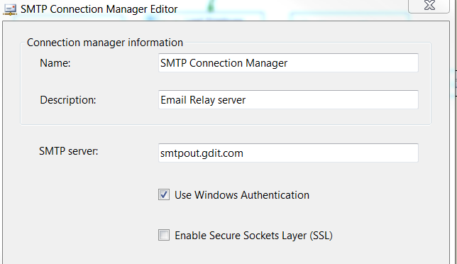

* + - 1. **Package Content**

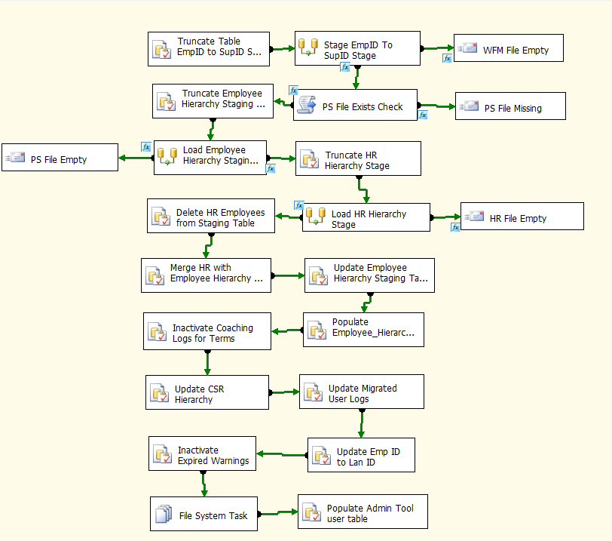

**Workflow**

**Summary of Steps**

1. SQL task – Truncate EmP ID To sup ID Staging Table
2. DFT – Stage WFM emp Info File data into Emp ID To Sup ID Table
   * IF WFM File empty – Send Mail Task. End Process.
   * IF PS File Missing – Send Mail Task. End process.
3. SQL task – Truncate Employee Hierarchy Staging Table
4. DFT – Stage PeopleSoft HR File data into Employee Hierarchy Staging Table
   * IF PS File empty – Send Mail Task. End Process.
5. SQL – Truncate HR Staging Table
6. DFT – Load HR Staging Table
   * IF HR File empty – Send Mail Task. End Process.
7. SQL Task – Delete HR Employees from Employee Staging Table
8. SQL Task – Merge HR Employees into main Employee staging table
9. SQL task – Update Employee Hierarchy Staging table.
10. SQL task – Populate Employee Hierarchy table
11. SQL task – Inactivate Coaching logs for termed users
12. SQL task – Update CSR Hierarchy Table
13. SQL task – Update Coaching Logs for migrated users
14. SQL task – Update Employee ID To Lan ID table
15. SQL task – Inactivate expired warning logs
16. File Task – Make backup of loaded HR file
17. Populate AT User Table

**Details**

Step 1: SQL task - Truncate Table EmpID to SupID Stage

Truncate Table [EC].[EmpID_To_SupID_Stage]

Step 2: DFT - Stage WFM Emp Info file

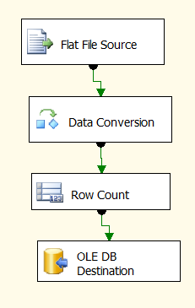

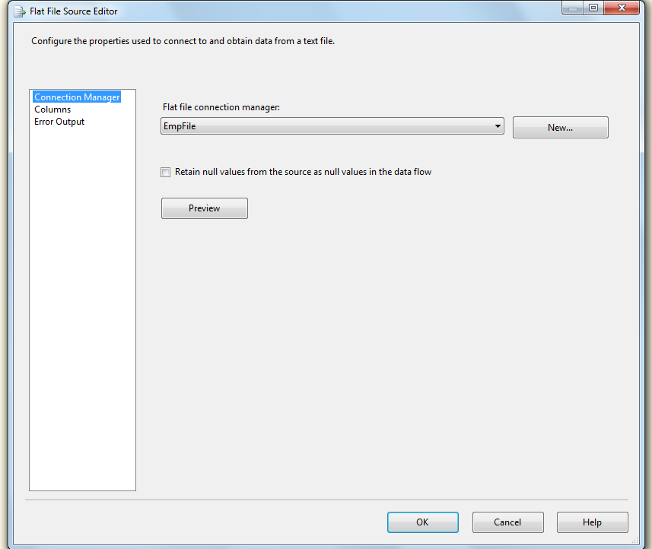

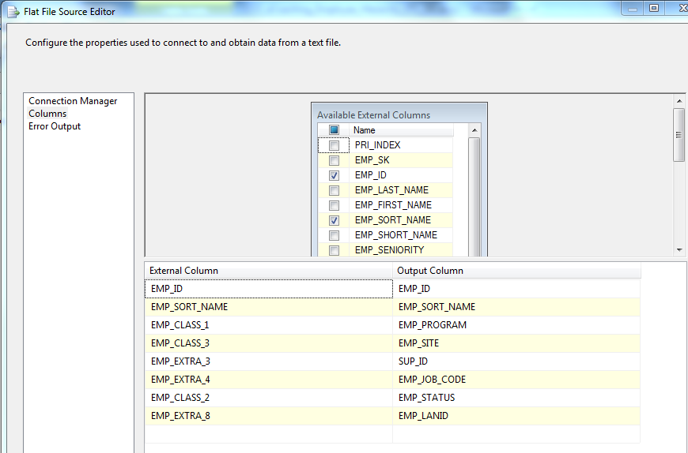

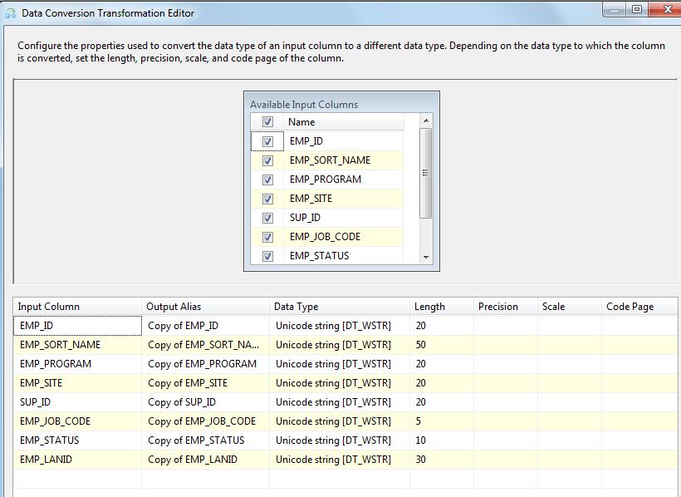

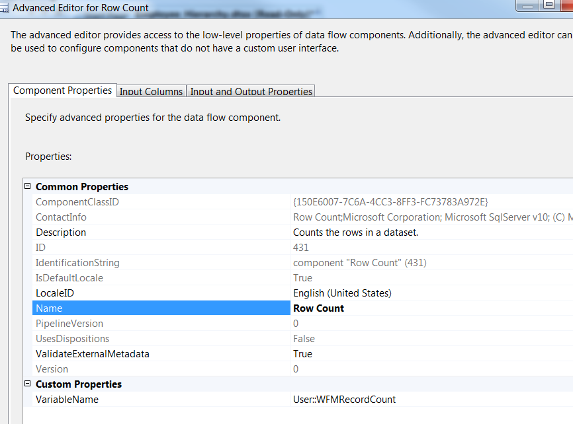

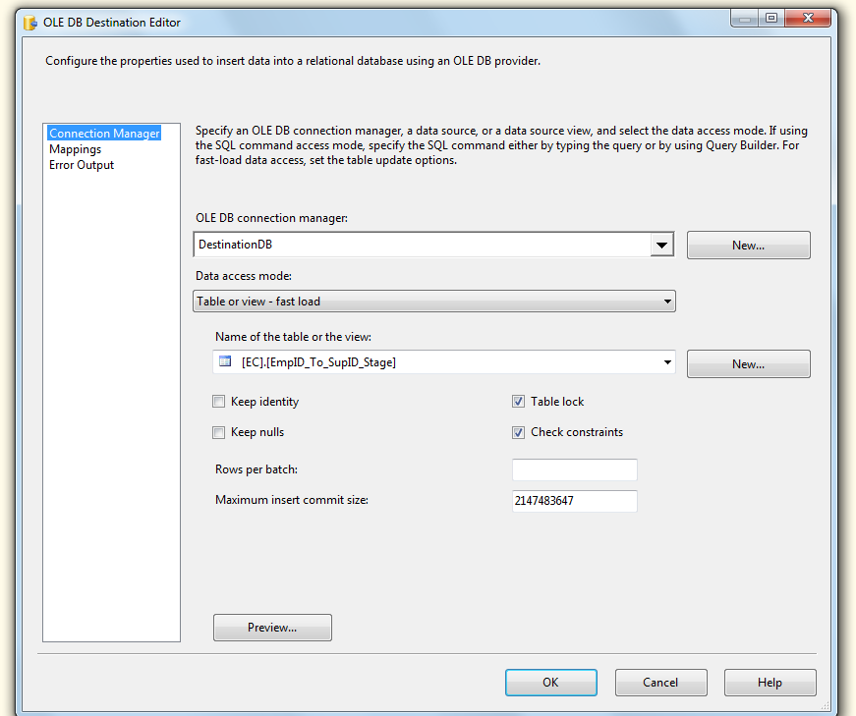

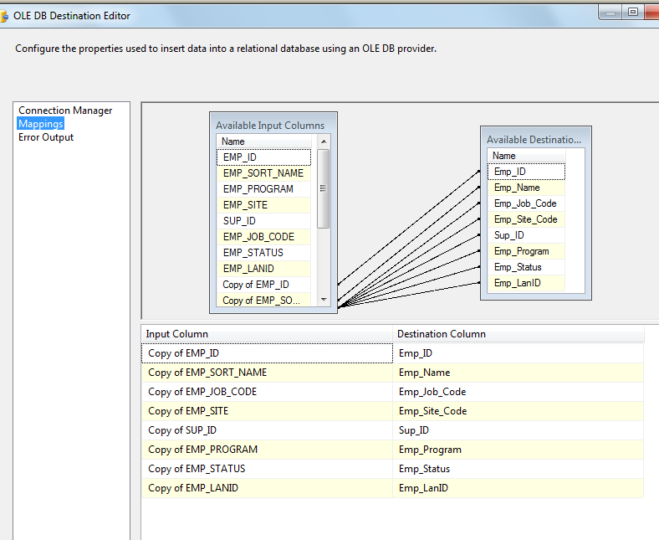

|  |  |
| --- | --- |
|  |  |
|  |  |
|  |  |
|  |  |

|  |  |
| --- | --- |
|  |  |
|  |  |
|  |  |
|  |  |
|  |  |
|  |  |
|  |  |
|  |  |

* End process.

|  |  |
| --- | --- |
|  |  |
|  |  |
|  |  |
|  |  |

|  |
| --- |
|  |
|  |

|  |  |
| --- | --- |
|  |  |
|  |  |
|  |  |
|  |  |

|  |  |
| --- | --- |
|  |  |
|  |  |
|  |  |
|  |  |
|  |  |
|  |  |
|  |  |
|  |  |

* End process.

|  |  |
| --- | --- |
|  |  |
|  |  |
|  |  |
|  |  |



Step 3: SQL Task - Truncate Employee Hierarchy Staging Table

IF EXISTS (SELECT * FROM sys.objects WHERE object_id = OBJECT_ID(N'[EC].[Employee_Hierarchy_Stage]') AND type in (N'U'))

Truncate TABLE [EC].[Employee_Hierarchy_Stage]

Step 4: DFT- Load Employee Hierarchy Staging Table

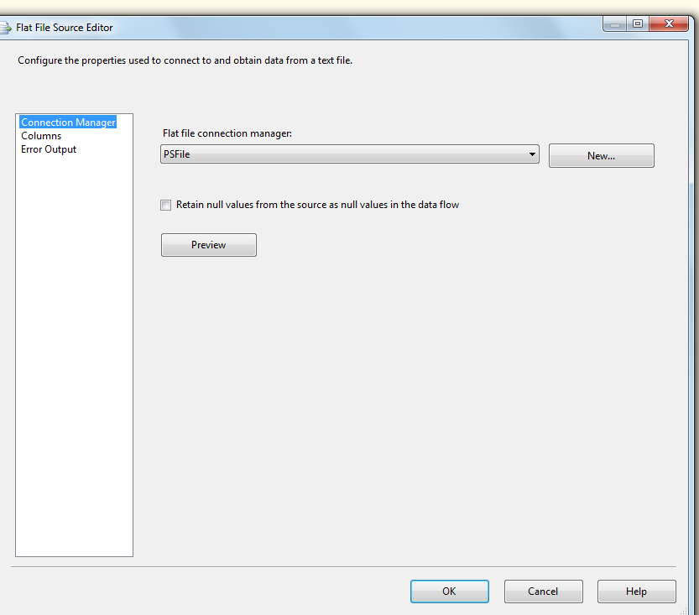

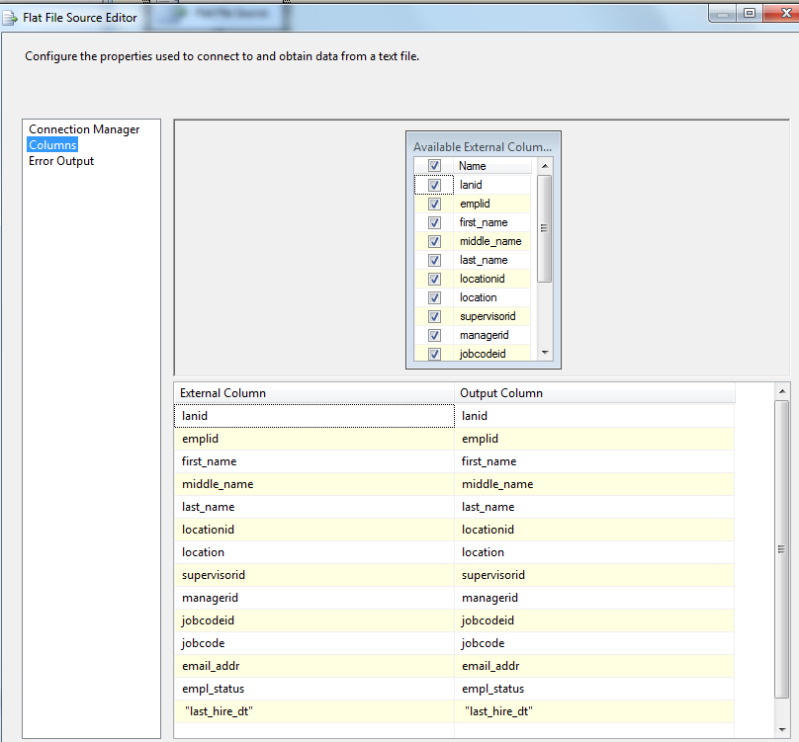

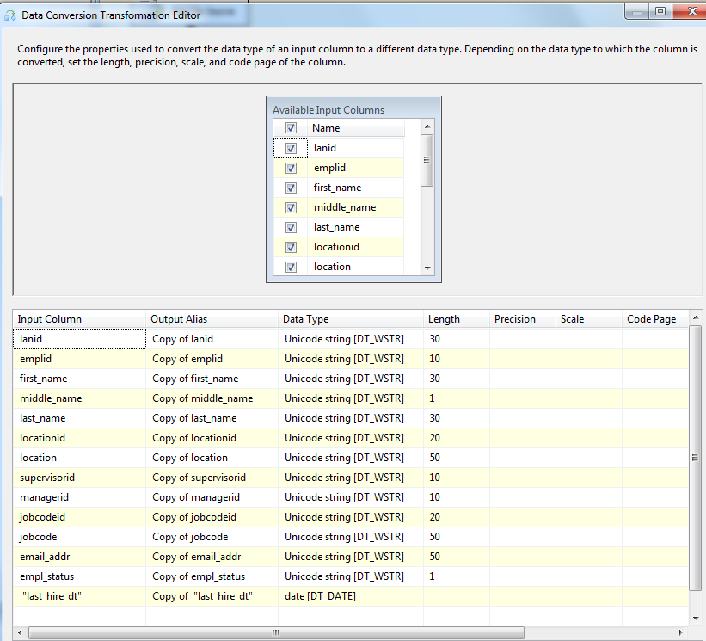

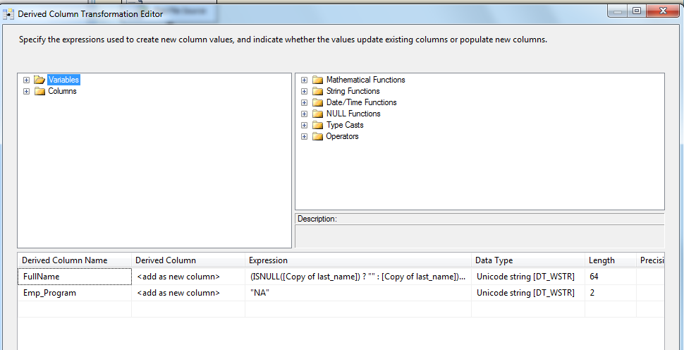

(ISNULL([Copy of last_name]) ? "" : [Copy of last_name]) + ", " + (ISNULL([Copy of first_name]) ? "" : [Copy of first_name]) + " " + (ISNULL([Copy of middle_name]) ? "" : [Copy of middle_name])

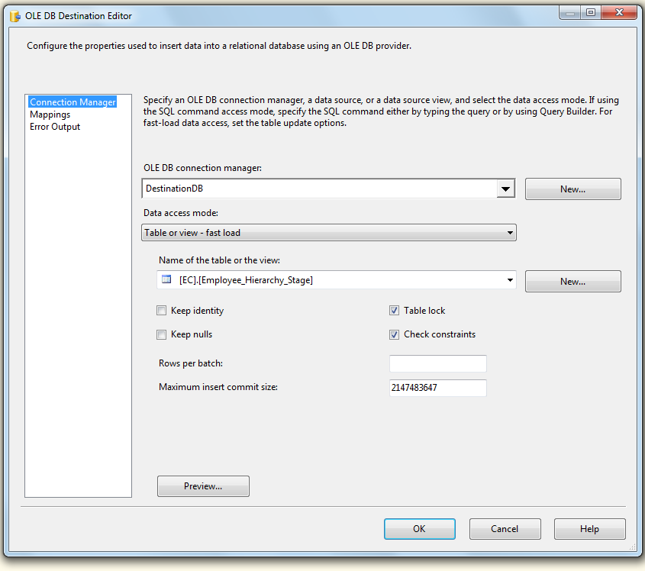

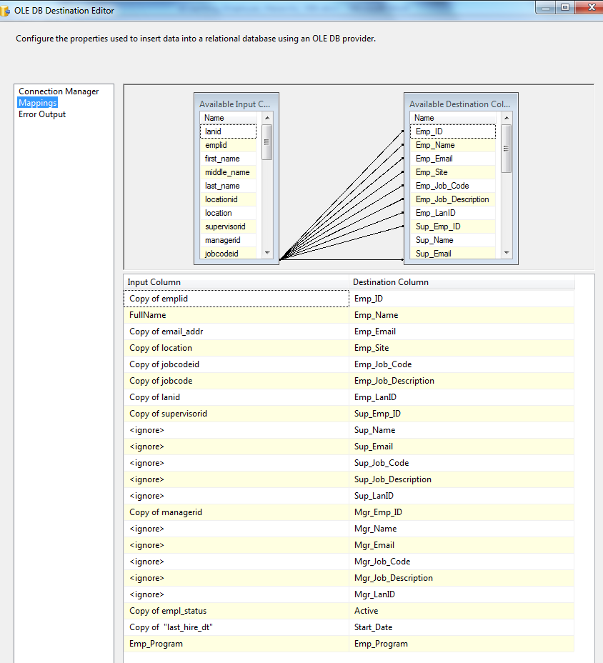

|  |  |
| --- | --- |
|  |  |
|  |  |
|  |  |
|  |  |

|  |  |
| --- | --- |
|  |  |
|  |  |
|  |  |
|  |  |
|  |  |
|  |  |
|  |  |
|  |  |

* End process.

|  |  |
| --- | --- |
|  |  |
|  |  |
|  |  |
|  |  |

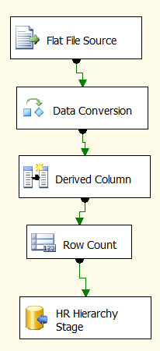

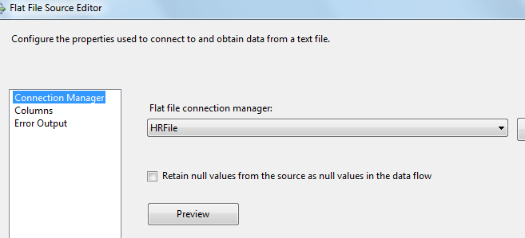

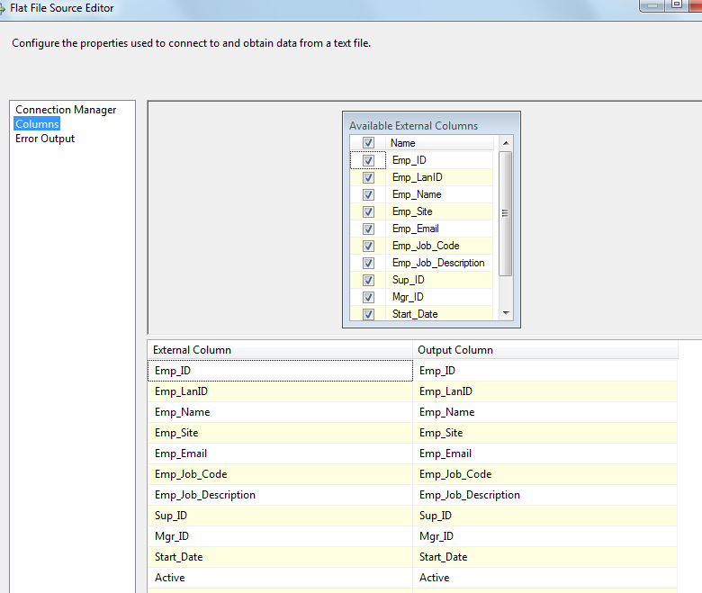

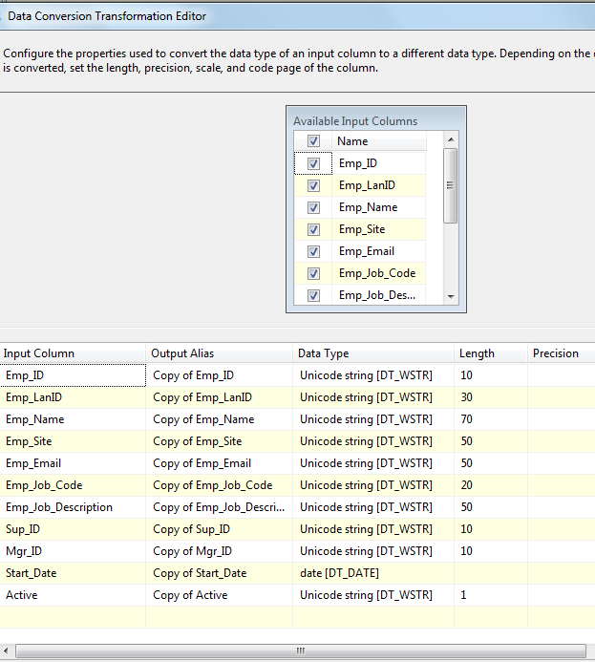

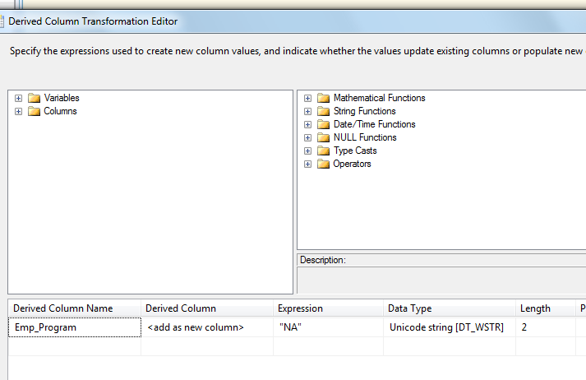

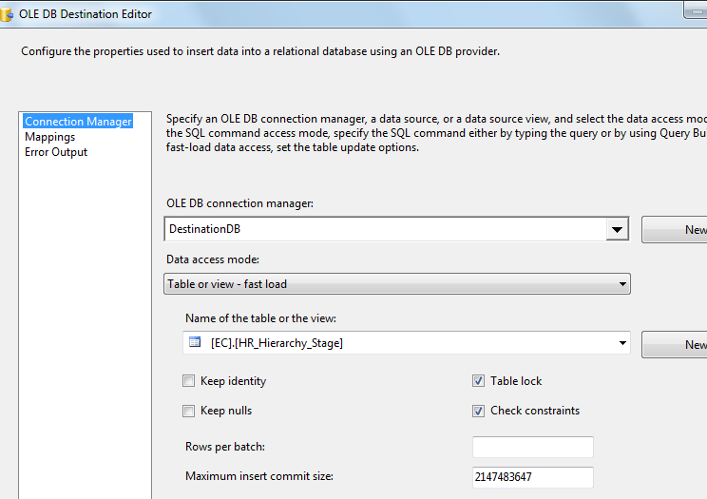

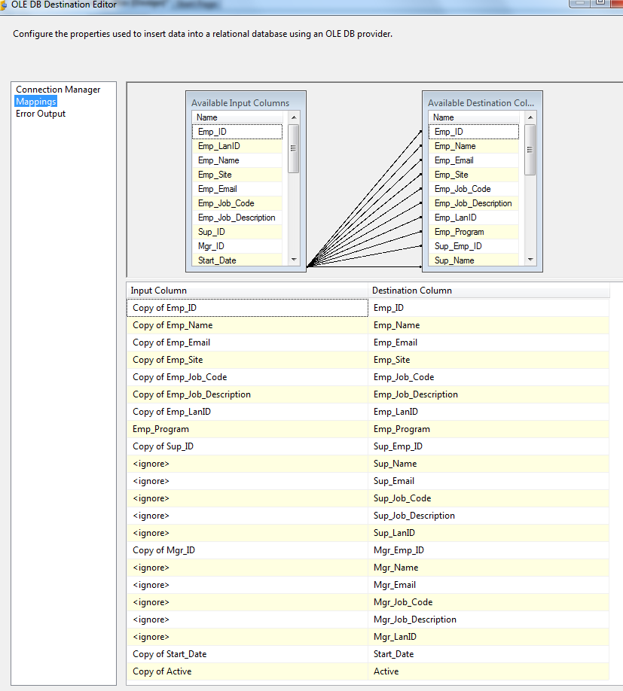



|  |  |
| --- | --- |
| Email Task |  |
| SmtpConnection | SMTP Connection Manager |
| From | Expression:FromLine: @[User::FromEmail] |
| CC | Expression:CCLine: @[User::CcEmail] |
| To | Expression:ToLine: @[User::ToEmail] |
| Subject | Employee Load process has been terminated. |
| Message Source Type | Direct Input |
| Message Source | HR File has no records.  Load process has been terminated. Please check it out. |

* End process.

|  |  |
| --- | --- |
|  |  |
|  |  |
|  |  |
|  |  |

|  |  |
| --- | --- |
| Step 7: SQL Task | Delete HR Employees from Employee Staging Table –  DELETE FROM [EC].[Employee_Hierarchy_Stage]  WHERE Emp_JOB_Code like 'WH%' |
| Step 8: SQL Task | Merge HR Employees into main Employee staging table –  Exec [EC].[sp_Merge_HR_Employee_Hierarchy_Stage] |
| Step 9: SQL Task | Update Employee Hierarchy Staging Table  EXEC [EC].[sp_Update_Employee_Hierarchy_Stage] |
| Step 10: SQL Task | Populate Employee_Hierarchy Table  Exec [EC].[sp_Populate_Employee_Hierarchy] |
| Step 11: SQL Task | Inactivate Coaching Logs for Terms  Exec [EC].[sp_InactivateCoachingLogsForTerms] |
| Step 12: SQL Task | Update CSR Hierarchy Table  Exec [EC].[sp_Update_CSR_Hierarchy] |
| Step 13: SQL Task | Update Coaching Logs for migrated users  Exec [EC].[sp_Update_Migrated_User_Logs] |
| Step 14: SQL Task | Update Employee ID To Lan ID Table  Exec [EC].[sp_Update_EmployeeID_To_LanID] |
| Step 15: SQL Task | Inactivate expired warning logs  Exec [EC].[sp_InactivateExpiredWarningLogs] |
| Step 17: SQL Task | Populate AT user Table  Exec [EC].[sp_AT_Populate_User] |

Step16: File System Task - Make backup of loaded HR file

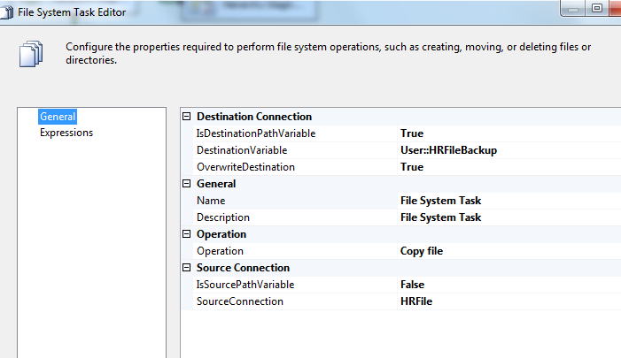

### Tables

|  | **Table Name** | **Table Description** |
| --- | --- | --- |
| 1. | Employee_Hierarchy | Table for storing Employee Information. |
| 2. | Employee_Hierarchy_Stage | Table used for staging the Employee Information from PeopleSoft during the Employee Hierarchy load process. |
| 3. | EmpID_To_SupID_Stage | Table used for staging the Sup Ids from Aspect eWFM during the Employee Hierarchy load process. |
| 4. | EmployeeID_To_LanID | Table used for storing Employee ID to Lan ID links over time. |
| 5. | CSR_Hierarchy | Table used for storing CSR Hierarchy records over time. |
| 6. | HR_Hierarchy_Stage | Table used to stage HR Hierarchy records |
| 7. | AT_User | Table for storing Admin Tool users |

### Procedures

|  | **Procedure Name** | **Usage** |
| --- | --- | --- |
| 1. | sp_Populate_Employee_Hierarchy | Load: Employee Data |
| 2. | sp_Update_CSR_Hierarchy | Load: Employee Data |
| 3. | sp_Update_Employee_Hierarchy_Stage | Load: Employee Data |
| 4. | sp_Update_EmployeeID_To_LanID | Load: Employee Data |
| 5. | sp_Update_Migrated_User_Logs | Housekeeping: Migrated user log update |
| 6. | sp_Merge_HR_Employee_Hierarchy_Stage | Load: Employee Data |
| 7. | sp_AT_Populate_User | Load: AT user Data |

Stored Procedure creates in TFS Source control at: \cms\eCoaching_V2\Code\DB\ Stored Procedures\*.sql