__________________________



**Title: eCoaching_ETS_Load**

**SSIS Detail Design Document**

__________________________

|  |  |  |
| --- | --- | --- |
| Last Revision | Last Review | Description |
| 8/14/2017 |  | TFS 7105 – Upgrade to SQL Server 2012 |

Prepared by: Susmitha Palacherla Date: 11/17/2014

Department, Location: Health Solutions Division

Approved by: Date:

**Change History Log**

| **Date** | **Version** | **Change Description** | **Author** |
| --- | --- | --- | --- |
| 11/19/2014 | 1.0 | Initial revision. Load process setup per SCR 13659. | Susmitha Palacherla |
| 12/15/2014 | 2.0 | Updated per SCR 14010 to increase column size of time_code attribute in ETS Tables to 30. | Susmitha Palacherla |
| 01/12/2015 | 3.0 | Incorporate load process for Outstanding Action (Compliance) reports per SCR 14031. | Susmitha Palacherla |
| 05/01/2015 | 4.0 | SMTP server name change. SCR 14803. | Susmitha Palacherla |
| 7/24/2017 | 5.0 | Incorporate 2 new feeds. HNC and ICC | Susmitha Palacherla |
| 8/14/2017 | 6.0 | TFS 7105 – Upgrade to SQL Server 2012 | Susmitha Palacherla |
|  |  |  |  |

Contents

1. Overview 4

1.1 Project Description 4

1.2 Document Scope 4

1.3 Source Files 4

1.4 Module List 6

1.5 Software and Hardware Interfaces 6

1.5.1 Software 6

1.5.2 Hardware 6

1.6 Users 6

2. Details 7

3.1 Source Files 7

3.2 Module Details 7

3.2.1 SQL agent job 7

3.2.2 SSIS Package 7

3.2.3 Tables 35

3.2.4 Procedures 36

3.2.5 Functions 36

# Overview

## Project Description

ETS (Electronic Time Keeping System) is the GDIT time tracking application. Employees and Approvers need to follow a strict set of guide lines while filling out and or approving timecards. Any non-compliance of these rules will result in an infraction. Operations will generate reports for these infractions committed by CCO CSRs, supervisors, and approvers.

These reports will be loaded into the eCoaching application so users can be coached and the Coaching documented in eCL.

Below is a list of reports that will be loaded into eCL. Each Report is identified by a 2-4 letter code.

* EA Excused Absence
* EOT Exempt Over Time
* FWH Future Worked Hours
* FWHA Future Worked Hours (Approver)
* HOL Incorrect Holiday
* HOLA Incorrect Holiday (Approver)
* ITD Invalid Timecodes Direct
* ITDA Invalid Timecodes Direct (Approver)
* ITI Invalid Timecodes Indirect
* ITIA Invalid Timecodes Indirect (Approver)
* UTL Utilization
* UTLA Utilization (Approver)
* OAE Outstanding Action (Employee)
* OAS Outstanding Action (Supervisor)
* HNC High Number of Changes
* ICC Incorrect Change Categories

## Document Scope

This document describes the load of the above ETS reports provided by Operations into the eCoaching database. Once the reports are loaded into the database the logs are tracked using the non CSE Non Quality coaching workflow similar to the submissions from the web interface.

## Source Files

The table below shows all of the ETS report types that can arrive as feeds. Currently active feeds are marked by an ‘X’ in the table below. Files have a naming convention eCL_ETS_Feed_XX(XX)(A)yyyymmdd.csv where XX(XX) stands for the

2-4 letter acronym used by the report as shown in the ‘Code’ column below. The (A) in the filename denoted an Approver report.

Files are staged at \\VRIVSCORS01\BCC Scorecards\Coaching\ETS\

|  |  |  |  |  |  |  |
| --- | --- | --- | --- | --- | --- | --- |
| **#** | **Metric/Report** | **Active Feed** | **Code** | **eCL Workflow** | **Entry** | **Coaching Reason** |
| 1 | Excused Absence | X | EA | Indirect non CSE | Sup | ETS |
| 2 | Exempt Over Time | X | EOT | Indirect non CSE | Sup | ETS |
| 3 | Future Worked Hours | X | FWH | Indirect non CSE | Sup | ETS |
| 4 | Future Worked Hours (Approver) | X | FWHA | Indirect non CSE | Sup | ETS |
| 5 | Incorrect Holiday | X | HOL | Indirect non CSE | Sup | ETS |
| 6 | Incorrect Holiday (Approver) | X | HOLA | Indirect non CSE | Sup | ETS |
| 7 | Invalid Timecodes Direct | X | ITD | Indirect non CSE | Sup | ETS |
| 8 | Invalid Timecodes Direct (Approver) | X | ITDA | Indirect non CSE | Sup | ETS |
| 9 | Invalid Timecodes Indirect | X | ITI | Indirect non CSE | Sup | ETS |
| 10 | Invalid Timecodes Indirect (Approver) | X | ITIA | Indirect non CSE | Sup | ETS |
| 11 | Utilization |  | UTL | Indirect non CSE | Sup | ETS |
| 12 | Utilization (Approver) |  | UTLA | Indirect non CSE | Sup | ETS |
| 13. | Outstanding Action (Employee) | X | OAE | Indirect non CSE  OMR workflow | Sup | ETS |
| 14. | Outstanding Action (Supervisor) | X | OAS | Indirect non CSE  OMR workflow | Sup | ETS |
| 15. | High number of Changes | x | HNC | Indirect non CSE | Sup | ETS |
| 16. | Incorrect Change Categories | x | ICC | Indirect non CSE | Sup | ETS |

## Module List

* SQL agent job
* SSIS Package
* Tables
* Procedures

## Software and Hardware Interfaces

### Software

* SQL Server 2012 SP3 Suite

### Hardware

* F3420-ECLDBD01 – Dev DB Server
* F3420-ECLDBT01 – Test DB Server
* F3420-ECLDBP01 – Prod Server
* \\F3420-ECLDBD01\data\ - Dev File staging share
* \\F3420-ECLDBT01\data\ - Test File staging share
* \\VRIVSCORS01\BCC Scorecards\ - Prod File staging share

## Users

* The first set of users for the ETS records loaded into the eCL database are the second level users (immediate supervisors) as all records have default state of ‘Pending Supervisor Review’ at the time of the load.
* After a Supervisor reviews the log and enters Coaching Notes the log goes to ‘Pending Employee Review’ for Employee acknowledgement. After Employee review eCLs enter Completed state.
* Second and Third level users will be able to access the logs from the historical Dashboards.

# Details



## Source Files

eCL_ETS_Feed_XX(XX)(A)yyyymmdd.csv where XX(XX) stands for the 2-4 letter acronym used by the report for the Report Type for non-Compliance Reports

eCL_Compliance_ETS_Feed_XX(XX)(A)yyyymmdd.csv where XX(XX) stands for the 2-4 letter acronym used by the report for the Report Type for Compliance Reports (OAE and OAS)

* Description: Files containing ETS system infractions by time card owners and approvers.
* Source system: ETS
* Staging location: \\vrivscors01\BCC Scorecards\Coaching\ETS\
* File name(s) eCL_ETSs_Feed_XXXyyyymmdd.csv/ eCL_Compliance_ETSs_Feed_XXXyyyymmdd.csv
* Frequency: Most reports are weekly arriving on Monday. A couple of reports are twice weekly with an additional run on Wednesdays.
* File arrival time: NA
* Destination Table: Coaching_Log and Coaching_Log_Reason

## Module Details

### SQL agent job

* Production Instance : F3420-ECLDBP01
* Production Job: CoachingETSLoad
* Production Package: \\F3420-ECLDBP01\ssis\Coaching\Packages\ETS_Coaching.dtsx
* Production Config File: Prod_ETS_Coaching.dtsConfig
* Owner: ecljobowner
* Run As: ECLProxy (ECL Credential using application service account VNGT\SVC-SQLECLP01
* Schedule: 6 PM EST Mondays and Wednesdays
* Destination File Location: N/A

### SSIS Package

* + - 1. **Variables**

|  |  |  |  |  |
| --- | --- | --- | --- | --- |
| **Name** | **Scope** | **DataType** | **Value** | **Evaluate As expression** |
| FilebakPath | ETS_Coaching | String | \\vrivscors01\BCC Scorecards\Coaching\ETS\Backups | False |
| FileNum | ETS_Coaching | Int32 | 0 | False |
| FilePath | ETS_Coaching | String | \\vrivscors01\BCC Scorecards\Coaching\ETS | False |
| varDBName | ETS_Coaching | String | Dev | False |
| varFileName | ETS_Coaching | String |  | False |
| FailMessage | ETS_Coaching | String | "ETS Coaching file \"" + @[User::VarFileName] + "\" failed in " + @[User::VarDBName] | True |
| StagedCount | ETS_Coaching | Int32 | 0 | False |
| RejectedCount | ETS_Coaching | Int32 | 0 | False |
| LoadedCount | ETS_Coaching | Int32 | 0 | False |
| CC | ETS_Coaching | String | Susmitha.palacherla@gdit.com | True |
| From | ETS_Coaching | String | Susmitha.palacherla@gdit.com | True |
| To | ETS_Coaching | String | Susmitha.palacherla@gdit.com | True |
| Subject | ETS_Coaching | String | ETS Load failed in Dev | True |
| varCompFileName | ETS_Coaching | String |  | False |
|  |  |  |  |  |

* + - 1. **Connection Manager Entries**
         1. Destinationdb
* Dev – F3420-ECLDBD01 DB – eCoachingdev
* Test - F3420-ECLDBT01 DB – eCoachingtest
* Prod - F3420-ECLDBP01 – eCoaching
  + - * 1. ETS_File
* \\vrivscors01\bcc scorecards\Coaching\ETS\eCL_ETS_feed_XXXAyyyymmdd.csv

Where XXX is not HNC or ICC.

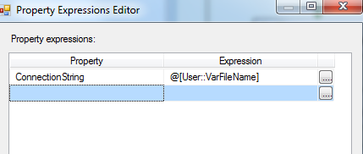

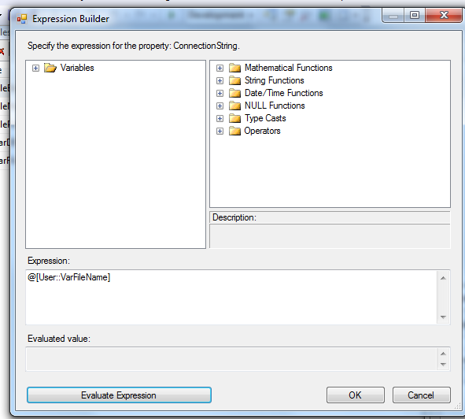

* + - * 1. ETS_File2
* \\vrivscors01\bcc scorecards\Coaching\ETS\eCL_ETS_feed_XXXyyyymmdd.csv

Where XXX is either HNC or ICC.

* + - * 1. Compliance_File
* \\vrivscors01\bcc scorecards\Coaching\ETS\eCL_Compliance_ETS_feed_XXXXAyyyymmdd.csv

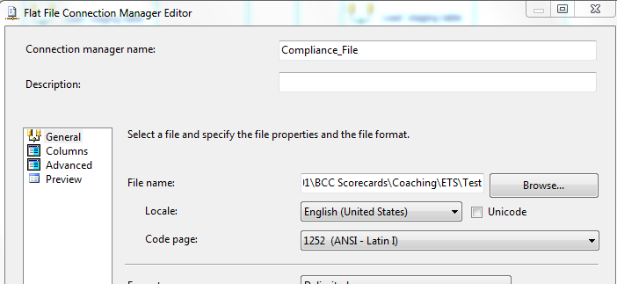

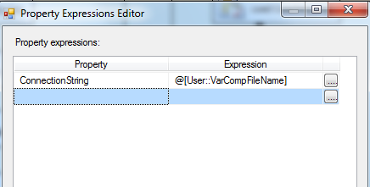

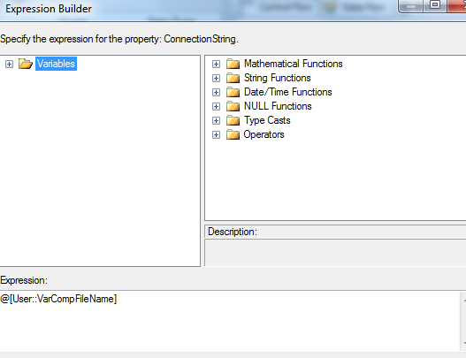

* + - * 1. SMTP Connection Manager

The following SMTP servers can be used.

HQ100-SMTP01, HQ100-SMTP01 or smtpout.gdit.com

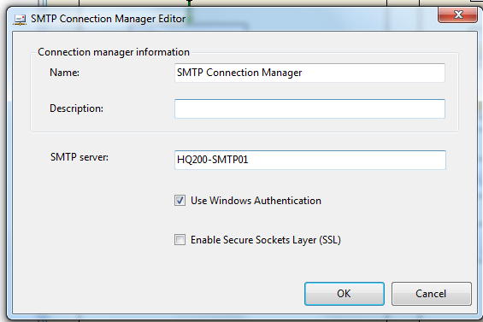

* + - 1. **Package Content**

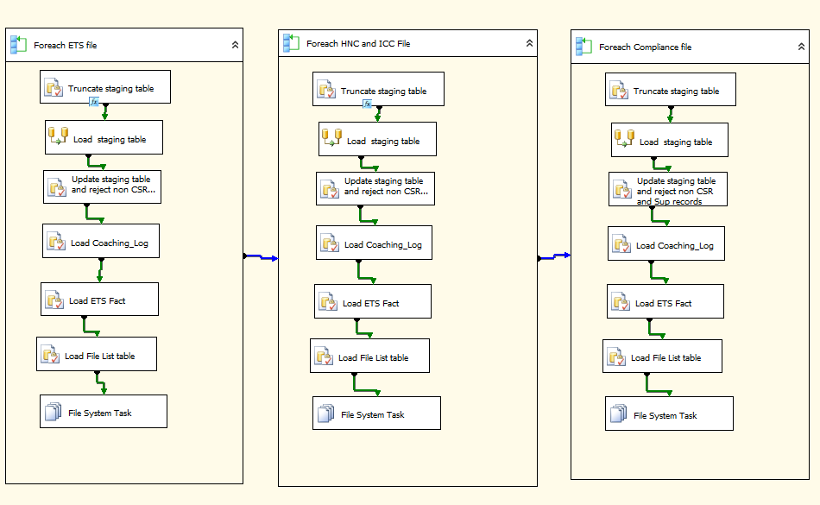

**Workflow**

* + - * 1. **For each ETS file in Staging directory (Non HNC and ICC)**

**Summary of Steps**

1. SQL task – Truncate ETS Staging table
2. DFT – Stage ETS Staging table
3. SQL task Update ETS Staging table
4. SQL task – Load Coaching Log
5. SQL task – Load ETS Fact Table
6. SQL task – Load File list table
7. File system task – Backup files to Backups directory

**Details**

Container: For each ETS File Loop (Not HNC or ICC)

Folder: \\vrivscors01\BCC Scorecards\Coaching\ETS

Files: eCL_ETS_Feed*.csv

1. SQL task – Truncate ETS Staging table

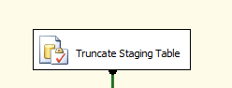

Executes Truncate Table [EC].[ETS_Coaching_Stage]

1. DFT: Load ETS staging table

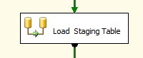

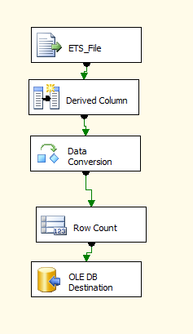

Flat File source

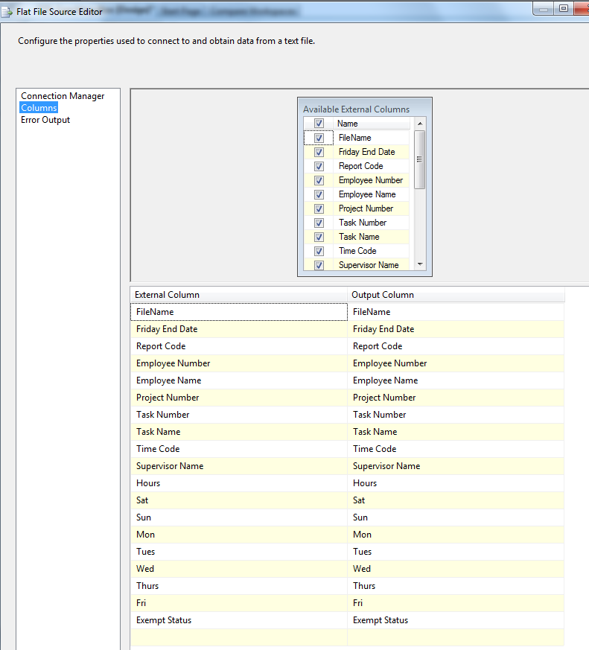

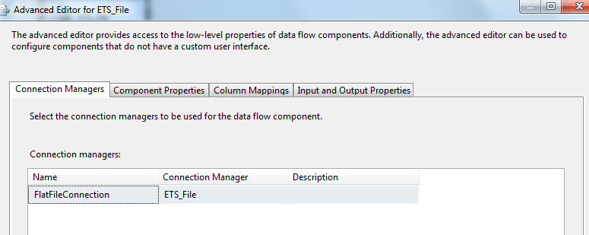

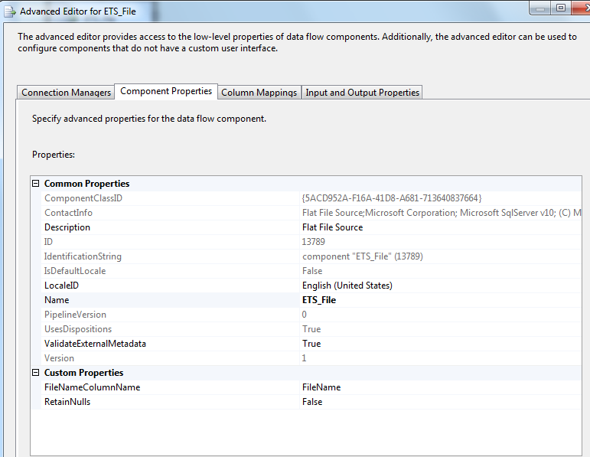

1. Derived Column

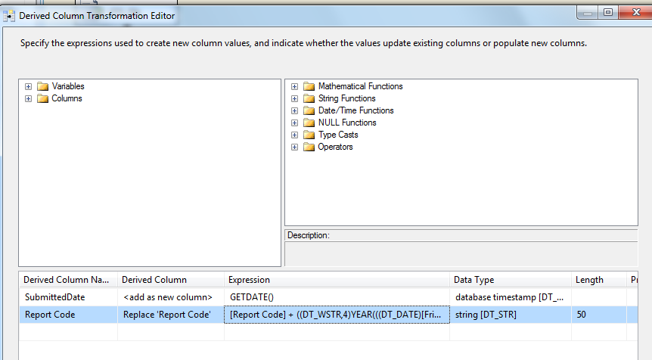

|  |  |
| --- | --- |
| Column | Expression |
| Report Code | [Report Code] + ((DT_WSTR,4)YEAR(((DT_DATE)[Friday End Date]))) + RIGHT("0" + ((DT_WSTR,2)MONTH(((DT_DATE)[Friday End Date]))),2) + RIGHT("0" + ((DT_WSTR,2)DAY(((DT_DATE)[Friday End Date]))),2) |
| SubmittedDate | GetDate() |

1. Data Conversion

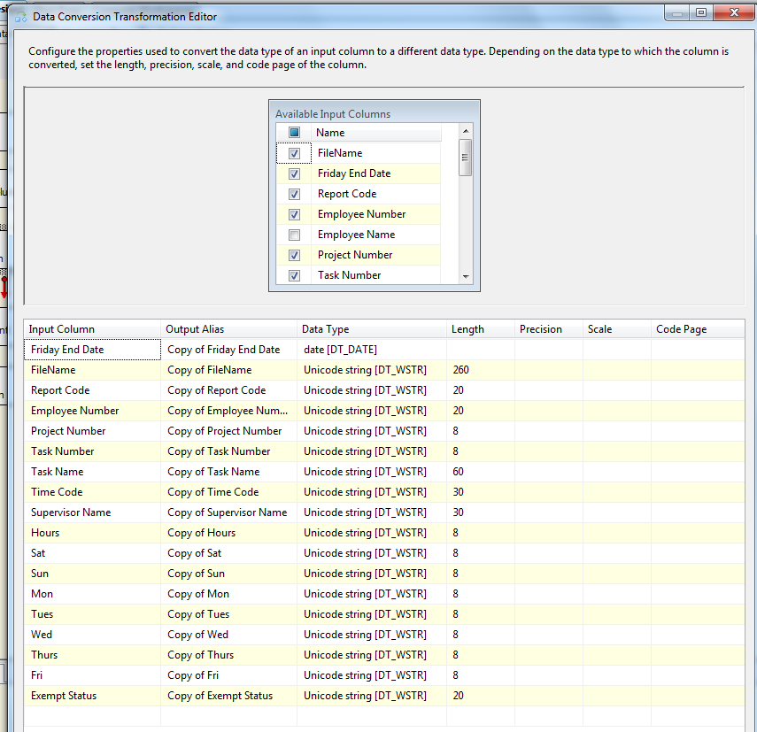

1. Row count

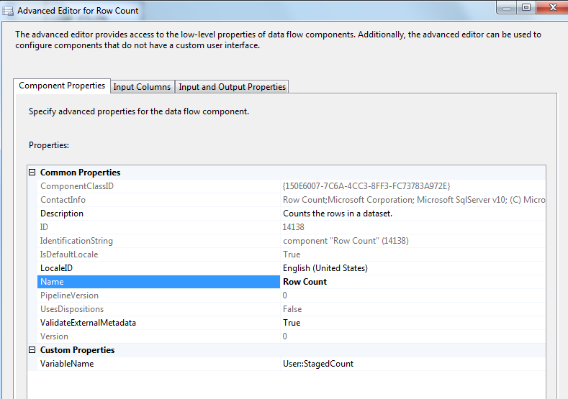

1. OLEDB Destination

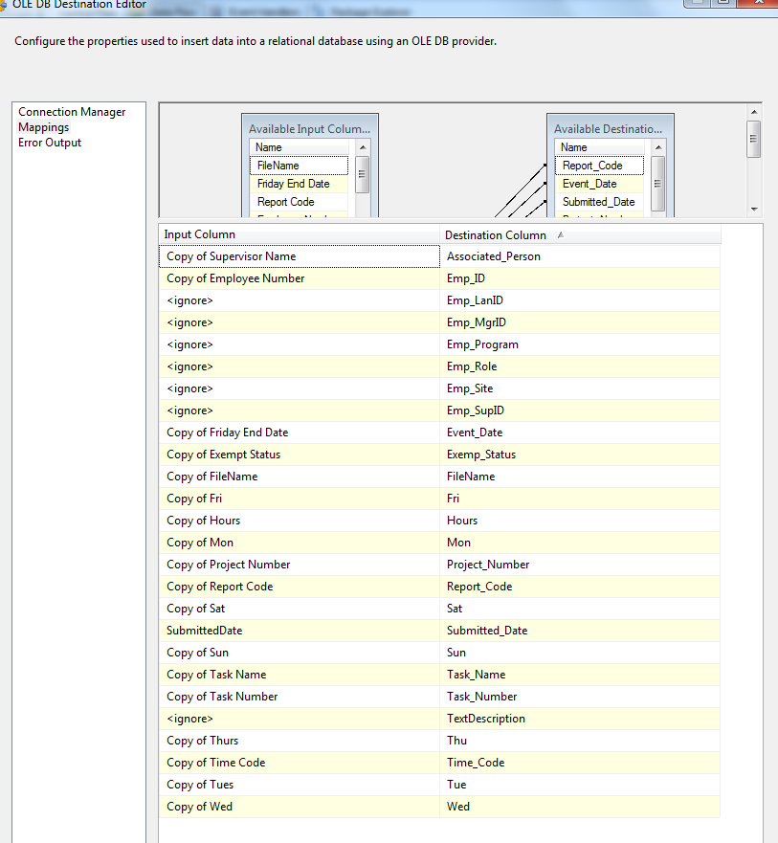

1. SQL task: Update ETS Staging table

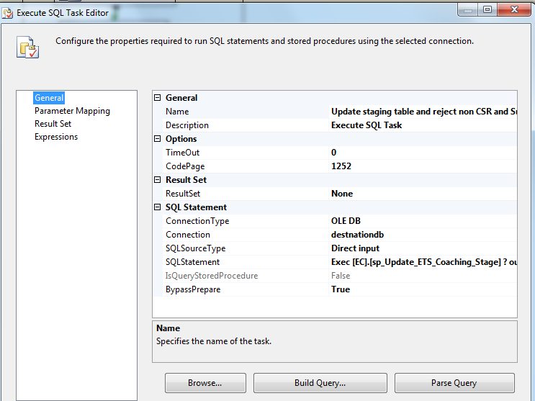

Exec [EC].[sp_Update_ETS_Coaching_Stage] ? output

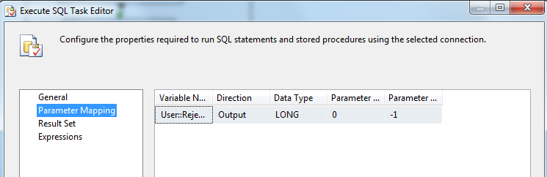

1. SQL task: Load Coaching_Log Table

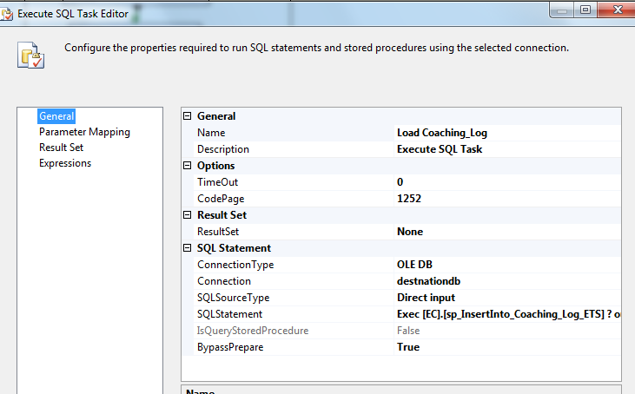

Exec [EC].[sp_InsertInto_Coaching_Log_ETS] ? output

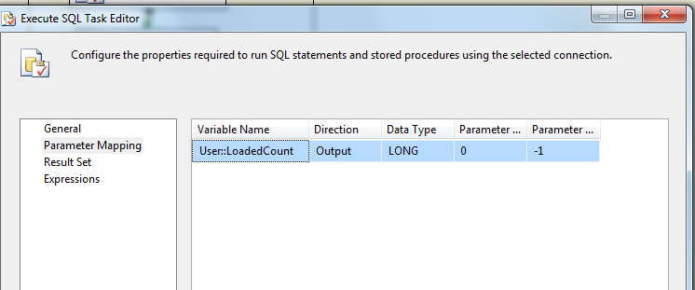

1. SQL Task: Load ETS Fact table

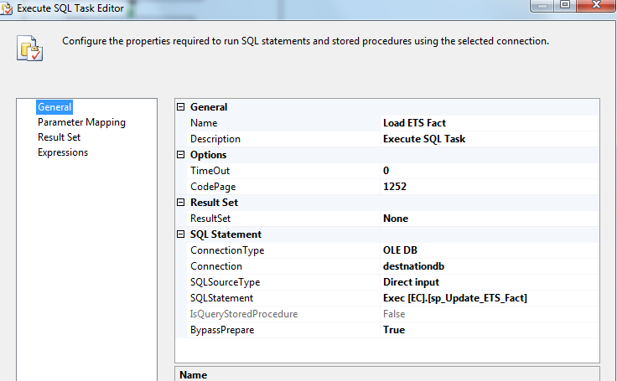

1. SQL Task: Load File List Table

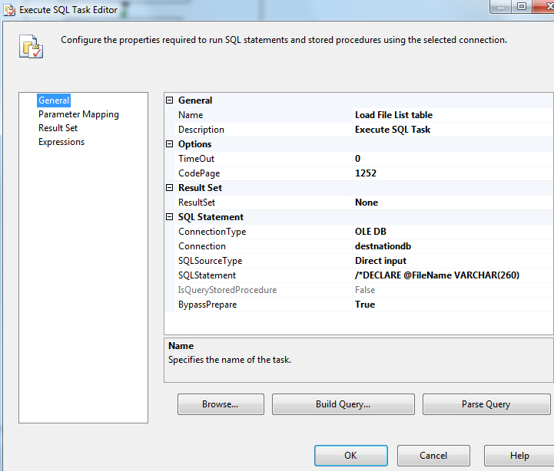

INSERT INTO [EC].[ETS_FileList]

([File_Name]

,[File_LoadDate]

,[Count_Staged]

,[Count_Loaded]

,[Count_Rejected])

VALUES (?,GetDate(), ?, ?,?)

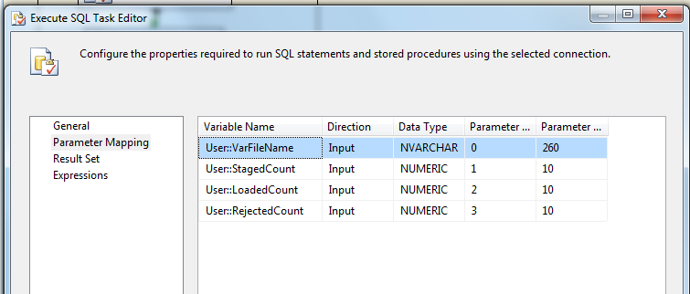

1. File System Task: Backup Loaded Files

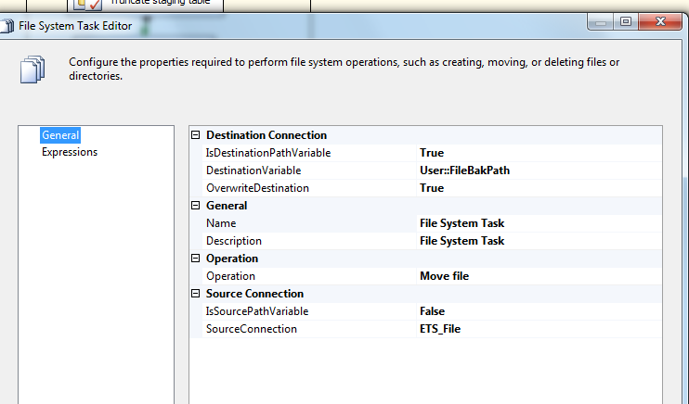

* + - * 1. **For each ETS file in Staging directory (HNC or ICC)**

**Summary of Steps**

1. SQL task – Truncate ETS Staging table
2. DFT – Stage ETS Staging table
3. SQL task Update ETS Staging table
4. SQL task – Load Coaching Log
5. SQL task – Load ETS Fact Table
6. SQL task – Load File list table
7. File system task – Backup files to Backups directory

**Details**

Container: Foreach ETS File Loop (HNC or ICC)

Folder: \\vrivscors01\BCC Scorecards\Coaching\ETS

Files: eCL_ETS_Feed*.csv

*Steps I and III. Through VII same as rest of ETS Files in container 1

1. DFT: Load ETS staging table



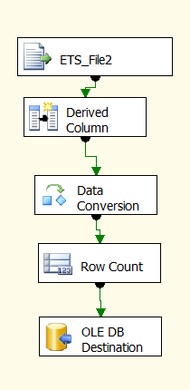

Flat File source

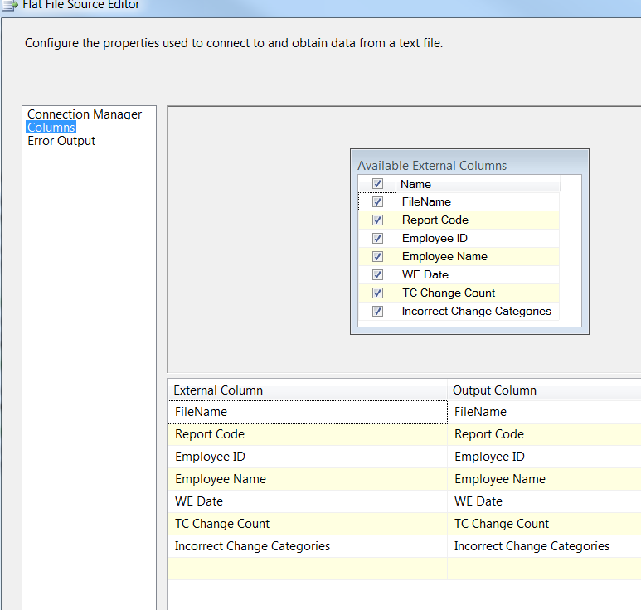

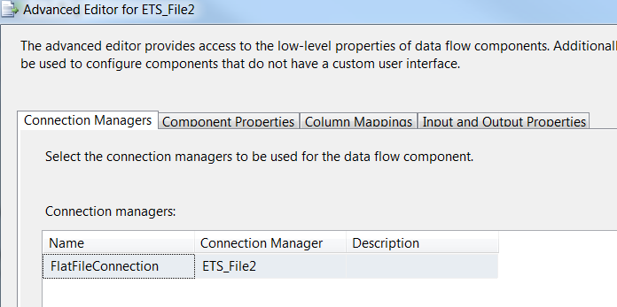

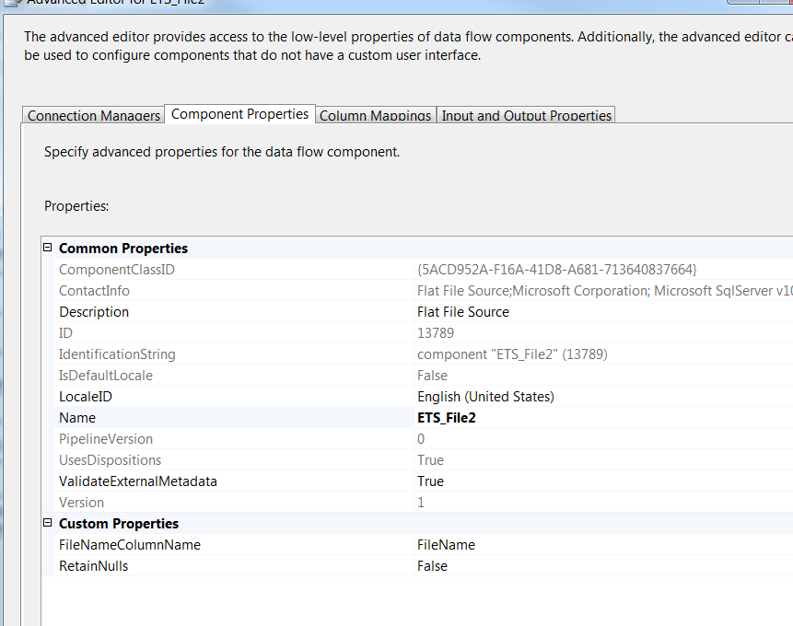

1. Derived Column

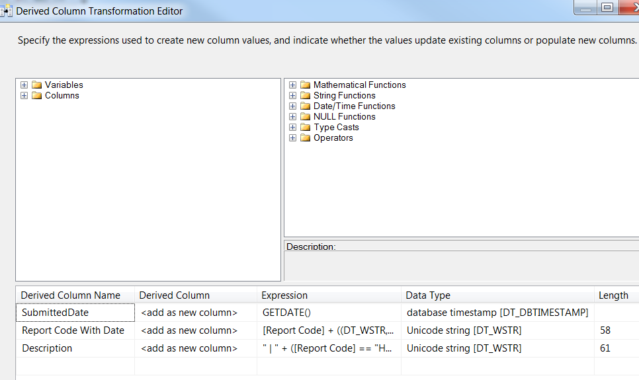

|  |  |
| --- | --- |
| Column | Expression |
| Report Code with Date | [Report Code] + ((DT_WSTR,4)YEAR(((DT_DATE)[WE Date]))) + RIGHT("0" + ((DT_WSTR,2)MONTH(((DT_DATE)[WE Date]))),2) + RIGHT("0" + ((DT_WSTR,2)DAY(((DT_DATE)[WE Date]))),2) |
| Description | " | " + ([Report Code] == "HNC" ? [TC Change Count] : [Report Code] == "ICC" ? [Incorrect Change Categories] : " ") + " Changes" |

1. Data Conversion

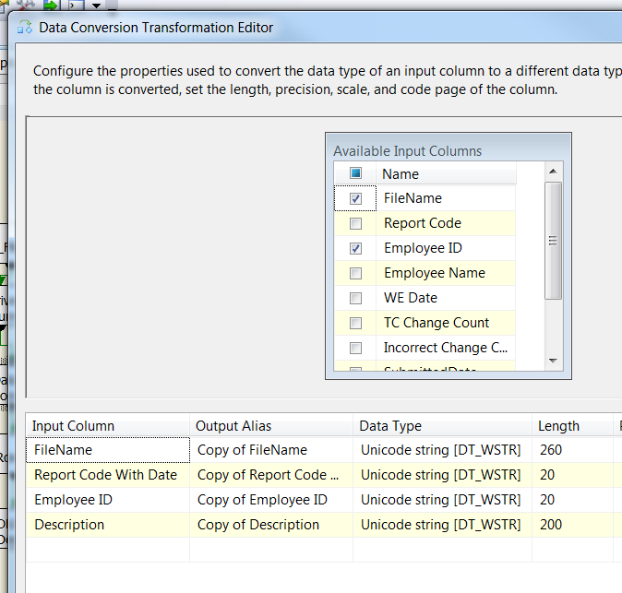

1. Row count

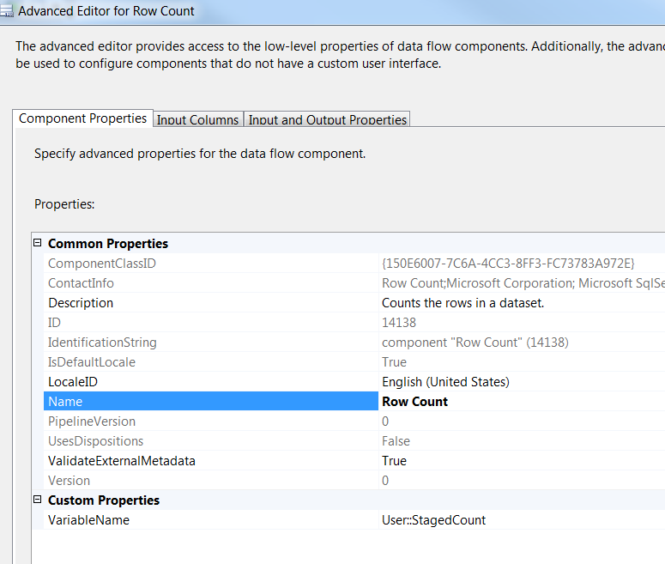

1. OLEDB Destination

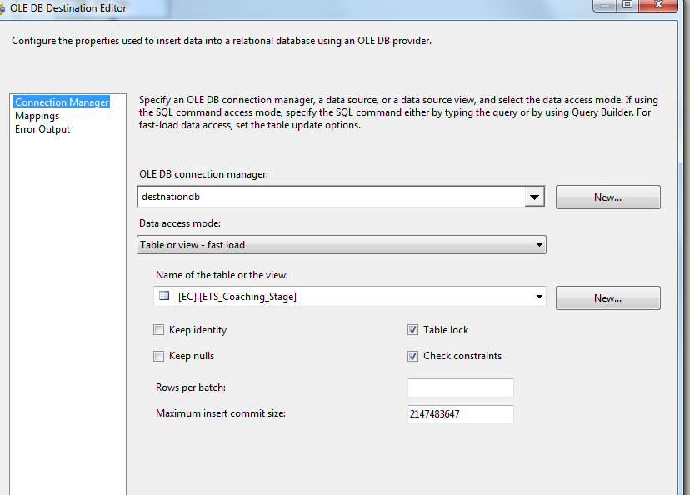

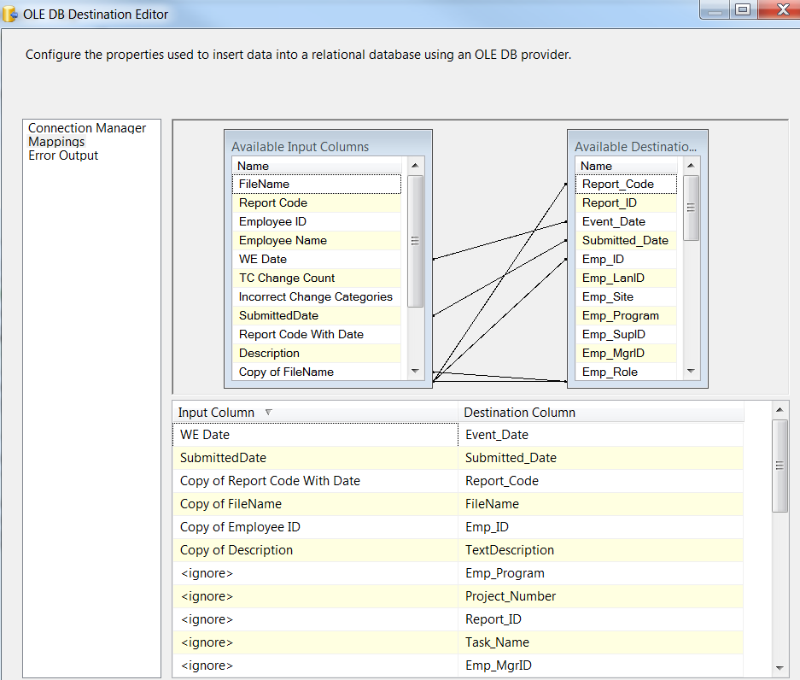

* + - * 1. **For each Compliance file in Staging directory**

Container: Foreach Compliance File Loop (OAS and OAE)

Folder: \\vrivscors01\BCC Scorecards\Coaching\ETS

Files: eCL_Compliance_ETS_Feed*.csv

*Steps I and III Through VII same as rest of ETS Files in container 1

1. DFT: Load ETS staging table



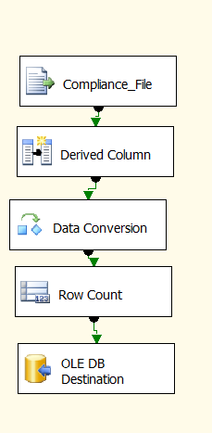

Flat File source

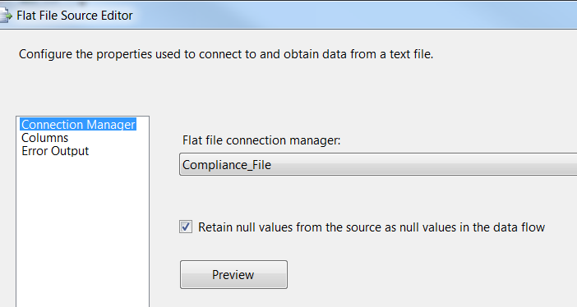

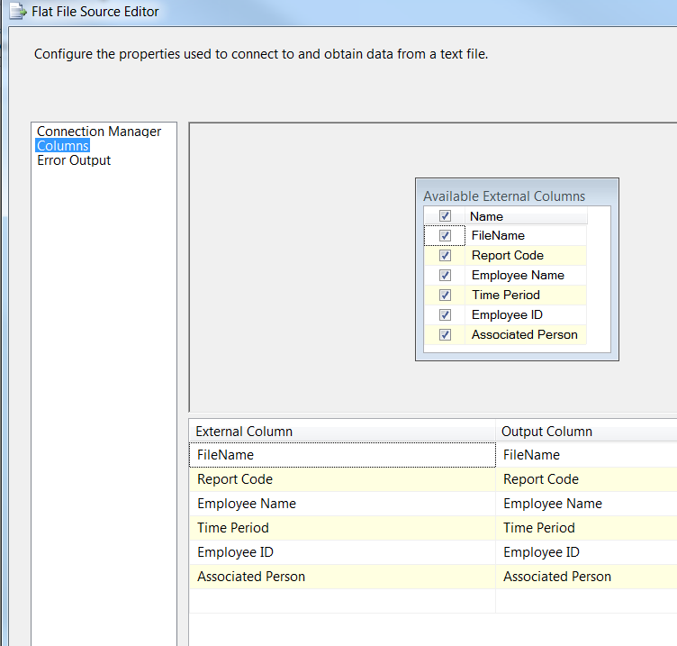

1. Derived Column



|  |  |
| --- | --- |
| Column | Expression |
| Report Code with Date | [Report Code] + ((DT_WSTR,4)YEAR(((DT_DATE)[Time Period]))) + RIGHT("0" + ((DT_WSTR,2)MONTH(((DT_DATE)[Time Period]))),2) + RIGHT("0" + ((DT_WSTR,2)DAY(((DT_DATE)[Time Period]))),2) |

1. Data Conversion

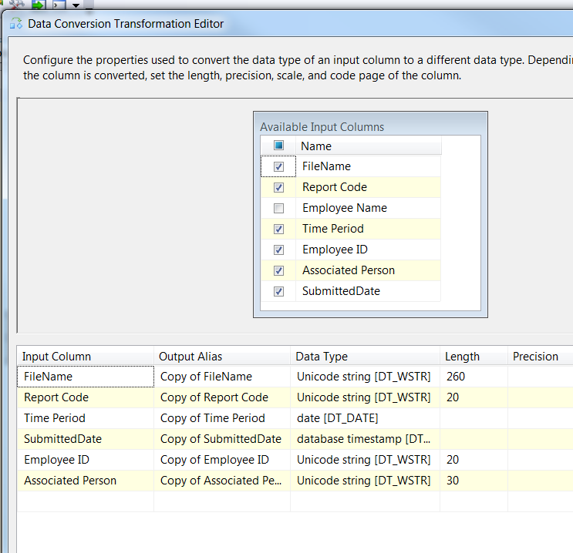

1. Row count



1. OLEDB Destination



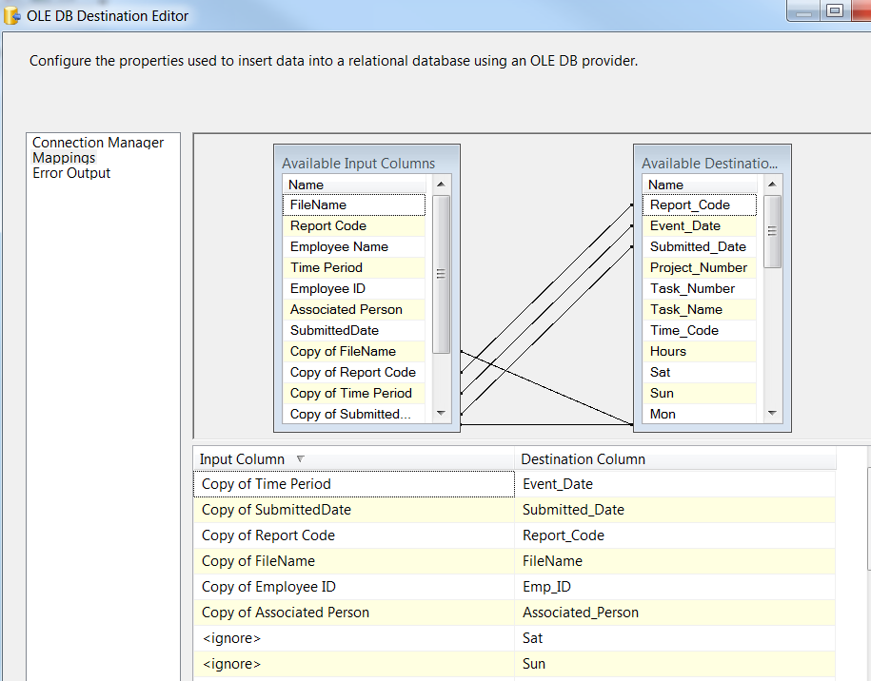

* + - 1. **Event Handlers**

Executable: ETS_coaching

EventHandler: OntaskFailed

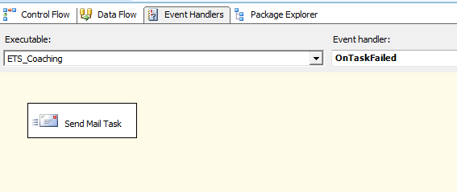

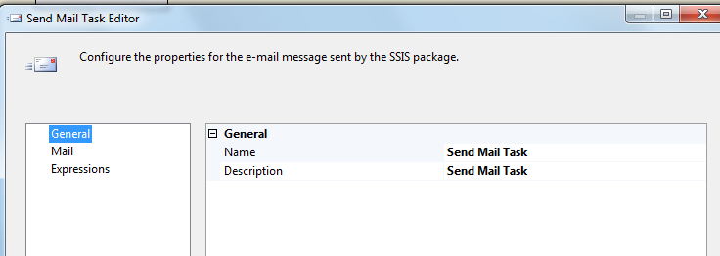

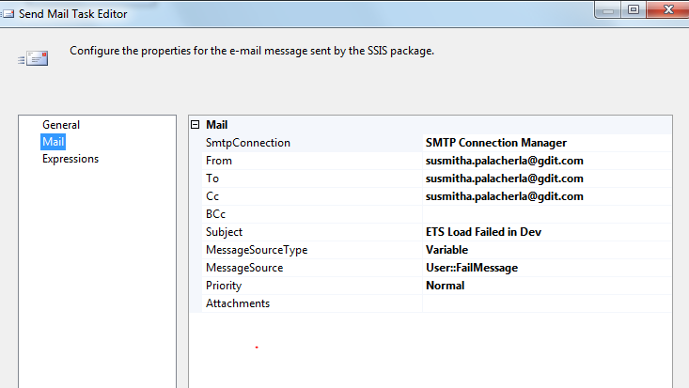

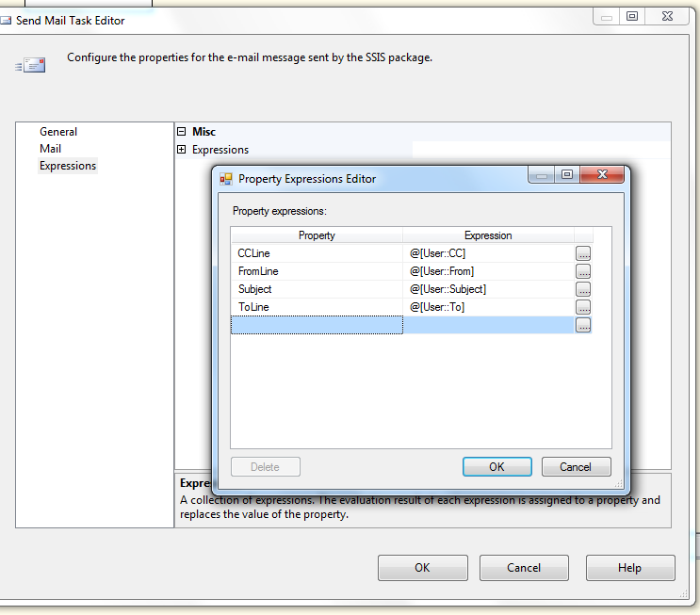

### Tables

|  | **Table Name** | **Table Description** |
| --- | --- | --- |
| 1. | ETS_Coaching_Stage | Table used for staging the ETS records during the insert into Coaching_Log table. |
| 2. | ETS_Coaching_Fact | Table used for storing ETS source records loaded into the Coaching Log table. |
| 3. | ETS_Coaching_Rejected | Table used for storing the rejected ETS records during the insert into Coaching_Log table. Logs are rejected when a record does not belong to a CSR or Supervisor job code. |
| 4. | ETS_Description | Table used to store the 2-4 letter Report Code, Description and the hardcoded Description for the Report. |
| 5. | ETS_FileList | Table used for storing the ETS file names and Load dates. |

Table structure and details in document: eCoaching_Database_DD.docx

Table creates in document: CCO_eCoaching_ETS_Load_Tables_Create.sql

### Procedures

|  | **Procedure Name** | **Usage** |
| --- | --- | --- |
| 1. | sp_Update_ETS_Coaching_Stage | Feed Load: ETS |
| 2. | sp_InsertInto_Coaching_Log_ETS | Feed Load: ETS |
| 3. | sp_Update_ETS_Fact | Feed Load: ETS |
| 4. | Sp_Insert_Into_ETS_Rejected | Feed Load: ETS |

### Functions

|  | **Function Name** | **Usage** |
| --- | --- | --- |
| 1. | fn_intSubCoachReasonIDFromETSRptCode | Feed Load: ETS  Given the 3 or 4 letter ETS Report Code returns the Sub coaching reason for the ETS log. |