**eCoaching Log System**

**eCoaching_Generic_Load**

**SSIS Detail Design Document**

__________________________

|  |  |  |
| --- | --- | --- |
| Last Revision | Last Review | Description |
| 7/31/2020 |  | TFS 17716 - Removed company specific references |

Prepared by: Susmitha Palacherla Date: 12/12/2016

Department, Location: Health Solutions Division

Approved by: Date:

**Change History Log**

| **Date** | **Change Description** | **Author** |
| --- | --- | --- |
| 4/11/2016 | 1.0 Initial revision. TFS 2470 | Susmitha Palacherla |
| 12/12/2016 | 2.0 Updates for TFS 4916. Adding an additional container for non-SEA Ad-hoc generic feeds where attributes will be included in the file. | Susmitha Palacherla |
| 8/14/2017 | 3.0 TFS 7105 – Upgrade to SQL Server 2012 | Susmitha Palacherla |
| 9/1/2017 | 4.0 TFS 7647 – Incorporate Attendance discrepancy (DTT) feed | Susmitha Palacherla |
| 12/28/2017 | TFS 7854 – Encryption related changes for feed files and staging tables | Susmitha Palacherla |
| 07/10/2019 | TFS 14706 - Switch smtpout.gdit.com to ironport.maximus.com | Susmitha Palacherla |
| 08/26/2019 | TFS 15095 – ATT - Create feed to eCL for Attendance Policy Earnback | Susmitha Palacherla |
| 7/29/2020 | TFS 17716 - Removed company specific references | Susmitha Palacherla |

Contents

1. Overview 4

1.1 Project Description 4

1.2 Document Scope 4

1.3 Source Files 4

1.4 Module List 5

1.5 Software and Hardware Interfaces 5

1.5.1 Software 5

1.5.2 Hardware 5

1.6 Users 5

2. Details 6

2.1 Source Files 6

2.1.1 File layout and Mappings 6

2.2 Module Details 9

2.2.1 SQL agent job 9

2.2.2 SSIS Package 9

2.2.3 Tables 33

2.2.4 Procedures 34

2.2.5 Functions 34

# Overview

## Project Description

The coaching process is a standard process to facilitate consistent communication when a performance opportunity or reinforcement exists. It provides a method to make a determination of whether coaching is needed, when to initiate coaching and verification that the performance issue has been addressed. The Generic (General) feed(s) will be used for mass loading of general ecls that would have normally been submitted through the User Interface into the database. Utilizing the eCL work-flow, items can be tracked from start to finish to verify if items have been addressed.

## Document Scope

This document describes the load of the ‘Generic’ or general feeds that will be used to mass load ecls into the database. Once the reports are loaded into the database the logs are tracked through the workflow like any Coaching log entered from the web interface.

## Source Files

The table below shows the attributes for the ‘Generic’ reports.

Files are loaded from \\f3420-ecldbp01\data\Coaching\Generic\Decrypt_Out\

|  |  |  |  |  |  |  |
| --- | --- | --- | --- | --- | --- | --- |
| **#** | **Metric/Report** | **Active Feed** | **Code** | **eCL Workflow** | **Entry** | **Coaching Reason** |
| 1 | Generic Other Report | Y | OTH | Indirect Coach | Feed | Current Coaching Initiatives |
| 2 | Seasonal Employee Attendance Report | Y | SEA | Indirect Coach | Feed | CCO Processes and Procedures |
| 3 | Attendance Discrepancy Report | Y | DTT | Indirect Coach | Feed | Attendance |
| 4 | Weekly Attendance Opportunities | y | SEAA | Indirect Coach | Feed | Attendance |
| 5 | Weekly Attendance Reinforcement | y | SEAR | Indirect Coach | Feed | Attendance |
| 6 | Attendance Perfect Week | y | APW | Indirect Coach | Feed | Attendance |
| 7 | Attendance Perfect Shifts | y | APS | Indirect Coach | Feed | Attendance |

Encrypted files are staged at \\f3420-ecldbp01\data\Coaching\Generic\Encrypt_Out with naming convention eCL_Generic_Feed_XXX[_ZZZ]<YYYYMMDD>.csv.zip.encrypt until scheduled load time.

Files are decrypted during the load process to naming convention eCL_Generic_Feed_XXX[_ZZZ]<<YYYYMMDD>.csv where

<YYYYMMDD> represents the Year, Month and Day and XXX is the 3 letter OTH Report Code for the generic report and _ZZZ represents a specific Report Code.

## Module List

* SQL agent job
* SSIS Package
* Tables
* Procedures

## Software and Hardware Interfaces

### Software

* SQL Server 2012 SP3 Suite

### Hardware

* F3420-ECLDBD01 – Dev DB Server
* F3420-ECLDBT01 – Test DB Server
* F3420-ECLDBP01 – Prod Server
* \\F3420-ECLDBD01\data\ - Dev File staging share
* \\F3420-ECLDBT01\data\ - Test File staging share
* \\F3420-ECLDBP01\data\ - Prod File staging share

## Users

* The first set of users for the Generic records loaded into the eCL database are the CCO Supervisors as all records have default state of ‘Pending Supervisor Review’ at the time of the load.
* After a Supervisor reviews the log, the logs goes to Pending Employee review and the Employee becomes the user.
* CCO Supervisors and Managers and specific HR staff will be able to access the logs from the historical Dashboards.

# Details



## Source Files

eCL_Generic _Feed_xxxyyyymmdd.csv is the naming convention for the feed where xxx is the 3 letter Report code.

Source system: NA

* Staging location: \\F3420-ECLDBP01\data\Coaching\Generic\
* File name eCL_Generic _Feed_xxxyyyymmdd.csv
* Frequency: Ad-hoc
* File arrival time: NA
* Destination Table: Coaching_Log and Coaching_Log_Reason

### File layout and Mappings

* + - 1. **Non OTH Files (DTT, SEA, SEAA, SEAR, AOS, APW)**

|  |  |  |  |
| --- | --- | --- | --- |
| Element # | File Element | Staging table  [EC].[Generic_Coaching_Stage] | Destination table(s)  [EC].[Coaching_Log]CL  [EC].[Coaching_Log_Reason]CLR |
|  | numReportID | Report_ID | CL.numReportID |
|  | strReportCode | Report_Code | CL.strReportCode  SEAyyyymmdd  SEARyyyymmdd  SEAAyyyymmdd  DTTyyyymmdd  APSyyyymmdd  APWyyyymmdd  CLR.SubCoachingReasonID(Derived from Report Code) |
|  | strFormType | Form_Type | CL.SourceID (Derived)  DTT – Empower  OTH – From file  All Others – Internal CCO Reporting |
|  | strSource | Source |
|  | strFormStatus | Form_Status | CL.StatusID(Derived)  OTH – From file  All Others – Pending Acknowledgement |
|  | EventDate | Event_Date | CL.EventDate |
|  | SubmittedDate | Submitted_Date | CL.submittedDate |
|  | StartDate | Start_Date | CL.StartDate |
|  | strSubmitterName | Submitter_Name | CL.SubmitterID(Derived) |
|  | strSubmitterEmail |  | NA |
|  | EmpID | CSR_EMPID | CL.EmpID |
|  | strCSRSite | CSR_Site | CL.SiteID(Derived) |
|  | strCoachReason_Current_Coaching_Initiatives | strCoachReason_Current_Coaching_Initiatives | CLR.value |
|  | txtDescription | TextDescription | CL.Description |
|  | strProgram | Program | CL.ProgramName |

* + - 1. **OTH File**

|  |  |  |  |
| --- | --- | --- | --- |
| Element # | File Element | Staging table  [EC].[Generic_Coaching_Stage] | Destination table(s)  [EC].[Coaching_Log]CL  [EC].[Coaching_Log_Reason]CLR |
|  | numReportID | Report_ID | CL.numReportID |
|  | strReportCode | Report_Code | CL.strReportCode  CLR.SubCoachingReasonID(Derived) |
|  | numModuleID | Module_ID | CL.ModuleID |
|  | strFormType | Form_Type | NA |
|  | numSourceID | Source_ID | CL.SourceID |
|  | numisCSE | isCSE | CL.isCSE |
|  | numStatusID | Status_ID | CL.StatusID |
|  | numCRID | CoachingReason_ID | CLR.CoachingReasonID |
|  | numSubCRID | SubCoachingReason_ID | CLR.SubCoachingReasonID |
|  | Value | Value | CLR.Value |
|  | EventDate | Event_date | CL.EventDate |
|  | EmpID | CSR_EMPID | CL.Formname  CL.EmpID |
|  | LANID |  | Not used |
|  | SubmittedDate | Submitted_Date | CL.SubmittedDate |
|  | StartDate | Start_Date | CL.Start_Date |
|  | SubmitterID | Submitter_ID | CL.SubmitterID |
|  | txtDescription | TextDescription | CL.Description |
|  | EmailSent | EmailSent | CL.EmailSent |

## Module Details

### SQL agent job

* Production Instance : F3420-ECLDBP01
* Production Job: CoachingGenericLoad
* Production Package: \\F3420-ECLDBP01\ssis\Coaching\Packages\Generic _Coaching.dtsx
* Production Config File: Prod_Generic_Coaching.dtsConfig
* Owner: ecljobowner
* Run As: ECLProxy (ECL Credential using application service account SVC-F3420-APPECLP01)
* Schedule: Tuesdays - On-demand
* Destination File Location: N/A

### SSIS Package

* + - 1. **Variables**

|  |  |  |  |  |
| --- | --- | --- | --- | --- |
| **Name** | **Scope** | **Data**  **Type** | **Value** | **Evaluate As expression** |
| DecryptedOutPath | Generic_Coaching | String | \\f3420-ecldbp01\data\coaching\Generic\Decrypt_out\ | False |
| DecryptInPath | Generic_Coaching | Int32 | \\f3420-ecldbp01\data\coaching\Generic\Decrypt_in\ | False |
| EncryptedBackupPath | Generic_Coaching | String | \\f3420-ecldbp01\data\coaching\Generic\\Backups\ | False |
| EncryptedOutPath | Generic_Coaching | String | \\f3420-ecldbp01\data\coaching\Generic\Encrypt_out\ | False |
| EncryptInPath | Generic_Coaching | String | \\f3420-ecldbp01\data\coaching\Generic\Encrypt_in\ | False |
| FailMessage | Generic_Coaching | String | "Generic Coaching Load of file \"" + @[User::VarFileName] + "\" failed in " + @[User::VarDBName]+"." | True |
| StagedCount | Generic_Coaching | Int32 | 0 | False |
| RejectedCount | Generic_Coaching | Int32 | 0 | False |
| LoadedCount | Generic_Coaching | Int32 | 0 | False |
| varDBName | Generic_Coaching | String | Prod | False |
| varFileName | Generic_Coaching | String |  | False |
| varEncryptedFileName | Generic_Coaching | String |  | False |
| varFailedFile | Generic_Coaching | String |  | False |
|  |  |  |  |  |

* + - 1. **Connection Manager Entries**
         1. Destinationdb
* Dev – F3420-ECLDBD01 DB – eCoachingdev
* Test - F3420-ECLDBT01 DB – eCoachingtest
* Prod - F3420-ECLDBP01 – eCoaching
  + - * 1. NON-OTH_File
* \\F3420-ECLDBP01\Data\Coaching\Generic \eCL_Generic_Feed_OTH_[DTT/SEA/SEAA/SEAR/APS/APW]*.csv

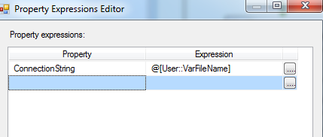

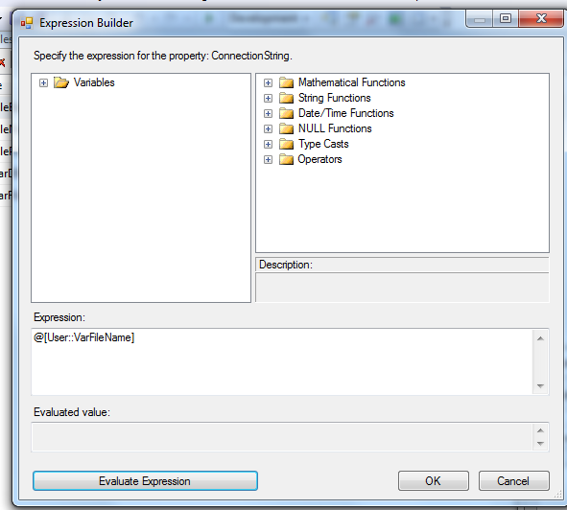

* + - * 1. OTH_File
* \\F3420-ECLDBP01\Data\Coaching\Generic\eCL_Generic_Feed_OTH20*.csv





* + - * 1. Encrypted_File

Expression: @[User::EncryptedOutPath]+ @[User::VarEncryptedFileName]

* + - * 1. Failed_File

Expression: @[User::DecryptedOutPath]+ @[User::VarFailedName

* + - * 1. SMTP Connection Manager

ironport.maximus.com

* + - 1. **Package Content(Control Flow)**

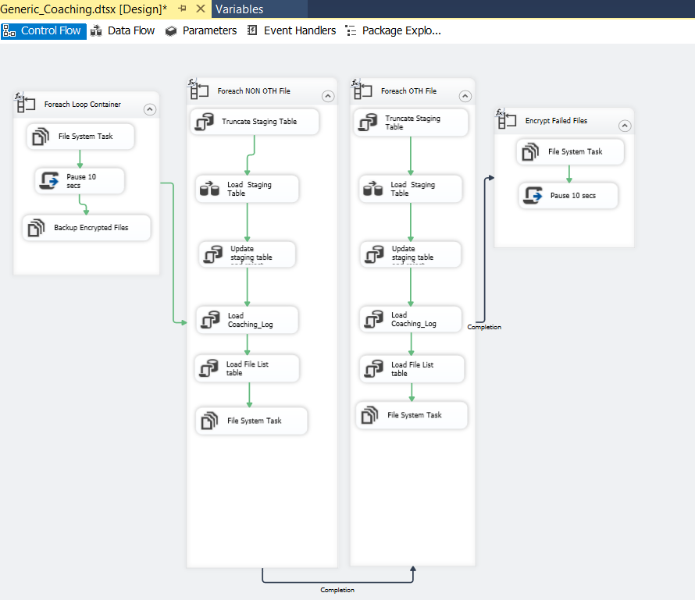

* + - * 1. **Foreach Loop Container ( Decrypt and stage files)**

**Summary of Steps**

1. File system task – Decrypt files
2. Script task - Pause 10 seconds
3. File system task – Backup encrypted files

**Details**

Container: Foreach File Loop

Folder: \\f3420-ecldbp01\data\coaching\Generic\Encrypt_out\

Files: eCL*Generic_*.encrypt

Retrieve file name: Name and Extension

1. File system task – Decrypt files

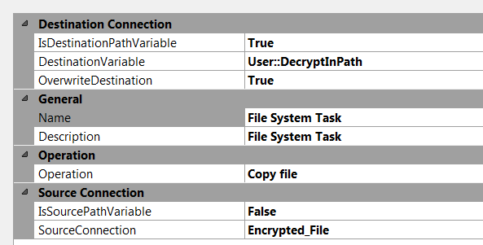

1. Script task- Pause 10 secs

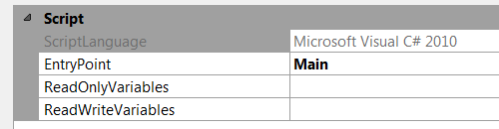

public void Main()

{

// TODO: Add your code here

// Sleep for 10 seconds (*1000)

System.Threading.Thread.Sleep(10000);

Dts.TaskResult = (int)ScriptResults.Success;

}

1. File System task – Backup Encrypted files

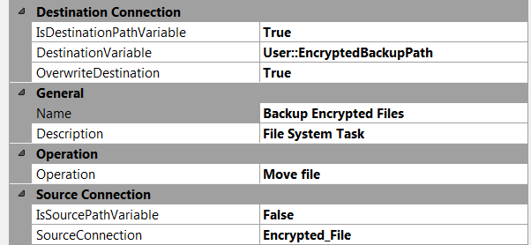

* + - * 1. **Foreach NON-OTH File container**

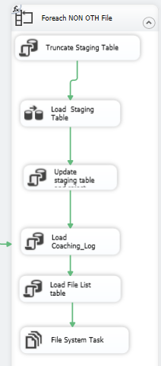

**Workflow**

**For each NON-OTH file in staging directory workflow**

Container: Foreach NON-OTH file

Collection:

Enumerator: Foreach file enumerator

Expression: Directory: @[User::DecryptedOutPath]

Evaluates to: \\f3420-ecldbd01\data\coaching\Generic\Decrypt_out\

Files: eCL_Generic_Feed_OTH_*.csv

Retrieve file name: Name and Extension

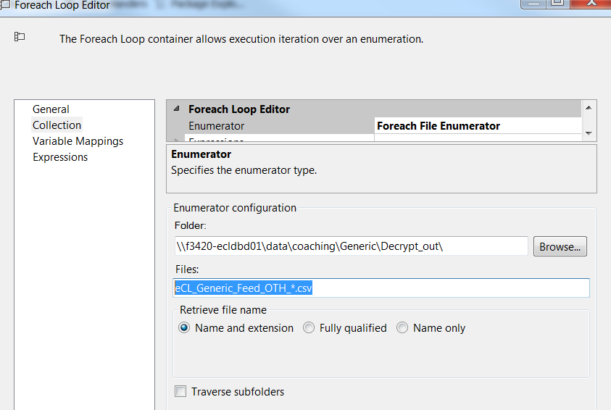

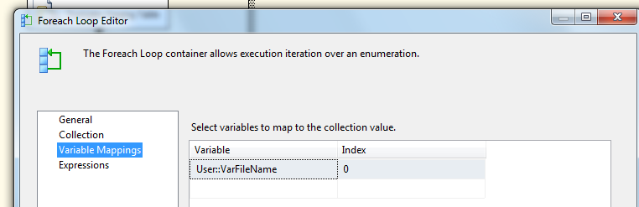

**Summary of Steps**

1. SQL task – Truncate Generic Staging table
2. DFT – Stage Generic Staging table
3. SQL task – Update Staging table and Reject records
4. SQL task Load Coaching_Log and Coaching_Log_Reason tables
5. SQL task – Load File list table
6. File system task – Backup files to Backups directory

**Details of Steps**

1. SQL task – Truncate Generic Staging table



Executes Truncate Table [EC].[Generic_Coaching_Stage]

Precedence Constraint Editor

|  |  |
| --- | --- |
| Evaluation Operation | Constraint |
| Value | Success |
| Multiple Constraints | Logical AND |

1. DFT: Load Generic staging table

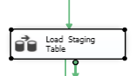

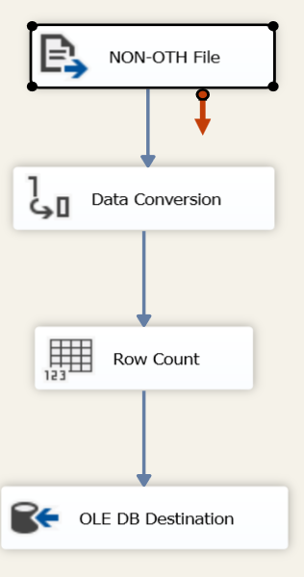

1. Flat File source

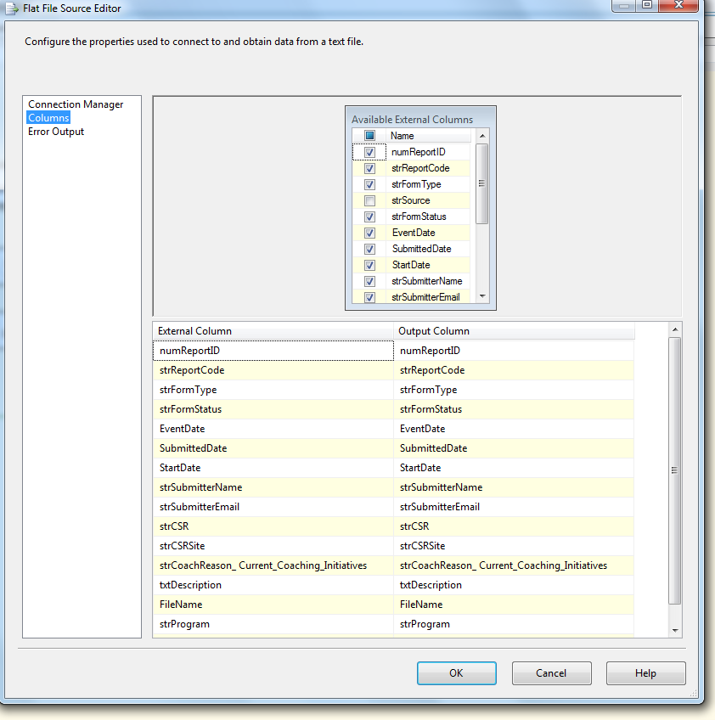

1. Data Conversion

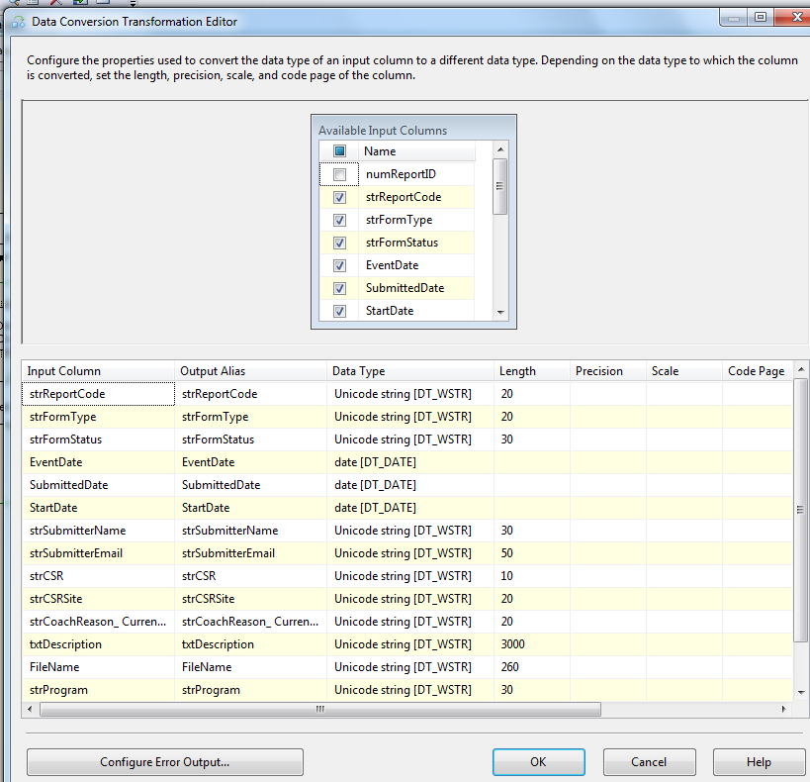

1. Row Count Transformation

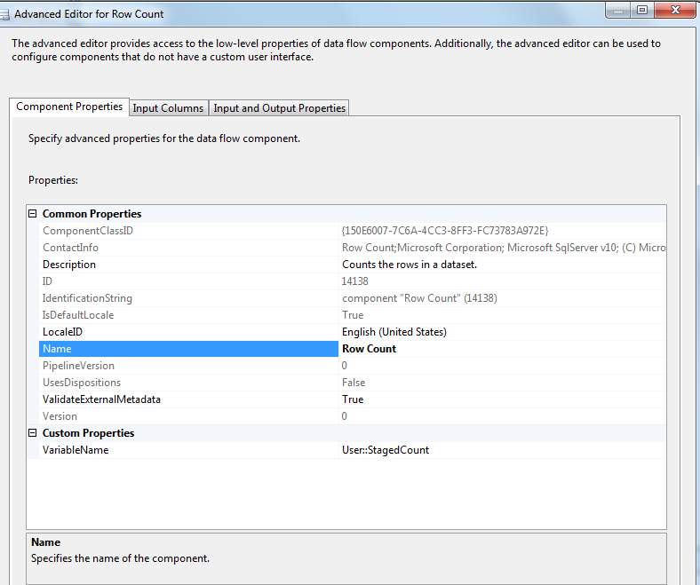

1. Oledb destination

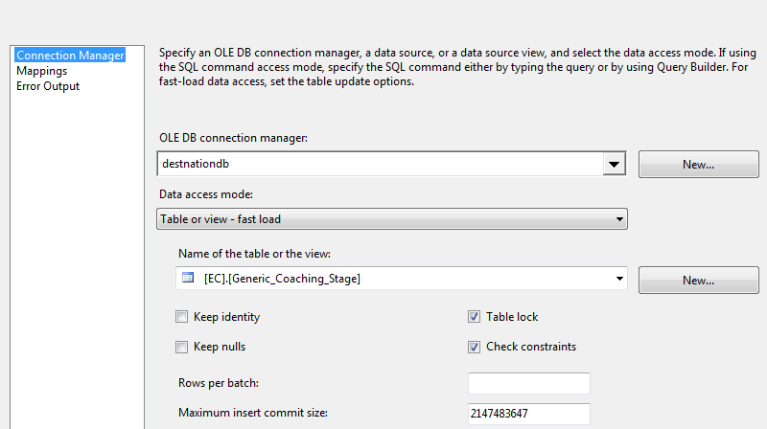

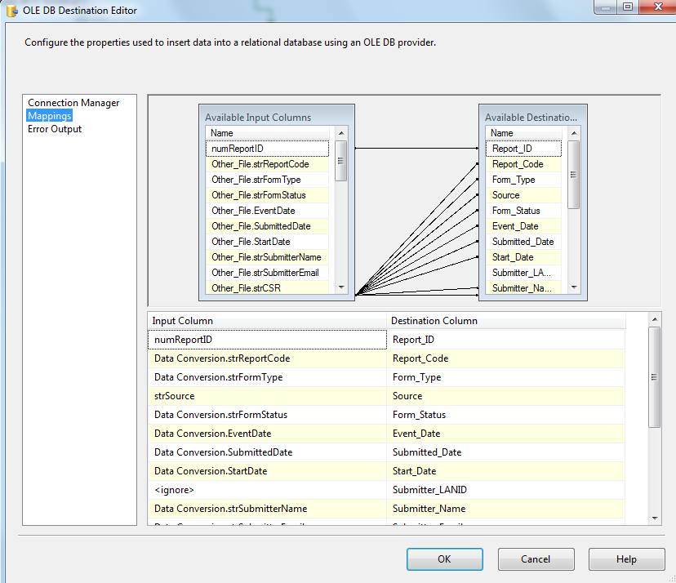

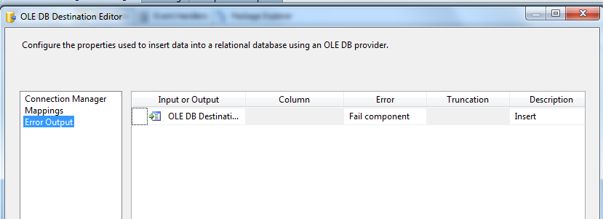

1. SQL Task: Update Staging table and Reject Records

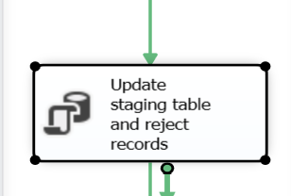

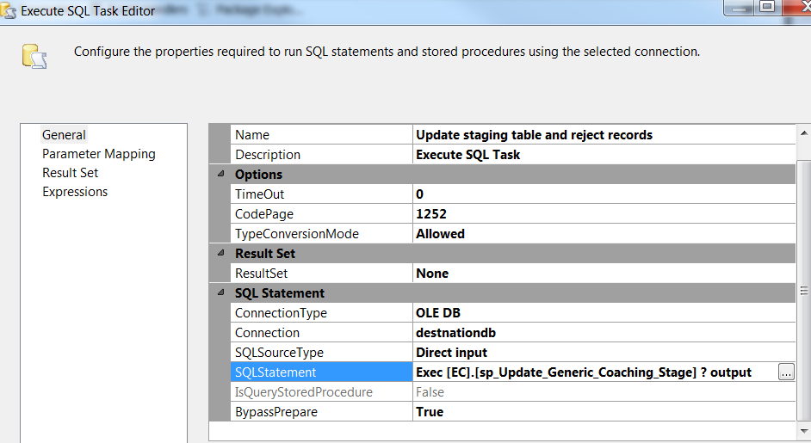

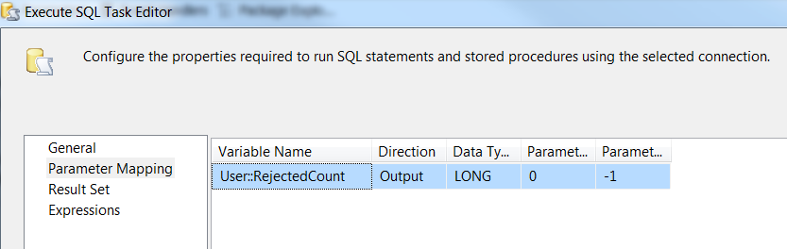

1. SQL Task: Load Coaching_Log table

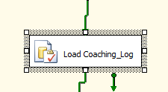

SQLStatement: Exec [EC].[sp_InsertInto_Coaching_Log_Generic] ? output

Parameter Mapping:



1. SQL Task: Load Generic File List table

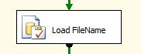

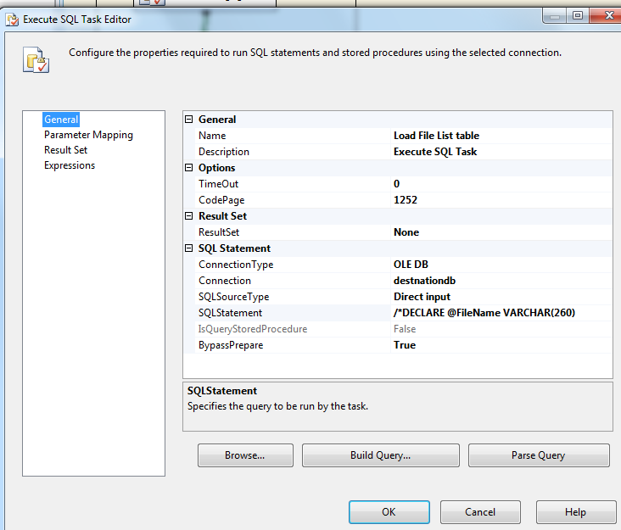

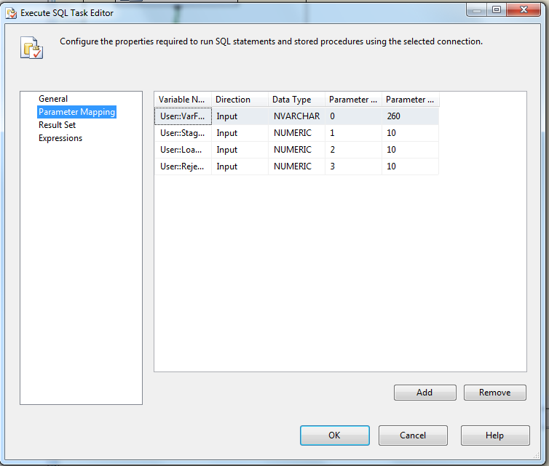

Executes the following sql

INSERT INTO [EC].[Generic_FileList]

([File_Name]

,[File_LoadDate]

,[Count_Staged]

,[Count_Loaded]

,[Count_Rejected])

VALUES (?,GetDate(), ?, ?,?)

1. File System Task: Delete File

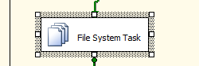

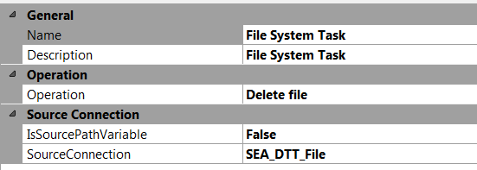

* + - * 1. **Foreach Generic OTH File container**

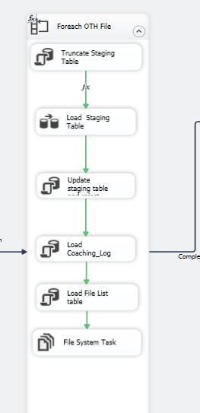

**Workflow**

**For each OTH file in staging directory workflow**

Container: Foreach OTH file

Collection:

Enumerator: Foreach file enumerator

Expression: Directory: @[User::FilePath]

Evaluates to: \\vrivscors01\BCC Scorecards\Coaching\Generic

Retrieve file name: Name and Extension

Files: eCL_Generic_Feed_OTH20*.csv

**Summary of Steps**

1. SQL task – Truncate Generic Staging table
2. DFT – Stage Generic Staging table
3. SQL task – Update Staging table and Reject records
4. SQL task Load coaching_Log and Coaching_Log_Reason tables
5. SQL task – Load File list table
6. File system task – Backup files to Backups directory

**Details of Steps**

1. SQL task – Truncate Generic Staging table – similar to [SEA/DTT] files

Executes Truncate Table [EC].[Generic_Coaching_Stage]

1. DFT: Load Generic staging table

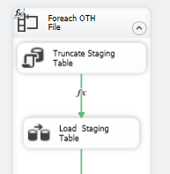

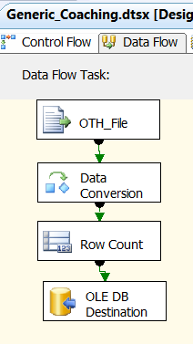

1. Flat File source

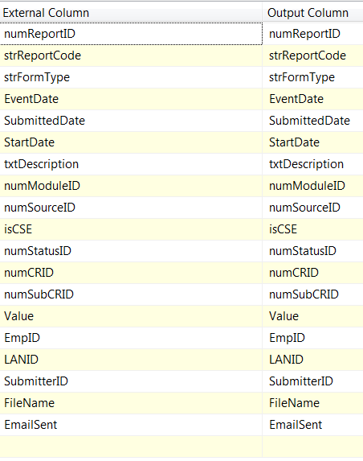

1. Data Conversion

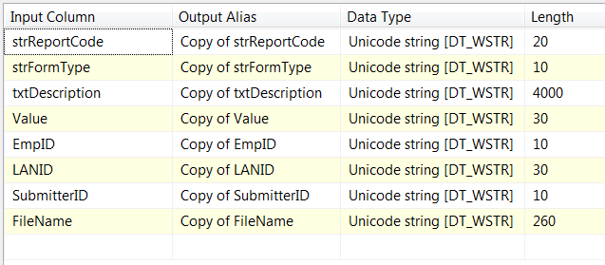

1. Row Count Transformation



1. Oledb destination



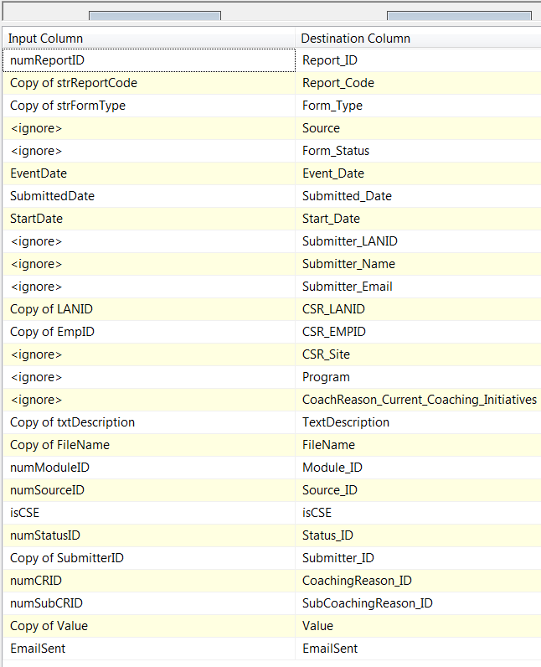

1. SQL Task: Update staging table and reject records

SQLStatement: Exec [EC].[sp_Update_Generic_Coaching_Stage] ? output

Parameter mapping:

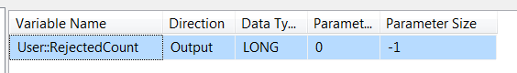

1. SQL Task: Load Coaching_Log table



SQLStatement: Exec [EC].[sp_InsertInto_Coaching_Log_Generic]? output

Parameter mapping:

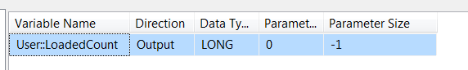

1. SQL Task: Load Generic File List table



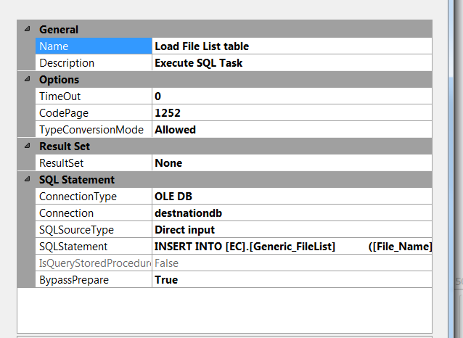

INSERT INTO [EC].[Generic_FileList]

([File_Name]

,[File_LoadDate]

,[Count_Staged]

,[Count_Loaded]

,[Count_Rejected])

VALUES (?,GetDate(), ?, ?,?)

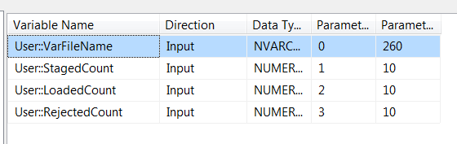

1. File System Task: Delete File

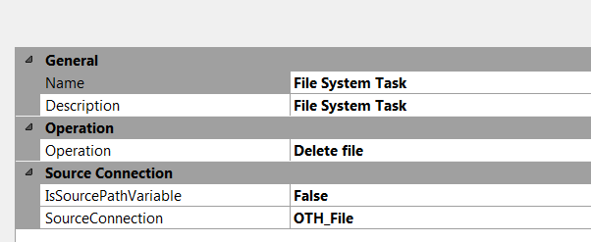

* + - * 1. **For each Loop Container ( Encrypt failed files)**

**Summary of Steps**

1. File system task – Encrypt failed files
2. Script task - Pause 10 seconds

**Details**

Container: For each File Loop

Precedence Constraint - Completion

Folder: \\f3420-ecldbp01\data\coaching\Generic\Decrypt_out\

Files: eCL*.csv

Retrieve file name: Name and Extension

1. File system task – Encrypt files

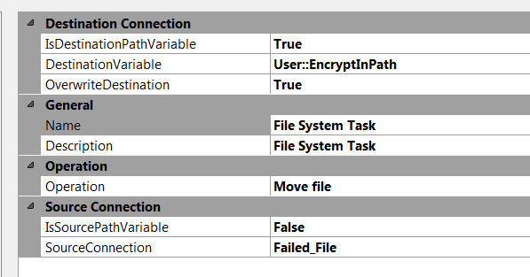

1. Script task- Pause 10 secs



public void Main()

{

// TODO: Add your code here

// Sleep for 10 seconds (*1000)

System.Threading.Thread.Sleep(10000);

Dts.TaskResult = (int)ScriptResults.Success;

}

* + - 1. **Package Content(Event Handlers)**

Executables: Generic _Coaching

EventHandler: OntaskFailed

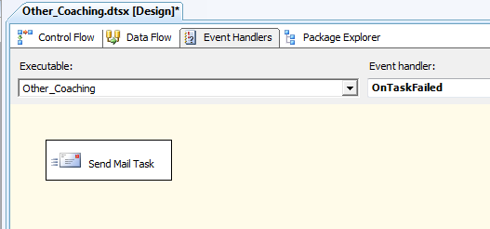

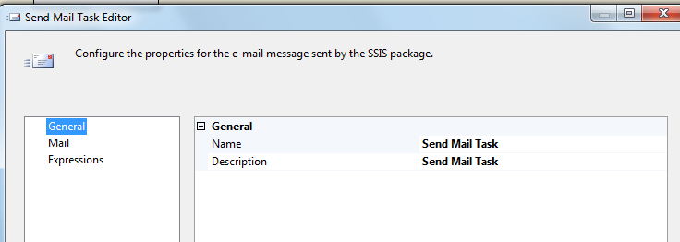

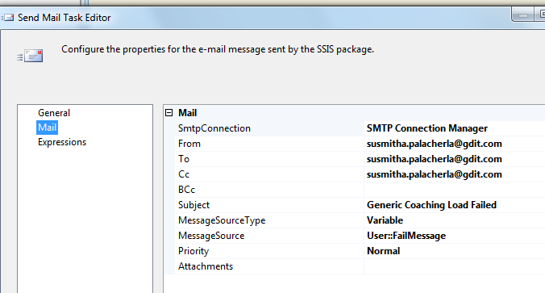

### Tables

|  | **Table Name** | **Table Description** |
| --- | --- | --- |
| 1. | Generic_Coaching_Stage | Table used for staging the Generic records during the insert into Coaching_Log table. |
| 2. | Generic_Coaching_Rejected | Table used for storing the rejected Generic records during the insert into Coaching_Log table. Logs are rejected when an incoming Lan ID does not exist in the Employee_Hierarchy table. |
| 3. | Generic_Coaching_Fact | Table used for storing Generic source records loaded into the Coaching Log table. |
| 4. | Generic_FileList | Table used for storing the Generic file names and Load dates. |

Table structure and details in document: eCoaching_Database_DD.docx

### Procedures

|  | **Procedure Name** | **Usage** |
| --- | --- | --- |
| 1. | sp_InsertInto_Coaching_Log_Generic | Load: Generic Data |
| 2. | sp_Update_Generic_Coaching_Stage | Load: Populate attributes like lanid, site, program, Module etc |
| 3. | sp_InsertInto_Generic_Rejected | Load: Reject records that do not belong to valid Active employee record for required Module. |

### Functions

|  | **FunctionName** | **Usage** |
| --- | --- | --- |
| 1. | fn_intModuleIDFromEmpID | Load: Generic Data |
| 2. | n_intSubCoachReasonIDFromRptCode | Load: Determine subcoachingReasonID |