__________________________

[Picture](http://cwe.vangent.local/sites/teams/CMS/Image%20Library/Forms/Logos.aspx)

**Title: CCO eCoaching Log**

**IIS Log Load**

**SSIS D etailed Design Document**

__________________________

|  |  |  |
| --- | --- | --- |
| Last Revision | Last Review | Description |
| 11/20/2018 | 11/20/2018 | TFS 12568 – Add IIS activity Reporting function to eCoaching Admin Portal. |

|  |  |  |  |  |
| --- | --- | --- | --- | --- |
| Prepared by: | Lili Huang |  | Date: | 11/20/2018 |
| Department / Location: |  |  |  |  |
| Approved by: |  |  | Date: |  |

**Change History Log**

| **Date** | **Change Description** | **Author** |
| --- | --- | --- |
| 11/20/2018 | Initial Revision  TFS 12568 – Add IIS activity Reporting function to eCoaching Admin Portal; | Lili Huang |
|  |  |  |
|  |  |  |

# Summary

This process will load IIS Log CSV files into the database. The feed files to this process come from a separate Windows DOS script batch job run, which parses IIS Log files to CSV files.

# SSIS package for IISLogImport.dtsx

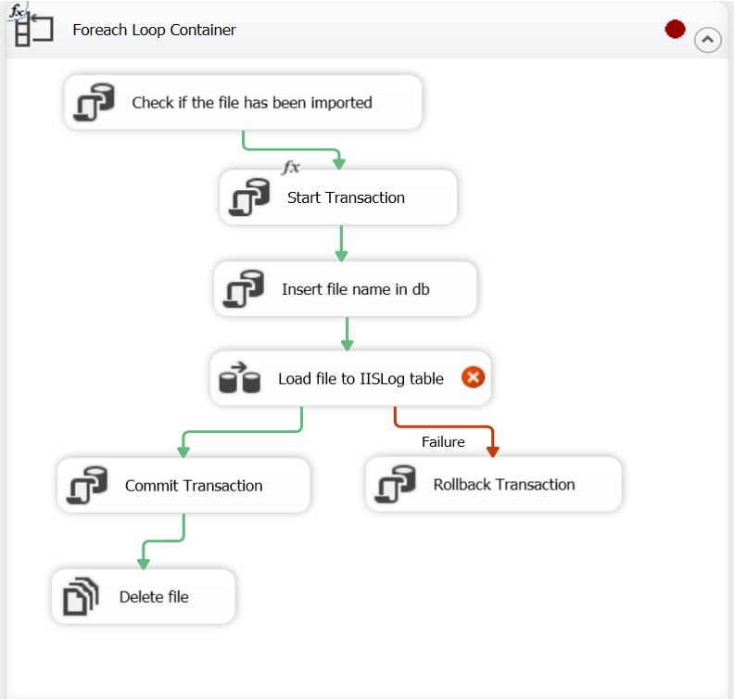

# SSIS Logic Flow Overview

|  |  |  |  |
| --- | --- | --- | --- |
| **Step #** | **Task** | **On Success** | **On Failure** |
|  | **Foreach Loop Container** |  |  |
|  | **Check if the file has been imported**  SQLStatement:  SELECT COUNT(*) AS FileCount  FROM ec.IISLog_FileImport  WHERE FileName = ?; | If FileCount == 0,  continue with next step;  Else, continue with next loop. |  |
|  | **Start Transaction**  SQLStatement:  BEGIN TRANSACTION; |  |  |
|  | **Insert file name in database**  SQLStatement:  INSERT INTO ec.IISLog_FileImport  VALUES (?, GETDATE(), 1); | Continue with next step. |  |
|  | **Load file to IISLog table**  Encapsulates Data Flow Task |  |  |
|  | **Flat File Source** | Continue with next step. | Go to step 7. |
|  | **OLE DB Destination**  Load date to table [EC].[IISLog]. | Go to step 8. | Go to step 7. |
|  | **End of Load file to IISLog table** |  |  |
|  | **Rollback Transaction** | -Continue with next loop. |  |
|  | **Commit Transaction** |  |  |
|  | **Delete file**  Delete the file that has been imported from source folder. | Continue with next loop. |  |

# SSIS Connection Managers

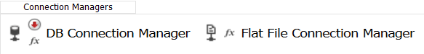

**DB Connection Manager** – Database connection

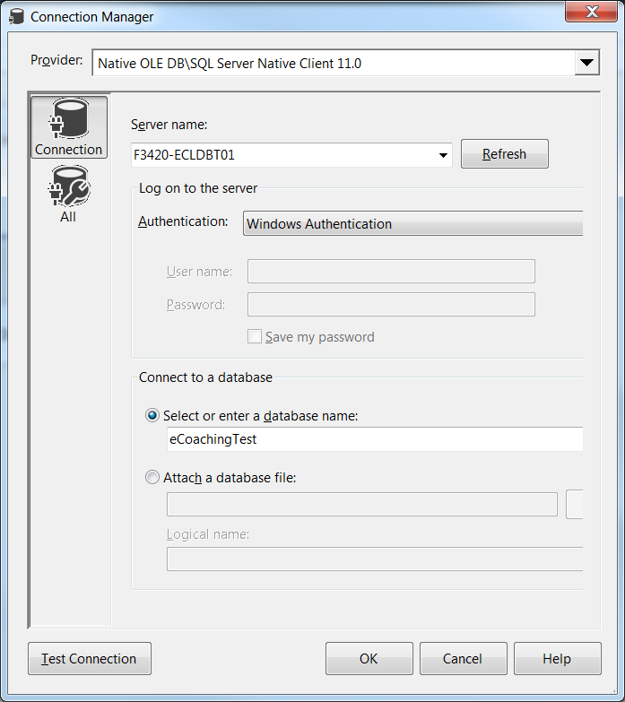

Properties Section 🡪 Expressions:

Connection String:

@[User::vDBConnStr]

( @[User::vEnv] ) == "PROD" ? "Data Source=F3420-ECLDBP01;Initial Catalog=eCoaching;Provider=SQLNCLI11;Integrated Security=SSPI;" :

( @[User::vEnv] ) == "UAT" ? "Data Source=F3420-ECLDBT01;Initial Catalog=eCoachingUat;Provider=SQLNCLI11;Integrated Security=SSPI;" :

( @[User::vEnv] ) == "TEST" ? "Data Source=F3420-ECLDBT01;Initial Catalog=eCoachingTest;Provider=SQLNCLI11;Integrated Security=SSPI;" :

"Data Source=F3420-ECLDBD01;Initial Catalog=eCoachingDev;Provider=SQLNCLI11;Integrated Security=SSPI;"

**Flat File Connection Manager** – Import comma-delimited value flat file connection IIS Log file (CSV).

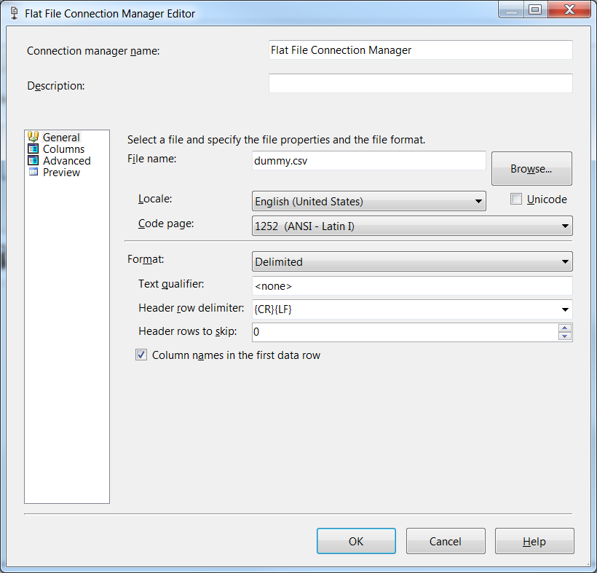

Columns:

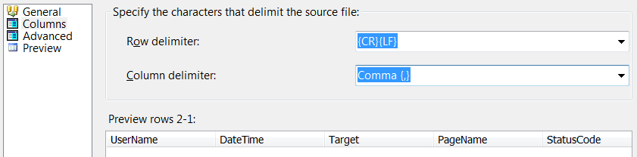

Advanced:

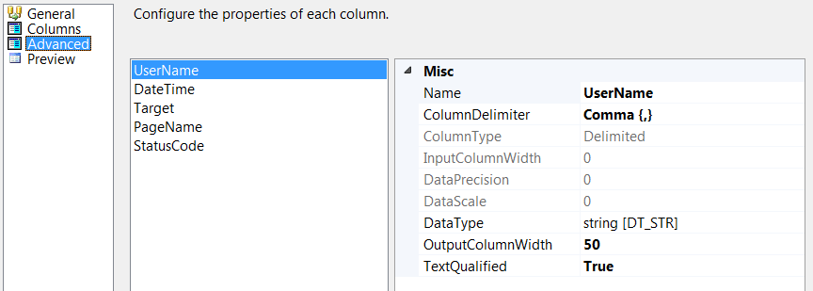

Properties Section 🡪 Expressions:

*ConnectionString:*

@[User::vCurrentFile]

( @[User::vEnv] ) == "PROD" ? "\\\\f3420-ecldbp01\\Data\\Coaching\\IISLogImport" :

( @[User::vEnv] ) == "TEST" ? " \\\\f3420-ecldbt01\\Data\\Coaching\\IISLogImport" :

"\\\\f3420-ecldbd01\\Data\\Coaching\\IISLogImport"

# Variables

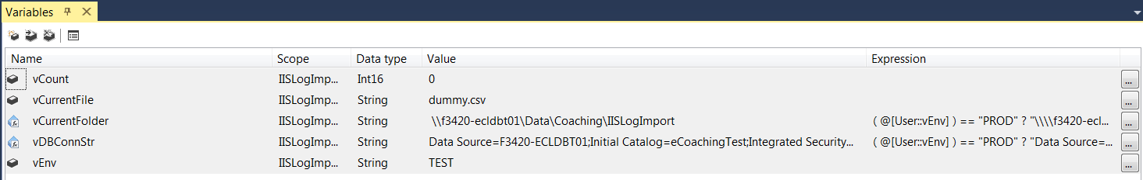

## vCount

*\*\* The total count for the current processing file in table [EC].[IISLog_FileImport]*

## vCurrentFile

*\*\* The file name being processed.*

DEFAULT: dummy.csv

## vCurrentFolder

*\*\* The full path of the folder that holds the data files to be processed.*

Expression:

( @[User::vEnv] ) == "PROD" ? "\\\\f3420-ecldbp01\\Data\\Coaching\\IISLogImport" :

( @[User::vEnv] ) == "TEST" ? " \\\\f3420-ecldbt01\\Data\\Coaching\\IISLogImport" :

"\\\\f3420-ecldbd01\\Data\\Coaching\\IISLogImport"

## vDBConnStr

*\*\* Database connection string.*

Expression:

( @[User::vEnv] ) == "PROD" ? "Data Source=F3420-ECLDBD01;Initial Catalog=eCoachingDev;Integrated Security=SSPI;" :

( @[User::vEnv] ) == "UAT" ? "Data Source=F3420-ECLDBD01;Initial Catalog=eCoachingDev;Integrated Security=SSPI;" :

( @[User::vEnv] ) == "TEST" ? "Data Source=F3420-ECLDBT01;Initial Catalog=eCoachingTest;Integrated Security=SSPI;" :

"Data Source=F3420-ECLDBD01;Initial Catalog=eCoachingDev;Provider=SQLNCLI11;Integrated Security=SSPI;"

## vEnv

*\*\* The environment that this process is running.*

Default: TEST

# Task Details

1. **Foreach Loop Container**

Foreach Loop.

Collection:

Enumerator: Foreach File Enumerator

Expressions:

Directory: @[User::vCurrentFolder]

FileSpec: “*.csv”

Enumerator configuration:

Default to \\f3420-ecldbt01\Data\Coaching\IISLogImport

Files:

*.csv

Retrieve file name:

Fully qualified

Traverse subfolders: unchecked

Variable Mappings:



1. **Check if the if the file has been imported**

Execute SQL Task.

General:

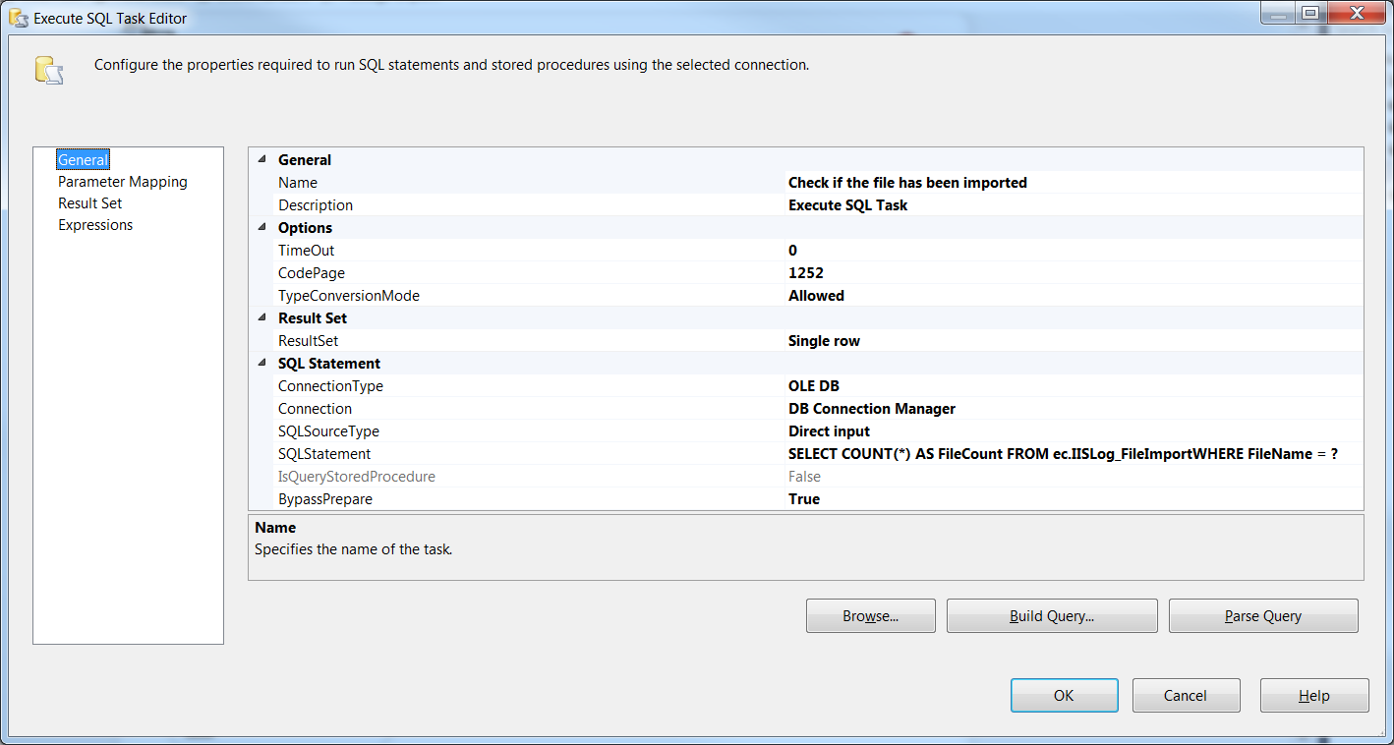

Parameter Mapping:



Result Set:



Expressions: None

1. **Start Transaction**

Execute SQL Task

General:

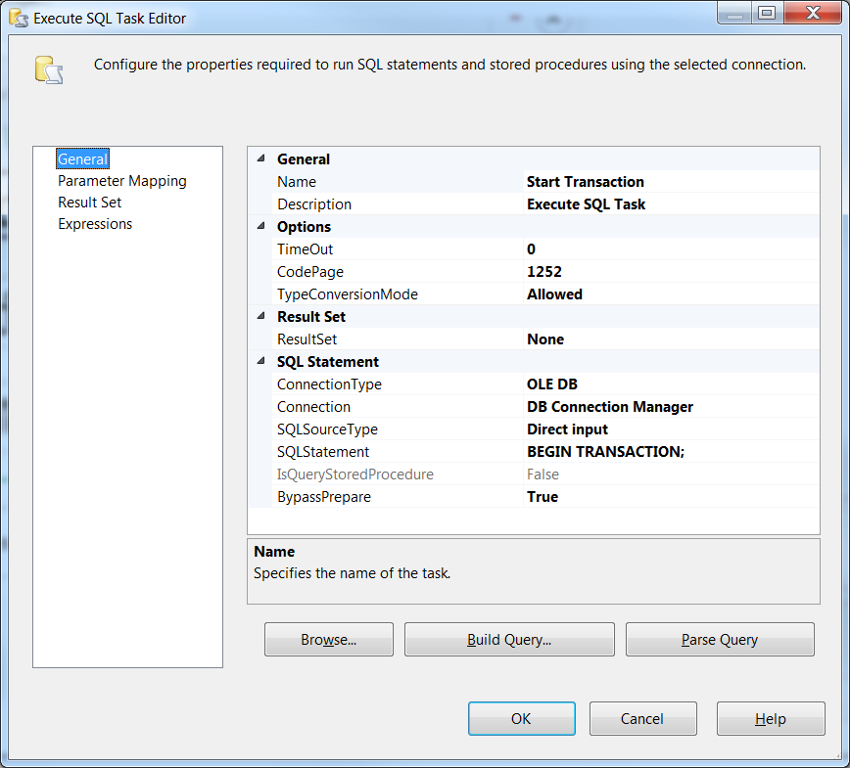

Parameter Mapping: None

Result Set: None

Expressions: None

1. **Insert file name in database**

Execute SQL Task

General:

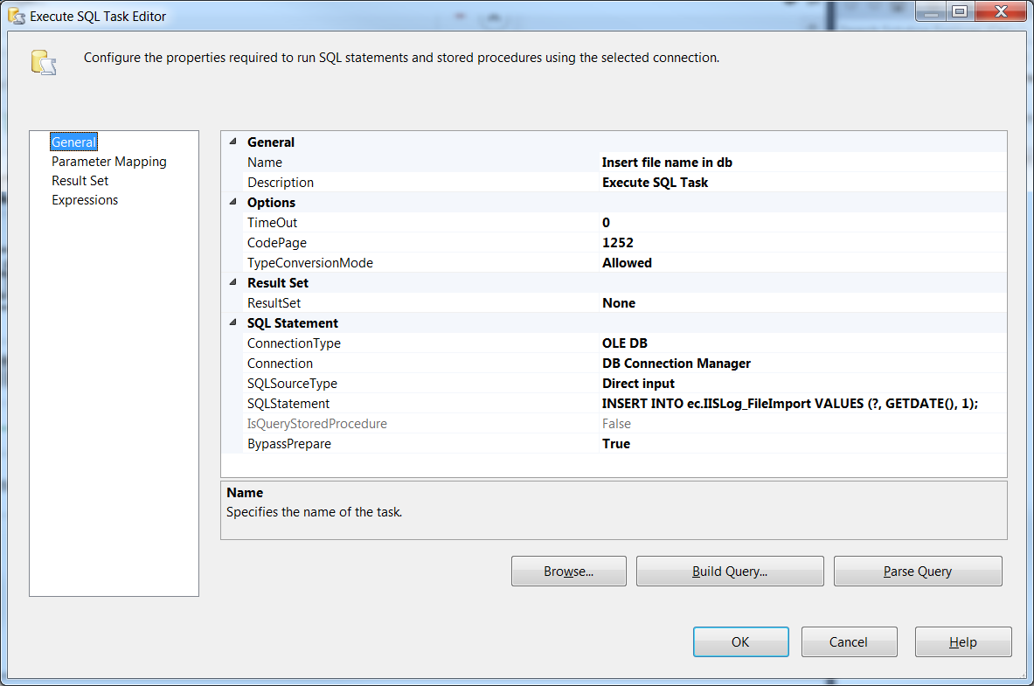

Parameter Mapping:

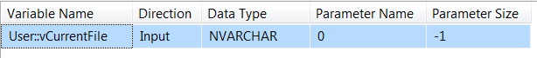

Result Set: None

Expressions: None

1. **Load file to IISLog table**

Data Flow Task

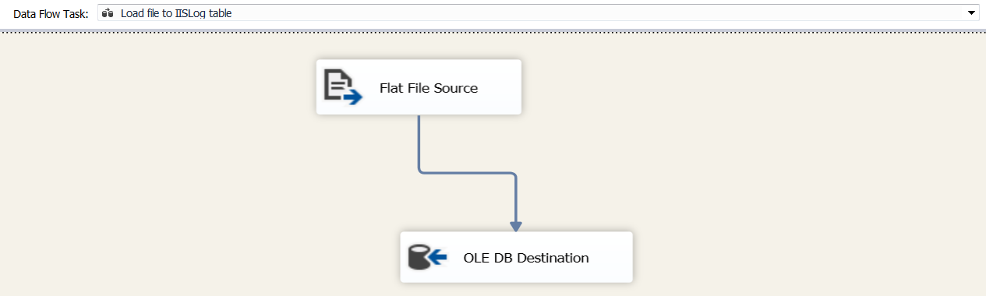

1. **Flat File Source**

Flat File Source.

Connection Manager:

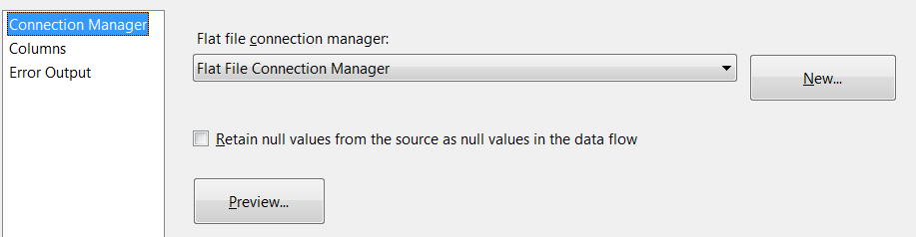

Columns:

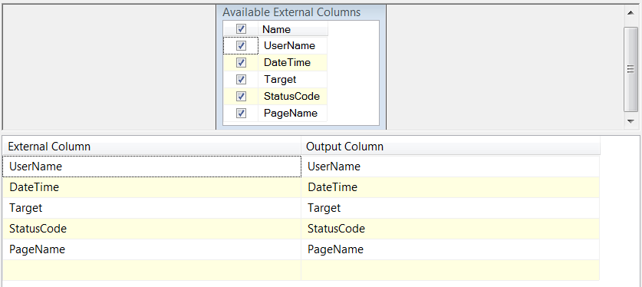

Error Output:

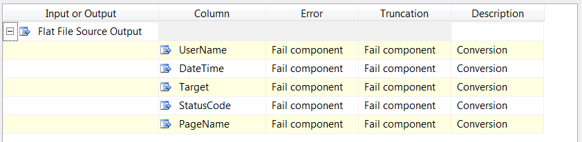

1. **OLE DB Destination**

OLE DB Destination

Connection Manager:

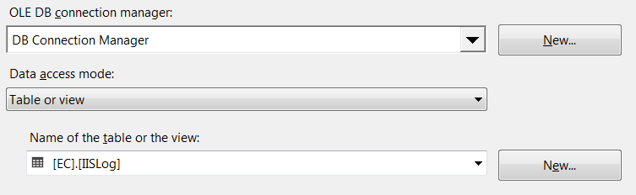

Mappings:

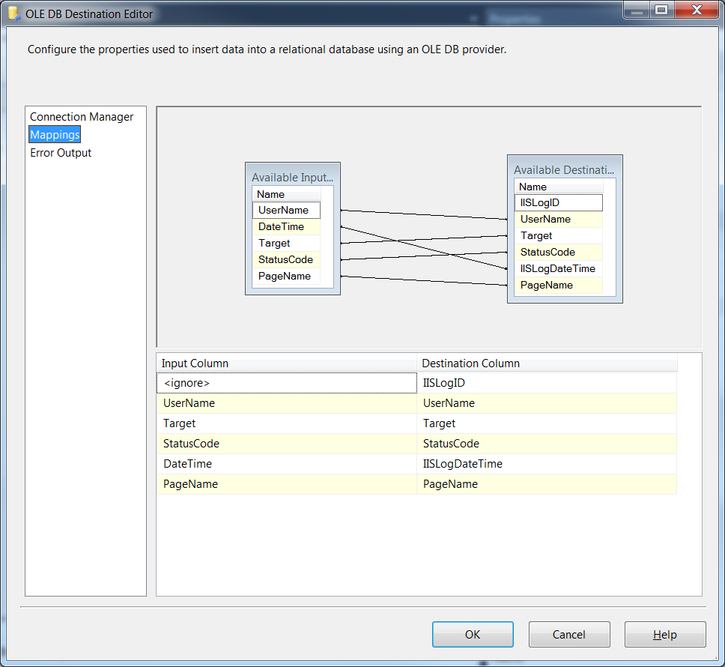

Error Output: None

1. **Rollback Transaction**

Execute SQL Task

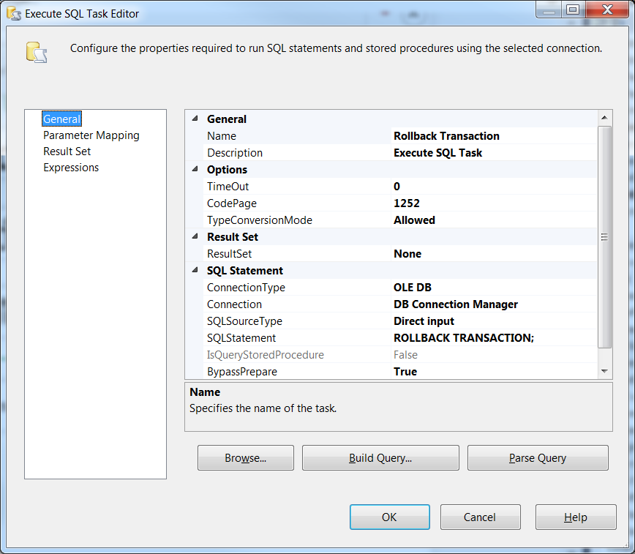

Parameter Mapping: None

Result Set: None

Expressions: None

1. **Commit Transaction**

Execute SQL Task

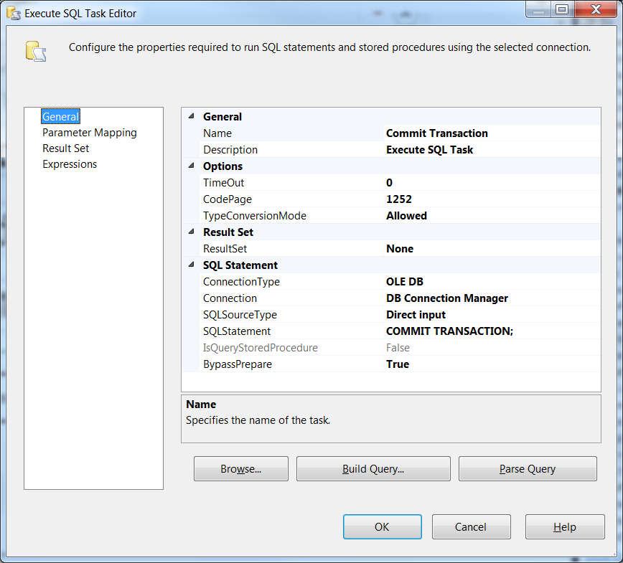

Parameter Mapping: None

Result Set: None

Expressions: None

1. **Delete file**

File System Task

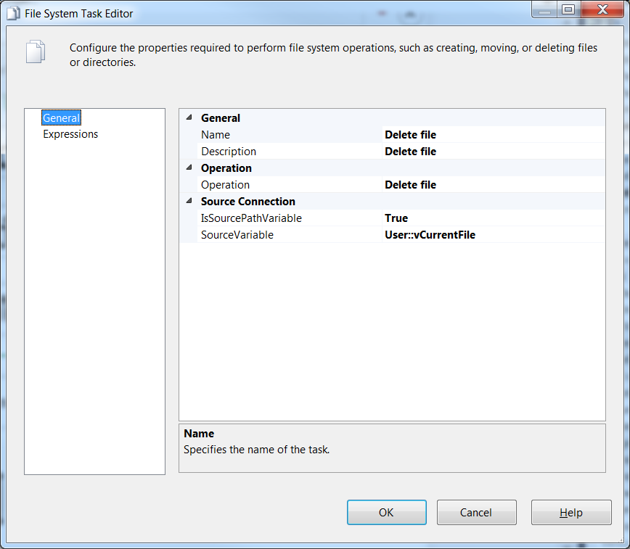

# Timings

This process will be executed via the job [DEV_|TEST_|UAT_]**CoachingIISLogImport**.