**eCoaching Log System**

**Job Trigger**

**SSIS Detail Design Document**

__________________________

|  |  |  |
| --- | --- | --- |
| Last Revision | Last Review | Description |
| 8/15/2024 |  | TFS 28298 - Targeted Coaching - Automated Supervisor Reporting |

Prepared by: Susmitha Palacherla Date: 08/15/2024

Department, Location: Health Solutions Division

**Change History Log**

| **Date** | **Change Description** | **Author** |
| --- | --- | --- |
| 08/15/2024 | TFS 28298 - Targeted Coaching - Automated Supervisor Reporting | Susmitha Palacherla |
|  |  |  |
|  |  |  |
|  |  |  |
|  |  |  |
|  |  |  |
|  |  |  |

Contents

1. Overview 4

1.1 Project Description 4

1.2 Document Scope 4

1.3 Source Data 4

1.4 Module List 4

1.5 Software and Hardware Interfaces 4

1.5.1 Software 4

1.5.2 Hardware 4

2. Details 5

2.1 Source Data 5

2.2 Module Details 5

2.2.1 SQL agent job 5

2.2.2 SSIS Package 5

2.2.3 Tables 13

2.2.4 Procedures and Functions 14

# Overview

## Description

This job will be used to trigger the corresponding load job when a file is requested to be loaded closer to the staged time than waiting until the regular schedule at night.

## Document Scope

This document describes the call to the file load job.

## Source Data

Staged files

## Module List

* SQL agent job
* SSIS Package

## Software and Hardware Interfaces

### Software

* SQL Server 2019 Suite (SSIS and SSRS)

### Hardware

* UVAADADSQL50CCO– Dev DB Server
* UVAADADSQL52CCO – Test DB Server
* UVAAPADSQL50CCO – Prod Server

# Details



## Source Data

The trigger or source data for this job is a specific file or files being staged for load to the staging directories.

## Module Details

### SQL agent job

* Production Instance : UVAAPADSQL50CCO
* Production Job: CoachingJobTrigger
* Production Package: \\UVAAPADSQL50CCO\ssis\Coaching\Packages\JobTrigger_Coaching.dtsx
* Production Config File: JobTrigger_Coaching.dtsConfig
* Owner: ecljobowner
* Run As: ECLProxy (ECL Credential using application service account MAXCORP\SVC_ECL-APPP01)
* Schedule: Daily – Every 15 minutes at :00, :15, :30. :45
* Destination File Location: N/A

### SSIS Package

* + - 1. **Variables**

|  |  |  |  |  |
| --- | --- | --- | --- | --- |
| **Name** | **Scope** | **DataType** | **Value** | **Evaluate As expression** |
| VarEnv | Package | String | Prod | False |
| VarFileDir | Package | String | \\UVAADADSQL50CCO.ad.local\data\coaching\Outliers\Encrypt_Out\ | False |
| VarFileName | Package | String |  | False |
|  |  |  |  |  |
|  |  |  |  |  |
|  |  |  |  |  |

* + - 1. **Connection Manager Entries**
         1. agentdb
* Dev – UVAADADSQL50CCODB.ad.local/eCoachingdev
* Test - UVAADADSQL52CCODB.ad.local/eCoachingtest
* Prod - UVAAPADSQL50CCO.ad.local/eCoaching
  + - * 1. SMTP Connection Manager

smtpint.maxcorp.maximus

* + - 1. **Package Content**

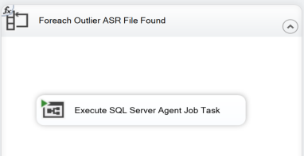

**Workflow**

* + - * 1. **Foreach Outlier ASR File Found**

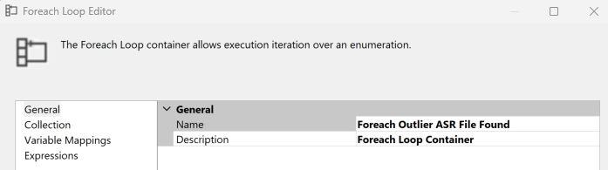

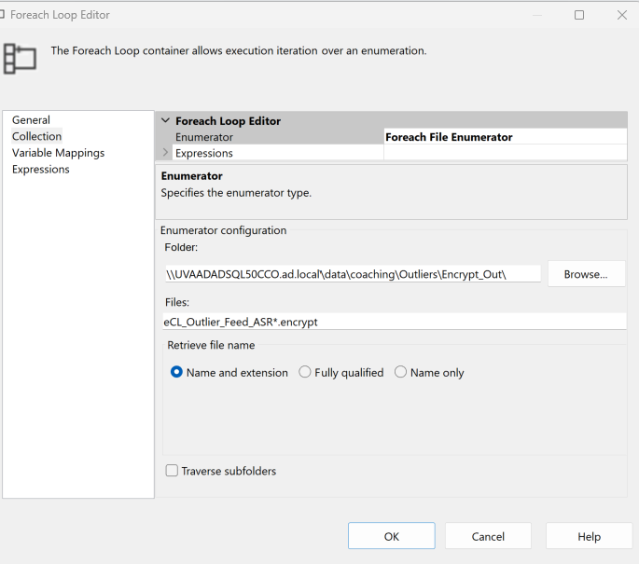

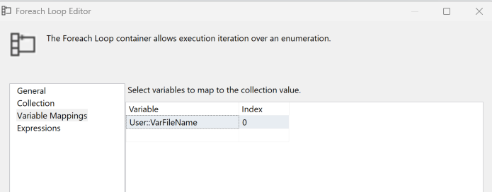

**Execute SQL Agent Job Task**

