__________________________



**Title: eCoaching_Outliers_Load**

**SSIS Detail Design Document**

__________________________

|  |  |  |
| --- | --- | --- |
| Last Revision | Last Review | Description |
| 07/30/2018 |  | TFS 11451 - New feed file for CSRs who took inappropriate action |

Prepared by: Susmitha Palacherla Date: 12/04/2013

Department, Location: Health Solutions Division

Approved by: Date:

**Change History Log**

| **Date** | **Change Description** | **Author** |
| --- | --- | --- |
| 12/04/2013 | 1.0 Initial revision | Susmitha Palacherla |
| 05/01/2015 | 2.0 SMTP server change. SCR 14803. | Susmitha Palacherla |
| 05/26/2015 | 3.0 LSAT feed Addition. SCR 14818. | Susmitha Palacherla |
| 09/21/2015 | 4.0 IAT and IAE feed(s) Addition. TFS 644.  Added IAT file to Section 1.3 and checked IAE as Active.  Added Section 2.2.2.3.2  Added Section 2.2.5 (Functions)  General updates to LCS and General OMR workflow sections for consistency. | Susmitha Palacherla |
| 04/13/2017 | 5.0 BRL and BRN feeds added. TFS 6145.  1.3 - Added 2 new files #21 and #22  2.2.2.3 -Replaced package flow screen capture  2.2.2.3.3 - Added new step III | Susmitha Palacherla |
| 04/25/2017 | 6.0 BRL and BRN feeds for Quality and Sup Modules – TFS 6377  2.2.2.1 – Variables – updated expression for FailMessage to add file name.  2.2.2.3 -Replaced package flow screen capture  2.2.2.4 Added new section describing containers  2.2.2.5 updated workflow to remove additional steps that were replaced with consolidated stored procedure  2.2.4 Added 2 new stored procedures and updated description  2.2.5 Updated description on function | Susmitha Palacherla |
| 8/14/2017 | TFS 7105 – Upgrade to SQL Server 2012 | Susmitha Palacherla |
| 12/29/2017 | TFS 9451 – update documentation to show new OMR report code IAEF | Susmitha Palacherla |
| 01/02/2018 | TFS 7854 – Encryption related changes for feed files and staging tables | Susmitha Palacherla |
|  | TFS 11451 – Section 1.3 Source Files  Added # 25 for PBH Feed.  (Also added missing #23 and #24 for MSR and MSRS and fixed coaching Reason for older entries) | Susmitha Palacherla |

Contents

1. Overview 4

1.1 Project Description 4

1.2 Document Scope 4

1.3 Source Files 4

1.4 Module List 6

1.5 Software and Hardware Interfaces 6

1.5.1 Software 6

1.5.2 Hardware 6

1.6 Users 6

2. Details 7

2.1 Source Files 7

2.2 Module Details 7

2.2.1 SQL agent job 7

2.2.2 SSIS Package 7

2.2.3 Tables 35

2.2.4 Procedures 36

2.2.5 Functions 36

# Overview

## Project Description

The eCL outlier research and coaching process is a standard process to facilitate consistent communication when a performance opportunity exists. It provides a method to make a determination of whether coaching is needed, when to initiate coaching and verification that the performance issue has been addressed. Outlier reports are created by the CCO Analytics team which identifies thresholds and exceptions that require coaching or further research by Call Center Mangers (CCM). All items are entered into the eCL either through a Point of Contact (POC) via the standard entry form or through a data feed. Utilizing the eCL work-flow, items can be tracked from start to finish to verify if items have been addressed. The eCL will also provide reporting on the number of outliers entered into the system, the number coached, pending coaching, pending review or reasons why coaching was not required.

## Document Scope

This document describes the load of the Outliers reports provided by the Analytics team into the eCoaching database. Once the reports are loaded into the database the logs are tracked through the workflow like any Coaching log entered from the web interface.

## Source Files

The table below shows all of the outlier report types that can arrive as feeds. Currently active feeds are marked by an ‘X’ in the table below.

Files have a naming convention eCL_Outlier_Feed_XXXyyyymmdd.csv where XXX stands for the 3 letter acronym used by the report as shown in the ‘Code’ column below.

Files are staged at \\f3420-ecldbp01\data\Coaching\Outliers\Encrypt_Out\

|  |  |  |  |  |  |  |
| --- | --- | --- | --- | --- | --- | --- |
| **#** | **Metric/Report** | **Active Feed** | **Code** | **eCL Workflow** | **Entry** | **Coaching Reason** |
| 1 | OMR: Inappropriate ACO Escalation |  | ACO | Direct Coach | POC | OMR / Exceptions |
| 2 | OMR: ACW |  | ACW | Direct Coach | POC | OMR / Exceptions |
| 3 | OMR: AHT |  | AHT | Direct Coach | POC | OMR / Exceptions |
| 4 | OMR: Cancelled Calls | X | CAN | Manager Review | Data Feed | OMR / Exceptions |
| 5 | OMR: Default Qualifiers | X | DFQ | Manager Review | Data Feed | OMR / Exceptions |
| 6a | OMR: Inappropriate ARC Escalation | X | IAE | Direct Coach | Data Feed | OMR / Exceptions |
| 6b | OMR: Inappropriate ARC Escalation FFM | X | IAEF | Direct Coach | Data Feed | OMR / Exceptions |
| 7 | OMR: Inappropriate DME Escalation |  | IDE | Direct Coach | POC | OMR / Exceptions |
| 8 | OMR: Inappropriate EE/MM Escalation |  | IEE | Direct Coach | POC | OMR / Exceptions |
| 9 | OMR: Inappropriate NGD Feedback |  | INF | Direct Coach | POC | OMR / Exceptions |
| 10 | OMR: ISG Consults |  | ISG | Manager Review | Data Feed | OMR / Exceptions |
| 11 | OMR: Short Calls – Inbound | X | ISQ | Manager Review | Data Feed | OMR / Exceptions |
| 12 | OMR: Low CSAT | X | LCS | Direct Coach | Data Feed | OMR / Exceptions |
| 13 | OMR: Scripts Logged |  | SLG | Direct Coach | POC | OMR / Exceptions |
| 14 | OMR: NGD Inappropriate Transfer |  | NIT | Manager Review | Data Feed | OMR / Exceptions |
| 15 | OMR: Open Calls | X | OPN | Manager Review | Data Feed | OMR / Exceptions |
| 16 | OMR: Short Calls – Outbound | X | OSC | Manager Review | Data Feed | OMR / Exceptions |
| 17 | OMR: Returned MAC Escalation |  | RME | Direct Coach | POC | OMR / Exceptions |
| 18 | OMR: BCC Security and Privacy Incident Coaching |  | SPI | Direct Coach | POC | OMR / Exceptions |
| 19 | OMR: Transfers |  | TRN | Manager Review | Data Feed | OMR / Exceptions |
| 20 | OMR: Inappropriate ARC Transfer | X | IAT | Direct Coach | Data Feed | OMR / Exceptions |
| 21. | OMR: Exceed Number of Breaks | x | BRN | Direct Coach | Data Feed | Breaks |
| 22. | OMR: Exceed Break Length | x | BRL | Direct Coach | Data Feed | Breaks |
| 23. | Monthly Scorecard Review | x | MSR | Direct Coach | Data Feed | Current Coaching Initiatives |
| 24. | Monthly Scorecard Review – Supervisor | x | MSRS | Direct Coach | Data Feed | Current Coaching Initiatives |
| 25. | OMR: Potential Hardship | x | PBH | Direct Coach | Data Feed | OMR / Exceptions |

## Module List

* SQL agent job
* SSIS Package
* Tables
* Procedures

## Software and Hardware Interfaces

### Software

* SQL Server 2012 SP3 Suite

### Hardware

* F3420-ECLDBD01 – Dev DB Server
* F3420-ECLDBT01 – Test DB Server
* F3420-ECLDBP01 – Prod Server
* \\F3420-ECLDBD01\data\ - Dev File staging share
* \\F3420-ECLDBT01\data\ - Test File staging share
* \\F3420-ECLDBP01\data\ - Prod File staging share

## Users

* The first set of users for the OMR records loaded into the eCL database are the CCO Managers as all records have default state of ‘Pending Manager Review’ at the time of the load.
* After a Manager reviews the log and determines that a Coaching is required the log gets assigned to the CSRs and they become the users.
* CCO Supervisors will be able to access the logs from the historical Dashboards.

# Details



## Source Files

eCL_Outliers_Feed_XXXyyyymmdd.csv where XXX is the 3 letter acronym for the Report Type.

Description: A file containing records for agents that exceed a certain threshold for each of the identified metrics. The Analytics team captures records that meet the Outlier thresholds and generate a feed. Once the feed is loaded into eCL the Managers have the opportunity to determine if a Coaching is needed or additional research is needed.

Source system: CCO Analytics

* Staging location: \\f3420-ecldbp01\data\Coaching\Outliers\Encrypt_Out\
* File name eCL_Outliers_Feed_XXXyyyymmdd.csv
* Frequency: N/A No regular schedule. Files are sent at random intervals.
* File arrival time: NA
* Destination Table: Coaching_Log and Coaching_Log_Reason

## Module Details

### SQL agent job

* Production Instance : F3420-ECLDBP01
* Production Job: CoachingOutlierLoad
* Production Package: \\F3420-ECLDBP01\ssis\Coaching\Packages\Outlier_Coaching.dtsx
* Production Config File: Prod_Outlier_Coaching.dtsConfig
* Owner: ecljobowner
* Run As: ECLProxy (ECL Credential using application service account VNGT\SVC-SQLECLP01
* Schedule: Daily 8:30 PM EST daily IF Files exist to be loaded
* Destination File Location: N/A

### SSIS Package

* + - 1. **Variables**

|  |  |  |  |
| --- | --- | --- | --- |
| **Name** | **Scope** | **DataType** | **Value** |
| DecryptedOutPath | Outlier_Coaching | String | \\f3420-ecldbp01\data\coaching\OUTLIERS\Decrypt_out\ |
| DecryptInPath | Outlier_Coaching | String | \\f3420-ecldbp01\data\coaching\OUTLIERS\Decrypt_in\ |
| EncryptedBackupPath | Outlier_Coaching | String | \\f3420-ecldbp01\data\coaching\OUTLIERS\Backups\ |
| EncryptedOutPath | Outlier_Coaching | String | \\f3420-ecldbp01\data\coaching\OUTLIERS\Encrypt_out\ |
| EncryptInPath | Outlier_Coaching | String | \\f3420-ecldbp01\data\coaching\OUTLIERS\Encrypt_in\ |
| varDBName | Outlier_Coaching | String | Dev |
| varEncryptedFileName | Outlier_Coaching | String |  |
| varFailedFile | Outlier_Coaching | String |  |
| varFileName | Outlier_Coaching | String |  |
| FailMessage | Outlier_Coaching | String | "Ouliers Coaching file \"" + @[User::VarFileName] + "\" failed in " + @[User::VarDBName] |
| StagedCount | Outlier_Coaching | Int32 | 0 |
| RejectedCount | Outlier_Coaching | Int32 | 0 |
| LoadedCount | Outlier_Coaching | Int32 | 0 |
|  |  |  |  |

* + - 1. **Connection Manager Entries**
         1. Destinationdb
* Dev – F3420-ECLDBD01 DB – eCoachingdev
* Test - F3420-ECLDBT01 DB – eCoachingtest
* Prod - F3420-ECLDBP01 – eCoaching
  + - * 1. Outlier_File

Expression: @[User::DecryptedOutPath] +@[User::VarFileName]

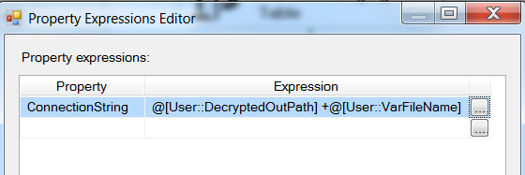

* + - * 1. SMTP Connection Manager

smtpout.gdit.com

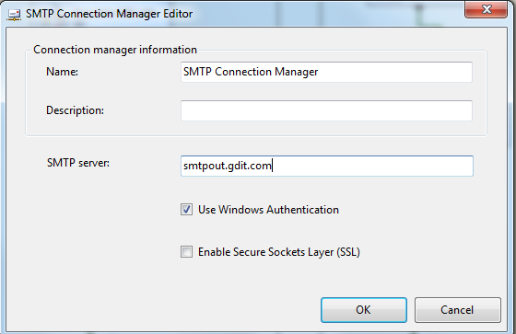

* + - * 1. LCS_File

Expression: @[User::DecryptedOutPath] +@[User::VarFileName]

* + - * 1. ARC_File

Expression: @[User::DecryptedOutPath] +@[User::VarFileName]

* + - * 1. Encrypted_File

Expression: @[User::EncryptedOutPath] + @[User::varEncryptedFileName]

* + - * 1. Failed_File

Expression: @[User::DecryptedOutPath]+ @[User::varFailedFile]

* + - 1. **Package Content**

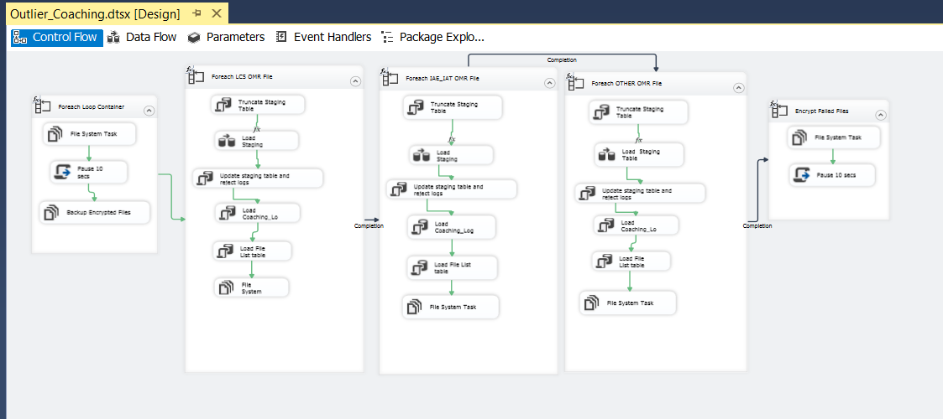

* + - 1. **Containers**
         1. **Foreach File**

Function: Decrypt and backup Encrypted Files

* + - * 1. **Foreach LCS OMR File**

Function: Load LCS Files

Expresion: FINDSTRING(@[User::VarFileName],"LCS",1 ) > 1

* + - * 1. **Foreach IAE_IAT OMR File**

Function: Load IAE/IAT Files

Expresion: (FINDSTRING(@[User::VarFileName],"IAE",1 ) > 0 )

||(FINDSTRING(@[User::VarFileName],"IAT",1 ) > 0 )

* + - * 1. **Foreach OTHER OMR File**

Function: Load all Other Outliers files

Expresion: (FINDSTRING(@[User::VarFileName],"IAE",1 ) == 0)

&&(FINDSTRING(@[User::VarFileName],"IAT",1 ) == 0 )

&&(FINDSTRING(@[User::VarFileName],"LCS",1 ) == 0 )

* + - * 1. **Foreach File**

Function: Encrypt failed files

* + - 1. **Workflow** 
         1. **Foreach Loop Container ( Decrypt and stage files)**

**Summary of Steps**

1. File system task – Decrypt files
2. Script task - Pause 10 seconds
3. File system task – Backup encrypted files

**Details**

Container: For each File Loop

Folder: \\f3420-ecldbp01\data\coaching\Outliers\Encrypt_out\

Files: eCL*ETS_*.encrypt

Retrieve file name: Name and Extension

1. File system task – Decrypt files

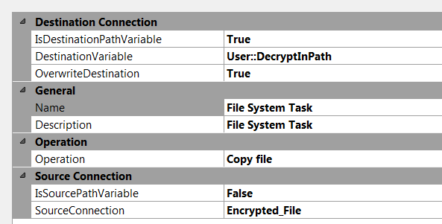

1. Script task- Pause 10 secs

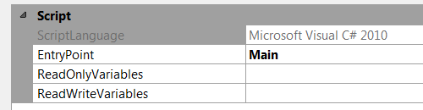

public void Main()

{

// TODO: Add your code here

// Sleep for 10 seconds (*1000)

System.Threading.Thread.Sleep(10000);

Dts.TaskResult = (int)ScriptResults.Success;

}

1. File System task – Backup Encrypted files

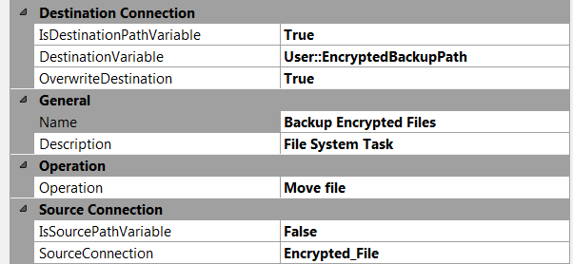

* + - * 1. **For each LCS Outlier file in Staging directory**

Container: Foreach Loop

Folder: \\f3420-ecldbd01\data\coaching\Outliers\Decrypt_out\

Files: eCL_Outlier_Feed_LCS*.csv

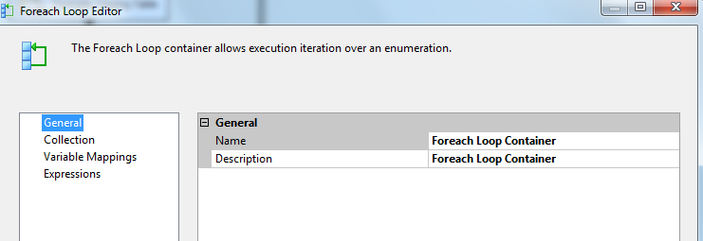

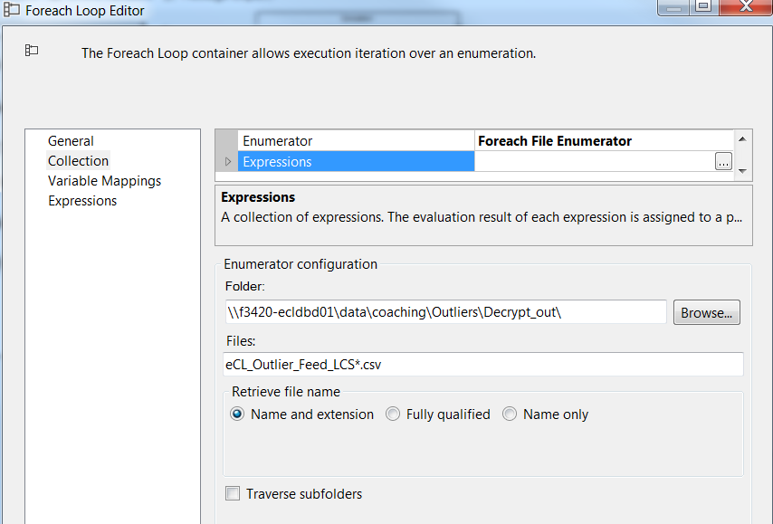

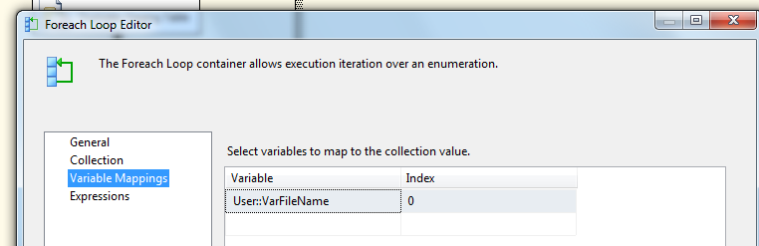

**Summary of Steps**

1. SQL task – Truncate Outliers Staging table
2. DFT – Stage Outliers Staging table
3. SQL task – Update staging table and reject logs
4. SQL task Load Coaching_Log and Coaching_Log_Reason tables
5. SQL task – Load File list table
6. File system task – Delete file

**Details of Steps**

1. SQL task – Truncate Outliers Staging table

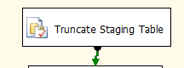

Truncate Table [EC].[Outlier_Coaching_Stage]

1. DFT: Load Outliers staging table

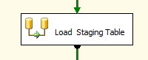

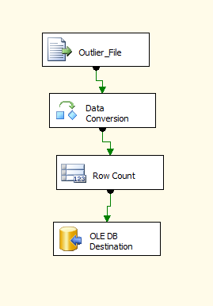

1. Flat File source

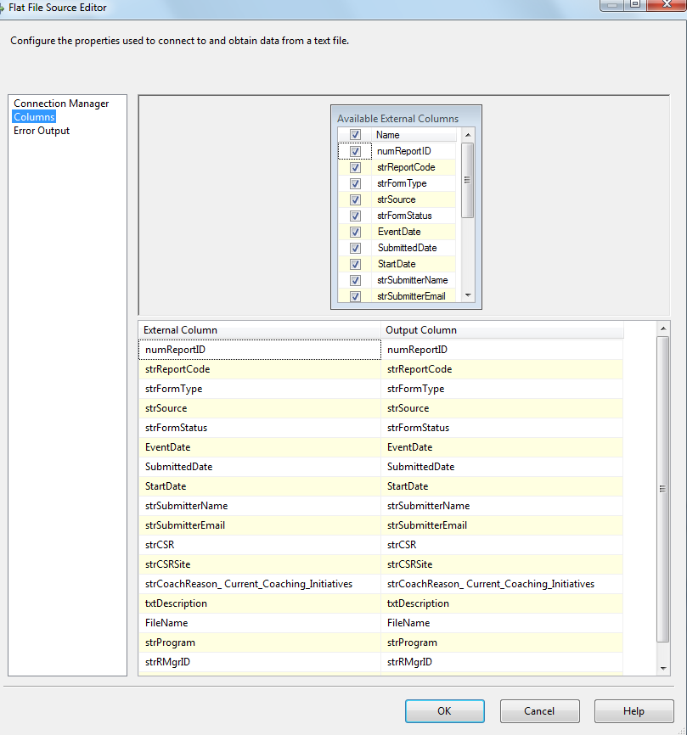

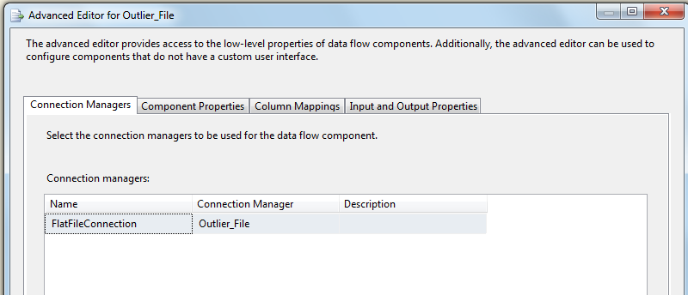

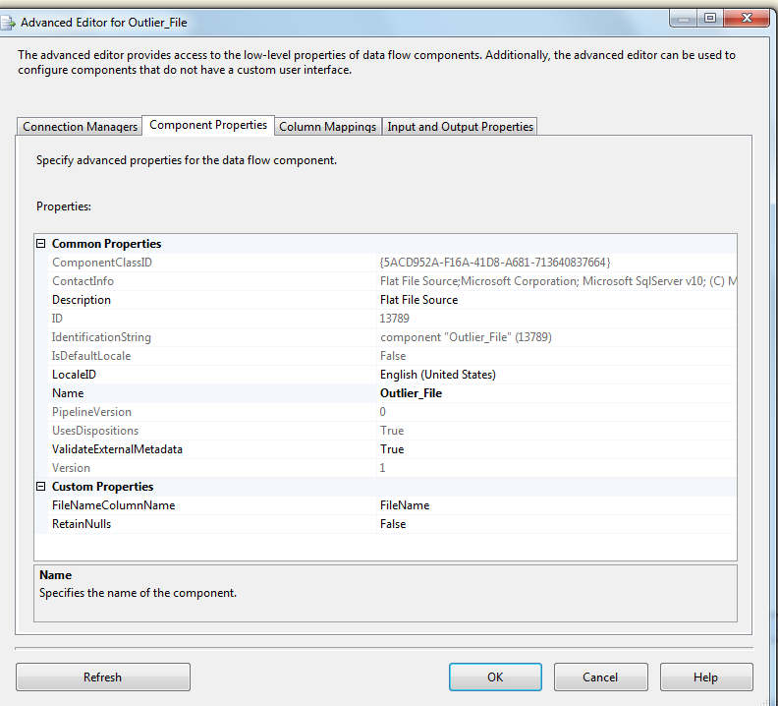

1. Data Conversion

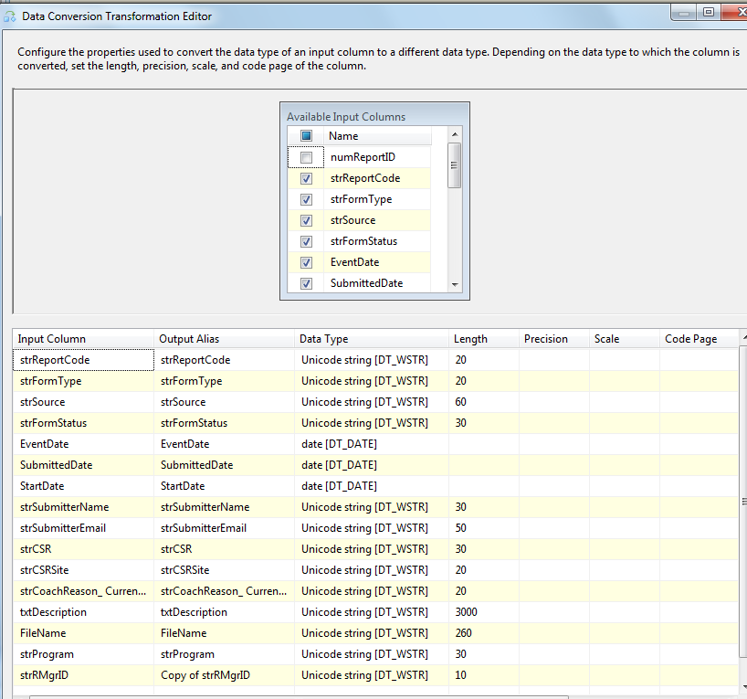

1. Row Count Transformation

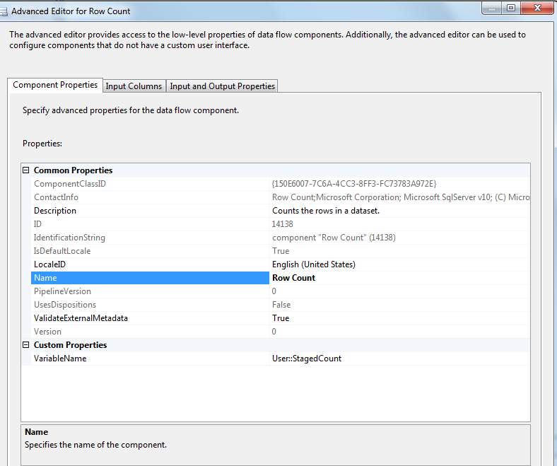

1. Oledb destination

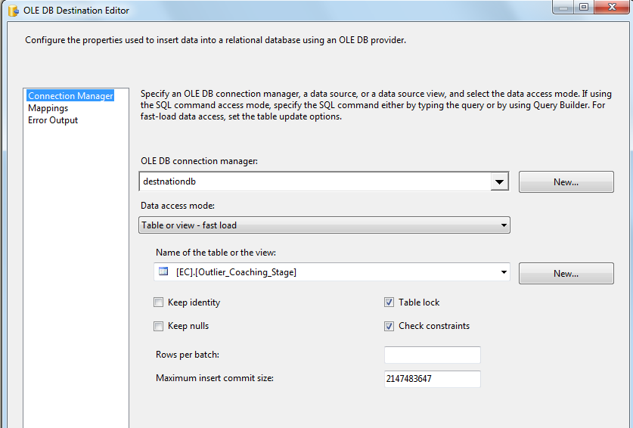

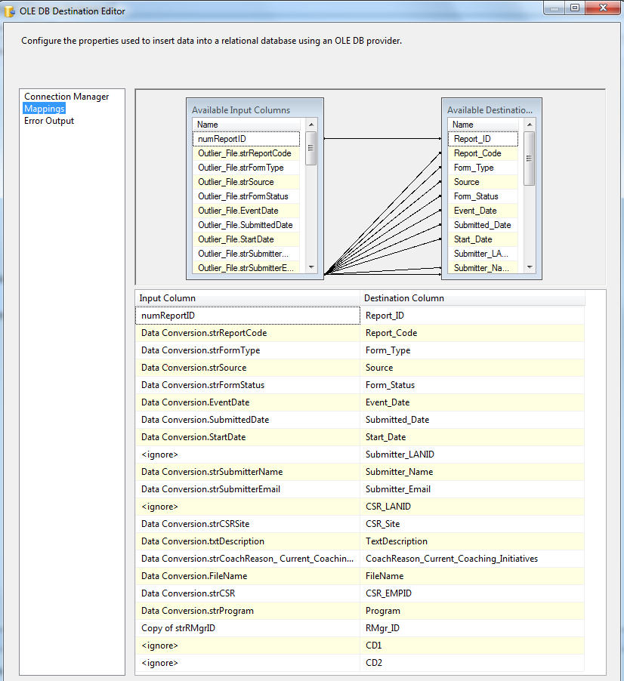

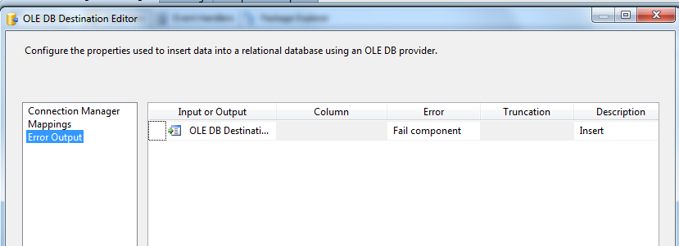

1. SQL Task: Update staging table and reject logs

SQLStatement: Exec [EC].[sp_Update_Outlier_Coaching_Stage] ? output

Parameter Mapping:

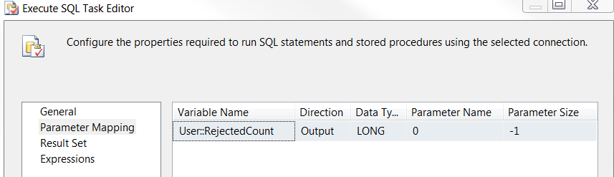

1. SQL Task: Load Coaching_Log table

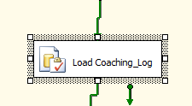

SQLStatement: Exec [EC].[sp_InsertInto_Coaching_Log_Outlier]? Output

Parameter Mapping:

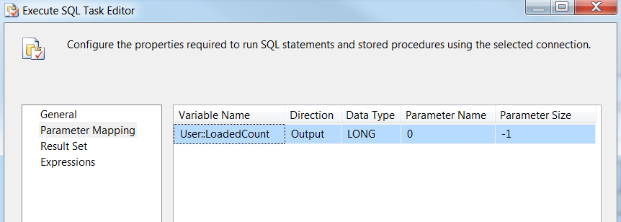

1. SQL Task: Load Outliers File List table

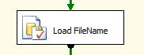

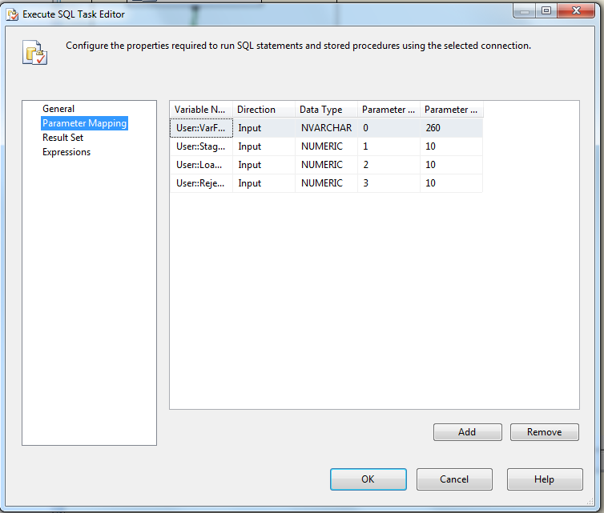

Executes the following sql

INSERT INTO [EC].[Outlier_FileList]

([File_Name]

,[File_LoadDate]

,[Count_Staged]

,[Count_Loaded]

,[Count_Rejected])

VALUES (?,GetDate(), ?, ?,?)

1. File System Task: Delete file

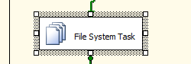

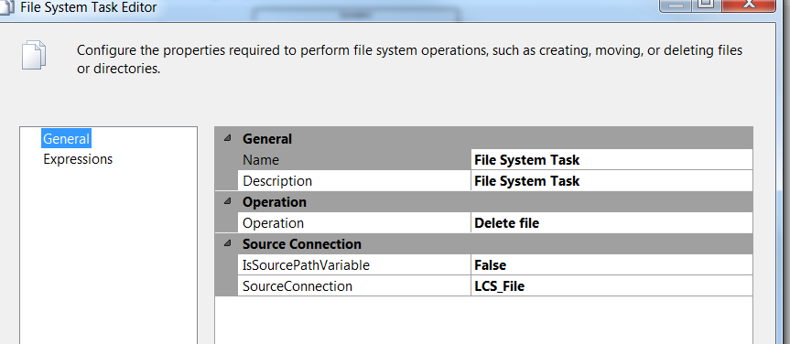

* + - * 1. **For each IAT and IAE Outlier file in Staging directory**

Container: Foreach Loop - Foreach IAE_IAT OMR File

Folder: \\f3420-ecldbd01\data\coaching\Outliers\Decrypt_out\

Files: eCL_Outlier_Feed_*.csv

(*Expression used to distinguish from rest of non LCS OMR Files in conditional workflow)

**Summary of Steps**

1. SQL task – Truncate Outliers Staging table
2. DFT – Stage Outliers Staging table
3. SQL task – Update staging table and reject logs
4. SQL task Load Coaching_Log and Coaching_Log_Reason tables
5. SQL task – Load File list table
6. File system task – Backup files to Backups directory

**Details of Steps**

1. SQL task – Truncate Outliers Staging table

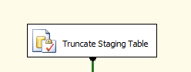

Truncate Table [EC].[Outlier_Coaching_Stage]

1. DFT: Load Outliers staging table

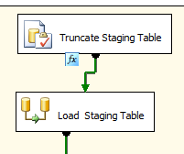

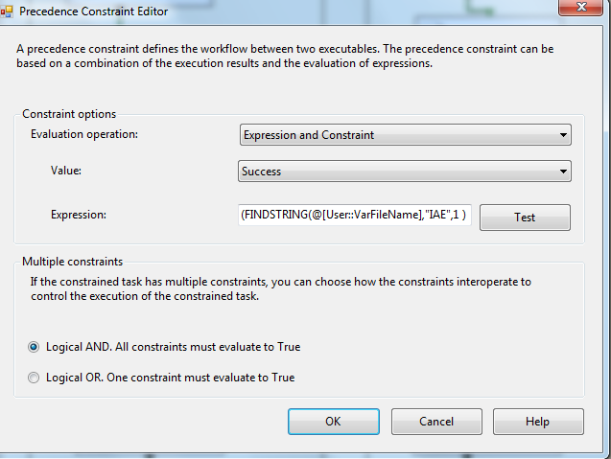

Expression: (FINDSTRING(@[User::VarFileName],"IAE",1 ) > 0 ) ||(FINDSTRING(@[User::VarFileName],"IAT",1 ) > 0 )

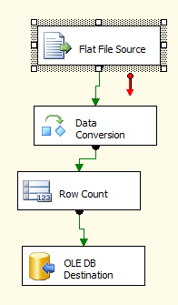

1. Flat File source

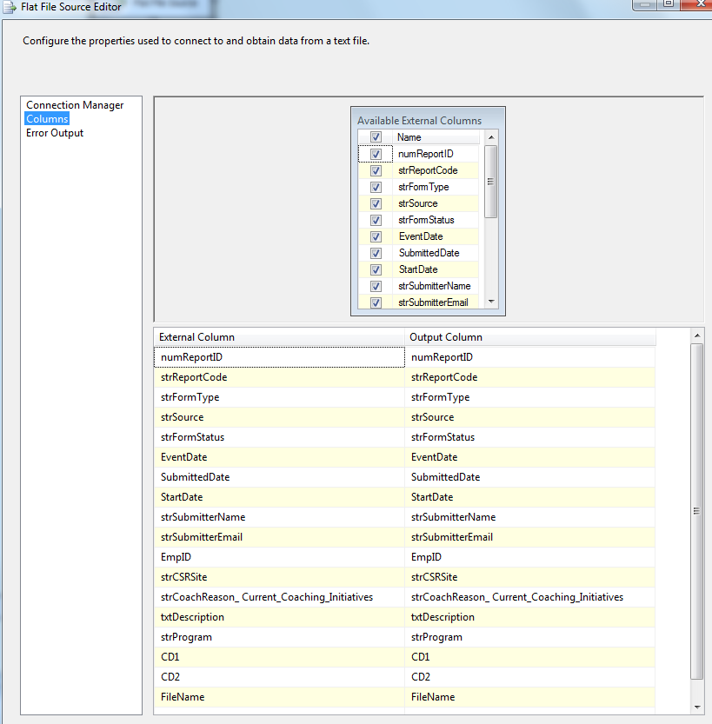

1. Data Conversion

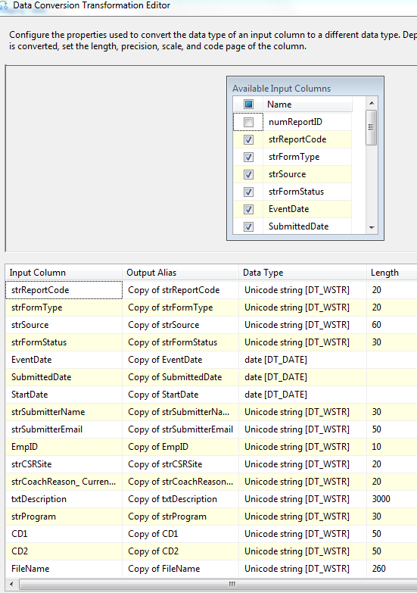

1. Row Count Transformation

Similar to LCS File

1. Oledb destination

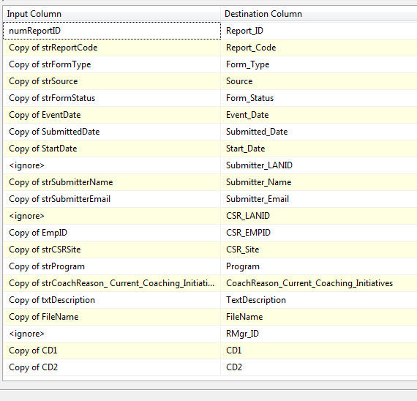

1. SQL Task: Update staging table and reject logs

Same as LCS File

1. SQL Task: Load Coaching_Log table

Same as LCS File

1. SQL Task: Load Outliers File List table

Same as LCS File

1. File System Task: Delete file

Same as LCS File

* + - * 1. **For each NON LCS, IAT and IAE Outlier file in Staging directory Workflow**

Container: Foreach Loop – Foreach OTHER OMR File

Folder: \\f3420-ecldbd01\data\coaching\Outliers\Decrypt_out\ Files: eCL_Outlier_Feed_*.csv

**Summary of Steps**

1. SQL task – Truncate Outliers Staging table
2. DFT – Stage Outliers Staging table
3. SQL task – Update staging table and reject logs
4. SQL task Load Coaching_Log and Coaching_Log_Reason tables
5. SQL task – Load File list table
6. File system task – Backup files to Backups directory

**Details**

1. SQL task – Truncate Outliers Staging table



Truncate Table [EC].[Outlier_Coaching_Stage]

1. DFT: Load Outliers staging table



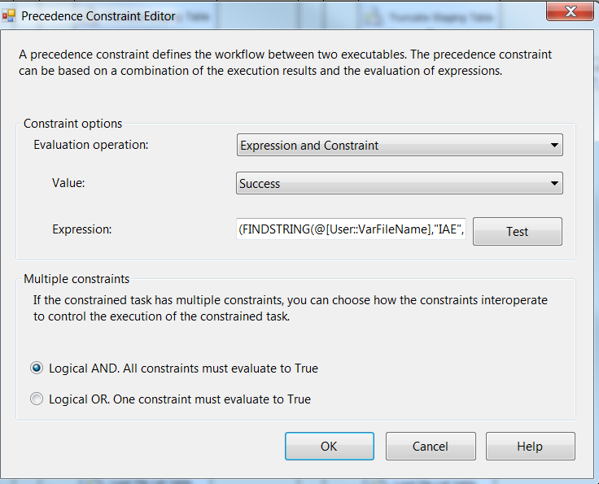

(FINDSTRING(@[User::VarFileName],"IAE",1 ) == 0 )&&(FINDSTRING(@[User::VarFileName],"IAT",1 ) == 0 )&&(FINDSTRING(@[User::VarFileName],"LCS",1 ) == 0 )



1. Flat File source

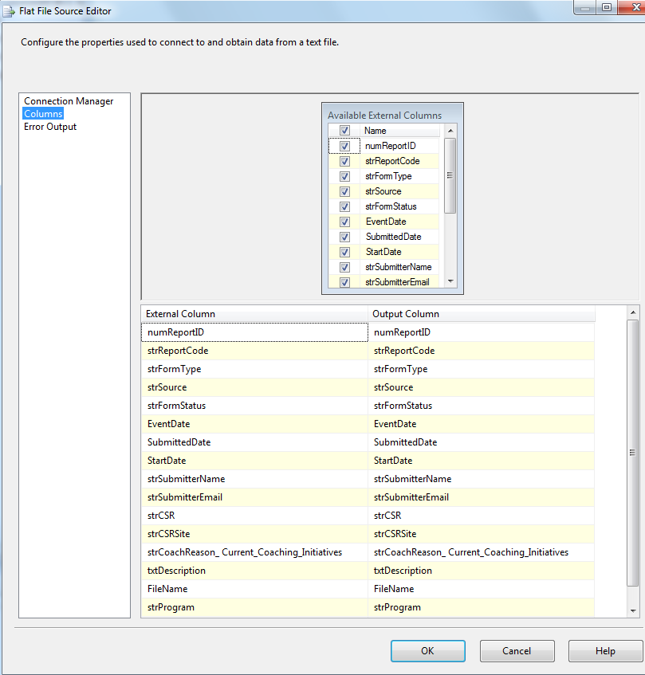





1. Data Conversion

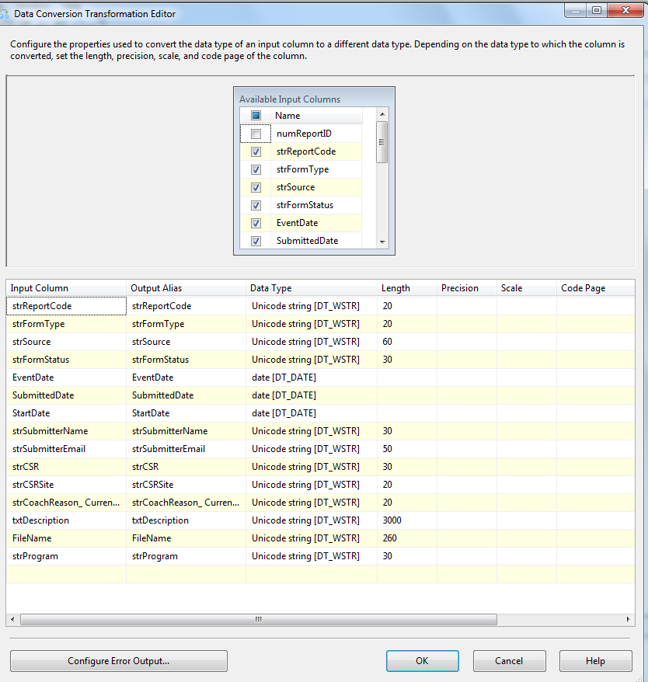

1. Row Count Transformation



1. Oledb destination



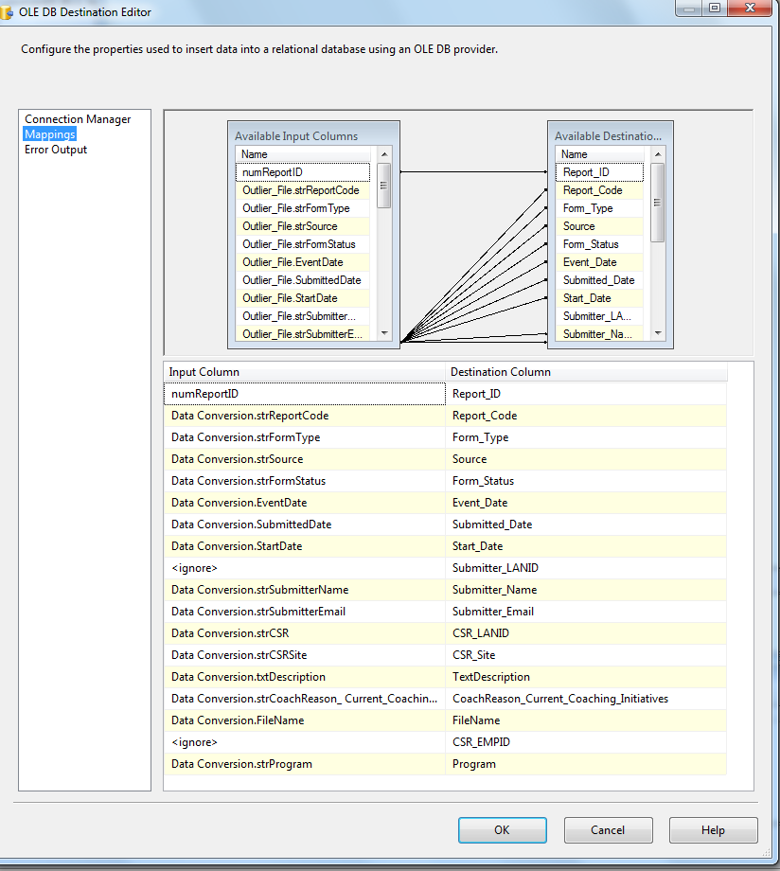



1. SQL Task: Update staging table and reject logs

Same as LCS File

1. SQL Task: Load Coaching_Log table

Same as LCS File

1. SQL Task: Load Outliers File List table

Same as LCS File

1. File System Task: Delete file

Same as LCS File

* + - * 1. **For each failed file (Encrypt failed files)**

**Summary of Steps**

1. File system task – Encrypt failed files
2. Script task - Pause 10 seconds

**Details**

Container: For each File Loop

Precedence Constraint - Completion

Folder: \\f3420-ecldbp01\data\coaching\Outliers\Decrypt_out\

Files: eCL*.csv

Retrieve file name: Name and Extension

1. File system task – Encrypt files

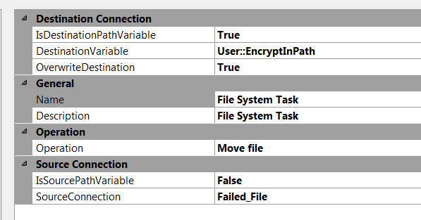

1. Script task- Pause 10 secs



public void Main()

{

// TODO: Add your code here

// Sleep for 10 seconds (*1000)

System.Threading.Thread.Sleep(10000);

Dts.TaskResult = (int)ScriptResults.Success;

}

* + - 1. **Package Content(Event Handlers)**

Executables: Outlier_Coaching

EventHandler: OntaskFailed

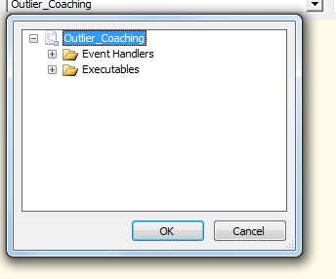

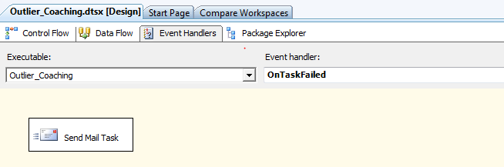

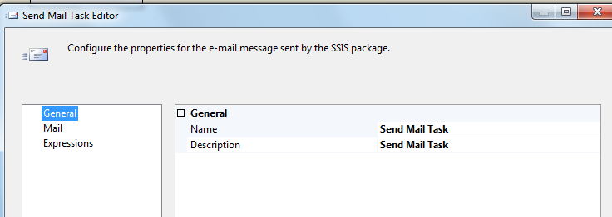

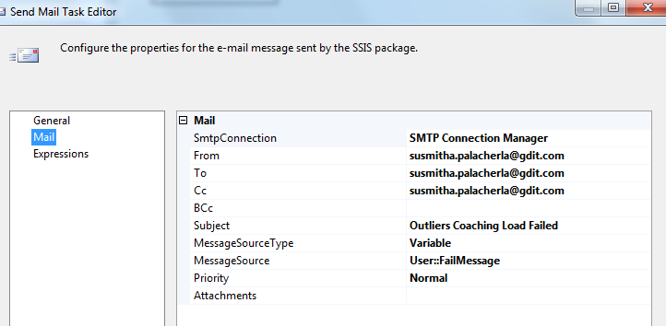

### Tables

|  | **Table Name** | **Table Description** |
| --- | --- | --- |
| 1. | Outlier_Coaching_Stage | Table used for staging the OMR records during the insert into Coaching_Log table. |
| 2. | Outlier_Coaching_Rejected | Table used for storing the rejected OMR records during the insert into Coaching_Log table. Logs are rejected when an incoming Lan ID does not exist in the Employee_Hierarchy table. |
| 3. | Outlier_Coaching_Fact | Table used for storing Outliers source records loaded into the Coaching Log table. |
| 4. | Outlier_FileList | Table used for storing the OMR file names and Load dates. |

Table structure and details in document: eCoaching_Database_DD.docx

### Procedures

|  | **Procedure Name** | **Usage** |
| --- | --- | --- |
| 1. | sp_InsertInto_Coaching_Log_Outlier | Load: Outliers Data into Coaching_Log and Coaching_Log_Reason log tables from staging table |
| 2. | sp_Update_Outlier_Coaching_Stage | Load: Update attributes like Emp ID, Lan ID m program and site in outlier staging table |
| 3. | sp_InsertInto_Outlier_Rejected | Load: Rejection logic for OMR records |

### Functions

|  | **FunctionName** | **Usage** |
| --- | --- | --- |
| 1. | fn_intSubCoachReasonIDFromRptCode | Load: Outliers Data: Assign subCoaching Reason ID based on report code. |