**eCoaching Log System**

**eCoaching_Quality_Other_Load**

**SSIS Detail Design Document**

__________________________

|  |  |  |
| --- | --- | --- |
| Last Revision | Last Review | Description |
| 12/28/2023 |  | TFS 27441 - Setup email alert when unexpected file staged |

Prepared by: Susmitha Palacherla Date: 6/11/2016

Department, Location: Health Solutions Division

**Change History Log**

| **Date** | **Change Description** | **Author** |
| --- | --- | --- |
| 6/11/2016 | 1.0 Initial revision. CTC Feed per TFS 2268 | Susmitha Palacherla |
| 7/15/2016 | 2.0 Updates for HFC and KUD Feeds per TFS 3179 & 3186 | Susmitha Palacherla |
| 8/2/2016 | 3.0 Updates for KUD feed per TFS 3179 | Susmitha Palacherla |
| 9/7/2016 | 4.0 Update to Description derived column expression in CTC files when any of the 4 text fields are NULL (2.2.2.3.1 step II b) | Susmitha Palacherla |
| 2/5/2017 | 5.0 Updates for NPN feed per TFS 5903 | Susmitha Palacherla |
| 2/8/2017 | 5.1 Updates from V&V for NPN feed per TFS 5903 | Susmitha Palacherla |
| 8/14/2017 | 6.0 TFS 7105 – Upgrade to SQL Server 2012 | Susmitha Palacherla |
| 12/28/2017 | 7.0 TFS 7854 – Encryption related changes for feed files and staging tables | Susmitha Palacherla |
| 07/10/2019 | 8.0 TFS 14706 - Switch smtpout.gdit.com to ironport.maximus.com | Susmitha Palacherla |
| 08/16/2019 | 9.0 TFS 15063 - Quality Now Rewards and Recognition (Bingo) | Susmitha Palacherla |
| 09/27/2019 | 10.0 TFS 15465 - eCoaching - London Alternate Channel Bingo logs | Susmitha Palacherla |
| 7/29/2020 | TFS 17716 - Removed company specific references | Susmitha Palacherla |
| 4/19/2021 | TFS 20677 - AD island to AD AWS environment changes | Susmitha Palacherla |
| 6/24/2021 | TFS 21796 - change email server from ironport to maxcorp | Susmitha Palacherla |
| 8/2/2021 | TFS 22443 - Add trigger and review performance for Bingo upload job | Susmitha Palacherla |
| 3/15/2022 | TFS 23967 - Send alerts if xlsx files staged | Susmitha Palacherla |
| 12/28/2023 | TFS 27441 - Setup email alert when unexpected file staged | Susmitha Palacherla |

Contents

1. Overview 3

1.1 Project Description 3

1.2 Document Scope 4

1.3 Source Files 4

1.4 Module List 4

1.5 Software and Hardware Interfaces 5

1.5.1 Software 5

1.5.2 Hardware 5

1.6 Users 5

2. Details 5

2.1 Source Files 5

2.2 Module Details 6

2.2.1 SQL agent job 6

2.2.2 SSIS Package 6

2.2.3 Tables 34

2.2.4 Procedures 34

2.2.5 Functions 34

# Overview

## Project Description

The coaching process is a standard process to facilitate consistent communication when a performance opportunity or reinforcement exists. It provides a method to make a determination of whether coaching is needed, when to initiate coaching and verification that the performance issue has been addressed. The Quality_Other feed(s) will be used for mass loading of ecls from the Quality system that would have normally been submitted through the User Interface into the database. Utilizing the eCL work-flow, items can be tracked from start to finish to verify if items have been addressed.

## Document Scope

This document describes the load of the ‘Quality_Other’ feeds (Related to Quality systems but not directly based on the actual evalautions) that will be used to mass load ecls into the database. Once the reports are loaded into the database the logs are tracked through the workflow like any Coaching log entered from the web interface.

## Source Files

The table below shows the attributes for the ‘Quality_Other’ reports.

Encrypted Files are staged at \\UVAAPADSQL50CCO\data\Coaching\Quality_Other\Encrypt_Out until loaded. Encrypted files have naming convention eCL_Quality_Feed_xxxyyyymmdd.csv.zip.encrypt

Decrypted files ready to load have Files have a naming convention eCL_Quality_Feed_**xxx**yyyymmdd.csv where xxx is the 3 letter Report code.

|  |  |  |  |  |  |  |
| --- | --- | --- | --- | --- | --- | --- |
| **#** | **Metric/Report** | **Active Feed** | **Code** | **eCL Workflow** | **Entry** | **Coaching Reason** |
| 1 | Coach the coach | Y | CTC | Acknowledgement only | Feed | Coaching |
| 2 | Kudos | Y | KUD | Acknowledgement only | Feed | Recognition |
| 3 | High CSAT | Y | HFC | Acknowledgement only | Feed | Quality |
| 4. | National Producer Number | Y | NPN | Pending Supervisor Review | Feed | Current Coaching Initiatives |
| 5. | Quality (QCM &QM) for CSRs and Supervisors | Y | BQN BQNS  BQM  BQMS | Pending Acknowledgement | Feed | Quality |

## Module List

* SQL agent job
* SSIS Package
* Tables
* Procedures

## Software and Hardware Interfaces

### Software

* SQL Server 2019 Suite (SSIS and SSRS)

### Hardware

* UVAADADSQL50CCO– Dev DB Server
* UVAADADSQL52CCO – Test DB Server
* UVAAPADSQL50CCO – Prod Server
* \\UVAADADSQL50CCO\Data\Coaching\Quality\ - Dev File staging share
* \\UVAADADSQL52CCO\Data\Coaching\Quality\ - Test File staging share
* \\UVAAPADSQL50CCO\Quality\ - Prod File staging share

## Users

* The first set of users for the Quality_Other records loaded into the eCL database are the CCO Supervisors and their immediate supervisors. Logs are loaded at pending Acknowledgement status and can be acknowledged by either the Supervisor (owner) or Manager of the Supervisor first.
* CCO Supervisors and Managers and specific HR staff will be able to access the logs from the historical Dashboards.

# Details



## Source Files

eCL_Quality_Feed_xxxyyyymmdd.csv is the naming convention for the feed where xxx is the 3 letter Report code.

Source system: NA

* Staging location: \\UVAAPADSQL50CCO\data\Coaching\Quality_Other\Dencrypt_Out
* File name eCL_Quality_Feed_xxxyyyymmdd.csv
* Frequency: Ad-hoc
* File arrival time: NA
* Destination Table: Coaching_Log and Coaching_Log_Reason

## Module Details

### SQL agent job

* Production Instance : UVAAPADSQL50CCO
* Production Job: CoachingQualityOtherLoad
* Production Package: \\UVAAPADSQL50CCO\ssis\Coaching\Packages\Quality_Other _Coaching.dtsx
* Production Config File: Prod_Quality_Other_Coaching.dtsConfig
* Owner: ecljobowner
* Run As: ECLProxy (ECL Credential using application service account AD\SVC-F3420-APPECLP01
* Schedule: Daily 10 PM EST
* Destination File Location: N/A

### SSIS Package

* + - 1. **Variables**

|  |  |  |  |
| --- | --- | --- | --- |
| **Name** | **Scope** | **DataType** | **Value** |
| DecryptedOutPath | Quality_Other_Coaching | String | \\UVAAPADSQL50CCO\data\coaching\QUALITY\Decrypt_out\ |
| DecryptInPath | Quality_Other_Coaching | String | \\UVAAPADSQL50CCO\data\coaching\QUALITY\Decrypt_in\ |
| EncryptedBackupPath | Quality_Other_Coaching | String | \\UVAAPADSQL50CCO\data\coaching\QUALITY\Backups\ |
| EncryptedOutPath | Quality_Other_Coaching | String | \\UVAAPADSQL50CCO\data\coaching\QUALITY\Encrypt_out\ |
| EncryptInPath | Quality_Other_Coaching | String | \\UVAAPADSQL50CCO\data\coaching\QUALITY\Encrypt_in\ |
| varDBName | Quality_Other_Coaching | String | Dev |
| FailMessage | Quality_Other_Coaching | String | "Quality Other Coaching Load of file \"" + @[User::VarFileName] + "\" failed in " + @[User::VarDBName]+"." |
| StagedCount | Quality_Other_Coaching | Int32 | 0 |
| RejectedCount | Quality_Other_Coaching | Int32 | 0 |
| LoadedCount | Quality_Other_Coaching | Int32 | 0 |
| varFileName | Quality_Other_Coaching | String |  |
| varEncryptedFileName | Quality_Other_Coaching | String |  |
| varFailedFile | Quality_Other_Coaching | String |  |
| FeedNotificationTo | Generic_Coaching | String |  |
| FeedNotificationCc | Generic_Coaching | String |  |
| FeedNotificationPOC1 | Generic_Coaching | String |  |
| FeedNotificationPOC2 | Generic_Coaching | String |  |
| FeedNotificationBody | Generic_Coaching | String | "Quality Other File " + @[User::VarFileName] + " was posted in 'xls(x)' format and could not be loaded into eCL." + "\n" +  "Please work with the feed providers to restage the file in '.csv' format." + "\n" +  "Primary point of contact(s) for file: " + RTRIM(@[User::FeedNotificationPOC1]) + " & " + "\n" +  "Secondary point of contact(s) for file: " + @[User::FeedNotificationPOC2] + ".\n" + "\n" +  "Thank you," + "\n" +  "eCoaching Log Team." |
| VarUnexpectedFile | Outlier_Coaching | String | @[User::DecryptedOutPath]+ @[User::VarFileName] |
| ReportCode | Outlier_Coaching | String |  |

* + - 1. **Connection Manager Entries**
         1. Destinationdb
* Dev – UVAADADSQL50CCO – eCoachingdev
* Test - UVAADADSQL52CCO – eCoachingtest
* Prod - UVAAPADSQL50CCO – eCoaching
  + - * 1. CTC_File

Expression: @[User::DecryptedOutPath] + @[User::VarFileName]

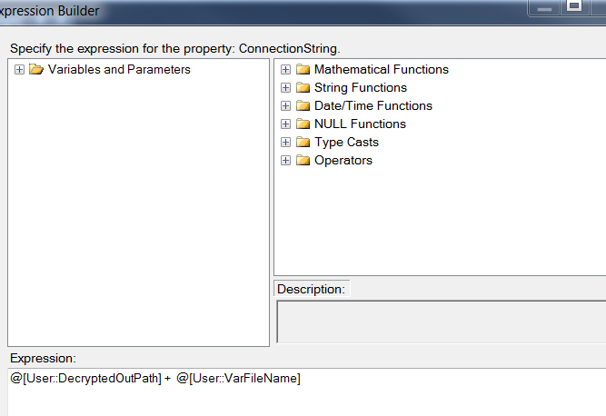

* + - * 1. Bingo_File

Expression: @[User::DecryptedOutPath] + @[User::VarFileName]

* + - * 1. OTH_File

Expression: @[User::DecryptedOutPath] + @[User::VarFileName]

* + - * 1. Failed_File

Expression: @[User::DecryptedOutPath]+ @[User::varFailedFile]

* + - * 1. Encrypted_File

Expression: @[User::EncryptedOutPath] + @[User::varEncryptedFileName]

* + - * 1. SMTP Connection Manager

smtpint.maxcorp.maximus

* + - 1. **Package Content(Control Flow)**

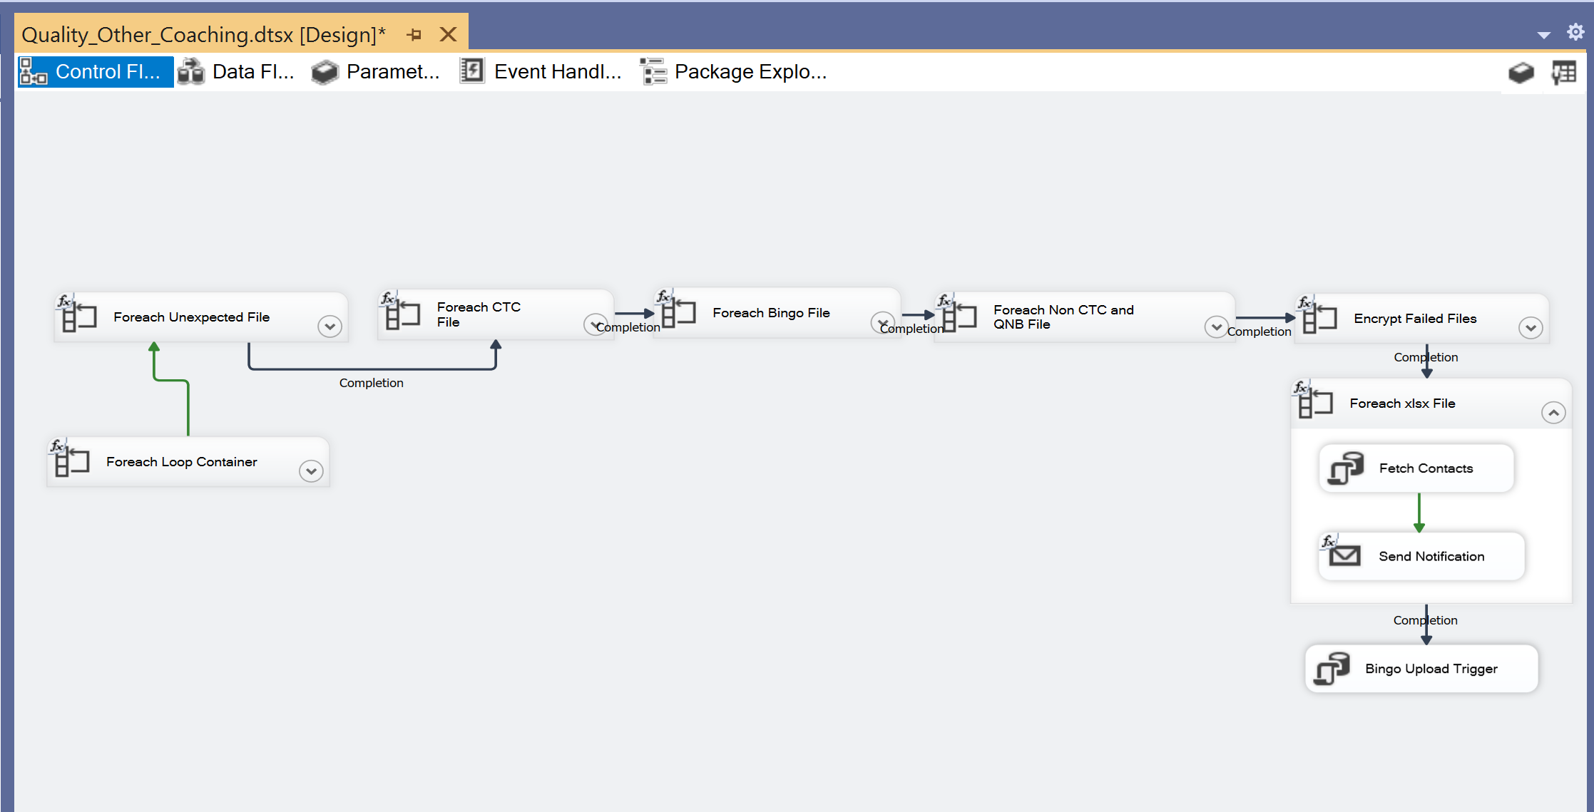

**Workflow**

* + - * 1. **Decrypt Encrypted Files**

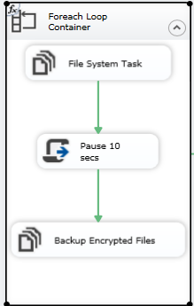

**Summary of Steps**

1. File system task – Decrypt files
2. Script task - Pause 10 seconds
3. File system task – Backup encrypted files

**Details**

Container: Foreach File Loop

Folder: \\UVAAPADSQL50CCO\data\coaching\Quality\Encrypt_out\

Files: eCL*ETS_*.encrypt

Retrieve file name: Name and Extension

1. File system task – Decrypt files

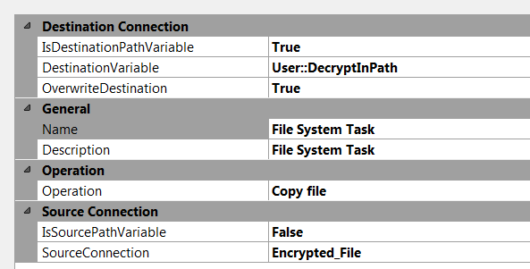

1. Script task- Pause 10 secs

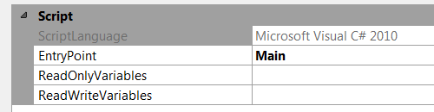

public void Main()

{

// TODO: Add your code here

// Sleep for 10 seconds (*1000)

System.Threading.Thread.Sleep(10000);

Dts.TaskResult = (int)ScriptResults.Success;

}

1. File System task – Backup Encrypted files

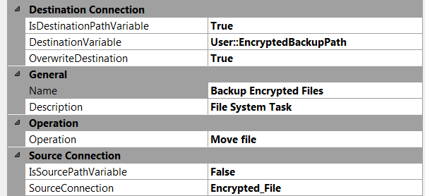

* + - * 1. **For each Unexpected File**

**Summary of Steps**

1. SQL task – Fetch Report Code
2. Email task – Send Notification
3. File system task – Delete File(s)

**Details**

Container: Foreach Loop

Folder: \\UVAADADSQL50CCO\data\coaching\Quality\Decrypt_out\

Files: eCL_*.csv

Retrieve file name: Name and Extension

1. SQL task – Fetch Report Code

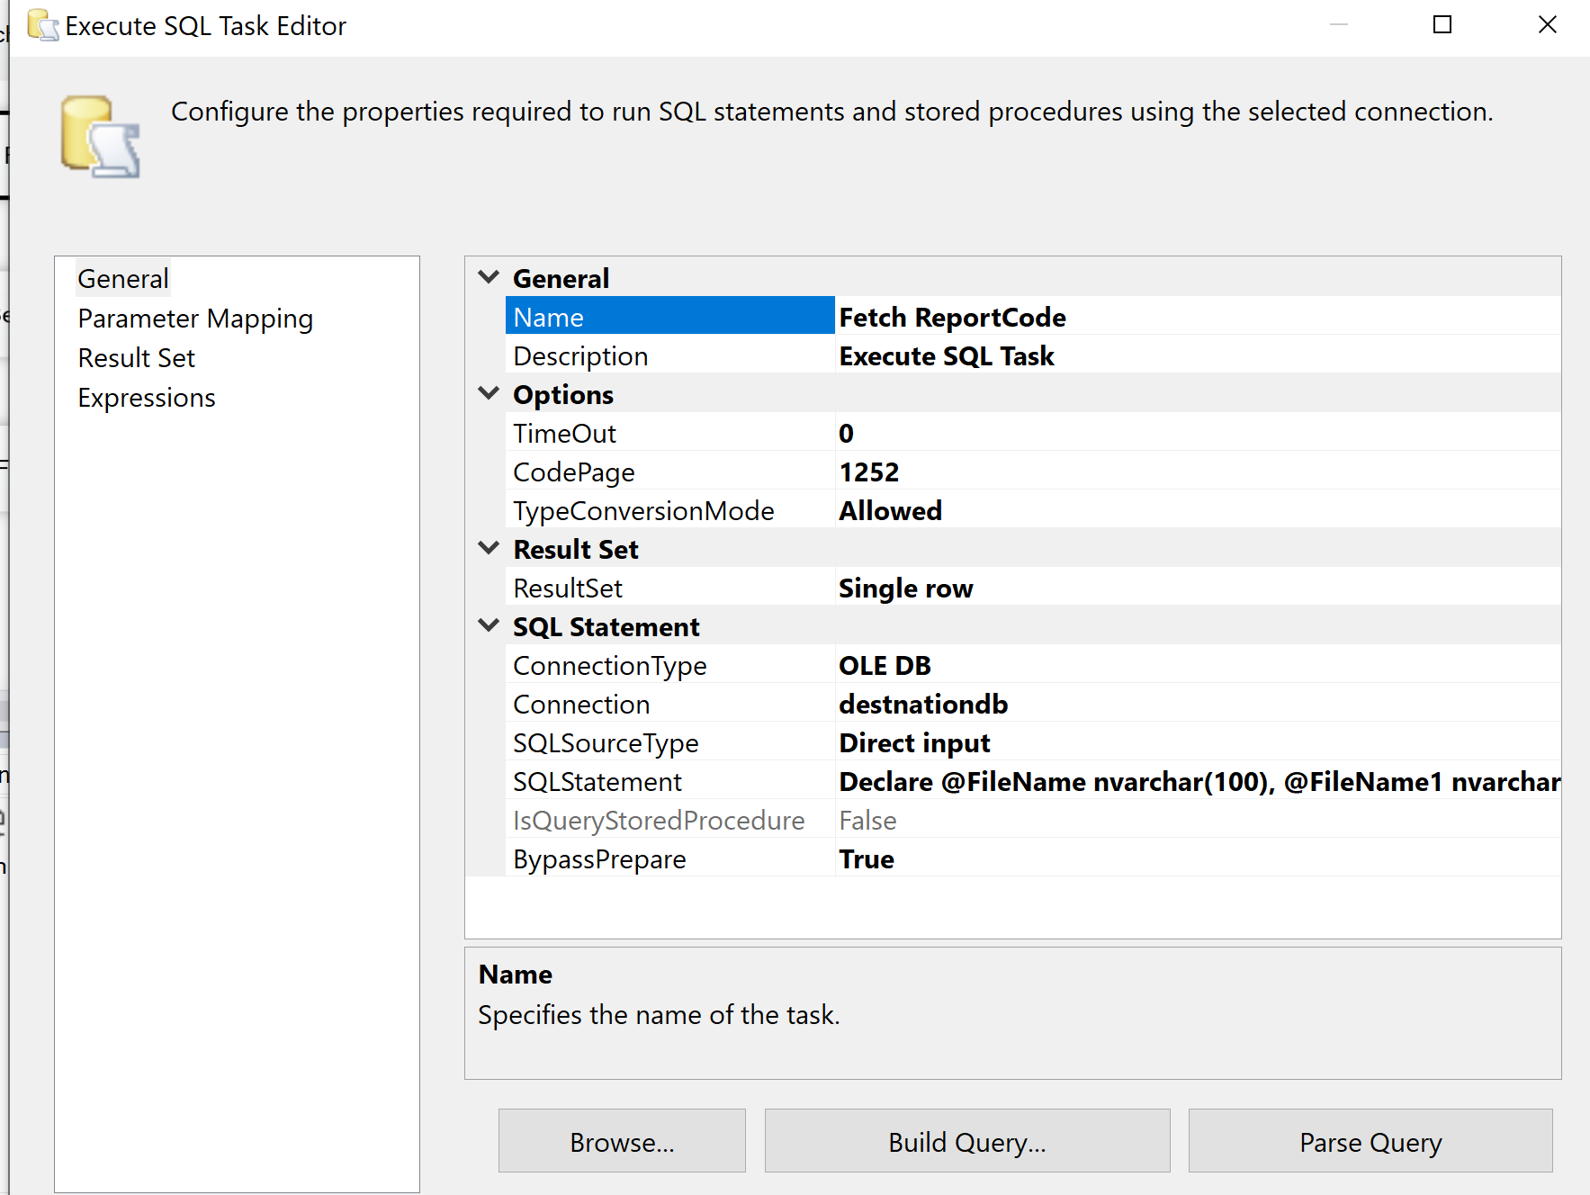

Declare @FileName nvarchar(100), @FileName1 nvarchar(100)

SELECT TOP 1 [ReportCode] FROM

(SELECT TOP 1 [ReportCode] FROM [EC].[Feed_Contacts]

WHERE (CHARINDEX([ReportCode], ? ) > 0 AND CHARINDEX('Quality', ? ) > 0)

UNION ALL

SELECT DISTINCT 'Unknown' AS [ReportCode] FROM [EC].[Feed_Contacts] ) pocs

ORDER BY CASE WHEN [ReportCode] = 'Unknown' THEN 2 ELSE 1 END

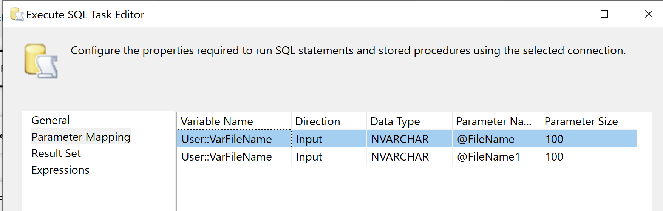

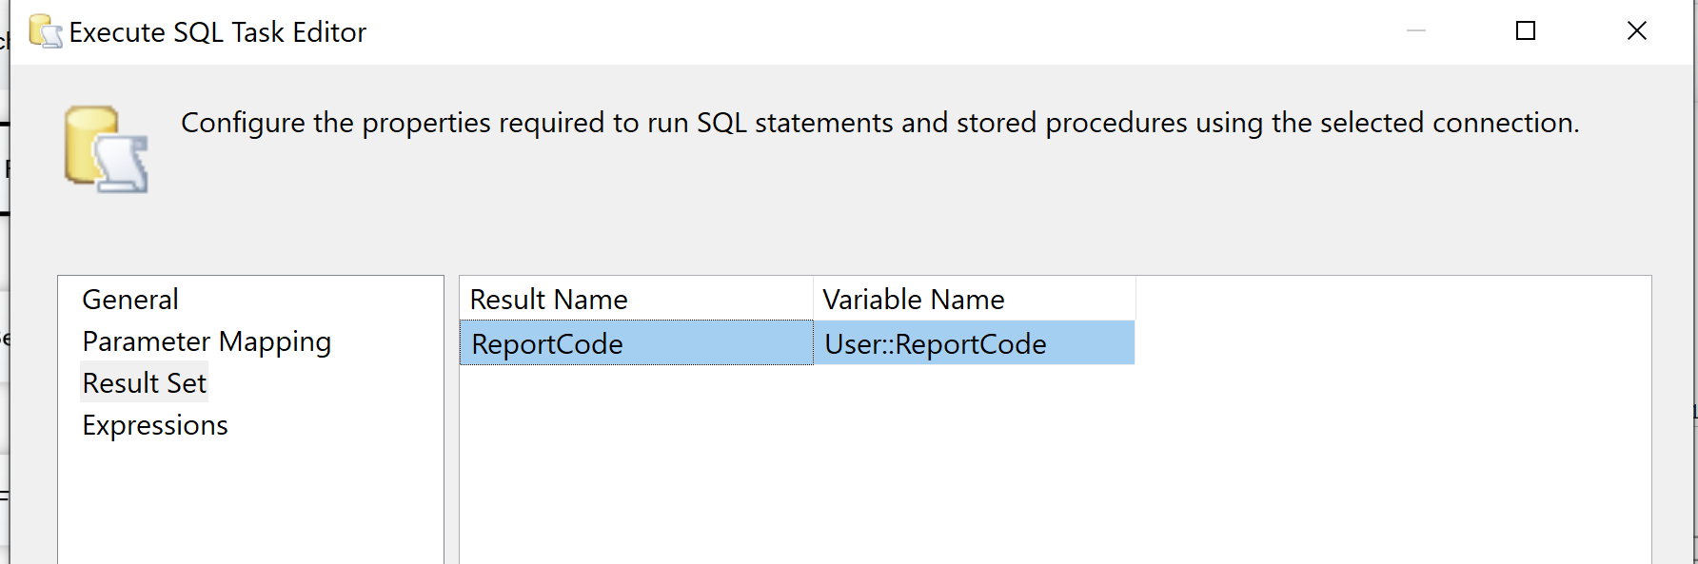

1. Email task – Send Notification

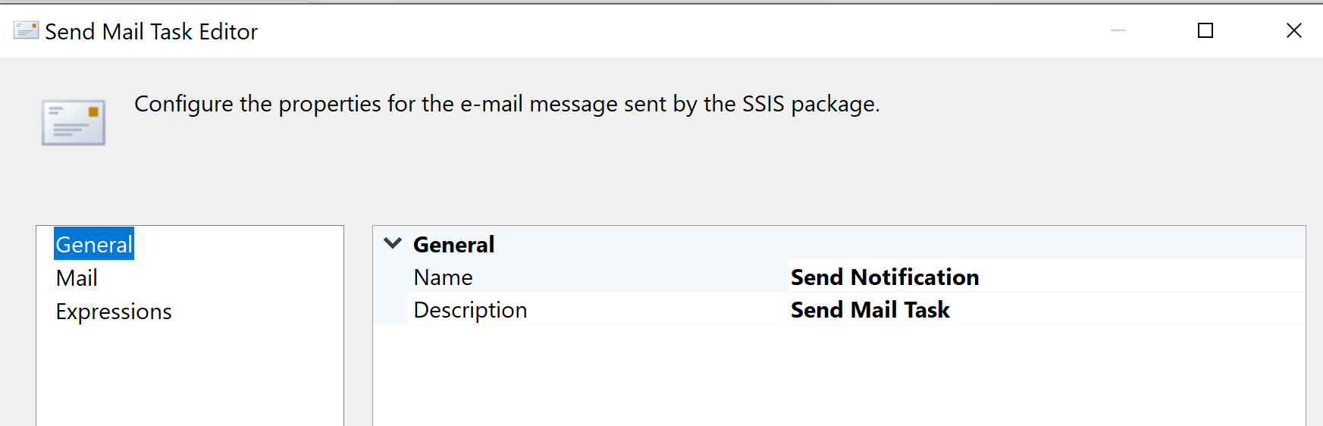

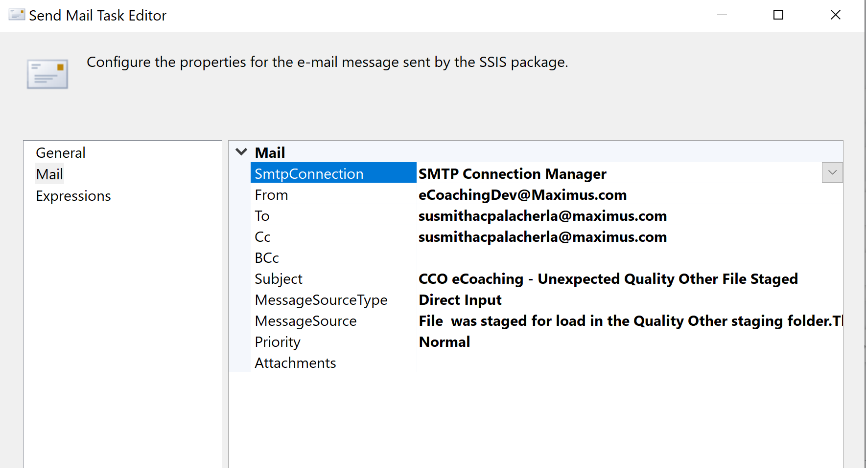

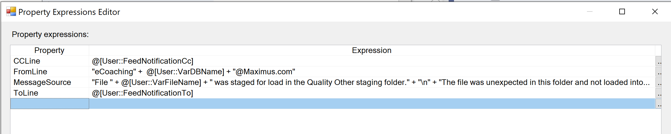

1. File system task – Delete File(s)

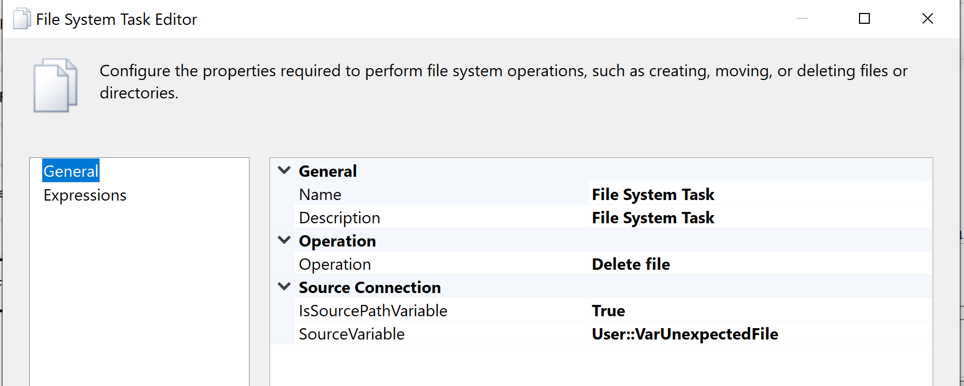

* + - * 1. **For each CTC file in Staging directory Workflow**

**Container properties to set**

1. Fail Package on failure- True
2. Fail Parent on failure- False
3. Maximum Error count – 1
4. Event handlers – System Variables – Propagate - True

Container: Foreach Loop

Folder: \\UVAAPADSQL50CCO\data\coaching\Quality\Encrypt_out\

Files: eCL_Quality_Feed_*.csv

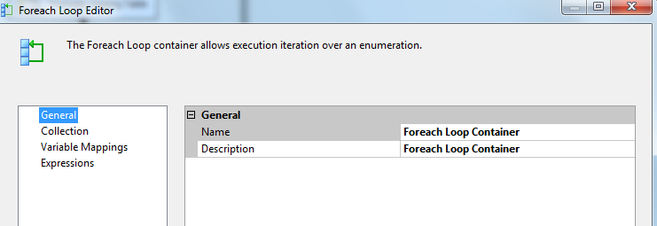

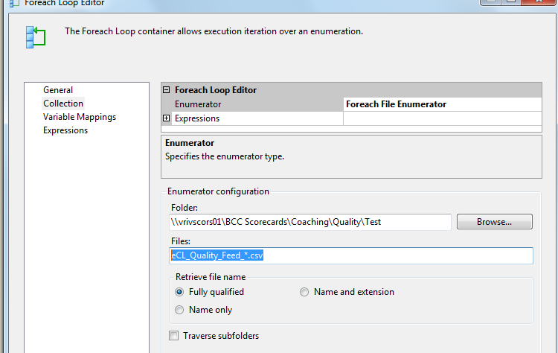

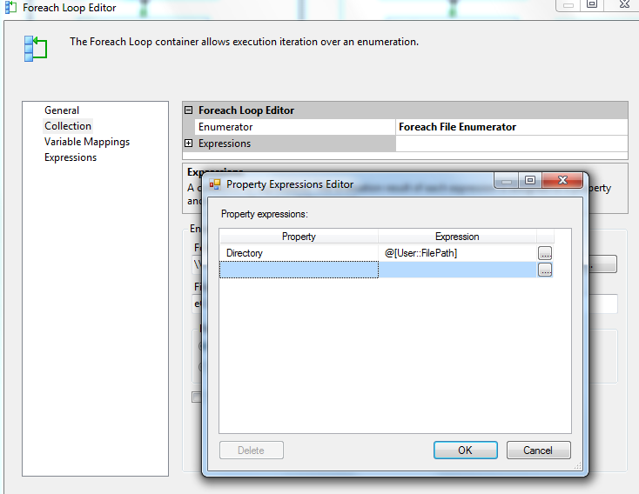

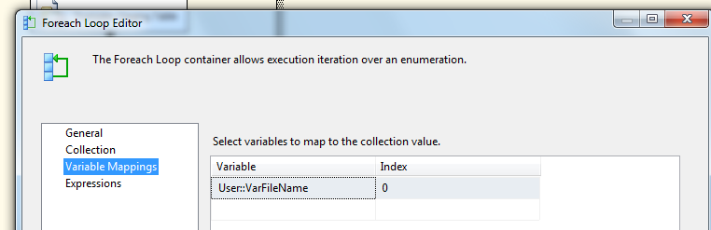

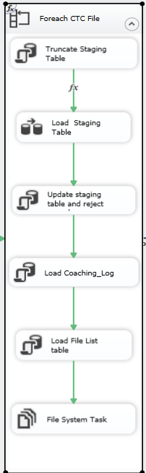

**Summary of Steps**

1. SQL task – Truncate Quality_Other Staging table
2. DFT – Load Quality_Other Staging table
3. SQL task – Update Staging table and Reject Logs
4. SQL task Load Coaching_Log and Coaching_Log_Reason tables
5. SQL task – Load File list table
6. File system task – Delete loaded file

**Details of Steps**

1. SQL task – Truncate Quality_Other Staging table

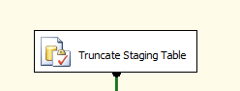

Executes Truncate Table [EC].[Quality_Other_Coaching_Stage]

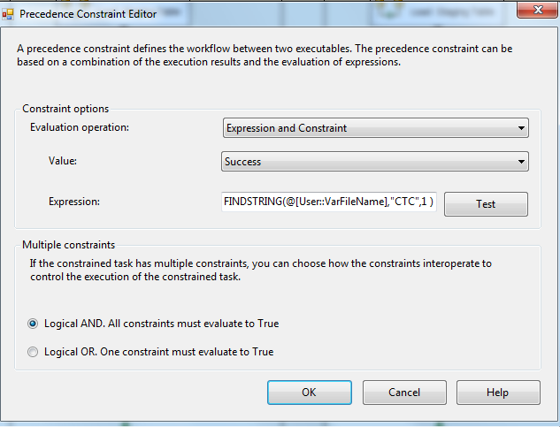

FINDSTRING(@[User::VarFileName],"CTC",1 ) > 0

1. DFT: Load Quality_Other staging table

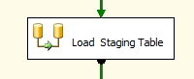

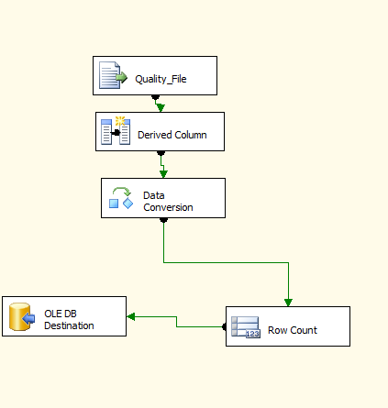

1. Flat File source

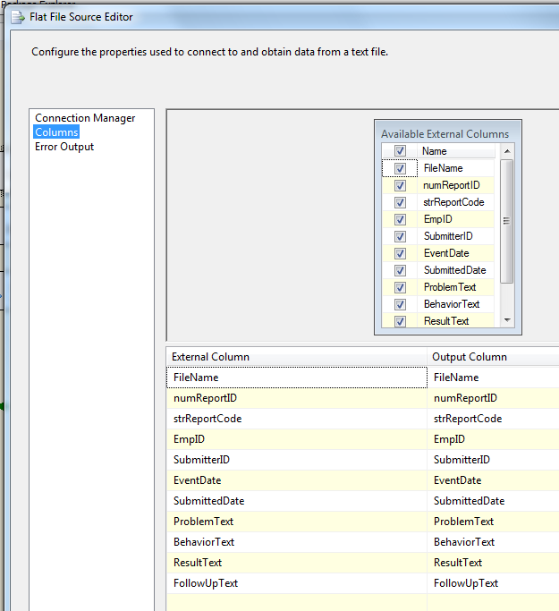

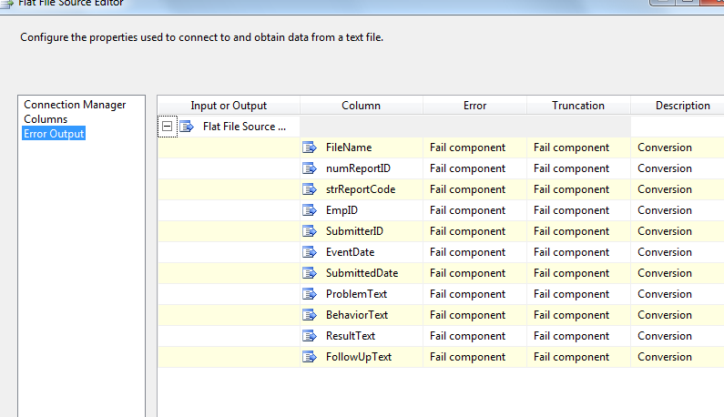

1. Derived column

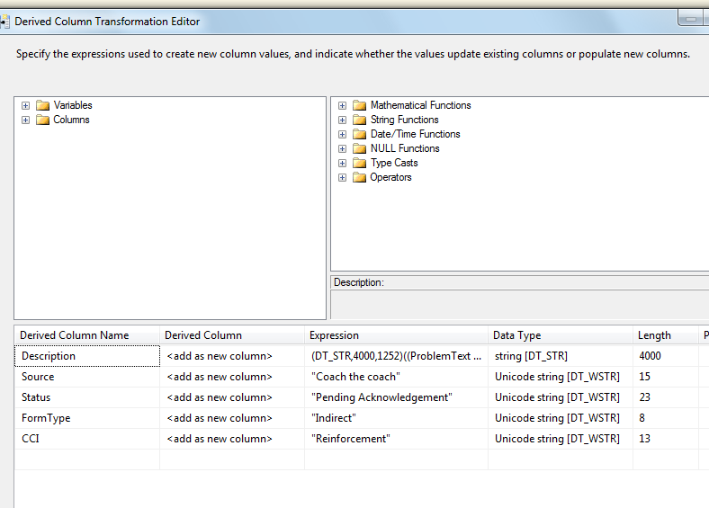

(DT_STR,4000,1252)((ISNULL(ProblemText) ? "Problem: N/A|" : ProblemText + "|") + (ISNULL(BehaviorText) ? "Behavior: N/A|" : BehaviorText + "|") + (ISNULL(ResultText) ? "Result: N/A|" : ResultText + "|") + (ISNULL(FollowUpText) ? "Follow Up: N/A|" : FollowUpText))

1. Data Conversion

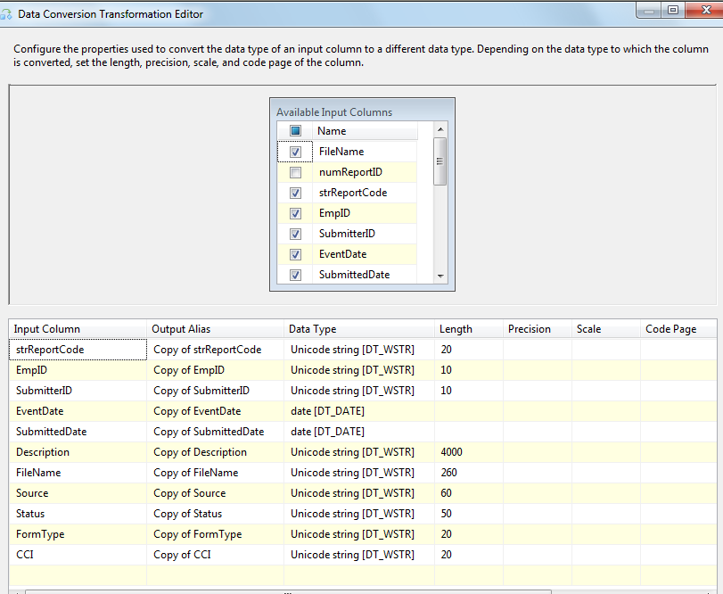

1. Row Count Transformation

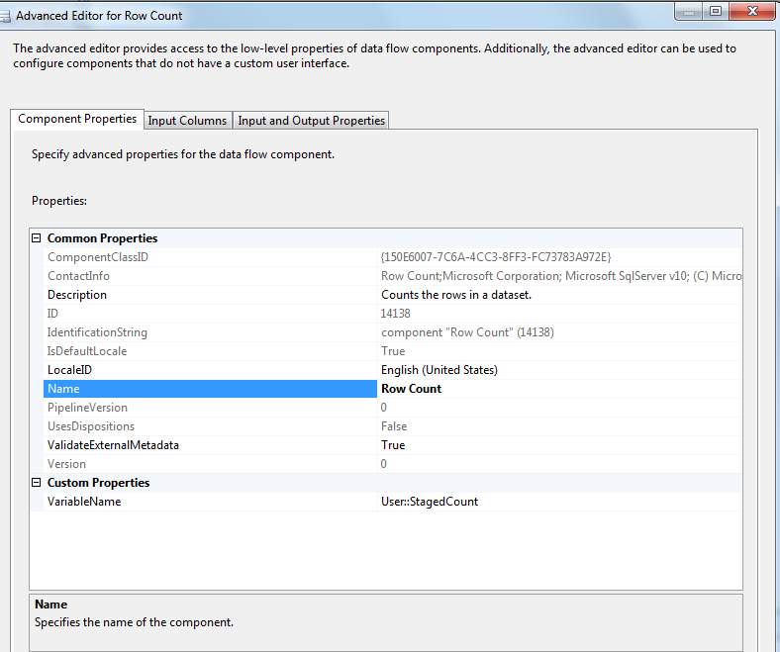

1. oledb destination

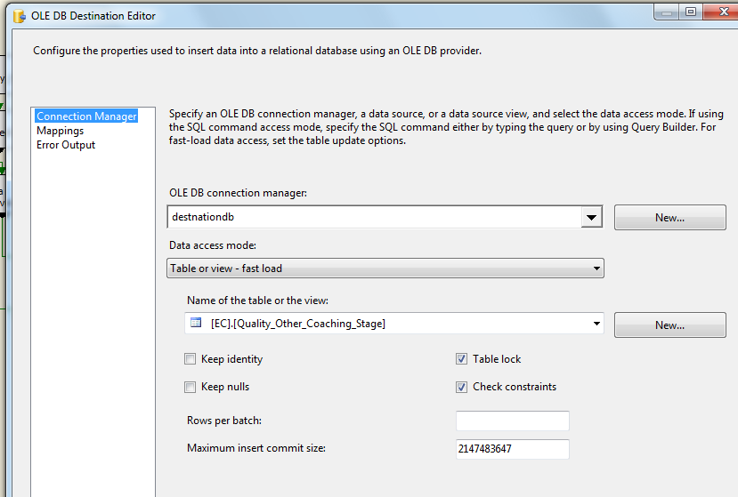

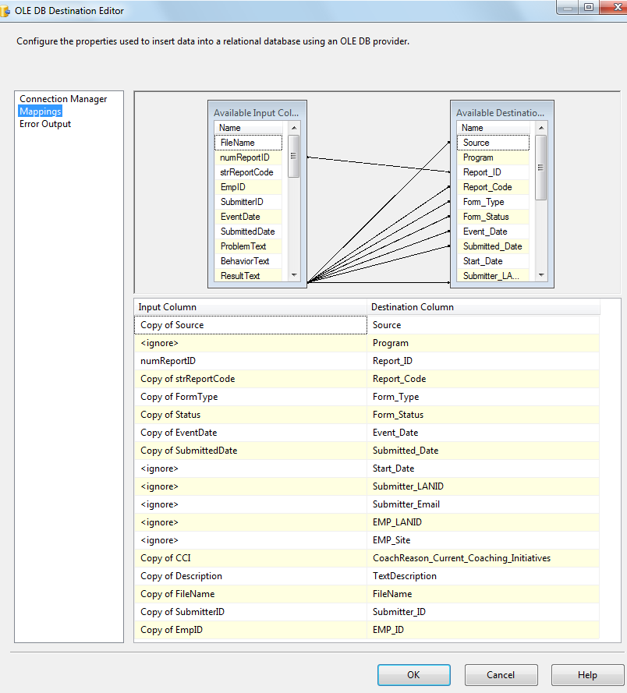

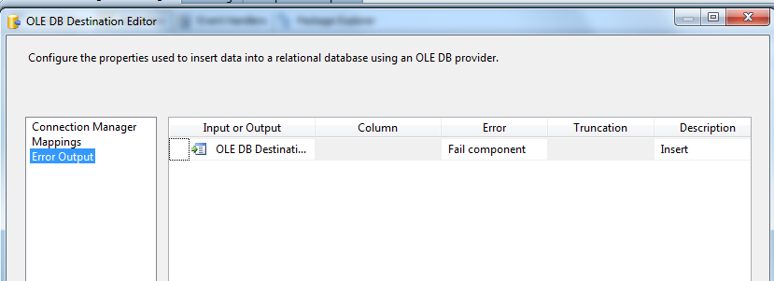

1. SQL Task: Update Staging table and reject logs

Exec [EC].[sp_Update_Quality_Other_Coaching_Stage] ? output

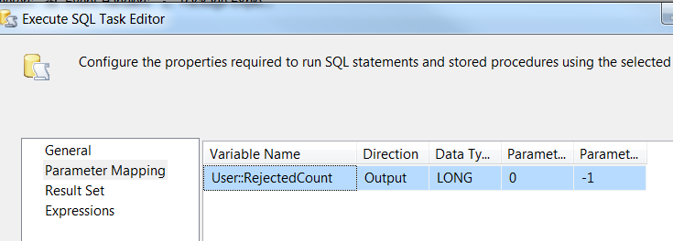

1. SQL Task: Load Coaching_Log table

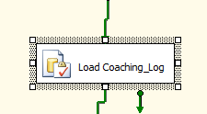

Exec [EC].[sp_InsertInto_Coaching_Log_Quality_Other]

1. SQL Task: Load Quality_Other File List table

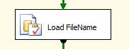

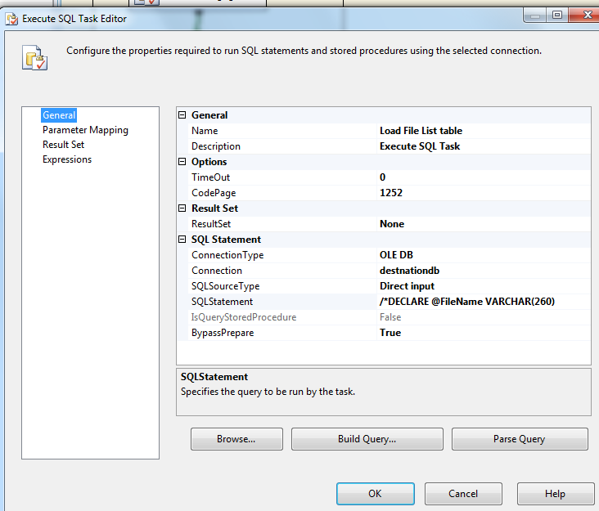

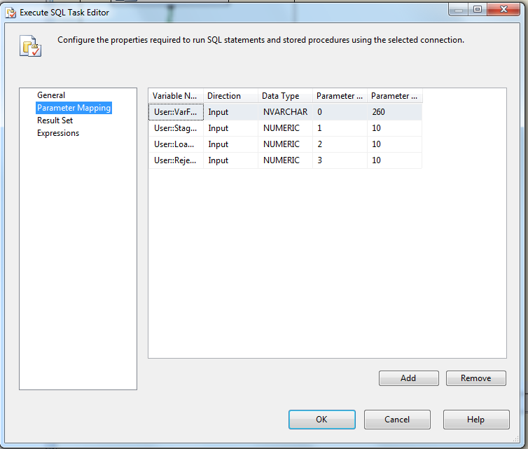

Executes the following sql

INSERT INTO [EC].[Quality_Other_FileList]

([File_Name]

,[File_LoadDate]

,[Count_Staged]

,[Count_Loaded]

,[Count_Rejected])

VALUES (?,GetDate(), ?, ?,?)

1. File System Task: Delete loaded file

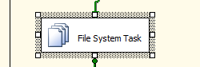

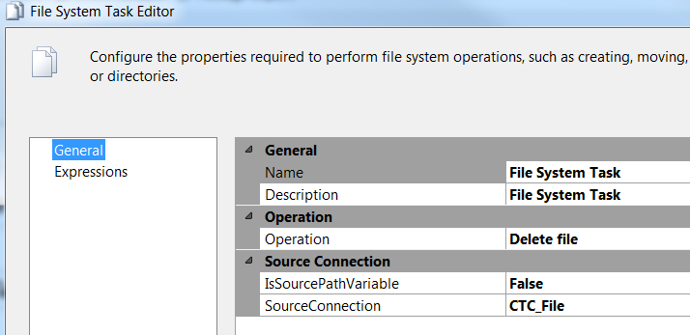

* + - * 1. **For each BQN file in Staging directory Workflow**

**Container properties to set**

1. Fail Package on failure- True
2. Fail Parent on failure- False
3. Maximum Error count – 1
4. Event handlers – System Variables – Propagate - True

Container: Foreach Loop

Folder: \\UVAAPADSQL50CCO\data\coaching\Quality\Encrypt_out\

Files: eCL_Quality_Feed_*.csv









**Summary of Steps**

1. SQL task – Truncate Quality_Other Staging table
2. DFT – Load Quality_Other Staging table
3. SQL task – Update Staging table and Reject Logs
4. SQL task Load Coaching_Log and Coaching_Log_Reason tables
5. SQL task – Load File list table
6. File system task – Delete loaded file

**Details of Steps**

1. SQL task – Truncate Quality_Other Staging table



Executes Truncate Table [EC].[Quality_Other_Coaching_Stage]



FINDSTRING(@[User::VarFileName],"BQ",1 ) > 0

1. DFT: Load Quality_Other staging table



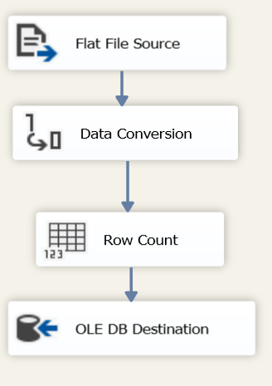

1. Flat File source

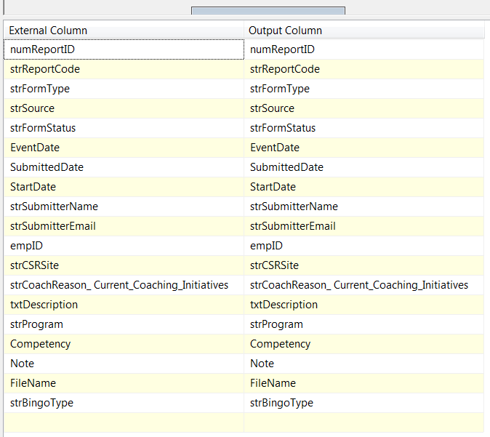

1. Data Conversion

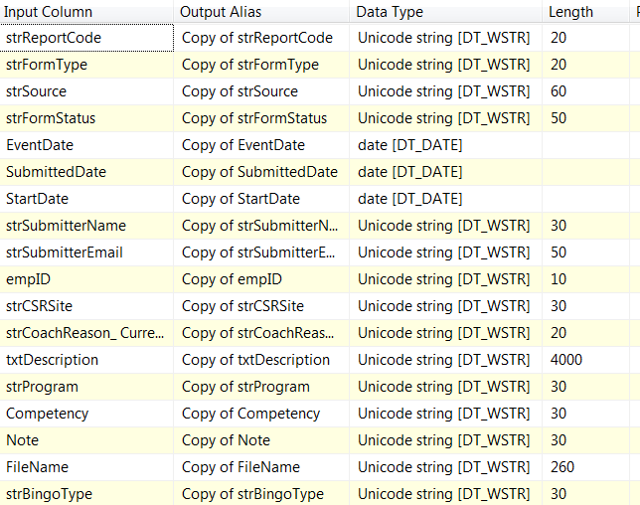

1. Row Count Transformation

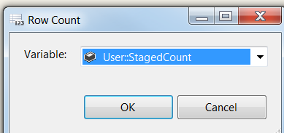

1. oledb destination

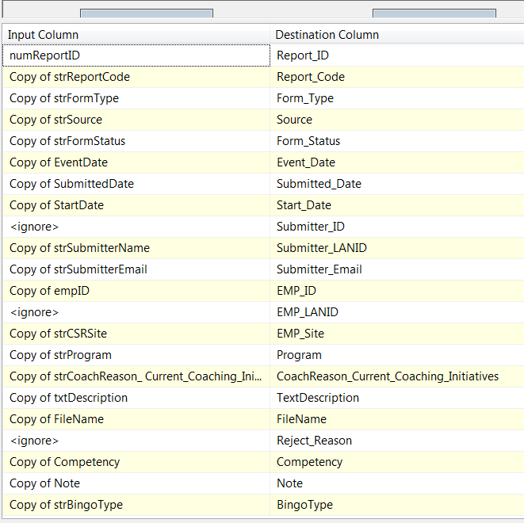

1. SQL Task: Update Staging table and reject logs

Exec [EC].[sp_Update_Quality_Other_Coaching_Stage] ? output



1. SQL Task: Load Coaching_Log table



Exec [EC].[sp_InsertInto_Coaching_Log_Quality_Other]

1. SQL Task: Load Quality_Other File List table







Executes the following sql

INSERT INTO [EC].[Quality_Other_FileList]

([File_Name]

,[File_LoadDate]

,[Count_Staged]

,[Count_Loaded]

,[Count_Rejected])

VALUES (?,GetDate(), ?, ?,?)

1. File System Task: Delete loaded file





* + - * 1. **For each Non CTC and BQ file in Staging directory Workflow**

Container: Foreach Loop

Folder: \\UVAAPADSQL50CCO\data\coaching\Quality\Encrypt_out\

Files: eCL_Quality_Feed_*.csv

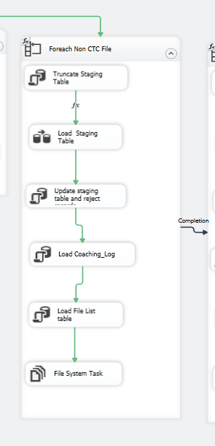

**Container properties to set**

1. Fail Package on failure- False
2. Fail Parent on failure- False
3. Maximum Error count – 0
4. Event handlers – System Variables – Propagate - False

**Summary of Steps**

1. SQL task – Truncate Quality_Other Staging table
2. DFT –Load Quality_Other Staging table
3. SQL task – Update Staging table and Reject Records
4. SQL task Load coaching_Log and Coaching_Log_Reason tables
5. SQL task – Load File list table
6. File system task – Backup files to Backups directory

**Details of Steps**

1. SQL task – Truncate Quality_Other Staging table



Executes Truncate Table [EC].[Quality_Other_Coaching_Stage]

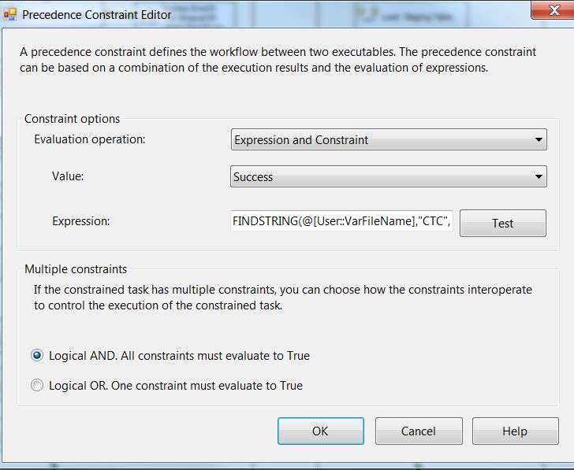

FINDSTRING(@[User::VarFileName],"CTC",1 ) == 0 && FINDSTRING(@[User::VarFileName],"BQ",1 ) == 0

1. DFT: Load Quality_Other staging table



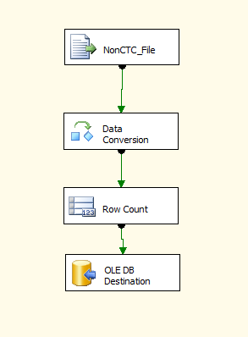

1. Flat File source

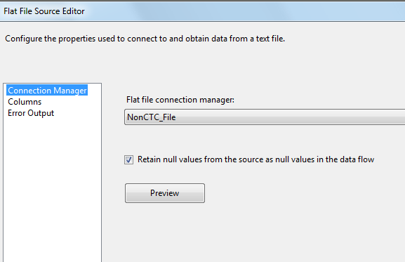

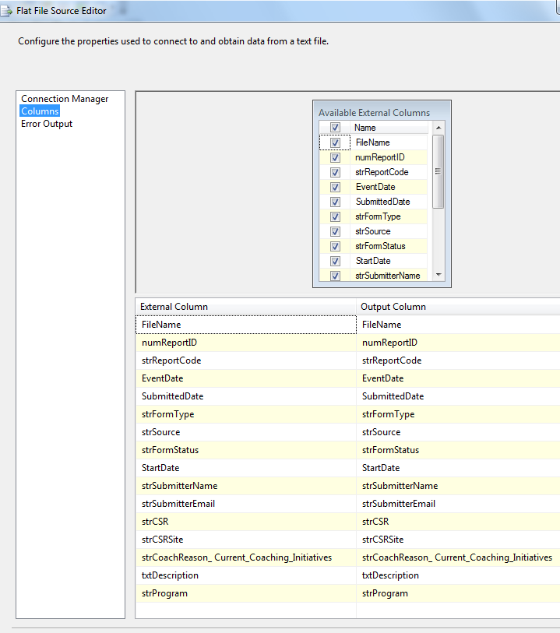

1. Data Conversion

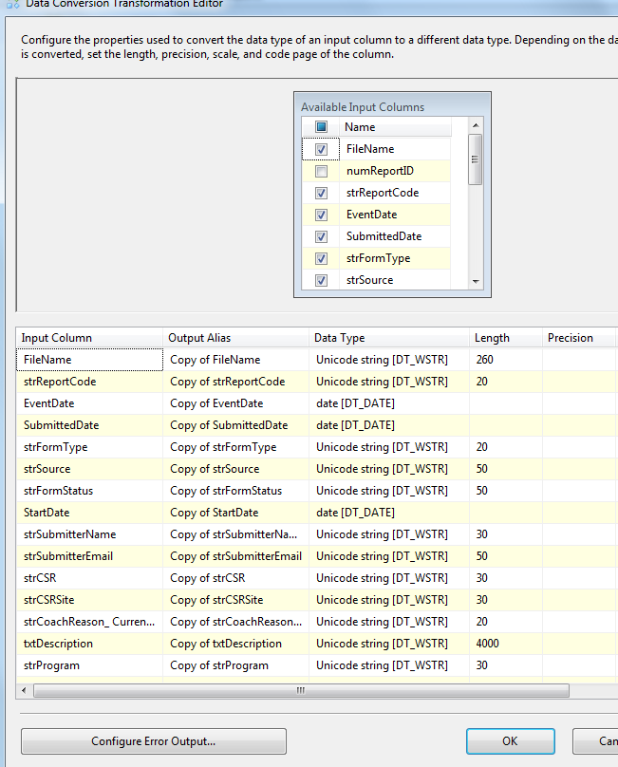

1. Row Count Transformation



1. Oledb destination



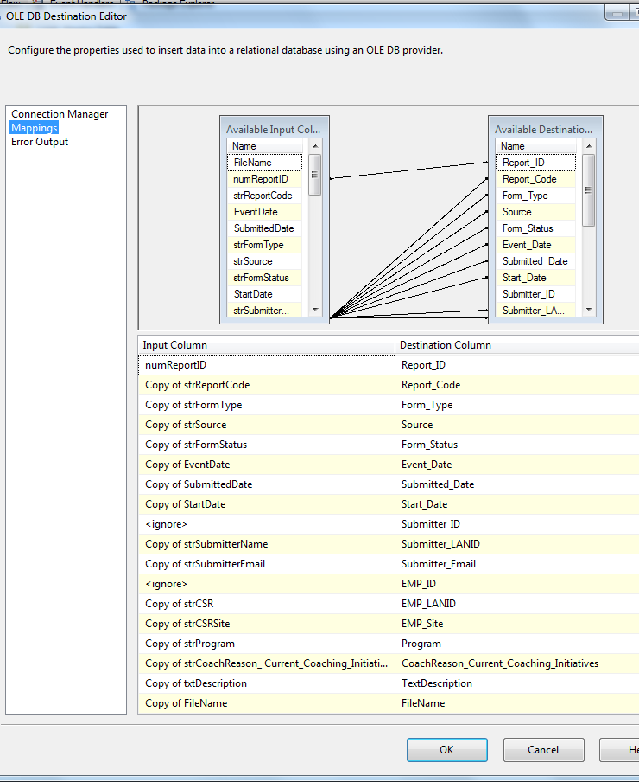

1. SQL Task: Update Staging table and Reject Records

Exec [EC].[sp_Update_Quality_Other_Coaching_Stage] ? output

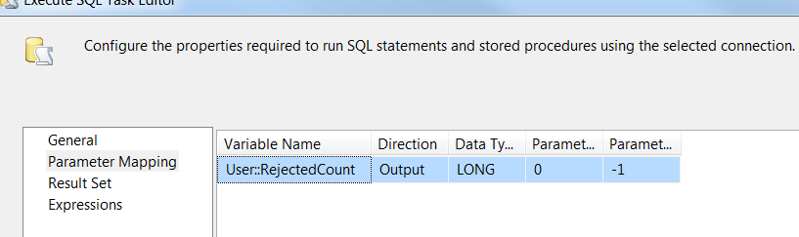

1. SQL Task: Load Coaching_Log table



Exec [EC].[sp_InsertInto_Coaching_Log_Quality_Other]

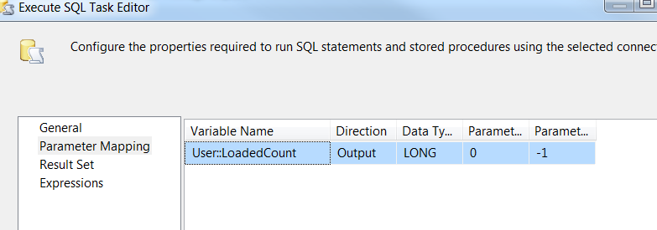

1. SQL Task: Load Quality_Other File List table

INSERT INTO [EC].[Quality_Other_FileList]

([File_Name]

,[File_LoadDate]

,[Count_Staged]

,[Count_Loaded]

,[Count_Rejected])

VALUES (?,GetDate(), ?, ?,?)

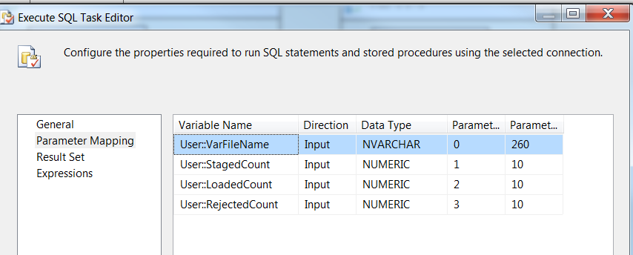

1. File System Task: Delete Files

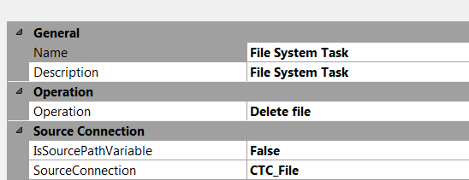

Precedence Constraint between Non-CTC and CTC containers

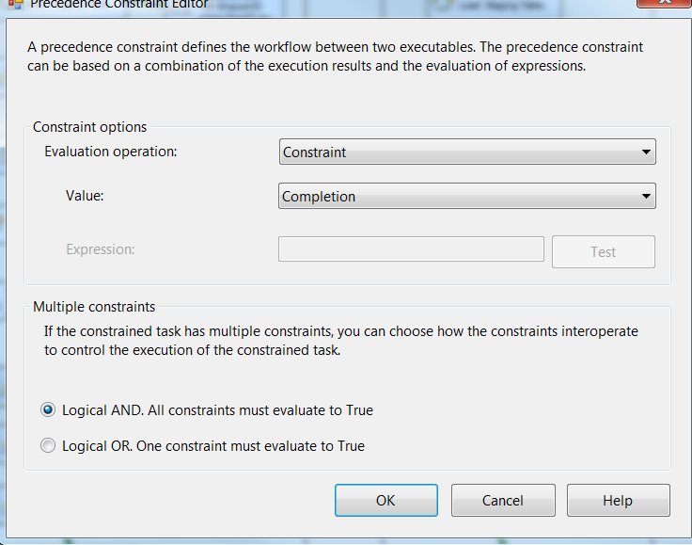

* + - * 1. **For each Failed File ( Encrypt failed files)**

**Summary of Steps**

1. File system task – Encrypt failed files
2. Script task - Pause 10 seconds

**Details**

Container: For each File Loop

Precedence Constraint - Completion

Folder: \\UVAAPADSQL50CCO\data\coaching\ETS\Decrypt_out\

Files: eCL*.csv

Retrieve file name: Name and Extension

1. File system task – Encrypt files

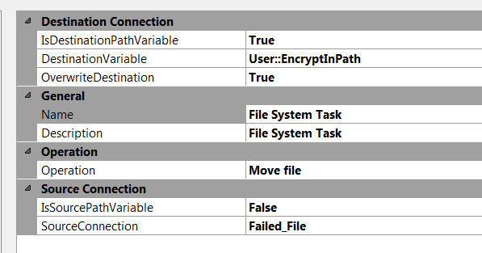

1. Script task- Pause 10 secs



public void Main()

{

// TODO: Add your code here

// Sleep for 10 seconds (*1000)

System.Threading.Thread.Sleep(10000);

Dts.TaskResult = (int)ScriptResults.Success;

}

* + - * 1. **For each Loop Container (xls(x) files)**

**Summary of Steps**

1. SQL task – Fetch Contacts
2. Send Mail Task – Send Notification

**Details**

Container: For each File Loop

Precedence Constraint - Completion

Folder: \\UVAADADSQL50CCO\data\coaching\Quality\Decrypt_out\ Derived from Expression for Foreach File enumerator

Files: eCL_*.xls*

Retrieve file name: Name and Extension

1. SQL task – Fetch Contacts

General

Result Set – Single Row

Connection Type – OLE DB

Connection – destinationdb

SQL Statement - Declare @FileName nvarchar(100)

SELECT TOP 1 PrimaryPOC, SecondaryPOC FROM

(SELECT TOP 1 PrimaryPOC, SecondaryPOC FROM [EC].[Feed_Contacts]

WHERE CHARINDEX([ReportCode], ? ) > 0

UNION ALL

SELECT DISTINCT 'Unknown' AS PrimaryPOC, 'Unknown' AS SecondaryPOC FROM [EC].[Feed_Contacts]) pocs

ORDER BY CASE WHEN PrimaryPOC = 'Unknown' THEN 2 ELSE 1 END

Parameter Mapping

|  |  |  |  |  |
| --- | --- | --- | --- | --- |
| Variable Name | Direction | Data Type | Parameter Name | Parameter Size |
| User::VarFileName | Input | NVARCHAR | @FileName | 100 |

Result Set

|  |  |
| --- | --- |
| Result Name | Variable Name |
| PrimaryPOC | User::FeedNotificationPOC1 |
| SecondaryPOC | User::FeedNotificationPOC2 |

1. Send Mail Task – Send Notification

|  |  |  |
| --- | --- | --- |
| Property | Source | Expression/Value |
| SmtpConnection | Connection Manager | SMTP Connection Manager |
| From | Expression(FromLine) | "eCoaching" + @[User::VarDBName] + "@Maximus.com" |
| To | Expression(toLine) | @[User::FeedNotificationTo] |
| Cc | Expression(CcLine) | @[User::FeedNotificationCc] |
| Subject | Hardcoded Value | CCO Quality eCoaching Feed Format Issue |
| Message Source | Variable | User::FeedNotificationBody |

* + - * 1. **SQL Task ( Bingo Upload Trigger)**

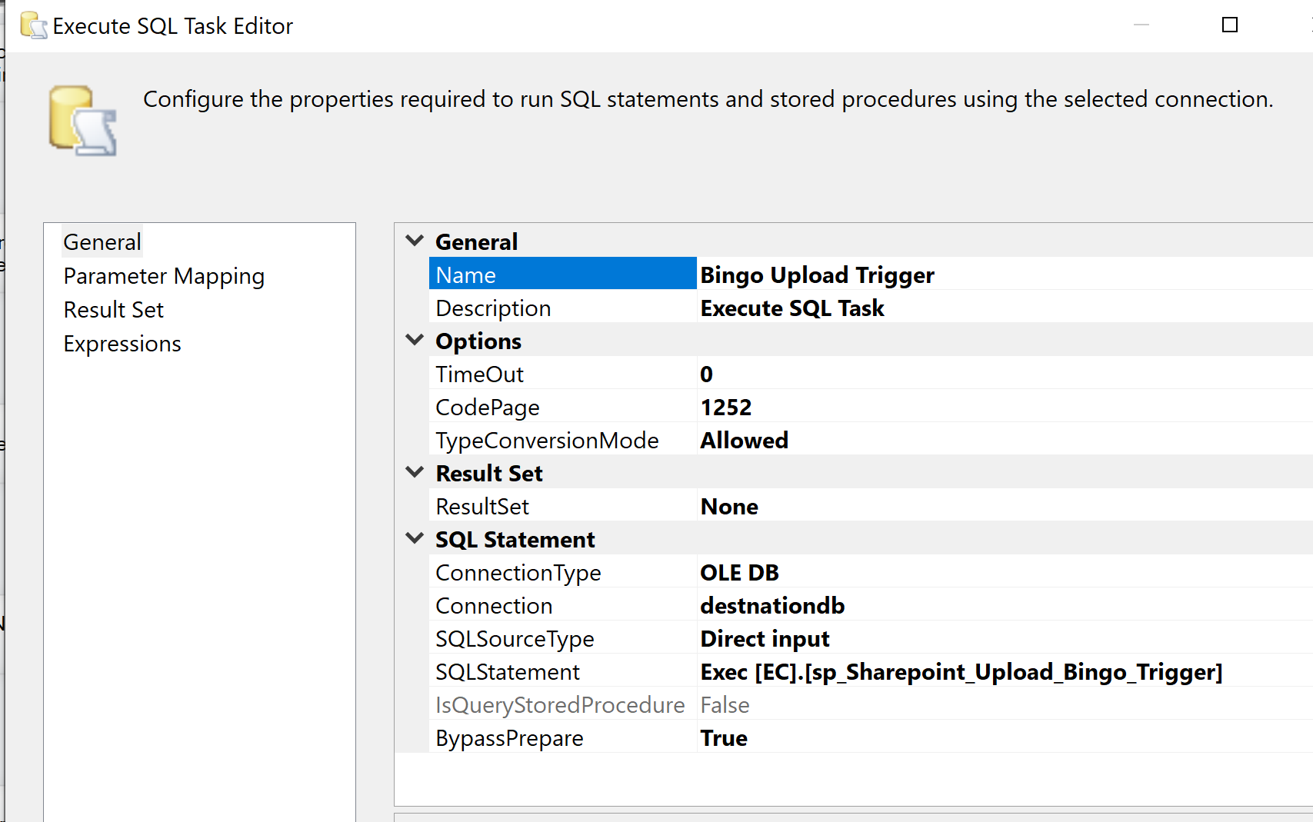

* + - 1. **Package Content(Event Handlers)**

Executables: Quality_Other _Coaching

EventHandler: OntaskFailed

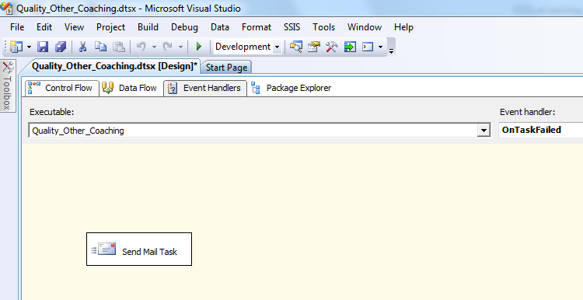

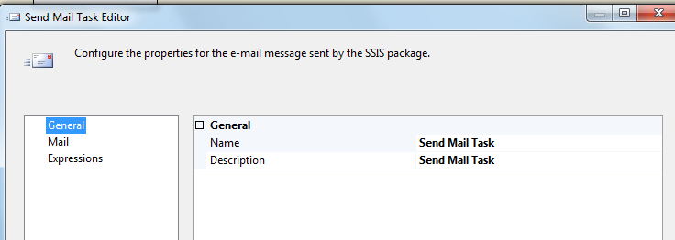

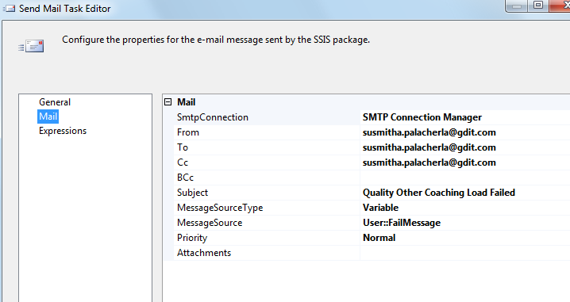

### Tables

|  | **Table Name** | **Table Description** |
| --- | --- | --- |
| 1. | Quality_Other_Coaching_Stage | Table used for staging the Quality_Other records during the insert into Coaching_Log table. |
| 2. | Quality_Other_Coaching_Rejected | Table used for storing the rejected Quality_Other records during the insert into Coaching_Log table. Logs are rejected when an incoming Lan ID does not exist in the Employee_Hierarchy table. |
| 3. | Quality_Other_Coaching_Fact | Table used for storing Quality_Other source records loaded into the Coaching Log table. |
| 4. | Quality_Other_FileList | Table used for storing the Quality_Other file names and Load dates. |
| 5. | EC. Coaching_Log_Bingo | Holds the details of Achievements earned by the employee for each month. An agent can have 1 through 7 achievements (detail records) for a month that are tied to one parent eCL. |
| 6. | EC. Bingo_Images | A table to hold the list of Images for the competency the image is associated with. |

Table structure and details in document: CCO_eCoaching_Quality_Other_Load_Tables_Create.sql

### Procedures

|  | **Procedure Name** | **Usage** |
| --- | --- | --- |
| 1. | sp_InsertInto_Coaching_Log_Quality_Other | Load: Quality_Other Data |
| 2. | sp_Update_Quality_Other_Coaching_Stage | Load: Quality_Other Data |
| 3. | sp_SelectCoaching4Bingo | Notifications: Bingo Data |
| 4. | sp_Sharepoint_Upload_Bingo_Trigger | Upload: Bingo SharePoint upload |

### Functions

|  | **FunctionName** | **Usage** |
| --- | --- | --- |
| 1. | fn_strBingoDescriptionFromCompDesc | Given an EmpID Consolidates individual Descriptions for each competency to a single value for the Employee |
| 2. | fn_strAchievementsForCoachingId | Given a CoachingID consolidates all the Competency Image refrences to a single string |
| 3. | fn_strBingoCompetenciesFromEmpID | Given an EmployeeID and Bingo Type returns the Bingo Competency Values for the Employee concatenated as a single string of values separated by a '|' |