__________________________



**Title: eCoaching_Training_Load**

**SSIS Detail Design Document**

__________________________

|  |  |  |
| --- | --- | --- |
| Last Revision | Last Review | Description |
| 7/10/2019 |  | TFS 14706 - Switch smtpout.gdit.com to ironport.maximus.com |

Prepared by: Susmitha Palacherla Date: 03/23/2016

Department, Location: Health Solutions Division

Approved by: Date:

**Change History Log**

| **Date** | **Change Description** | **Author** |
| --- | --- | --- |
| 03/23/2016 | 1.0 Initial revision. TFS 2283. | Susmitha Palacherla |
| 8/14/2017 | 2.0 TFS 7105 – Upgrade to SQL Server 2012 | Susmitha Palacherla |
| 12/28/2017 | 3.0 TFS 7854 – Encryption related changes for feed files and staging tables | Susmitha Palacherla |
| 07/10/2019 | 4.0 TFS 14706 - Switch smtpout.gdit.com to ironport.maximus.com | Susmitha Palacherla |
|  |  |  |
|  |  |  |
|  |  |  |

Contents

1. Overview 4

1.1 Project Description 4

1.2 Document Scope 4

1.3 Source Files 4

1.4 Module List 5

1.5 Software and Hardware Interfaces 5

1.5.1 Software 5

1.5.2 Hardware 5

1.6 Users 5

2. Details 6

2.1 Source Files 6

2.2 Module Details 6

2.2.1 SQL agent job 6

2.2.2 SSIS Package 6

2.2.3 Tables 25

2.2.4 Procedures 25

2.2.5 Functions 25

# Overview

## Project Description

The coaching process is a standard process to facilitate consistent communication when a performance opportunity exists. It provides a method to make a determination of whether coaching is needed, when to initiate coaching and verification that the performance issue has been addressed. The Training feed contains records for TQC GDIT verified Training when prescribed length of Training session is completed much sooner than expected. Training reports are created by the Quality team which identifies thresholds and exceptions that require coaching or further research by Call Center Supervisors. All items are entered into the eCL via a data feed. Utilizing the eCL work-flow, items can be tracked from start to finish to verify if items have been addressed. The eCL will also provide reporting on the number of Training entered into the system, the number coached, pending coaching, pending review or reasons why coaching was not required.

## Document Scope

This document describes the load of the Training reports provided by the Training and Development team into the eCoaching database. Once the reports are loaded into the database the logs are tracked through the workflow like any Coaching log entered from the web interface.

## Source Files

The table below shows all of the Training report types that can arrive as feeds. Currently active feeds are marked by an ‘X’ in the table below.

Encrypted files are staged at \\f3420-ecldbp01\data\Coaching\Training\Encrypt_Out with naming convention eCL_Training_Feed_XXXyyyymmdd.csv.zip.encrypt until scheduled load time.

Files are decrypted during the load process to naming convention eCL_Training_Feed_XXXyyyymmdd.csv and placed in directory \\f3420-ecldbp01\data\Coaching\Training\Decrypt_Out from where they get loaded.

|  |  |  |  |  |  |  |
| --- | --- | --- | --- | --- | --- | --- |
| **#** | **Metric/Report** | **Active Feed** | **Code** | **eCL Workflow** | **Entry** | **Coaching Reason** |
| 1 | Training: Short Duration Reporting | x | SDR | Direct Coach | Feed | Current Coaching Initiatives |
| 2 | Training: Overdue Training report | x | ODT | Direct Coach | Feed | Current Coaching Initiatives |

## Module List

* SQL agent job
* SSIS Package
* Tables
* Procedures

## Software and Hardware Interfaces

### Software

* SQL Server 2012 SP3 Suite

### Hardware

* F3420-ECLDBD01 – Dev DB Server
* F3420-ECLDBT01 – Test DB Server
* F3420-ECLDBP01 – Prod Server
* \\F3420-ECLDBD01\data\ - Dev File staging share
* \\F3420-ECLDBT01\data\ - Test File staging share
* \\F3420-ECLDBP01\data\ - Prod File staging share

## Users

* The first set of users for the Training records loaded into the eCL database are the CCO Supervisors as all records have default state of ‘Pending Supervisor Review’ at the time of the load.
* After a Supervisor reviews the log and determines that a Coaching is required the log gets assigned to the CSRs and they become the users.
* CCO Supervisors and Managers will be able to access the logs from the historical Dashboards.

# Details



## Source Files

eCL_Training _Feed_xxxyyyymmdd.csv is the naming convention for the feed where xxx is the 3 letter Report code.

Description: Files contain records for agents that fall below the required threshold times to complete a required Training in TQC or are past due on a required Training. The Training and Development team captures records that meet the above conditions and generate files for them. Once the feed are loaded into eCL the Supervisors have the opportunity to determine if a Coaching is needed or additional research is needed.

Source system: TQC

* Staging location: \\f3420-ecldbp01\data\Coaching\Training\Decrypt_Out\
* File name eCL_Training _Feed_xxxyyyymmdd.csv
* Frequency: File is expected to be placed on the share on Thursdays
* File arrival time: NA
* Destination Table: Coaching_Log and Coaching_Log_Reason

## Module Details

### SQL agent job

* Production Instance : F3420-ECLDBP01
* Production Job: CoachingTrainingLoad
* Production Package: \\F3420-ECLDBP01\ssis\Coaching\Packages\Training _Coaching.dtsx
* Production Config File: Prod_Training_Coaching.dtsConfig
* Owner: ecljobsowner
* Run As: ECLProxy (ECL Credential using application service account VNGT\SVC-SQLECLP01
* Schedule: Fridays 8:00 AM EST IF Files exist to be loaded
* Destination File Location: N/A

### SSIS Package

* + - 1. **Variables**

|  |  |  |  |
| --- | --- | --- | --- |
| **Name** | **Scope** | **DataType** | **Value** |
| DecryptedOutPath | Training_Coaching | String | \\f3420-ecldbp01\data\coaching\TRAINING\Decrypt_out\ |
| DecryptInPath | Training_Coaching | String | \\f3420-ecldbp01\data\coaching\TRAINING\Decrypt_in\ |
| EncryptedBackupPath | Training_Coaching | String | \\f3420-ecldbp01\data\coaching\TRAINING\Backups\ |
| EncryptedOutPath | Training_Coaching | String | \\f3420-ecldbp01\data\coaching\TRAINING\Encrypt_out\ |
| EncryptInPath | Training_Coaching | String | \\f3420-ecldbp01\data\coaching\TRAINING\Encrypt_in\ |
| FailMessage | Training_Coaching | String | "Training Coaching Load of file \"" + @[User::VarFileName] + "\" failed in " + @[User::VarDBName]+"." |
| StagedCount | Training_Coaching | Int32 | 0 |
| RejectedCount | Training_Coaching | Int32 | 0 |
| LoadedCount | Training_Coaching | Int32 | 0 |
| VarDBName | Training_Coaching | String | Dev |
| varFileName | Training_Coaching | String |  |
| varEncryptedFileName | Training_Coaching | String |  |

* + - 1. **Connection Manager Entries**
         1. Destinationdb
* Dev – F3420-ECLDBD01 DB – eCoachingdev
* Test - F3420-ECLDBT01 DB – eCoachingtest
* Prod - F3420-ECLDBP01 – eCoaching
  + - * 1. Training _File

Connection String Expression: @[User::DecryptedOutPath] + @[User::VarFileName]

* + - * 1. Encrypted _File

Connection String Expression: @[User::EncryptedOutPath]+ @[User::VarEncryptedFileName]

* + - * 1. SMTP Connection Manager

ironport.maximus.com

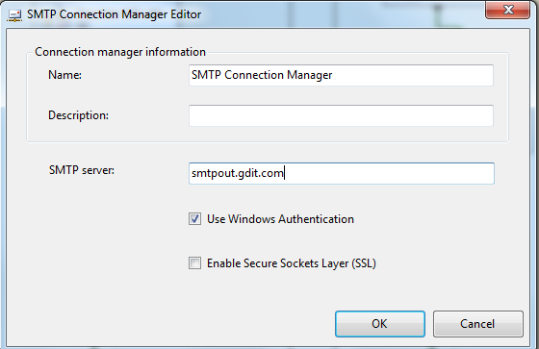

* + - 1. **Package Content(Control Flow)**

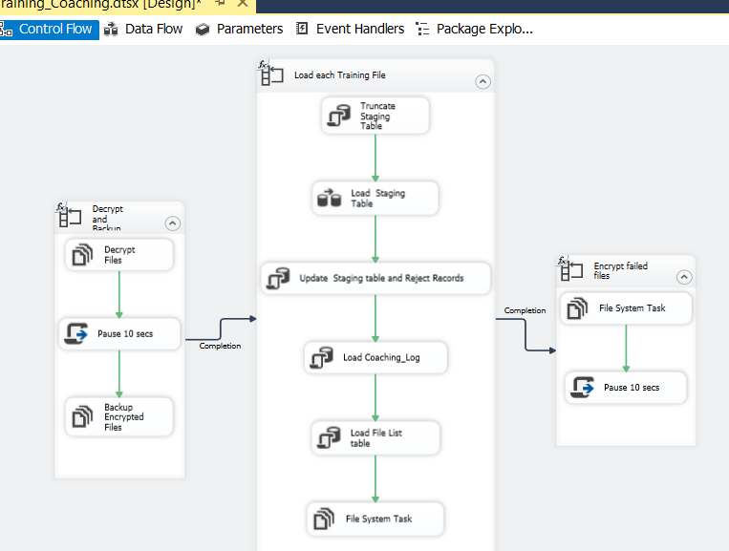

**Workflow**

* + - * 1. **Foreach Loop Container ( Decrypt and stage files)**

Container: For each File Loop

Folder: \\f3420-ecldbp01\data\coaching\Training\Encrypt_out\

Files: eCL* Training _*.encrypt

Retrieve file name: Name and Extension

**Summary of Steps**

1. File system task – Decrypt files
2. Script task - Pause 10 seconds
3. File system task – Backup encrypted files

**Details**

1. File system task – Decrypt files

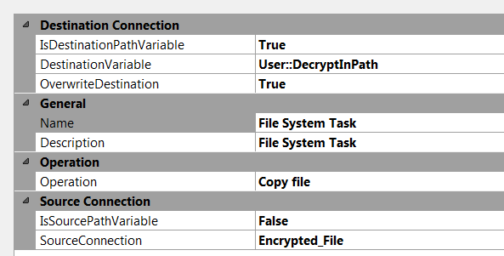

1. Script task- Pause 10 secs

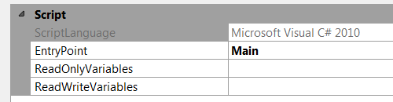

public void Main()

{

// TODO: Add your code here

// Sleep for 10 seconds (*1000)

System.Threading.Thread.Sleep(10000);

Dts.TaskResult = (int)ScriptResults.Success;

}

1. File System task – Backup Encrypted files

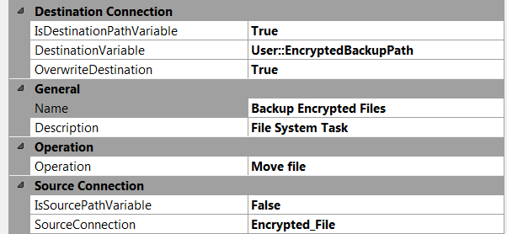

* + - * 1. **For each Training file in Staging directory Workflow**

Container: Foreach Loop

Folder: \\vrivscors01\BCC Scorecards\Coaching\Training

Files: eCL_Training _Feed_*.csv

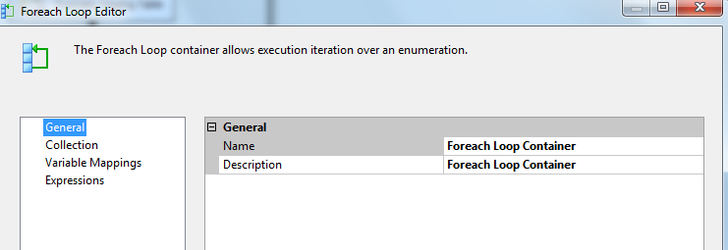

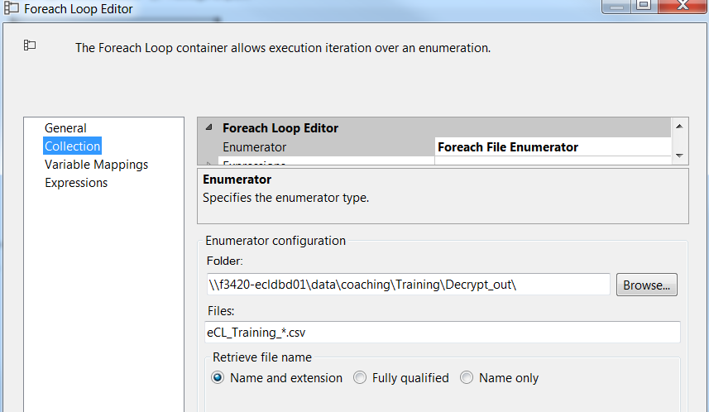

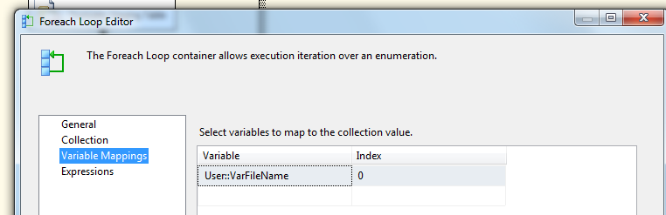

**Summary of Steps**

1. SQL task – Truncate Training Staging table
2. DFT – Load Training Staging table
3. SQL task – Update Staging table and reject logs
4. SQL task Load coaching_Log and Coaching_Log_Reason tables
5. SQL task – Load File list table
6. File system task – Backup files to Backups directory

**Details of Steps**

1. SQL task – Truncate Training Staging table

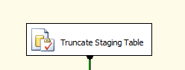

Executes Truncate Table [EC].[Training_Coaching_Stage]

1. DFT: Load Training staging table

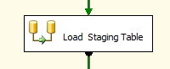

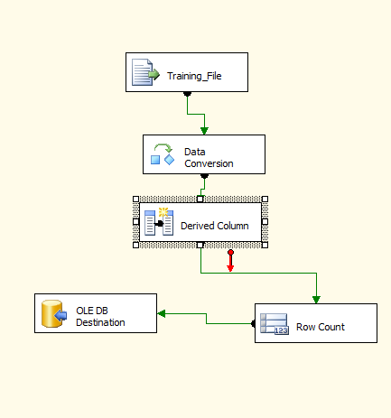

1. Flat File source

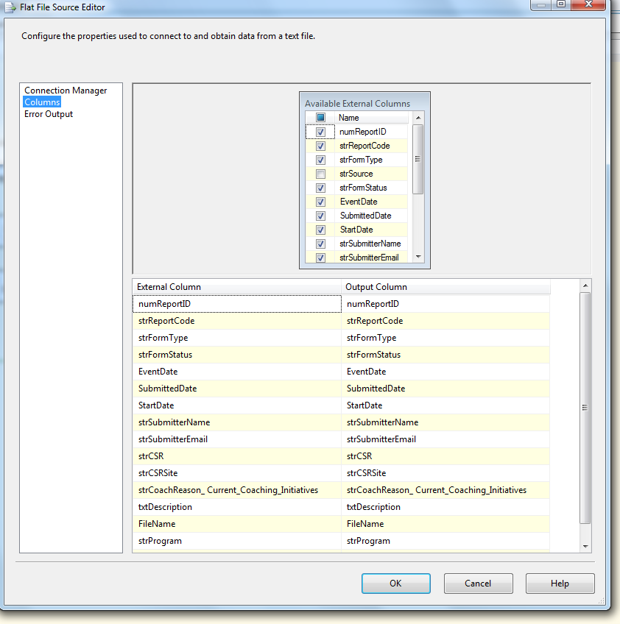

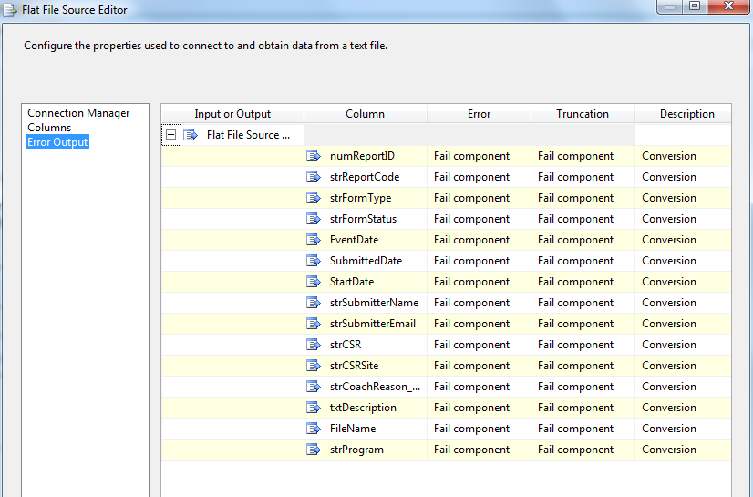

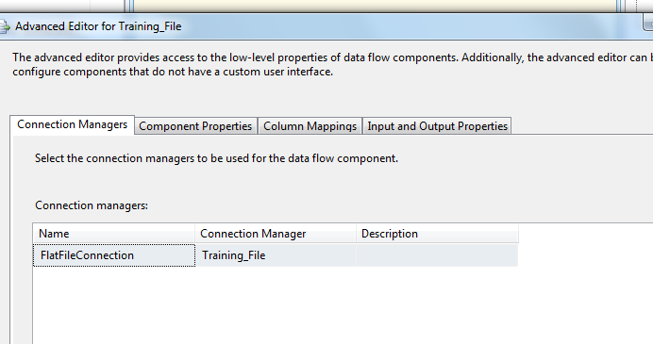

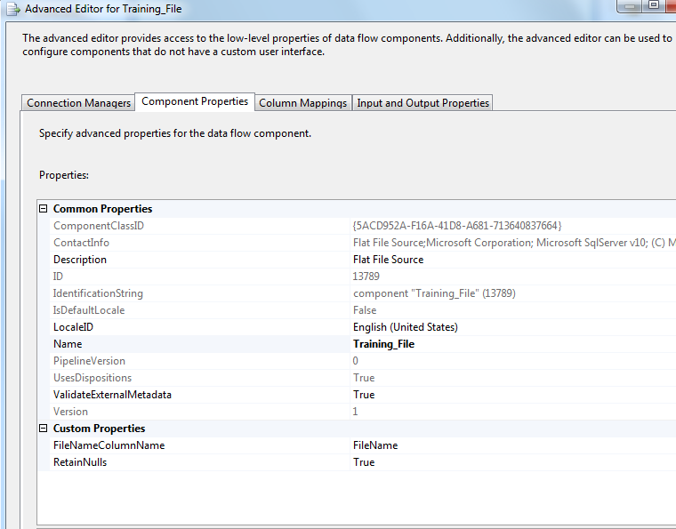

1. Data Conversion

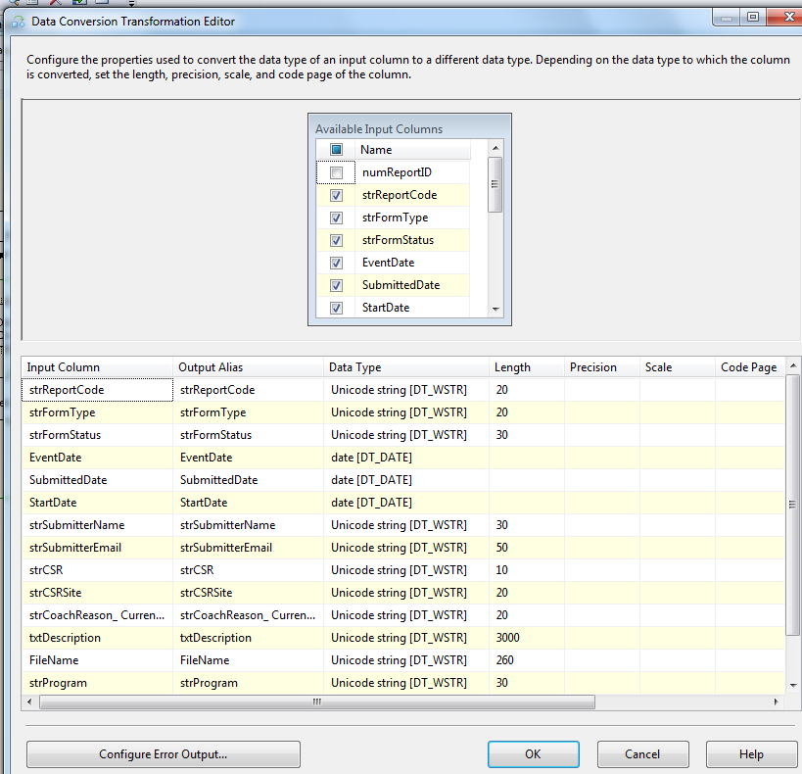

1. Derived Column

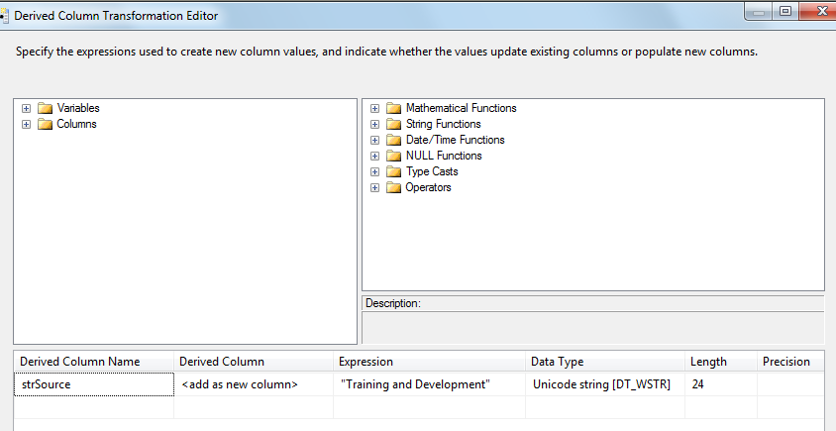

1. Row Count Transformation

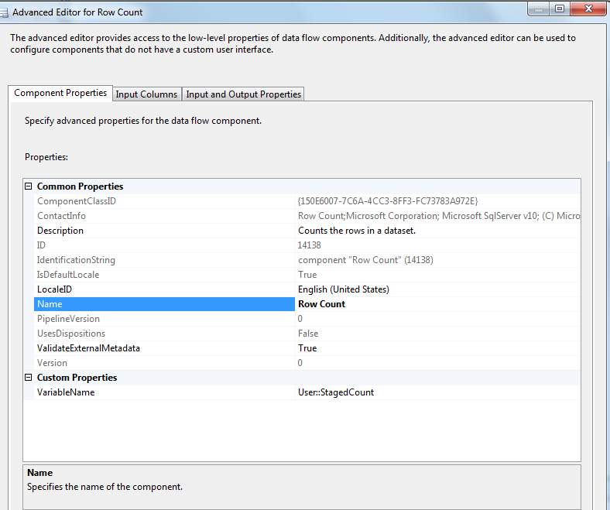

1. Oledb destination

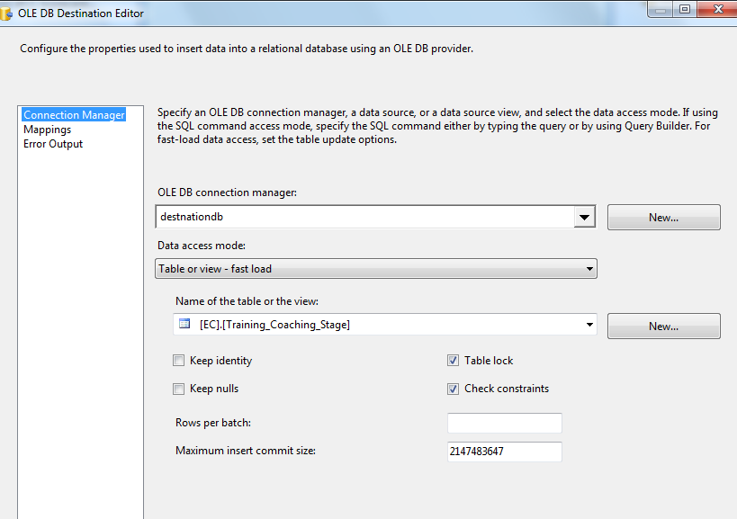

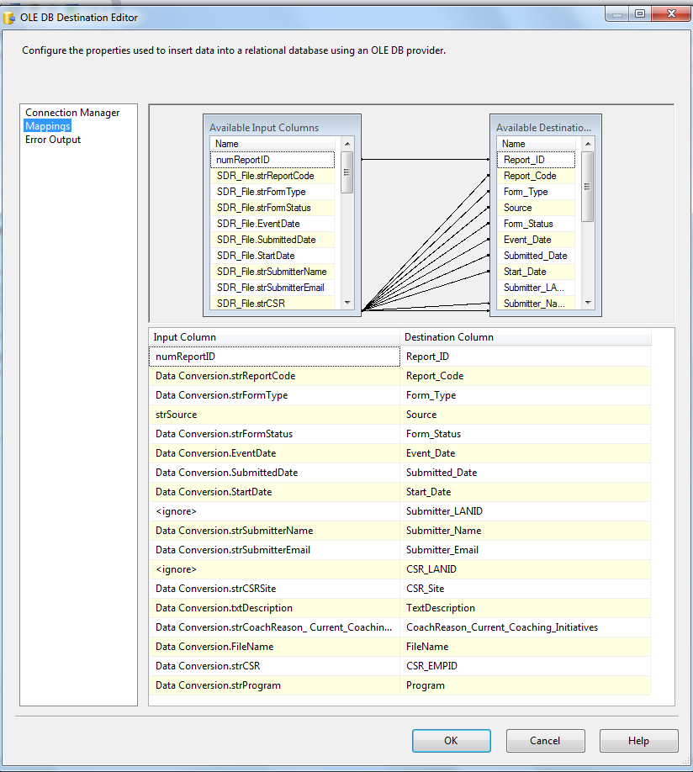

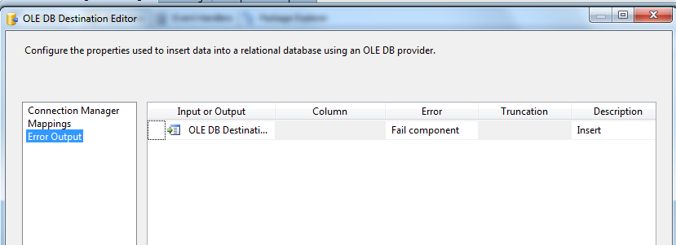

1. SQL Task: Update Staging Table and Reject Logs

Exec [EC].[sp_Update_Training_Coaching_Stage] ? output

1. SQL Task: Load Coaching_Log table

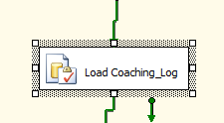

Executes Exec [EC].[sp_InsertInto_Coaching_Log_ Training]

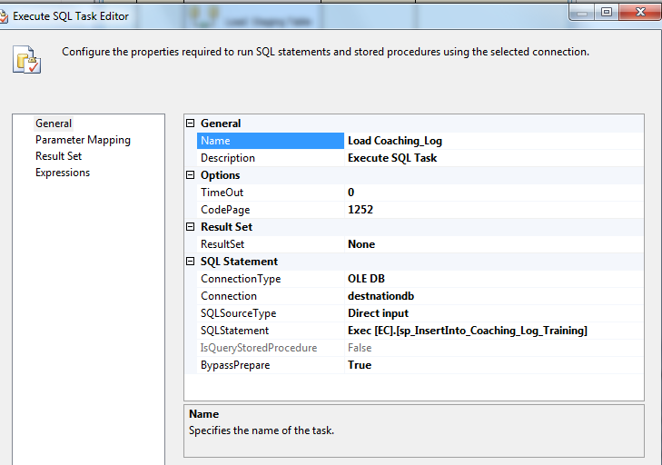

1. SQL Task: Load Training File List table

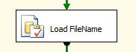

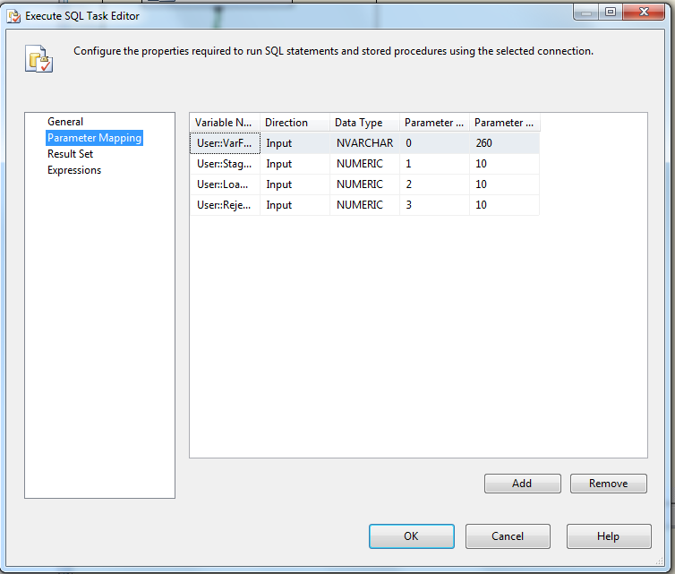

Executes the following sql

INSERT INTO [EC].[Training_FileList]

([File_Name]

,[File_LoadDate]

,[Count_Staged]

,[Count_Loaded]

,[Count_Rejected])

VALUES (?,GetDate(), ?, ?,?)

1. File System Task: Delete loaded file

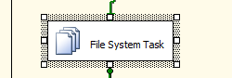

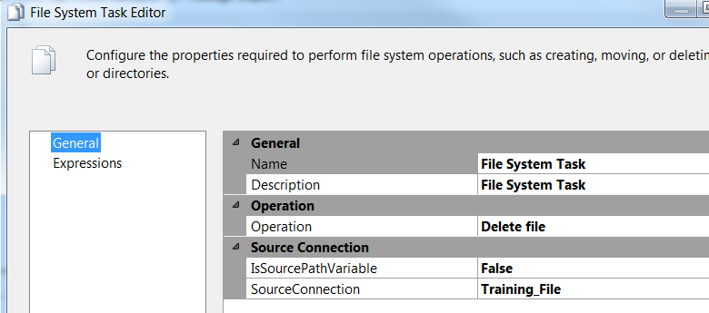

* + - * 1. **For each Loop: Encrypt Failed Files**

Container: For each File Loop

Precedence Constraint - Completion

Folder: \\f3420-ecldbp01\data\coaching\ETS\Decrypt_out\

Files: eCL*.csv

Retrieve file name: Name and Extension

**Summary of Steps**

1. File system task – Encrypt failed files
2. Script task - Pause 10 seconds

**Details**

1. File system task – Encrypt files

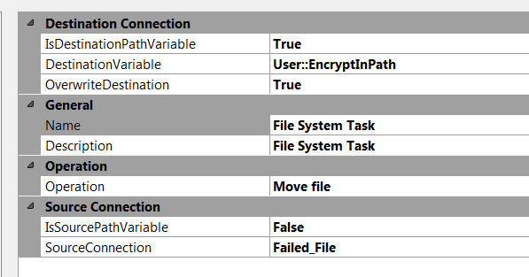

1. Script task- Pause 10 secs



public void Main()

{

// TODO: Add your code here

// Sleep for 10 seconds (*1000)

System.Threading.Thread.Sleep(10000);

Dts.TaskResult = (int)ScriptResults.Success;

}

* + - 1. **Package Content(Event Handlers)**

Executables: Training _Coaching

EventHandler: OntaskFailed

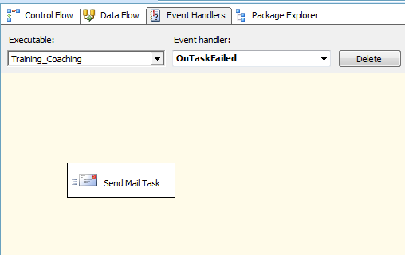

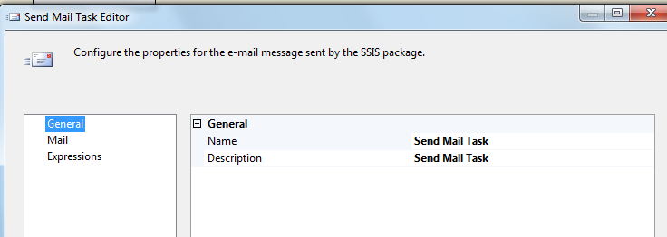

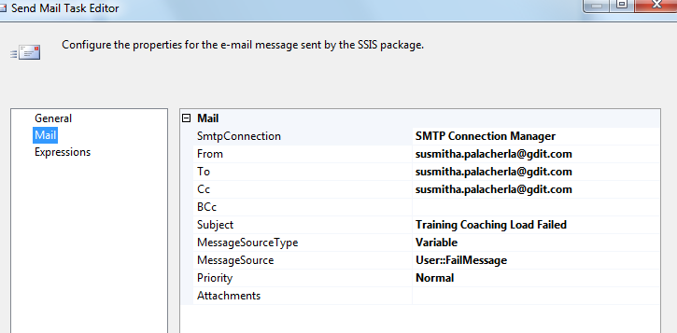

### Tables

|  | **Table Name** | **Table Description** |
| --- | --- | --- |
| 1. | Training_Coaching_Stage | Table used for staging the Training records during the insert into Coaching_Log table. |
| 2. | Training_Coaching_Rejected | Table used for storing the rejected Training records during the insert into Coaching_Log table. Logs are rejected when an incoming Lan ID does not exist in the Employee_Hierarchy table. |
| 3. | Training_Coaching_Fact | Table used for storing Training source records loaded into the Coaching Log table. |
| 4. | Training_FileList | Table used for storing the Training file names and Load dates. |

Table structure and details in document: eCoaching_Database_DD.docx

### Procedures

|  | **Procedure Name** | **Usage** |
| --- | --- | --- |
| 1. | sp_InsertInto_Coaching_Log_Training | Load: Training Data |
| 2. | sp_Update_Training_Coaching_Stage | Load: Training Data |

### Functions

|  | **FunctionName** | **Usage** |
| --- | --- | --- |
| 1. |  |  |

Reference Document for Objects and Code: eCoaching_Training_Load_Create