__________________________



**Title: eCoaching_Training_Load**

**SSIS Detail Design Document**

__________________________

|  |  |  |
| --- | --- | --- |
| Last Revision | Last Review | Description |
| 8/14/2017 |  | TFS 7105 – Upgrade to SQL Server 2012 |

Prepared by: Susmitha Palacherla Date: 03/23/2016

Department, Location: Health Solutions Division

Approved by: Date:

**Change History Log**

| **Date** | **Change Description** | **Author** |
| --- | --- | --- |
| 03/23/2016 | 1.0 Initial revision. TFS 2283. | Susmitha Palacherla |
| 8/14/2017 | 2.0 TFS 7105 – Upgrade to SQL Server 2012 | Susmitha Palacherla |
|  |  |  |
|  |  |  |
|  |  |  |
|  |  |  |
|  |  |  |

Contents

1. Overview 4

1.1 Project Description 4

1.2 Document Scope 4

1.3 Source Files 4

1.4 Module List 6

1.5 Software and Hardware Interfaces 6

1.5.1 Software 6

1.5.2 Hardware 6

1.6 Users 6

2. Details 6

2.1 Source Files 6

2.2 Module Details 7

2.2.1 SQL agent job 7

2.2.2 SSIS Package 7

2.2.3 Tables 82

2.2.4 Procedures 82

2.2.5 Functions 82

# Overview

## Project Description

The coaching process is a standard process to facilitate consistent communication when a performance opportunity exists. It provides a method to make a determination of whether coaching is needed, when to initiate coaching and verification that the performance issue has been addressed. The Training feed contains records for TQC GDIT verified Training when prescribed length of Training session is completed much sooner than expected. Training reports are created by the Quality team which identifies thresholds and exceptions that require coaching or further research by Call Center Supervisors. All items are entered into the eCL via a data feed. Utilizing the eCL work-flow, items can be tracked from start to finish to verify if items have been addressed. The eCL will also provide reporting on the number of Training entered into the system, the number coached, pending coaching, pending review or reasons why coaching was not required.

## Document Scope

This document describes the load of the Training reports provided by the Training and Development team into the eCoaching database. Once the reports are loaded into the database the logs are tracked through the workflow like any Coaching log entered from the web interface.

## Source Files

The table below shows the attributes for the Training reports.

Files have a naming convention eCL_Training _Feed_**xxx**yyyymmdd.csv where xxx is the 3 letter Report code.

Files are staged at \\VRIVSCORS01\BCC Scorecards\Coaching\Training\

|  |  |  |  |  |  |  |
| --- | --- | --- | --- | --- | --- | --- |
| **#** | **Metric/Report** | **Active Feed** | **Code** | **eCL Workflow** | **Entry** | **Coaching Reason** |
| 1 | Training: Short Duration Reporting | Y | SDR | Direct Coach | Feed | Current Coaching Initiatives |
| 2 | Training: Overdue Training report | Y | ODT | Direct Coach | Feed | Current Coaching Initiatives |

## Module List

* SQL agent job
* SSIS Package
* Tables
* Procedures

## Software and Hardware Interfaces

### Software

* SQL Server 2012 SP3 Suite

### Hardware

* F3420-ECLDBD01 – Dev DB Server
* F3420-ECLDBT01 – Test DB Server
* F3420-ECLDBP01 – Prod Server
* \\F3420-ECLDBD01\data\ - Dev File staging share
* \\F3420-ECLDBT01\data\ - Test File staging share
* \\VRIVSCORS01\BCC Scorecards\ - Prod File staging share

## Users

* The first set of users for the Training records loaded into the eCL database are the CCO Supervisors as all records have default state of ‘Pending Supervisor Review’ at the time of the load.
* After a Supervisor reviews the log and determines that a Coaching is required the log gets assigned to the CSRs and they become the users.
* CCO Supervisors and Managers will be able to access the logs from the historical Dashboards.

# Details



## Source Files

eCL_Training _Feed_xxxyyyymmdd.csv is the naming convention for the feed where xxx is the 3 letter Report code.

Description: Files contain records for agents that fall below the required threshold times to complete a required Training in TQC or are past due on a required Training. The Training and Development team captures records that meet the above conditions and generate files for them. Once the feed are loaded into eCL the Supervisors have the opportunity to determine if a Coaching is needed or additional research is needed.

Source system: TQC

* Staging location: \\vrivscors01\BCC Scorecards\Coaching\Training\
* File name eCL_Training _Feed_xxxyyyymmdd.csv
* Frequency: File is expected to be placed on the share on Thursdays
* File arrival time: NA
* Destination Table: Coaching_Log and Coaching_Log_Reason

## Module Details

### SQL agent job

* Production Instance : F3420-ECLDBP01
* Production Job: CoachingTrainingLoad
* Production Package: \\F3420-ECLDBP01\ssis\Coaching\Packages\Training _Coaching.dtsx
* Production Config File: Prod_Training_Coaching.dtsConfig
* Owner: ecljobsowner
* Run As: ECLProxy (ECL Credential using application service account VNGT\SVC-SQLECLP01
* Schedule: Fridays 8:00 AM EST IF Files exist to be loaded
* Destination File Location: N/A

### SSIS Package

* + - 1. **Variables**

|  |  |  |  |
| --- | --- | --- | --- |
| **Name** | **Scope** | **DataType** | **Value** |
| FilebakPath | Training _Coaching | String | \\vrivscors01\BCC Scorecards\Coaching\ Training \Backups |
| FileNum | Training _Coaching | Int32 | 0 |
| FilePath | Training_Coaching | String | \\vrivscors01\BCC Scorecards\Coaching\ Training |
| varDBName | Training_Coaching | String | Dev |
| varFileName | Training_Coaching | String |  |
| FailMessage | Training_Coaching | String | Training Coaching Load failed in Dev |
| StagedCount | Training_Coaching | Int32 | 0 |
| RejectedCount | Training_Coaching | Int32 | 0 |
| LoadedCount | Training_Coaching | Int32 | 0 |
|  |  |  |  |

* + - 1. **Connection Manager Entries**
         1. Destinationdb
* Dev – F3420-ECLDBD01 DB – eCoachingdev
* Test - F3420-ECLDBT01 DB – eCoachingtest
* Prod - F3420-ECLDBP01 – eCoaching
  + - * 1. Training _File
* \\vrivscors01\bcc scorecards\Coaching\Training\eCL_Training _Feed_*.csv

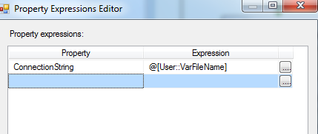

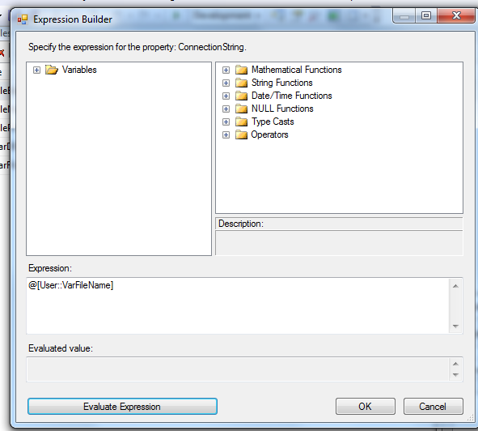

* + - * 1. SMTP Connection Manager

smtpout.gdit.com

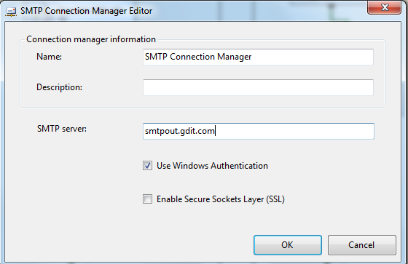

* + - 1. **Package Content(Control Flow)**

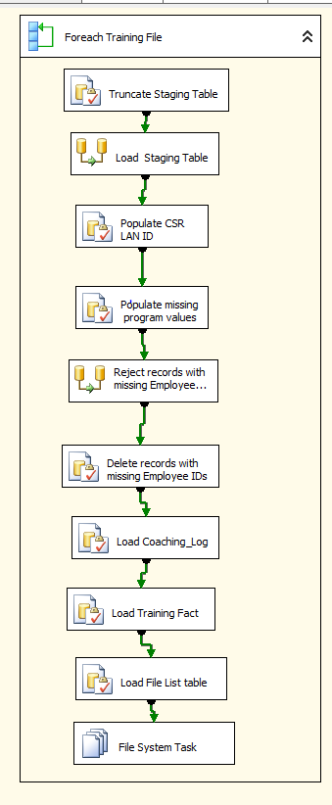

**Workflow**

* + - * 1. **For each Training file in Staging directory Workflow**

Container: Foreach Loop

Folder: \\vrivscors01\BCC Scorecards\Coaching\Training

Files: eCL_Training _Feed_*.csv

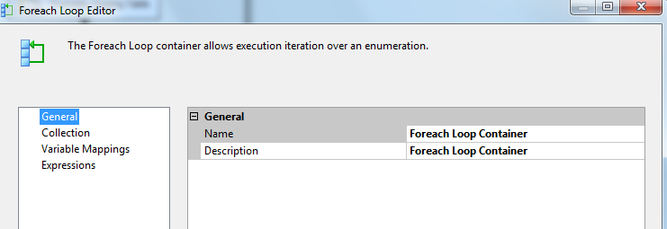

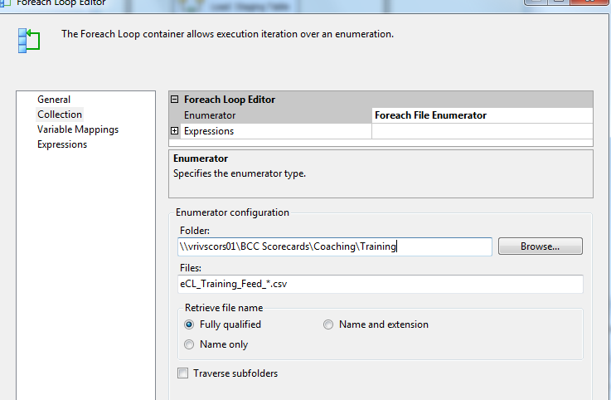

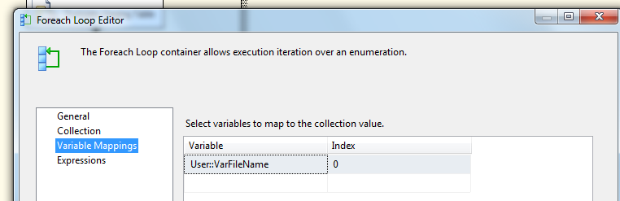

**Summary of Steps**

1. SQL task – Truncate Training Staging table
2. DFT – Stage Training Staging table
3. SQL task – Populate CSR LAN ID for LCS
4. SQL Task – Populate missing Program Values
5. DFT Rejected records with missing Employee attributes
6. SQL task – Delete records with missing employee ID from Staging table
7. SQL task Load coaching_Log and Coaching_Log_Reason tables
8. SQL task – Load Training Fact table
9. SQL task – Load File list table
10. File system task – Backup files to Backups directory

**Details of Steps**

1. SQL task – Truncate Training Staging table

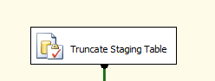

Executes Truncate Table [EC].[Training_Coaching_Stage]

1. DFT: Load Training staging table

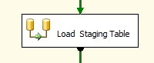

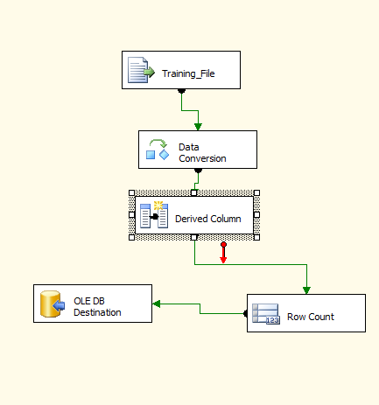

1. Flat File source

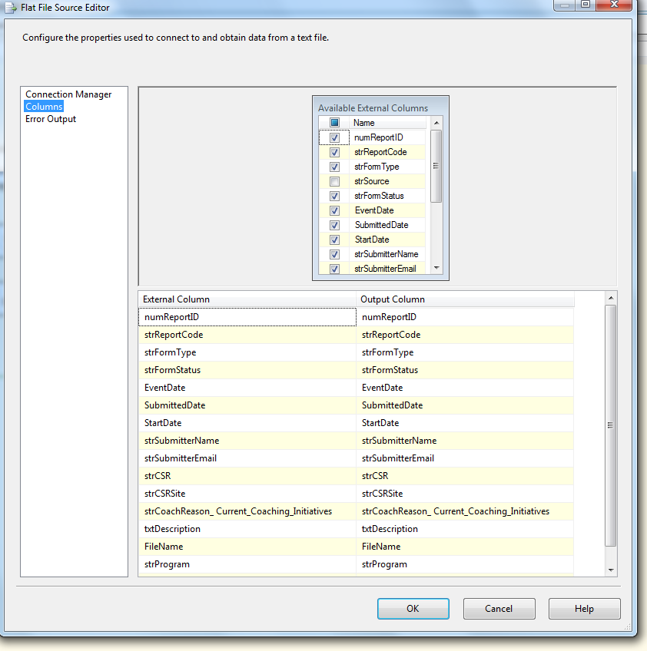

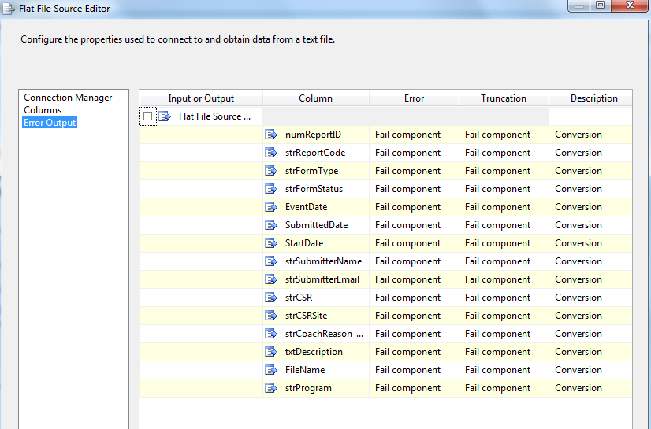

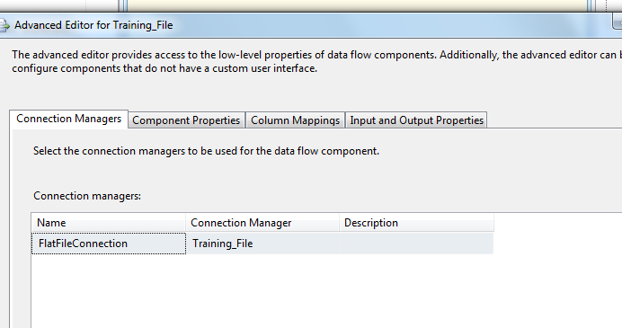

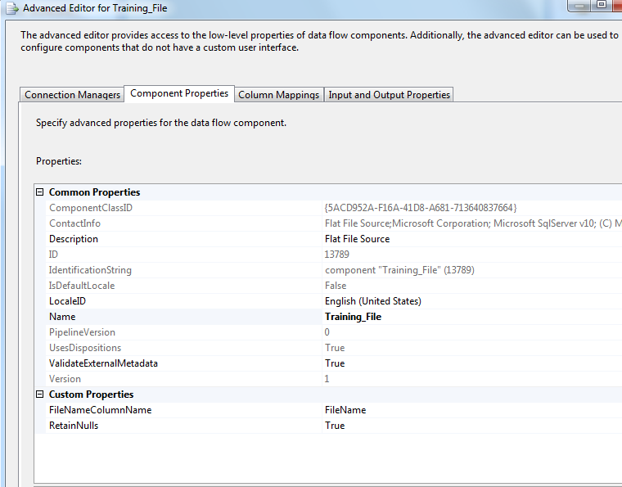

1. Data Conversion

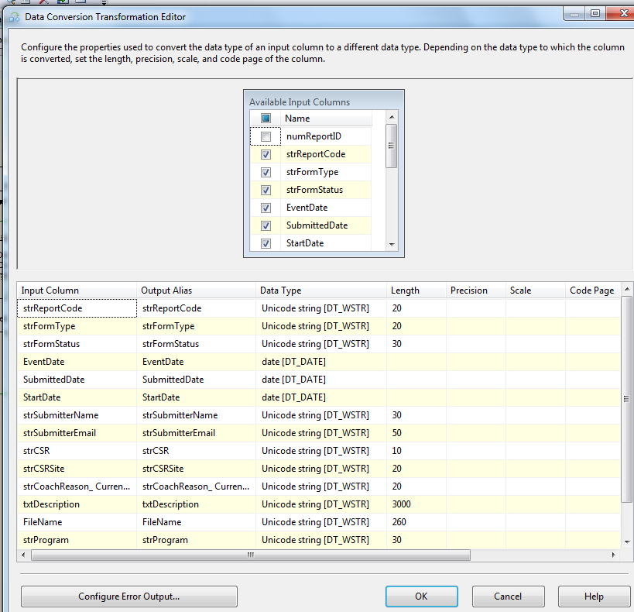

1. Derived Column

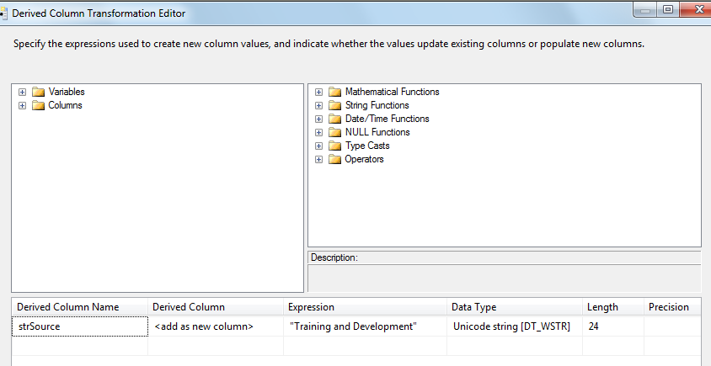

1. Row Count Transformation

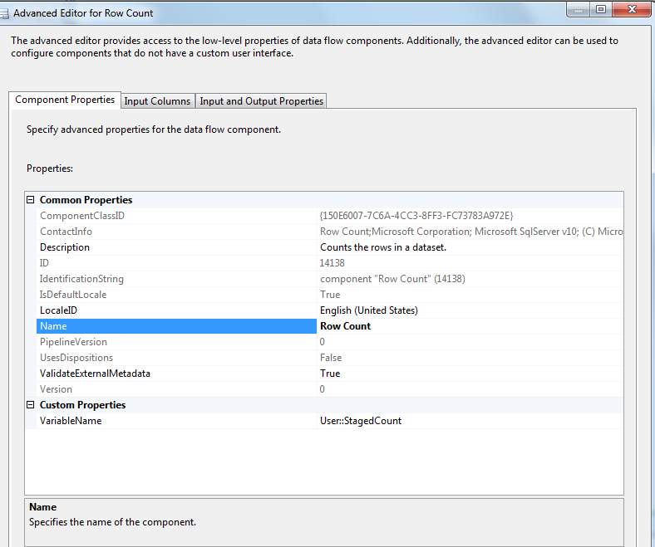

1. Oledb destination

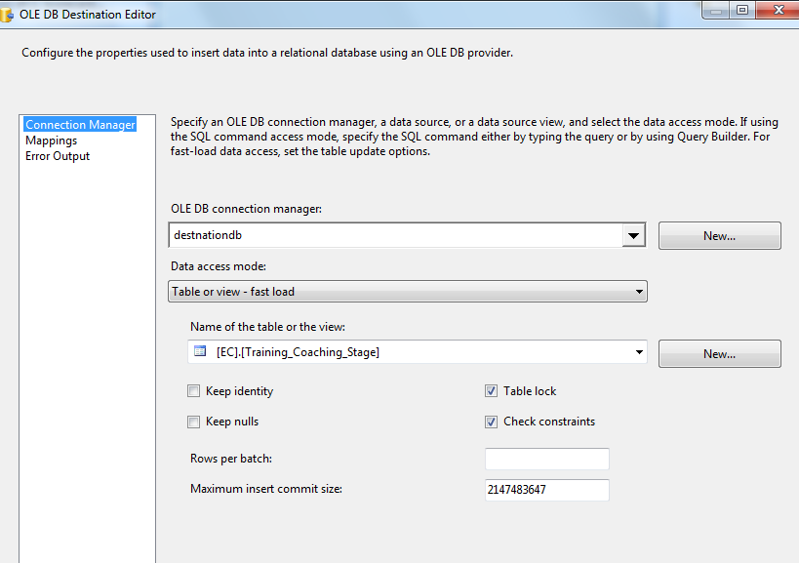

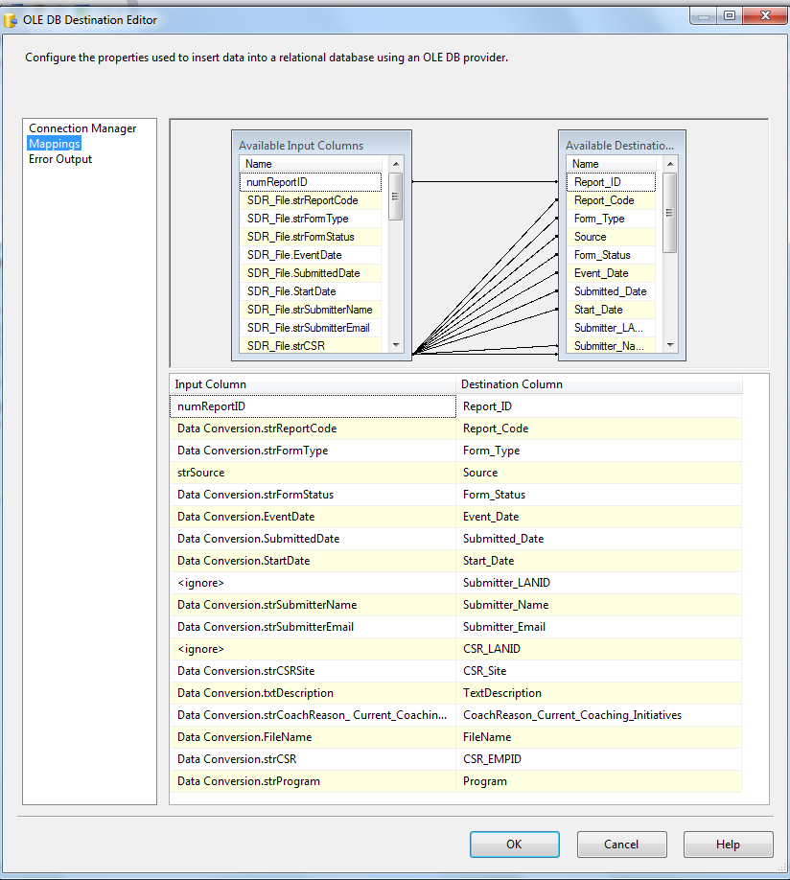

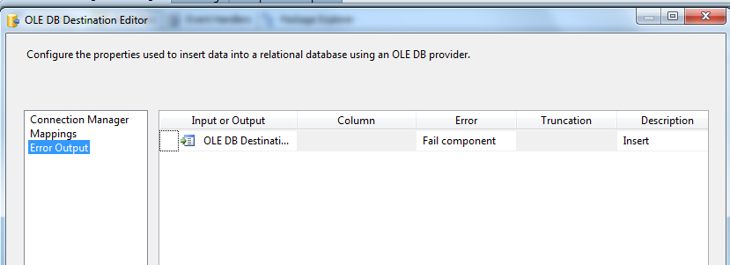

1. SQL Task: Populate CSR LAND ID

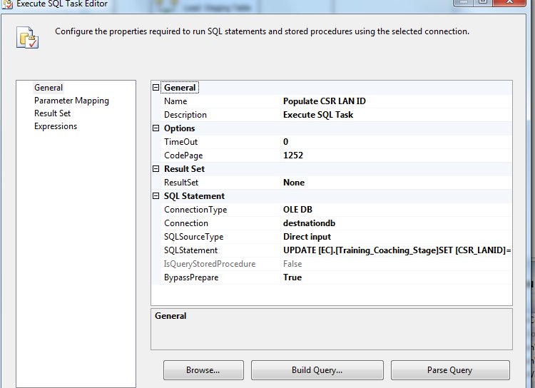

UPDATE [EC].[Training_Coaching_Stage]

SET [CSR_LANID]= [EC].[fn_strEmpLanIDFromEmpID]([CSR_EMPID])

1. SQL Task: Populate missing program values

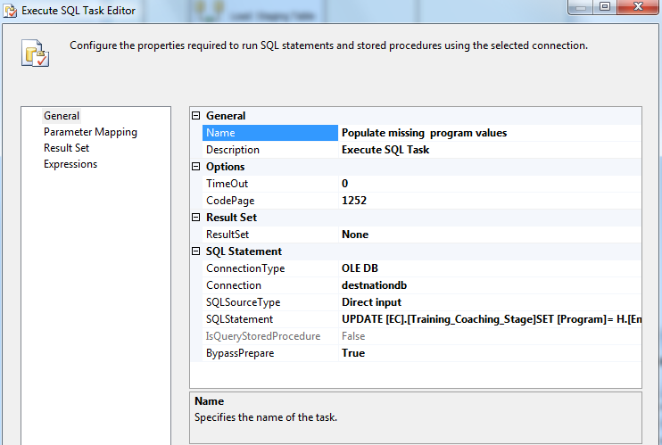

UPDATE [EC].[Training_Coaching_Stage]

SET [Program]= H.[Emp_Program]

FROM [EC].[Training_Coaching_Stage]S JOIN [EC].[Employee_Hierarchy]H

ON S.[CSR_EMPID]=H.[Emp_ID]

WHERE (S.Program IS NULL OR S.Program ='')

1. DFT: Reject Records with Missing Employee ID

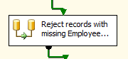

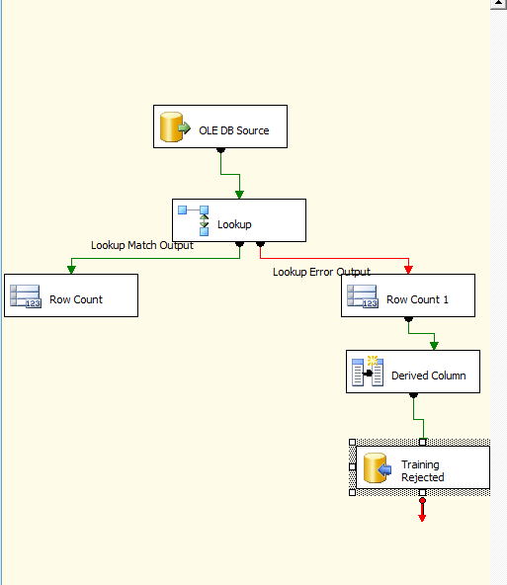

1. Oledb source

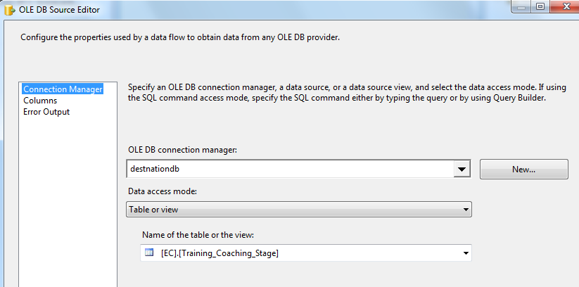

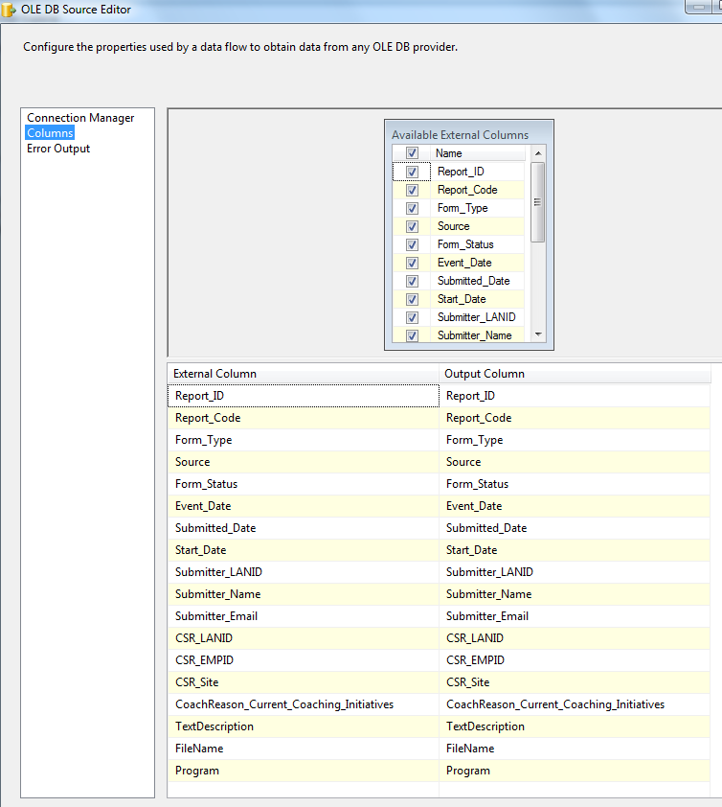

1. Lookup Transformation

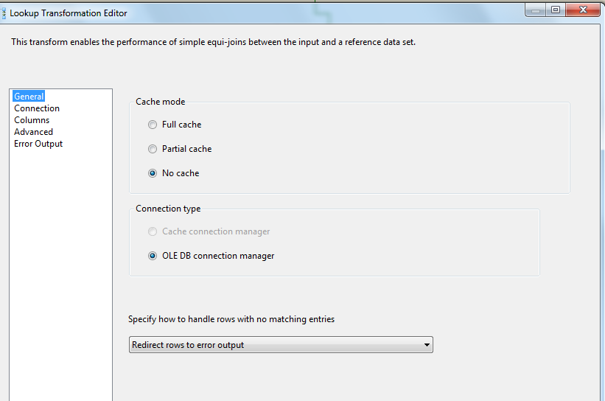

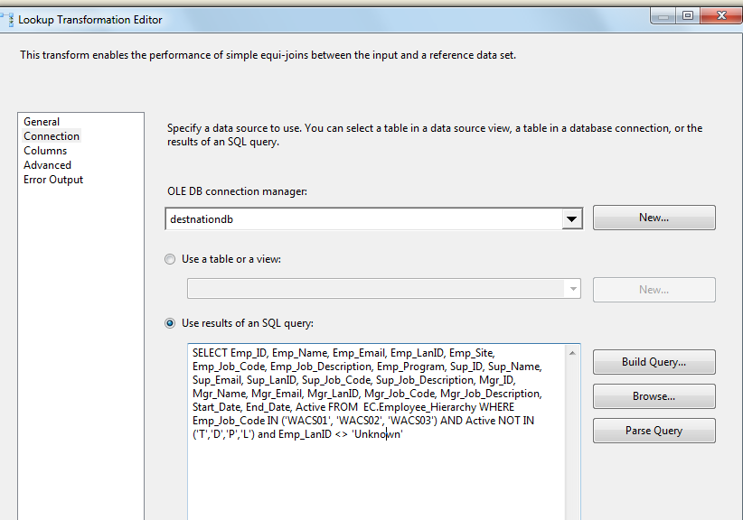

SELECT Emp_ID, Emp_Name, Emp_Email, Emp_LanID, Emp_Site, Emp_Job_Code, Emp_Job_Description,

Emp_Program, Sup_ID, Sup_Name, Sup_Email, Sup_LanID, Sup_Job_Code, Sup_Job_Description,

Mgr_ID, Mgr_Name, Mgr_Email, Mgr_LanID, Mgr_Job_Code, Mgr_Job_Description, Start_Date, End_Date, Active

FROM EC.Employee_Hierarchy

WHERE Emp_Job_Code IN ('WACS01', 'WACS02', 'WACS03')

AND Active NOT IN ('T','D','P','L') and Emp_LanID <> 'Unknown'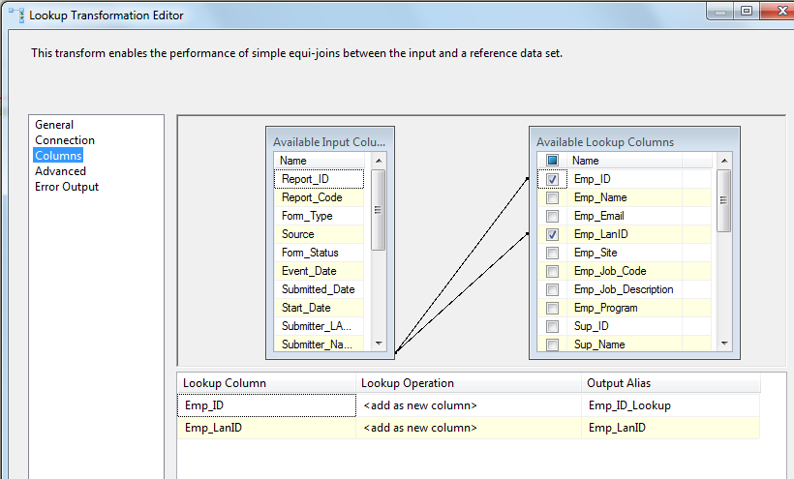

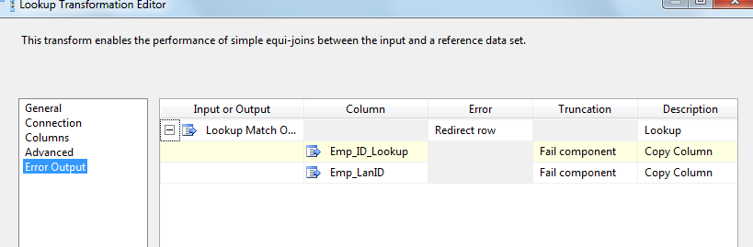

1. Lookup Match Output – Row Count Transformation to get Loaded Count

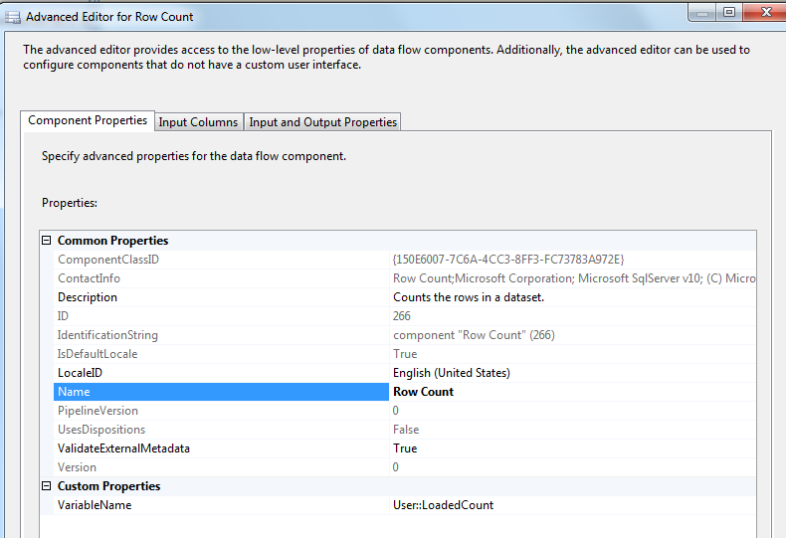

Lookup Transformation No Match Output – Row Count Transformation to get Rejected Count

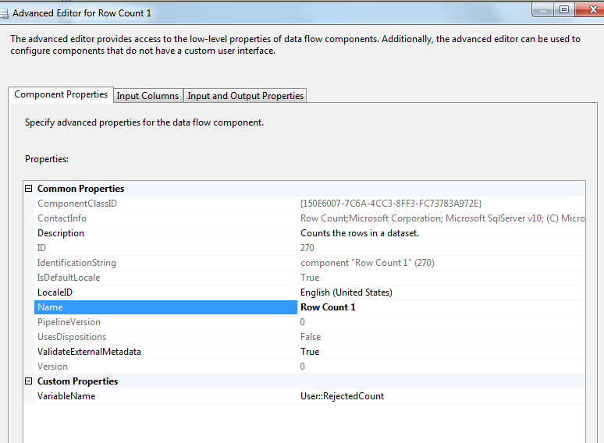

Derived Column – To get Reject Reason and Reject Date

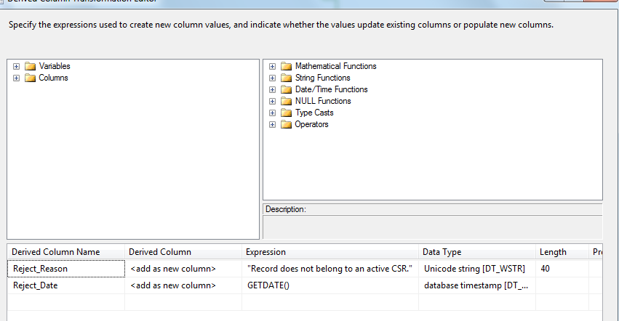

oledb destination – Write rejected records to Training rejected table

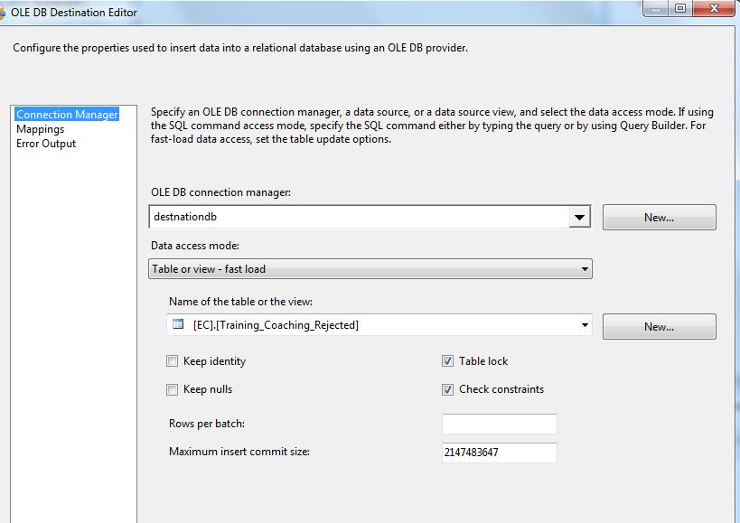

1. SQL Task: Delete records with missing Employee ID from Staging table

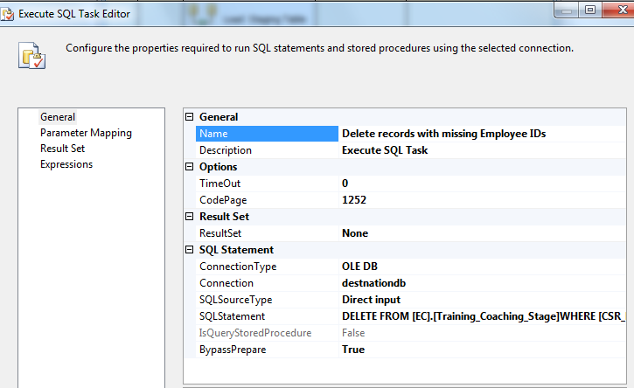

DELETE FROM [EC].[Training_Coaching_Stage]

WHERE [CSR_EMPID] IS NULL OR [CSR_EMPID] ='' OR [CSR_LANID] = 'Unknown'

DELETE os FROM

[EC].[Training_Coaching_Stage] os JOIN [EC].[Employee_Hierarchy] eh

ON os.CSR_EMPID = eh.Emp_ID

WHERE eh.Emp_Job_Code not in ('WACS01','WACS02','WACS03')

OR Active in ('T','D','L','P')

GO

1. SQL Task: Load Coaching_Log table

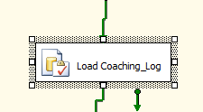

Executes Exec [EC].[sp_InsertInto_Coaching_Log_ Training]

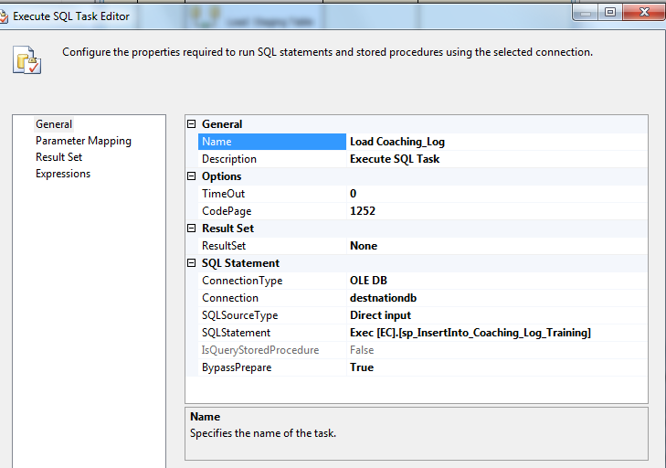

1. SQl Task: Load Training Fact table

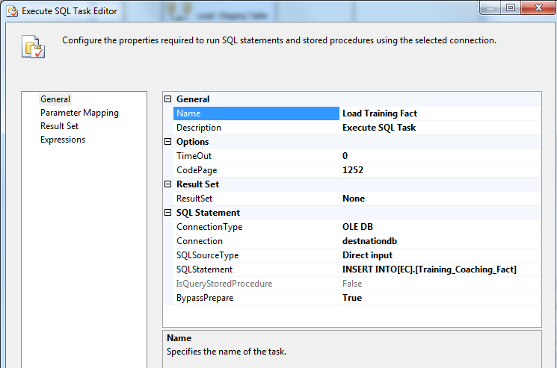

INSERT INTO[EC].[Training_Coaching_Fact]

([Report_ID]

,[Report_Code]

,[Form_Type]

,[Source]

,[Form_Status]

,[Event_Date]

,[Submitted_Date]

,[Start_Date]

,[Submitter_LANID]

,[Submitter_Name]

,[Submitter_Email]

,[CSR_LANID]

,[CSR_Site]

,[Program]

,[CoachReason_Current_Coaching_Initiatives]

,[TextDescription]

,[FileName]

)

SELECT S.[Report_ID]

,S.[Report_Code]

,S.[Form_Type]

,S.[Source]

,S.[Form_Status]

,S.[Event_Date]

,S.[Submitted_Date]

,S.[Start_Date]

,S.[Submitter_LANID]

,S.[Submitter_Name]

,S.[Submitter_Email]

,S.[CSR_LANID]

,S.[CSR_Site]

,S.[Program]

,S.[CoachReason_Current_Coaching_Initiatives]

,S.[TextDescription]

,S.[FileName]

FROM [EC].[Training_Coaching_Stage]S LEFT OUTER JOIN [EC].[SDR_Coaching_Fact]F

ON S.[Report_ID]=F.[Report_ID]

AND S.Report_Code = F.Report_Code

WHERE F.[Report_ID] IS NULL AND F.Report_Code IS NULL

GO

1. SQL Task: Load Training File List table

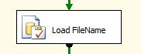

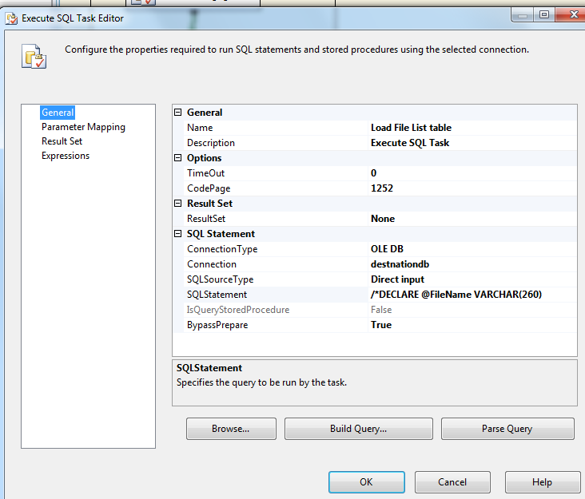

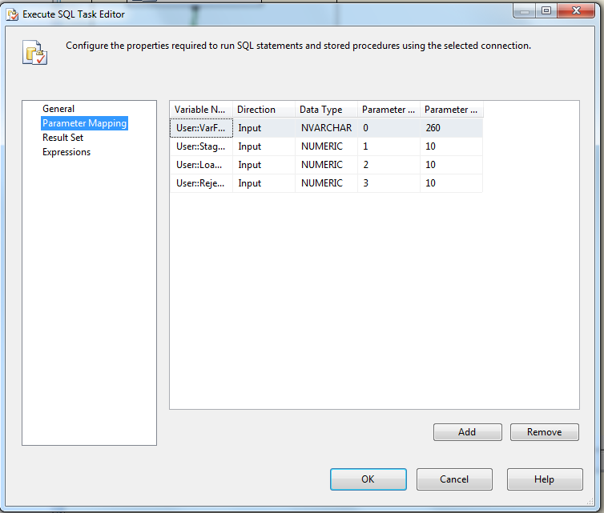

Executes the following sql

INSERT INTO [EC].[Training_FileList]

([File_Name]

,[File_LoadDate]

,[Count_Staged]

,[Count_Loaded]

,[Count_Rejected])

VALUES (?,GetDate(), ?, ?,?)

1. File System Task: Move file to backup folder

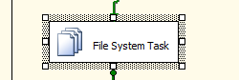

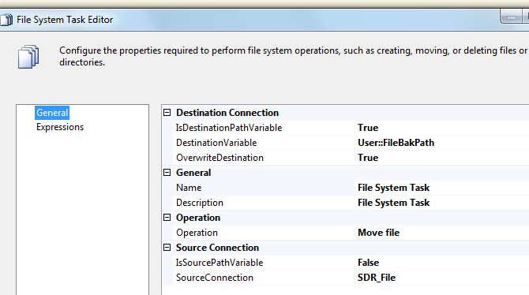

* + - 1. **Package Content(Event Handlers)**

Executables: Training _Coaching

EventHandler: OntaskFailed

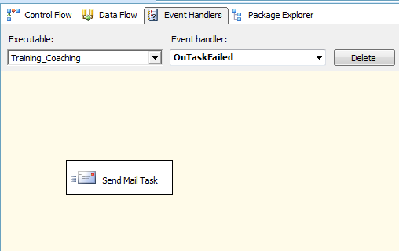

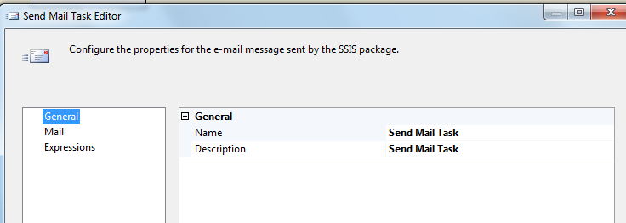

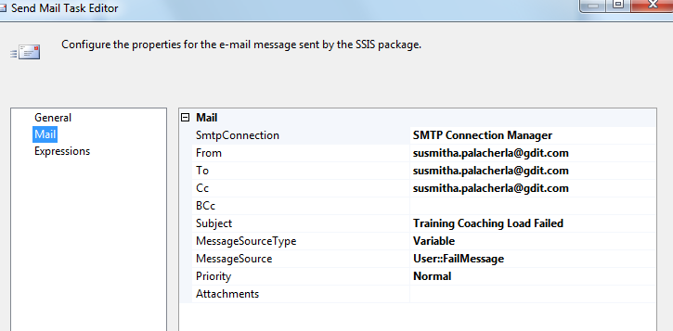

### Tables

|  | **Table Name** | **Table Description** |
| --- | --- | --- |
| 1. | Training_Coaching_Stage | Table used for staging the Training records during the insert into Coaching_Log table. |
| 2. | Training_Coaching_Rejected | Table used for storing the rejected Training records during the insert into Coaching_Log table. Logs are rejected when an incoming Lan ID does not exist in the Employee_Hierarchy table. |
| 3. | Training_Coaching_Fact | Table used for storing Training source records loaded into the Coaching Log table. |
| 4. | Training_FileList | Table used for storing the Training file names and Load dates. |

Table structure and details in document: eCoaching_Database_DD.docx

### Procedures

|  | **Procedure Name** | **Usage** |
| --- | --- | --- |
| 1. | sp_InsertInto_Coaching_Log_Training | Load: Training Data |

### Functions

|  | **FunctionName** | **Usage** |
| --- | --- | --- |
| 1. |  |  |

Reference Document for Objects and Code: eCoaching_Training_Load_Create