__________________________

***Contact Center Operations***

**Title: CCO eCoaching Coaching Summary Report**

**SSRS Detail Design Document**

__________________________

|  |  |  |
| --- | --- | --- |
| Last Revision | Last Review | Description |
| 4/18/2017 |  | TFS 5621 - Initial reporting for eCL |

Prepared by: Suzy Palacherla Date: 4/18/2017

Department, Location: HCSD

Approved by: Date:

**Change History Log**

| **Date** | **Change Description** | **Author** |
| --- | --- | --- |
| 4/18/2017 | TFS 5621 – Initial revision | Susmitha Palacherla |
|  |  |  |
|  |  |  |
|  |  |  |
|  |  |  |
|  |  |  |
|  |  |  |
|  |  |  |
|  |  |  |
|  |  |  |
|  |  |  |
|  |  |  |

# Purpose

The purpose of the Coaching summary report is for Engineering, Program and support staff that need to be able to view the details of the coaching logs and or generate Reports based on the coaching logs to be able to do so without having to login to the database and run direct queries.

# XML Information

The location of the RDL “executable” code for the report can be found in TFS at:

\cms\eCoaching_V2\Code\SSRS\eCoachingReport\eCoachingReport\CoachingSummary.rdl

This contains all the code that defines the SQL, the formatting, and any other special effects.

# Report Parameters

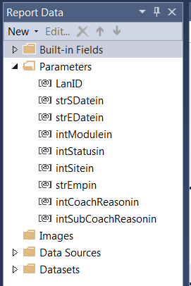

The Coaching Summary report will take the following parameters:

|  |  |  |  |  |
| --- | --- | --- | --- | --- |
| **Name** | **User Prompt** | **Type** | **Required?** | **Description** |
| LanID | NA [Hidden] | Text | Yes | Lan ID of Logged in user. Will be passed in from UI code. Used to determine Role of logged in user to display list of available Modules. |
| strSdatein | Start Date | Date/Time | Yes | Start date for list of coaching logs to be displayed based on log submitted date. |
| strEDatein | End Date | Date/Time | Yes | End date for list of coaching logs to be displayed based on log submitted date. |
| intModulein | Module | Text | Yes | Dropdown list populated by dataset ModuleRef (value field: ModuleID label field: Module) |
| intStatusin | Status | Text | Yes | Dropdown List populated by dataset CoachingStatusRef (value field: StatusID label field: Status) |
| intSitein | Site | Text | Yes | Dropdown List populated by dataset CoachingSiteRef (value field: SiteID label field: Site) |
| strEmpin | Employee | Text | Yes | Dropdown List populated by dataset CoachingEmployeeRef (value field: EmpID label field: EmpName) |
| intCoachReasonin | Coaching Reason | Text | Yes | Dropdown List populated by dataset CoachingReasonRef (value field: CoachingReasonID label field: CoachingReason) |
| intsubCoachReasonin | Coaching SubReason | Text | Yes | Dropdown List populated by dataset CoachingSubReasonRef (value field: SubCoachingReasonID label field: SubCoachingReason) |

# Report Datasets

* 1. **CoachingSummary**

Query the Coaching logs for selected set of parameters.

Query:

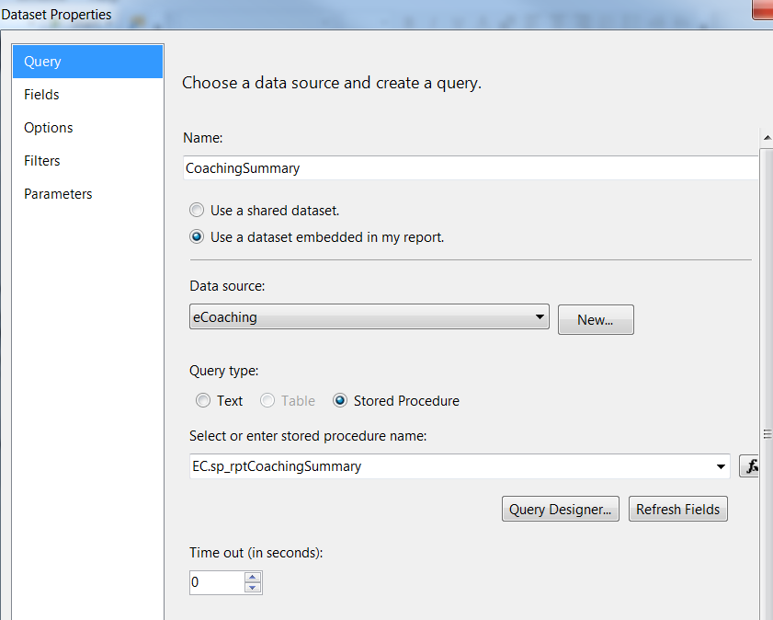

Fields:

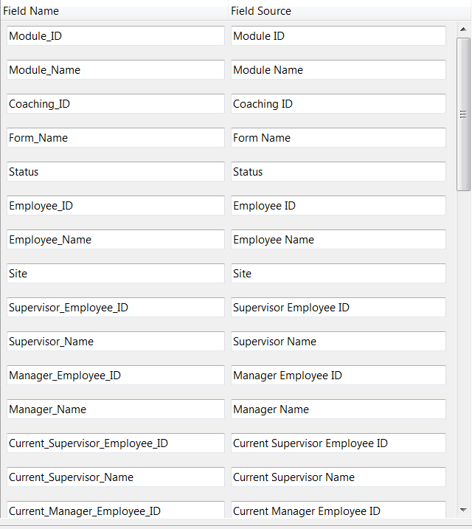

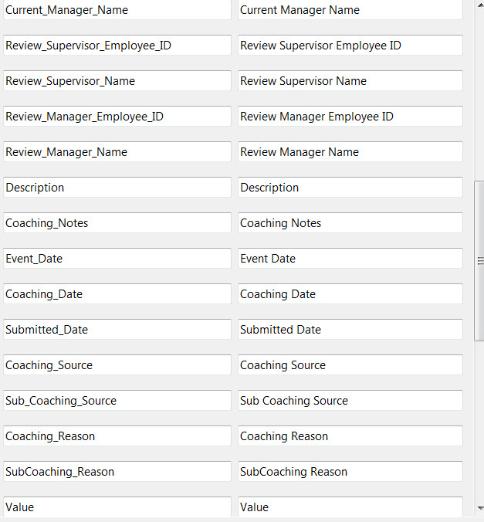

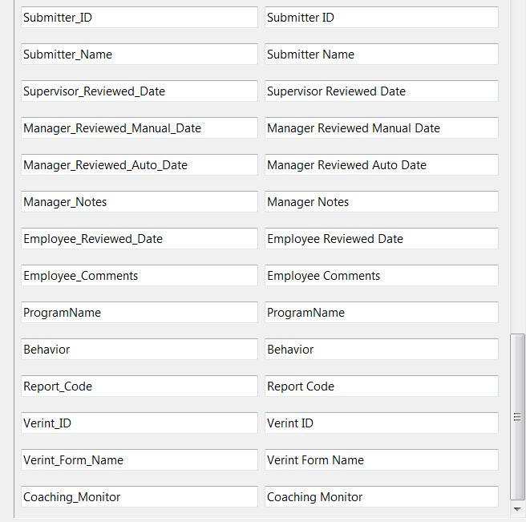

Parameters:

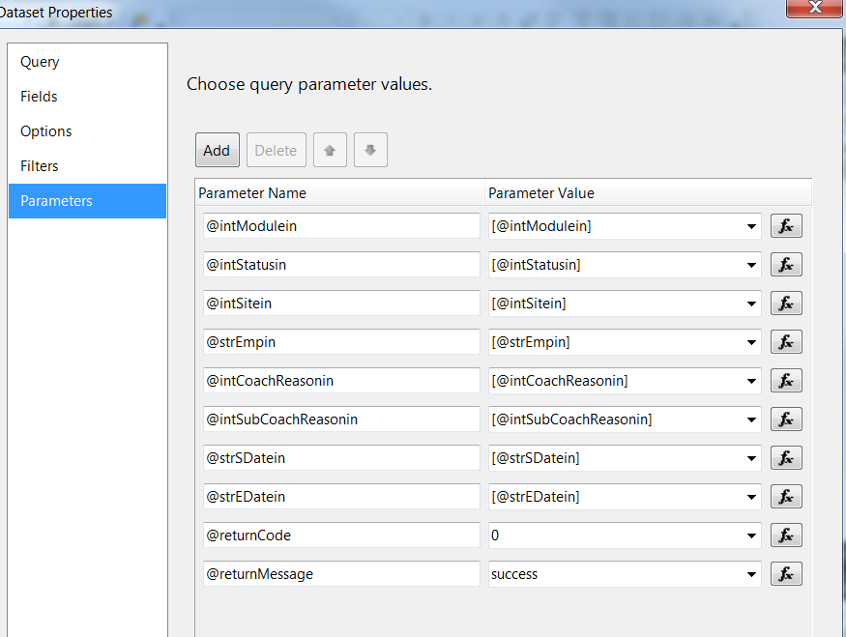

* 1. **CoachingReasonRef (uses shared dataset CoachingReasonList)**

Query:

SELECT CoachingReasonID, CoachingReason

FROM (SELECT - 1 AS CoachingReasonID, 'All' AS CoachingReason

UNION

SELECT DISTINCT clr.CoachingReasonID, dcr.CoachingReason

FROM EC.Coaching_Log AS cl INNER JOIN

EC.Coaching_Log_Reason AS clr ON cl.CoachingID = clr.CoachingID INNER JOIN

EC.DIM_Coaching_Reason AS dcr ON clr.CoachingReasonID = dcr.CoachingReasonID

WHERE (cl.ModuleID =(@intModulein) or @intModulein = -1) ) AS s

ORDER BY CASE WHEN CoachingReasonID = - 1 THEN 0 ELSE 1 END, CoachingReason

Fields:

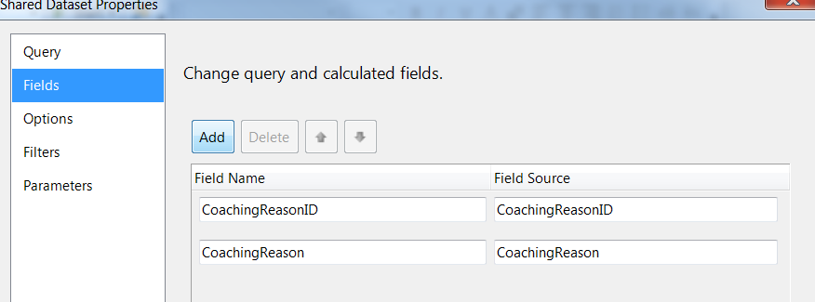

Parameters:

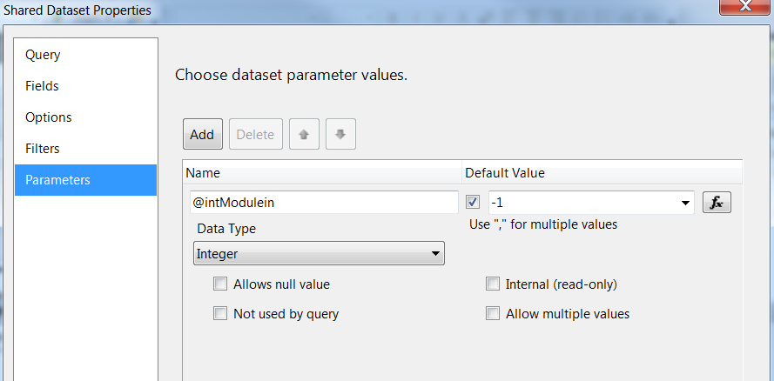

* 1. **CoachingEmployeeRef (uses shared dataset CoachingEmployeeList)**

Query:

Select s.EmpID, s.EmpName

FROM (Select '-1' as EmpID, 'All' as EmpName

UNION

SELECT DISTINCT CL.EmpID EmpID, EH.[Emp_Name] EmpName

FROM EC.Coaching_Log AS cl JOIN EC.Employee_Hierarchy eh

ON cl.EmpID = eh.Emp_ID

WHERE (cl.ModuleID =(@intModulein) or @intModulein = -1)

and (cl.SiteID =(@intSitein) or @intSitein = -1)

)as S

ORDER BY CASE WHEN EmpID = '-1' THEN 0 ELSE 1 END, EmpName

Fields:

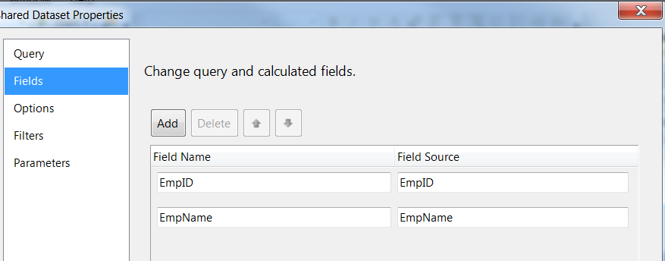

Parameters:

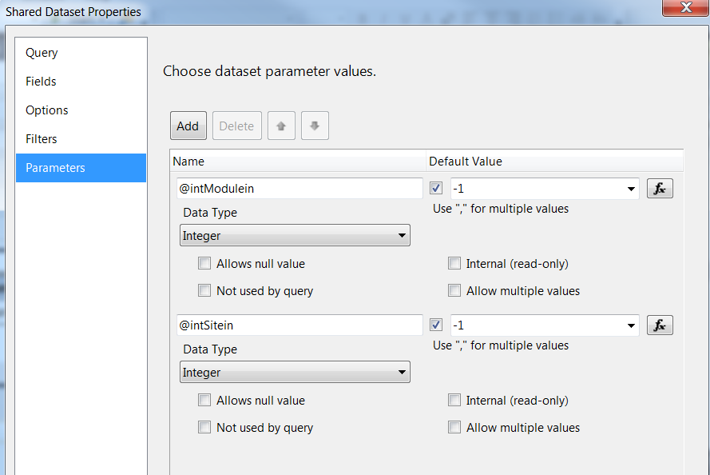

* 1. **ModuleRef (uses shared dataset ModuleList)**

Query:

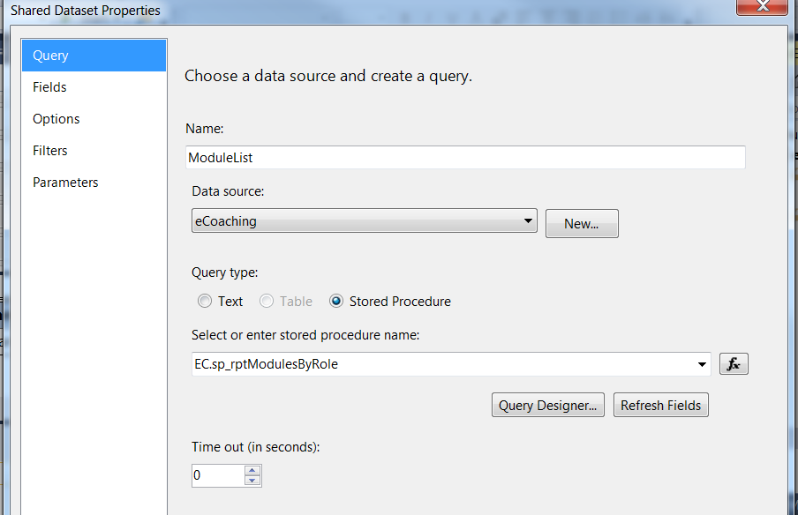Fields:

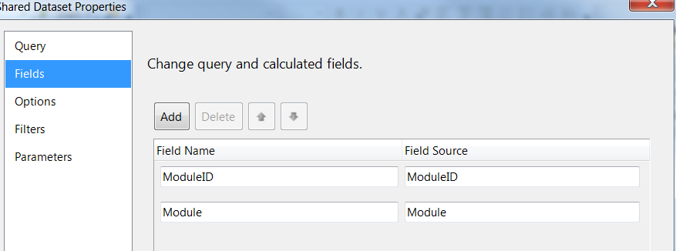

Parameters:

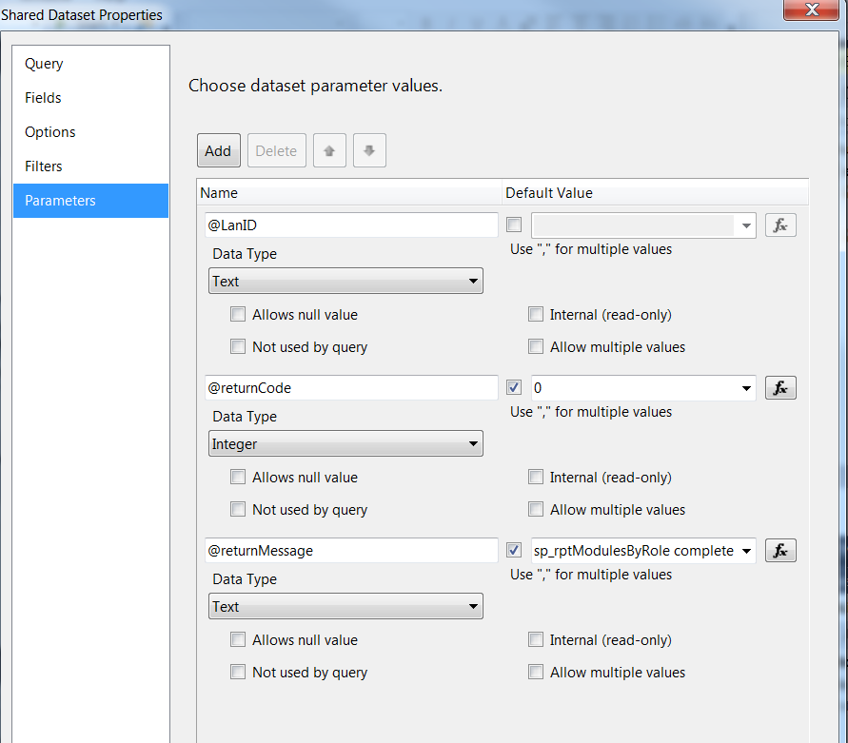

* 1. **CoachingStatusRef (uses shared dataset CoachingStatusList)**

Query:

SELECT StatusID, Status

FROM (

SELECT -1 AS StatusID, 'All' AS Status

UNION

SELECT DISTINCT cl.StatusID, ds.Status

FROM EC.Coaching_Log AS cl INNER JOIN EC.DIM_Status ds

ON cl.StatusID = ds.StatusID

WHERE (cl.ModuleID =(@intModulein) or @intModulein = -1)

AND cl.StatusID <> 2

)AS S

ORDER BY CASE WHEN StatusID = - 1 THEN 0 ELSE 1 END, Status

Fields:

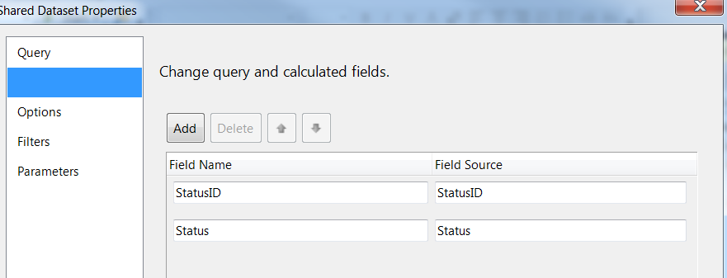

Parameters:

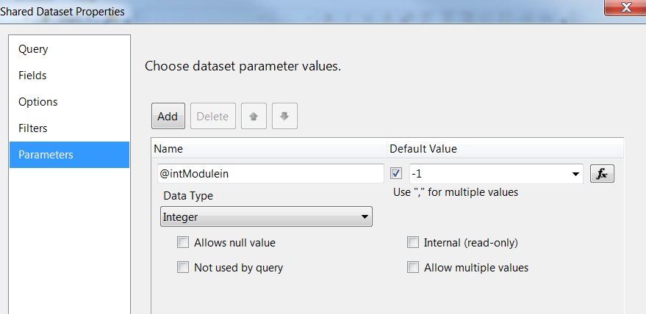

* 1. **CoachingSubReasonRef (uses shared dataset CoachingSubReasonList)**

Query:

SELECT SubCoachingReasonID, SubCoachingReason

FROM (SELECT - 1 AS SubCoachingReasonID, 'All' AS SubCoachingReason

UNION

SELECT DISTINCT clr.SubCoachingReasonID, dscr.SubCoachingReason

FROM EC.Coaching_Log_Reason AS clr INNER JOIN

EC.DIM_Sub_Coaching_Reason AS dscr ON clr.SubCoachingReasonID = dscr.SubCoachingReasonID

WHERE (clr.CoachingReasonID =(@intCoachReasonin) or @intCoachReasonin = -1) ) AS s

WHERE SubCoachingReason <> 'unknown'

ORDER BY CASE WHEN SubCoachingReasonID = - 1 THEN 0 ELSE 1 END, SubCoachingReason

Fields:

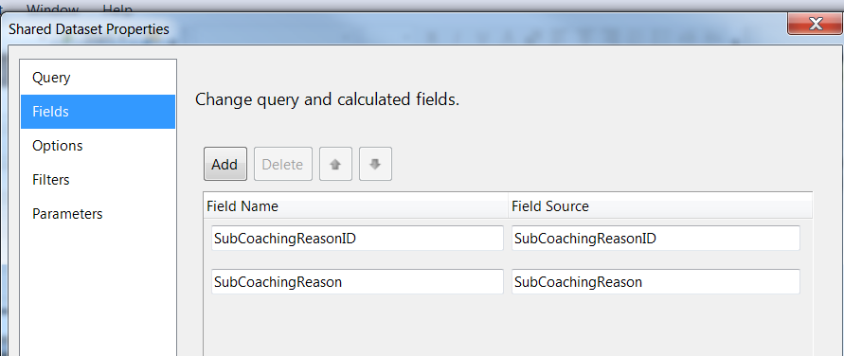

Parameters:

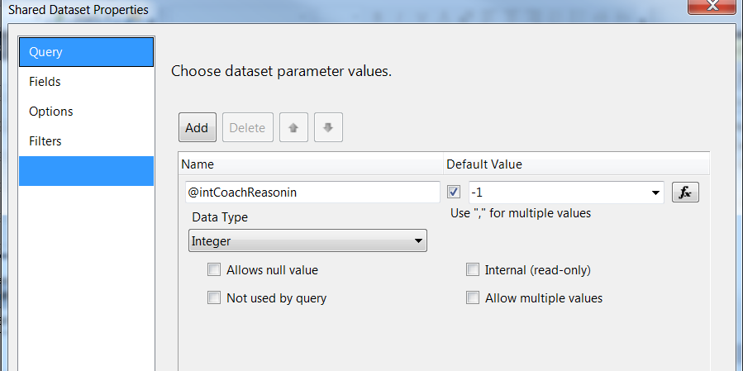

* 1. **CoachingSiteRef (uses shared dataset CoachingSiteList)**

Query:

SELECT SiteID, Site

FROM (

SELECT -1 AS SiteID, 'All' AS Site

UNION

SELECT DISTINCT cl.SiteID, cs.City AS Site

FROM EC.Coaching_Log AS cl INNER JOIN EC.DIM_Site cs

ON cl.SiteID = cs.SiteID

WHERE (cl.ModuleID =(@intModulein) or @intModulein = -1)

and cs.City <> 'Unknown'

)AS S

ORDER BY CASE WHEN SiteID = - 1 THEN 0 ELSE 1 END, SiteFields:

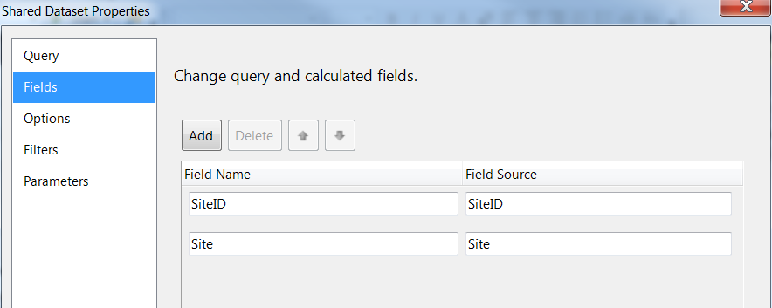

Parameters:

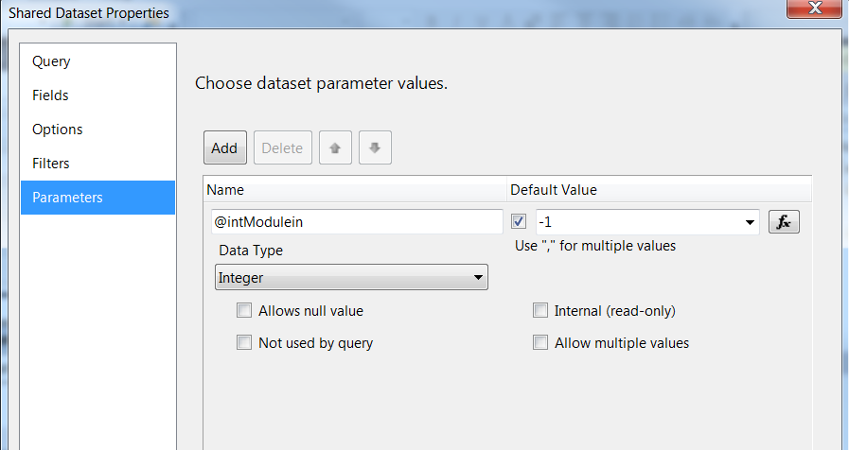

# Report Display

**Report Title: None (Defined in UI)**

**Subtitle: None**

**Report Elements:**

|  |  |  |
| --- | --- | --- |
| **Number** | **Field** | **Description** |
| 1 | Module ID | Module the log was submitted in |
| 2 | Module Name | Name of the module |
| 3 | Coaching ID | ID of the coaching log |
| 4 | Form name | Coaching log form name |
| 5 | Status | Current status of the coaching log |
| 6 | Employee ID | Employee ID of the log recipient |
| 7 | Employee name | The last, first mi name of employee |
| 8 | City | Site of the employee |
| 9 | Supervisor employee ID | Employee ID of the supervisor of the log recipient at time the log is submitted |
| 10 | Supervisor name | The last, first mi name of supervisor of employee |
| 11 | Manager employee ID | Employee ID of the manager of the log recipient at time log is submitted |
| 12 | Manager name | The last, first mi name of manager of employee |
| 13 | Current Supervisor employee ID | Employee ID of the supervisor of the log recipient at time the report is run |
| 14 | Current Supervisor name | The last, first mi name of supervisor of employee |
| 15 | Current Manager employee ID | Employee ID of the manager of the log recipient at time the report is |
| 16 | Current Manager name | The last, first mi name of manager of employee |
| 17 | Review Supervisor employee ID | Employee ID of the supervisor who reviewed/coached the log recipient |
| 18 | Review Supervisor name | The last, first mi name of supervisor of employee |
| 19 | Review Manager employee ID | Employee ID of the manager who reviewed the log |
| 20 | Review Manager name | The last, first mi name of manager of employee |
| 21 | Description | Description or behavior subject to coaching |
| 22 | Coaching notes | Coaching notes for log |
| 23 | Event date | Date of event associated with log |
| 24 | Coaching date | Date of coaching associated with log |
| 25 | Submitted date | Date the log was submitted |
| 26 | Coaching source | Source of coaching (Direct, Indirect) |
| 27 | Sub-coaching source | How the coaching was identified |
| 28 | Coaching reason | Coaching reason of log |
| 29 | Coaching sub-reason | Coaching sub-reason of log |
| 30 | Value | Value of log (Opportunity, Reinforcement,…) |
| 31 | Submitter ID | Employee ID of the submitter of the log |
| 32 | Submitter name | Name of the submitter of the log |
| 33 | Supervisor reviewed date | Date/time supervisor reviewed and acknowledged the coaching log |
| 34 | Manager reviewed manual date | Date/time manager entered when reviewed and acknowledged the coaching log |
| 35 | Manager reviewed auto date | Date/time manager reviewed and acknowledged the coaching log |
| 36 | Manager notes | Comments or notes entered by manager |
| 37 | Employee reviewed date | Date when the recipient reviewed and acknowledged or entered comments. |
| 38 | Employee comments | Comments entered by employee |
| 39 | Program | Program associated with the log (Medicare, Marketplace, NA) |
| 40 | Behavior | Behavior associated with the log in the Training module (Production, Training, Other) |
| 41 | Report Code | Report code of log related to input data feed |
| 42 | Verint ID | ID of the Verint call record scorecard associated with the coaching log |
| 43 | Verint Form name | Form name in Verint related to coaching log |
| 44 | Coaching Monitor | Whether the log from Verint is a coaching monitor (Yes, No) |

**Tablix Properties:**

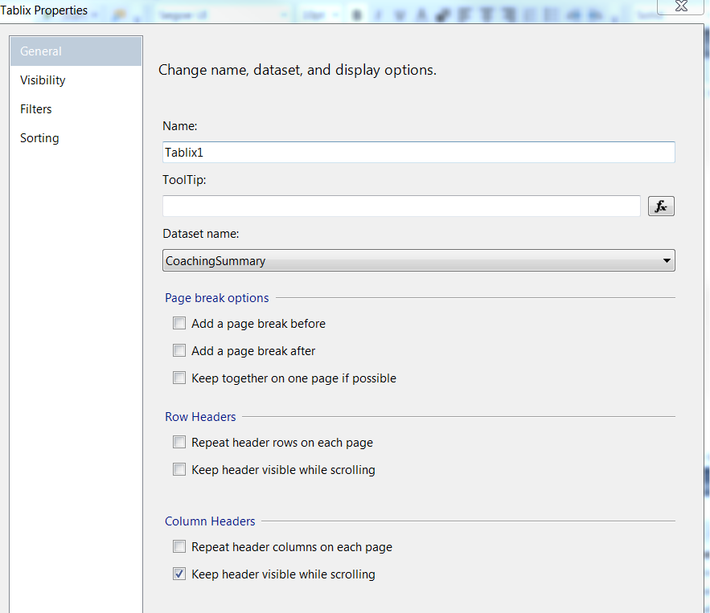

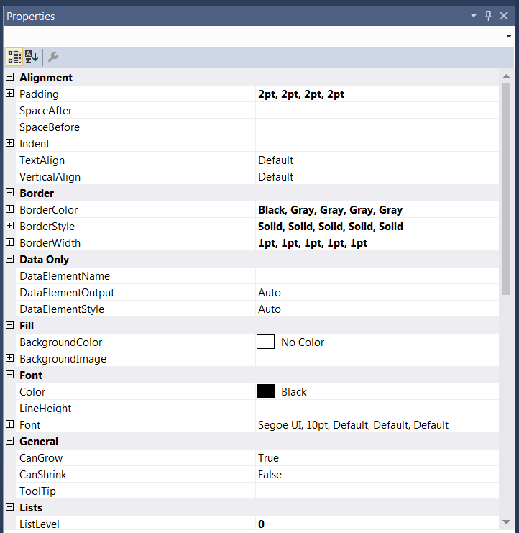

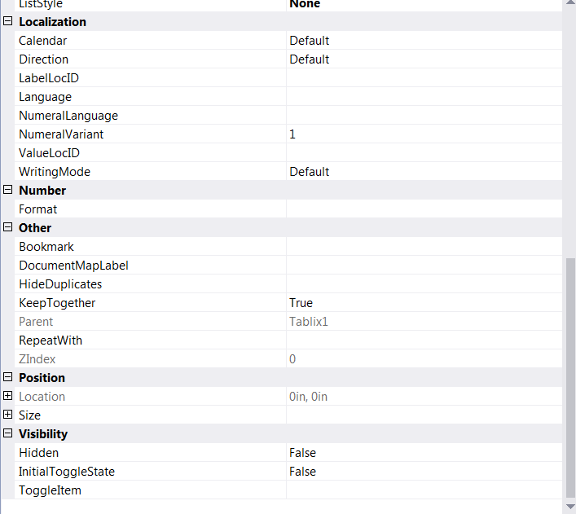

# Preview Sample

