__________________________

***Contact Center Operations***

**CCO eCoaching Admin Activity Summary Report**

**SSRS Detail Design Document**

__________________________

|  |  |  |
| --- | --- | --- |
| Last Revision | Last Review | Description |
| 02/11/2019 |  | TFS 13437 - Update urls in SSRS Reporting for AD domain |

Prepared by: Suzy Palacherla Date: 4/18/2017

Department, Location: HCSD

Approved by: Date:

**Change History Log**

| **Date** | **Change Description** | **Author** |
| --- | --- | --- |
| 4/18/2017 | TFS 5621 – Initial revision | Susmitha Palacherla |
| 8/15/2017 | TFS 7106 – Upgrade for SQL Server 2012 | Susmitha Palacherla |
| 08/27/2018 | TFS 11663 - Update urls in SSRS Reporting for Shared Services domain.  Updated Section 7.0 Deployment properties and added Section 8.0 for Data Source(s) | Susmitha Palacherla |
| 02/11/2019 | TFS 13437 - Update urls in SSRS Reporting for AD domain.  Updated Section 7.0 Deployment properties and added Section 8.0 for Data Source(s) | Susmitha Palacherla |

Contents

1.0 Purpose 4

2.0 XML Information 4

3.0 Report Parameters 4

4.0 Report Datasets 5

4.1 AdminActivitySummary 5

4.2 AdminLogTypeRef (uses shared dataset AdminLogTypeList) 8

4.3 AdminActionRef (uses shared dataset AdminActionList) 9

4.4 AdminFormRef (uses shared dataset AdminFormList) 10

5.0 Report Display 12

6.0 Preview Sample 17

7.0 Deployment Properties 17

7.1 Dev 17

7.2 SysTest 18

7.3 Production 18

8.0 Data Source(s) 18

# Purpose

The purpose of the Warning summary report is for Engineering, Program and support staff that need to be able to view the details of the Admin activity audit logs and or generate Reports based on the Admin activity audit logs to be able to do so without having to login to the database and run direct queries.

# XML Information

The location of the RDL “executable” code for the report can be found in TFS at:

\cms\eCoaching_V2\Code\SSRS\eCoachingReport\eCoachingReport\AdminActivitySummary.rdl

This contains all the code that defines the SQL, the formatting, and any other special effects.

# Report Parameters

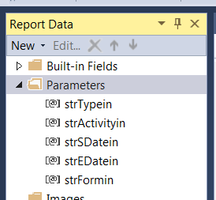

The Coaching Summary report will take the following parameters:

|  |  |  |  |  |
| --- | --- | --- | --- | --- |
| **Name** | **User Prompt** | **Type** | **Required?** | **Description** |
| strTypein | Log Type | Text | Yes | Gives the user an option to choose from Coaching, Warning or All |
| strActivityin | Activity | Text | Yes | Gives user the option to choose from the Activity to report on. Includes Inactivate, Reactivate, Reassign and or All. Depends on the Type selected. |
| strSdatein | Start Date | Date/Time | Yes | Start date for list of Admin activity audit logs to be displayed based on Action date |
| strEDatein | End Date | Date/Time | Yes | End date for list of Admin activity audit logs to be displayed based on Action date |
| strFormin | Form Name | Text | Yes | Dropdown list populated by all form names available for above selected parameters with All being an available option. |

# Report Datasets

# AdminActivitySummary

Query the Coaching logs for selected set of parameters.

Query:

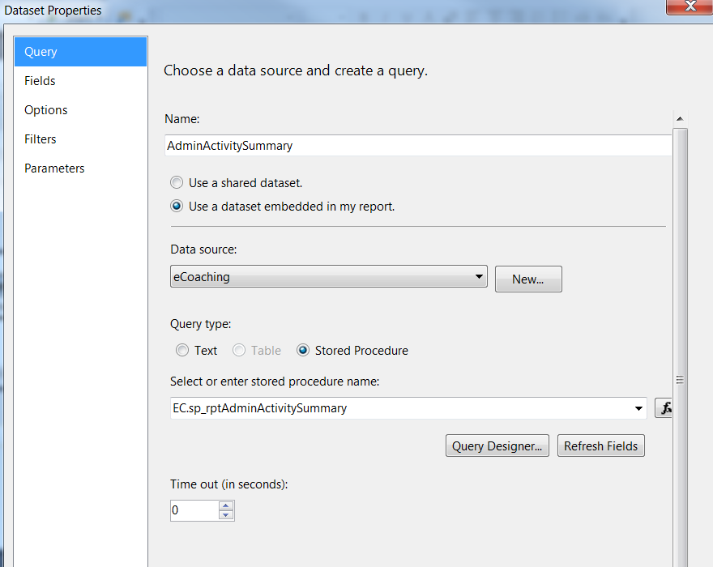

Fields:

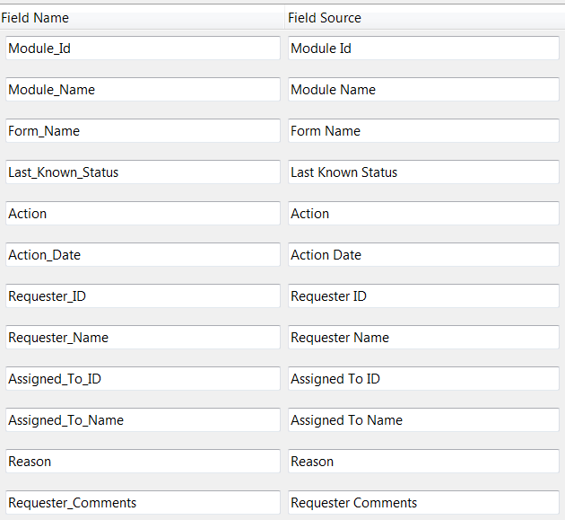

Parameters:

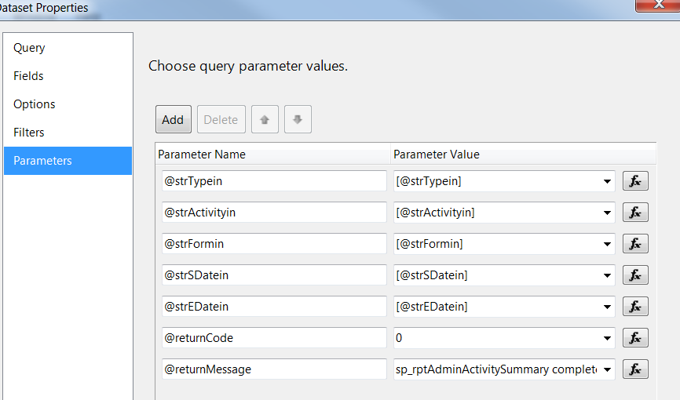

# AdminLogTypeRef (uses shared dataset AdminLogTypeList)

Query:

Select a.* FROM

(Select 'All' AS LogType

UNION

Select 'Coaching' AS LogType

UNION

Select 'Warning' AS LogType)a

ORDER BY CASE WHEN a.LogType = 'All' THEN 0 ELSE 1 END

Fields:

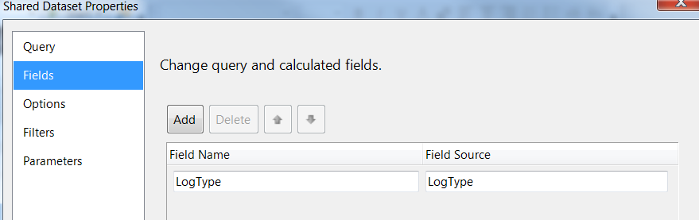

Parameters: None

# AdminActionRef (uses shared dataset AdminActionList)

Query:

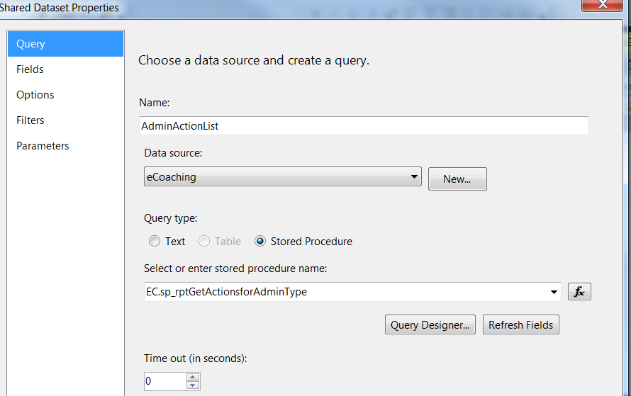

Fields:

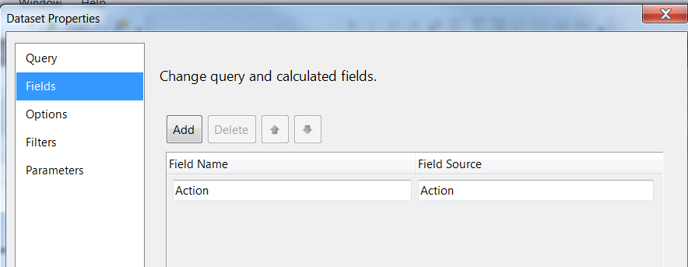

Parameters:

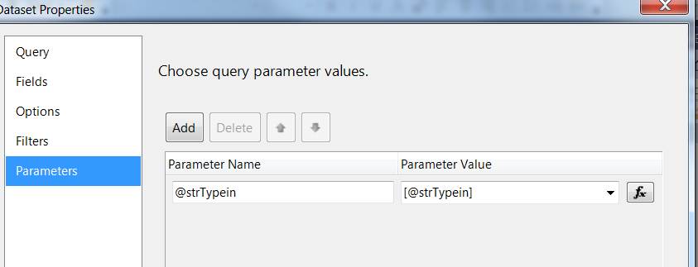

# AdminFormRef (uses shared dataset AdminFormList)

Query:

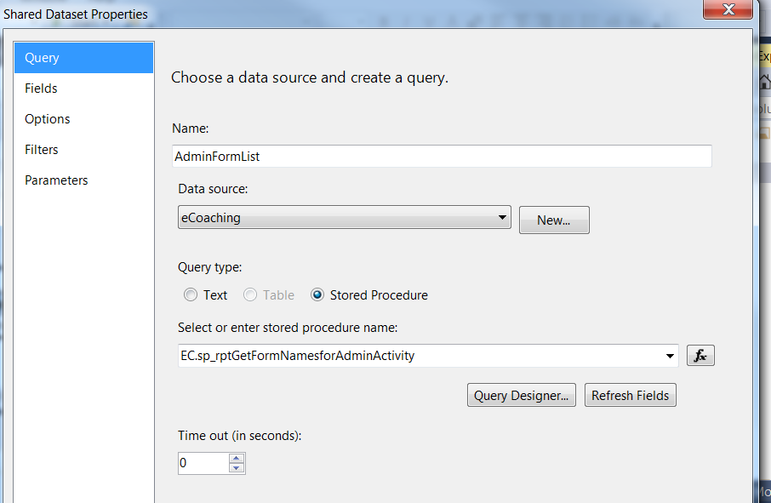 Fields:

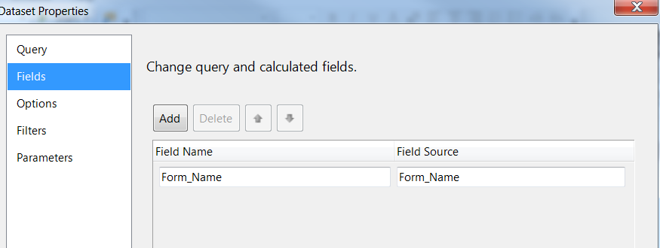

Parameters:

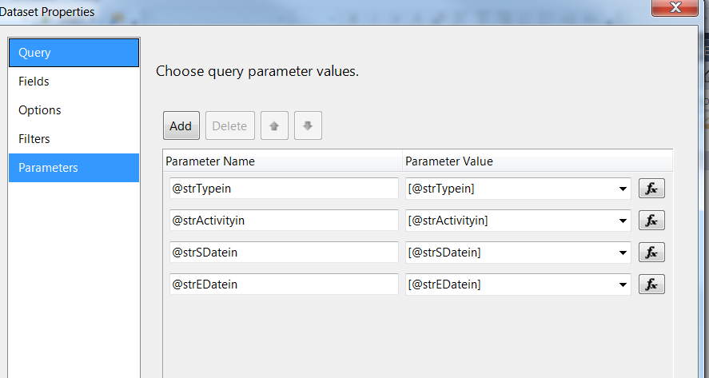

# Report Display

**Report Title: None (Defined in UI)**

**Subtitle: None**

**Report Elements:**

|  |  |  |
| --- | --- | --- |
| **Number** | **Field** | **Description** |
| 1 | Module ID | Module the log was submitted in |
| 2 | Module Name | Name of the module |
| 3 | Form name | Coaching or warning log form name |
| 4 | Last known status | The last known status of the log prior to activity |
| 5 | Action | Action or activity which occurred (or ‘Reassignment’ for reassigned logs) |
| 6 | Action date | Date of activity |
| 7 | Requester ID | The employee id of person requesting the activity |
| 8 | Requester name | The last, first mi name of person requesting the activity |
| 9 | Assigned to ID | The employee id of person the log is reassigned to (‘-‘ if not applicable) |
| 10 | Assigned to name | The last, first mi name of person the log is reassigned to (‘-‘ if not applicable) |
| 11 | Reason | Reason selected for the activity |
| 12 | Requester comments | Additional comments entered by the requester |

**Tablix Properties:**

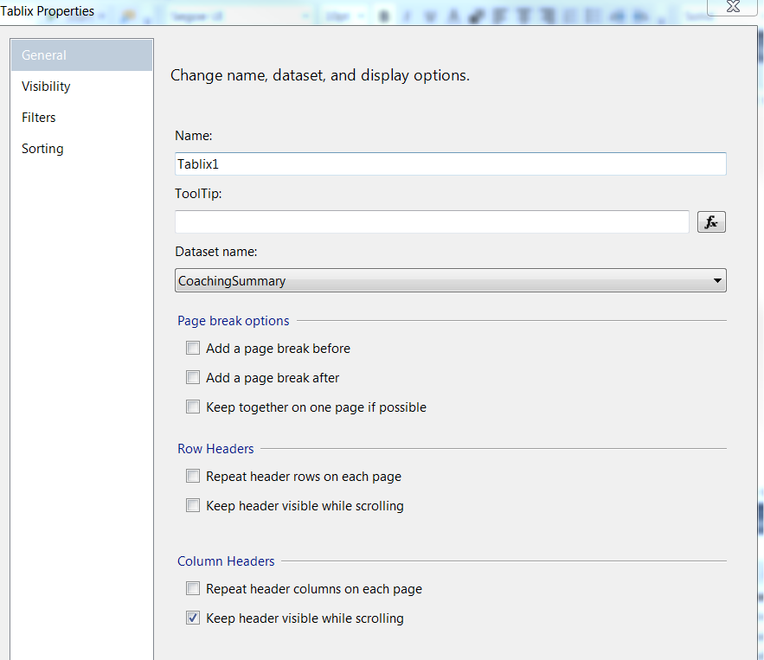

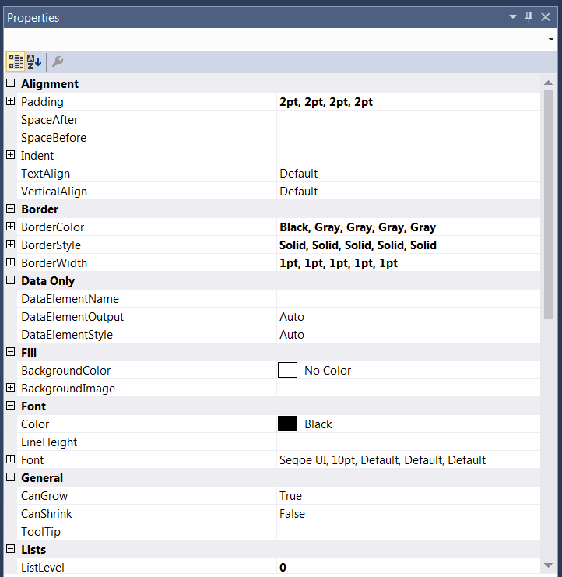

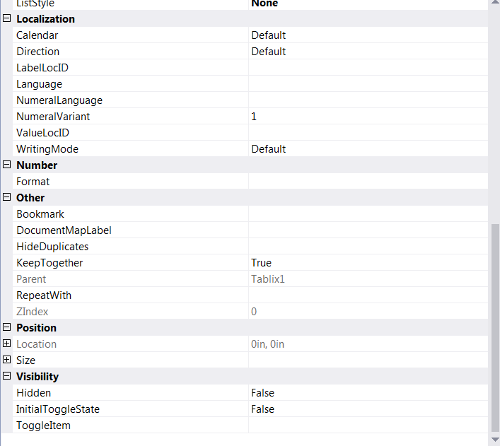

# Preview Sample

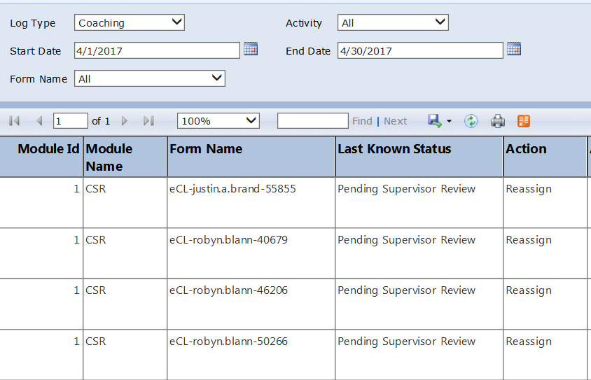

# Deployment Properties

# Dev

|  |  |
| --- | --- |
| **Overwrite Datasets** | True |
| **Overwrite DataSources** | False |
| **TargetDatasetFolder** | /eCoaching/Datasets |
| **TargetDataSourceFolder** | /eCoaching/DataSources |
| **TargetReportFolder** | /eCoaching/Reports |
| **TargetReportPartFolder** | Report Parts |
| **TargetServerURL** | https://f3420-ecldbd01/ReportServer |
| **TargetServerVersion** | SQL Server 2008 R2, 2012 or 2014 |
| **Report Portal** | https://f3420-ecldbd01/Reports_ECLD01 |

# SysTest

|  |  |
| --- | --- |
| **Overwrite Datasets** | True |
| **Overwrite DataSources** | False |
| **TargetDatasetFolder** | /eCoaching/Datasets |
| **TargetDataSourceFolder** | /eCoaching/DataSources |
| **TargetReportFolder** | /eCoaching/Reports |
| **TargetReportPartFolder** | Report Parts |
| **TargetServerURL** | https://f3420-ecldbt01/ReportServer |
| **TargetServerVersion** | SQL Server 2008 R2, 2012 or 2014 |
| **Report Portal** | https://f3420-ecldbt01/Reports_ECLT01 |

# Production

|  |  |
| --- | --- |
| **Overwrite Datasets** | True |
| **Overwrite DataSources** | False |
| **TargetDatasetFolder** | /eCoaching/Production/Datasets |
| **TargetDataSourceFolder** | /eCoaching/Production/DataSources |
| **TargetReportFolder** | /eCoaching/Production/Reports |
| **TargetReportPartFolder** | Report Parts |
| **TargetServerURL** | https://f3420-ecldbp01/ReportServer |
| **TargetServerVersion** | SQL Server 2008 R2, 2012 or 2014 |
| **Report Portal** | https://f3420-ecldbp01/Reports_ECLP01 |

# Data Source(s)

|  |  |  |
| --- | --- | --- |
| **Name** |  | eCoaching |
| **Type** |  | Microsoft SQL Server |
| **Connection String(s)** |  | Dev: Data Source=F3420-ECLDBD01;Initial Catalog=eCoachingDev  Sys Test: Data Source=F3420-ECLDBT01;Initial Catalog=eCoachingTest  Production: Data Source=F3420-ECLDBP01;Initial Catalog=eCoaching |
| **Connect Using** |  | Windows Integrated Security |

# Report Properties

|  |  |
| --- | --- |
| **Parameters** |  |
| **Data Source** | /eCoaching/DataSources/eCoaching |
| **Shared Datasets** | AdminActionRef: /eCoaching/Datasets/AdminActionList  AdminFormRef: /eCoaching/Datasets/AdminFormList  AdminLogTypeRef: /eCoaching/Datasets/AdminLogTypeList |