__________________________

***Contact Center Operations***

**CCO eCoaching Hierarchy Summary Report**

**SSRS Detail Design Document**

__________________________

|  |  |  |
| --- | --- | --- |
| Last Revision | Last Review | Description |
| 02/11/2019 |  | TFS 13437 - Update urls in SSRS Reporting for AD domain |

Prepared by: Suzy Palacherla Date: 4/18/2017

Department, Location: HCSD

Approved by: Date:

**Change History Log**

| **Date** | **Change Description** | **Author** |
| --- | --- | --- |
| 4/22/2017 | TFS 5621 – Initial revision | Susmitha Palacherla |
| 8/15/2017 | TFS 7106 – Upgrade for SQL Server 2012 | Susmitha Palacherla |
| 04/09/2018 | TFS 10588 - Update SSRS DD docs with peer review finding. Updated HierarchyEmployeeList dataset to replace embedded query with stored procedure that was implemented to support Encryption of sensitive data during TFS 7856. | Susmitha Palacherla |
| 08/27/2018 | TFS 11663 - Update urls in SSRS Reporting for Shared Services domain.  Updated Section 7.0 Deployment properties and added Section 8.0 for Data Source(s) | Susmitha Palacherla |
| 02/11/2019 | TFS 13437 - Update urls in SSRS Reporting for AD domain.  Updated Section 7.0 Deployment properties and added Section 8.0 for Data Source(s) | Susmitha Palacherla |
|  |  |  |
|  |  |  |
|  |  |  |
|  |  |  |
|  |  |  |
|  |  |  |
|  |  |  |

Contents

1.0 Purpose 4

2.0 XML Information 4

3.0 Report Parameters 4

4.0 Report Datasets 5

4.1 HierarchySummary 5

4.2 HierarchySiteRef (uses shared dataset HierarchySiteList) 7

4.3 HierarchyEmployeeRef (uses shared dataset HierarchyEmployeeList) 9

5.0 Report Display 10

6.0 Preview Sample 15

7.0 Deployment Properties 15

7.1 Dev 15

7.2 SysTest 15

7.3 Production 16

8.0 Data Source(s) 16

# Purpose

The purpose of the Hierarchy summary report is for Engineering, Program and support staff that need to be able to view the details of employee Hierarchy and or generate Reports based on the Hierarchy to be able to do so without having to login to the database and run direct queries.

# XML Information

The location of the RDL “executable” code for the report can be found in TFS at:

\cms\eCoaching_V2\Code\SSRS\eCoachingReport\eCoachingReport\HierarchySummary.rdl

This contains all the code that defines the SQL, the formatting, and any other special effects.

# Report Parameters

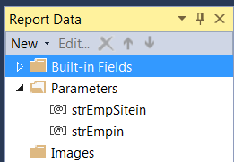

The Coaching Summary report will take the following parameters:

|  |  |  |  |  |
| --- | --- | --- | --- | --- |
| **Name** | **User Prompt** | **Type** | **Required?** | **Description** |
| strEmpSitein | Employee Site | Text | Yes | A list of CCO sites to select from. |
| strEmpin | Employee | Text | Yes | A list of employees for selected site above to pick from with All being an available option. |

# Report Datasets

# HierarchySummary

Query the Employee Hierarchy table for selected set of parameters.

Query:

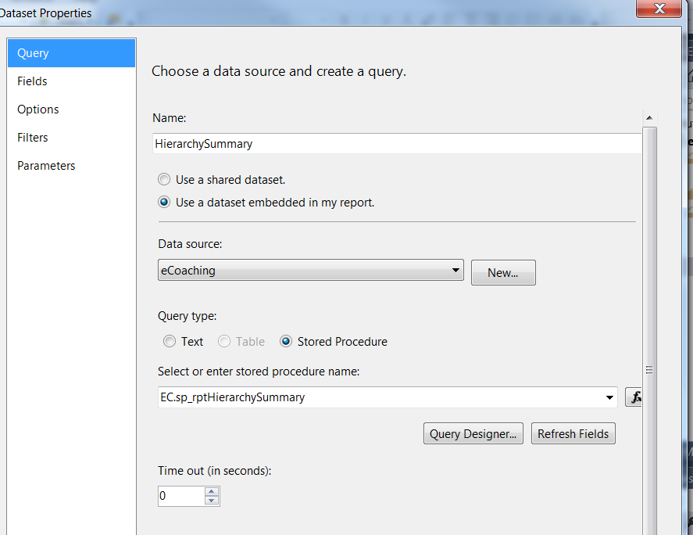

Fields:

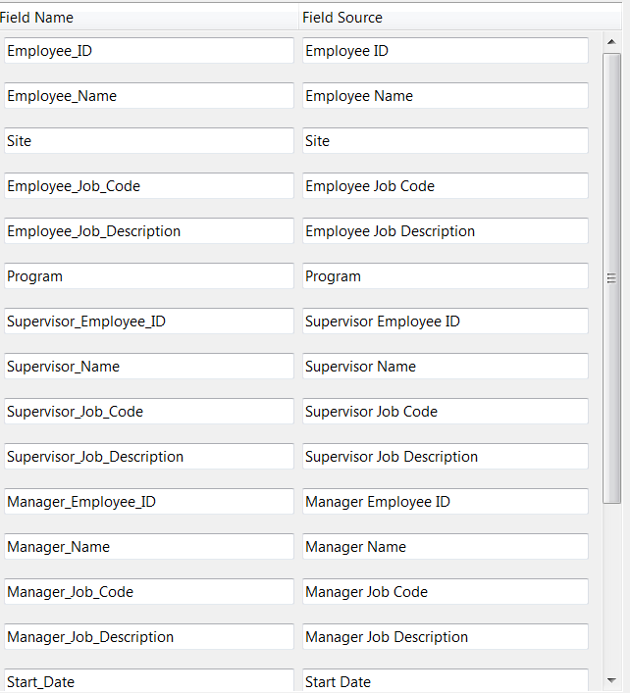

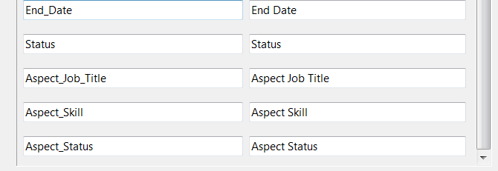

Parameters:

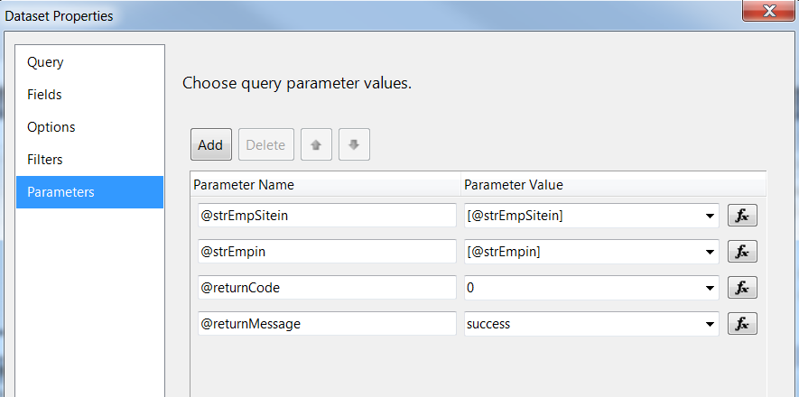

# HierarchySiteRef (uses shared dataset HierarchySiteList)

Query:

SELECT Site

FROM (

SELECT 'All' AS Site

UNION

SELECT DISTINCT Emp_Site AS Site

FROM EC.Employee_Hierarchy eh join EC.DIM_Site ds

ON eh.Emp_Site = ds.city

WHERE Emp_Site <> 'Unknown'

UNION

SELECT DISTINCT 'Other' AS Site

FROM EC.Employee_Hierarchy

WHERE Emp_Site = 'Other'

)AS S

ORDER BY CASE

WHEN Site = 'All' THEN 0

WHEN Site = 'OTHER' THEN 2

ELSE 1 END, Site

Fields:

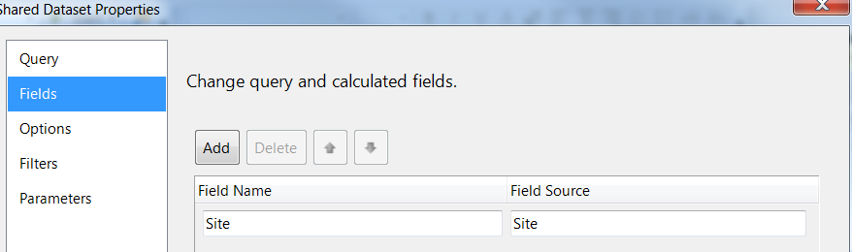

Parameters: None

# HierarchyEmployeeRef (uses shared dataset HierarchyEmployeeList)

Query:

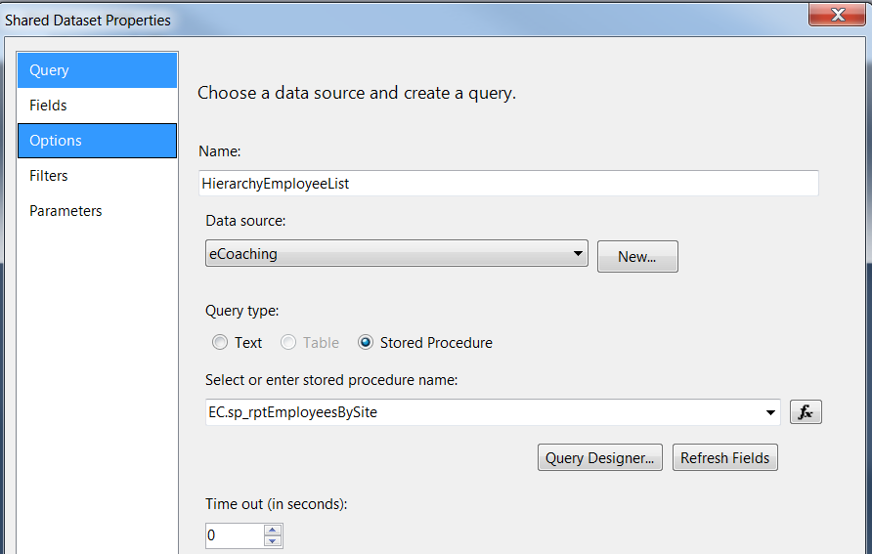

Fields:

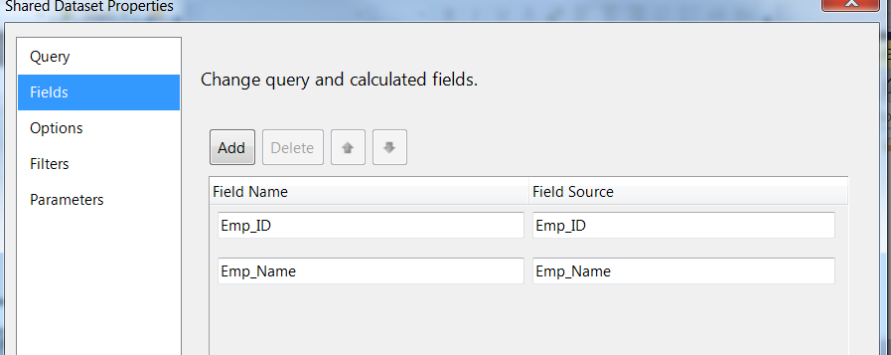

Parameters:

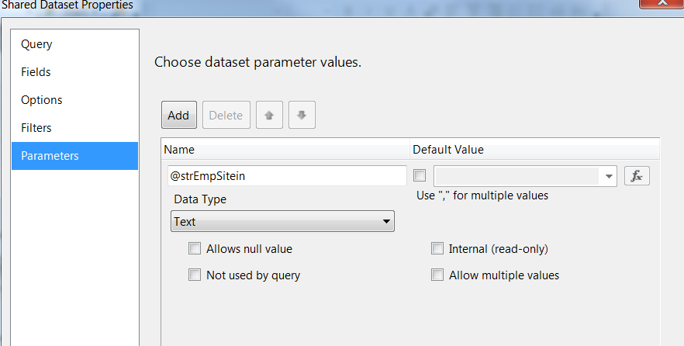

# Report Display

**Report Title: None (Defined in UI)**

**Subtitle: None**

**Report Elements:**

|  |  |  |
| --- | --- | --- |
| **Number** | **Field** | **Description** |
| 1 | Employee ID | Employee ID of the log recipient |
| 2 | Module Name | Name of the module |
| 3 | Employee name | The last, first mi name of employee |
| 4 | City | Site of the employee |
| 5 | Employee job code | Job code of the employee |
| 6 | Employee job description | Job description/title of the employee |
| 7 | Program | Program associated with the employee (Medicare, Marketplace, NA) |
| 8 | Supervisor employee ID | Employee ID of the supervisor of the log recipient at time the report is run |
| 9 | Supervisor name | The last, first mi name of supervisor of employee |
| 10 | Supervisor job code | Job code of the supervisor |
| 11 | Supervisor job description | Job description/title of the supervisor |
| 12 | Manager employee ID | Employee ID of the manager of the log recipient at time the report is |
| 13 | Manager name | The last, first mi name of manager of employee |
| 14 | Manager job code | Job code of the manager |
| 15 | Manager job description | Job description/title of the manager |
| 16 | Start date | Start or hire date of the employee |
| 17 | End date | End or termination date of the employee |
| 18 | Status | Status of the employee |

**Tablix Properties:**

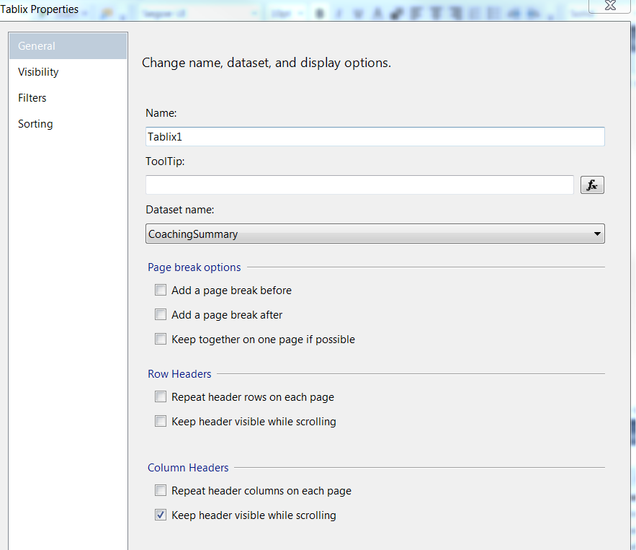

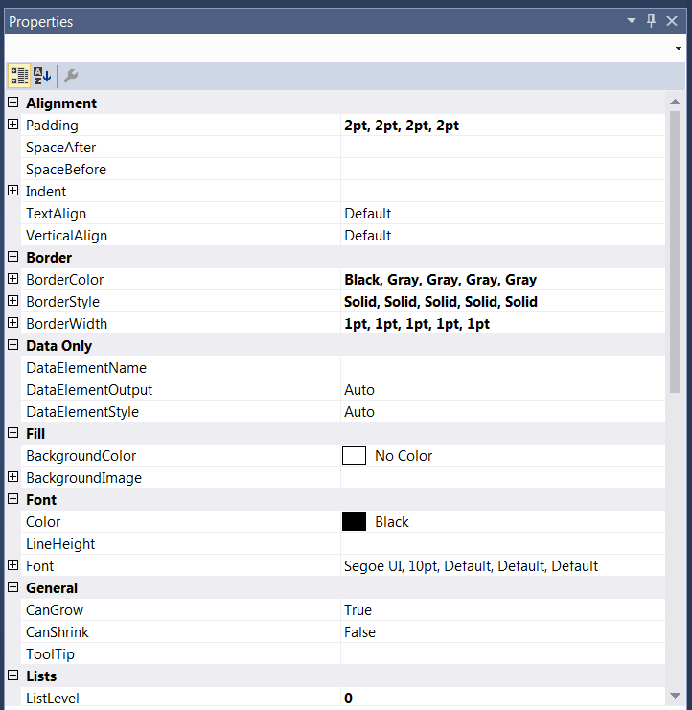

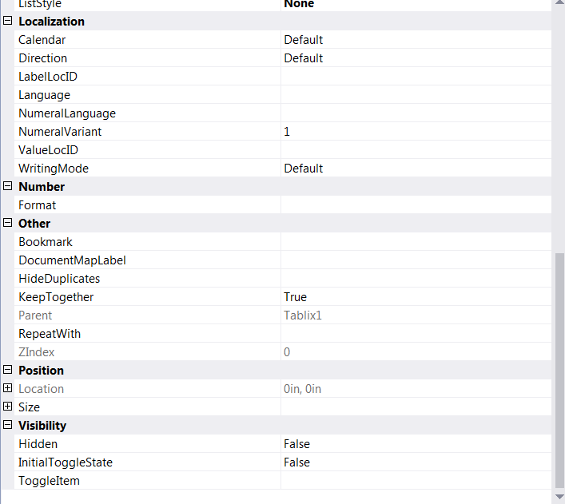

# Preview Sample

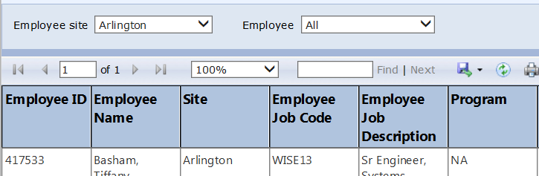

# Deployment Properties

# Dev

|  |  |
| --- | --- |
| **Overwrite Datasets** | True |
| **Overwrite DataSources** | False |
| **TargetDatasetFolder** | /eCoaching/Datasets |
| **TargetDataSourceFolder** | /eCoaching/DataSources |
| **TargetReportFolder** | /eCoaching/Reports |
| **TargetReportPartFolder** | Report Parts |
| **TargetServerURL** | https://f3420-ecldbd01/ReportServer |
| **TargetServerVersion** | SQL Server 2008 R2, 2012 or 2014 |
| **Report Portal** | https://f3420-ecldbd01/Reports_ECLD01 |

# SysTest

|  |  |
| --- | --- |
| **Overwrite Datasets** | True |
| **Overwrite DataSources** | False |
| **TargetDatasetFolder** | /eCoaching/Datasets |
| **TargetDataSourceFolder** | /eCoaching/DataSources |
| **TargetReportFolder** | /eCoaching/Reports |
| **TargetReportPartFolder** | Report Parts |
| **TargetServerURL** | https://f3420-ecldbt01/ReportServer |
| **TargetServerVersion** | SQL Server 2008 R2, 2012 or 2014 |
| **Report Portal** | https://f3420-ecldbt01/Reports_ECLT01 |

# Production

|  |  |
| --- | --- |
| **Overwrite Datasets** | True |
| **Overwrite DataSources** | False |
| **TargetDatasetFolder** | /eCoaching/Production/Datasets |
| **TargetDataSourceFolder** | /eCoaching/Production/DataSources |
| **TargetReportFolder** | /eCoaching/Production/Reports |
| **TargetReportPartFolder** | Report Parts |
| **TargetServerURL** | https://f3420-ecldbp01/ReportServer |
| **TargetServerVersion** | SQL Server 2008 R2, 2012 or 2014 |
| **Report Portal** | https://f3420-ecldbp01/Reports_ECLP01 |

# Data Source(s)

|  |  |
| --- | --- |
| **Name** | eCoaching |
| **Type** | Microsoft SQL Server |
| **Connection String(s)** | Dev: Data Source=F3420-ECLDBD01;Initial Catalog=eCoachingDev  Sys Test: Data Source=F3420-ECLDBT01;Initial Catalog=eCoachingTest  Production: Data Source=F3420-ECLDBP01;Initial Catalog=eCoaching |
| **Connect Using** | Windows Integrated Security |

1. **Report Properties**

|  |  |
| --- | --- |
| **Parameters** |  |
| **Data Source** | /eCoaching/DataSources/eCoaching |
| **Shared Datasets** | HierarchyEmployeeRef: /eCoaching/Datasets/HierarchyEmployeeList  HierarchySiteRef: /eCoaching/Datasets/HierarchySiteList |