__________________________

**eCoaching Log System**

**Coaching Summary QN Report**

**SSRS Detail Design Document**

__________________________

|  |  |  |
| --- | --- | --- |
| Last Revision | Last Review | Description |
| 8/3/2020 |  | TFS 17716 - Removed company specific references |

Prepared by: Suzy Palacherla Date: 4/18/2017

Department, Location: HCSD

Approved by: Date:

**Change History Log**

| **Date** | **Change Description** | **Author** |
| --- | --- | --- |
| 4/4/2019 | TFS 13333 – Initial revision. Quality Now Initiative. | Susmitha Palacherla |
| 8/3/2020 | TFS 17716 - Removed company specific references | Susmitha Palacherla |
|  |  |  |
|  |  |  |
|  |  |  |
|  |  |  |
|  |  |  |
|  |  |  |
|  |  |  |
|  |  |  |
|  |  |  |
|  |  |  |

Contents

1.0 Purpose 4

2.0 XML Information 4

3.0 Report Parameters 4

4.0 Report Datasets 5

5.0 Report Display 21

6.0 Preview Sample 27

7.0 Deployment Properties 27

7.1 Dev 27

7.2 SysTest 27

7.3 Production 28

8.0 Data Source(s) 28

# Purpose

The purpose of the Coaching summary report is for Engineering, Program and support staff that need to be able to view the details of the coaching logs and or generate Reports based on the coaching logs to be able to do so without having to login to the database and run direct queries. This report will display the Quality Now eCls.

# XML Information

The location of the RDL “executable” code for the report can be found in TFS at:

\cms\eCoaching_V2\Code\SSRS\eCoachingReport\eCoachingReport\CoachingSummaryQN.rdl

This contains all the code that defines the SQL, the formatting, and any other special effects.

# Report Parameters

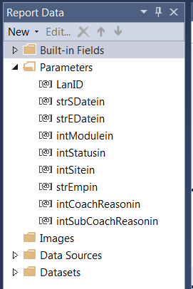

The Coaching Summary report will take the following parameters:

|  |  |  |  |  |
| --- | --- | --- | --- | --- |
| **Name** | **User Prompt** | **Type** | **Required?** | **Description** |
| LanID | NA [Hidden] | Text | Yes | Lan ID of Logged in user. Will be passed in from UI code. Used to determine Role of logged in user to display list of available Modules. |
| strSdatein | Start Date | Date/Time | Yes | Start date for list of coaching logs to be displayed based on log submitted date. |
| strEDatein | End Date | Date/Time | Yes | End date for list of coaching logs to be displayed based on log submitted date. |
| intModulein | Employee Level | Text | Yes | Dropdown list populated by dataset ModuleRef (value field: ModuleID label field: Module) |
| intStatusin | Status | Text | Yes | Dropdown List populated by dataset CoachingStatusRef (value field: StatusID label field: Status) |
| intSitein | Site | Text | Yes | Dropdown List populated by dataset CoachingSiteRef (value field: SiteID label field: Site) |
| strEmpin | Employee | Text | Yes | Dropdown List populated by dataset CoachingEmployeeRef (value field: EmpID label field: EmpName) |
| intCoachReasonin | Coaching Reason | Text | Yes | Dropdown List populated by dataset CoachingReasonRef (value field: CoachingReasonID label field: CoachingReason) |
| intsubCoachReasonin | Coaching SubReason | Text | Yes | Dropdown List populated by dataset CoachingSubReasonRef (value field: SubCoachingReasonID label field: SubCoachingReason) |

# Report Datasets

* 1. **CoachingSummaryQN**

Query the Coaching logs for selected set of parameters.

Query:

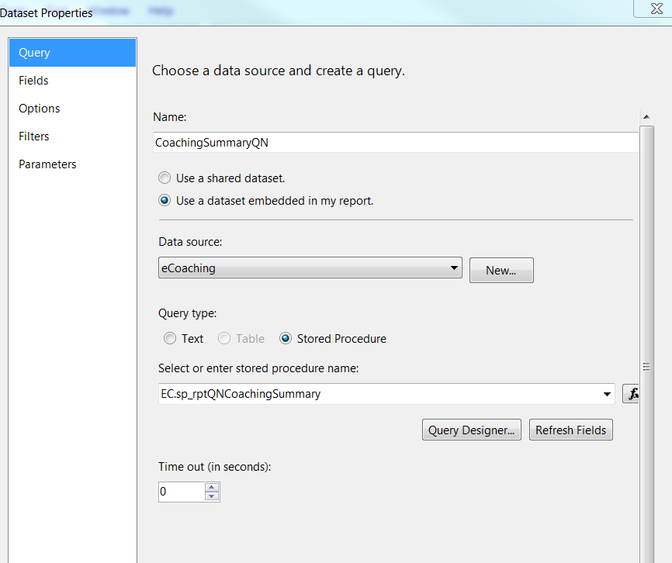

Fields:

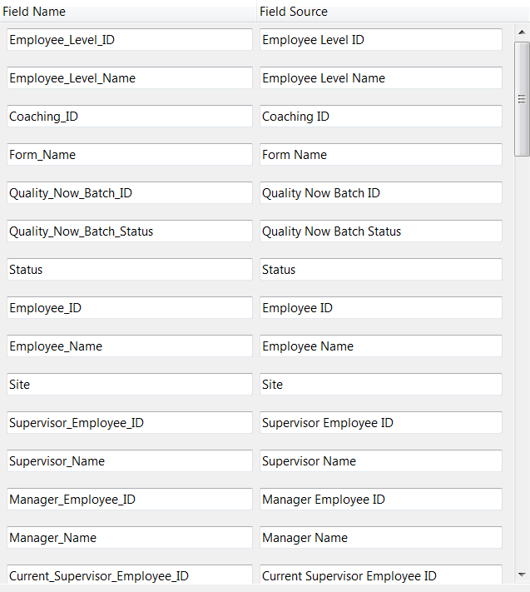

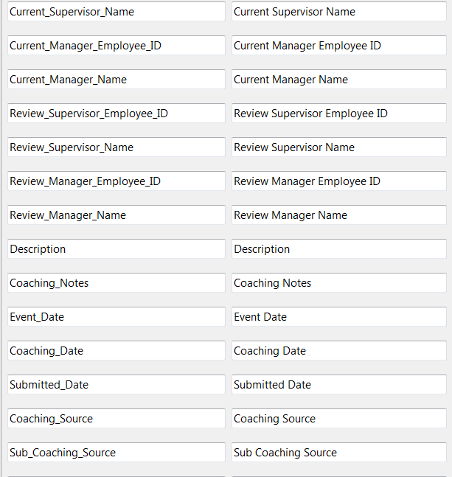

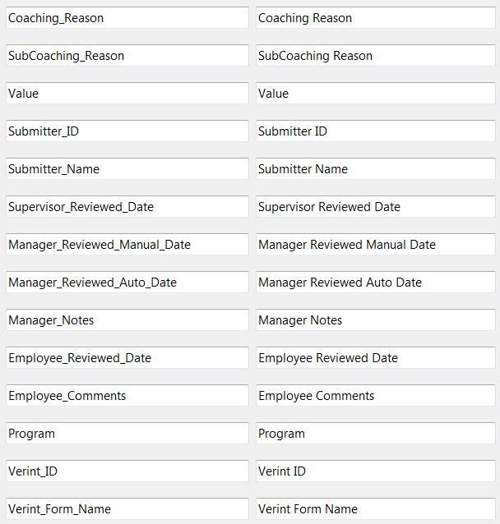

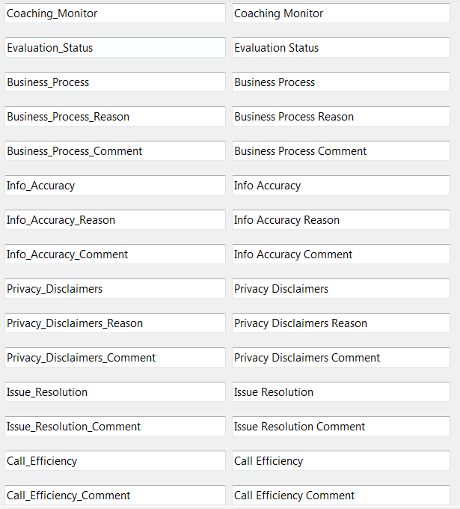

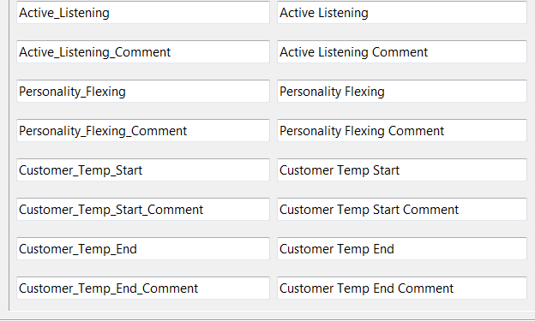

Parameters:

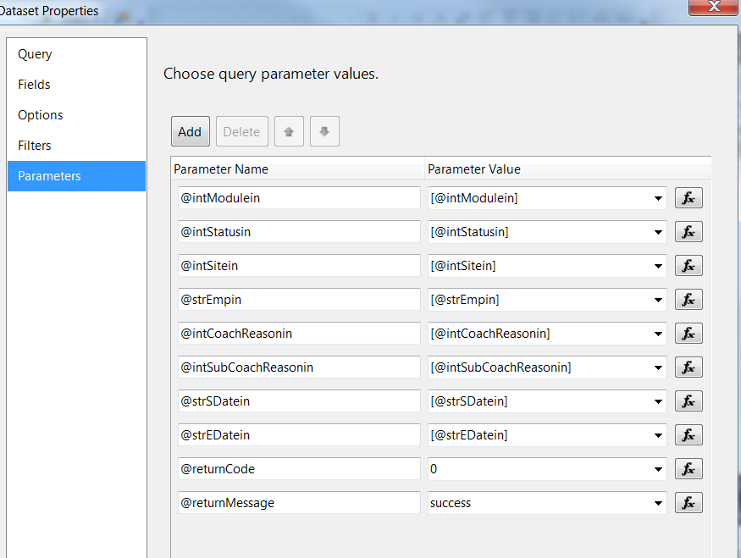

* 1. **CoachingReasonRef (uses shared dataset CoachingReasonList)**

Query:

SELECT CoachingReasonID, CoachingReason

FROM (SELECT - 1 AS CoachingReasonID, 'All' AS CoachingReason

UNION

SELECT DISTINCT clr.CoachingReasonID, dcr.CoachingReason

FROM EC.Coaching_Log AS cl INNER JOIN

EC.Coaching_Log_Reason AS clr ON cl.CoachingID = clr.CoachingID INNER JOIN

EC.DIM_Coaching_Reason AS dcr ON clr.CoachingReasonID = dcr.CoachingReasonID

WHERE (cl.ModuleID =(@intModulein) or @intModulein = -1) ) AS s

ORDER BY CASE WHEN CoachingReasonID = - 1 THEN 0 ELSE 1 END, CoachingReason

Fields:

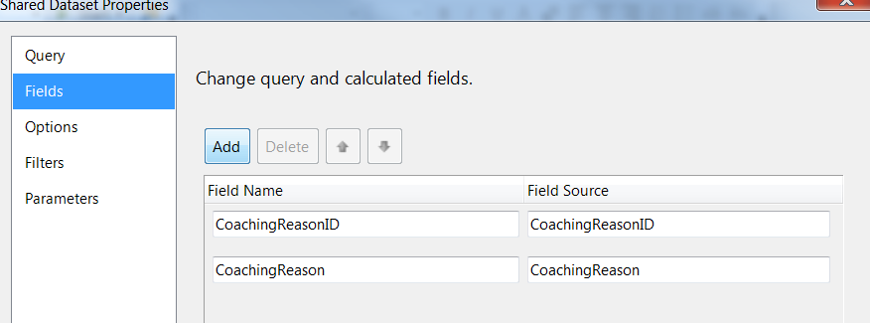

Parameters:

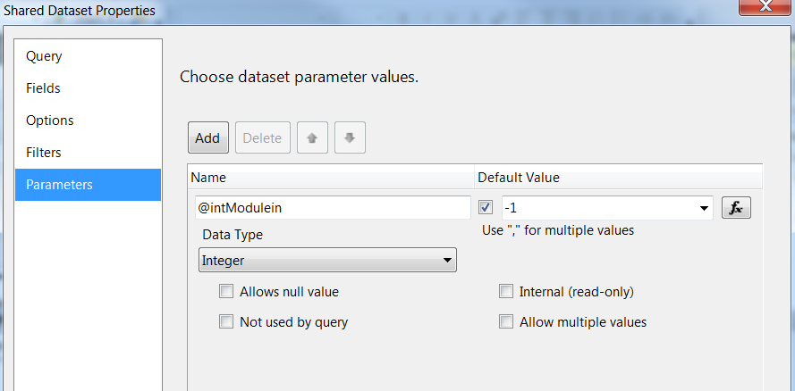

* 1. **CoachingEmployeeRef (uses shared dataset CoachingEmployeeList)**

Query:

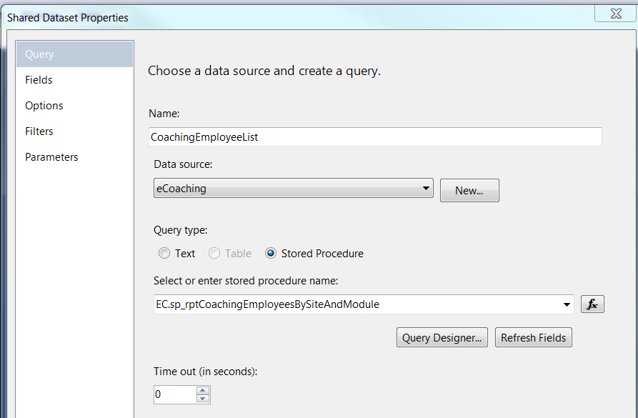

Fields:

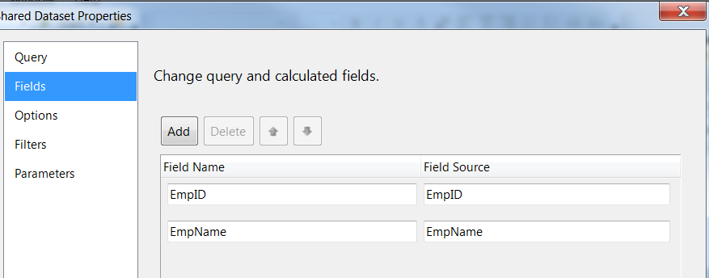

Parameters:

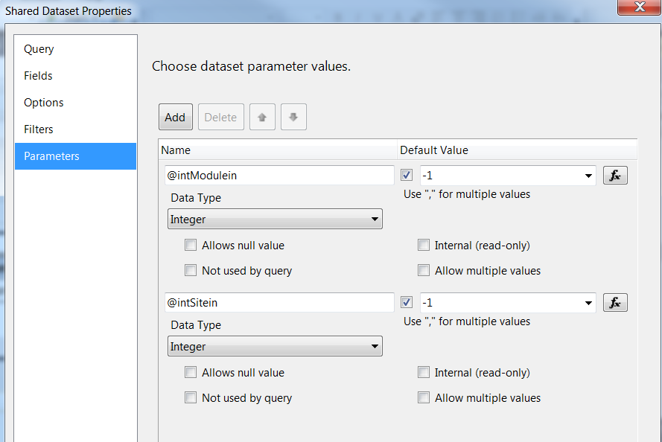

* 1. **ModuleRef (uses shared dataset ModuleList)**

Query:

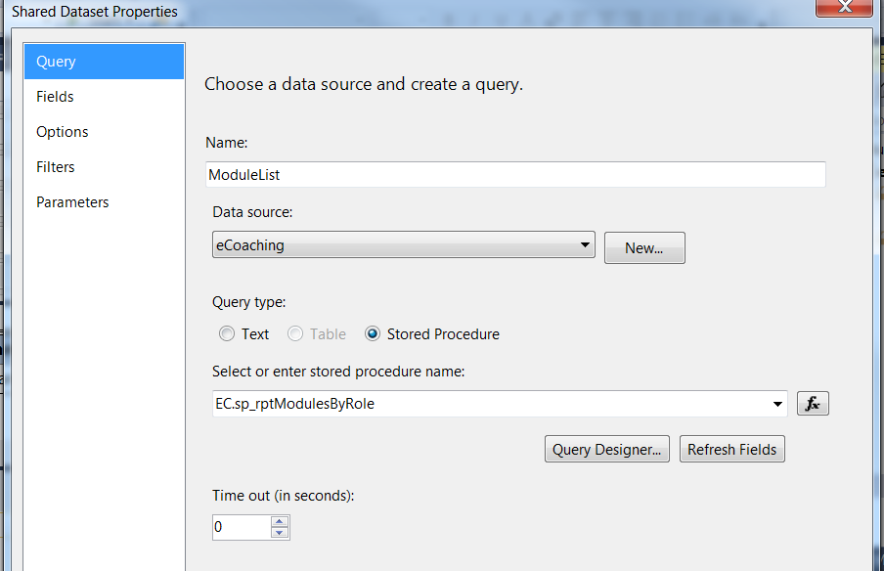Fields:

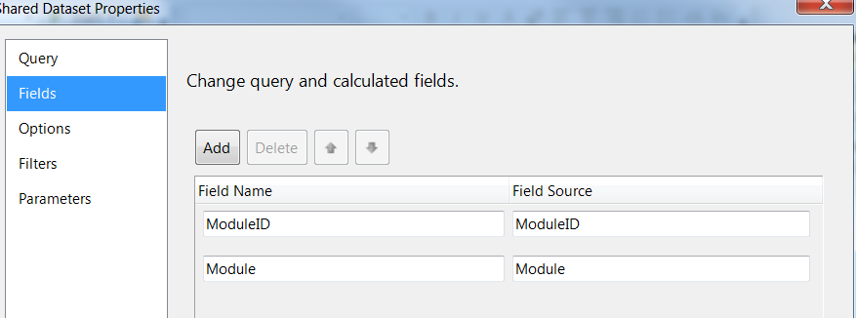

Parameters:

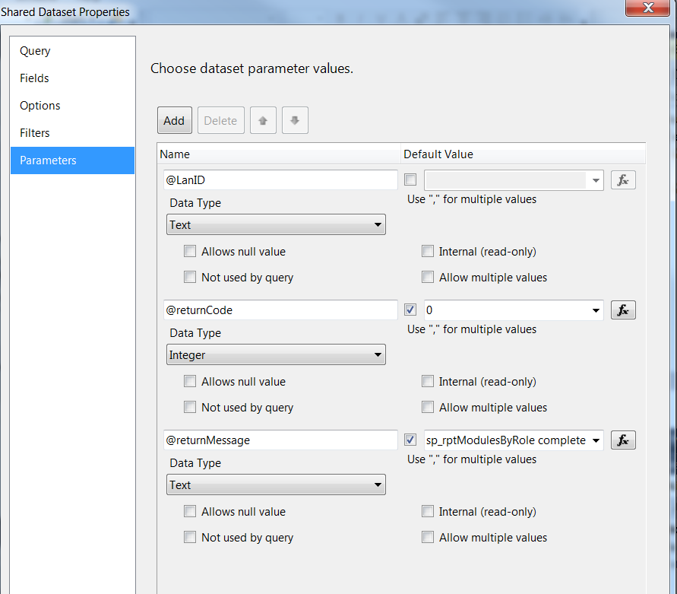

* 1. **CoachingStatusRef (uses shared dataset CoachingStatusList)**

Query:

SELECT StatusID, Status

FROM (

SELECT -1 AS StatusID, 'All' AS Status

UNION

SELECT DISTINCT cl.StatusID, ds.Status

FROM EC.Coaching_Log AS cl INNER JOIN EC.DIM_Status ds

ON cl.StatusID = ds.StatusID

WHERE (cl.ModuleID =(@intModulein) or @intModulein = -1)

AND cl.StatusID <> 2

)AS S

ORDER BY CASE WHEN StatusID = - 1 THEN 0 ELSE 1 END, Status

Fields:

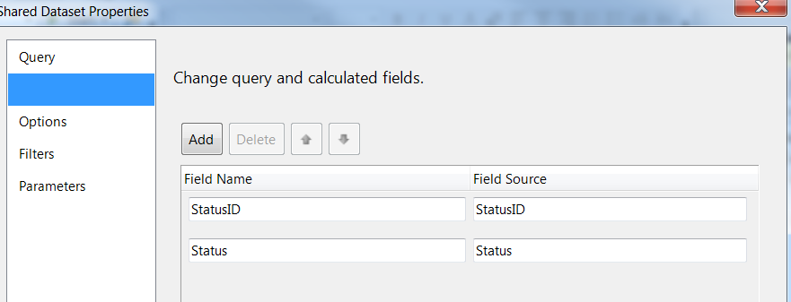

Parameters:

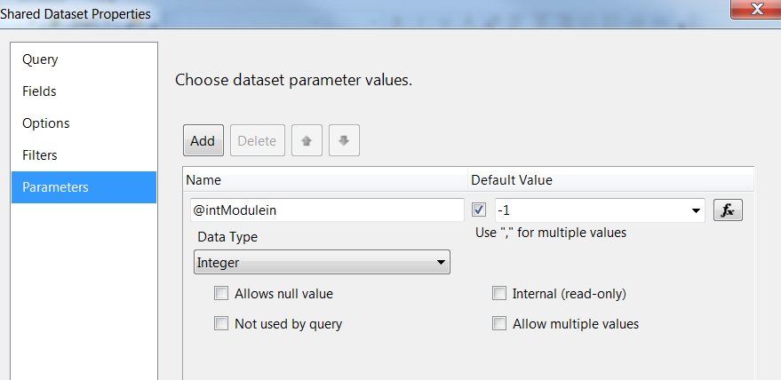

* 1. **CoachingSubReasonRef (uses shared dataset CoachingSubReasonList)**

Query:

SELECT SubCoachingReasonID, SubCoachingReason

FROM (SELECT - 1 AS SubCoachingReasonID, 'All' AS SubCoachingReason

UNION

SELECT DISTINCT clr.SubCoachingReasonID, dscr.SubCoachingReason

FROM EC.Coaching_Log_Reason AS clr INNER JOIN

EC.DIM_Sub_Coaching_Reason AS dscr ON clr.SubCoachingReasonID = dscr.SubCoachingReasonID

WHERE (clr.CoachingReasonID =(@intCoachReasonin) or @intCoachReasonin = -1) ) AS s

WHERE SubCoachingReason <> 'unknown'

ORDER BY CASE WHEN SubCoachingReasonID = - 1 THEN 0 ELSE 1 END, SubCoachingReason

Fields:

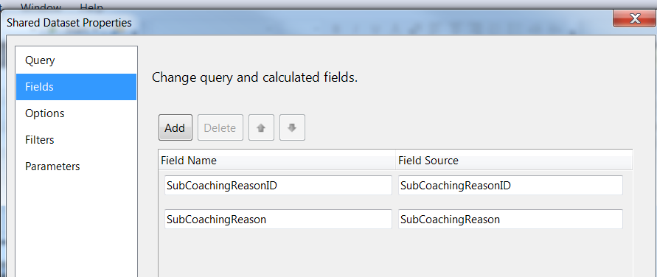

Parameters:

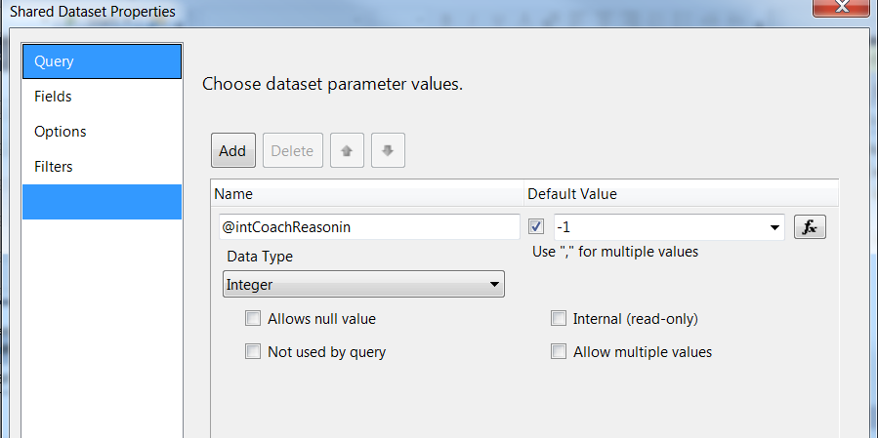

* 1. **CoachingSiteRef (uses shared dataset CoachingSiteList)**

Query:

SELECT SiteID, Site

FROM (

SELECT -1 AS SiteID, 'All' AS Site

UNION

SELECT DISTINCT cl.SiteID, cs.City AS Site

FROM EC.Coaching_Log AS cl INNER JOIN EC.DIM_Site cs

ON cl.SiteID = cs.SiteID

WHERE (cl.ModuleID =(@intModulein) or @intModulein = -1)

and cs.City <> 'Unknown'

)AS S

ORDER BY CASE WHEN SiteID = - 1 THEN 0 ELSE 1 END, SiteFields:

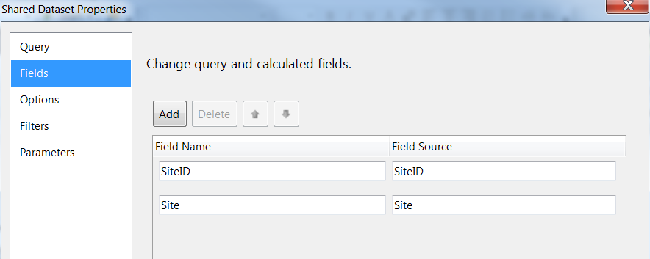

Parameters:

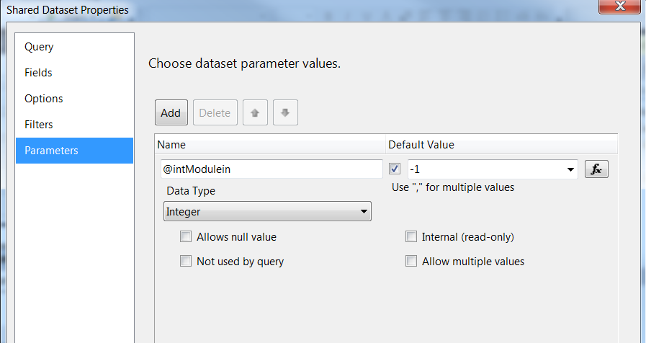

# Report Display

**Report Title: None (Defined in UI)**

**Subtitle: None**

**Report Elements:**

|  |  |  |
| --- | --- | --- |
| **Number** | **Field** | **Description** |
| 1 | Employee Level ID | Module the log was submitted in |
| 2 | Employee Level Name | Name of the module |
| 3 | Coaching ID | ID of the coaching log |
| 4 | Form name | Coaching log form name |
| 5 | Quality Now Batch ID | ID of the Quality Now Batch |
| 6 | Quality Now Batch Status | Status of the Quality Now Batch |
| 7 | Status | Current status of the coaching log |
| 8 | Employee ID | Employee ID of the log recipient |
| 9 | Employee name | The last, first mi name of employee |
| 10 | City | Site of the employee |
| 11 | Supervisor employee ID | Employee ID of the supervisor of the log recipient at time the log is submitted |
| 12 | Supervisor name | The last, first mi name of supervisor of employee |
| 13 | Manager employee ID | Employee ID of the manager of the log recipient at time log is submitted |
| 14 | Manager name | The last, first mi name of manager of employee |
| 15 | Current Supervisor employee ID | Employee ID of the supervisor of the log recipient at time the report is run |
| 16 | Current Supervisor name | The last, first mi name of supervisor of employee |
| 17 | Current Manager employee ID | Employee ID of the manager of the log recipient at time the report is |
| 18 | Current Manager name | The last, first mi name of manager of employee |
| 19 | Review Supervisor employee ID | Employee ID of the supervisor who reviewed/coached the log recipient |
| 20 | Review Supervisor name | The last, first mi name of supervisor of employee |
| 21 | Review Manager employee ID | Employee ID of the manager who reviewed the log |
| 22 | Review Manager name | The last, first mi name of manager of employee |
| 23 | Coaching notes | Coaching notes for log |
| 24 | Coaching date | Date of coaching associated with log |
| 25 | Submitted date | Date the log was submitted |
| 26 | Coaching source | Source of coaching (Direct, Indirect) |
| 27 | Sub-coaching source | How the coaching was identified |
| 28 | Supervisor reviewed date | Date/time supervisor reviewed and acknowledged the coaching log |
| 29 | Manager reviewed manual date | Date/time manager entered when reviewed and acknowledged the coaching log |
| 30 | Manager reviewed auto date | Date/time manager reviewed and acknowledged the coaching log |
| 31 | Manager notes | Comments or notes entered by manager |
| 32 | Employee reviewed date | Date when the recipient reviewed and acknowledged or entered comments. |
| 33 | Employee comments | Comments entered by employee |
| For each evaluation associated with batch, report the following | | |
| 34 | Event date | Date of event associated with log |
| 35 | Description | Description or behavior subject to coaching |
| 36 | Coaching reason | Coaching reason of log |
| 37 | Coaching sub-reason | Coaching sub-reason of log |
| 38 | Value | Shall be N/A |
| 39 | Submitter ID | Employee ID of the submitter of the log |
| 40 | Submitter name | Name of the submitter of the log |
| 41 | Program | Program associated with the log (Medicare, Marketplace, Dual, NA) |
| 42 | Verint ID | ID of the Verint call record scorecard associated with the coaching log |
| 43 | Verint Form name | Form name in Verint related to coaching log |
| 44 | Coaching Monitor | Whether evaluation is a coaching monitor or not |
| 45 | Evaluation Status | The status of the individual record within a Quality Now batch |
| 46 | Business Process | Rating for business process |
| 47 | Business Process Reason | Selected reason for business process |
| 48 | Business Process Comment | Entered comments for business process |
| 49 | Info Accuracy | Rating for information accuracy |
| 50 | Info Accuracy Reason | Selected reason for information accuracy |
| 51 | Info Accuracy Comment | Entered comments for information accuracy |
| 52 | Privacy Disclaimers | Rating for privacy disclaimer |
| 53 | Privacy Disclaimers Reason | Selected reason for privacy disclaimer |
| 54 | Privacy Disclaimers Comment | Entered comments for privacy disclaimer |
| 55 | Issue Resolution | Rating for issue resolution |
| 56 | Issue Resolution Comment | Entered comments for issue resolution |
| 57 | Call Efficiency | Rating for call efficiency |
| 58 | Call Efficiency Comment | Entered comments for call efficiency |
| 59 | Active Listening | Rating for active listening |
| 60 | Active Listening Comment | Entered comments for active listening |
| 61 | Personality Flexing | Rating for personality flexing |
| 62 | Personality Flexing Comment | Entered comments for personality flexing |
| 63 | Customer Temp Start | Value for start temperature of caller |
| 64 | Customer Temp Start Comment | Entered comments for start temperature |
| 65 | Customer Temp End | Value for end temperature of caller |
| 66 | Customer Temp End Comment | Entered comments for end temperature |

**Tablix Properties:**

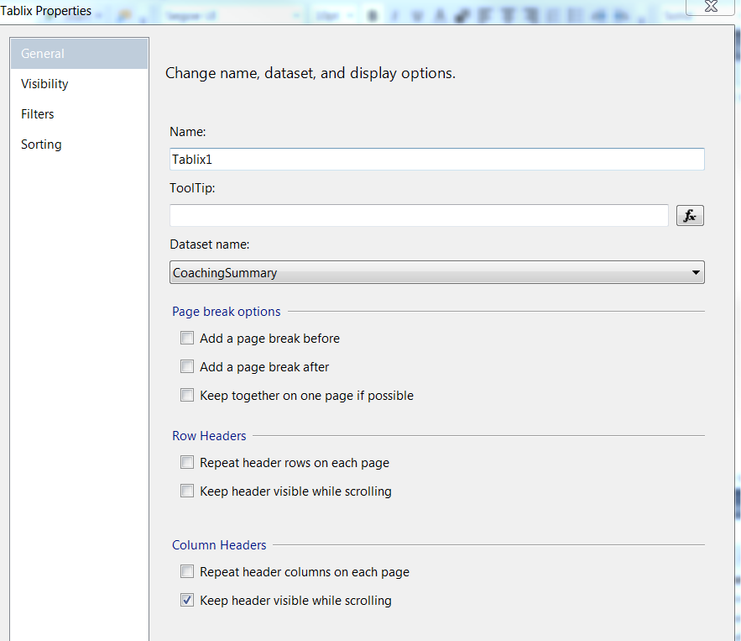

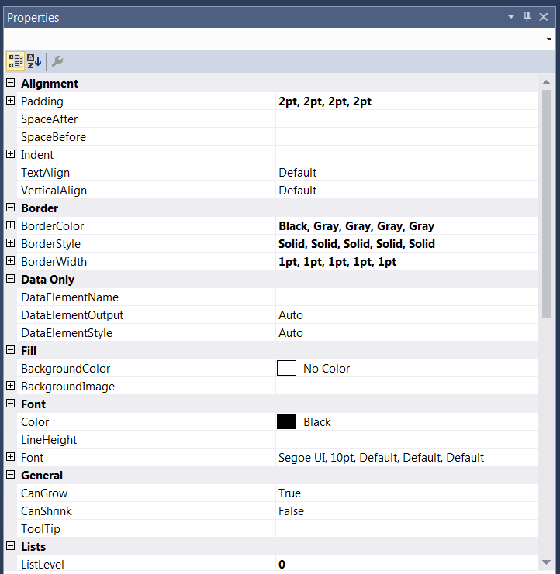

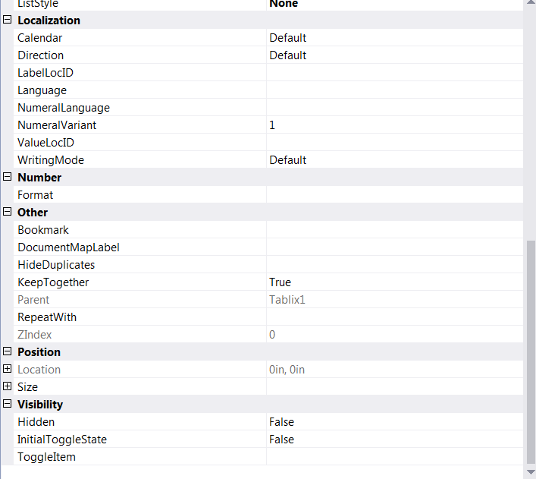

# Preview Sample

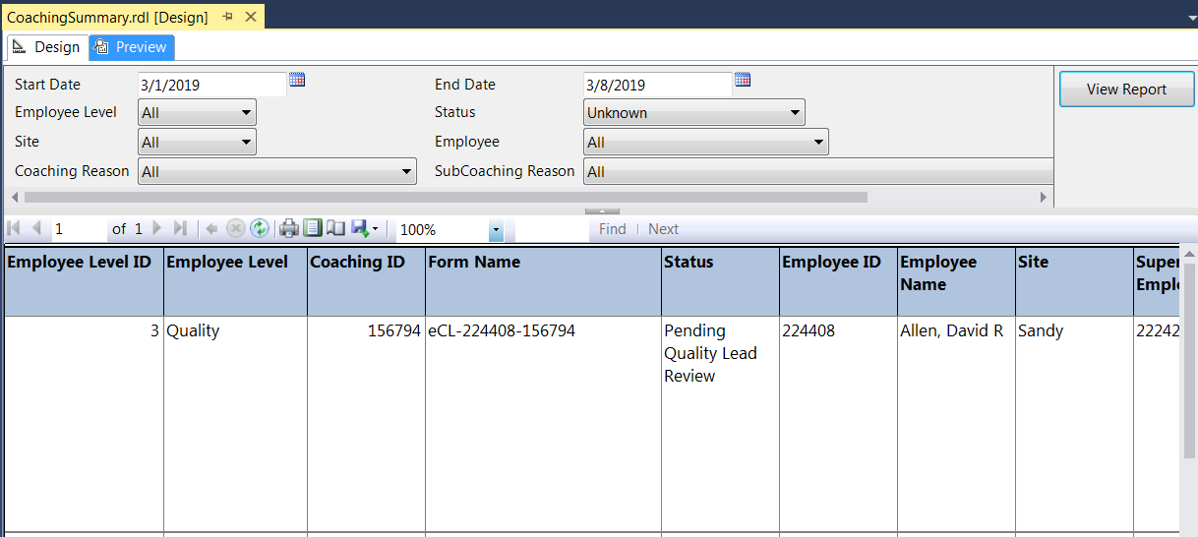

# Deployment Properties

# Dev

|  |  |
| --- | --- |
| **Overwrite Datasets** | True |
| **Overwrite DataSources** | False |
| **TargetDatasetFolder** | /eCoaching/Datasets |
| **TargetDataSourceFolder** | /eCoaching/DataSources |
| **TargetReportFolder** | /eCoaching/Reports |
| **TargetReportPartFolder** | Report Parts |
| **TargetServerURL** | https://f3420-ecldbd01/ReportServer |
| **TargetServerVersion** | SQL Server 2008 R2, 2012 or 2014 |
| **Report Portal** | https://f3420-ecldbd01/Reports_ECLD01 |

# SysTest

|  |  |
| --- | --- |
| **Overwrite Datasets** | True |
| **Overwrite DataSources** | False |
| **TargetDatasetFolder** | /eCoaching/Datasets |
| **TargetDataSourceFolder** | /eCoaching/DataSources |
| **TargetReportFolder** | /eCoaching/Reports |
| **TargetReportPartFolder** | Report Parts |
| **TargetServerURL** | https://f3420-ecldbt01/ReportServer |
| **TargetServerVersion** | SQL Server 2008 R2, 2012 or 2014 |
| **Report Portal** | https://f3420-ecldbt01/Reports_ECLT01 |

# Production

|  |  |
| --- | --- |
| **Overwrite Datasets** | True |
| **Overwrite DataSources** | False |
| **TargetDatasetFolder** | /eCoaching/Production/Datasets |
| **TargetDataSourceFolder** | /eCoaching/Production/DataSources |
| **TargetReportFolder** | /eCoaching/Production/Reports |
| **TargetReportPartFolder** | Report Parts |
| **TargetServerURL** | https://f3420-ecldbp01/ReportServer |
| **TargetServerVersion** | SQL Server 2008 R2, 2012 or 2014 |
| **Report Portal** | https://f3420-ecldbp01/Reports_ECLP01 |

# Data Source(s)

|  |  |
| --- | --- |
| **Name** | eCoaching |
| **Type** | Microsoft SQL Server |
| **Connection String(s)** | Dev: Data Source=F3420-ECLDBD01;Initial Catalog=eCoachingDev  Sys Test: Data Source=F3420-ECLDBT01;Initial Catalog=eCoachingTest  Production: Data Source=F3420-ECLDBP01;Initial Catalog=eCoaching |
| **Connect Using** | Windows Integrated Security |

1. **Report Properties**

|  |  |
| --- | --- |
| **Parameters** |  |
| **Data Source** | /eCoaching/DataSources/eCoaching |
| **Shared Datasets** | CoachingEmployeeRef: /eCoaching/Datasets/CoachingEmployeeList  CoachingReasonRef: /eCoaching/Datasets/CoachingReasonList  CoachingSiteRef: /eCoaching/Datasets/CoachingSiteList  CoachingStatusRef: /eCoaching/Datasets/CoachingStatusList  CoachingSubReasonRef: /eCoaching/Datasets/CoachingSubReasonList  ModuleRef: /eCoaching/Datasets/ModuleList |