__________________________

***Contact Center Operations***

**CCO eCoaching Warning Summary Report**

**SSRS Detail Design Document**

__________________________

|  |  |  |  |  |
| --- | --- | --- | --- | --- |
| Last Revision | Last Review | Description | | |
| 08/27/2018 |  | TFS 11663 - Update urls in SSRS Reporting for Shared Services domain | | |

Prepared by: Suzy Palacherla Date: 4/18/2017

Department, Location: HCSD

Approved by: Date:

**Change History Log**

| **Date** | **Change Description** | **Author** |
| --- | --- | --- |
| 4/18/2017 | TFS 5621 – Initial revision | Susmitha Palacherla |
| 8/15/2017 | TFS 7106 – Upgrade for SQL Server 2012 | Susmitha Palacherla |
| 04/09/2018 | TFS 10588 - Update SSRS DD docs with peer review finding. Updated WarningEmployeeList dataset to replace embedded query with stored procedure that was implemented to support Encryption of sensitive data during TFS 7856. | Susmitha Palacherla |
| 08/27/2018 | TFS 11663 - Update urls in SSRS Reporting for Shared Services domain.  Updated Section 7.0 Deployment properties and added Section 8.0 for Data Source(s) | Susmitha Palacherla |
|  |  |  |
|  |  |  |
|  |  |  |
|  |  |  |
|  |  |  |
|  |  |  |
|  |  |  |
|  |  |  |

Contents

1.0 Purpose 4

2.0 XML Information 4

3.0 Report Parameters 4

4.0 Report Datasets 5

4.1 WarningSummary 5

4.2 WarningReasonRef (uses shared dataset WarningReasonList) 10

4.3 WarningEmployeeRef (uses shared dataset WarningEmployeeList) 11

4.4 ModuleRef (uses shared dataset ModuleList) 13

4.5 warningStatusRef (uses shared dataset warningStatusList) 15

4.6 WarningSubReasonRef (uses shared dataset WarningSubReasonList) 17

4.7 WarningSiteRef (uses shared dataset WarningSiteList) 18

5.0 Report Display 20

6.0 Preview Sample 25

7.0 Deployment Properties 25

7.1 Dev 25

7.2 SysTest 25

7.3 Production 26

8.0 Data Source(s) 26

# Purpose

The purpose of the Warning summary report is for Engineering, Program and support staff that need to be able to view the details of the warning logs and or generate Reports based on the warning logs to be able to do so without having to login to the database and run direct queries.

# XML Information

The location of the RDL “executable” code for the report can be found in TFS at:

\cms\eCoaching_V2\Code\SSRS\eCoachingReport\eCoachingReport\WarningSummary.rdl

This contains all the code that defines the SQL, the formatting, and any other special effects.

# Report Parameters

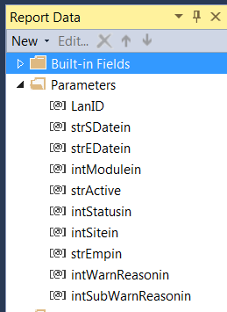

The Coaching Summary report will take the following parameters:

|  |  |  |  |  |
| --- | --- | --- | --- | --- |
| **Name** | **User Prompt** | **Type** | **Required?** | **Description** |
| LanID | NA [Hidden] | Text | Yes | Lan ID of Logged in user. Will be passed in from UI code. Used to determine Role of logged in user to display list of available Modules. |
| strSdatein | Start Date | Date/Time | Yes | Start date for list of coaching logs to be displayed based on log submitted date. |
| strEDatein | End Date | Date/Time | Yes | End date for list of coaching logs to be displayed based on log submitted date. |
| intModulein | Module | Text | Yes | Dropdown list populated by dataset ModuleRef (value field: ModuleID label field: Module) |
| intStatusin | Status | Text | Yes | Dropdown List populated by dataset CoachingStatusRef (value field: StatusID label field: Status) |
| intSitein | Site | Text | Yes | Dropdown List populated by dataset CoachingSiteRef (value field: SiteID label field: Site) |
| strEmpin | Employee | Text | Yes | Dropdown List populated by dataset CoachingEmployeeRef (value field: EmpID label field: EmpName) |
| intwarnReasonin | Warning Reason | Text | Yes | Dropdown List populated by dataset WarningReasonRef (value field: CoachingReasonID label field: CoachingReason) |
| intsubwarnReasonin | Warning SubReason | Text | Yes | Dropdown List populated by dataset WarningSubReasonRef (value field: SubCoachingReasonID label field: SubCoachingReason) |

# Report Datasets

# WarningSummary

Query the Coaching logs for selected set of parameters.

Query:

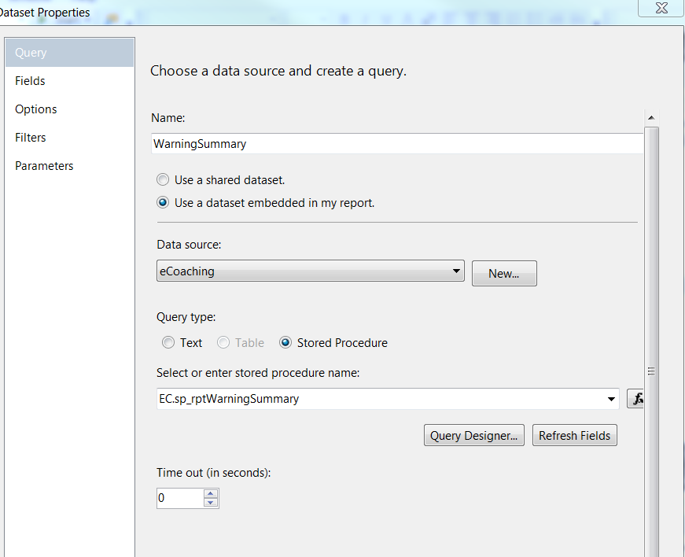

Fields:

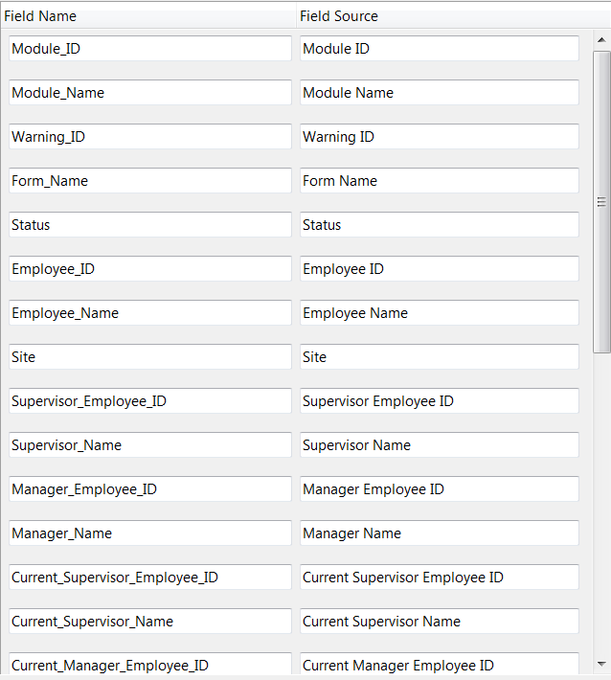

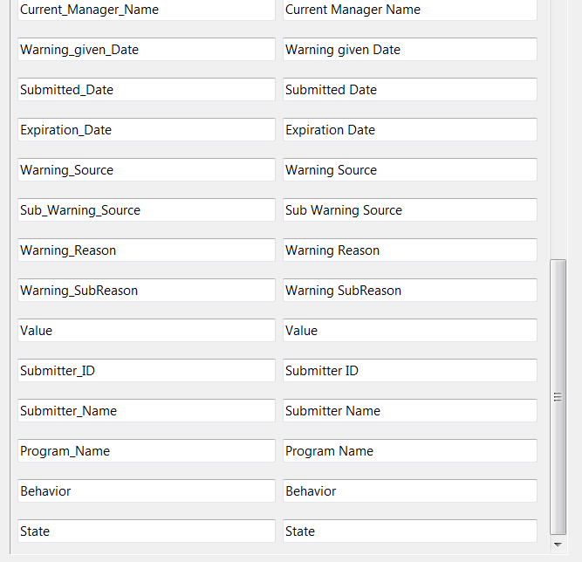

Parameters:

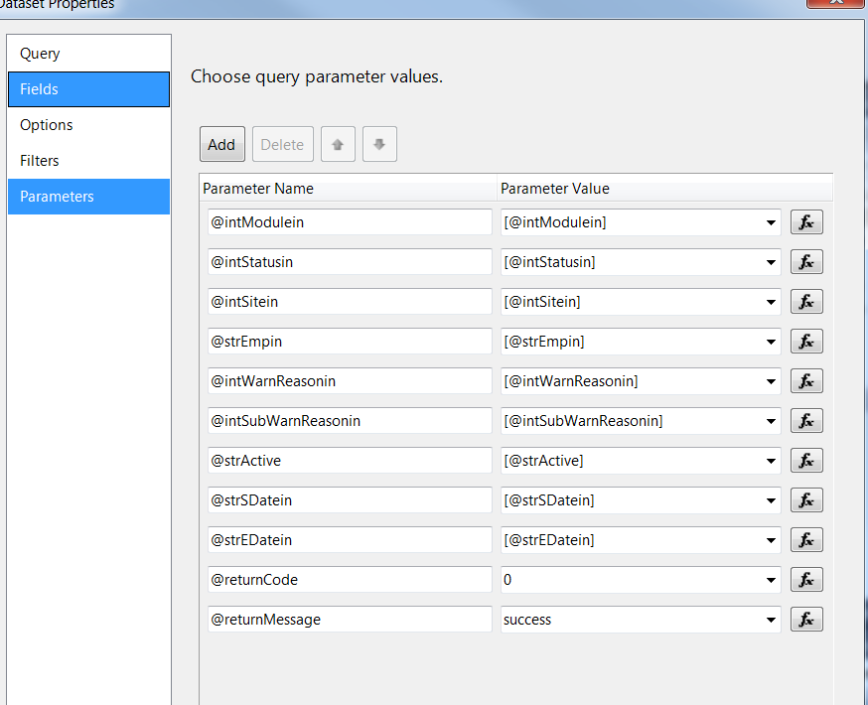

# WarningReasonRef (uses shared dataset WarningReasonList)

Query:

SELECT CoachingReasonID, CoachingReason

FROM (SELECT - 1 AS CoachingReasonID, 'All' AS CoachingReason

UNION

SELECT DISTINCT wlr.CoachingReasonID, dcr.CoachingReason

FROM EC.warning_log AS wl INNER JOIN

EC.warning_log_Reason AS wlr ON wl.WarningID = wlr.WarningID INNER JOIN

EC.DIM_Coaching_Reason AS dcr ON wlr.CoachingReasonID = dcr.CoachingReasonID

WHERE (wl.ModuleID =(@intModulein) or @intModulein = -1) ) AS s

ORDER BY CASE WHEN CoachingReasonID = - 1 THEN 0 ELSE 1 END, CoachingReason

Fields:

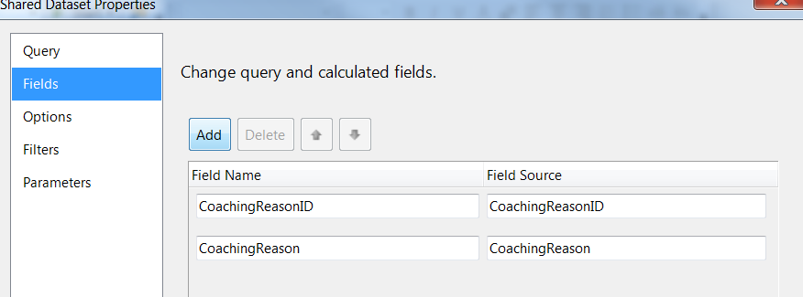

Parameters:

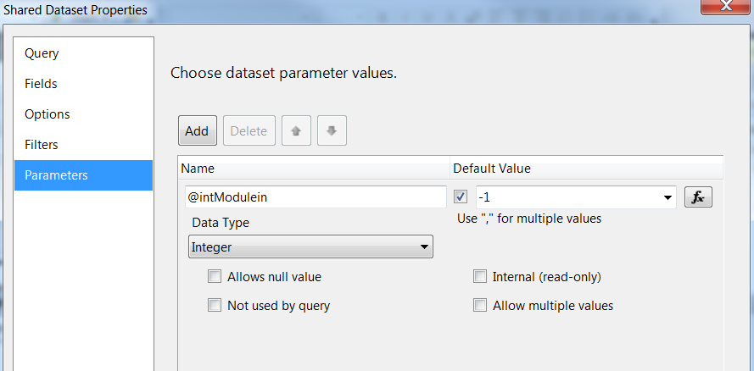

# WarningEmployeeRef (uses shared dataset WarningEmployeeList)

Query:

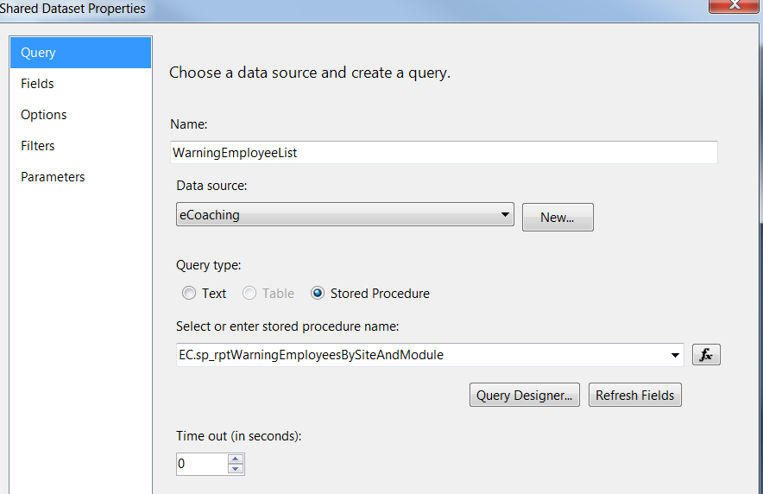

Fields:

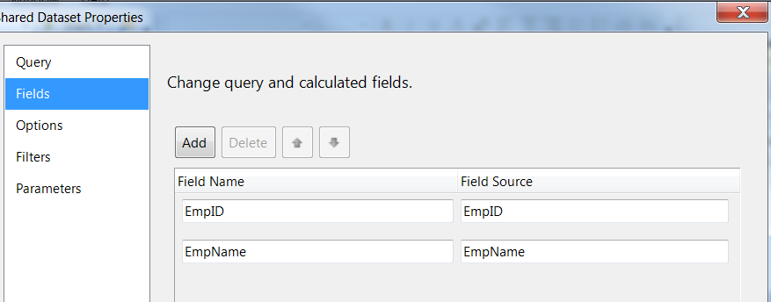

Parameters:

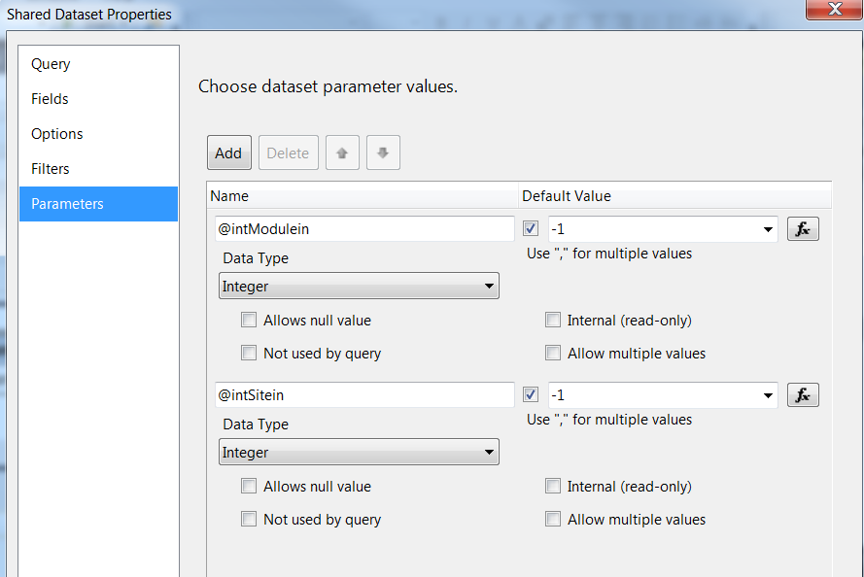

# ModuleRef (uses shared dataset ModuleList)

Query:

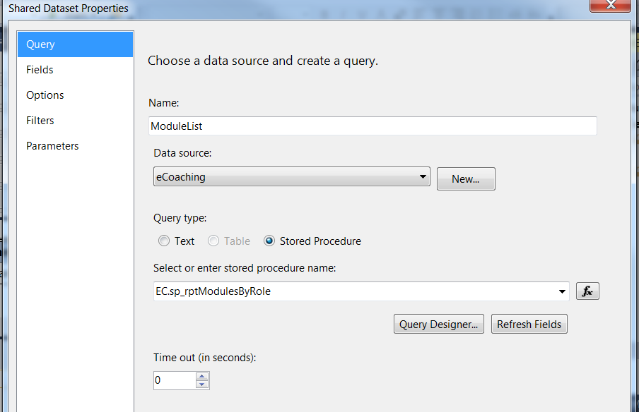Fields:

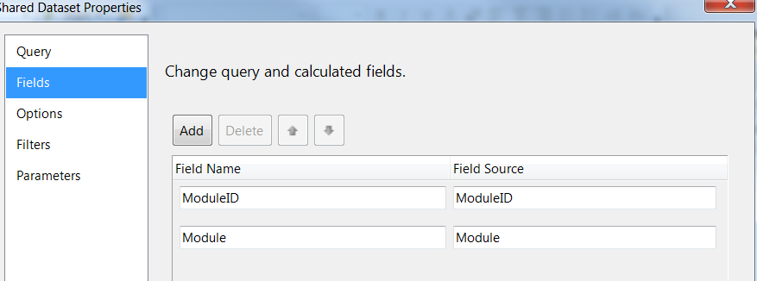

Parameters:

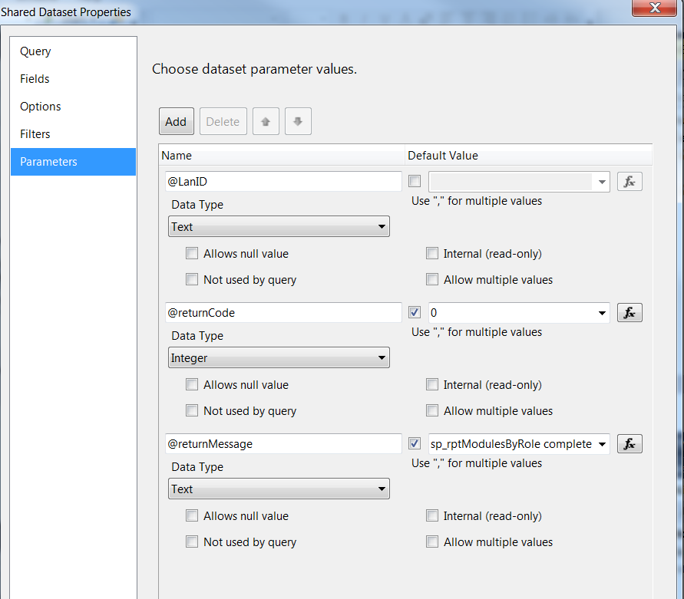

# warningStatusRef (uses shared dataset warningStatusList)

Query:

SELECT StatusID, Status

FROM (

SELECT -1 AS StatusID, 'All' AS Status

UNION

SELECT DISTINCT wl.StatusID, ds.Status

FROM EC.Warning_Log AS wl INNER JOIN EC.DIM_Status ds

ON wl.StatusID = ds.StatusID

WHERE (wl.ModuleID =(@intModulein) or @intModulein = -1)

AND wl.StatusID <> 2

)AS S

ORDER BY CASE WHEN StatusID = - 1 THEN 0 ELSE 1 END, Status

Fields:

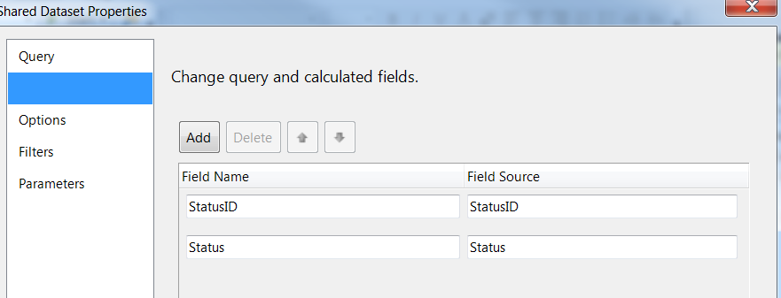

Parameters:

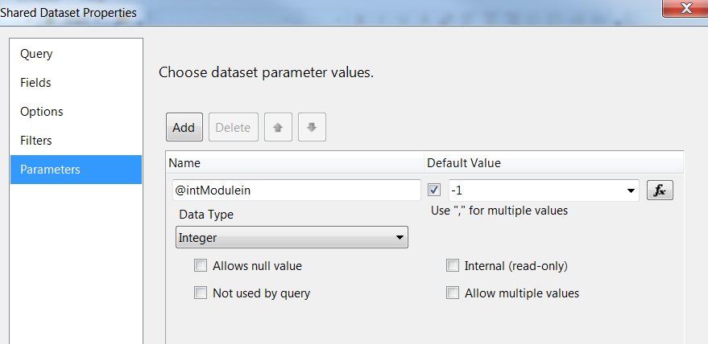

# WarningSubReasonRef (uses shared dataset WarningSubReasonList)

Query:

SELECT SubCoachingReasonID, SubCoachingReason

FROM (SELECT - 1 AS SubCoachingReasonID, 'All' AS SubCoachingReason

UNION

SELECT DISTINCT wlr.SubCoachingReasonID, dscr.SubCoachingReason

FROM EC.Warning_Log_Reason AS wlr INNER JOIN

EC.DIM_Sub_Coaching_Reason AS dscr ON wlr.SubCoachingReasonID = dscr.SubCoachingReasonID

WHERE (wlr.CoachingReasonID =(@intWarnReasonin) or @intWarnReasonin = -1) ) AS s

WHERE SubCoachingReason <> 'unknown'

ORDER BY CASE WHEN SubCoachingReasonID = - 1 THEN 0 ELSE 1 END, SubCoachingReason

Fields:

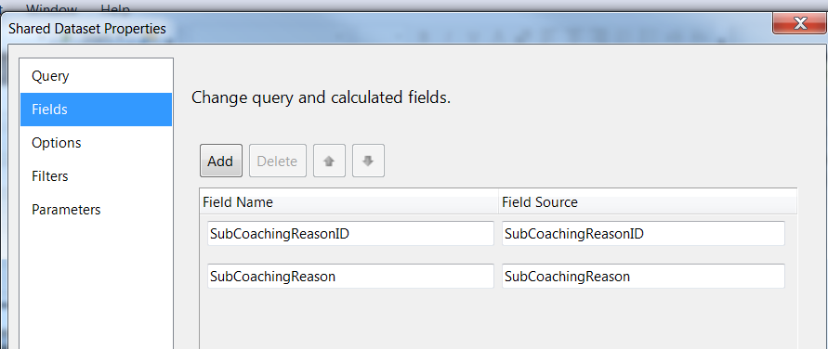

Parameters:

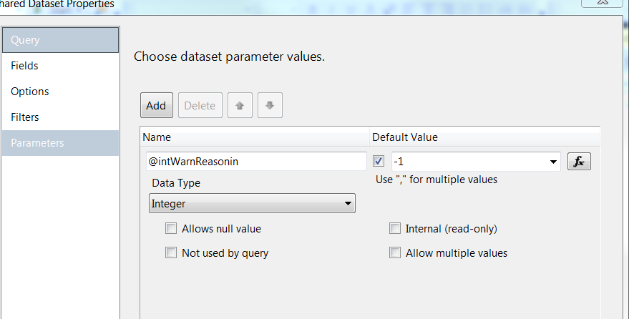

# WarningSiteRef (uses shared dataset WarningSiteList)

Query:

SELECT SiteID, Site

FROM (

SELECT -1 AS SiteID, 'All' AS Site

UNION

SELECT DISTINCT wl.SiteID, cs.City AS Site

FROM EC.Warning_Log AS wl INNER JOIN EC.DIM_Site cs

ON wl.SiteID = cs.SiteID

WHERE (wl.ModuleID =(@intModulein) or @intModulein = -1)

and cs.City <> 'Unknown'

)AS S

ORDER BY CASE WHEN SiteID = - 1 THEN 0 ELSE 1 END, Site

Fields:

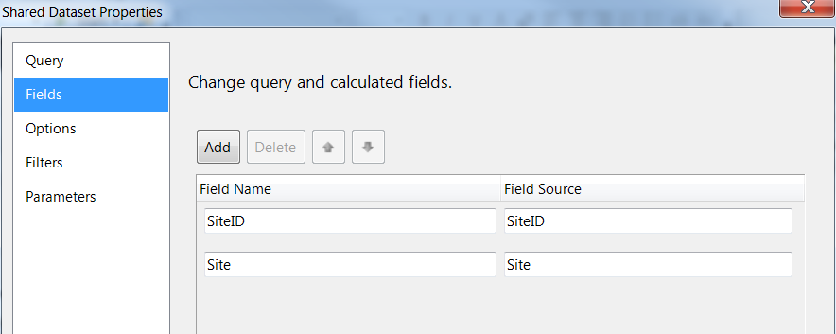

Parameters:

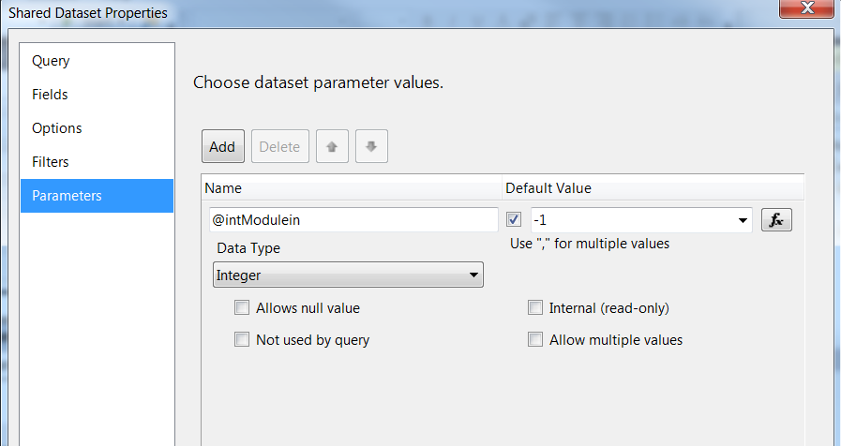

# Report Display

**Report Title: None (Defined in UI)**

**Subtitle: None**

**Report Elements:**

|  |  |  |
| --- | --- | --- |
| **Number** | **Field** | **Description** |
| 1 | Module ID | Module the log was submitted in |
| 2 | Module Name | Name of the module |
| 3 | Warning ID | ID of the warning log |
| 4 | Form name | Warning log form name |
| 5 | Status | Current status of the warning log (Completed, Inactive) |
| 6 | State | Current state of the warning log (Active, Expired) |
| 7 | Employee ID | Employee ID of the log recipient |
| 8 | Employee name | The last, first mi name of employee |
| 9 | City | Site of the employee |
| 10 | Supervisor employee ID | Employee ID of the supervisor of the log recipient at time the log is submitted |
| 11 | Supervisor name | The last, first mi name of supervisor of employee |
| 12 | Manager employee ID | Employee ID of the manager of the log recipient at time log is submitted |
| 13 | Manager name | The last, first mi name of manager of employee |
| 14 | Current Supervisor employee ID | Employee ID of the supervisor of the log recipient at time the report is run |
| 15 | Current Supervisor name | The last, first mi name of supervisor of employee |
| 16 | Current Manager employee ID | Employee ID of the manager of the log recipient at time the report is |
| 17 | Current Manager name | The last, first mi name of manager of employee |
| 18 | Warning given date | Date warning log was given |
| 19 | Submitted date | Date the log was submitted |
| 20 | Expiration date | Date the warning log will or did expire (Warning given date + 91 days) |
| 21 | Warning source | Source of warning (Direct, Indirect) |
| 22 | Sub-coaching source | How the warning was identified |
| 23 | Warning reason | Warning reason of log |
| 24 | Warning sub-reason | Warning sub-reason of log |
| 25 | Value | Value of log (Opportunity) |
| 26 | Submitter ID | Employee ID of the submitter of the log |
| 27 | Submitter name | Name of the submitter of the log |
| 28 | Program | Program associated with the log (Medicare, Marketplace, NA) |
| 29 | Behavior | Behavior associated with the log in the Training module (Production, Training, Other) |

**Tablix Properties:**

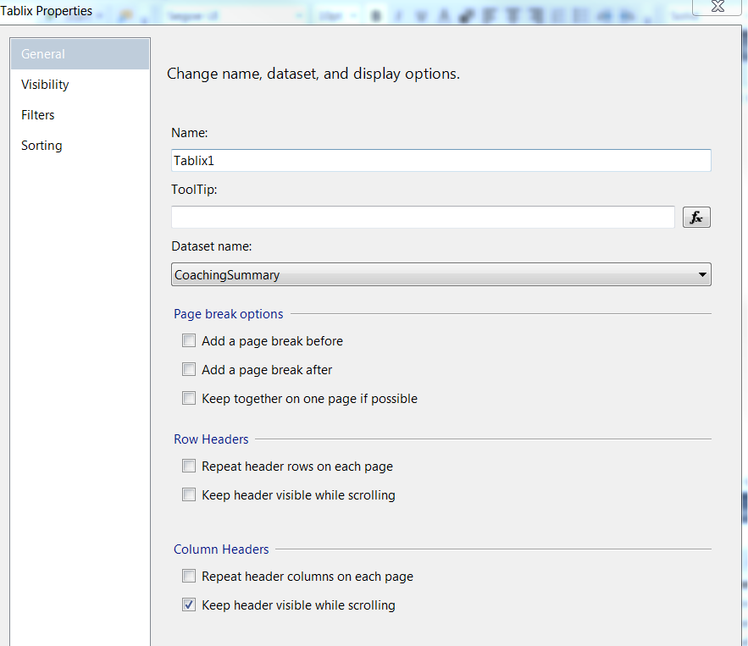

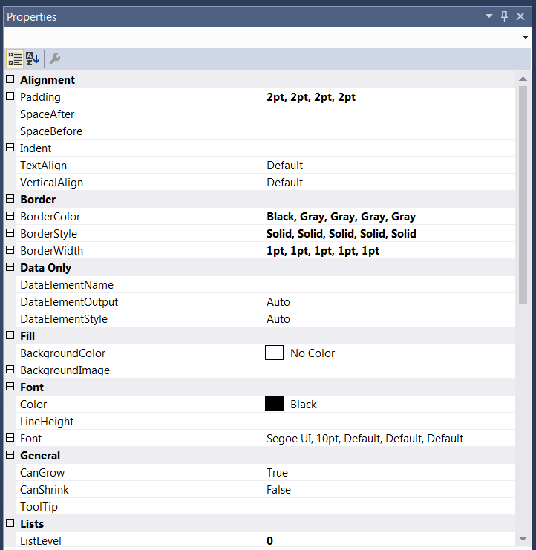

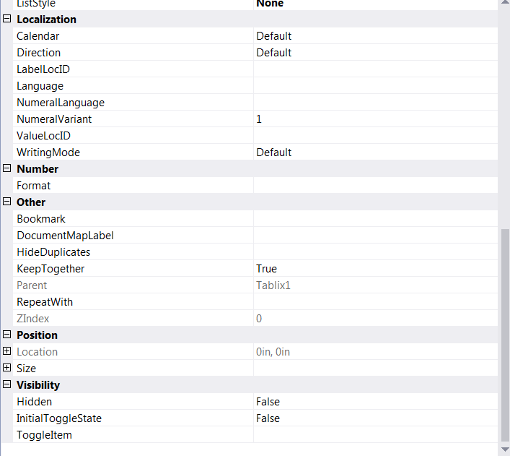

# Preview Sample

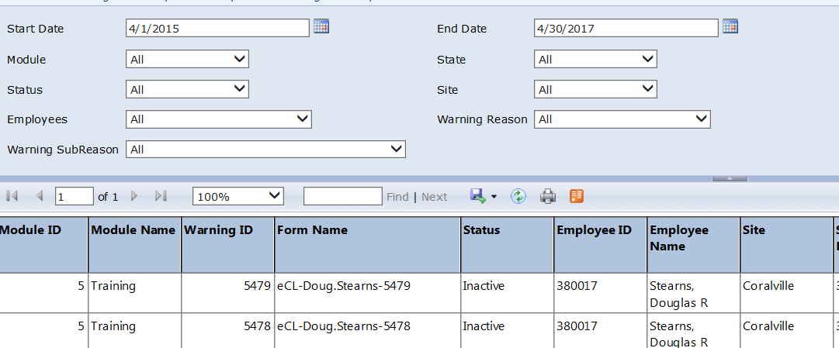















# Deployment Properties

# Dev

|  |  |
| --- | --- |
| **Overwrite Datasets** | True |
| **Overwrite DataSources** | False |
| **TargetDatasetFolder** | /eCoaching/Datasets |
| **TargetDataSourceFolder** | /eCoaching/DataSources |
| **TargetReportFolder** | /eCoaching/Reports |
| **TargetReportPartFolder** | Report Parts |
| **TargetServerURL** | https://f3420-ecldbd01.sharedservices.local/ReportServer |
| **TargetServerVersion** | SQL Server 2008 R2, 2012 or 2014 |
| **Report Portal** | https://f3420-ecldbd01.sharedservices.local/Reports_ECLD01 |

# SysTest

|  |  |
| --- | --- |
| **Overwrite Datasets** | True |
| **Overwrite DataSources** | False |
| **TargetDatasetFolder** | /eCoaching/Datasets |
| **TargetDataSourceFolder** | /eCoaching/DataSources |
| **TargetReportFolder** | /eCoaching/Reports |
| **TargetReportPartFolder** | Report Parts |
| **TargetServerURL** | https://f3420-ecldbt01. sharedservices.local/ReportServer |
| **TargetServerVersion** | SQL Server 2008 R2, 2012 or 2014 |
| **Report Portal** | https://f3420-ecldbt01. sharedservices.local/Reports_ECLT01 |

# Production

|  |  |
| --- | --- |
| **Overwrite Datasets** | True |
| **Overwrite DataSources** | False |
| **TargetDatasetFolder** | /eCoaching/Production/Datasets |
| **TargetDataSourceFolder** | /eCoaching/Production/DataSources |
| **TargetReportFolder** | /eCoaching/Production/Reports |
| **TargetReportPartFolder** | Report Parts |
| **TargetServerURL** | https://f3420-ecldbp01. sharedservices.local/ReportServer |
| **TargetServerVersion** | SQL Server 2008 R2, 2012 or 2014 |
| **Report Portal** | https://f3420-ecldbp01.sharedservices.local/Reports_ECLP01 |

# Data Source(s)

|  |  |
| --- | --- |
| **Name** | eCoaching |
| **Type** | Microsoft SQL Server |
| **Connection String(s)** | Dev: Data Source=F3420-ECLDBD01;Initial Catalog=eCoachingDev  Sys Test: Data Source=F3420-ECLDBT01;Initial Catalog=eCoachingTest  Production: Data Source=F3420-ECLDBP01;Initial Catalog=eCoaching |
| **Connect Using** | Windows Integrated Security |