________________________



Detail Design: CCO eCoaching Admin Manage Employee Logs

________________________

Prepared by: Lili Huang Date: 05/02/2016

Department: HCSD

Change History Log

| Date | Change Description | Author |
| --- | --- | --- |
| 05/02/2016  01/06/2017 | Initial Revision – TFS 1709  TFS 4893 | Lili Huang  Lili Huang |
|  |  |  |

Table of Contents

**1.** **Description** 4

**2.** **Controllers** 4

2.1. EmployeeLogController.cs 4

2.1.1. SearchForInactivate action - HttpGet 4

2.1.2. SearchForInactivate action - HttpPost 4

2.1.3. Inactivate action - HttpPost 4

2.1.4. SearchForReassign action - HttpGet 4

2.1.5. SearchForReassign action - HttpPost 4

2.1.6. Reassign action - HttpPost 5

2.1.7. SearchForReactivate action - HttpGet 5

2.1.8. SearchForReactivate action - HttpPost 5

2.1.9. Reactivate action - HttpPost 5

**3.** **Page details** 5

3.1. Inactivate Employee Logs (Views\EmployeeLog\SearchForInactivate.cshtml) 5

3.1.1. Razor pages comprising Web Page 5

3.1.2. Layout Page 6

3.1.3. Screenshot 6

3.1.4. Links 7

3.1.5. Web Page Invoked Events 7

3.1.6. Form Fields 9

3.2. Reassign Employee Logs (Views\EmployeeLog\SearchForReassign.cshtml) 11

3.2.1. Razor pages comprising Web Page 11

3.2.2. Layout Page 11

3.2.3. Screenshot 11

3.2.4. Links 13

3.2.5. Web Page Invoked Events 13

3.2.6. Form Fields 14

3.3. Reactivate Employee Logs (Views\EmployeeLog\SearchForReactivate.cshtml) 16

3.3.1. Razor pages comprising Web Page 16

3.3.2. Layout Page 16

3.3.3. Screenshot 16

3.3.4. Links 18

3.3.5. Web Page Invoked Events 18

3.3.6. Form Fields 20

1. **Description**

This document covers the functions provided to administrators and managers to manage eCoaching logs.

Active coaching logs and warning logs are allowed to be inactivated. Inactivated coaching logs and warning logs are allowed to be reactivated to their previous status. Users must provide a valid reason when inactivating and reactivating eCoaching logs.

Pending review coaching logs are allowed to be reassigned to a different reviewer at the same hierarchy level. Users must provide a valid reason when reassigning eCoaching logs.

Administrators are allowed to manage coaching logs and warning logs across all sites, while managers are allowed to manage coaching logs only from their own sites.

1. **Controllers**
   1. EmployeeLogController.cs
      1. SearchForInactivate action - HttpGet

Call GetModules method in the EmployeeLogService class to return modules.

Save the modules returned in ViewBag.Modules.

Call GetTypes method in the EmployeeLogService class to return log types (coaching or warning).

Save the types returned in ViewBag.Types.

Initialize employee list to only have one item “Please select an employee” with value -1.

Save employee list in ViewBag.Employees.

Return SearchForInactivate.cshtml view.

* + 1. SearchForInactivate action - HttpPost

Get the selected log type ID and the selected employee ID for the current request.

Call GetLogsByEmpIdAndAction method in EmployeeLogService class to return logs for the selected employee with the selected log type (coaching and/or warning).

Return _SearchEmployeeLogResultPartial.cshtml partial view with the logs returned from previous step.

* + 1. Inactivate action - HttpPost

Get the following information for the current request:

* The user LAN ID
* Selected Logs IDs
* Selected Reason ID
* Other Reason text
* Comment text

Call ProcessActivation method in EmployeeLogService class to inactivate the selected logs and save the result to database.

Return success or fail via JSON based on the result from the previous step.

* + 1. SearchForReassign action - HttpGet

Call GetModules method in the EmployeeLogService class to return modules.

Save the modules returned in ViewBag.Modules.

Call GetPendingStatusesForReassign method in the EmployeeLogService class to return log types (coaching and/or warning).

Save the pending statuses returned in ViewBag.Statuses.

Initialize reviewer list to only have one item “Please select a reviewer” with value -1.

Save reviewer list in ViewBag.Reviewers.

Return SearchForReassign view.

* + 1. SearchForReassign action - HttpPost

Get the selected Status ID and the selected reviewer ID for the current request.

Call GetPendingLogsByReviewerEmpId method in EmployeeLogService class to return logs for the selected reviewer with the selected status.

Return _SearchEmployeeLogResultPartial.cshtml partial view with the logs returned from previous step.

* + 1. Reassign action - HttpPost

Get the following information for the current request:

* The user LAN ID
* Selected Logs IDs
* Reviewer Reassigned To
* Selected Reason ID
* Other Reason text
* Comment text

Call ProcessReassign method in EmployeeLogService class to reassign the selected logs to the new reviewer and save the result to database.

If the previous step is successful, send email to the new reviewer.

Return success or fail via JSON based on the result from ProcessReassign call.

* + 1. SearchForReactivate action - HttpGet

Call GetModules method in the EmployeeLogService class to return modules.

Save the modules returned in ViewBag.Modules.

Call GetTypes method in the EmployeeLogService class to return log types (coaching and/or warning).

Save the types returned in ViewBag.Types.

Initialize employee list to have only one item “Please select an employee” with value -1.

Save employee list in ViewBag.Employees.

Return SearchForReactivate.cshtml view.

* + 1. SearchForReactivate action - HttpPost

Get the selected log type ID and the selected employee ID for the current request.

Call GetLogsByEmpIdAndAction method in EmployeeLogService class to return logs for the selected employee with the selected log type (coaching or warning).

Return _SearchEmployeeLogResultPartial.cshtml partial view with the logs returned from previous step.

* + 1. Reactivate action - HttpPost

Get the following information for the current request:

* The user LAN ID
* Selected Logs IDs
* Selected Reason ID
* Other Reason text
* Comment text

Call ProcessActivation method in EmployeeLogService class to reactivate the selected logs and save the result to database.

If the previous step is successful, send email to the logs’ employee, supervisor or manager in the current hierarchy based on the logs’ previous status (before being inactivated).

Return success or fail via JSON based on the result from ProcessActivation call.

1. **Page details**
   1. Inactivate Employee Logs (Views\EmployeeLog\SearchForInactivate.cshtml)
      1. Razor pages comprising Web Page

EmployeeLogSelectEditorViewModel.cshtml

_SearchEmployeeLogResultPartial.cshtml

_InactivatePartial.cshtml

_ReasonPartial.cshtml

_CommentPartial.cshtml

* + 1. Layout Page

Views\Shared\_Layoutcshtml

* + 1. Screenshot

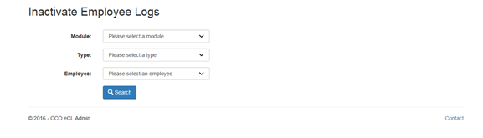

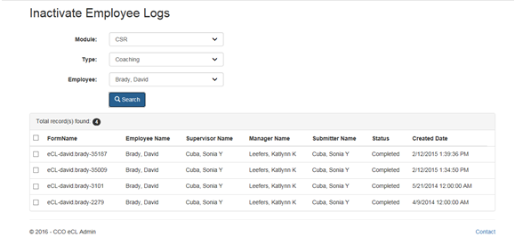

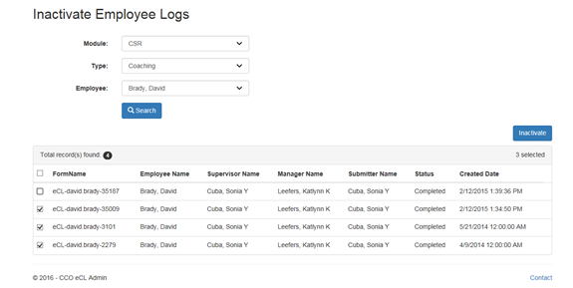

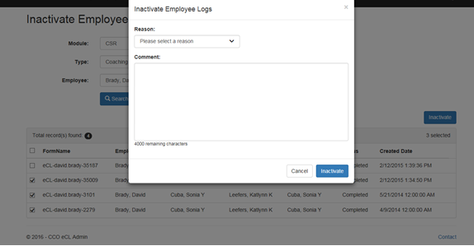

* + 1. Links

None

* + 1. Web Page Invoked Events

| Action | Processing & Result |
| --- | --- |
| Select a module from “Module:” dropdown list | If a type is already selected, an ajax call is made to get all the employees having active logs with the selected module and log type.  Controller: EmployeeLog  Action: GetEmployees  “Employee:” dropdown will be populated with the employees returned from the above ajax call. |
| Select a type from “Type:” dropdown list | If a type is already selected, an ajax call is made to get all the employees having active logs with the selected module and log type.  Controller: EmployeeLog;  Action: GetEmployees  “Employee:” dropdown will be populated with the employees returned from the above ajax call. |
| Select an employee from “Employee” dropdown  Click on “Search” button | An ajax call is posted back with selected module, type, and employee:  Controller: EmployeeLog  Action: SearchForInactivate [HttpPost] |
| Check/Uncheck any log(s) from the search result. | Javascript hideShowInactivateLink() is called to show/hide “Inactivate” link button.  If more than one log selected, “Inactivate” link button displays. Otherwise, “Inactivate” link button hides. |
| Click on “Inactivate” link button | jQuery $(‘body’).on(‘click’, ‘.modal-link’) function is called.  “Inactivate Employee Log” modal dialog displays. |
| Select a reason from “Reason:” dropdown list | If the selected reason is “Other”, a text box displays. |
| Click on “Inactivate” button (modal dialog). | An ajax call is posted back with the following data:  Selected Log Ids;  Selected reason id;  Other reason text entered;  Comment entered.  Controller: EmployeeLog  Action: Inactivate [HttpPost]  “Inactivate Employee Log” modal dialog closes.  A message will display to indicate the inactivation process whether the inactivation process is successful.  If success:  Display success message (“The selected logs have been successfully inactivated.”);  Hide searched result;  Reset all three dropdowns (Module, Type, and Employee).  Otherwise:  Display fail message (“Failed to inactivate the selected logs.”). |

* + 1. Form Fields

|  |  |  |  |  |  |
| --- | --- | --- | --- | --- | --- |
| **Page Name** | **Field Type** | **Field Name** | **Default Value** | **Data Element Source** | **Validation** |
| SearchForInactivate.cshtml | Label |  | Module: |  |  |
| DropDownList | module | -1 | AT_Module_Access |  |
| Label |  | Type: |  |  |
| DropDownList | logType | -1 |  |  |
| Label |  | Employee: |  |  |
| DropDownList | employee | -1 | Employee_Hierarchy |  |
| Start display Search Result: | | | | | |
| _SearchEmployeeLogResultPartial.cshtml | Label |  | Total record(s) found: |  |  |
| Label |  |  | EmployeeLogSelectViewModel.EmployeeLogs.Count |  |
| Checkbox | checkall | unchecked |  |  |
| Label |  | FormName |  |  |
| Label |  | Employee Name |  |  |
| Label |  | Supervisor Name |  |  |
| Label |  | Manager Name |  |  |
| Label |  | Submitter Name |  |  |
| Label |  | Status |  |  |
| Label |  | Created Date |  |  |
| Repeat for each log returned: |  |  |  |  |  |
| EmployeeLogSelectEditorViewModel.cshtml | Checkbox | EmployeeLogs[i].Selected | unchecked |  |  |
| Text |  |  | Coaching_Log.FormName if selected Type is “Coaching”  Or  Warning_Log.FormName if selected Type is “Warning” |  |
| Text |  |  | Employee_Hierarchy.Emp_Name |  |
| Text |  |  | Employee_Hierarchy.Sup_Name |  |
| Text |  |  | Employee_Hierarchy.Mgr_Name |  |
| Text |  |  | Employee_Hierarchy.Mgr_Name |  |
| Text |  |  | Employee_Hierarchy.Emp_Name  (Employee_Hierarchy.Emp_ID = Coaching_log.SubmitterID or Warning_Log.SubmitterID) |  |
| Text |  |  | DIM_Status.Status |  |
| Text |  |  | Coaching_Log.SubmittedDate if selected Type is “Coaching”  Or  Warning_Log.SubmittedDate |  |
| Hidden | EmployeeLogs[i].ID |  | Coaching_Log.CoachingID if selected Type is “Coaching”  Or  Warning_Log.WarningID if selected Type is “Warning” |  |
| Hidden | EmployeeLogs[i].FormName |  | Coaching_Log.FormName if selected Type is “Coaching”  Or  Warning_Log.FormName if selected Type is “Warning” |  |
| Hidden | EmployeeLogs[i].StatusId |  | Coaching_Log.StatusId if selected Type is “Coaching”  Or  Warning_Log.StatusId if selected Type is “Warning” |  |
| Hidden | EmployeeLogs[i].PreviousStatusId |  | AT_Coaching_Inactivate_Reactivate_Audit.LastKnownStatus |  |
| End of “Repeat for each log returned:” |  |  |  |  |  |
| End of “Start display Search Result:” | | | | | |
| _InactivatePartial.cshtml | Label |  | Reason: |  |  |
| DropDownList | reason | -1 | AT_Action_Reasons |  |
| Label |  | Comment: |  |  |
| TextArea | comment |  |  |  |

* 1. Reassign Employee Logs (Views\EmployeeLog\SearchForReassign.cshtml)
     1. Razor pages comprising Web Page

EmployeeLogSelectEditorViewModel.cshtml

_SearchEmployeeLogResultPartial.cshtml

_ReassignPartial.cshtml

_ReasonPartial.cshtml

_CommentPartial.cshtml

* + 1. Layout Page

Views\Shared\_Layoutcshtml

* + 1. Screenshot

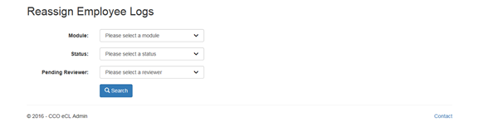

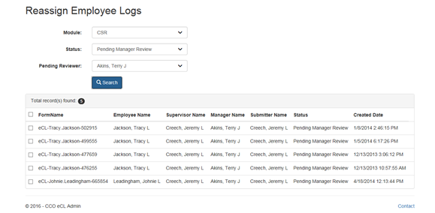

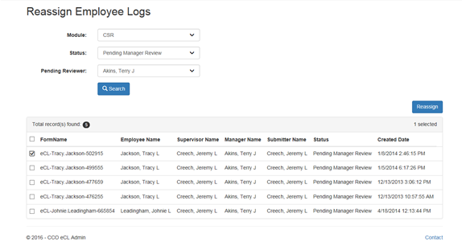

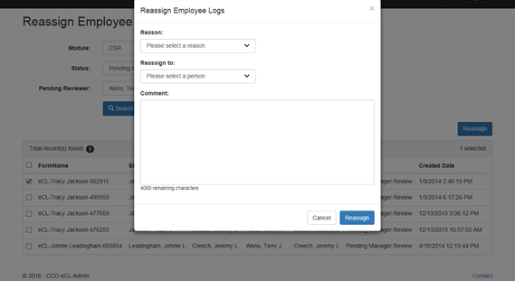

* + 1. Links

None

* + 1. Web Page Invoked Events

| Action | Processing & Result |
| --- | --- |
| Select a module from “Module:” dropdown list | An ajax call is made to get all pending statuses for the selected module.  Controller: EmployeeLog  Action: GetPendingStatuses |
| Select a status from “Status:” dropdown list | An ajax call is made to get all pending reviewers for the selected module and status.  Controller: EmployeeLog;  Action: GetPendingReviewers  “Pending Reviewer:” dropdownlist will be populated with the result from the ajax call. |
| Select a reviewer from “Pending Reviewer:” dropdown  Click on “Search” button | An ajax call is posted back with selected module, status, and reviewer:  Controller: EmployeeLog  Action: SearchForReassign [HttpPost] |
| Check/Uncheck any log(s) from the search result. | Javascript hideShowReassignLink() is called to show/hide “Reassign” link button.  If more than one log selected, “Reassign” link button displays. Otherwise, “Reassign” link button hides. |
| Click on “Reassign” link button | jQuery $(‘body’).on(‘click’, ‘.modal-link’) function is called.  “Reassign Employee Logs” modal dialog displays. |
| Select a reason from “Reason:” dropdown list | If the selected reason is “Other”, a text box displays. |
| Click on “Reassign” button (modal dialog). | An ajax call is posted back with the following data:  Selected Log Ids;  Selected reason id;  Other reason text entered;  Employee Id assigned to;  Comment entered.  Controller: EmployeeLog  Action: Reassign [HttpPost]  “Reassign Employee Logs” modal dialog closes.  A message will display to indicate if the reassignment is successful.  If success:  Success message (“The selected logs have been successfully reassigned.”) will be displayed. Searched result will hide and all the three dropdowns (Module, Status, and Pending Reviewer) will reset to default values.  Otherwise:  Fail message (“Failed to reassign the selected logs.”) will display. |

* + 1. Form Fields

|  |  |  |  |  |  |
| --- | --- | --- | --- | --- | --- |
| **Page Name** | **Field Type** | **Field Name** | **Default Value** | **Data Element Source** | **Validation** |
| SearchForReassign.cshtml | Label |  | Module: |  |  |
| DropDownList | module | -1 | AT_Module_Access |  |
| Label |  | Status: |  |  |
| DropDownList | employeeLogStatus | -1 | AT_Reassign_Status_For_Module |  |
| Label |  | Pending Reviewer: |  |  |
| DropDownList | employee | -1 | Employee_Hierarchy |  |
| Start display Search Result: | | | | | |
| _SearchEmployeeLogResultPartial.cshtml | Label |  | Total record(s) found: |  |  |
| Label |  |  | EmployeeLogSelectViewModel.EmployeeLogs.Count |  |
| Checkbox | checkall | unchecked |  |  |
| Label |  | FormName |  |  |
| Label |  | Employee Name |  |  |
| Label |  | Supervisor Name |  |  |
| Label |  | Manager Name |  |  |
| Label |  | Submitter Name |  |  |
| Label |  | Status |  |  |
| Label |  | Created Date |  |  |
| Repeat for each log returned: |  |  |  |  |  |
| EmployeeLogSelectEditorViewModel.cshtml | Checkbox | EmployeeLogs[i].Selected | unchecked |  |  |
| Text |  |  | Coaching_Log.FormName if selected Type is “Coaching”  Or  Warning_Log.FormName if selected Type is “Warning” |  |
| Text |  |  | Employee_Hierarchy.Emp_Name |  |
| Text |  |  | Employee_Hierarchy.Sup_Name |  |
| Text |  |  | Employee_Hierarchy.Mgr_Name |  |
| Text |  |  | Employee_Hierarchy.Mgr_Name |  |
| Text |  |  | Employee_Hierarchy.Emp_Name  (Employee_Hierarchy.Emp_ID = Coaching_log.SubmitterID or Warning_Log.SubmitterID) |  |
| Text |  |  | DIM_Status.Status |  |
| Text |  |  | Coaching_Log.SubmittedDate if selected Type is “Coaching”  Or  Warning_Log.SubmittedDate |  |
| Hidden | EmployeeLogs[i].ID |  | Coaching_Log.CoachingID if selected Type is “Coaching”  Or  Warning_Log.WarningID if selected Type is “Warning” |  |
| Hidden | EmployeeLogs[i].FormName |  | Coaching_Log.FormName if selected Type is “Coaching”  Or  Warning_Log.FormName if selected Type is “Warning” |  |
| Hidden | EmployeeLogs[i].StatusId |  | Coaching_Log.StatusId if selected Type is “Coaching”  Or  Warning_Log.StatusId if selected Type is “Warning” |  |
| Hidden | EmployeeLogs[i].PreviousStatusId |  | AT_Coaching_Inactivate_Reactivate_Audit.LastKnownStatus |  |
| End of “Repeat for each log returned:” |  |  |  |  |  |
| End of “Start display Search Result:” | | | | | |
| _ReassignPartial.cshtml | Label |  | Reason: |  |  |
| DropDownList | reason | -1 | AT_Action_Reasons |  |
| TextArea |  | otherreason |  |  |
| Label |  | Reassign to: |  |  |
| DropDownList | assignTo | -1 | Employee_Hierarchy |  |
| Label |  | Comment: |  |  |
| TextArea | comment |  |  |  |

* 1. Reactivate Employee Logs (Views\EmployeeLog\SearchForReactivate.cshtml)
     1. Razor pages comprising Web Page

EmployeeLogSelectEditorViewModel.cshtml

_SearchEmployeeLogResultPartial.cshtml

_ReactivatePartial.cshtml

_ReasonPartial.cshtml

_CommentPartial.cshtml

* + 1. Layout Page

Views\Shared\_Layoutcshtml

* + 1. Screenshot

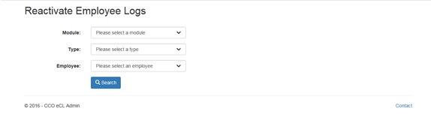

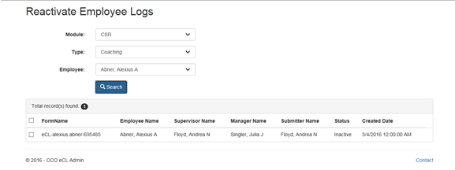

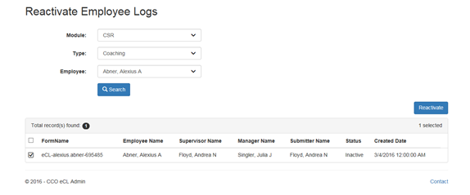

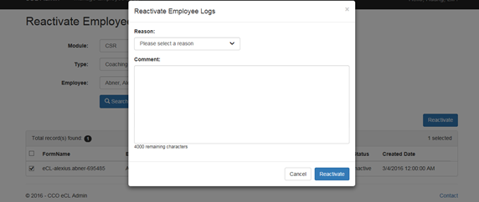

* + 1. Links

None

* + 1. Web Page Invoked Events

| Action | Processing & Result |
| --- | --- |
| Select a module from “Module:” dropdown list | If a type is already selected, an ajax call is made to get all the employees having active logs with the selected module and log type.  Controller: EmployeeLog  Action: GetEmployees  “Employee:” dropdown will be populated with the employees returned from the above ajax call. |
| Select a type from “Type:” dropdown list | If a type is already selected, an ajax call is made to get all the employees having active logs with the selected module and log type.  Controller: EmployeeLog;  Action: GetEmployees  “Employee:” dropdown will be populated with the employees returned from the above ajax call. |
| Select an employee from “Employee” dropdown  Click on “Search” button | An ajax call is posted back with selected module, type, and employee:  Controller: EmployeeLog  Action: SearchForReactivate [HttpPost] |
| Check/Uncheck any log(s) from the search result. | Javascript hideShowInactivateLink() is called to show/hide “Inactivate” link button.  If more than one log selected, “Reactivate” link button displays. Otherwise, “Reactivate” link button hides. |
| Click on “Reactivate” link button | jQuery $(‘body’).on(‘click’, ‘.modal-link’) function is called.  “Reactivate Employee Logs” modal dialog displays. |
| Select a reason from “Reason:” dropdown list | If the selected reason is “Other”, a text box displays. |
| Click on “Reactivate” button (modal dialog). | An ajax call is posted back with the following data:  Selected Log Ids;  Selected reason id;  Other reason text entered;  Comment entered.  Controller: EmployeeLog  Action: Reactivate [HttpPost]  “Reactivate Employee Logs” modal dialog closes.  A message will display to indicate if the reactivation is successful.  If success:  Success message (“The selected logs have been successfully reactivated.”) will be displayed. Searched result will hide and all the three dropdowns (Module, Type, and Employee) will be reset to default values.  Otherwise:  Fail message (“Failed to reactivate the selected logs.”) will display. |

* + 1. Form Fields

|  |  |  |  |  |  |
| --- | --- | --- | --- | --- | --- |
| **Page Name** | **Field Type** | **Field Name** | **Default Value** | **Data Element Source** | **Validation** |
| SearchForReactivate.cshtml | Label |  | Module: |  |  |
| DropDownList | module | -1 | AT_Module_Access |  |
| Label |  | Type: |  |  |
| DropDownList | logType | -1 |  |  |
| Label |  | Employee: |  |  |
| DropDownList | employee | -1 | Employee_Hierarchy |  |
| Start display Search Result: | | | | | |
| _SearchEmployeeLogResultPartial.cshtml | Label |  | Total record(s) found: |  |  |
| Label |  |  | EmployeeLogSelectViewModel.EmployeeLogs.Count |  |
| Checkbox | checkall | unchecked |  |  |
| Label |  | FormName |  |  |
| Label |  | Employee Name |  |  |
| Label |  | Supervisor Name |  |  |
| Label |  | Manager Name |  |  |
| Label |  | Submitter Name |  |  |
| Label |  | Status |  |  |
| Label |  | Created Date |  |  |
| Repeat for each log returned: |  |  |  |  |  |
| EmployeeLogSelectEditorViewModel.cshtml | Checkbox | EmployeeLogs[i].Selected | unchecked |  |  |
| Text |  |  | Coaching_Log.FormName if selected Type is “Coaching”  Or  Warning_Log.FormName if selected Type is “Warning” |  |
| Text |  |  | Employee_Hierarchy.Emp_Name |  |
| Text |  |  | Employee_Hierarchy.Sup_Name |  |
| Text |  |  | Employee_Hierarchy.Mgr_Name |  |
| Text |  |  | Employee_Hierarchy.Mgr_Name |  |
| Text |  |  | Employee_Hierarchy.Emp_Name  (Employee_Hierarchy.Emp_ID = Coaching_log.SubmitterID or Warning_Log.SubmitterID) |  |
| Text |  |  | DIM_Status.Status |  |
| Text |  |  | Coaching_Log.SubmittedDate if selected Type is “Coaching”  Or  Warning_Log.SubmittedDate |  |
| Hidden | EmployeeLogs[i].ID |  | Coaching_Log.CoachingID if selected Type is “Coaching”  Or  Warning_Log.WarningID if selected Type is “Warning” |  |
| Hidden | EmployeeLogs[i].FormName |  | Coaching_Log.FormName if selected Type is “Coaching”  Or  Warning_Log.FormName if selected Type is “Warning” |  |
| Hidden | EmployeeLogs[i].StatusId |  | Coaching_Log.StatusId if selected Type is “Coaching”  Or  Warning_Log.StatusId if selected Type is “Warning” |  |
| Hidden | EmployeeLogs[i].PreviousStatusId |  | AT_Coaching_Inactivate_Reactivate_Audit.LastKnownStatus |  |
| End of “Repeat for each log returned:” |  |  |  |  |  |
| End of “Start display Search Result:” | | | | | |
| _ReactivatePartial.cshtml | Label |  | Reason: |  |  |
| DropDownList | reason | -1 | AT_Action_Reasons |  |
| Label |  | Comment: |  |  |
| TextArea | comment |  |  |  |