________________________



Detail Design: CCO eCoaching Admin Dashboard

________________________

Prepared by: Lili Huang Date: 01/06/2017

Department: HCSD

Change History Log

| Date | Change Description | Author |
| --- | --- | --- |
| 01/06/2017 | Initial Revision – TFS 4893 | Lili Huang |
|  |  |  |

Table of Contents

**1.** **Description** 4

**2.** **Controllers** 4

2.1. DashboardController.cs 4

2.1.1. Index – HttpGet 4

2.1.2. FetchDataByMonth – HttpPost 4

2.1.3. GetPending – HttpPost 4

2.1.4. GetCompleted – HttpPost 4

2.1.5. GetActive – HttpPost 5

2.1.6. LoadData – HttpPost 5

2.1.7. GetLogDetail – HttpPost 5

**3.** **Page details** 5

3.1. Dashboard (Views\Dashboard\Index.cshtml) 5

3.1.1. Razor pages comprising Web Page 5

3.1.2. Layout Page 5

3.1.3. Screenshot 5

3.1.4. Links 7

3.1.5. Web Page Invoked Events 7

3.1.6. Form Fields 9

1. **Description**

This document covers the functions for dashboard.

1. **Controllers**
   1. DashboardController.cs
      1. Index – HttpGet

Redirect user to un-authorized page if user is not allowed to access this page;

Otherwise:

Get the month selected on the page;

Create DashboardIndexViewModel object;

Get pending coaching logs count by calling DashboardService.GetLogCount for the given user and the selected month;

Get completed coaching logs count by calling DashboardService.GetLogCount for the given user and the selected month;

Get active warning logs count by calling DashboardService.GetLogCount for the given user and month;

Create and populate DashboardGraphViewModel object for a given user and month by calling DashboardService.GetChartDataCoachingCompleted, DashboardService.GetChartDataCoachingPending, and DashboardService.GetChartDataWarningActive;

Populate DashboardIndexViewModel object with:

* Pending Coaching Logs Count
* Completed Coaching Logs Count
* Active Warning Logs Count
* DashboardGraphViewModel object

Return Index.cshtml view with DashboardIndexViewModel object.

* + 1. FetchDataByMonth – HttpPost

Get the month selected on the page;

Save the selected month to session;

Create DashboardIndexViewModel object;

Get pending coaching logs count by calling DashboardService.GetLogCount for the given user and the selected month;

Get completed coaching logs count by calling DashboardService.GetLogCount for the given user and the selected month;

Get active warning logs count by calling DashboardService.GetLogCount for the given user and month;

Create and populate DashboardGraphViewModel object for a given user and month by calling DashboardService.GetChartDataCoachingCompleted, DashboardService.GetChartDataCoachingPending, and DashboardService.GetChartDataWarningActive;

Populate DashboardIndexViewModel object with:

* Pending Coaching Logs Count
* Completed Coaching Logs Count
* Active Warning Logs Count
* DashboardGraphViewModel object

Return Index.cshtml view with DashboardIndexViewModel object.

* + 1. GetPending – HttpPost

Set ViewBag.LogStatus to “Pending”;

Set ViewBag.Coaching to true;

Set Session[“Coaching”] to true;

Return partial view _List.cshtml.

* + 1. GetCompleted – HttpPost

Set ViewBag.LogStatus to “Completed”;

Set ViewBag.Coaching to true;

Set Session[“Coaching”] to true;

Return partial view _List.cshtml.

* + 1. GetActive – HttpPost

Set ViewBag.LogStatus to “Active”;

Set ViewBag.Coaching to false;

Set Session[“Coaching”] to false;

Return partial view _List.cshtml.

* + 1. LoadData – HttpPost

Get selected month from session;

Get the current page number selected from http request;

Get the page size from http request;

Get the current sorting column from http request;

Get the current sorting direction from http request;

Get the search text from http request;

Get the list of logs for the current page by calling Dashboard.GetLogList;

Get the total count for the current search by calling DashboardService.GetLogListTotal;

Return the list of logs for the current page, the total count for the current search in JsonResult object.

* + 1. GetLogDetail – HttpPost

Get the log detail object by calling DashboardService.GetLogDetail;

If the log is Coaching, return partial view _CaochingDetail.cshtml with the log detail object;

Else return partial view _WarningDetail.cshtml with the log detail object.

1. **Page details**
   1. Dashboard (Views\Dashboard\Index.cshtml)
      1. Razor pages comprising Web Page

_Dashboard.cshtml

_Chart.cshtml

_List.cshtml

_CoachingDetail.cshtml

_WarningDetail.cshtml

* + 1. Layout Page

Views\Shared\_Layoutcshtml

* + 1. Screenshot

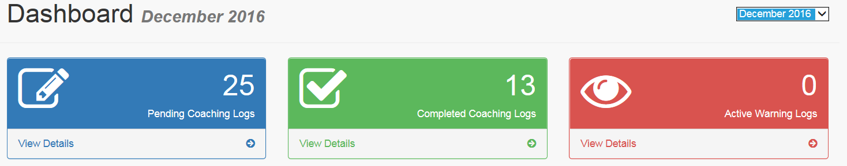

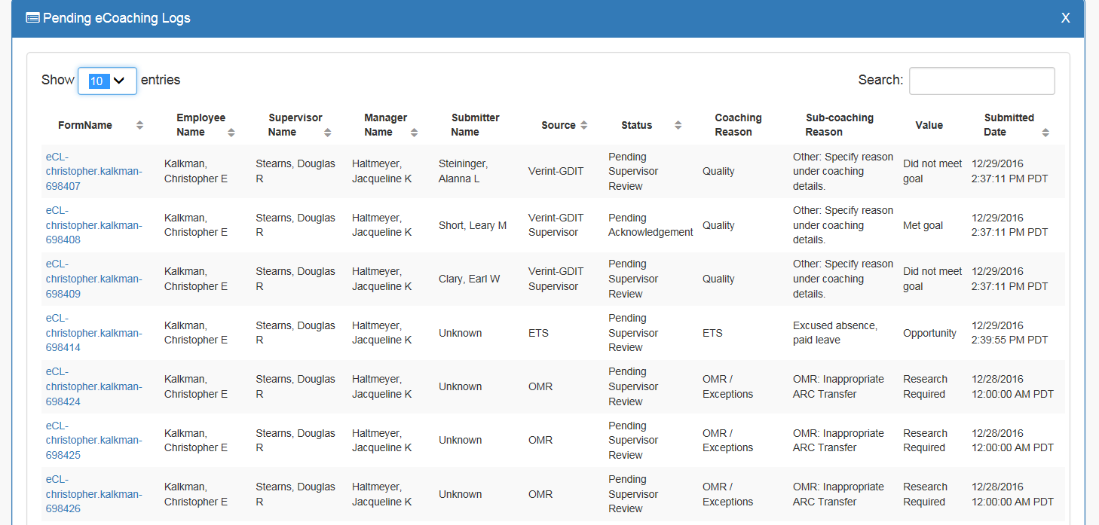

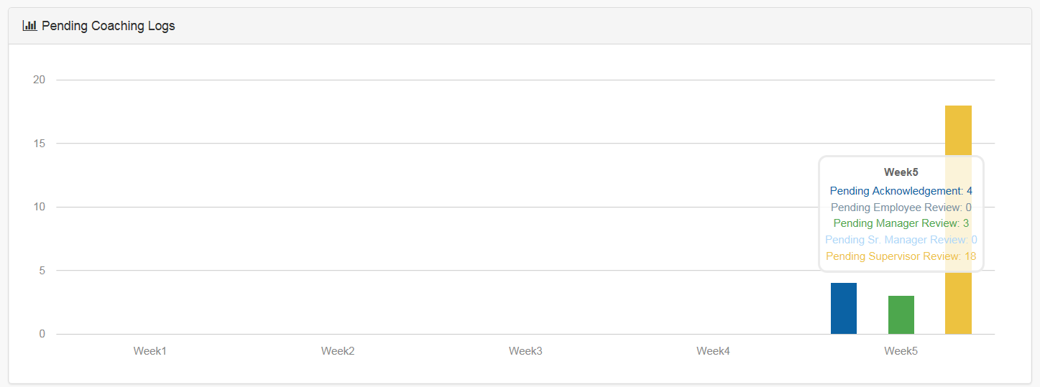

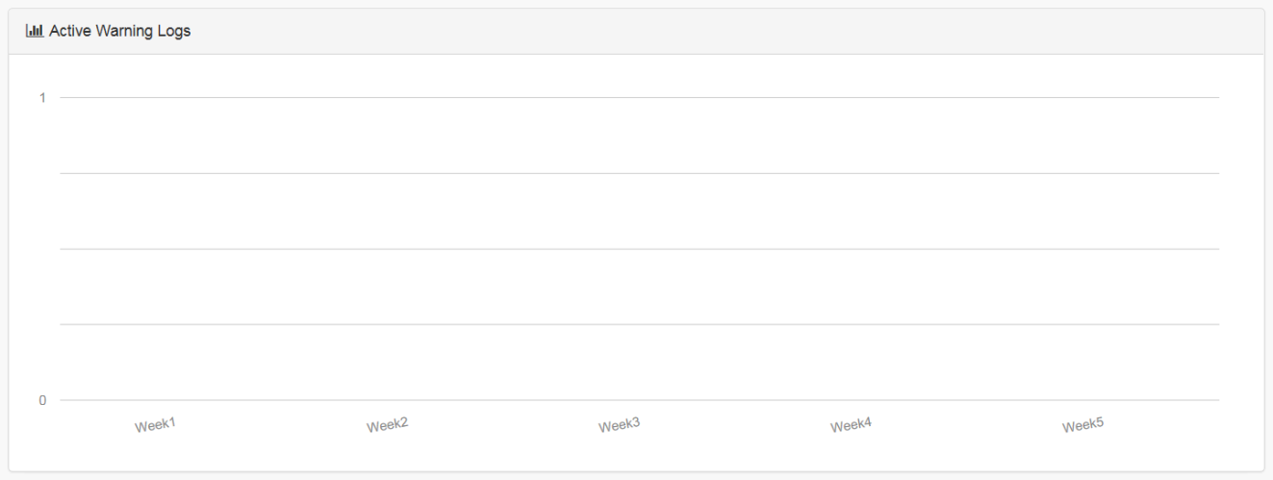

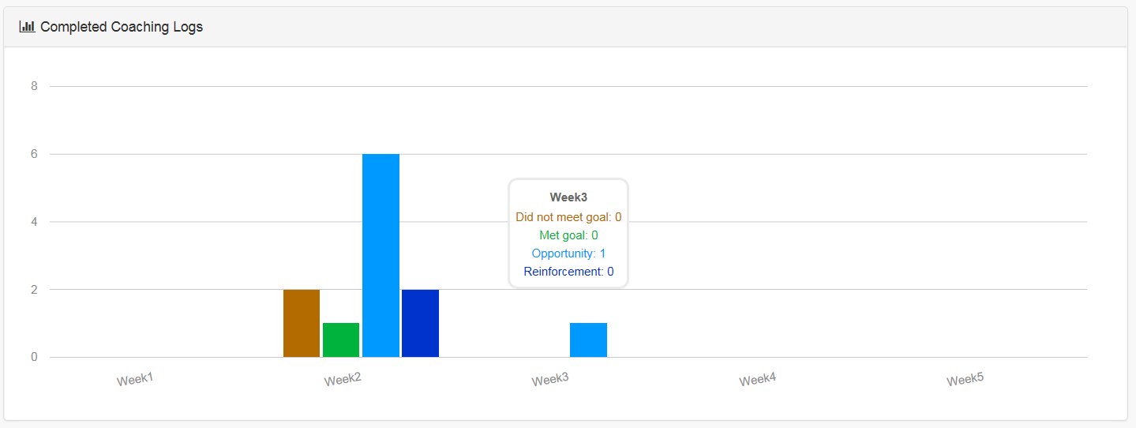

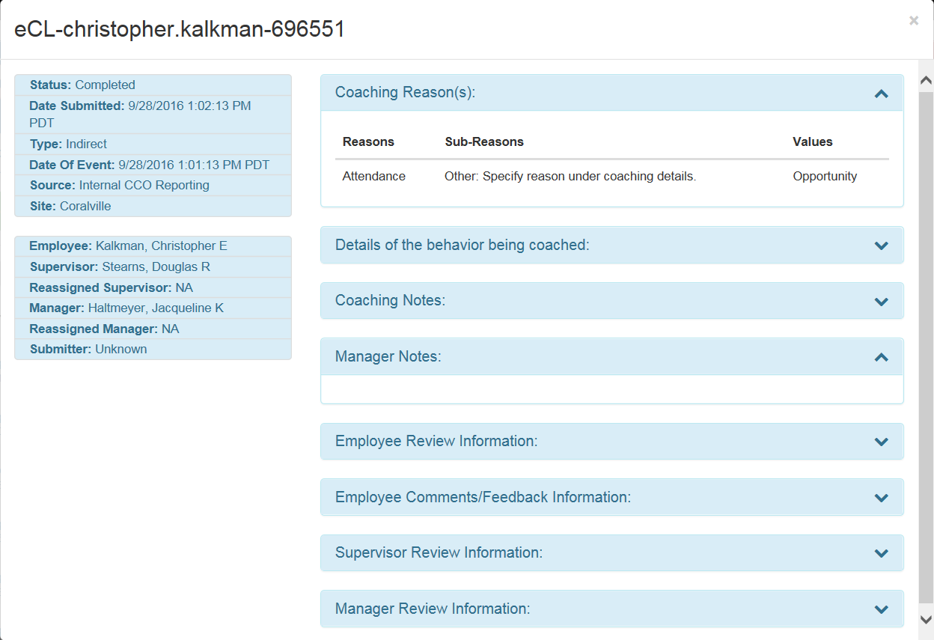

* + 1. Links

None

* + 1. Web Page Invoked Events

| Action | Processing & Result |
| --- | --- |
| Select a month from dropdown list | An ajax call is made to get all the counts for the selected month.  Controller: Dashboard  Action: FetchDataByMonth  Page is refreshed with the data for the selected month. |
| Click “View Details” for Pending Coaching Logs. | An ajax call is made to get the pending logs.  Controller: Dashboard  Action: GetPending  Pending log list will be displayed on the page. |
| Click “View Details” for Completed Coaching Logs. | An ajax call is made to get the completed logs.  Controller: Dashboard  Action: GetCompleted  Completed log list will be displayed on the page. |
| Click “View Details” for “Active Warning Logs”. | An ajax call is made to get the active logs.  Controller: Dashboard  Action: GetActive  Active log list will be displayed on the page. |
| Click any log in the View Detail section (Log list). | An ajax call is made to get the details of the clicked log.  Controller: Dashboard  Action: GetLogDetail  A modal dialog displays the details of the log. |
| Enter text in Search textbox (View Detail section – Log List). | An ajax call is made to get the searched result (Searchable columns: Employee Name, Supervisor Name, and Manager Name).  Controller: Dashboard  Action: LoadData  The log list is refreshed with the search result. |
| Click the following column headers:  FormName  Employee Name  Supervisor Name  Manager Name  Submitter Name  Source  Status  Submitted Date | An ajax call is made to sort the list.  Controller: Dashboard  Action: LoadData  The log list is sorted by the clicked column header. |
| Click “X” on the right top corner of the View Details section (Log List). | View Details section (Log List) will disappear. |

* + 1. Form Fields

|  |  |  |  |  |  |  |
| --- | --- | --- | --- | --- | --- | --- |
| **Page Name** | **Field Type** | **Field Name** | **Default Value** | **Data Element Source** | **Validation** | **Note** |
| Index.cshtml | Label |  | Dashboard |  |  |  |
| Lable |  | Current month year | ddl-month |  |  |
| DropDownList | ddl-month | Current month year | Most recent 10 months |  |  |
| _Dashboard.cshtml | Text |  |  | DashboardIndexViewModel.  TotalPendingCoachings |  | Pending Count |
| Label |  | Pending Coaching Logs |  |  |  |
| Text |  |  | DashboardIndexViewModel.  TotalCompletedCoachings |  | Completed Count |
| Label |  | Completed Coaching Logs |  |  |  |
| Text |  |  | DashboardIndexViewModel.  TotalPendingWarnings |  | Active Count |
| Label |  | Active Warning Logs |  |  |  |
| _Chart.cshtml | Label |  | Pending Coaching Logs |  |  |  |
| div | pending-bar-chart |  |  |  | morris bar chart |
| Label |  | Completed Coaching Logs |  |  |  |
| div | completed-bar-chart |  |  |  | morris bar chart |
| Label |  | Active Logs |  |  |  |
| div | active-warning-bar-chart |  |  |  | morris bar chart |
| _List.cshtml | Label |  | FormName |  |  | Column Header |
| Label |  | Employee Name |  |  | Column Header |
| Label |  | Supervisor Name |  |  | Column Header |
| Label |  | Manager Name |  |  | Column Header |
| Label |  | Submitter Name |  |  | Column Header |
| Label |  | Source |  |  | Column Header |
| Label |  | Status |  |  | Column Header |
| Label |  | Coaching Reason |  |  | Column Header |
| Label |  | Sub-coaching Reason |  |  | Column Header |
| Label |  | Value |  |  | Column Header |
| Label |  | Submitted Date |  |  | Column Header |
|  | Begin - Repeat for each row returned | | | | | |
| link |  |  | EmployeeLog.FormName |  |  |
| Text |  |  | EmployeeLog.EmployeeName |  |  |
| Text |  |  | EmployeeLog.SupervisorName |  |  |
| Text |  |  | EmployeeLog.ManagerName |  |  |
| Text |  |  | EmployeeLog.SubmitterName |  |  |
| Text |  |  | EmployeeLog.Source |  |  |
| Text |  |  | EmployeeLog.Status |  |  |
| Text |  |  | EmployeeLog.Reasons |  |  |
| Text |  |  | EmployeeLog.SubReasons |  |  |
| Text |  |  | EmployeeLog.Value |  |  |
| Text |  |  | EmployeeLog.CreatedDate |  |  |
| End – Repeat for each row returned | | | | | |
| _CoachingDetail.cshtml | Text |  |  | CoachingLogDetail.FormName |  |  |
| Label |  | Status: |  |  |  |
| Text |  |  | CoachingLogDetail.Status |  |  |
| Label |  | Date Submitted: |  |  |  |
| Text |  |  | CoachingLogDetail.CreatedDate |  |  |
| Label |  | Type: | CoachingLogDetail.Type |  |  |
| Begin - If it is direct coaching | | | | | |
| Label |  | Date Of Coaching: |  |  |  |
| Text |  |  | CoachingLogDetail.CoachingDate |  |  |
| else | | | | | |
| Label |  | Date Of Event: |  |  |  |
| Text |  |  | CoachingLogDetail.EventDate |  |  |
| End – If it is direct coaching | | | | | |
| Label |  | Source: |  |  |  |
| Text |  |  | CoachingLogDetail.Source |  |  |
| Begin – If it is Verint Monitor | | | | | |
| Label |  | Verint ID: |  |  |  |
| Text |  |  | CoachingLogDetail.VerintId |  |  |
| Label |  | Scorecard Name: |  |  |  |
| Text |  |  | CoachingLogDetail.  VerintFormName |  |  |
| Label |  | Coaching Monitor: |  |  |  |
| Text |  |  | CoachingLogDetail.  CoachingMonitor |  |  |
| End – If it is Verint Monitor | | | | | |
| Begin – If it is behavior analytics monitor | | | | | |
| Label |  | Avoke ID: |  |  |  |
| Text |  |  | CoachingLogDetail.  BehaviorAnalyticsId |  |  |
| End – If it is behavior analytics monitor | | | | | |
| Begin – If it is NGD activity | | | | | |
| Label |  | NGD Activity ID: |  |  |  |
| Text |  |  | CoachingLogDetail.NgdActivityId |  |  |
| End – If it is NGD activity | | | | | |
| Begin – If it is universal call | | | | | |
| Label |  | Universal Call ID: |  |  |  |
| Text |  |  | CoachingLogDetail.Ucid |  |  |
| End – If it is universal call | | | | | |
| Label |  | Employee: |  |  |  |
| Text |  |  | CoachingLogDetail.EmployeeName |  |  |
| Label |  | Supervisor: |  |  |  |
| Text |  |  | CoachingLogDetail.  SupervisorName |  |  |
| Label |  | Reassigned Supervisor: |  |  |  |
| Text |  |  | CoachingLogDetail.  ReassignedSupervisorName |  |  |
| Label |  | Manager: |  |  |  |
| Text |  |  | CoachingLogDetail.ManagerName |  |  |
| Label |  | Reassigned Manager: |  |  |  |
| Text |  |  | CoachingLogDetail.  ReassignedManagerName |  |  |
| Label |  | Submitter: |  |  |  |
| Text |  |  | CoachingLogDetail.SubmitterName |  |  |
| Label |  | Coaching Reason(s): |  |  |  |
| Begin – Coaching Reason(s) display | | | | | |
| Label |  | Reasons |  |  | Column Header |
| Label |  | Sub-Reasons |  |  | Column Header |
| Label |  | Values |  |  | Column Header |
| Text |  |  | CoachingLogDetail.Reasons |  |  |
| Text |  |  | CoachingLogDetail.SubReasons |  |  |
| *Text* |  |  | CoachingLogDetail.Value |  |  |
| *End – Coaching Reason(s) display* | | | | | |
| *Label* |  | Details of the behavior being coached: |  |  |  |
| Text |  |  | CoachingLogDetail.Behavior |  |  |
| Label |  | Coaching Notes: |  |  |  |
| Text |  |  | CoachingLogDetail.CoachingNotes |  |  |
| Label |  | Manager Notes: |  |  |  |
| Text |  |  | CoachingLogDetail.MgrNotes |  |  |
| Label |  | Employee Review Information: |  |  |  |
| Text |  |  | CoachingLogDetail.EmployeeName  Reviewed and acknowledged on:  CoachingLogDetail.  EmployeeReviewDate |  |  |
| Label |  | Employee Comments/Feedback Information: |  |  |  |
| Text |  |  | CoachingLogDetail.  EmployeeComments |  |  |
| Label |  | Supervisor Review Information: |  |  |  |
| Text |  |  | CoachingLogDetail.  ReviewedSupervisorName  Reviewed and acknowledged on:  CoachingLogDetail.  SupReviewedAutoDate |  |  |
| Label |  | Manager Review Information: |  |  |  |
| Text |  |  | CoachingLogDetail.  ReviewedManagerName  Reviewed and acknowledged on:  CoachingLogDetail.  MgrReviewAutoDate |  |  |
|  |  |  |  |  |  |  |
|  |  |  |  |  |  |  |
| _WarningDetail.cshtml | Text |  |  | WarningLogDetail.FormName |  |  |
| Label |  | Status: |  |  |  |
| Text |  |  | WarningLogDetail.Status |  |  |
| Label |  | Date the warning was issued: |  |  |  |
| Text |  |  | WarningLogDetail.EventDate |  |  |
| Label |  | Source: |  |  |  |
| Text |  |  | WarningLogDetail.Source |  |  |
| Label |  | Site: |  |  |  |
| Text |  |  | WarningLogDetail.EmployeeSite |  |  |
| Label |  | Employee: | WarningLogDetail.EmployeeName |  |  |
|  |  |  |  |  |  |
| Label |  | Supervisor: |  |  |  |
| Text |  |  | WarningLogDetail.  SupervisorName |  |  |
| Label |  | Reassigned Supervisor: |  |  |  |
| Text |  |  | WarningLogDetail.  ReassignedSupervisorName |  |  |
| Label |  | Manager: |  |  |  |
| Text |  |  | WarningLogDetail.ManagerName |  |  |
| Label |  | Submitter: |  |  |  |
| Text |  |  | WarningLogDetail.SubmitterName |  |  |
| Label |  | Coaching Reason(s): |  |  |  |
| Begin – Coaching Reason(s) display | | | | | |
| Label |  | Warning Type |  |  | Column Header |
| Label |  | Warning Reason(s) |  |  | Column Header |
| Label |  | Values |  |  | Column Header |
| Text |  |  | WarningLogDetail.Reasons |  |  |
| Text |  |  | WarningLogDetail.SubReasons |  |  |
| *Text* |  |  | WarningLogDetail.Value |  |  |
| *End – Coaching Reason(s) display* | | | | | |