________________________

[MAXIMUS logo](https://www.maximus.com/)

Detail Design: eCoaching Admin Manage Employee Logs

________________________

Prepared by: Lili Huang Date: 05/02/2016

Department: HCSD

Change History Log

| Date | Change Description | Author |
| --- | --- | --- |
| 05/02/2016 | Initial Revision – TFS 1709 | Lili Huang |
| 01/06/2017 | TFS 4893 | Lili Huang |
| 03/07/2017 | TFS 5693 – Delete logs | Lili Huang |
| 03/08/2019 | TFS 13717 – Update Module to Employee Level | Lili Huang |
| 07/24/2020 | TFS 17803 – GDIT to MAXIMUS | Lili Huang |
| 0906/2022 | TFS 25243 – Manage Logs – Add to search by log name | Lili Huang |
| 03/22/2023 | TFS 26396 – Reassign: add site dropdown to allow user to choose a reviewer from the selected site.  Added:  2.2.6 GetReviewersBySite  Updated:  3.2.3 Screenshot  3.2.5 Web Page Invoked Events  3.2.6 Form Fields | Lili Huang |
| 09/19/2023 | TFS 27187 – Inactivate: allow users to search by multiple log names.  Updated screenshots. | Lili Huang |
| 02/16/2024 | TFS 27695 – Subcontractor  **Updated:**  1 Description | Lili Huang |

Table of Contents

**1.** **Description** 4

**2.** **Controllers** 4

2.1. EmployeeLogBaseController.cs 4

2.1.1. GetLogDetail action 4

2.2. EmployeeLogController.cs 4

2.2.1. SearchForInactivate action - HttpGet 4

2.2.2. SearchForInactivate action – HttpPost 4

2.2.3. Inactivate action - HttpPost 4

2.2.4. SearchForReassign action - HttpGet 4

2.2.5. SearchForReassign action – HttpPost 4

2.2.6. GetReviewersBySite action - HttpPost 4

2.2.7. Reassign action - HttpPost 5

2.2.8. SearchForReactivate action - HttpGet 5

2.2.9. SearchForReactivate action - HttpPost 5

2.2.10. Reactivate action - HttpPost 5

2.2.11. SearchForDelete – HttpGet 5

2.2.12. SearchForDelete – HttpPost 5

2.2.13. ViewLogDetail 5

2.2.14. InitDetelete – HttpGet 5

2.2.15. Delete – HttpPost 6

**3.** **Page details** 6

3.1. Inactivate Employee Logs (Views\EmployeeLog\SearchForInactivate.cshtml) 6

3.1.1. Razor pages comprising Web Page 6

3.1.2. Layout Page 6

3.1.3. Screenshot 6

3.1.4. Links 7

3.1.5. Web Page Invoked Events 7

3.1.6. Form Fields 10

3.2. Reassign Employee Logs (Views\EmployeeLog\SearchForReassign.cshtml) 12

3.2.1. Razor pages comprising Web Page 12

3.2.2. Layout Page 12

3.2.3. Screenshot 12

3.2.4. Links 14

3.2.5. Web Page Invoked Events 14

3.2.6. Form Fields 16

3.3. Reactivate Employee Logs (Views\EmployeeLog\SearchForReactivate.cshtml) 18

3.3.1. Razor pages comprising Web Page 18

3.3.2. Layout Page 18

3.3.3. Screenshot 18

3.3.4. Links 19

3.3.5. Web Page Invoked Events 19

3.3.6. Form Fields 21

3.4. Delete Employee Logs (Views\EmployeeLog\SearchForDelete.cshtml) 23

3.4.1. Razor pages comprising Web Page 23

3.4.2. Layout Page 23

3.4.3. Screenshot 23

3.4.4. Links 25

3.4.5. Web Page Invoked Events 25

3.4.6. Form Fields 26

1. **Description**

This document covers the functions provided to administrators and managers to manage eCoaching logs.

Active coaching logs and warning logs are allowed to be inactivated. Inactivated coaching logs and warning logs are allowed to be reactivated to their previous status. Users must provide a valid reason when inactivating and reactivating eCoaching logs.

Pending review coaching logs are allowed to be reassigned to a different reviewer at the same hierarchy level. Subcontractor logs are allowed to be reassigned to a different reviewer at the same hierarchy level from their own sites only. Users must provide a valid reason when reassigning eCoaching logs.

Administrators are allowed to manage coaching logs and warning logs across all sites, while managers are allowed to manage coaching logs only from their own sites.

1. **Controllers**
   1. EmployeeLogBaseController.cs
      1. GetLogDetail action

Get the detail for the given log (log id and log type) by calling EmployeeLogService.GetLogDetail;

Return partial view _CoachingDetail.cshtml or _WarningDetail based on the log type with the log detail model.

* 1. EmployeeLogController.cs
     1. SearchForInactivate action - HttpGet

Collect data for dropdowns – Log Type; Employee Level, and Employee;

Return SearchForInactivate.cshtml view.

* + 1. SearchForInactivate action – HttpPost

Call SearchLog method in EmployeeLogService class to return logs for the selected employee or log name with the selected log type (coaching or warning).

Return _SearchEmployeeLogResultPartial.cshtml partial view with the logs returned from previous step.

* + 1. Inactivate action - HttpPost

Get the following information for the current request:

* The user LAN ID
* Selected Logs IDs
* Selected Reason ID
* Other Reason text
* Comment text

Call ProcessActivation method in EmployeeLogService class to inactivate the selected logs and save the result to database.

Return success or fail via JSON based on the result from the previous step.

* + 1. SearchForReassign action - HttpGet

Collect data fro dropdowns – Log Type, Log Status, and Reviewer;

Return SearchForReassign view.

* + 1. SearchForReassign action – HttpPost

Call SearchLogForReactivate method in EmployeeLogService class to return logs for the selected reviewer with the selected status or log name.

Return _SearchEmployeeLogResultPartial.cshtml partial view with the logs returned from previous step.

* + 1. GetReviewersBySite action - HttpPost

Call GetReviewersBySite method in EmployeeLogService class to return reviewers for the selected site.

Return the reviewers from the previous step.

* + 1. Reassign action - HttpPost

Get the following information for the current request:

* The user LAN ID
* Selected Logs IDs
* Reviewer Reassigned To
* Selected Reason ID
* Other Reason text
* Comment text

Call ProcessReassign method in EmployeeLogService class to reassign the selected logs to the new reviewer and save the result to database.

If the previous step is successful, send email to the new reviewer.

Return success or fail via JSON based on the result from ProcessReassign call.

* + 1. SearchForReactivate action - HttpGet

Collect data for dropdowns – Log Type; Employee Level, and Employee;

Return SearchForReactivate.cshtml view.

* + 1. SearchForReactivate action - HttpPost

Call SearchLog method in EmployeeLogService class to return logs for the selected employee or log name with the selected log type (coaching or warning).

Return _SearchEmployeeLogResultPartial.cshtml partial view with the logs returned from previous step.

* + 1. Reactivate action - HttpPost

Get the following information for the current request:

* The user LAN ID
* Selected Logs IDs
* Selected Reason ID
* Other Reason text
* Comment text

Call ProcessActivation method in EmployeeLogService class to reactivate the selected logs and save the result to database.

If the previous step is successful, send email to the logs’ employee, supervisor or manager in the current hierarchy based on the logs’ previous status (before being inactivated).

Return success or fail via JSON based on the result from ProcessActivation call.

* + 1. SearchForDelete – HttpGet

Return SearchForDelete.cshtml.

* + 1. SearchForDelete – HttpPost

Set ViewBag.Success to be null;

Set ViewBag.Fail to be null;

Get the logs with the given name by calling EmployeeLogService.GetLogsByLogName;

Return partial view _LogForDeletePartial.cshtml with the logs for the given name.

* + 1. ViewLogDetail

Get log detail by calling GetLogDetail in EmployeeLogBaseController for the given log and type;

Return partial view _CoachingDetail.cshtml or _WarningDetail.cshtml with the log detail based on the log type.

* + 1. InitDetelete – HttpGet

Create an EmployeeLog object with the log id and type passed in;

Return partial view _Delete.cshtml with the EmployeeLog object created.

* + 1. Delete – HttpPost

Delete the given log by calling EmployeeLogService.Delete;

If success, set ViewBag.Success message;

Else set ViewBag.Fail message;

Return view SearchForDelete.cshtml.

1. **Page details**
   1. Inactivate Employee Logs (Views\EmployeeLog\SearchForInactivate.cshtml)
      1. Razor pages comprising Web Page

EmployeeLogSelectEditorViewModel.cshtml

_SearchEmployeeLogResultPartial.cshtml

_InactivatePartial.cshtml

_SearchOption.cshtml

_SearchByLogName.cshtml

_ReasonPartial.cshtml

_CommentPartial.cshtml

* + 1. Layout Page

Views\Shared\_Layoutcshtml

* + 1. Screenshot

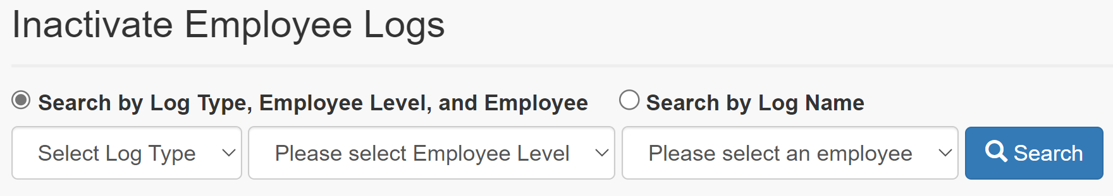

**Searchy by Log Type, Employee Level, and Employee:**

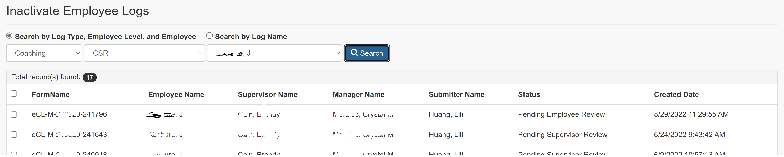

**Searchy by Log Name:**

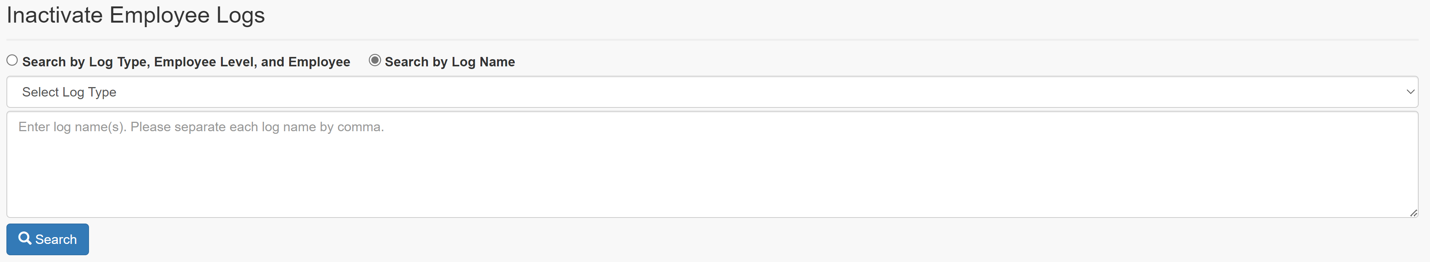

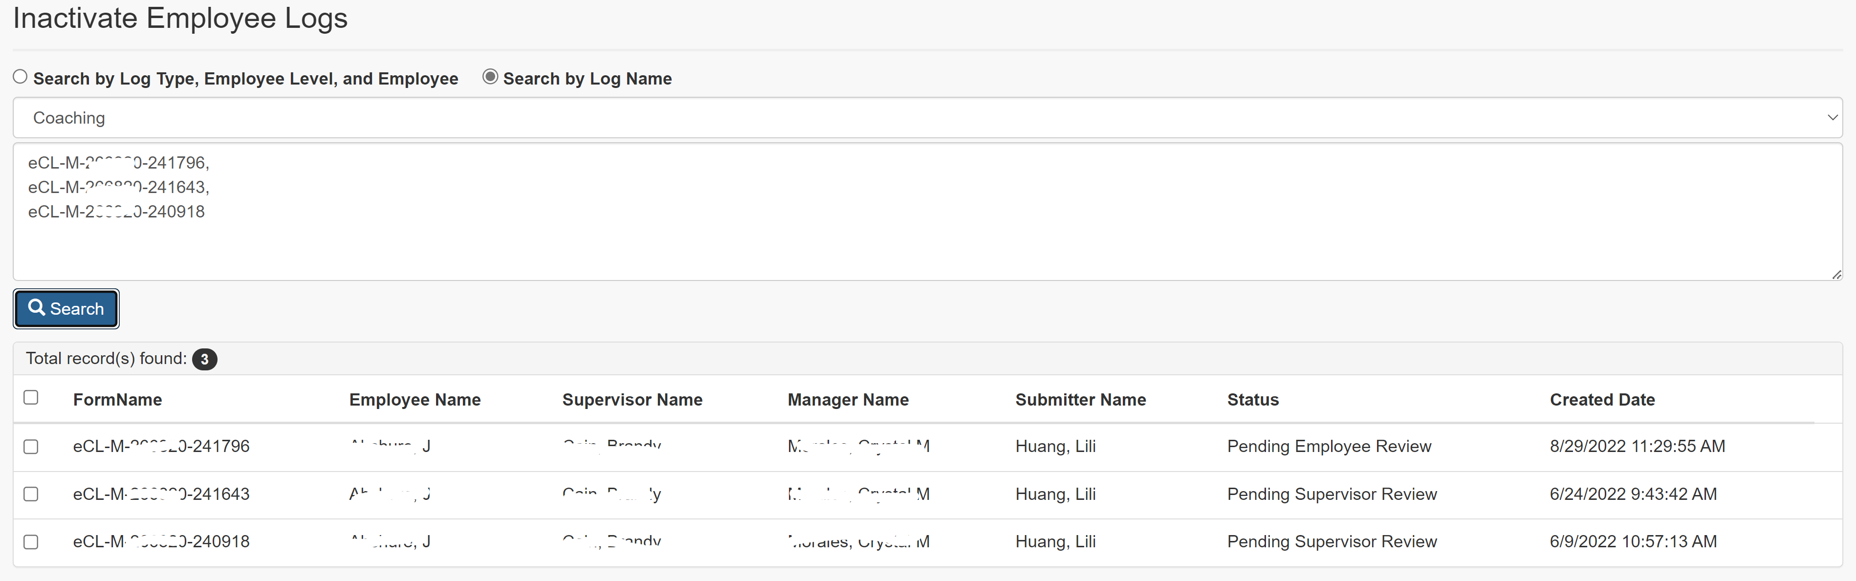

**Inactivate Employee Logs:**

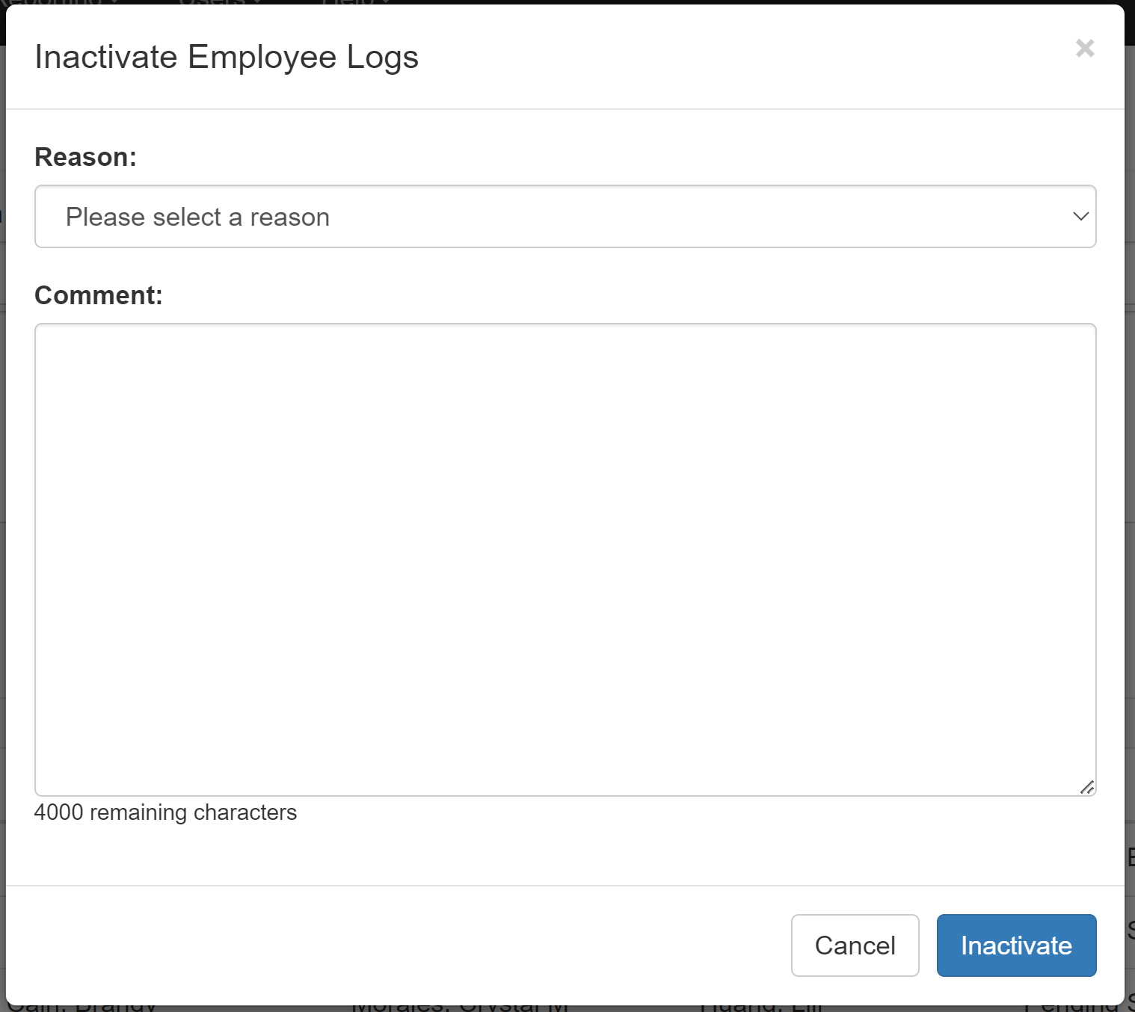

* + 1. Links

None

* + 1. Web Page Invoked Events

| Action | Processing & Result |
| --- | --- |
| Click Radio button “Search by Log Type, Employee Level, and Employee” | Javascript:  Display Search by Log Type, Employee Level, and Employee; |
| Click Radio button “Search by Log Name” | Javascript:  Display Search by Log Name; |
| Select Employee Level from “Employee Level:” dropdown list | If a type is already selected, an ajax call is made to get all the employees having active logs with the selected Employee Level and log type.  Controller: EmployeeLog  Action: GetEmployees  “Employee:” dropdown will be populated with the employees returned from the above ajax call. |
| Select a type from “Type:” dropdown list | If a type is already selected, an ajax call is made to get all the employees having active logs with the selected Employee Level and log type.  Controller: EmployeeLog;  Action: GetEmployees  “Employee:” dropdown will be populated with the employees returned from the above ajax call. |
| Select an employee from “Employee” dropdown  Click on “Search” button | An ajax call is posted back with selected Employee Level, type, employee, and log name.  Controller: EmployeeLog  Action: SearchForInactivate [HttpPost] |
| Check/Uncheck any log(s) from the search result. | Javascript hideShowInactivateLink() is called to show/hide “Inactivate” link button.  If more than one log selected, “Inactivate” link button displays. Otherwise, “Inactivate” link button hides. |
| Click on “Inactivate” link button | jQuery $(‘body’).on(‘click’, ‘.modal-link’) function is called.  “Inactivate Employee Log” modal dialog displays. |
| Select a reason from “Reason:” dropdown list | If the selected reason is “Other”, a text box displays. |
| Click on “Inactivate” button (modal dialog). | An ajax call is posted back with the following data:  Selected Log Ids;  Selected reason id;  Other reason text entered;  Comment entered.  Controller: EmployeeLog  Action: Inactivate [HttpPost]  “Inactivate Employee Log” modal dialog closes.  A message will display to indicate the inactivation process whether the inactivation process is successful.  If success:  Display success message (“The selected logs have been successfully inactivated.”);  Hide searched result;  Reset all three dropdowns (Employee Level, Type, and Employee).  Otherwise:  Display fail message (“Failed to inactivate the selected logs.”). |

* + 1. Form Fields

|  |  |  |  |  |  |
| --- | --- | --- | --- | --- | --- |
| **Page Name** | **Field Type** | **Field Name** | **Default Value** | **Data Element Source** | **Validation** |
| _SearchOption.cshtml  SearchForInactivate.csthml | Radio Btn | searchType | “default” | “Search By Log Type, Employee Level, and Employee”;  “Search by Log Name” |  |
| DropDownList | module | -1 | AT_Module_Access |  |
| DropDownList | logType | -1 |  |  |
| DropDownList | employee | -1 | Employee_Hierarchy |  |
| Start display Search Result: | | | | | |
| _SearchEmployeeLogResultPartial.cshtml | Label |  | Total record(s) found: |  |  |
| Label |  |  | EmployeeLogSelectViewModel.EmployeeLogs.Count |  |
| Checkbox | checkall | unchecked |  |  |
| Label |  | FormName |  |  |
| Label |  | Employee Name |  |  |
| Label |  | Supervisor Name |  |  |
| Label |  | Manager Name |  |  |
| Label |  | Submitter Name |  |  |
| Label |  | Status |  |  |
| Label |  | Created Date |  |  |
| Repeat for each log returned: |  |  |  |  |  |
| EmployeeLogSelectEditorViewModel.cshtml | Checkbox | EmployeeLogs[i].Selected | unchecked |  |  |
| Text |  |  | Coaching_Log.FormName if selected Type is “Coaching”  Or  Warning_Log.FormName if selected Type is “Warning” |  |
| Text |  |  | Employee_Hierarchy.Emp_Name |  |
| Text |  |  | Employee_Hierarchy.Sup_Name |  |
| Text |  |  | Employee_Hierarchy.Mgr_Name |  |
| Text |  |  | Employee_Hierarchy.Mgr_Name |  |
| Text |  |  | Employee_Hierarchy.Emp_Name  (Employee_Hierarchy.Emp_ID = Coaching_log.SubmitterID or Warning_Log.SubmitterID) |  |
| Text |  |  | DIM_Status.Status |  |
| Text |  |  | Coaching_Log.SubmittedDate if selected Type is “Coaching”  Or  Warning_Log.SubmittedDate |  |
| Hidden | EmployeeLogs[i].ID |  | Coaching_Log.CoachingID if selected Type is “Coaching”  Or  Warning_Log.WarningID if selected Type is “Warning” |  |
| Hidden | EmployeeLogs[i].FormName |  | Coaching_Log.FormName if selected Type is “Coaching”  Or  Warning_Log.FormName if selected Type is “Warning” |  |
| Hidden | EmployeeLogs[i].StatusId |  | Coaching_Log.StatusId if selected Type is “Coaching”  Or  Warning_Log.StatusId if selected Type is “Warning” |  |
| Hidden | EmployeeLogs[i].PreviousStatusId |  | AT_Coaching_Inactivate_Reactivate_Audit.LastKnownStatus |  |
| End of “Repeat for each log returned:” |  |  |  |  |  |
| End of “Start display Search Result:” | | | | | |
| _InactivatePartial.cshtml | Label |  | Reason: |  |  |
| DropDownList | reason | -1 | AT_Action_Reasons |  |
| Label |  | Comment: |  |  |
| TextArea | comment |  |  |  |

* 1. Reassign Employee Logs (Views\EmployeeLog\SearchForReassign.cshtml)
     1. Razor pages comprising Web Page

EmployeeLogSelectEditorViewModel.cshtml

_SearchEmployeeLogResultPartial.cshtml

_ReassignPartial.cshtml

_SearchOption.cshtml

_SearchByLogName.cshtml

_ReasonPartial.cshtml

_CommentPartial.cshtml

* + 1. Layout Page

Views\Shared\_Layoutcshtml

* + 1. Screenshot

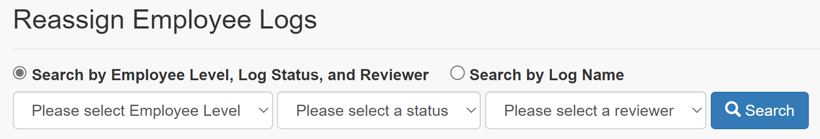

**Search by Employee Level, Log Status, and Reviewer:**

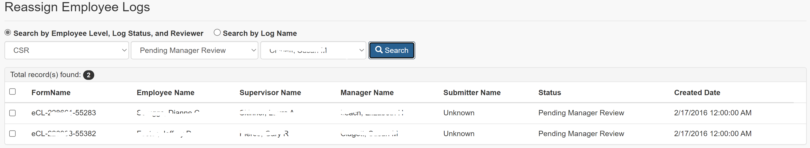

**Search by Log Name:**

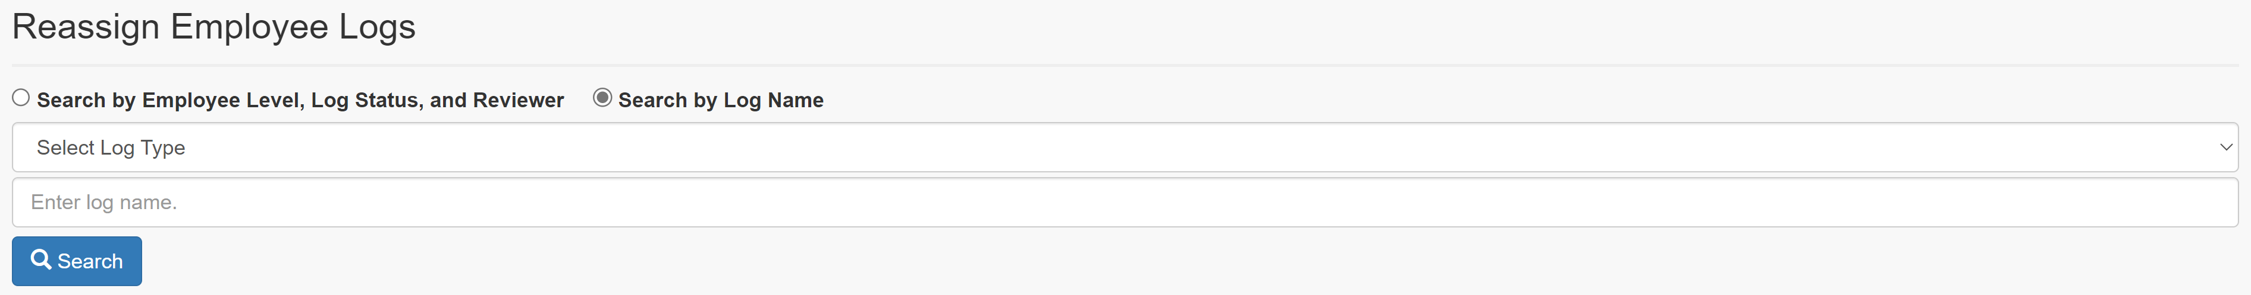

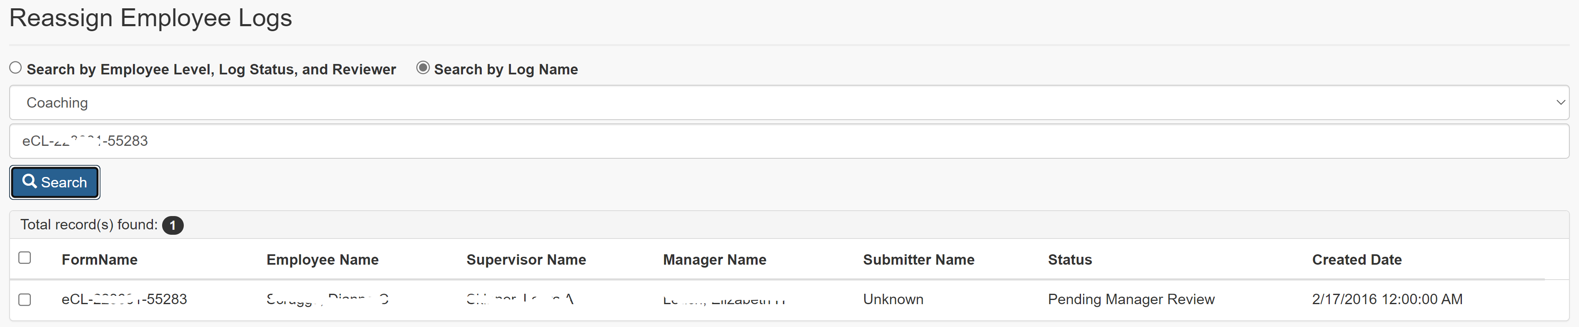

**Reassign Employee Logs:**

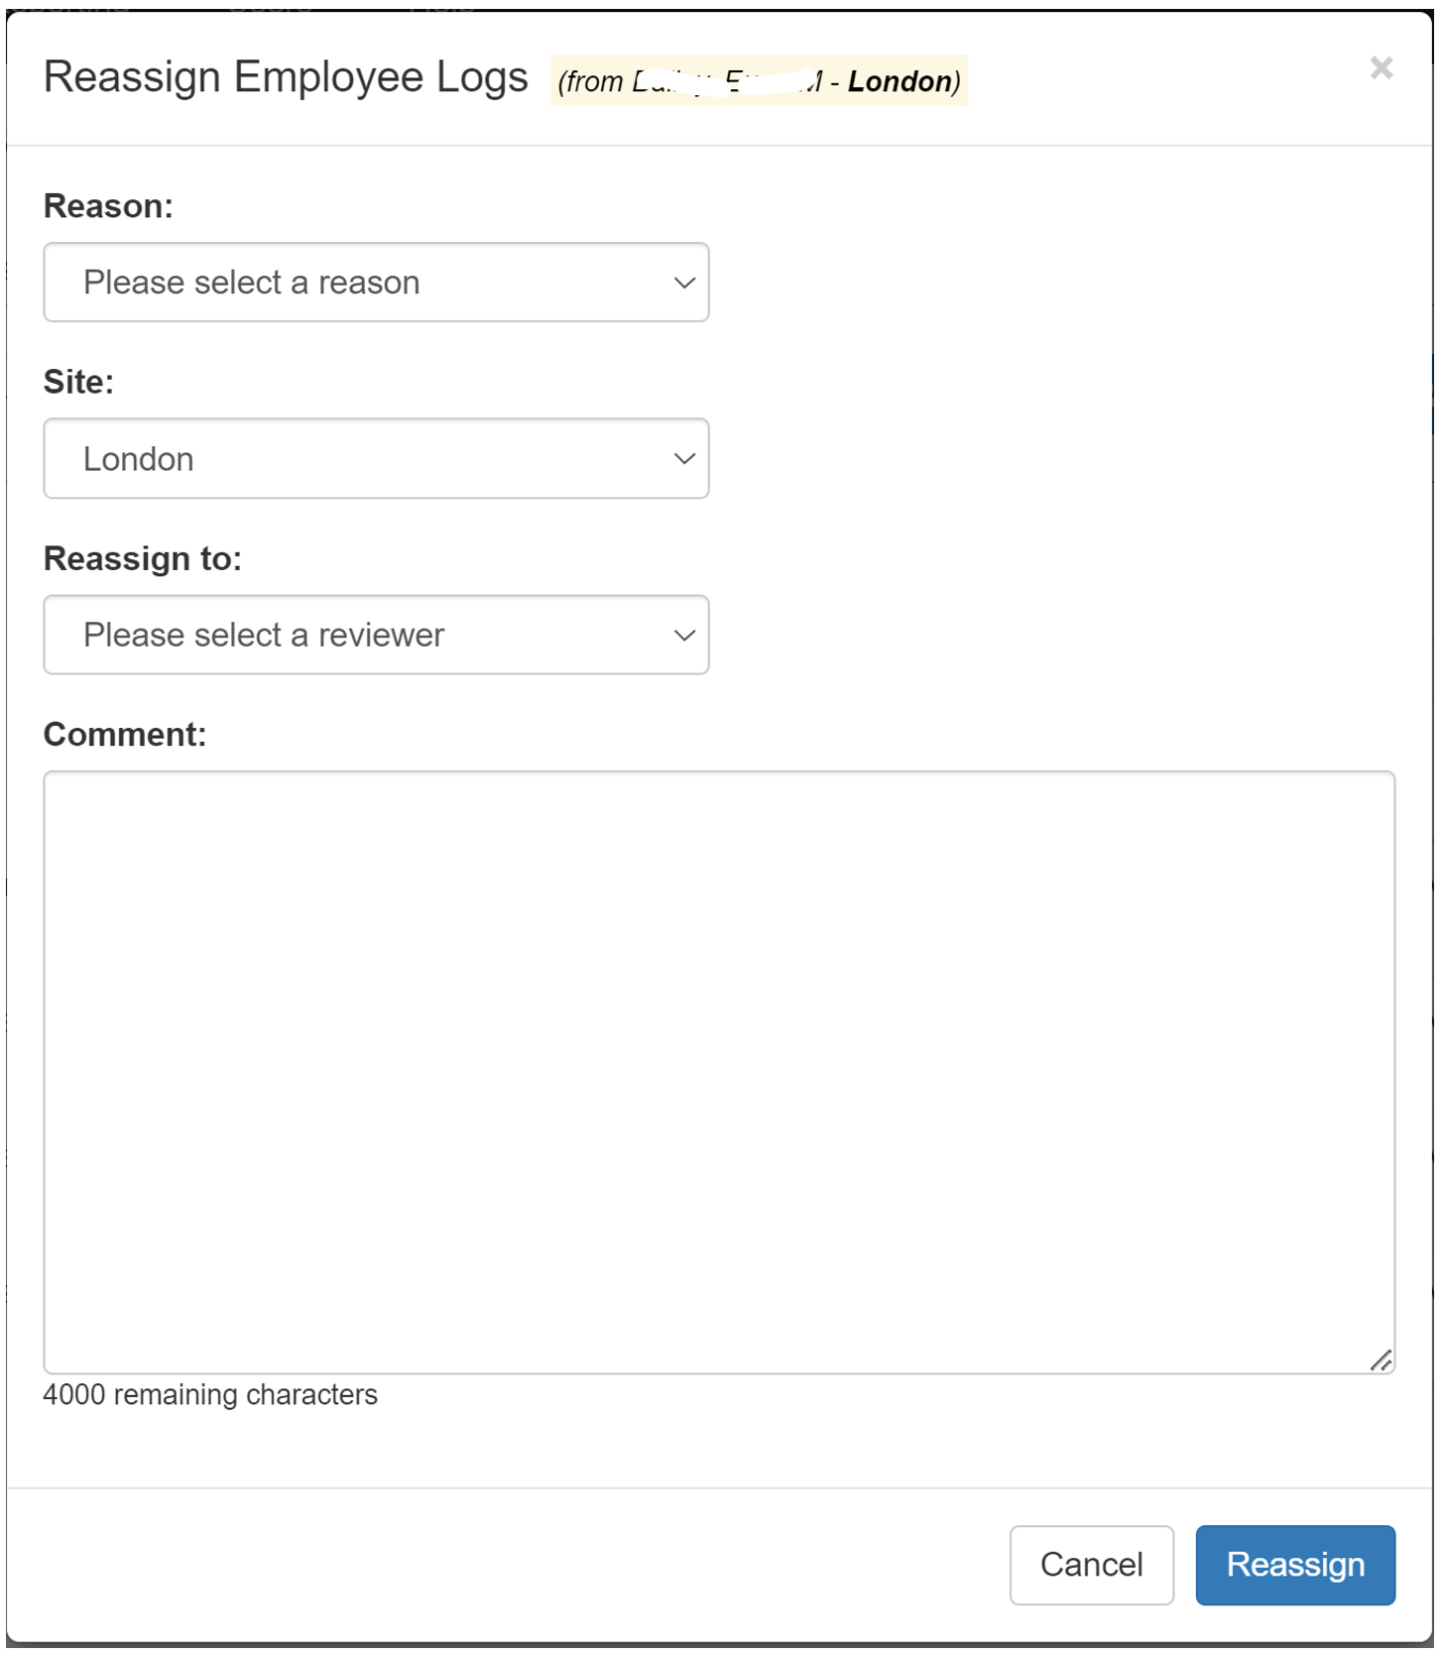

* + 1. Links

None

* + 1. Web Page Invoked Events

| Action | Processing & Result | |
| --- | --- | --- |
| Click Radio button “Search by Log Type, Employee Level, and Employee” | Javascript:  Display Search by Log Type, Employee Level, and Employee; |
| Click Radio button “Search by Log Name” | Javascript:  Display Search by Log Name; |
| Select Employee Level from “Employee Level:” dropdown list | An ajax call is made to get all pending statuses for the selected Employee Level.  Controller: EmployeeLog  Action: GetPendingStatuses | |
| Select a status from “Status:” dropdown list | An ajax call is made to get all pending reviewers for the selected Employee Level and status.  Controller: EmployeeLog;  Action: GetPendingReviewers  “Pending Reviewer:” dropdown will be populated with the result from the ajax call. | |
| Select a reviewer from “Pending Reviewer:” dropdown  Click on “Search” button | An ajax call is posted back with selected Employee Level, status, reviewer, and log name:  Controller: EmployeeLog  Action: SearchForReassign [HttpPost] | |
| Check/Uncheck any log(s) from the search result. | Javascript hideShowReassignLink() is called to show/hide “Reassign” link button.  If more than one log selected, “Reassign” link button displays. Otherwise, “Reassign” link button hides. | |
| Click on “Reassign” link button | jQuery $(‘body’).on(‘click’, ‘.modal-link’) function is called.  “Reassign Employee Logs” modal dialog displays. | |
| Select a reason from “Reason:” dropdown list | If the selected reason is “Other”, a text box displays. | |
| Select a site from “Site:” dropdown list | An ajax call is posted back with the following data:  Selected Site Id.  Controller: EmployeeLog  Action: GetReviewersBySite  “Reassign To:” dropdown will be populated with the reviewers from the selected site. | |
| Click on “Reassign” button (modal dialog). | An ajax call is posted back with the following data:  Selected Log Ids;  Selected reason id;  Other reason text entered;  Employee Id assigned to;  Comment entered.  Controller: EmployeeLog  Action: Reassign [HttpPost]  “Reassign Employee Logs” modal dialog closes.  A message will display to indicate if the reassignment is successful.  If success:  Success message (“The selected logs have been successfully reassigned.”) will be displayed. Searched result will hide and all the three dropdowns (Employee Level, Status, and Pending Reviewer) will reset to default values.  Otherwise:  Fail message (“Failed to reassign the selected logs.”) will display. | |

* + 1. Form Fields

|  |  |  |  |  |  |
| --- | --- | --- | --- | --- | --- |
| **Page Name** | **Field Type** | **Field Name** | **Default Value** | **Data Element Source** | **Validation** |
| _SearchOption.cshtml  SearchForReassign.cshtml | Radio Btn | searchType | “default” | “Search By Log Type, Employee Level, and Employee”;  “Search by Log Name” |  |
| DropDownList | module | -1 | AT_Module_Access |  |
| DropDownList | employeeLogStatus | -1 | AT_Reassign_Status_For_Module |  |
| DropDownList | employee | -1 | Employee_Hierarchy |  |
| Start display Search Result: | | | | | |
| _SearchEmployeeLogResultPartial.cshtml | Label |  | Total record(s) found: |  |  |
| Label |  |  | EmployeeLogSelectViewModel.EmployeeLogs.Count |  |
| Checkbox | checkall | unchecked |  |  |
| Label |  | FormName |  |  |
| Label |  | Employee Name |  |  |
| Label |  | Supervisor Name |  |  |
| Label |  | Manager Name |  |  |
| Label |  | Submitter Name |  |  |
| Label |  | Status |  |  |
| Label |  | Created Date |  |  |
| Repeat for each log returned: |  |  |  |  |  |
| EmployeeLogSelectEditorViewModel.cshtml | Checkbox | EmployeeLogs[i].Selected | unchecked |  |  |
| Text |  |  | Coaching_Log.FormName if selected Type is “Coaching”  Or  Warning_Log.FormName if selected Type is “Warning” |  |
| Text |  |  | Employee_Hierarchy.Emp_Name |  |
| Text |  |  | Employee_Hierarchy.Sup_Name |  |
| Text |  |  | Employee_Hierarchy.Mgr_Name |  |
| Text |  |  | Employee_Hierarchy.Mgr_Name |  |
| Text |  |  | Employee_Hierarchy.Emp_Name  (Employee_Hierarchy.Emp_ID = Coaching_log.SubmitterID or Warning_Log.SubmitterID) |  |
| Text |  |  | DIM_Status.Status |  |
| Text |  |  | Coaching_Log.SubmittedDate if selected Type is “Coaching”  Or  Warning_Log.SubmittedDate |  |
| Hidden | EmployeeLogs[i].ID |  | Coaching_Log.CoachingID if selected Type is “Coaching”  Or  Warning_Log.WarningID if selected Type is “Warning” |  |
| Hidden | EmployeeLogs[i].FormName |  | Coaching_Log.FormName if selected Type is “Coaching”  Or  Warning_Log.FormName if selected Type is “Warning” |  |
| Hidden | EmployeeLogs[i].StatusId |  | Coaching_Log.StatusId if selected Type is “Coaching”  Or  Warning_Log.StatusId if selected Type is “Warning” |  |
| Hidden | EmployeeLogs[i].PreviousStatusId |  | AT_Coaching_Inactivate_Reactivate_Audit.LastKnownStatus |  |
| End of “Repeat for each log returned:” |  |  |  |  |  |
| End of “Start display Search Result:” | | | | | |
| _ReassignPartial.cshtml | Label |  | Reason: |  |  |
| DropDownList | reason | -1 | AT_Action_Reasons |  |
| TextArea |  | otherreason |  |  |
| Label |  | Site: |  |  |
| DropDownList | site | Current reviewer’s site id |  |  |
| Label |  | Reassign to: |  |  |
| DropDownList | assignTo | -1 | Employee_Hierarchy |  |
| Label |  | Comment: |  |  |
| TextArea | comment |  |  |  |

* 1. Reactivate Employee Logs (Views\EmployeeLog\SearchForReactivate.cshtml)
     1. Razor pages comprising Web Page

EmployeeLogSelectEditorViewModel.cshtml

_SearchEmployeeLogResultPartial.cshtml

_ReactivatePartial.cshtml

_SearchOption.cshtml

_SearchByLogName.cshtml

_ReasonPartial.cshtml

_CommentPartial.cshtml

* + 1. Layout Page

Views\Shared\_Layoutcshtml

* + 1. Screenshot

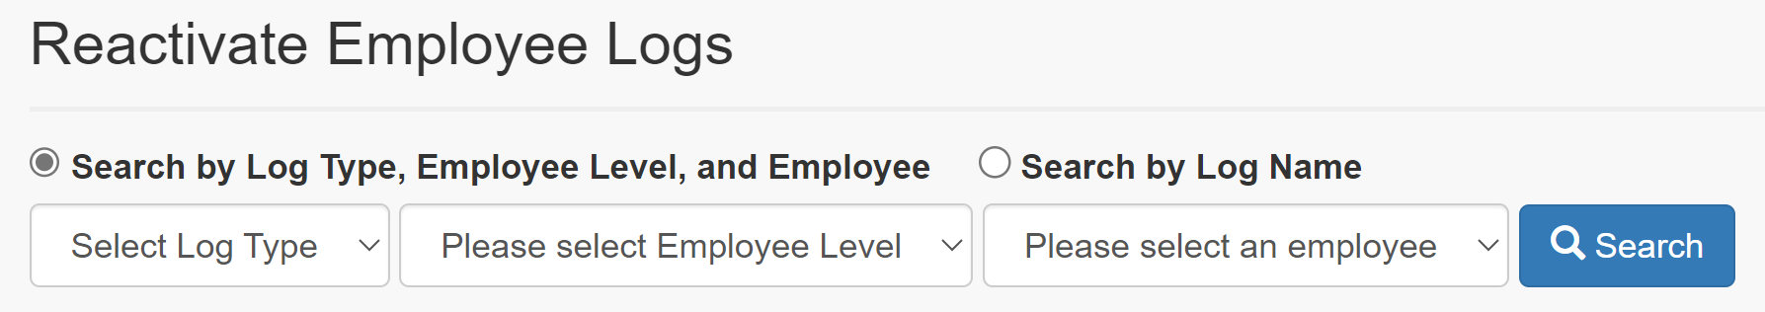

**Search by Log Type, Employee Level, and Employee:**

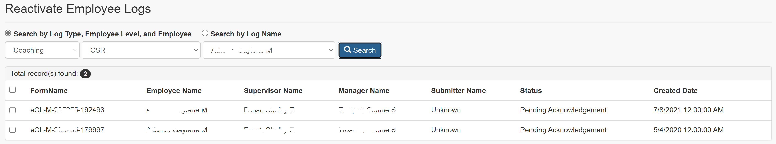

**Search by Log Name:**

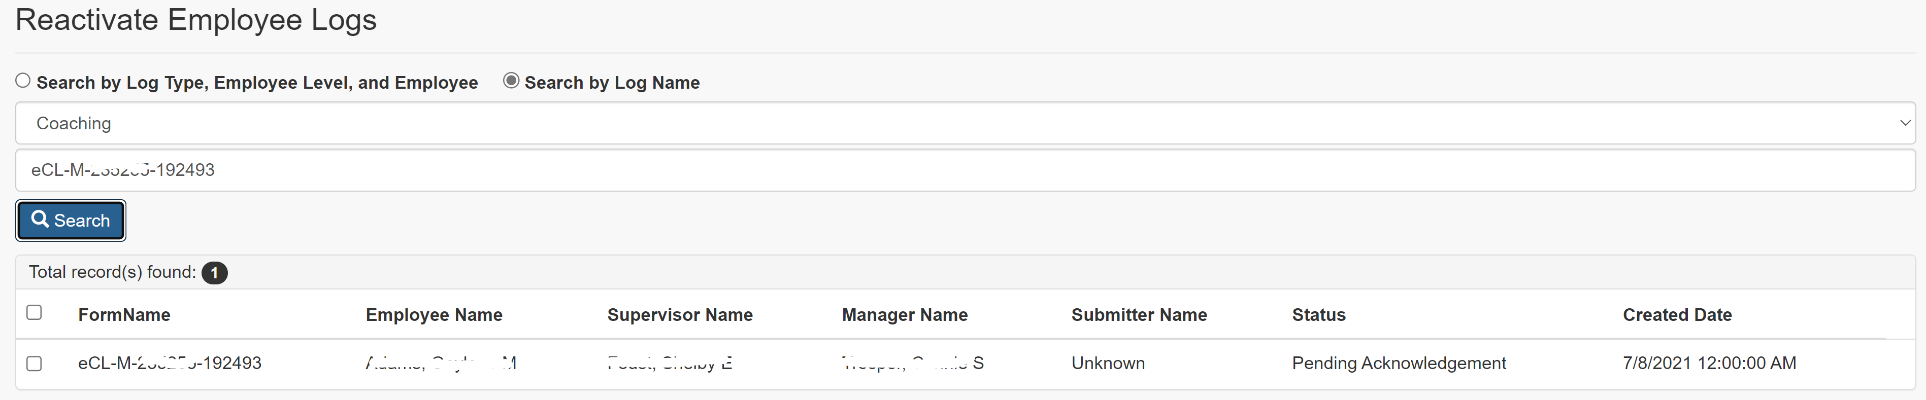

**Reactivate Employee Logs:**

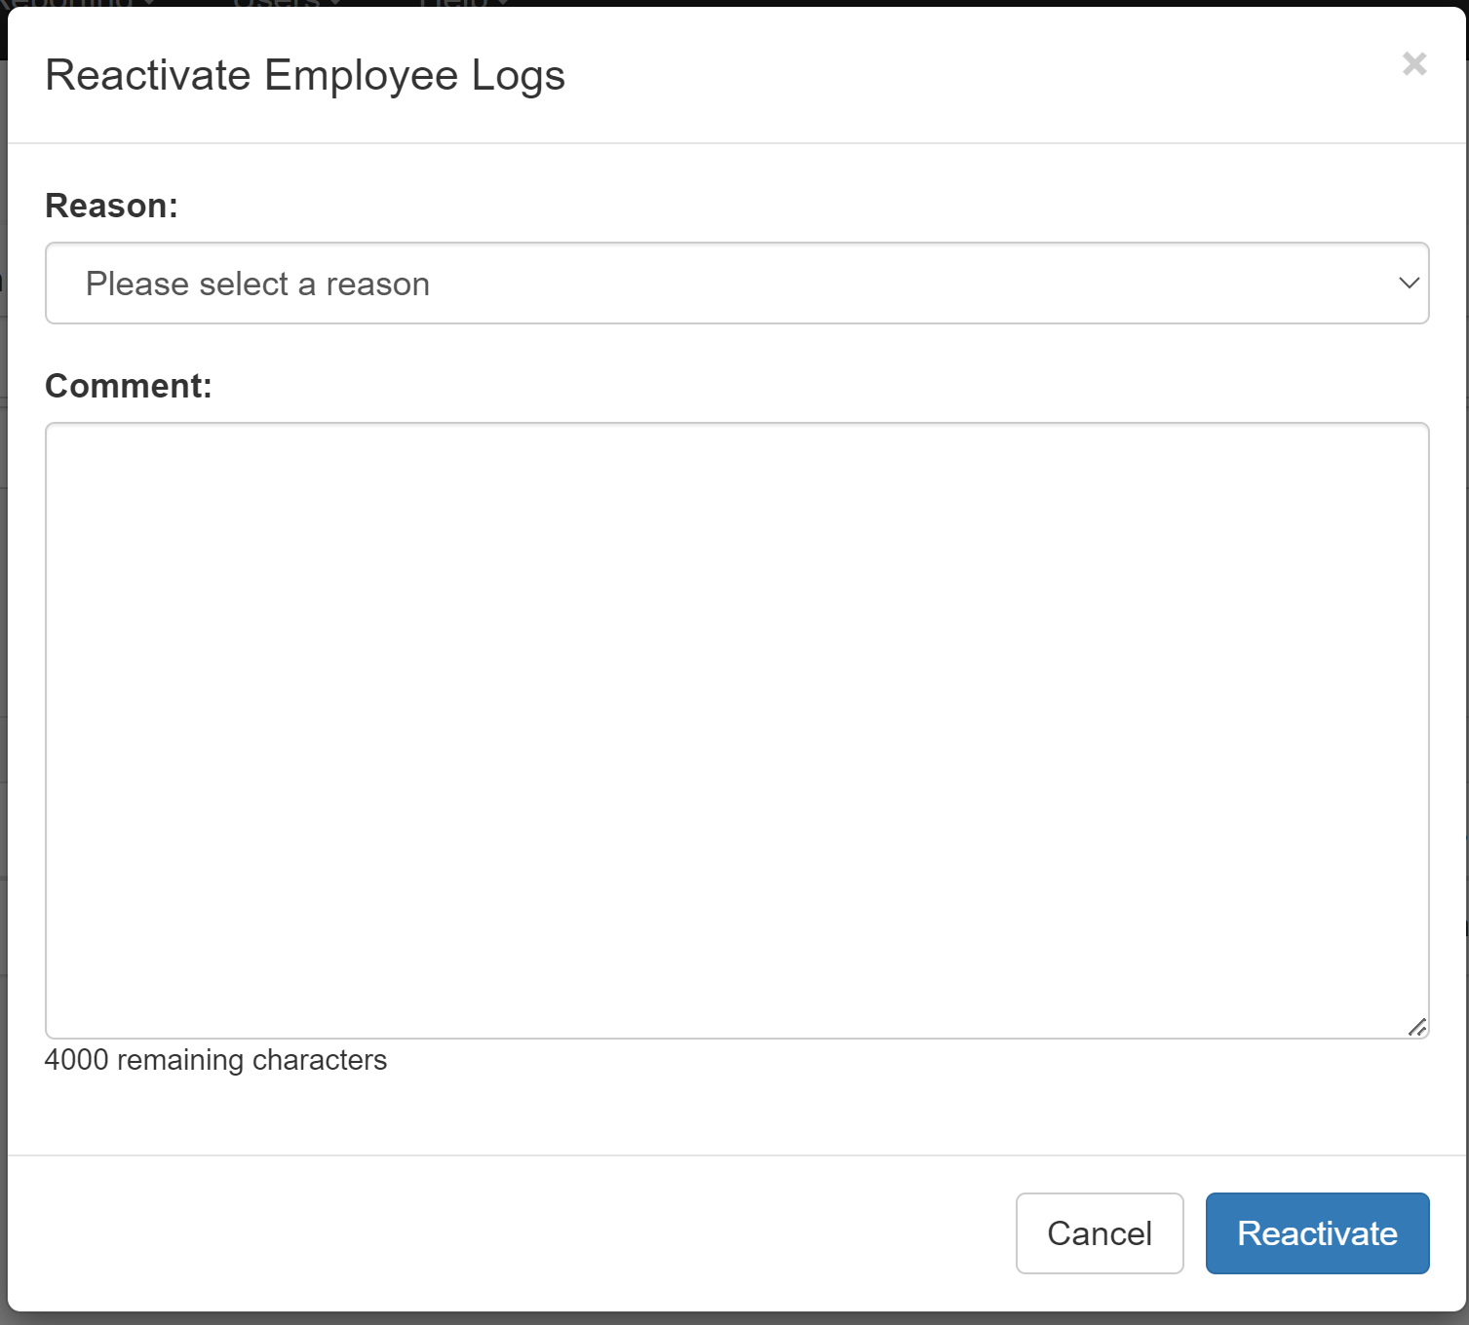

* + 1. Links

None

* + 1. Web Page Invoked Events

| Action | Processing & Result | |
| --- | --- | --- |
| Click Radio button “Search by Log Type, Employee Level, and Employee” | Javascript:  Display Search by Log Type, Employee Level, and Employee; |
| Click Radio button “Search by Log Name” | Javascript:  Display Search by Log Name; |
| Select Employee Level from “Employee Level:” dropdown list | If a type is already selected, an ajax call is made to get all the employees having active logs with the selected Employee Level and log type.  Controller: EmployeeLog  Action: GetEmployees  “Employee:” dropdown will be populated with the employees returned from the above ajax call. | |
| Select a type from “Type:” dropdown list | If a type is already selected, an ajax call is made to get all the employees having active logs with the selected Employee Level and log type.  Controller: EmployeeLog;  Action: GetEmployees  “Employee:” dropdown will be populated with the employees returned from the above ajax call. | |
| Select an employee from “Employee” dropdown  Click on “Search” button | An ajax call is posted back with selected Employee Level, type, employee, and log name.  Controller: EmployeeLog  Action: SearchForReactivate [HttpPost] | |
| Check/Uncheck any log(s) from the search result. | Javascript hideShowInactivateLink() is called to show/hide “Inactivate” link button.  If more than one log selected, “Reactivate” link button displays. Otherwise, “Reactivate” link button hides. | |
| Click on “Reactivate” link button | jQuery $(‘body’).on(‘click’, ‘.modal-link’) function is called.  “Reactivate Employee Logs” modal dialog displays. | |
| Select a reason from “Reason:” dropdown list | If the selected reason is “Other”, a text box displays. | |
| Click on “Reactivate” button (modal dialog). | An ajax call is posted back with the following data:  Selected Log Ids;  Selected reason id;  Other reason text entered;  Comment entered.  Controller: EmployeeLog  Action: Reactivate [HttpPost]  “Reactivate Employee Logs” modal dialog closes.  A message will display to indicate if the reactivation is successful.  If success:  Success message (“The selected logs have been successfully reactivated.”) will be displayed. Searched result will hide and all the three dropdowns (Employee Level, Type, and Employee) will be reset to default values.  Otherwise:  Fail message (“Failed to reactivate the selected logs.”) will display. | |

* + 1. Form Fields

|  |  |  |  |  |  |
| --- | --- | --- | --- | --- | --- |
| **Page Name** | **Field Type** | **Field Name** | **Default Value** | **Data Element Source** | **Validation** |
| _SearchOption.cshtml  SearchForReactivate.cshtml | Radio Btn | searchType | “default” | “Search By Log Type, Employee Level, and Employee”;  “Search by Log Name” |  |
| DropDownList | module | -1 | AT_Module_Access |  |
| DropDownList | logType | -1 |  |  |
| DropDownList | employee | -1 | Employee_Hierarchy |  |
| Start display Search Result: | | | | | |
| _SearchEmployeeLogResultPartial.cshtml | Label |  | Total record(s) found: |  |  |
| Label |  |  | EmployeeLogSelectViewModel.EmployeeLogs.Count |  |
| Checkbox | checkall | unchecked |  |  |
| Label |  | FormName |  |  |
| Label |  | Employee Name |  |  |
| Label |  | Supervisor Name |  |  |
| Label |  | Manager Name |  |  |
| Label |  | Submitter Name |  |  |
| Label |  | Status |  |  |
| Label |  | Created Date |  |  |
| Repeat for each log returned: |  |  |  |  |  |
| EmployeeLogSelectEditorViewModel.cshtml | Checkbox | EmployeeLogs[i].Selected | unchecked |  |  |
| Text |  |  | Coaching_Log.FormName if selected Type is “Coaching”  Or  Warning_Log.FormName if selected Type is “Warning” |  |
| Text |  |  | Employee_Hierarchy.Emp_Name |  |
| Text |  |  | Employee_Hierarchy.Sup_Name |  |
| Text |  |  | Employee_Hierarchy.Mgr_Name |  |
| Text |  |  | Employee_Hierarchy.Mgr_Name |  |
| Text |  |  | Employee_Hierarchy.Emp_Name  (Employee_Hierarchy.Emp_ID = Coaching_log.SubmitterID or Warning_Log.SubmitterID) |  |
| Text |  |  | DIM_Status.Status |  |
| Text |  |  | Coaching_Log.SubmittedDate if selected Type is “Coaching”  Or  Warning_Log.SubmittedDate |  |
| Hidden | EmployeeLogs[i].ID |  | Coaching_Log.CoachingID if selected Type is “Coaching”  Or  Warning_Log.WarningID if selected Type is “Warning” |  |
| Hidden | EmployeeLogs[i].FormName |  | Coaching_Log.FormName if selected Type is “Coaching”  Or  Warning_Log.FormName if selected Type is “Warning” |  |
| Hidden | EmployeeLogs[i].StatusId |  | Coaching_Log.StatusId if selected Type is “Coaching”  Or  Warning_Log.StatusId if selected Type is “Warning” |  |
| Hidden | EmployeeLogs[i].PreviousStatusId |  | AT_Coaching_Inactivate_Reactivate_Audit.LastKnownStatus |  |
| End of “Repeat for each log returned:” |  |  |  |  |  |
| End of “Start display Search Result:” | | | | | |
| _ReactivatePartial.cshtml | Label |  | Reason: |  |  |
| DropDownList | reason | -1 | AT_Action_Reasons |  |
| Label |  | Comment: |  |  |
| TextArea | comment |  |  |  |

3. 4. Delete Employee Logs (Views\EmployeeLog\SearchForDelete.cshtml)
      1. Razor pages comprising Web Page

SearchForDelete.cshtml

_LogsForDeletePartial.cshtml

_CoachingDetail.cshtml

_WarningDetail.cshtml

_Delete.cshtml

* + 1. Layout Page

Views\Shared\_Layoutcshtml

* + 1. Screenshot



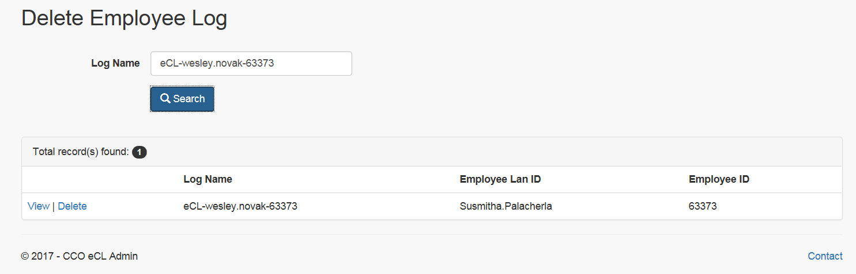

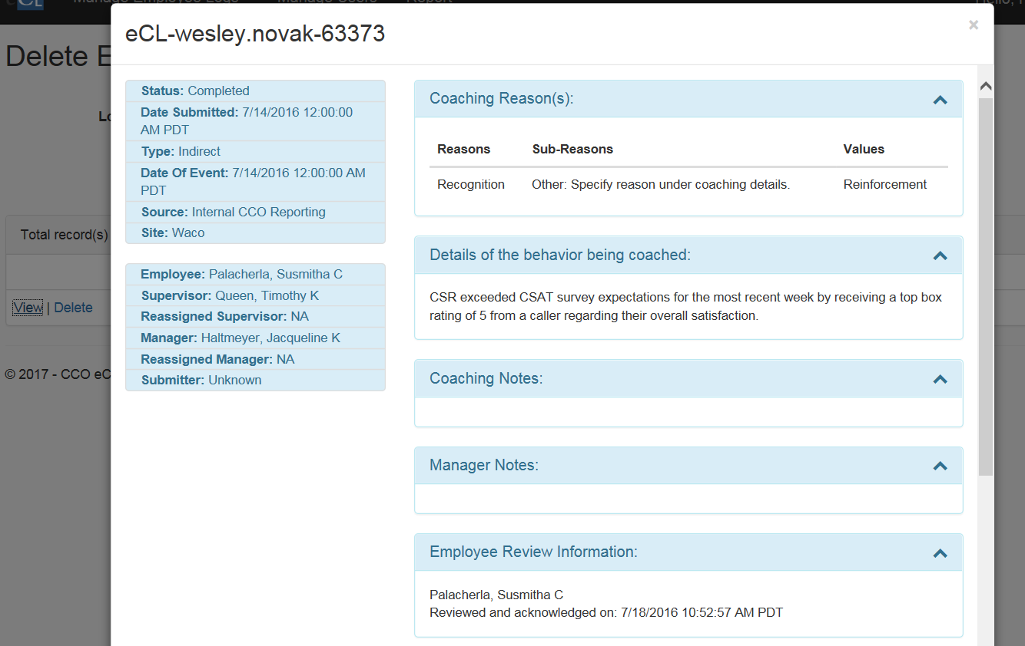

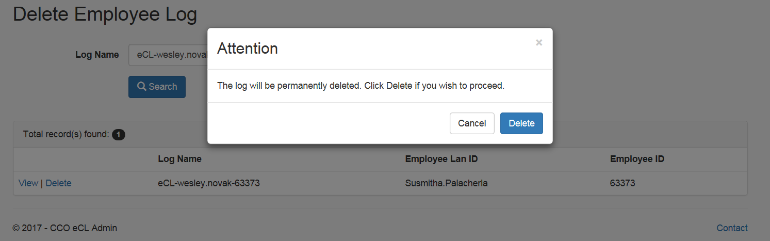

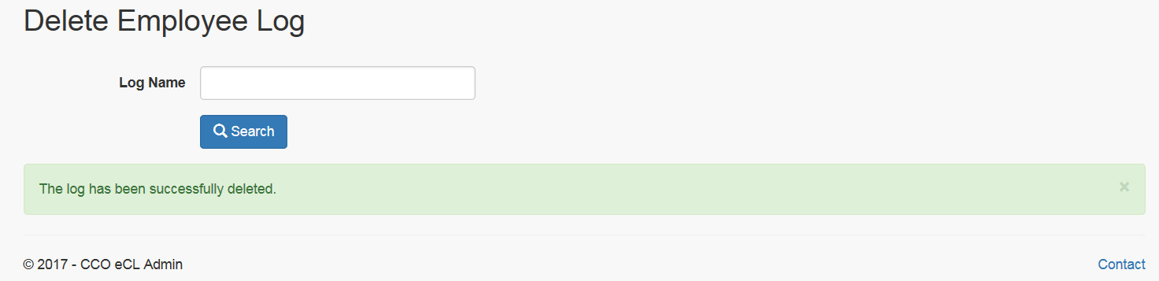

* + 1. Links

None

* + 1. Web Page Invoked Events

| Action | Processing & Result |
| --- | --- |
| Enter log name in Log Name textbox;  Click on “Search” button | An ajax call is posted back with the log name:  Controller: EmployeeLog  Action: SearchForDelete [HttpPost]  The log(s) found will be displayed. |
| Click “View” in the search result. | An ajax call is posted back with the following data:  Log Id  IsCoaching  Controller: EmployeeLog  Action: ViewLogDetail  The log detail displays in a modal popup dialog. |
| Click “Delete” in the search result. | An ajax call is posted back with the following data:  logId  isCoaching  Delete confirmation modal dialog displays. |
| Click “Delete” button in the confirmation modal dialog. | An ajax call is posted back with the following data:  Log Id  IsCoaching  Controller: EmployeeLog  Action: Delete  If successfully deleted, “The log has been successfully deleted.” Will be displayed on the Search page;  Otherwise, “Failed to delete the log.” Will be displayed on the Search page. |

* + 1. Form Fields

|  |  |  |  |  |  |
| --- | --- | --- | --- | --- | --- |
| **Page Name** | **Field Type** | **Field Name** | **Default Value** | **Data Element Source** | **Validation** |
| SearchForDelete.cshtml | Label |  | Log Name: |  |  |
| TextBox |  |  |  |  |
| Start display Search Result: | | | | | |
| _LogsForDeletePartial.cshtml | Label |  | Total record(s) found: |  |  |
| Label |  |  | @Model.Count() |  |
| Label |  | Log Name |  |  |
| Label |  | Employee Lan ID |  |  |
| Label |  | Employee ID |  |  |
| Repeat for each log returned: |  |  |  |  |  |
|  | @Html.ActionLink |  | View |  |  |
| @Html.ActionLink |  | Delete |  |  |
| Text |  |  | Coaching_Log.FormName |  |
| Text |  |  | Coaching_Log.EmpLanID |  |
| Text |  |  | Coaching_Log.SourceID |  |
| End of “Repeat for each log returned:” |  |  |  |  |  |
| End of “Start display Search Result:” | | | | | |
| _CoachingDetail.cshtml | Refer to CCO_eCoaching_Admin_Dashboard_DD 3.1.6 Form Fields | | | | |
| _WarningDetail.cshtml | Refer to CCO_eCoaching_Admin_Dashboard_DD 3.1.6 Form Fields | | | | |