________________________

[MAXIMUS logo](https://www.maximus.com/)

Detail Design: CCO eCoaching Log Activity Report

Prepared by: Lili Huang Date: 07/25/2023

Department:

Change History Log

| Date | Change Description | Author |
| --- | --- | --- |
| 07/25/2023 | Initial Revision  TFS 26819 – Replace SSRS reports with MVC/DataTables. | Lili Huang |

Table of Contents

**1.** **Description** 4

2. **Screenshot** 4

3. **Page Element / Data Source** 4

4. **Report Column** 4

1. **Description**

It provides the functionality for designated users to generate the report of coaching and warning logs inactivation, reactivation and reassignment activity based on the following search criteria.

* Start Date (*log submitted date*)
* End Date (*log submitted date*)
* Log Type
* Action
* Log Name or Employee Name

1. **Screenshot**



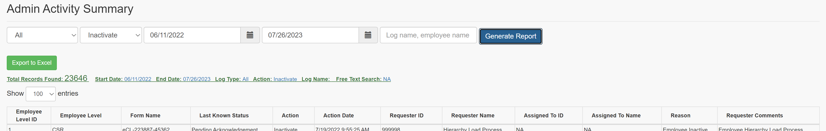

1. **Page Element / Data Source**

|  |  |  |
| --- | --- | --- |
| Element | Data Source | Comment |
| Activity Start Date | User selects/enters | required |
| Activity End Date | User selects/enters | required |
| Log Type | All  Coaching  Warning | required |
| Action | sp_rptGetActionsforAdminType | required |
| Log Name or Employee Name | User enters | optional |
|  | | |
| Report/Log List | sp_rptAdminActivitySummary |  |
| Export to Excel | sp_rptAdminActivitySummary |  |

1. **Report Column**

Refer to CCO_eCoaching_Log_FS.docx Appendix 7.0 for details.