________________________

[MAXIMUS logo](https://www.maximus.com/)

Detail Design: CCO eCoaching Coaching Log Report

Prepared by: Lili Huang Date: 07/25/2023

Department:

Change History Log

| Date | Change Description | Author |
| --- | --- | --- |
| 07/25/2023 | Initial Revision  TFS 26819 – Replace SSRS reports with MVC/DataTables. | Lili Huang |

Table of Contents

**1.** **Description** 4

2. **Screenshot** 4

3. **Page Element / Data Source** 4

4. **Report Column** 4

1. **Description**

It provides the functionality for designated users to generate coaching log report and export the report to excel file based on the following search criteria:

* Start Date (*log submitted date*)
* End Date (*log submitted date*)
* Hire Date
* Employee Level
* Site
* Employee
* Coaching Reason
* Coaching Sub Reason
* Log Status

1. **Screenshot**



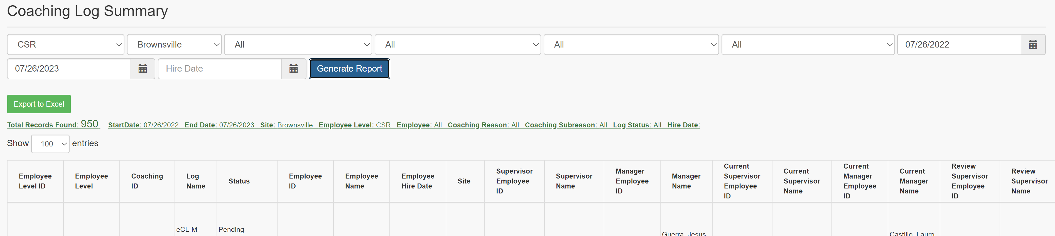

1. **Page Element / Data Source**

|  |  |  |
| --- | --- | --- |
| Element | Data Source | Comment |
| Submission Start Date | User selects/enters | required |
| Submission End Date | User selects/enters | required |
| Employee Level | sp_rptModulesByRole | required |
| Site | sp_rptSitesByRole | required |
| Employee | sp_rptCoachingEmployeesBySiteAndModule | required  *When “All” is selected as Site, Employee dropdown has “All Employees” as the only option.* |
| Coaching Reason | sp_rptCoachingReason | required |
| Coaching Subreason | sp_rptCoachingSubreason | required |
| Log Status | sp_rptLogStatusByModuleId | required |
| Hire Date | User selects/enters | optional |
|  | | |
| Report/Log List | sp_rptCoachingSummary |  |
| Export to Excel | sp_rptCoachingSummary |  |

1. **Report Column**

Refer to CCO_eCoaching_Log_FS.docx Appendix 7.0 for details.