________________________



Detail Design: CCO eCoaching Admin Report

________________________

Prepared by: Lili Huang Date: 03/16/2017

Department: HCSD

Change History Log

| Date | Change Description | Author |
| --- | --- | --- |
| 03/16/2017 | Initial Revision  TFS 5904 – Create infrastructure within eCL Admin Tool to allow for reporting;  TFS 5908 – Create Summary eCoaching Reports. | Lili Huang |
| 04/08/2019 | TFS 13333 – Add Quality Now Coaching Log Summary Report; | Lili Huang |

Table of Contents

**1.** **Description** 4

**2.** **Controllers** 4

2.1. ReportController.cs 4

2.1.1. GetReportInfo 4

2.1.2. RunCoachingSummary action 4

2.1.3. RunCoachingSummaryQN action 4

2.1.4. RunWarningSummary action 4

2.1.5. RunHierarchySummary action 4

2.1.6. RunAdminActivitySummary action 4

**3.** **Page details** 4

3.1. Coaching Log Summary (Views\Report\ReportTemplate.cshtml) 4

3.1.1. Razor pages comprising Web Page 4

3.1.2. Layout Page 4

3.1.3. Screenshot 4

3.1.4. Links 5

3.1.5. Web Page Invoked Events 5

3.1.6. Form Fields 5

3.2. Quality Now Coaching Log Summary (Views\Report\ReportTemplate.cshtml) 5

3.2.1. Razor pages comprising Web Page 5

3.2.2. Layout Page 5

3.2.3. Screenshot 5

3.2.4. Links 6

3.2.5. Web Page Invoked Events 6

3.2.6. Form Fields 6

3.3. Warning Log Summary (Views\Report\ReportTemplate.cshtml) 6

3.3.1. Razor pages comprising Web Page 6

3.3.2. Layout Page 6

3.3.3. Screenshot 6

3.3.4. Links 6

3.3.5. Web Page Invoked Events 6

3.3.6. Form Fields 6

3.4. Hierarchy Summary (Views\Report\ReportTemplate.cshtml) 6

3.4.1. Razor pages comprising Web Page 6

3.4.2. Layout Page 6

3.4.3. Screenshot 6

3.4.4. Links 7

3.4.5. Web Page Invoked Events 7

3.4.6. Form Fields 7

3.5. Admin Activity Summary (Views\Report\ReportTemplate.cshtml) 7

3.5.1. Razor pages comprising Web Page 7

3.5.2. Layout Page 7

3.5.3. Screenshot 7

3.5.4. Links 8

3.5.5. Web Page Invoked Events 8

3.5.6. Form Fields 8

1. **Description**

This document covers the reporting function.

1. **Controllers**
   1. ReportController.cs
      1. GetReportInfo

Create a ReportInfo object using the parameters passed in;

Return the ReportInfo object created.

* + 1. RunCoachingSummary action

Call GetReportInfo passing in report name, report description, report width, and report height to get the ReportInfo object;

Return ReportTemplate.cshtml with the ReportInfo object.

* + 1. RunCoachingSummaryQN action

Call GetReportInfo passing in report name, report description, report width, and report height to get the ReportInfo object;

Return ReportTemplate.cshtml with the ReportInfo object.

* + 1. RunWarningSummary action

Call GetReportInfo passing in report name, report description, report width, and report height to get the ReportInfo object;

Return ReportTemplate.cshtml with the ReportInfo object.

* + 1. RunHierarchySummary action

Call GetReportInfo passing in report name, report description, report width, and report height to get the ReportInfo object;

Return ReportTemplate.cshtml with the ReportInfo object.

* + 1. RunAdminActivitySummary action

Call GetReportInfo passing in report name, report description, report width, and report height to get the ReportInfo object;

Return ReportTemplate.cshtml with the ReportInfo object.

1. **Page details**
   1. Coaching Log Summary (Views\Report\ReportTemplate.cshtml)
      1. Razor pages comprising Web Page

None

* + 1. Layout Page

Views\Shared\_Layoutcshtml

* + 1. Screenshot

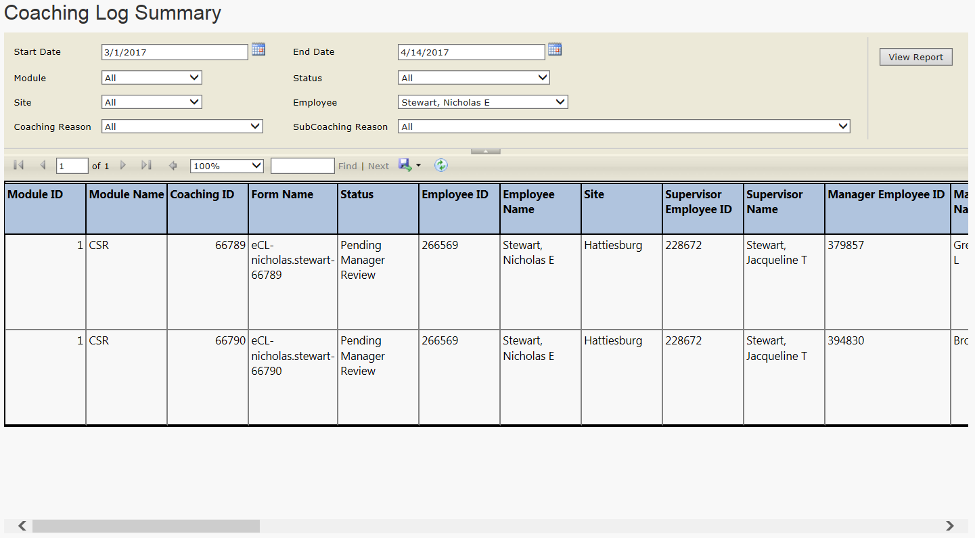

* + 1. Links

None

* + 1. Web Page Invoked Events

None

* + 1. Form Fields

None

* 1. Quality Now Coaching Log Summary (Views\Report\ReportTemplate.cshtml)
     1. Razor pages comprising Web Page

None

* + 1. Layout Page

Views\Shared\_Layoutcshtml

* + 1. Screenshot

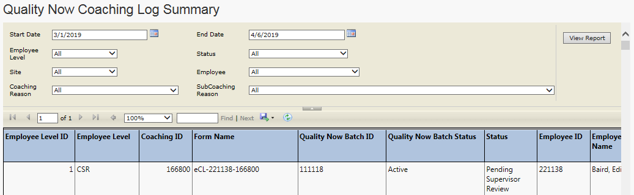

* + 1. Links

None

* + 1. Web Page Invoked Events

None

* + 1. Form Fields

None

* 1. Warning Log Summary (Views\Report\ReportTemplate.cshtml)
     1. Razor pages comprising Web Page

None

* + 1. Layout Page

Views\Shared\_Layoutcshtml

* + 1. Screenshot

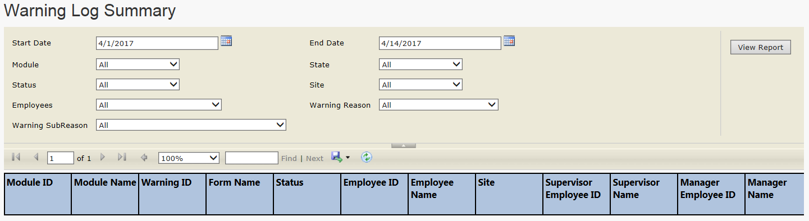

* + 1. Links

None

* + 1. Web Page Invoked Events

None

* + 1. Form Fields

None

* 1. Hierarchy Summary (Views\Report\ReportTemplate.cshtml)
     1. Razor pages comprising Web Page

None

* + 1. Layout Page

Views\Shared\_Layoutcshtml

* + 1. Screenshot

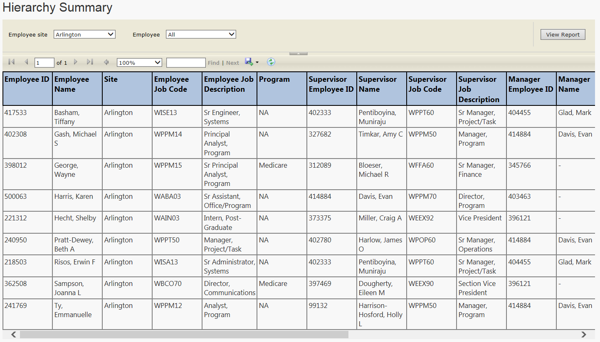

* + 1. Links

None

* + 1. Web Page Invoked Events

None

* + 1. Form Fields

None

* 1. Admin Activity Summary (Views\Report\ReportTemplate.cshtml)
     1. Razor pages comprising Web Page

None

* + 1. Layout Page

Views\Shared\_Layoutcshtml

* + 1. Screenshot

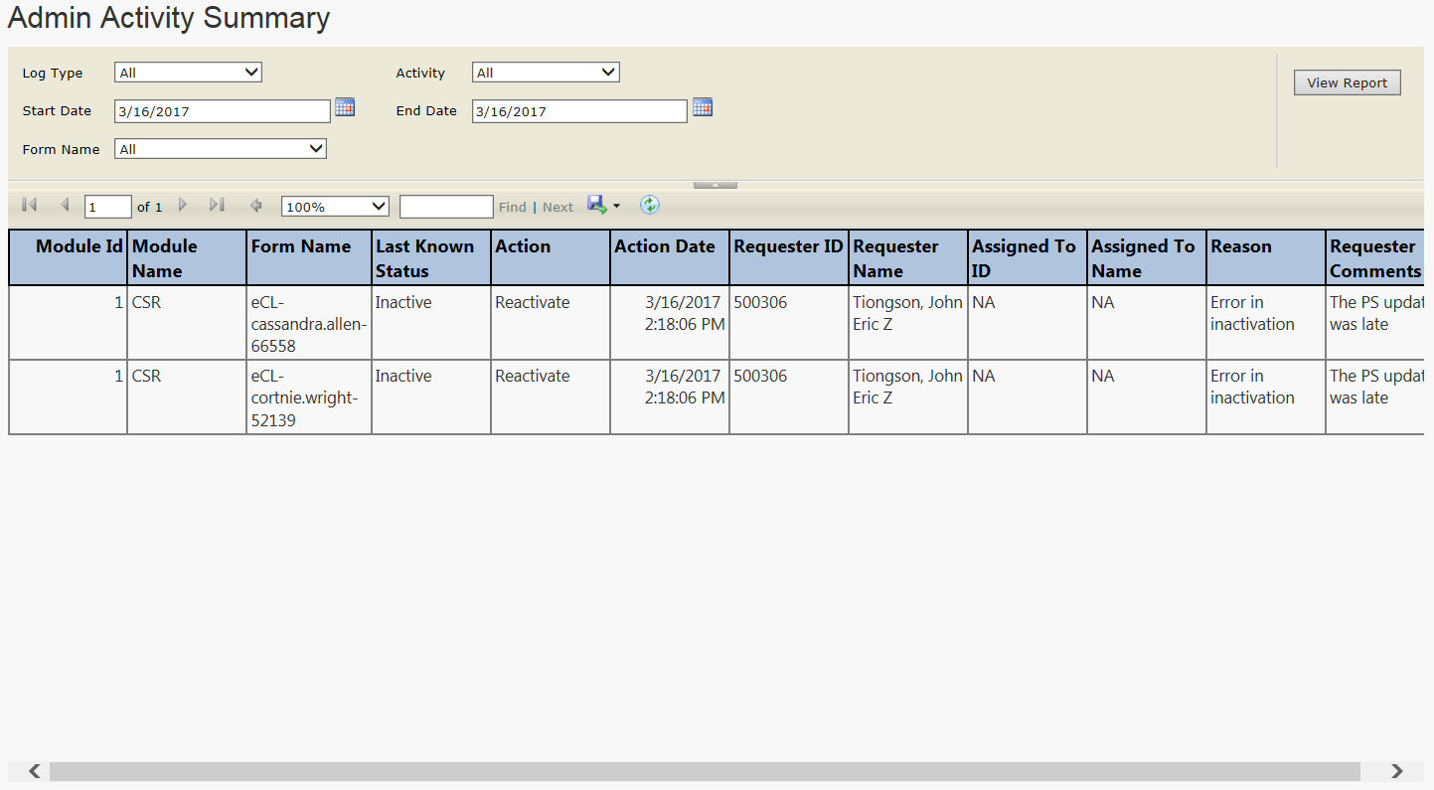

* + 1. Links

None

* + 1. Web Page Invoked Events

None

* + 1. Form Fields

None