________________________

[MAXIMUS logo](https://www.maximus.com/)

Detail Design: CCO eCoaching Hierarchy Report

Prepared by: Lili Huang Date: 12/26/2023

Department:

Change History Log

| Date | Change Description | Author |
| --- | --- | --- |
| 01/05/2024 | Initial Revision  TFS 27545 – Create Feed Load History report. | Lili Huang |

Table of Contents

**1.** **Description** 4

2. **Screenshot** 4

3. **Page Element / Data Source** 4

4. **Report Column** 4

1. **Description**

It provides the functionality for designated users to generate feed load history report and export the report to excel file based on the following search criteria.

* Start Date
* End Date
* Category
* Report Code

1. **Screenshot**

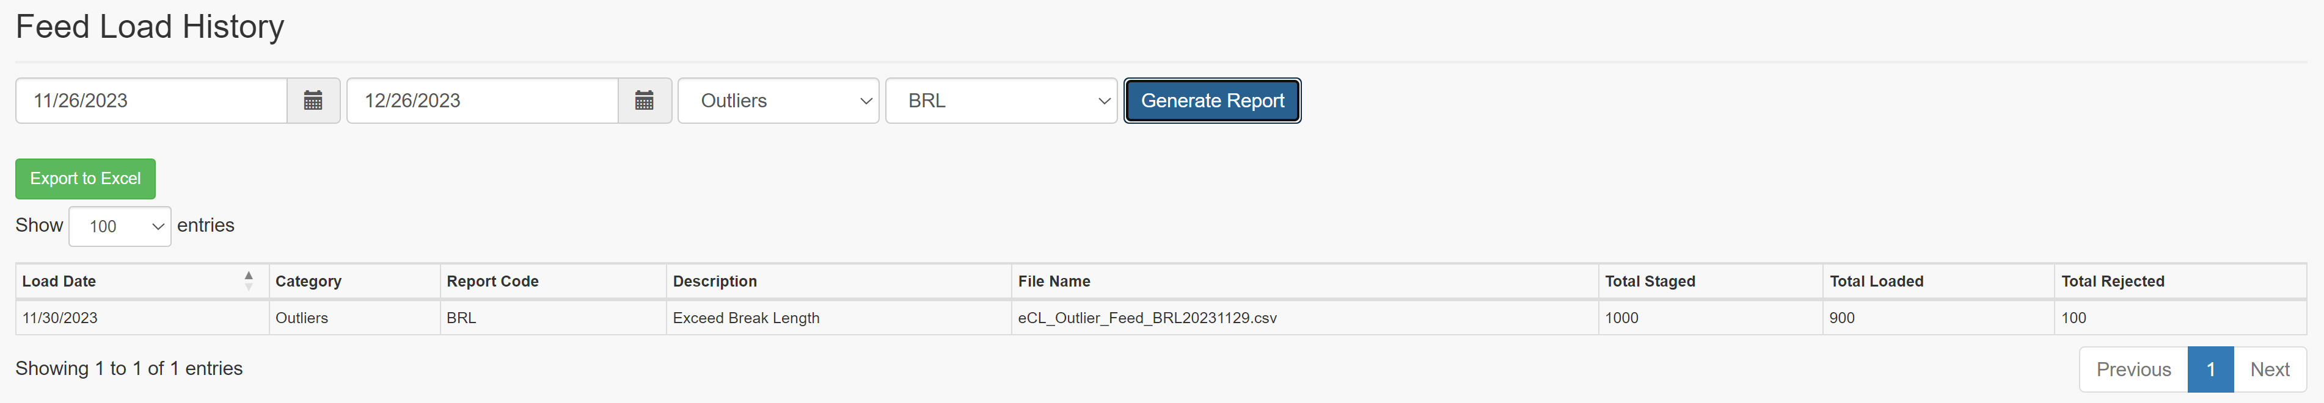

1. **Page Element / Data Source**

|  |  |  |
| --- | --- | --- |
| Element | Data Source | Comment |
| Search: | | |
| Start Date | Today minus 30 days | required |
| End Date | Today | required |
| Category | sp_Select_Report_Categories | required |
| Report Code | sp_Select_Report_Codes | required |
| Search Result: | | |
| Report/Log List | sp_SelectFrom_Feed_Load_History |  |
| Export to Excel | sp_SelectFrom_Feed_Load_History |  |

1. **Report Column**

Refer to CCO_eCoaching_Log_FS.docx Appendix 7.0 for details.