________________________

[MAXIMUS logoMAXIMUS logo](https://www.maximus.com/)

Detail Design: CCO eCoaching Admin eCoaching ACL

________________________

Prepared by: Lili Huang Date: 04/11/2017

Department: HCSD

Change History Log

| Date | Change Description | Author |
| --- | --- | --- |
| 04/11/2017 | Initial Revision – TFS 5920 | Lili Huang |
| 02/02/2024 | TFS 27695 – Subcontractors.  **Updated**  1 Description  3.1.3 Screenshot  3.2.3 Screenshot  3.2.6 Form Fields  3.3.3 Screenshot  3.3.6 Form Fields | Lili Huang |

Table of Contents

**1.** **Description** 4

**2.** **Controller** 4

2.1. UserController.cs 4

2.1.1. GetEcoachingAccessControlList action – HttpGet 4

2.1.2. InitEcoachingAccessControlDelete action - HttpPost 4

2.1.3. DeleteEcoachingAccessControl action - HttpPost 4

2.1.4. InitEcoachingAccessControlEdit action - HttpPost 4

2.1.5. UpdateEcoachingAccessControl action - HttpPost 4

2.1.6. InitEcoachingAccessControlAdd action - HttpPost 5

2.1.7. AddEcoachingAccessControl action – HttpPost 5

2.1.8. LoadUsersBySite action – HttpPost 5

**3.** **Page details** 5

3.1. List (Views\User\eCoachingAccessControlList.cshtml) 5

3.1.1. Razor pages comprising Web Page 5

3.1.2. Layout Page 5

3.1.3. Screenshot 5

3.1.4. Links 5

3.1.5. Web Page Invoked Events 5

3.1.6. Form Fields 7

3.2. Add (Views\User\_AddEcoachingAccessControl.cshtml) 8

3.2.1. Razor pages comprising Web Page 8

3.2.2. Layout Page 8

3.2.3. Screenshot 8

3.2.4. Links 9

3.2.5. Web Page Invoked Events 9

3.2.6. Form Fields 10

3.3. Edit (Views\User\_EditEcoachingAccessControl.cshtml) 11

3.3.1. Razor pages comprising Web Page 11

3.3.2. Layout Page 11

3.3.3. Screenshot 11

3.3.4. Links 12

3.3.5. Web Page Invoked Events 12

3.3.6. Form Fields 13

3.4. Delete (Views\User\_DeleteEcoachingAccessControl.cshtml) 14

3.4.1. Razor pages comprising Web Page 14

3.4.2. Layout Page 14

3.4.3. Screenshot 14

3.4.4. Links 15

3.4.5. Web Page Invoked Events 15

3.4.6. Form Fields 16

1. **Description**

This document covers the functions provided for administrators to grant eCL users special access in addition to their regular access (based on job codes) to eCL.

Roles:

* ARC
* New Submission: submit Maximus and Subcontractor CSR coaching logs
* DIR
* My Dashboard: director view
* DIRPM *new*
* My Dashboard: director view
* Historical Dashboard: view Subcontractor coaching logs, export to excel file
* DIRPMA *new*
  + My Dashboard: director view
  + Historical Dashboard: view Subcontractor coaching logs, export to excel file
  + New Submission: submit Subcontractor coaching logs
* ECL
* Historical Dashboard: view Maximus coaching logs, export to excel file
* PM *new*
* Historical Dashboard: view Subcontractor coaching logs, export to excel file
* PMA *new*
* New Submission: submit Subcontractor coaching logs
* Historical Dashboard: view Subcontractor coaching logs, export to excel file
* QAM *new*
* New Submission: submit Subcontractor coaching logs

1. **Controller**
   1. UserController.cs
      1. GetEcoachingAccessControlList action – HttpGet

Get eCoaching access control list by calling UserService.GetEcoachingAccessControlList;

Return Json result with total number of records found, total number of records filtered, and the list returned.

* + 1. InitEcoachingAccessControlDelete action - HttpPost

Get the eCoaching access control object to be deleted by row id by calling UserService.GetEcoachingAccessControl.

Return partial view _DeleteEcoachingAccessControl.cshtml with the eCoaching access control object returned from the previous step.

* + 1. DeleteEcoachingAccessControl action - HttpPost

Delete the specified record by calling UserService.DeleteEcoachingAccessControl;

Return Json result with success as true if the record has been successfully deleted; false otherwise.

* + 1. InitEcoachingAccessControlEdit action - HttpPost

Get the eCoaching access control object to be updated by row id by calling UserService.GetEcoachingAccessControl;

Return partial view _EditEcoachingAccessControl.cshtml with the eCoaching access control object returned from the previous step.

* + 1. UpdateEcoachingAccessControl action - HttpPost

Set result to “datainvalid”;

If ModelState is valid, call UserService.UpdateEcoachingAccessControl (eCoachingAccessControlViewModel) to update the record passed from the page, set result to “success” if update is successful, set result to “fail” otherwise;

Return Json result with the result from the previous step and the record passed from the page.

* + 1. InitEcoachingAccessControlAdd action - HttpPost

Get a list of all active sites by calling SiteService.GetSites();

Set the first site in the site list as the default selected site;

Get a list of all employees from the selected site by calling UserService.GetEcoachingAccessControlToAdd;

Create an object of eCoachingAccessControlAddViewModel with the above (SiteList, NameList).

Return partial view _AddEcoachingAccessControl.cshtml with the eCoachingAccessControlAddViewModel object.

* + 1. AddEcoachingAccessControl action – HttpPost

Set result to “datainvalid”;

If ModelState is valid

* Insert the record (eCoacingAccessControlAddViewModel object) passed from the page into database by calling UserService.AddEcoachingAccessControl;
* Check the row id returned from the previous step, if it is greater than 0, set success message that is going to be displayed on the page; set fail message otherwise;

End If ModelState is valid

Return Json result with the process message and the eCoacingAccessControlAddViewModel object passed from the page

* + 1. LoadUsersBySite action – HttpPost

Get all available employees for the specified site to add by calling UserService.GetEcoachingAccessControlsToAdd;

1. **Page details**
   1. List (Views\User\eCoachingAccessControlList.cshtml)
      1. Razor pages comprising Web Page

None

* + 1. Layout Page

Views\Shared\_Layoutcshtml

* + 1. Screenshot

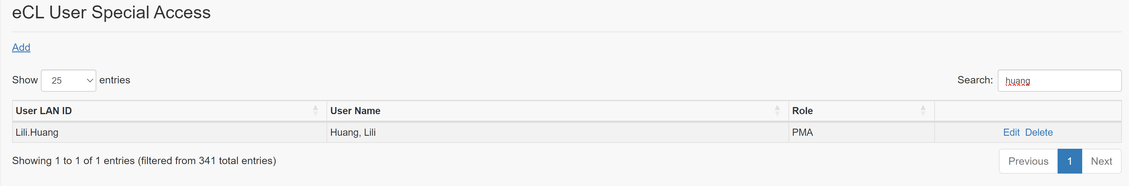

* + 1. Links

None

* + 1. Web Page Invoked Events

| Action | Processing & Result |
| --- | --- |
| Click “Edit” | An ajax call is made to get the selected user to edit.  Controller: User  Action: InitEcoachingAccessControlEdit  The selected user (LanId, Name, Role) will be displayed in a modal dialog. |
| Click “Delete” | An ajax call is made to get the selected user to delete.  Controller: User  Action: InitEcoachingAccessControlDelete  A modal dialog displays with delete confirmation message. |
| Click “Add” | An ajax call is made to get all the sites and employee names for the selected site.  Controller: User  Aciton: InitEcoachingAccessControlAdd  A modal dialog displays with Site dropdown and Name dropdown populated. |

* + 1. Form Fields

|  |  |  |  |  |  |
| --- | --- | --- | --- | --- | --- |
| **Page Name** | **Field Type** | **Field Name** | **Default Value** | **Data Element Source** | **Validation** |
| eCoachingAccessControlList.cshtml | Label |  | eCoaching Access Control |  |  |
| Link |  | Add |  |  |
|  | Start display user list | | | | |
| Label |  | User LAN ID |  |  |
| Label |  | User Name |  |  |
| Label |  | Role |  |  |
| Text |  |  | Historical_Dashboard_ACL.User_LanID |  |
| Text |  |  | Historical_Dashboard_ACL.User_Name |  |
| Text |  |  | Historical_Dashboard_ACL.Role |  |
| Link |  | Eidt |  |  |
| Link |  | Delete |  |  |
| End display user list | | | | |

* 1. Add (Views\User\_AddEcoachingAccessControl.cshtml)
     1. Razor pages comprising Web Page

None

* + 1. Layout Page

Views\Shared\_Layoutcshtml

* + 1. Screenshot

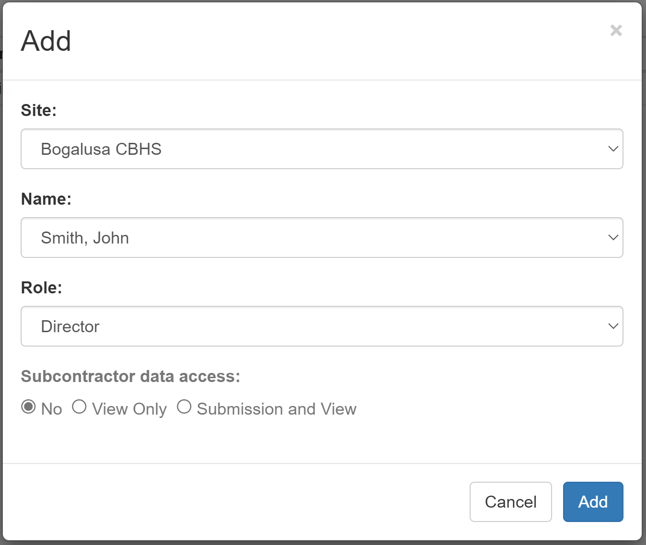

* + 1. Links

None

* + 1. Web Page Invoked Events

| Action | Processing & Result |
| --- | --- |
| Select a site from “Site:” dropdown list | An ajax call is made to get all employee for the selected site.  Controller: User  Action: LoadUserBySite |
| Click Cancel button | “Add” modal dialog disappears. |
| Click Add button | An ajax call is made to add the user.  Controller: User  Action: AddEcoachingAccessControl  Parameter: eCoachingAccessControlAddViewModel |

* + 1. Form Fields

|  |  |  |  |  |  |
| --- | --- | --- | --- | --- | --- |
| **Page Name** | **Field Type** | **Field Name** | **Default Value** | **Data Element Source** | **Validation** |
| _AddEcoachingAccessControl.cshtml | Label |  | Add |  |  |
| Label |  | Site: |  |  |
| DropDownList | SiteId |  | DIM_Site | Required |
| Label |  | Name: |  |  |
| DropDownList | LanId |  | Employee_Hierarchy.Emp_LanID | Required |
| Label |  | Role: |  |  |
| DropdownList | Role | ARC | ARC  Director  ECL  Partner Management  Partner Management Advanced  Quality Alignment Monitor | Required |
| Label |  | Subcontractor Data Access: |  | Display if Director is selected |
| Radio Button |  | No | No  View Only  Submission and View | Display if Director is selected as Role.  Required if Director is selected |

* 1. Edit (Views\User\_EditEcoachingAccessControl.cshtml)
     1. Razor pages comprising Web Page

None

* + 1. Layout Page

Views\Shared\_Layoutcshtml

* + 1. Screenshot

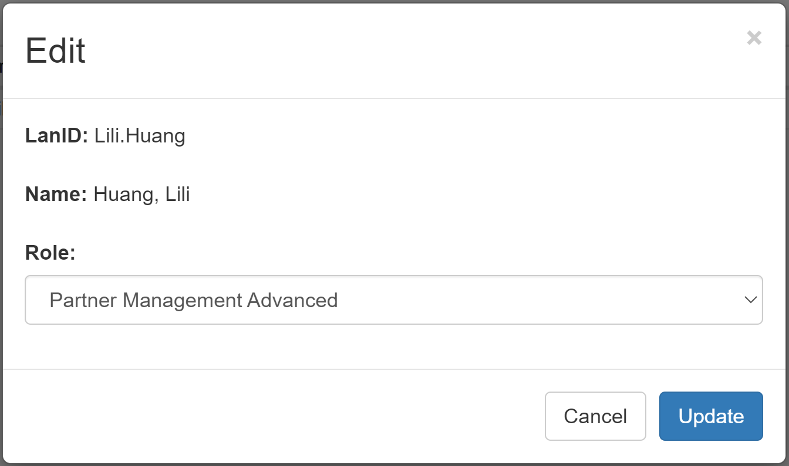

* + 1. Links

None

* + 1. Web Page Invoked Events

| Action | Processing & Result |
| --- | --- |
| Click Cancel button | “Edit” modal dialog disappears. |
| Click Update button | An ajax call is made to update the user.  Controller: User  Action: UpdateEcoachingAccessControl  Parameter: eCoachingAccessControlAddViewModel |

* + 1. Form Fields

|  |  |  |  |  |  |
| --- | --- | --- | --- | --- | --- |
| **Page Name** | **Field Type** | **Field Name** | **Default Value** | **Data Element Source** | **Validation** |
| _EditEcoachingAccessControl.cshtml | Label |  | Edit |  |  |
| Label |  | LanID: |  |  |
| Label |  |  | Historical_Dashboard_ACL.User_LanID |  |
| Label |  | Name: |  |  |
| Label |  |  | Historical_Dashboard_ACL.User_Name |  |
| Label |  | Role: |  |  |
| Dropdown |  | The user’s current role | ARC  Director  ECL  Partner Management  Partner Management Advanced  Quality Alignment Monitor |  |
| Label |  | Subcontractor Data Access: |  | Display if Director is selected |
| Radio Button |  | No | No  View Only  Submission and View | Display if Director is selected as Role.  Required if Director is selected |

* 1. Delete (Views\User\_DeleteEcoachingAccessControl.cshtml)
     1. Razor pages comprising Web Page

None

* + 1. Layout Page

Views\Shared\_Layoutcshtml

* + 1. Screenshot

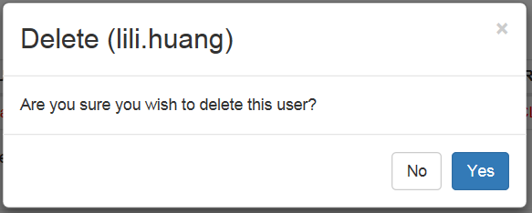

* + 1. Links

None

* + 1. Web Page Invoked Events

| Action | Processing & Result |
| --- | --- |
| Click No button | “Delete” modal dialog disappears. |
| Click Yes button | An ajax call is made to delete the user.  Controller: User  Action: DeleteEcoachingAccessControl  Parameter: rowId |

* + 1. Form Fields

|  |  |  |  |  |  |
| --- | --- | --- | --- | --- | --- |
| **Page Name** | **Field Type** | **Field Name** | **Default Value** | **Data Element Source** | **Validation** |
| _DeleteEcoachingAccessControl.cshtml | Label |  | Delete |  |  |
| Label |  |  | Historical_Dashboard_ACL.User_LanID |  |
| Label |  | Are you sure you wish to delete this user? |  |  |