________________________

[MAXIMUS logo](https://www.maximus.com/)

Detail Design: CCO eCoaching Admin eCL Site Usage

________________________

Prepared by: Lili Huang Date: 11/02/2018

Department:

Change History Log

| Date | Change Description | Author |
| --- | --- | --- |
| 11/02/2018  07/24/2020 | Initial Revision – TFS  TFS 17803 – GDIT to MAXIMUS | Lili Huang  Lili Huang |
|  |  |  |

Table of Contents

**1.** **Description** 4

**2.** **Controllers** 4

2.1. EclSiteUsageController.cs 4

2.1.1. Index – HttpGet 4

2.1.2. GetStatistics – HttpPost 4

**3.** **Page details** 4

3.1. Views\EclSiteUsage\Index.cshtml) 4

3.1.1. Razor pages comprising Web Page 4

3.1.2. Layout Page 4

3.1.3. Screenshot 4

3.1.4. Links 8

3.1.5. Web Page Invoked Events 8

3.1.6. Form Fields 10

1. **Description**

This module provides the following eCoaching Log site usage reports to authorized users:

* Hourly:

24 hours page hits and users for a given day

* Daily:

Daily page hits and users for a given date range

* Weekly:

Weekly page hits and users for a given date range

* Monthly:

Monthly page hits and users for a given date range

1. **Controllers**
   1. EclSiteUsageController.cs
      1. Index – HttpGet

Initialize EclSiteUsageViewModel;

Return Index.cshtml view with EclSiteUsageViewModel object.

* + 1. GetStatistics – HttpPost

Get Report Type (hour, day, week, or month) and dates selected on the page;

Call the following stored procedure to return counts based report type:

* sp_GetPageCountByHourOfDay, if by Hour
* sp_GetPageCountByDay, if by Day
* sp_GetPageCountByWeek, if by Week
* sp_getPageCountByMonth, if by Month

Populate EclSiteUsageViewModel with the counts returned above;

Return _Statistics.cshtml view.

1. **Page details**
   1. Views\EclSiteUsage\Index.cshtml)
      1. Razor pages comprising Web Page

_DateRangeByDay.cshtml

_DateRangeByHour.cshtml

_DateRangeByMonth.cshtml

_DateRangeByWeek.cshtml

* + 1. Layout Page

Views\Shared\_Layout.cshtml

* + 1. Screenshot

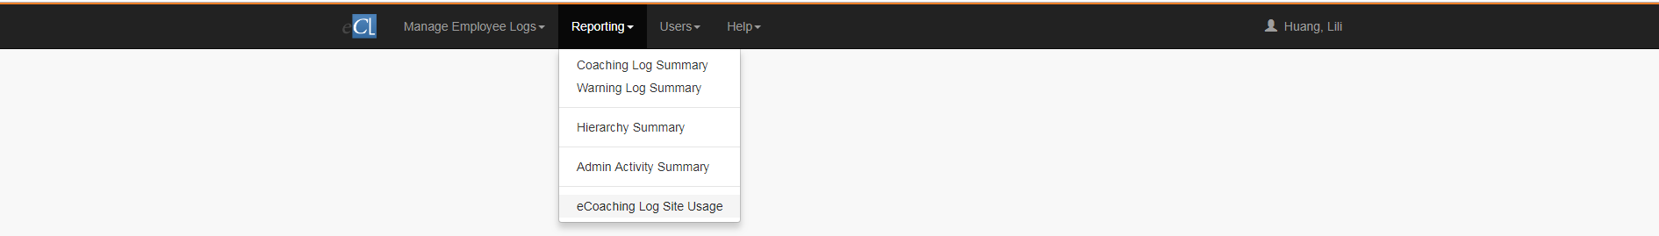

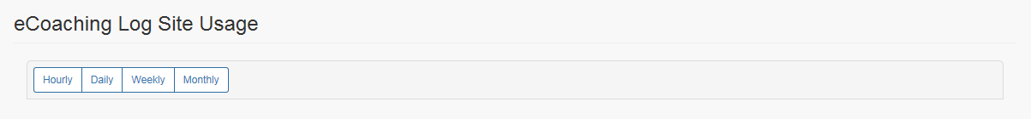

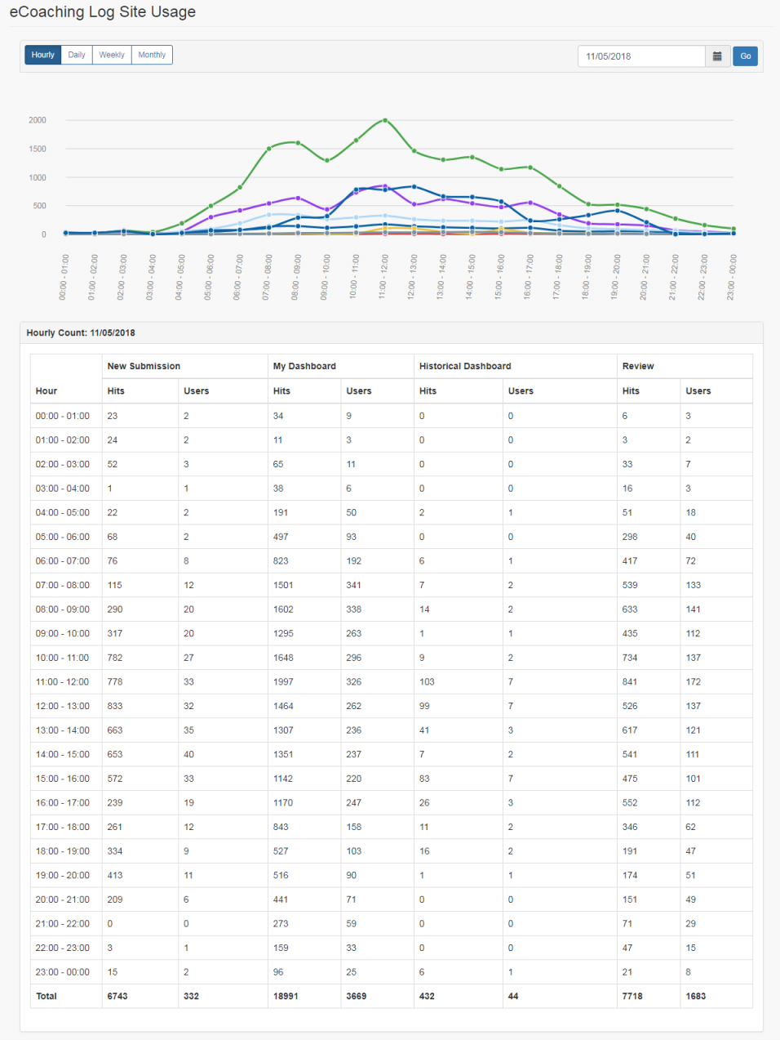

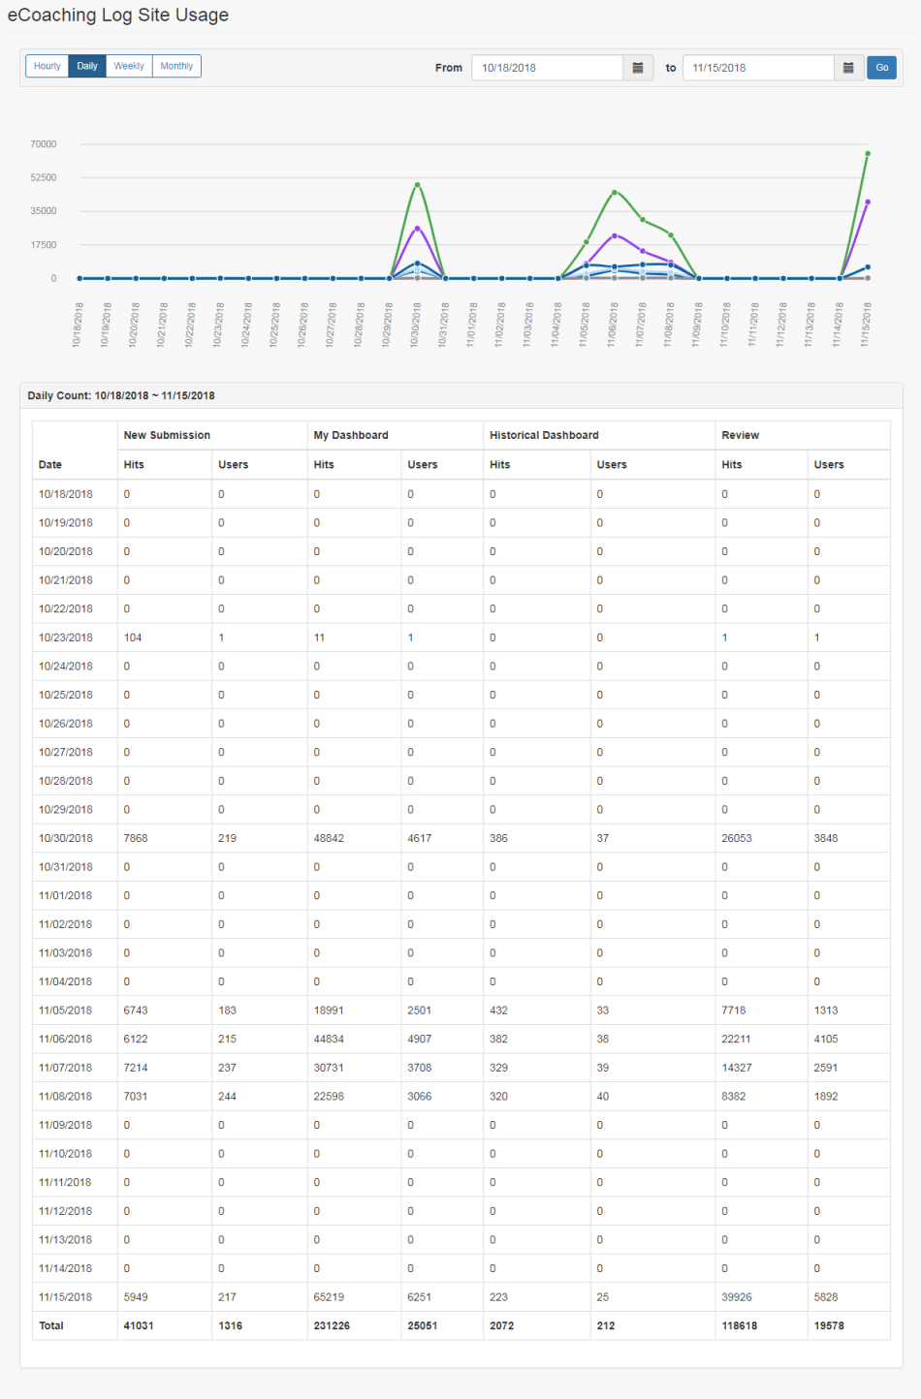

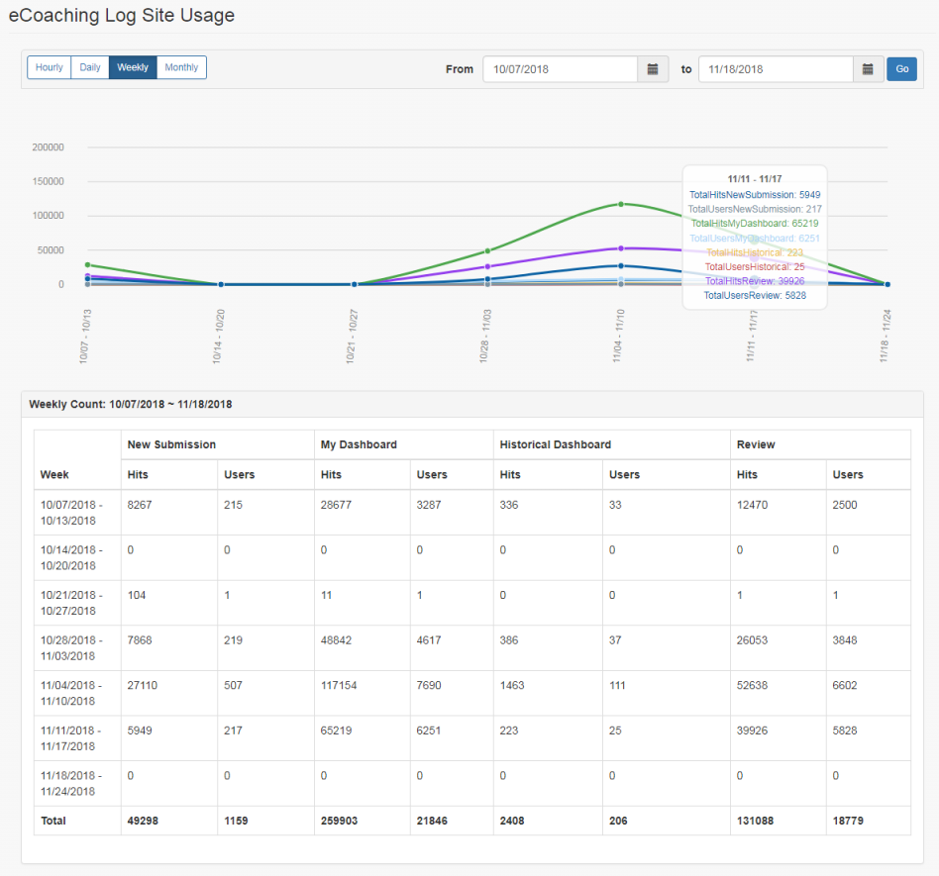

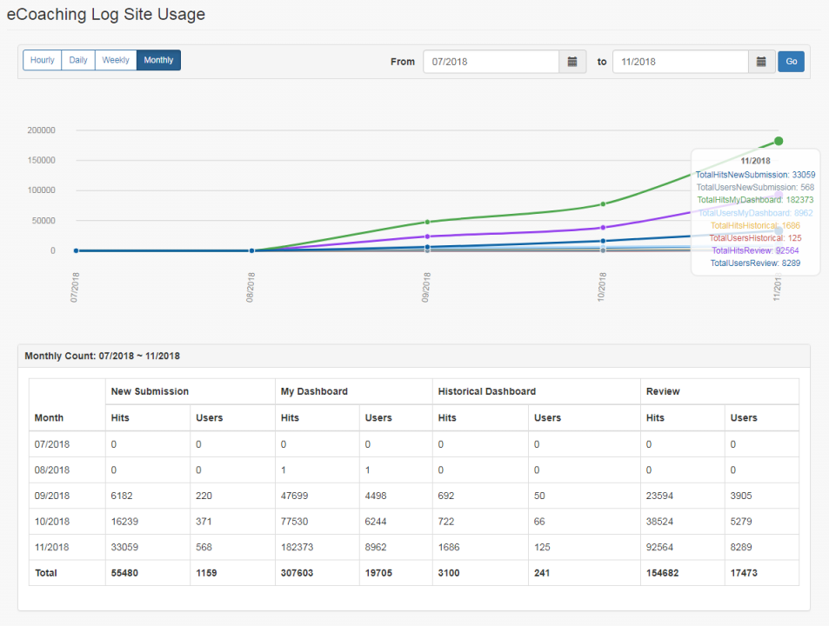

* + 1. Links

None

* + 1. Web Page Invoked Events

| Action | Processing & Result |
| --- | --- |
| Select “eCoaching Log Site Usage” from top menu bar. | A GET request is sent to server.  Controller: EclSiteUsage  Action: Index  Page displays with the following options to select:  Hourly;  Daily;  Weekly;  Monthly |
| Select “Hourly” | Hourly search section displays:  Textbox (followed by calendar icon);  Go button; |
| Select a Date, and click Go | An ajax call is made to get the selected Date counts.  Controller: EclSiteUsage  Action: GetStatistics  Hourly counts for the selected date display. |
| Select “Daily” | Daily search section displays:  Star: Textbox (followed by calendar icon)  End : Textbox (followed by calendar icon)  Go button; |
| Select a Start Date, End Date, and click Go | An ajax call is made to get the counts for the selected date range.  Controller: EclSiteUsage  Action: GetStatistics  Daily counts for the selected date display. |
| Select “Weekly” | Weekly search section displays:  Star: Textbox (followed by calendar icon)  End : Textbox (followed by calendar icon)  Go button; |
| Select a Start Date, End Date, and click Go | An ajax call is made to get the counts for the selected date range.  Controller: EclSiteUsage  Action: GetStatistics  Weekly counts for the selected date display. |
| Select “Monthly” | Monthly search section displays:  Star: Textbox (followed by calendar icon)  End : Textbox (followed by calendar icon)  Go button; |
| Select a Start Date, End Date, and click Go | An ajax call is made to get the counts for the selected date range.  Controller: EclSiteUsage  Action: GetStatistics  Monthly counts for the selected date display. |

* + 1. Form Fields

|  |  |  |  |  |  |  |  |
| --- | --- | --- | --- | --- | --- | --- | --- |
| **Page Name** | **Field Type** | **Field Name** | **Default Value** | | **Data Element Source** | **Validation** | **Note** |
| Index.cshtml | Button |  | Hourly | |  |  |  |
| Button |  | Daily | |  |  |  |
| Button |  | Weekly | |  |  |  |
| Button |  | Monthly | |  |  |  |
| _DateRangeByHour.cshtml | Input |  | Select Date | |  |  | Date |
| Icon |  |  | |  |  | Calendar icon |
| Button |  | Go | |  |  |  |
| _DateRangeByDay.cshtml | Input |  | Select Date | |  | Max range: 31 days. | Start Date |
| Input |  | Select Date | |  | End Date |
| Icon |  |  | |  |  | Calendar icon |
| Button |  | Go | |  |  |  |
| _DateRangeByWeek.cshtml | Input |  | Select Date | |  | Max range: 24 weeks. | Start Date |
| Input |  | Select Date | |  | End Date |
| Icon |  |  | |  |  | Calendar icon |
| Button |  | Go | |  |  |  |
| _DateRangeByMonth.cshtml | Input |  | Select Date | |  |  | Start Date |
| Input |  | Select Date | |  |  | End Date |
| Icon |  |  | |  |  | Calendar icon |
| Button |  | Go | |  |  |  |
| _Statistics.cshtml | **Header** | | | | | | |
| Label |  | Hour or Day or Week or Month | |  |  | Based on reporting type |
| Label |  | New Submission | |  |  |  |
| Hits | Users |
| Label |  | My Dashboard | |  |  |  |
| Hits | Users |
| Label |  | Historical Dashboard | |  |  |  |
| Hits | Users |
| Label |  | Review | |  |  |  |
| Hits | Users |
| **Begin - Repeat for each row returned** | | | | | | |
| Text |  |  | | Statistic.TimeSpan |  |  |
| Text |  |  | | Statistic.  TotalHitsNewSubmission |  |  |
| Text |  |  | | Statistic.  TotalUsersNewSubmission |  |  |
| Text |  |  | | Statistic.  TotalHitsMyDashboard |  |  |
| Text |  |  | | Statistic.  TotalUsersMyDashboard |  |  |
| Text |  |  | | Statistic.  TotalHitsHistorical |  |  |
| Text |  |  | | Statistic.  TotalUsersHistorical |  |  |
| Text |  |  | | Statistic.  TotalHitsReview |  |  |
| Text |  |  | | Statistic.  TotalUsersReview |  |  |
| **End – Repeat for each row returned** | | | | | | |
| Label |  | Total | |  |  |  |
| Text |  |  | | EclSiteUsageViewModel.  TotalHitsNewSubmission |  |  |
| Text |  |  | | EclSiteUsageViewModel.  TotalUsersNewSubmission |  |  |
| Text |  |  | | EclSiteUsageViewModel.  TotalHitsMyDashboard |  |  |
| Text |  |  | | EclSiteUsageViewModel.  TotalUsersMyDashboard |  |  |
| Text |  |  | | EclSiteUsageViewModel.  TotalHitsHistorical |  |  |
| Text |  |  | | EclSiteUsageViewModel.  TotalUsersHistorical |  |  |
| Text |  |  | | EclSiteUsageViewModel.  TotalHitsReview |  |  |
| Text |  |  | | EclSiteUsageViewModel.  TotalUsersReview |  |  |