________________________



Detail Design: CCO eCoaching Log – Historical Dashboard

________________________

Prepared by: Lili Huang Date: 05/22/2018

Department: FCD

Change History Log

| Date | Change Description | Author |
| --- | --- | --- |
| 05/22/2018 | Initial Revision – TFS 10220 | Lili Huang |
| 08/21/2018 | TFS11776 – Limit the number of records which can be exported to excel; | Lili Huang |
| 08/31/2018 | TFS11984 – Include a link to ecl sharepoint site to report issues;  Updated 3.1.4 – Web Page Invoked Events | Lili Huang |
| 09/04/2018 | TFS11984 - Include a link to ecl sharepoint site to report issues;  Moved the change to Common DD. | Lili Huang |
|  |  |  |

Table of Contents

**1.** **Description** 4

**2.** **Business Logic – HistoricalDashboardController.cs** 4

**3.** **Page details** 5

**3.1** **Views\HistoricalDashboard\Index.cshtml** 5

3.1.1 Razor pages comprising Web Page 5

3.1.2 Layout Page 5

3.1.3 Screenshot 5

3.1.4 Web Page Invoked Events 6

**4.** **Stored Procedures** 8

4.1. sp_select_sites_for_dashboard 8

4.2. sp_selectfrom_coaching_log_mgr_bysite 8

4.3. sp_selectfrom_coaching_log_sup_bymgr 8

4.4. sp_selectfrom_coaching_log_emp_bysup 8

4.5. sp_selectfrom_coaching_log_submitter 8

4.6. sp_select_statuses_for_dashboard 8

4.7. sp_select_sources_for_dashboard 8

4.8. sp_select_values_for_dashboard 8

4.9. sp_search_for_dashboards_details 8

4.10. sp_selectfrom_coaching_log_historical_export 8

4.11. sp_selectfrom_coaching_log_historical_export_count 8

1. **Description**

This module provides a way for authorized users to search historical eCoaching logs. Authorized users are designated as all CCO non-CSR employees and HRs.

Searching options:

* Submission Start Date
* Submission End Date
* Active Employee, Inactive Employee, or Both
* Site
* Manager
* Supervisor
* Employee
* Submitter
* Log Status
* Log Source
* Log Value

Authorized users enter the Historical Dashboard page by clicking “Historical Dashboard” on the top menu bar.

This module also provides a way to export the search result to an excel file.

1. **Business Logic – HistoricalDashboardController.cs**

Upon user enters the page, display all search options;

* Default Submission Start Date to 30 days before today, Submission End Date to today;
* Default Employee type to Active;
* Site dropdown has all sites populated, default to “—Select a Site –“;
* Manager dropdown is loaded for the selected site once user selects a site in Site dropdown;
* Supervisor dropdown is loaded for the selected manager once user selects a manager in Manager dropdown;
* Employee dropdown is loaded for the selected supervisor once user selects a supervisor in Supervisor dropdown;
* Submitter dropdown has all submitters populated, default to “All Submitters”;
* Status dropdown has all status populated, default to “All Status”;
* Source dropdown has all sources populated, default to “All Sources”;
* Value dropdown has all values populated, default to “All Values”.

When Search button is clicked,

* Validates all search options; If any search option is not selected, validation will fail.
* Upon passing validation, call stored procedure sp_search_for_dashboards_details to return log list based on the search options. Display log list on the page.

When Reset button is clicked, page will be reset to its initial settings.

When “Export to Excel” is clicked, call stored procedure sp_SelectFrom_Coaching_Log_Historical_Export_Count to get the total number of records to be exported;

If the total number of records is over 20,000, display message “The maximum number of records that can be exported at a time is 20,000. You are trying to export [total number of records to be exported] records. Please refine your filters and try again.”

Else

Call stored procedure sp_selectfrom_coaching_log_historical_export to return log list, which will be written in an excel file. The naming convention for the excel file will be “eCoachingLog_yyyyMMddHHmmssffff.xlsx”.

1. **Page details**
   1. **Views\HistoricalDashboard\Index.cshtml**
      1. Razor pages comprising Web Page

_Search.cshtml

* + 1. Layout Page

Views\Shared\_Layoutcshtml

* + 1. Screenshot

Page initial display:

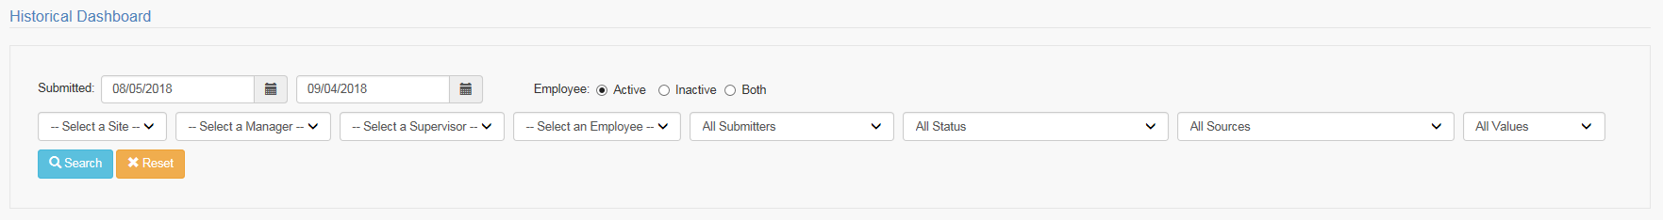

Click Search without selecting Manager, Supervisor, and Employee:

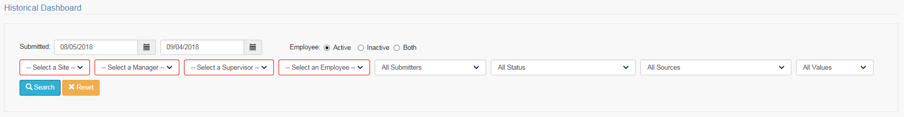

Search Result:

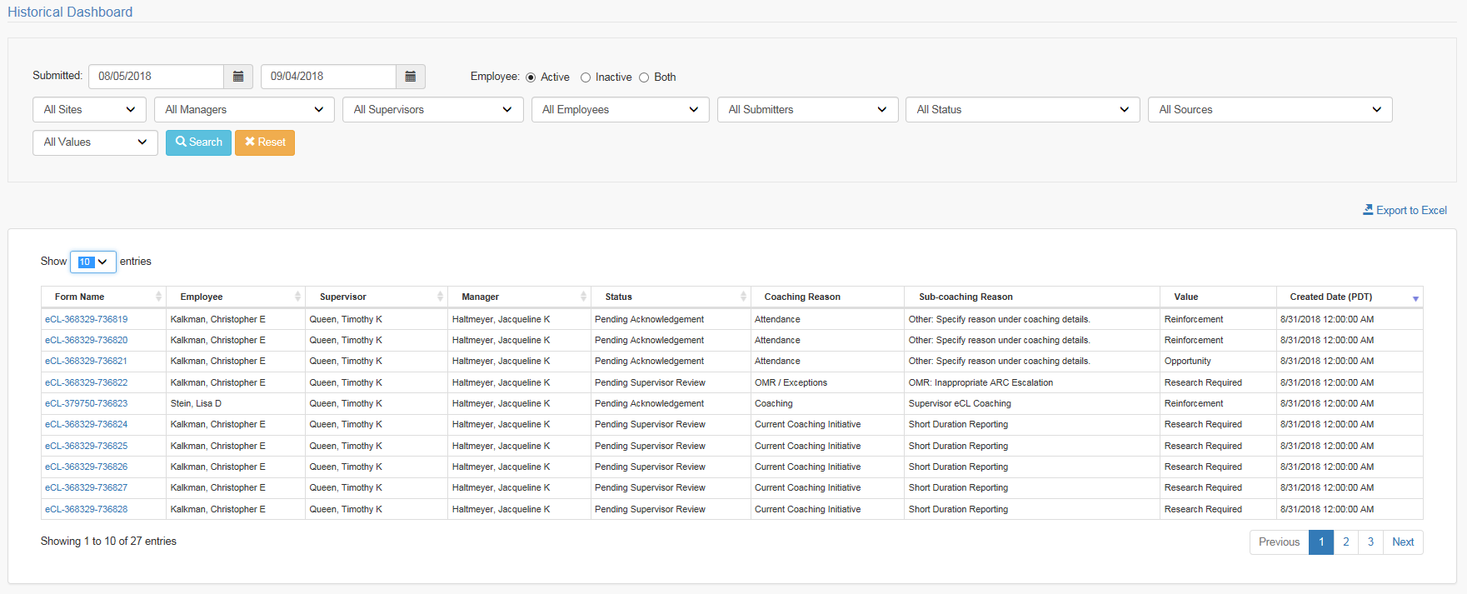

Unauthorized to view log details:

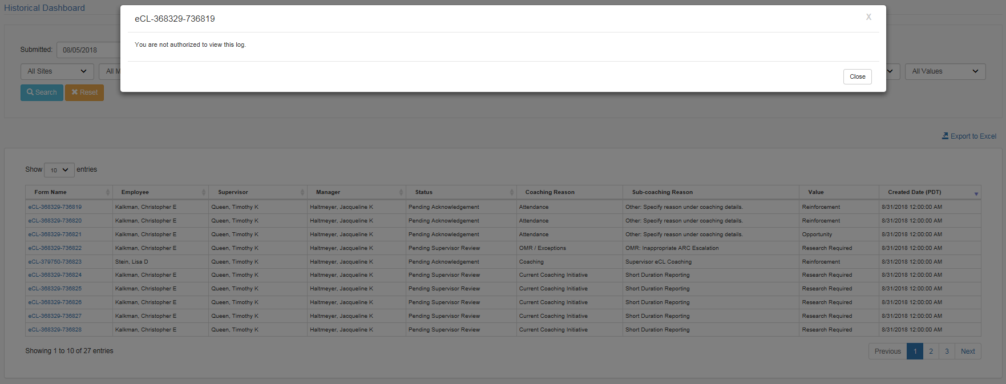

View log details:

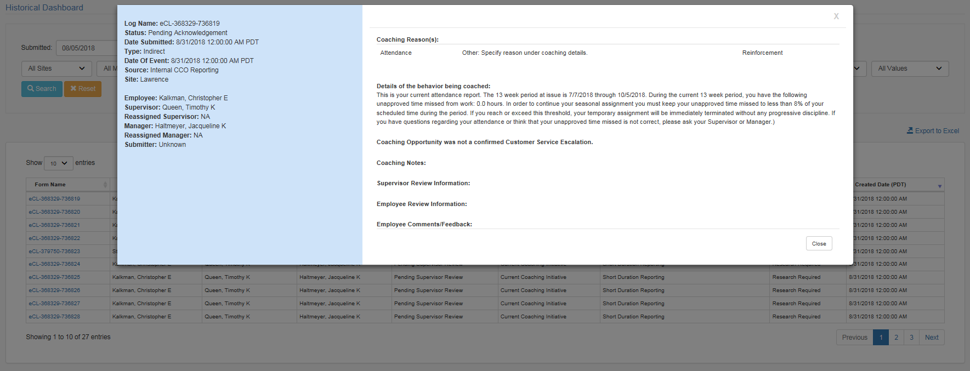

* + 1. Web Page Invoked Events

| Action | Processing & Result |
| --- | --- |
| Select site from Site dropdown | Ajax call is made to get all the managers on the selected site.  Controller: HistoricalDashboard  Action: GetManagersBySite  Manager dropdown is populated with all the managers on the selected site. |
| Select manager from Manager dropdown | Controller: HistoricalDashboard  Action: GetSupervisorsByMgr  Supervisor dropdown is populated with all the supervisors who report to the selected manager. |
| Select supervisor from Supervisor dropdown | Controller: HistoricalDashboard  Action: GetEmployeesBySup  Employee dropdown is populated with all the selected type of employees (inactive, active, or both) who report to the selected supervisor. |
| Select “Active Employee” radio button | Controller: HistoricalDashboard  Action: GetEmployeesBySup  Employee dropdown is populated with all the active employees who report to the selected supervisor. |
| Select “Inactive Employee” radio button | Controller: HistoricalDashboard  Action: GetEmployeesBySup  Employee dropdown is populated with all the inactive employees who report to the selected supervisor. |
| Select “Both” radio button | Controller: HistoricalDashboard  Action: GetEmployeesBySup  Employee dropdown is populated with all the inactive and active employees who report to the selected supervisor. |
| Click Search button | Controller: HistoricalDashboard  Action: Search  Logs that meet the search criteria are displayed on the page. |
| Click Export to Excel link | Controller: HistoricalDashboard  Action: ExportToExcel, Download  Logs that meet the search criteria are exported to excel file. |
| Click a log name in the log list | Controller: Review  Action: Index  Check if user is authorized to view the log details; If not, display unauthorized message; Otherwise, display the log details. |

1. **Stored Procedures**
   1. sp_select_sites_for_dashboard
   2. sp_selectfrom_coaching_log_mgr_bysite
   3. sp_selectfrom_coaching_log_sup_bymgr
   4. sp_selectfrom_coaching_log_emp_bysup
   5. sp_selectfrom_coaching_log_submitter
   6. sp_select_statuses_for_dashboard
   7. sp_select_sources_for_dashboard
   8. sp_select_values_for_dashboard
   9. sp_search_for_dashboards_details
   10. sp_selectfrom_coaching_log_historical_export
   11. sp_selectfrom_coaching_log_historical_export_count

Refer CCO_eCoaching_Log_Database_DD.docx for details.