________________________



Detail Design: CCO eCoaching Log – My Dashboard

________________________

Prepared by: Lili Huang Date: 06/15/2018

Department: FCD

Change History Log

| Date | Change Description | Author |
| --- | --- | --- |
| 06/15/2018 | Initial Revision – TFS 11388 | Lili Huang |
|  |  |  |

Table of Contents

**1.** **Description** 4

**2.** **Business Logic – MyDashboardController.cs** 4

**3.** **Page details** 7

3.1 Views\MyDashboard\_Default.cshtml, _DefaultDirector.cshtml 7

3.1.1 Razor pages comprising Web Page 7

3.1.2 Layout Page 7

3.1.3 Screenshot 7

3.1.4 Web Page Invoked Events 11

**4.** **Stored Procedures** 13

4.1. sp_Dashboard_Director_Summary_Count 13

4.2. sp_Dashboard_Director_Summary_Count_ByStatus 13

4.3. sp_Dashboard_Summary_Count 13

4.4. sp_Dashboard_Summary_Count_ByStatus 13

4.5. sp_SelectFrom_Coaching_LogMgrDistinctSup 13

4.6. sp_SelectFrom_Coaching_LogMgrDisntinctCSR 13

4.7. sp_SelectFrom_Coaching_LogSupDistinctCSRTeam 13

4.8. sp_SelectFrom_Coaching_LogMgrDistinctSUPTeam 13

4.9. sp_SelectFrom_Coaching_LogMgrDistinctCSRTeam 13

4.10. sp_Select_Sources_For_Dashboard 13

4.11. sp_SelectFrom_Coaching_LogSupDistinctMGRTeamCompleted 13

4.12. sp_SelectFrom_Coaching_LogSupDistinctCSRTeamCompleted 13

4.13. sp_SelectFrom_Coaching_LogMgrDistinctSUPTeamCompleted 13

4.14. sp_SelectFrom_Coaching_LogMgrDistinctCSRTeamCompleted 13

4.15. sp_Select_States_For_Dashboard 13

4.16. sp_Dashboard_Populate_Filter_Dropdowns 13

4.17. sp_Select_Statuses_For_Dashboard 13

4.18. sp_Search_For_Dashboards_Details 13

4.19. sp_Search_For_Dashboards_Count 13

1. **Description**

This module allows authorized users to search individual or team ecoaching logs. It also allows users to view their submitted logs.

Authorized users are designated as CCO employees and classified as the following roles:

* Director
* Senior Manager
* Manager
* Supervisor
* Restricted
* ARC
* CSR
* Other

Authorized users enter My Dashboard page by clicking “My Dashboard” on the top menu bar.

1. **Business Logic – MyDashboardController.cs**

User enters My Dashboard page:

* Get data for Pending Log bar chart based on user role;

**Director:**

A list of sites managed by the user with each site having the following status and count for the selected month:

* Pending Acknowledgement
* Pending Employee Review
* Pending Manager Review
* Pending Supervisor Review
* Pending Sr. Manager Review
* Pending Quality Lead Review
* Pending Deputy Program Manager Review
* Active Warnings

**Senior Manager, Manager:**

A list of the following status and count:

* Pending Acknowledgement
* Pending Employee Review
* Pending Manager Review
* Pending Sr. Manager Review
* Pending Deputy Program Manager Review

**Supervisor, Other:**

A list of the following status and count:

* Pending Acknowledgement
* Pending Employee Review
* Pending Supervisor Review
* Pending Quality Lead Review

**ARC, CSR:**

A list of the following status and count:

* Pending Acknowledgement
* Pending Employee Review
* Get log type list with associated counts based on user role;

**Director:**

A list of site managed by the user with each site having the following counts for the selected month, with each site displayed as a hyperlink:

* Pending
* Completed
* Warning

**Senior Manager, Manager:**

A list of the following logs and counts:

* My Pending
* My Completed
* My Team’s Pending
* My Team’s Completed
* My Team’s Warning
* My Submitted

**Supervisor, Other:**

A list of the following logs and counts:

* My Pending
* My Completed
* My Team’s Pending
* My Team’s Completed
* My Team’s Warning
* My Submitted

**ARC:**

A list of the following logs and counts:

* My Pending
* My Completed
* My Submitted

**CSR:**

A list of the following logs and counts:

* My Pending
* My Completed
* Display log summary - Pending log bar chart; log type list with their associated counts and view links.

Click View link:

* Get data to populate search dropdowns of the selected log type based on user role;

**Director:**

Radio buttons, default to “Pending”:

* Pending
* Completed
* Warning

**Senior Manager, Manager:**

* My Pending eCoaching Logs:
* Supervisor
* Employee
* My Team’s Pending eCoaching Logs:
* Supervisor
* Employee
* Source
* My Team’s Completed eCoaching Logs:
* Supervisor
* Employee
* Source
* Submitted Start/End Dates
* My Completed eCoaching Logs:

None

* My Team’s Warning eCoaching Logs:
* Status
* Submitted Start/End Dates
* My Submitted eCoaching Logs:
* Manager
* Supervisor
* Employee
* Status
* Submitted Start/End Dates

**Supervisor, Other:**

* My Pending eCoaching Logs:

None

* My Team’s Pending eCoaching Logs:
* Employee
* Source
* My Team’s Completed eCoaching Logs:
* Manager
* Employee
* Source
* Submitted Start/End Dates
* My Completed eCoaching Logs:

None

* My Team’s Warning eCoaching Logs:
* Status
* Submitted Start/End Dates
* My Submitted eCoaching Logs:
* Manager
* Supervisor
* Employee
* Status
* Submitted Start/End Dates

**ARC:**

* My Pending eCoaching Logs:

None

* My Completed eCoaching Logs:

None

* My Submitted eCoaching Logs:
* Manager
* Supervisor
* Employee
* Status
* Submitted Start/End Dates

**CSR:**

* My Pending eCoaching Logs:

None

* My Completed eCoaching Logs:

None

* Default dropdowns to All if applicable;
* Default End date to today, Start date to 30 days before today if applicable;
* Get log list from database
* Display the selected log type list section with search dropdowns and log list; Display log name as a hyperlink.

Click Go button:

* Call stored procedure to get log list based on the search criteria;
* Refresh the selected log type list section with the log list returned.

Click [Log Name] link:

* Redirect to ReviewController to display the selected log details in a modal dialog. See ReviewController for details.

1. **Page details**
   1. Views\MyDashboard\_Default.cshtml, _DefaultDirector.cshtml
      1. Razor pages comprising Web Page

_CountByStatus.cshtml

_CountBySite.cshtml

_MyCompleted.cshtml

_MyCompletedSearch.cshtml

_MyPending.cshtml

_MyPendingMgrSearch.cshtml

_MySiteLogs.cshtml

_MySiteLogSearch.cshtml

_MySubmission.cshtml

_MySubmissionSearch.cshtml

_MyTeamCompleted.cshtml

_MyTeamCompletedSearch.cshtml

_MyTeamPending.cshtml

_MyTeamPendingMgrSearch.cshtml

_MyTeamPendingSupSearch.cshtml

_MyTeamWarning.cshtml

_MyTeamWarningSearch.cshtml

_WarningList.cshtml

_LogList.cshtml

* + 1. Layout Page

Views\Shared\_Layoutcshtml

* + 1. Screenshot

**Director:**

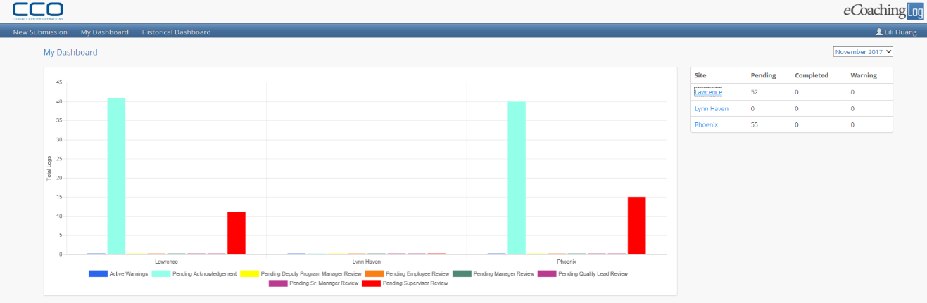

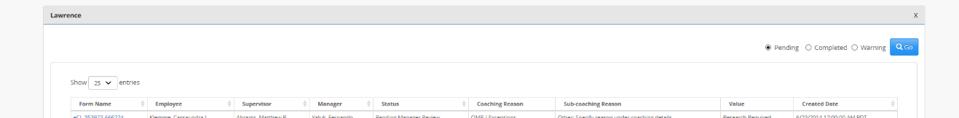

**Senior Manager, Manager:**

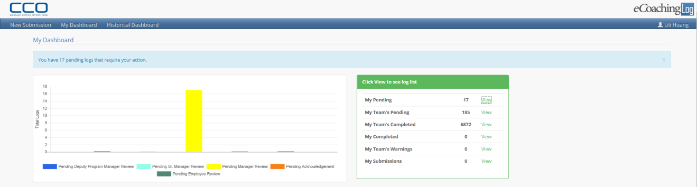

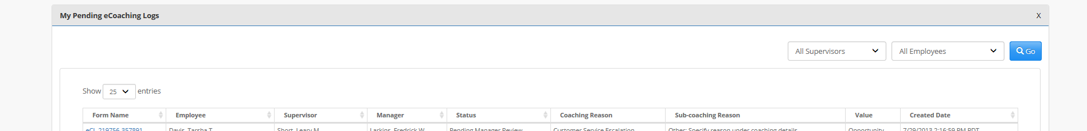

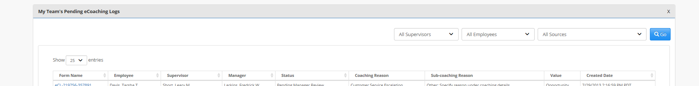

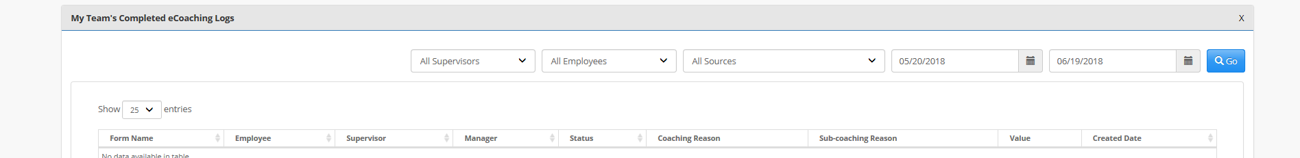

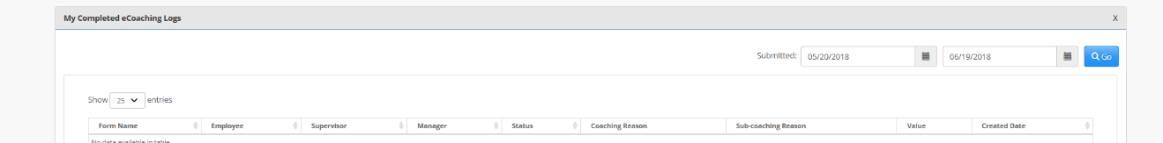

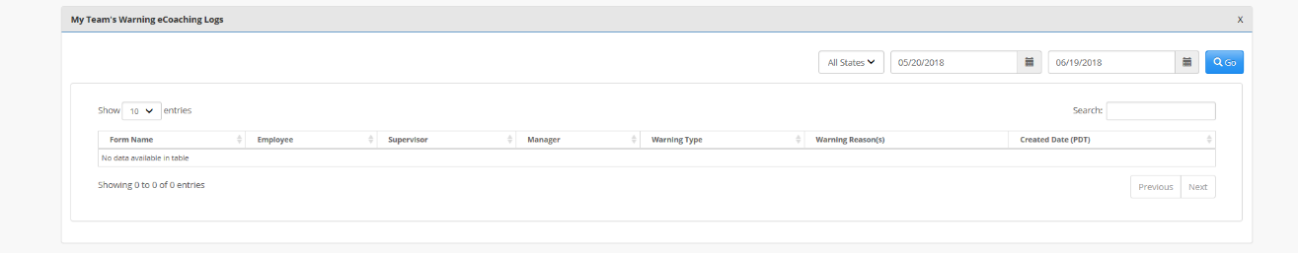

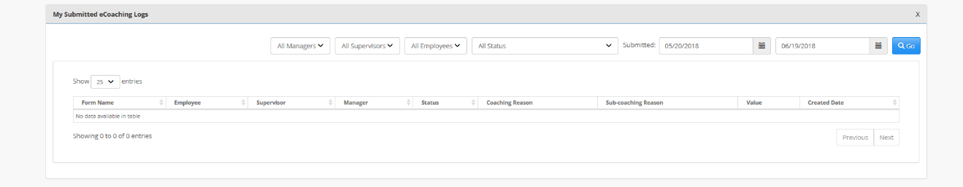

**Supervisor, Other:**

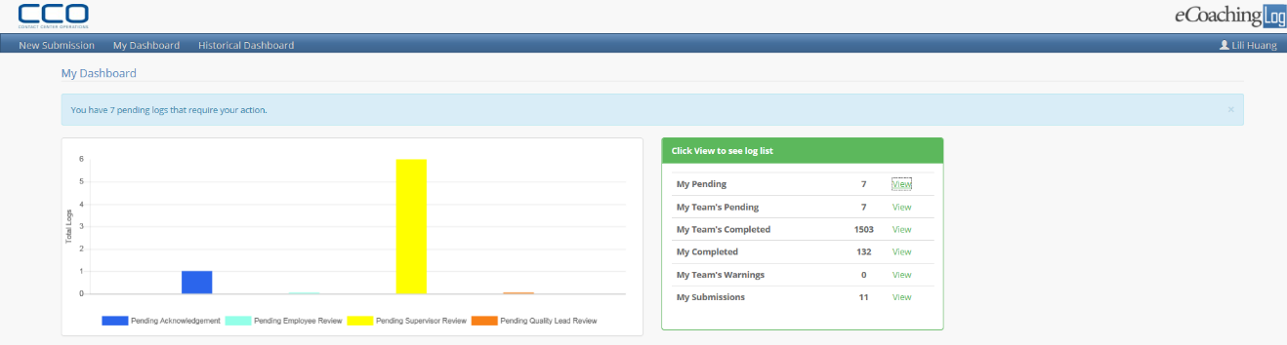

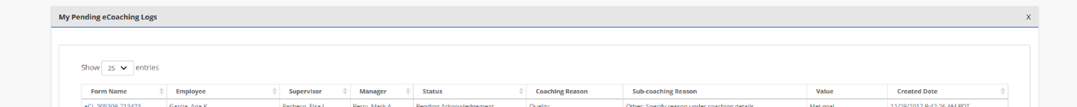

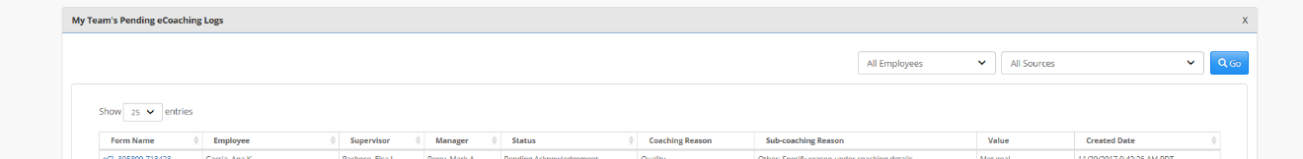

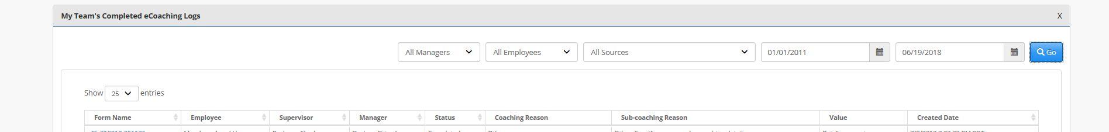

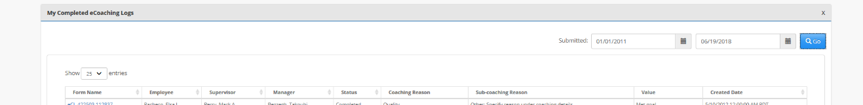

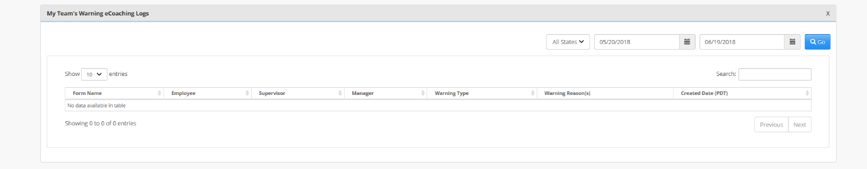

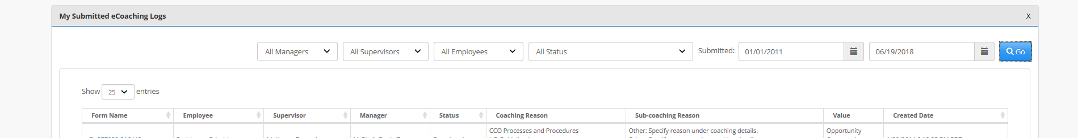

**ARC:**

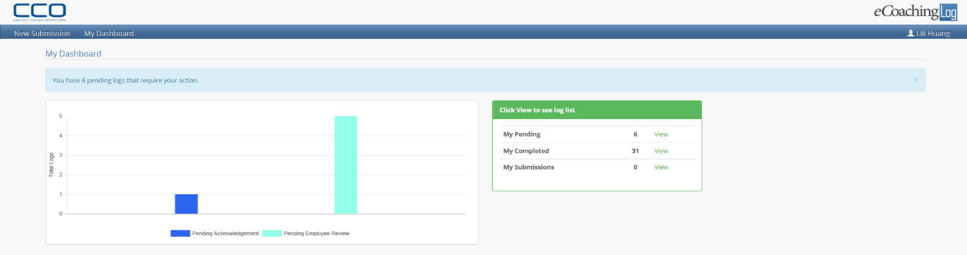

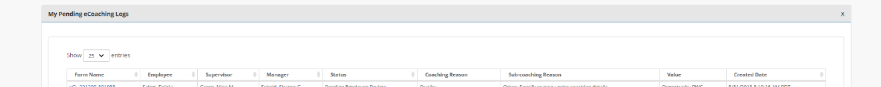

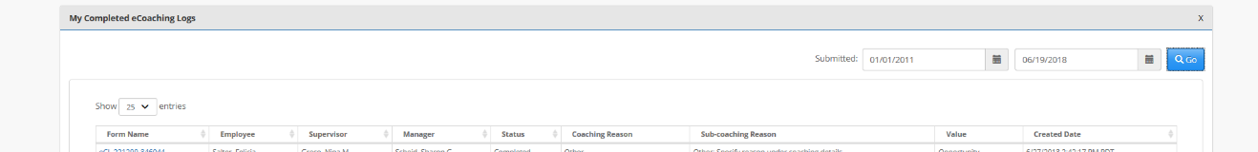

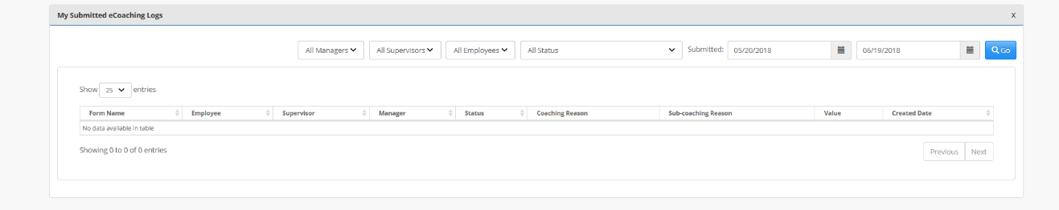

**CSR:**

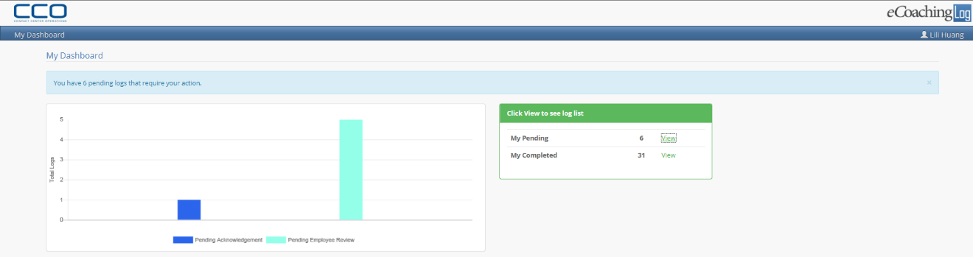





**Unauthorized to view log details:**

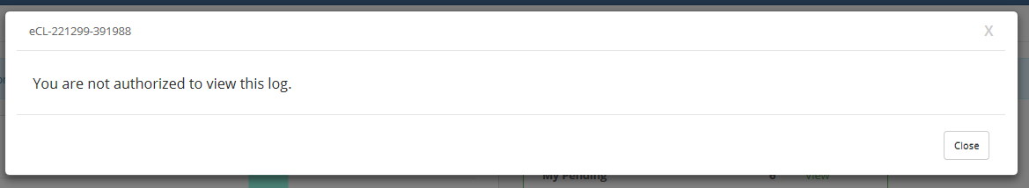

* + 1. Web Page Invoked Events

| Action | Processing & Result |
| --- | --- |
| **Director - start** | |
| Select different month | Controller: MyDashboard  Action: GetDataByMonth  Chart refreshes with data for the selected month;  Site list refreshes with data for the selected month. |
| Click any Site in the Site list table | Controller: MyDashboard  Action: GetLogs  “Pending” radio button is selected;  Pending log list for the selected site and selected month displays. |
| Select Completed radio button | Controller: MyDashboard  Action: GetLogs  “Completed” radio button is selected;  Completed log list for the selected site and selected month displays. |
| Select Warning radio button | Controller: MyDashboard  Action: GetLogs  “Warning” radio button is selected;  Warning log list for the selected site and selected month displays. |
| **Director - end** | |
| **Sr. Manager, Manager, Supervisor, Other - start** | |
| Click any Status in the Log Status List table | Controller: MyDashboard  Action: GetLogs  Logs with the selected status display, log names display as hyperlinks.  Appropriate populated filter dropdowns display. |
| Select different value(s) in the filter dropdown(s); Click “Go” | Controller: MyDashboard  Action: Search  Logs met the selected search criteria display; |
| Select a different page size | Controller: LogBase  Action: LoadData  Logs display per the selected page size; |
| Click any log name in the log list returned from the search. | Controller: LogBase  Action: GetLogDetail  Redirect to Review Controller, which display the selected log details. |
| **ARC, CSR - start** | |
| Click any Status in the Log Status List table | Controller: MyDashboard  Action: GetLogs  Logs with the selected status display, log names display as hyperlinks.  Appropriate populated filter dropdowns display. |
| Click any log name in the log list returned from the search. | Controller: LogBase  Action: GetLogDetail  Redirect to Review Controller, which display the selected log details. |
| **ARC, CSR - end** | |

1. **Stored Procedures**
   1. sp_Dashboard_Director_Summary_Count
   2. sp_Dashboard_Director_Summary_Count_ByStatus
   3. sp_Dashboard_Summary_Count
   4. sp_Dashboard_Summary_Count_ByStatus
   5. sp_SelectFrom_Coaching_LogMgrDistinctSup
   6. sp_SelectFrom_Coaching_LogMgrDisntinctCSR
   7. sp_SelectFrom_Coaching_LogSupDistinctCSRTeam
   8. sp_SelectFrom_Coaching_LogMgrDistinctSUPTeam
   9. sp_SelectFrom_Coaching_LogMgrDistinctCSRTeam
   10. sp_Select_Sources_For_Dashboard
   11. sp_SelectFrom_Coaching_LogSupDistinctMGRTeamCompleted
   12. sp_SelectFrom_Coaching_LogSupDistinctCSRTeamCompleted
   13. sp_SelectFrom_Coaching_LogMgrDistinctSUPTeamCompleted
   14. sp_SelectFrom_Coaching_LogMgrDistinctCSRTeamCompleted
   15. sp_Select_States_For_Dashboard
   16. sp_Dashboard_Populate_Filter_Dropdowns
   17. sp_Select_Statuses_For_Dashboard
   18. sp_Search_For_Dashboards_Details
   19. sp_Search_For_Dashboards_Count

Refer CCO_eCoaching_Log_Database_DD.docx for details.