________________________

[MAXIMUS logo](https://www.maximus.com/)

Detail Design: CCO eCoaching Log – My Dashboard – Quality Now

________________________

Prepared by: Lili Huang Date: 08/05/2021

Department:

Change History Log

| Date | Change Description | Author |
| --- | --- | --- |
| 08/05/2021 | Initial Revision – TFS 22256 Quality Now Logs Enhancement | Lili Huang |

Table of Contents

**1.** **Description** 4

**2.** **Business Logic** 4

**3.** **Screenshot** 7

1. **Description**

This module allows users with the following roles to search ecoaching Quality Now logs as well as to view their Quality Now log submissions. It is accessed by clicking “My Dashboard” in the top menu bar followed by “Quality Now”.

*Please reference CCO_eCoaching_Log_My_Dashboard_Common_DD.docx for role classification.*

* Analyst
* ARC
* CSR
* Employee
* Manager
* Supervisor

1. **Business Logic**

Upon entering Quality Now page:

* Get last three months performance count

**CSR:**

“My last three months performance”

**Manager, Supervisor:**

“My team’s last three months performance”

* Get log type list with associated counts based on user role;

**Analyst:**

A list of the following with counts:

* My Submitted

**ARC, Employee:**

A list of the following with counts:

* My Pending
* My Completed
* My Submitted

**CSR:**

A list of the following with counts:

* My Pending
* My Completed

**Manager:**

A list of the following with counts:

* My Pending
* My Completed
* My Team’s Pending
* My Team’s Completed
* My Team’s Warning
* My Submitted

**Supervisor:**

A list of the following with counts:

* My Pending
* My Completed
* My Team’s Pending
* My Team’s Completed
* My Team’s Warning
* My Submitted
* Display log summary - Pending log bar chart; log type list with their associated counts and view links.

Click View link:

* Get data to populate search dropdowns of the selected log type based on user role;

**Analyst:**

* My Submitted eCoaching Logs:
* Manager
* Supervisor
* Employee
* Status
* Submitted Start/End Dates

**ARC, Employee:**

* My Pending eCoaching Logs:
* None
* My Completed eCoaching Logs:
* None
* My Submitted eCoaching Logs:
* Manager
* Supervisor
* Employee
* Status
* Submitted Start/End Dates

**CSR:**

* My Pending eCoaching Logs:
* None
* My Follow-up eCoaching Logs:
* None
* My Completed eCoaching Logs:
* None

**Manager:**

* My Pending eCoaching Logs:
* Supervisor
* Employee
* My Team’s Pending eCoaching Logs:
* Supervisor
* Employee
* Source
* My Team’s Completed eCoaching Logs:
* Supervisor
* Employee
* Source
* Submitted Start/End Dates
* My Completed eCoaching Logs:

None

* My Team’s Warning eCoaching Logs:
* Status
* Submitted Start/End Dates
* My Submitted eCoaching Logs:
* Manager
* Supervisor
* Employee
* Status
* Submitted Start/End Dates

**Supervisor:**

* My Pending eCoaching Logs:

None

* My Team’s Pending eCoaching Logs:
* Employee
* Source
* My Team’s Completed eCoaching Logs:
* Manager
* Employee
* Source
* Submitted Start/End Dates
* My Completed eCoaching Logs:

None

* My Team’s Warning eCoaching Logs:
* Status
* Submitted Start/End Dates
* My Submitted eCoaching Logs:
* Manager
* Supervisor
* Employee
* Status
* Submitted Start/End Dates
* Default dropdowns to All if applicable;
* Default End date to today, Start date to 30 days before today if applicable;
* Get log list from database
* Display the selected log type list section with search dropdowns and log list; Display log name as a hyperlink.

Click Export to Excel link:

* Get record total count;
* If total count is over 20,000,

Display message “The maximum number of records that can be exported at a time is 20,000. You are trying to export [total number of records to be exported] records. Please refine your filters and try again.”

Else

Get log list, which will be written in an excel file. The naming convention for the excel file will be “eCoachingLog_yyyyMMddHHmmssffff.xlsx”.

Click Go button:

* Get log list based on the search criteria;
* Refresh the selected log type list section with the log list returned.

Click [Log Name] link:

* Redirect to Review module to display the selected log details in a modal dialog. *Please reference CCO_eCoaching_Log_Review_DD.docx for details.*

1. **Screenshot**

**Analyst:**



**ARC**

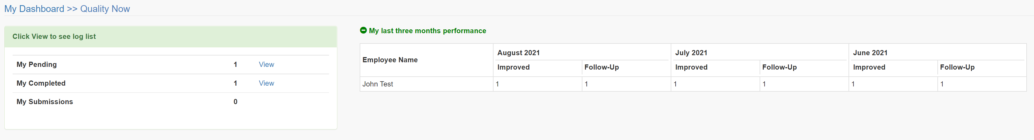

**CSR:**

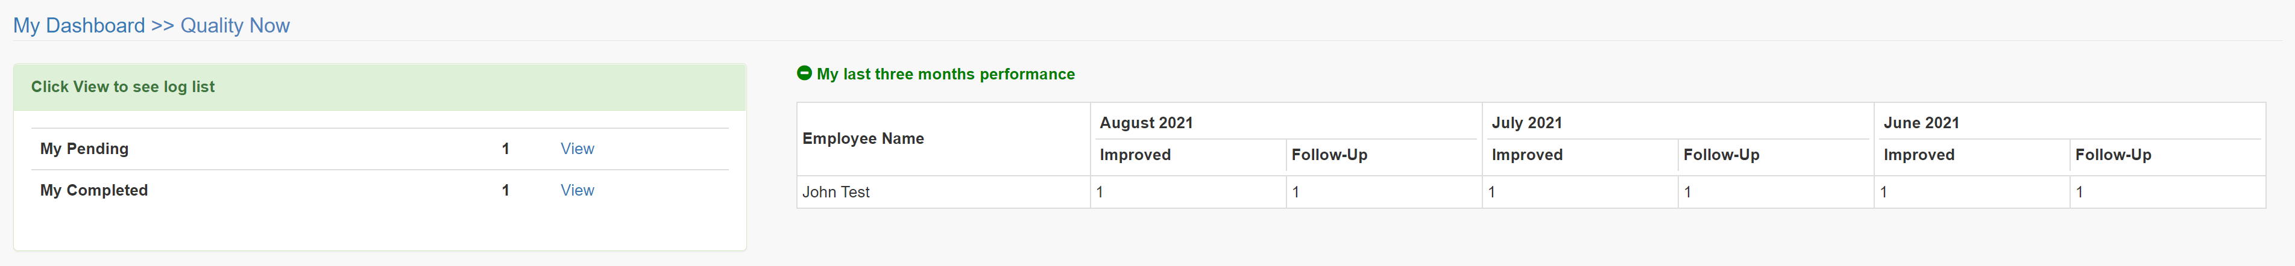

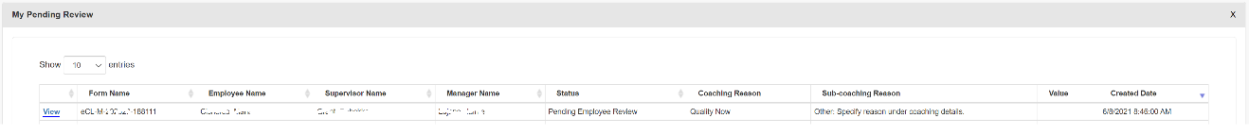

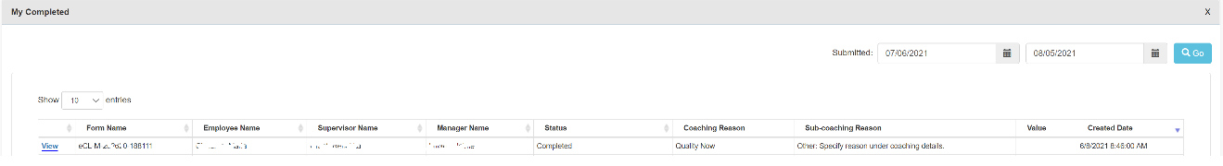

**Employee:**

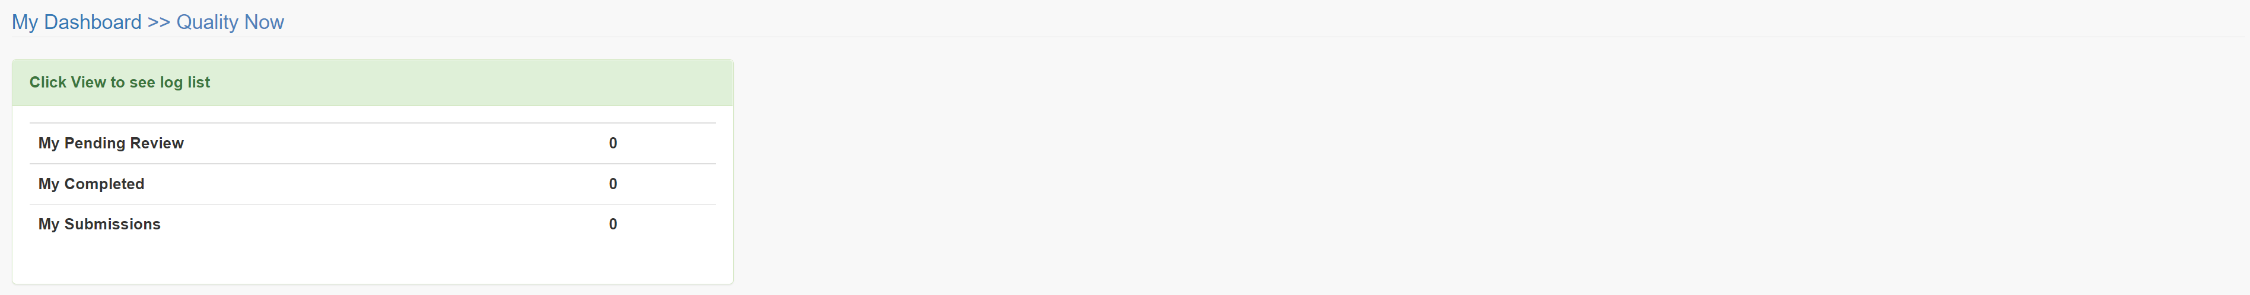

**Manager:**

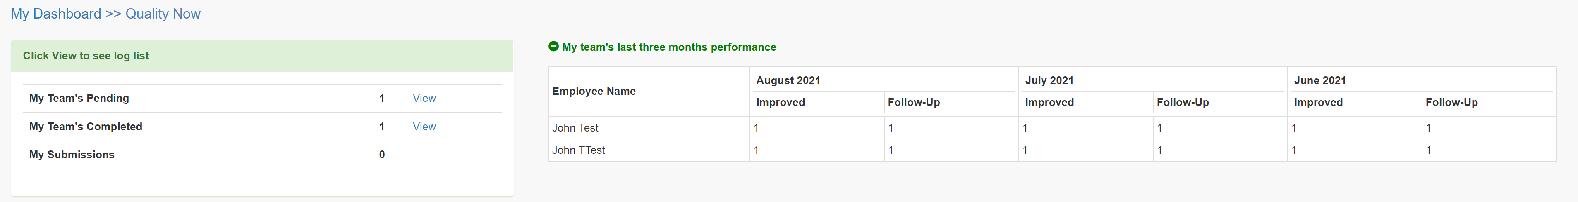

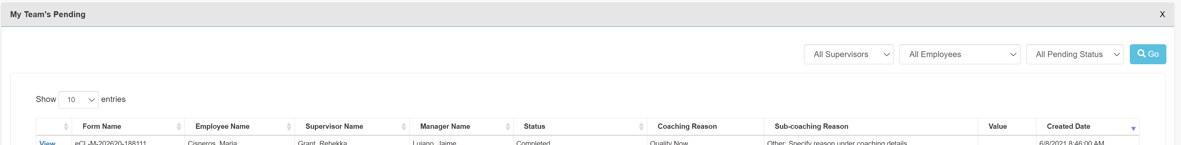

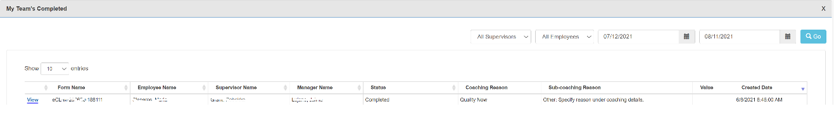

**Supervisor:**

