________________________

[MAXIMUS logo](https://www.maximus.com/)

Detail Design: CCO eCoaching Log - New Submission

________________________

Prepared by: Lili Huang Date: 04/23/2018

Department: FCD

Change History Log

| Date | Change Description | Author |
| --- | --- | --- |
| 04/23/2018 | Initial Revision – TFS 10200 | Lili Huang |
| 07/05/2018 | Minor update per review | Lili Huang |
| 08/31/2018 | TFS11984 – Include a link to ecl sharepoint site to report issues;  Updated 3.4 Web Page Invoked Events | Lili Huang |
| 09/04/2018 | TFS11984 - Include a link to ecl sharepoint site to report issues;  Moved the change to Common DD. | Lili Huang |
| 03/07/2019 | TFS13717 – Add Dual as a Program and Change Module label; | Lili Huang |
| 03/13/2019 | TFS13809 – New Submission: Changing Program resets Direct/Indirect radion btn; | Lili Huang |
| 09/04/2019 | TFS 14679 – Follow-up Process | Lili Huang |
| 07/24/2020 | TFS 17803 – GDIT to MAXIMUS | Lili Huang |
| 08/27/2020 | TFS 18322 – Work At Home (Return to Site Only) | Lili Huang |
| 10/05/2021 | TFS 23137 – Quality – new coaching reason pfd and pfd date;  Updated screenshot | Lili Huang |
| 06/07/2022 | TFS 24733 – Team Submission | Lili Huang |
| 04/11/2023 | TFS 26420 – New Coaching Reason: Claims View (Medicare Only).  Updated 2. Business Logic – NewSubmissionController.cs  Updated screenshot | Lili Huang |
| 12/04/2023 | 27483 - WAH coaching reason text change, subcoaching reason update; Add WFH (Return to Site) for Quality module.  Updated “Work At Home” to “Work From Home”. | Lili Huang |
| 02/14/2024 | TFS 27695 – Subcontractor;  Updated: 1. Description | Lili Huang |
| 05/05/2024 | TFS 28208 – ISG  Add ISG module (only for CCO sites);  Allow users with job codes of “WACS50 and “WACS60” to have the ability of mass submission for Supervisor Module;  All users with job oces of “WACQ13, WACQ40, and WPPM50” to have the ability of mass submission for Quality Module.  TFS 28134 – No warning logs for Subcontractors. | Lili Huang |
| 07/24/2024 | TFS 28468 – ASR  TFS 28490 – Production Planning  Updated:  1. Description 2. Business Logic 3.3 Screenshot 4. Log Initial Status | Lili Huang |
| 08/09/2024 | TFS 28645 – LSA.  Updated:  1. Description | Added LSA mass submission.  2. Business Logic – NewSubmisionController.cs | If LSA is selected section.  3. Screenshot | Lili Huang |
|  |  |  |

Table of Contents

**1.** **Description** 5

**2.** **Business Logic – NewSubmissionController.cs** 5

**3.** **Page details - Views\NewSubmission\Index.cshtml** 9

3.1 Razor pages comprising Web Page 9

3.2 Layout Page 9

3.3 Screenshot 9

3.4 Web Page Invoked Events 13

**4.** **Log Initial Status** 16

4.1 Coaching Log 16

4.2 Warning Log 16

1. **Description**

This module allows authorized users to submit coaching/warning logs for the following groups:

* **CSR** *(CCO and Subcontractors)*
* **ISG** (*CCO*)
* **LSA** *(CCO)*
* **Production Planning (*CCO*)**
* **QUALITY** *(CCO)*
* **SUPERVISOR** *(CCO and Subcontractors)*
* **TRAINING** *(CCO and Subcontractors)*

Authorized Maximus users can submit warning logs for those who directly report to them.

Authorized Maximus users with a role of ARC, or QAM, or PMA can submit coaching logs for subcontractors.

Authorized subcontractor users can submit coaching logs only for their own site.

Users access New Submission page by clicking “New Submission” on the top menu bar. Based on which Employee Level is selected, different information will be collected to complete the submission.

|  |  |
| --- | --- |
| **Employee Level** | **Authorized User based on job code (Configured in table Module_Submission)**  See database detail design for details. |
| CSR, ISG | select * from ec.Module_Submission where csr = 1 |
| LSA | select * from ec.Module_Submission where lsa = 1 |
| Production Planning | select * from ec.Module_Submission where productionplanning = 1 |
| Quality | select * from ec.Module_Submission where quality = 1 |
| Supervisor | select * from ec.Module_Submission where supervisor = 1) |
| Training | select * from ec.Module_Submission where training = 1 |

Users with job codes WACS40 or WACS50 or WACS60 can submit coaching logs for up to 100 employees in one submission. This is restricted to Employee Level of **CSR** only.

Users with job codes WACS50 or WPPM50 can submit coaching logs for up to 100 employees in one submission. This is restricted to Employee Level of **ISG** only.

Users with job codes WIHD50 can submit coaching logs for up to 100 employees in one submission. This is restricted to Employee Level of **LSA** only.

Users with job codes WMPR40 or WCWF50 or WPOP60 can submit coaching logs for up to 100 employees in one submission. This is restricted to Employee Level of **Production Planning** only.

Users with job codes WACQ13 or WACQ40 or WPPM50 can submit coaching logs for up to 100 employees in one submission. This is restricted to Employee Level of **QUALITY** only.

Users with job codes WACS50 or WACS60 can submit coaching logs for up to 100 employees in one submission. This is restricted to Employee Level of **SUPERVISOR** only.

1. **Business Logic – NewSubmissionController.cs**

Upon user enters the page, display Employee Level dropdown only, which is populated based on user’s job code.

* If CSR is selected,
* For users with job codes other than WACS40, WACS50, and WACS60, display Program dropdown, Site dropdown (all active CCO sites if user is Maximus employee; subcontractor own site if user is subcontractor employee), and Employee dropdown. Populate Employee dropdown with all active CSR employees for the selected site.
* For users with job codes WACS40 or WACS50 or WACS60, display Program dropdown, Site dropdown (all active CCO sites plus “All Sites” as an option if user is Maximus employee; subcontractor own site if uiser is subcontractor employee), and Employee dual select box. Populate Employee dual select box with all active CSR employees for the selected site. If user is Maximus employee, user is able to include CSR employees from site(s) other than the selected site by clicking “Add”, which is located above the Employee dual select box.
* If LSA is selected,
* For authorized users with job codes other than WIHD50, display Employee dropdown; The Employee dropdown has all employees on LSA team.
* For users with job code WIHD50, display Employee dual select box. Populate Employee dual select box with all employees on LSA team.

* If Quality is selected,
* For users with job codes other than WACQ13, WACQ40, and WPPM50, display Program dropdown and Employee dropdown. Populate Employee dropdown with all active employees on quality team.
* For users with job codes WACQ13 or WACQ40 or WPPM50, display Program dropdown, Site dropdown (all active CCO sites plus “All Sites” as an option if user is Maximus employee; subcontractor own site if user is subcontractor), and Employee dual select box. Populate Employee dual select box with all active employees on quality team for the selected site.
* If Supervisor is selected,
* For users with job codes other than WACS50 and WACS60, display Program dropdown and Employee dropdown. Populate Employee dropdown with all active supervisors.
* For users with job codes WACS50 or WACS60, display Program dropdown, Site dropdown (all active CCO sites plus “All Sites” as an option if user is Maximus employee; subcontractor site is user is subcontractor), and Employee dual select box. Populate Employee dual select box with all active supervisors for the selected site.
* If Training is selected,
* Display Employee dropdown and Behavior dropdown; The Employee dropdown has all employees on training team.
* If ISG is selected,
* For users with job codes other than WACS50 and WPPM50, display Program dropdown, Site dropdown (all active CCO sites), and Employee dropdown. Populate Employee dropdown with all active ISG employees for the selected site;
* For users with job codes WACS50 or WPPM50, display Program dropdown, Site dropdown (all active CCO sites, plus “All Sites” as an option), and Employee dual select box. Populate Employee dual select box with all active ISG employees for the selected site.
* If Production Planning is selected,
* Display Site dropdown and Employee dropdown. The Site dropdown has all active CCO sites with “All Sites” as an option. The Employee dropdown displays all active employees on the Production Planning team for the selected site.
* For users with job codes WMPR40 or WCWF50 or WPOP60, instead of displaying Employee dropdown, display Employee select list box, which allows users to create logs for multiple employees in one submission.

For individual submission, user selects an employee from the Employee dropdown,

* Display supervisor and manager names for the selected employee;

For mass submission, user selects employee(s) from the Employee dual select box.

User selects a program from the Program dropdown or a behavior from the Behavior dropdown,

* Display “Will you be delivering the coaching session?” with two radio buttons (Yes; No, I will not be delivering the coaching session.) if not already displayed.

**User selects “Yes” radio button (“Will you be delivering the coaching session?”), display the following:**

* If the user is a Maximus employee, and is the supervisor of the selected employee,
* Display “Do you need to submit a progressive disciplinary coaching (WARNING)?”, default to “No”.
* If “Yes” is selected,
* Display “Please select type of wanring:” with a dropdown.
* Display “Please select warning reason” with a dropdown.
* Display “Enter/Select the date the warning was issued:” with a textbox and a calendar icon.
* Display “I have verified that all the information on this form is true and complete to the best of my knowledge” with a checkbox.
* Go to “User submits the form by clicking Submit button”.
* “Enter/Select the date of coaching:” with a textbox and a calendar icon.
* “How was the coaching opportunity identified?” with dropdown.

Include “Automated Supervisor Reporting” as one of the options for CSR and ISG modules.

* “Is this a Customer Service Escalation (CSE)?” with two radio buttons as “Yes”, “No”, default to “No”; (For CSR, ISG, Supervisor, Training modules only. If “Automated Supervisor Reporting” is selected, disable CSE selection.)
* “Select the Type of Coaching from the Categories:”.
* “Coaching Reasons” as hyperlink, which toggles to show/hide the Coaching Reason list.
* [Coaching Reason list] with checkbox for the selected Module.
* Display sub coaching reason list under the checked coaching reason.
* Display “Opportunity” or “Reinforcement” or “Research Required” or all three options (based on the checked Coaching Reason) with radio buttons.
* “Provide details of the behavior to be coached:” with textarea, maximum 3000 characters if reasons other than “Work From Home (Return to Site Only) selected; Otherwise display “Provide details of the behavior to be coached:” with the following:

CCO employees who participate in the CCO Work From Home are obligated to comply with all Maximus policies and procedures. The purpose of this eCL is to notify you that your CCO Remote Work Agreement is being rescinded.

Effective you will be required to report to work at the site. You will be reporting to . Any wages adjustments that were completed based on your remote status and the county you live in will be adjusted to reflect the location you are working and your position.

Any equipment you have received for the Work From Home assignment should be returned to your supervisor on your first day of reporting to the site.

Maximus anticipates that a mutually beneficial employment relationship will continue as you work at the site.

* “Provide the details from the coaching session including action plans developed:” with textarea, maximum 3000 characters.
* If it is CSR or ISG or LSA or Production Planning module, display “Is follow-up required?” with two radio buttons as “Yes”, “No”.
* If “Yes” is selected,
* Display “Select the date of follow-up:” with a textbox and a calendar icon.
* “Is there a Call Record associated with the coaching?” with two radio buttons as “Yes”, “No”, default to “No”.
* If “Yes” is selected,
* Display Call Type dropdown (allow users to select a call type) with a textbox (allow users to enter the selected call ID).
* “I have verified that all the information on this form is true and complete to the best of my knowledge” with checkbox.

**User selects “No, I will not be delivering the coaching session.” radio button (“Will you be delivering the coaching session?”), display the following:**

* “Enter/Select the date of event:” with a textbox and a calendar icon.
* “How was the coaching opportunity identified?” with dropdown.

Include “Automated Supervisor Reporting” as one of the options for CSR and ISG modules.

* “Is this a Customer Service Escalation (CSE)?” with two radio buttons as “Yes”, “No”, default to “No”; (For CSR, ISG, Supervisor, Training modules only. If “Automated Supervisor Reporting” is selected, disable CSE selection.)
* “Select the Type of Coaching from the Categories:”.
* “Coaching Reasons” as hyperlink, which toggles to show/hide the Coaching Reason list.
* [Coaching Reason list] with checkbox for the selected Module.
* Display sub coaching reason list under the checked coaching reason.
* Display “Opportunity” or “Reinforcement” or “Reinforcement or all three options (based on the checked Coaching Reason) with radio buttons.
* If non-Medicare program is selected, display error message when user selects “Claims View (Medicare Only)” coaching reason.
* “Provide details of the behavior to be coached:” with textarea, maximum 3000 characters.
* If it is CSR or ISG or LSA or Production Planning modules, display “Is follow-up required?” with two radio buttons as “Yes”, “No”. Disable “Is follow-up required?” question if “Automated Supervisor Reporting” is selected for “How was the coaching opportunity identified?”
* If “Yes” is selected,
* Display “Select the date of follow-up:” with a textbox and a calendar icon.
* “Is there a Call Record associated with the coaching?” with two radio buttons as “Yes”, “No”, default to “No”.
* If “Yes” is selected,
* Display Call Type dropdown (allow users to select a call type) with a textbox (allow users to enter the selected call ID).
* “I have verified that all the information on this form is true and complete to the best of my knowledge” with checkbox.

User submits the form by clicking Submit button:

* Validate form data.
* If not valid, display validation errors.
* If valid, save data to database; if success, reset the page and display success message; otherwise, display save fail message.
* Generate/Stored email notification(s) in database.

User cancels the submission by clicking Cancel button:

* Reset the page.

1. **Page details - Views\NewSubmission\Index.cshtml**
   1. Razor pages comprising Web Page

_AddEmployee.cshtml

_EmployeeDualListBox.cshtml

_EmployeeSelection.cshtml

_Message.cshtml

_NewSubmission.cshtml

_NewSubmissionBottom.cshtml

_NewSubmissionCoach.cshtml

_NewSubmissionCoachingReasons.cshtml

_NweSubmissionIsCoachingByYou.cshtml

_NewSubmissionTop.cshtml

_NewSubmissionTop.csthml

_NewSubmissionWarning.cshtml

_NesSubmissionWarningChoice.cshtml

* 1. Layout Page

Views\Shared\_Layoutcshtml

* 1. Screenshot

Individual Indirect:

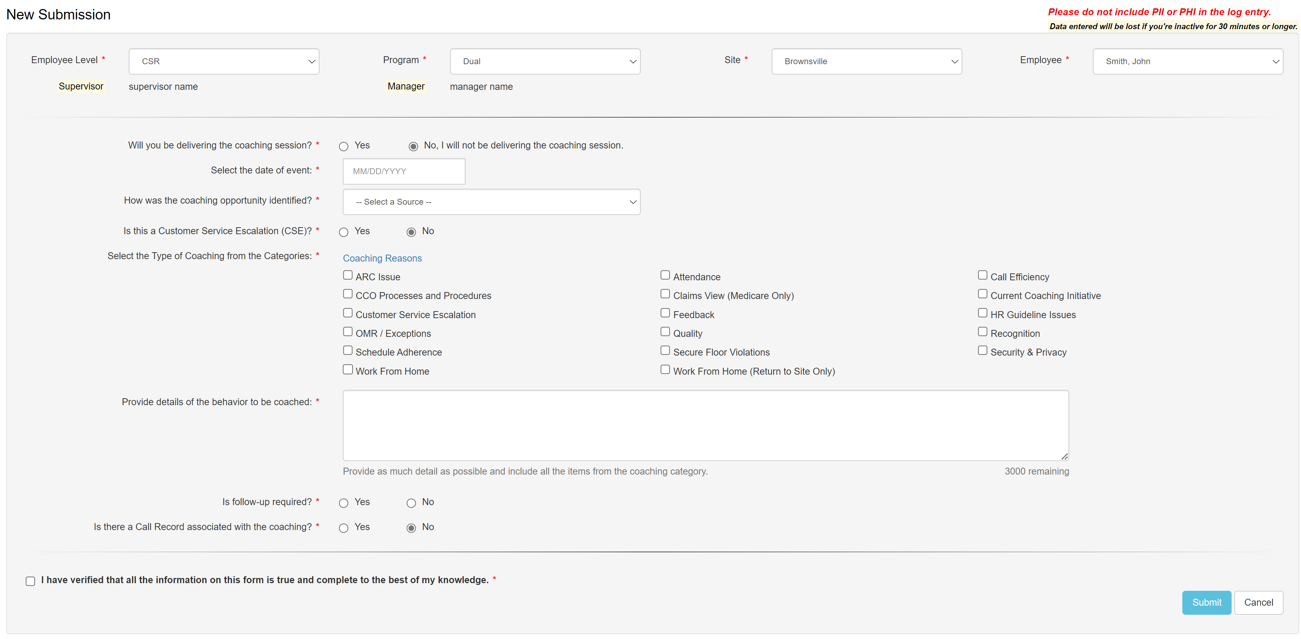

Note: Coaching Reasons vary based on Employee Level selection.

See database table Coaching_Reason_Selection for details.

Individual Direct:

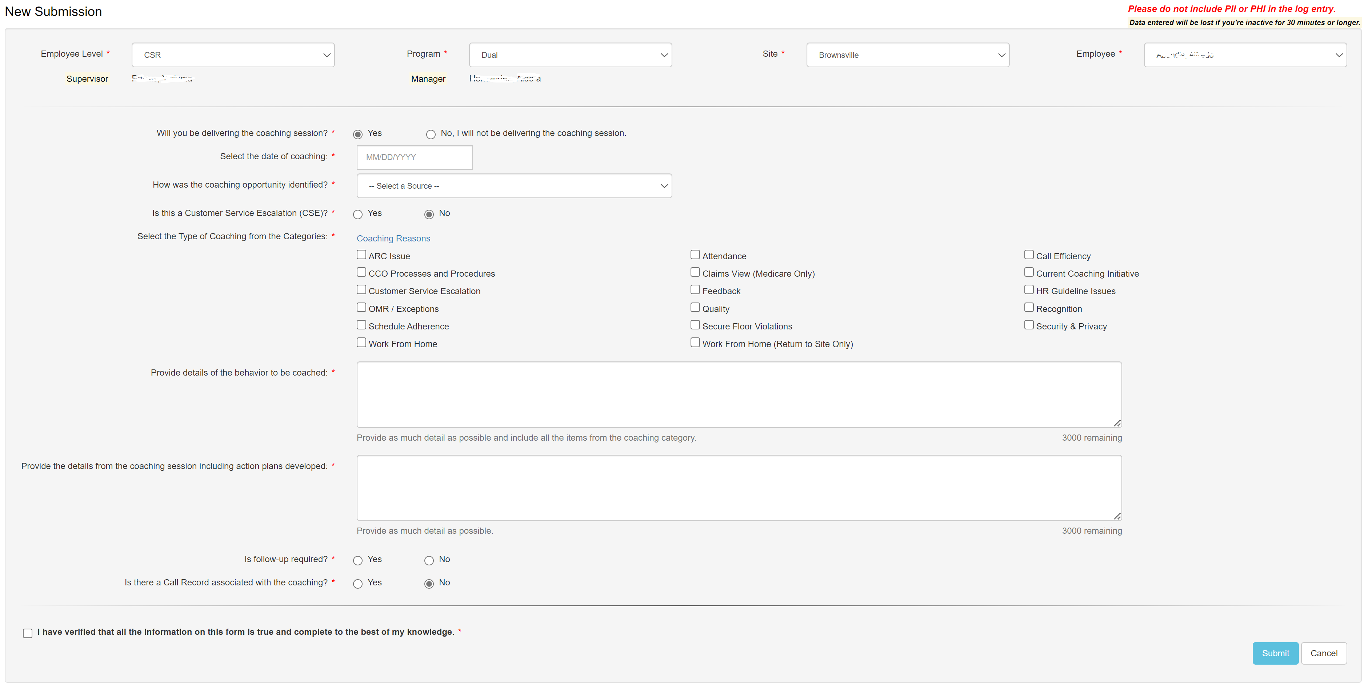

Note: Coaching Reasons vary based on Employee Level selection.

See database table Coaching_Reason_Selection for details.

Mass/Team Submission:

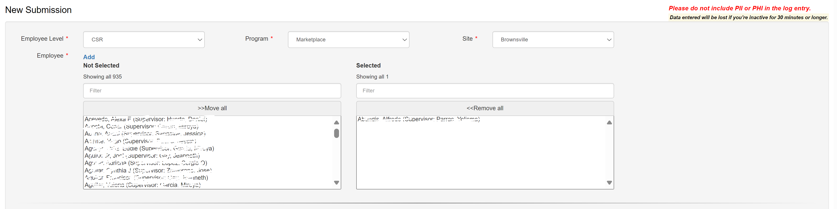

Customer Service Escalation (CSR, ISG, Supervisor, Training):

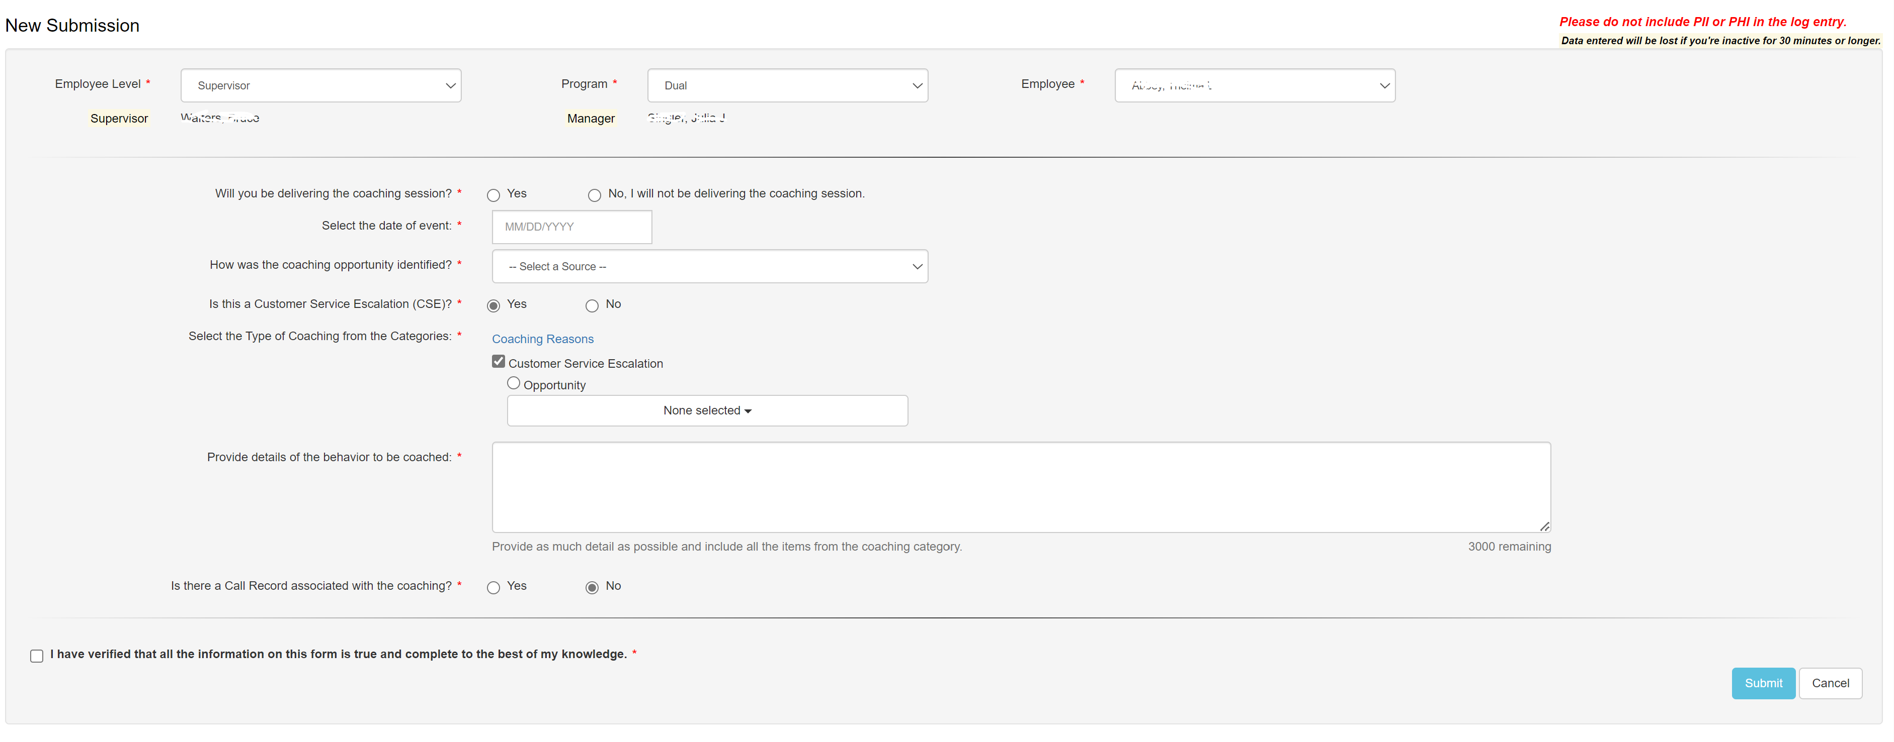

Follow-up Required (CSR, ISG, LSA, Production Planning):

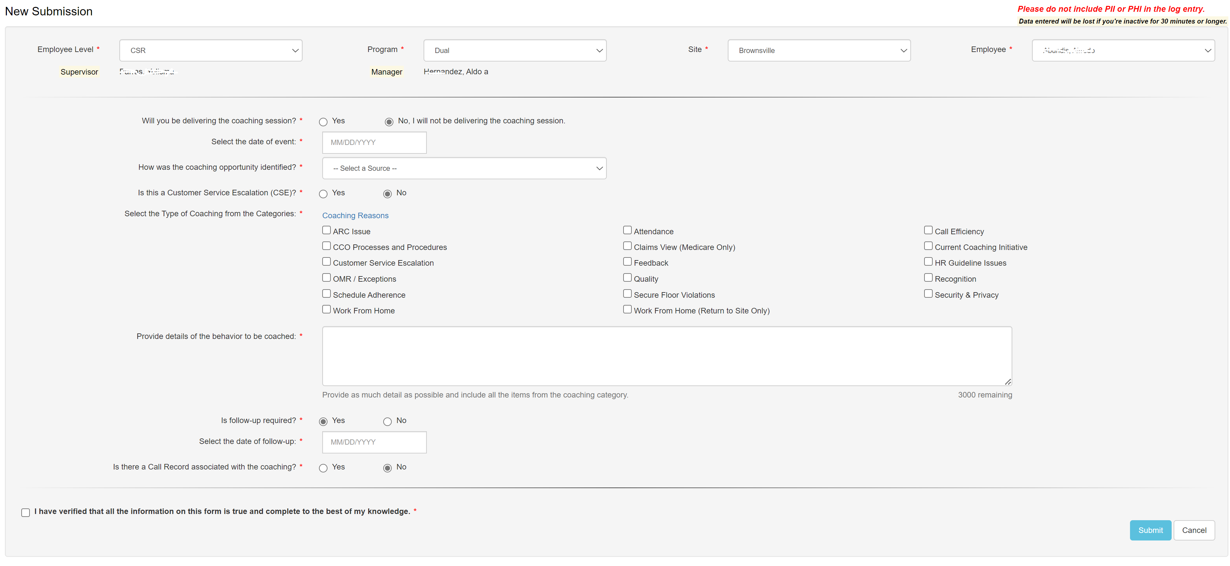

Note: Coaching Reasons vary based on Employee Level selection.

See database table Coaching_Reason_Selection for details.

Call Record Associated (CSR, ISG, Quality, Supervisor, Training):

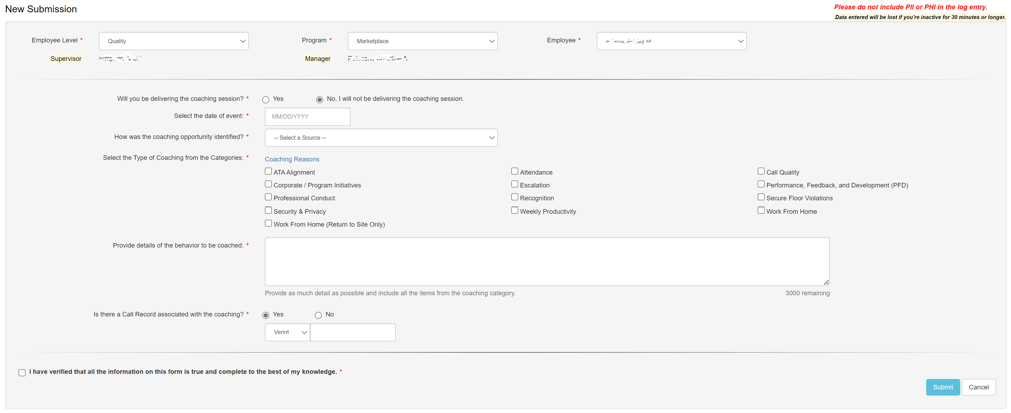

Note: Coaching Reasons vary based on Employee Level selection.

See database table Coaching_Reason_Selection for details.

Work From Home (Return to Site Only):

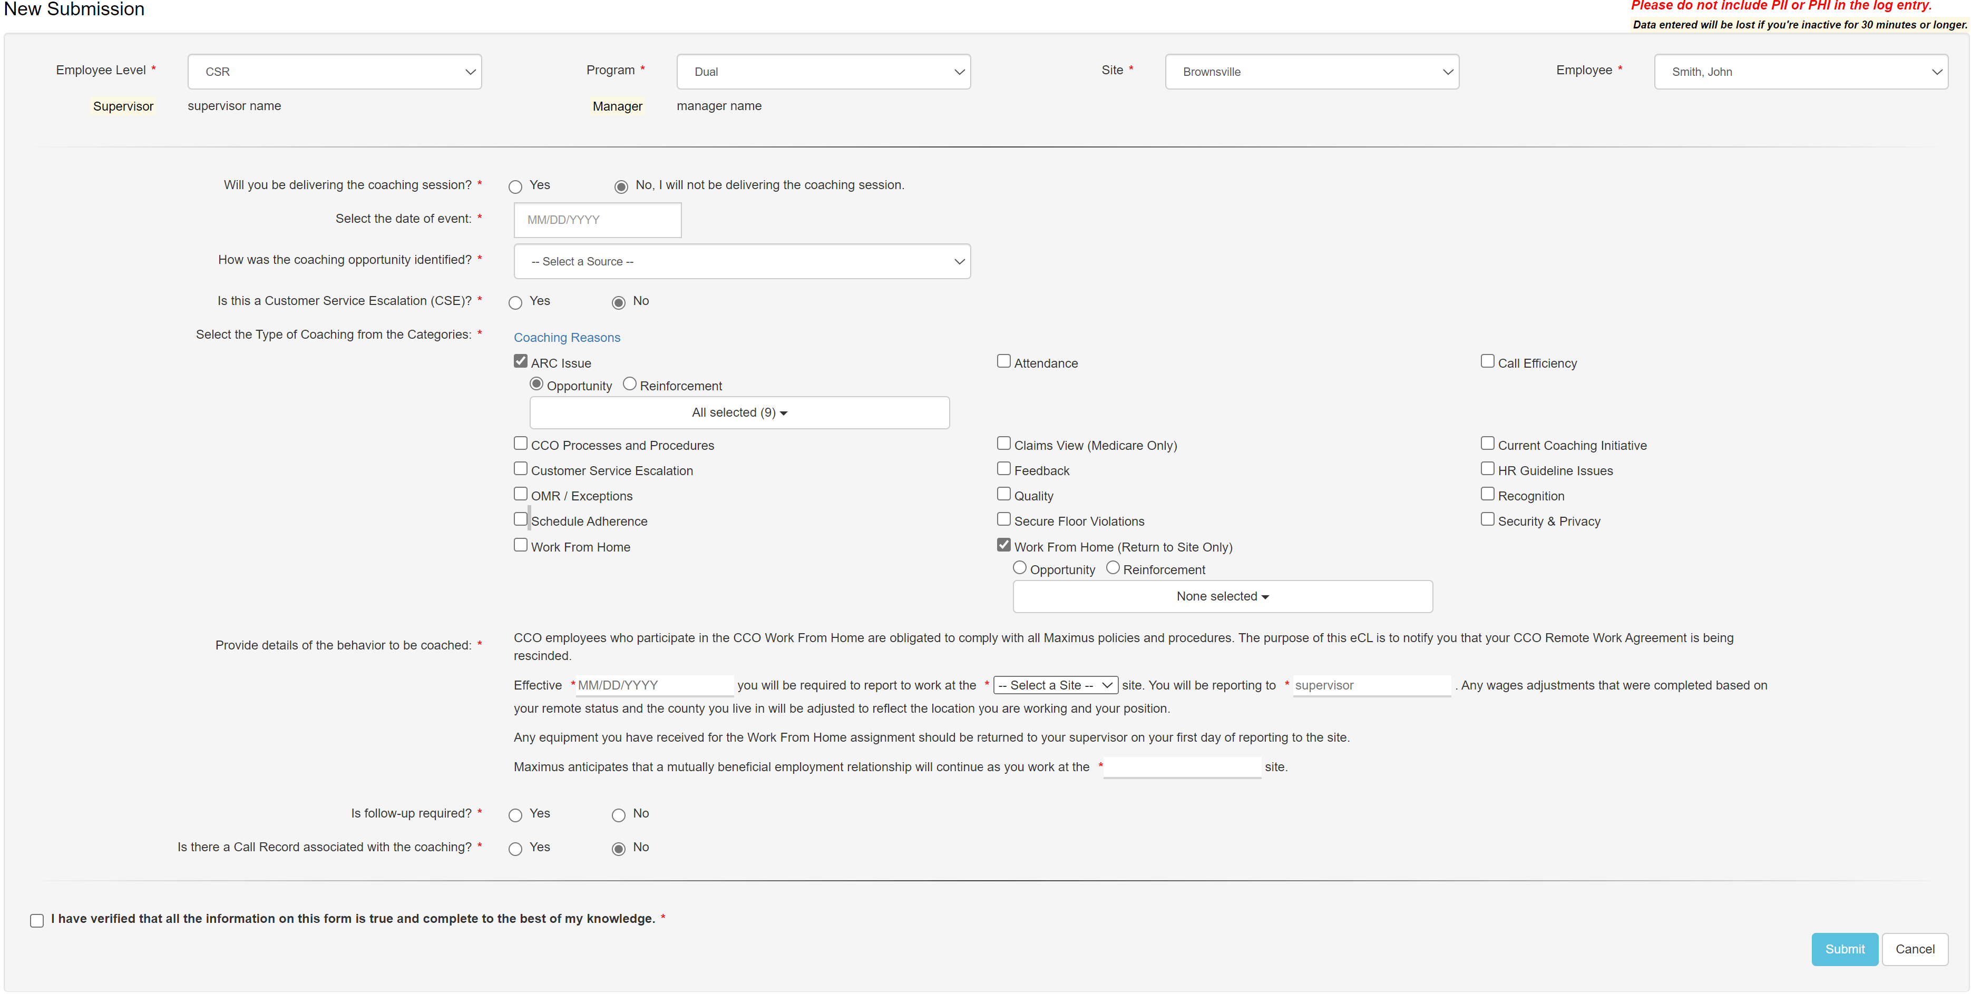

ASR Indirect (CSR and ISG only):

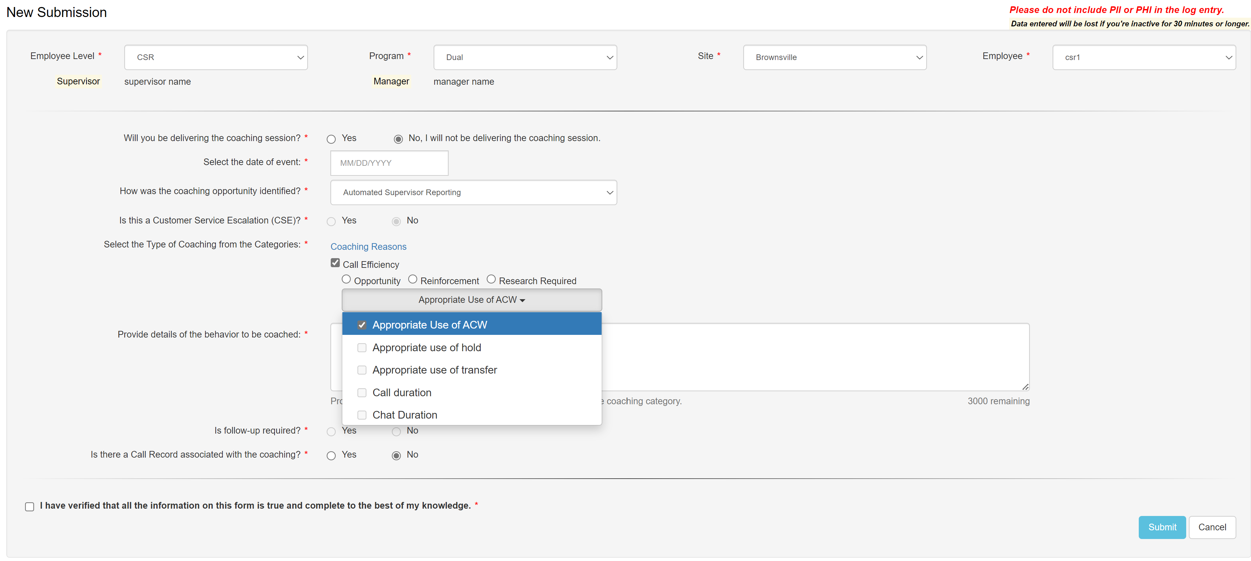

ASR Direct (CSR and ISG only):

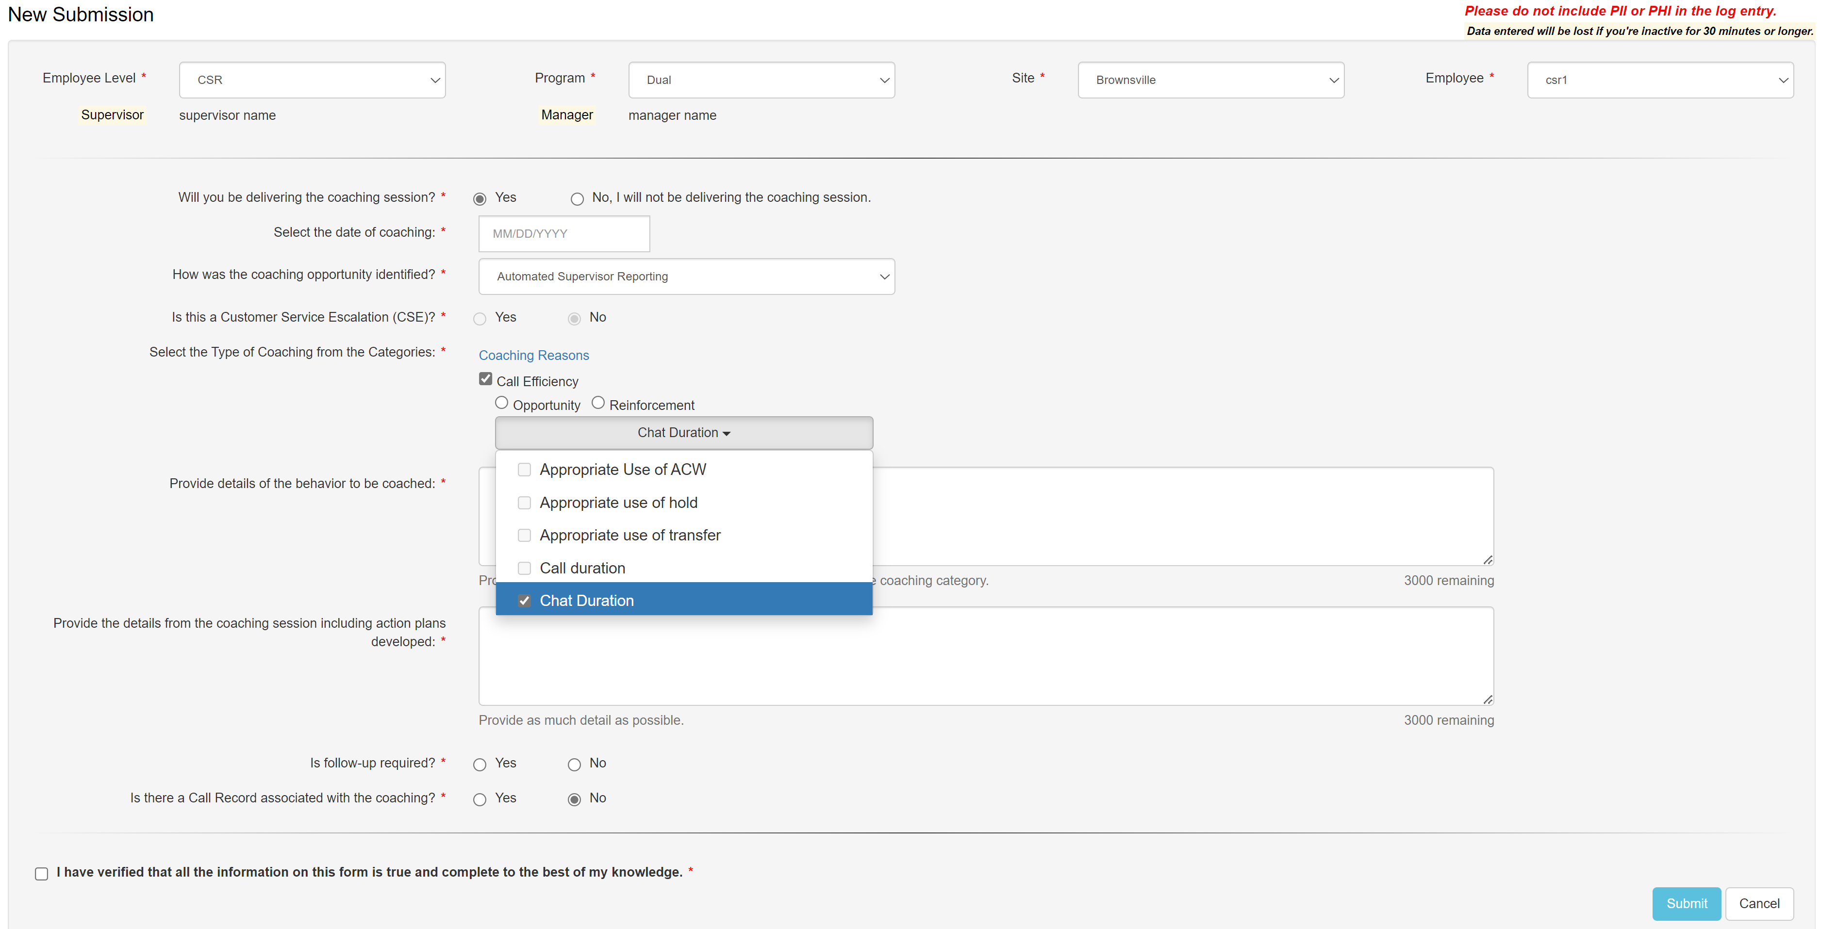

Warning (Direct, one employee selected only, user must be the supervisor or manager of the selected employee):

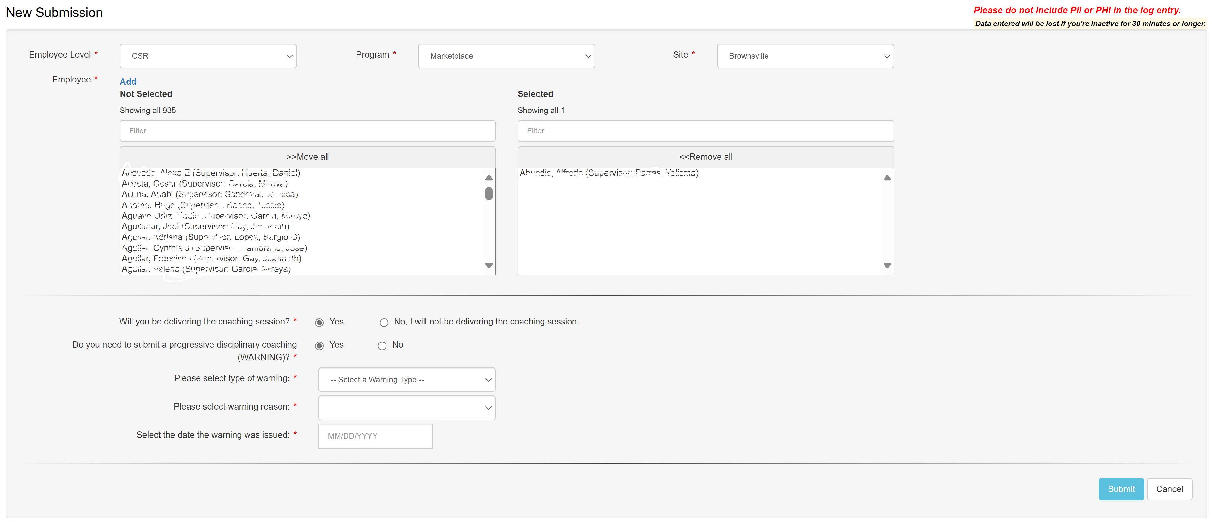

* 1. Web Page Invoked Events

| Action | Processing & Result |
| --- | --- |
| Select a module from “Employee Level:” dropdown | Ajax call is made to reset the page.  Controller: NewSubmission  Action: ResetPage  If the selected module is other than “CSR” and “Training”, the page displays populated Employee dropdown and Program dropdown;  If the select module is “CSR”, the page displays Site dropdown (with all active sites);  If the selected module is “Training”, the page displays populated Employee dropdown and Behavior dropdown. |
| Select a site from “Site:” dropdown | Controller: NewSubmission  Action: HandleSiteChanged  Display populated Employee dropdown (All CSRs for the selected site) and Program dropdown. |
| Select an employee from “Employee” dropdown | Controller: NewSubmission  Action: GetMgtInfo  Display Supervisor name and manager name of the selected employee. |
| Select employee(s) from “Employee” dual list box | Check if the number of selected employees has reached the limit (100 for coaching log, and 1 for warning log);  If it reaches the limit, display warning message. |
| Click “Yes” for “Will you be delivering the coaching session?” | Controller: NewSubmission  Action: ResetPageBottom  Page displays the rest of the questions required for the submission:  Do you need to submit a progressive disciplinary coaching (WARNING)? (*Note: this displays only if the user is the selected employee’s supervisor);*  Enter/Select the date of coaching;  Is this a Customer Service Escalation (CSE), (*Note: this is for CSR module only);*  Select the Type of Coaching from the Categories;  Provide details of the behavior to be coached;  Provide the details from the coaching session including action plans developed;  How was the coaching opportunity identified;  Is there a Call Record associated with the coaching |
| Click “Yes” for “Do you need to submit a progressive disciplinary coaching (WARNING)?” | Controller: NewSubmission  Action: ResetPageBottom  Page displays the rest of the questions required for the warning log submission:  Please select type of warning;  Pelase select warning reason;  Enter/Select the date the warning was issued. |
| Click “No” for “Will you be delivering the coaching session?” | Controller: NewSubmission  Action: ResetPageBottom  Same as “Yes”, except not displaying question “Provide the details from the coaching session including action plans developed”. |
| Click “Yes” for “Is this a Customer Service Escalation (CSE)?” | Controller: NewSubmission  Action: LoadCoachingReasons  Coaching Reasons section will be refreshed. |
| Select a Coaching reason by checking the checkbox | Controller: NewSubmission  Action: HandleCoachingReasonClicked  Display sub coaching reason dropdown and “Opportunity”, “Reinforcement” radio buttons for the selected Coaching reason. |
| UnSelect a Coaching reason by unchecking the checkbox | Controller: NewSubmission  Action: HandleCoachingReasonClicked  Hide sub coaching reason dropdown and “Opportunity”, “Reinforcement” radio buttons for the selected Coaching reason. |
| Select Coaching reason “Work From Home(Return to Site Only)” by checking the checkbox | Javascript to show:  Replace “Provide details of the behavior to be coached:” text area with the following:  CCO employees who participate in the CCO Work From Home are obligated to comply with all Maximus policies and procedures. The purpose of this eCL is to notify you that your CCO Remote Work Agreement is being rescinded.  Effective  you will be required to report to work at the site. You will be reporting to . Any wages adjustments that were completed based on your remote status and the county you live in will be adjusted to reflect the location you are working and your position.  Any equipment you have received for the Work From Home assignment should be returned to your supervisor on your first day of reporting to the site.  Maximus anticipates that a mutually beneficial employment relationship will continue as you work at the site. |
| Unselect Coaching reason “Work From Home(Return to Site Only)” by unchecking the checkbox | Javascript to show:  “Provide details of the behavior to be coached:” editable text area. |
| Select “Yes” for “Is follow-up required?” | Javascript to show:  Follow-up date textbox, and a calendar icon;  Note: Follow-up date must be within 30 days of the submission date. |
| Select “No” for “Is follow-up required?” | Javascrip to hide:  Follow-up date textbox, and the calendar icon |
| Select “Yes” for “Is there a Call Record associated with the coaching?” | Javascript to show:  Call Type dropdown, and a text box for entering Call ID |
| Select “No” for “Is there a Call Record associated with the coaching?” | Javascript to hide:  Call Type dropdown, and a text box for entering Call ID |
| Click Submit button | Controller: NewSubmission  Action: Save |

1. **Log Initial Status**
3. 1. Coaching Log

Coaching log initial status is based on Module/Employee Level, Source, Sub-source, and whether it is CSE (Customer Service Escalation). It is configured in table Email_Notifications.

See database detail design for details.

2. 2. Warning Log

All warning logs will be submitted as Pending Employee Review.