________________________

[MAXIMUS logo](https://www.maximus.com/)

Detail Design: CCO eCoaching Log – Review

________________________

Prepared by: Lili Huang Date: 06/20/2018

Department:

Change History Log

| Date | Change Description | Author |
| --- | --- | --- |
| 06/20/2018 | Initial Revision – TFS 11388 | Lili Huang |
| 07/30/2018 | TFS 11577 – New feed file (PBH) for CSRs who took inappropriate action;  Added:  6. Logic to determine next status;  Updated:  7. Instruction Text | Lili Huang |
| 12/03/2018  02/12/2019 | TFS 12836 – OverTurned quality Appeal coaching log;  TFS 13511 - Coaching entry field appear for supervisor when in pending manager review status | Lili Huang  Lili Huang |
| 02/25/2019  05/15/2019  05/31/2019 | TFS 13350 – Quality Now  TFS 14442 – Display MRS static text based on Source  TFS 14699 – Modify logic to handle short call logs  Plus: Cleanup | Lili Huang  Lili Huang  Lili Huang |
| 07/01/2019 | TFS 14850 – Review Page: Update GDIT links to corresponding MAXIMUS ones | Lili Huang |
| 08/16/2019  08/22/2019  8/28/2019  09/04/2019  09/24/2019  12/09/2019  03/23/2020  07/24/2020 | TFS 15063 – Quality Bingo  TFS 15232 – Attendance Policy Earnback  TFS 15232 – Attendance Policy Earnback  Updated section 8: added condition  TFS 14679 – Follow-up Process  TFS 15601 – London Alternate Channel Bingo  TFS 15833 – Workflow change for warning logs  (“Pending Employee Review” 🡪 Completed)  TFS 16893 – Allow employees to enter comments to warnings  TFS 17803 – Update GDIT to MAXIMUS | Lili Huang  Lili Huang  Lili Huang  Lili Huang  Lili Huang  Lili Huang  Lili Huang  Lili Huang |
|  |  |  |
|  |  |  |
|  |  |  |

Table of Contents

**1.** **Description** 4

**2.** **Business Logic – ReviewController.cs** 4

**3.** **Page details** 5

3.1 Views\Review\_ReviewCoachingHome.cshtml, _ViewWarningLog.cshtml 5

3.1.1 Razor pages comprising Web Page 5

3.1.2 Layout Page 5

3.1.3 Screenshot 5

3.1.4 Web Page Invoked Events 19

3.1.5 Web Page Fields 19

**4.** **Stored Procedures** 30

4.1. sp_SelectReviewFrom_Coaching_Log 30

4.2. sp_SelectReviewFrom_Coaching_Log_Reasons 30

4.3. sp_SelectReviewFrom_Warning_Log_Reasons 30

4.4. sp_Update_Review_Coaching_Log_Suerpvisor_Pending 30

4.5. sp_Update_Review_Coaching_Log_Supervisor_Acknowledge 30

4.6. sp_Update_Review_Coaching_Log_Employee_Pending 30

4.7. sp_Update_Review_Coaching_Log_Employee_Acknowledge 30

4.8. sp_Update_Review_Coaching_Log_Manager_Pending_Research 30

4.9. sp_Update_Review_Coaching_Log_Manager_Pending_CSE 30

4.10. sp_SelectReviewFrom_Coaching_Log_Quality_Now 30

4.11. sp_ShortCalls_Get_BehaviorList 30

4.12. sp_ShortCalls_Get_Actions 30

4.13. sp_ShortCalls_Get_CallList 30

4.14. sp_ShortCalls_Get_SupReivewDetails 30

4.15. sp_ShortCalls_SupReview_Submit 30

4.16. sp_ShortCalls_MgrReivew_Submit 30

4.17. sp_ShortCalls_getMgrReviewDetails 30

4.18. sp_Update_Review_Caoching_Log_Supervisor_Pending_Followup 30

4.19. sp_Update_Review_Caoching_Log_Employee_Pending_Followup 30

**5.** **Logic to determine pending form type** 30

5.1. Pending Acknowledgement 30

5.2. Pending Research 30

5.3. Pending CSE 30

5.4. Pending Short Call Review (Supervisor) 30

5.5. Pending Short Call Confirm (Manager) 30

5.6. Pending Follow-Up (Supervisor) 31

5.7. Pending Regular Review 31

**6.** **Logic to determine Review Page display mode (Ready Only vs Editable)** 31

**7.** **Logic to determine next status** 31

7.1. Pending Acknowledgement 31

7.2. Pending Research 32

7.3. Pending CSE 32

7.4. Pending Short Call Review (Supervisor) 32

7.5. Pending Short Call Confirm (Manager) 32

7.6. Pending Regular Review 32

7.7. Pending Follow-Up 33

**8.** **Instruction text** 33

1. **Description**

This module allows authorized users to view or complete individual or team logs. It also allows the authorized users to view their submitted logs.

Display Review form as read only if:

1. **Historical Dashboard:**

User submitted the log, OR

User is the log’s employee, OR

User is the supervisor, OR

User is the manager, OR

User has a role as “ECL” in Historical_Dashboard_ACL table (for coaching logs only), OR

User has a role as Senior Manager, OR

User is from Human Resource (with job code starting with WHHR or WHER or WHRC);

1. **My Dashboard:**

My Submission section: users who submitted the log, OR

Warning Logs section: same as Historical Dashboard, OR

The log is Pending Supervisor Review, and user is not the supervisor or re-assigned to, OR

The log is Pending Employee Review, and user is not the log’s employee, OR

The log is neither Pending Supervisor Review nor Pending Employee Review, OR

The log doesn’t require research or CSE determination, OR

Completed logs

1. **Survey:**

User is the log’s employee

Display Review form as editable if:

1. **My Dashboard:**

Pending Coaching Logs, and user is the supervisor or re-assigned to or the log’s employee

Authorized users enter Review page by clicking any log name in the log list either from My Dashboard, Historical Dashboard, or Survey page.

1. **Business Logic – ReviewController.cs**

User clicks [Log Name] link:

* Check if the user has access to view the selected log details;

If user is not authorized, redirect user to unauthorized page;

Else call stored procedure sp_SelectReviewFrom_Coaching_Log to get log details

* If current page is Historical Dashboard or Survey

Display Review page as Read Only; (_ViewCoachingLog.cshtml if coaching log; or _ViewWarningLog otherwise)

* If current page is My Dashboard

If Short Call

Load “Not valid behaviors” from database;

Load “Valid behaviors” from database;

Load short call list from database;

End If Short Call;

Determine Pending Form Type (See section 5 for details);

Determine Review Page display mode (Read Only vs Editable);

Display Review Page;

*Note:*

*See section “5. Logic to determine pending form type”.*

*See section “6. Logic to determine Review Page display mode”.*

Display Review Page;

User clicks Submit button:

* Validate form fields; See section 3.1.5 Web Page Fields for details.

If validation passes,

Update the reviewed log in database;

Close log detail modal dialog;

Refresh log list section on My Dashboard page.

Else display validation errors

User clicks Close button:

* Close log detail modal dialog;

1. **Page details**
   1. Views\Review\_ReviewCoachingHome.cshtml, _ViewWarningLog.cshtml
      1. Razor pages comprising Web Page

_AcknowledgeCoaching.cshtml

_ConfirmReviewShortCalls.cshtml

_EmployeeReivewInfo.cshtml

_Error.cshtml

_ManagerReviewInfo.cshtml

_Reasons.cshtml

_ReviewCoaching.cshtml

_ReviewCoachingCse.cshtml

_ReviewCoachingHome.cshtml

_ReivewCoachingPending.cshtml

_ReviewCoachingResearch.cshtml

_ReviewInfo.cshtml_ReviewShortCalls.cshtml

_Scorecards.xhtml

_ShortCalls.cshtml

_SupervisorReviewInfo.cshtml

_Unauthorized.cshtml

_ViewCoachingLog.cshtml

_ViewWarningLog.cshtml

* + 1. Layout Page

Views\Shared\_Layoutcshtml

* + 1. Screenshot

**Review – Warning log (Pending Employee Review) – Editable View - user is the employee of the log**

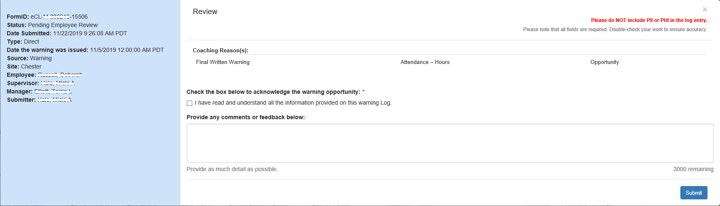

**Review – Warning log (Pending Employee Review) – Read Only View - User is the supervisor or manager of the employee**

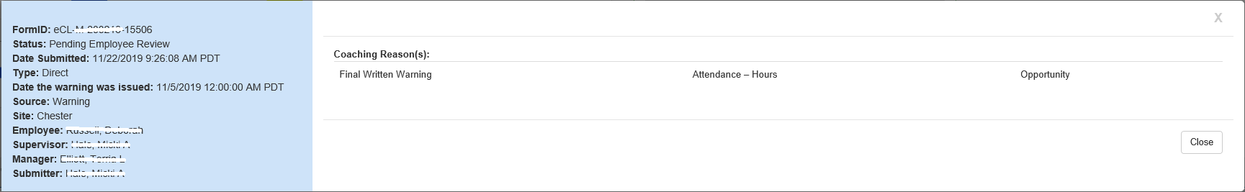

**Review – Warning log (Completed) – Supervisor or manager of the employee View**

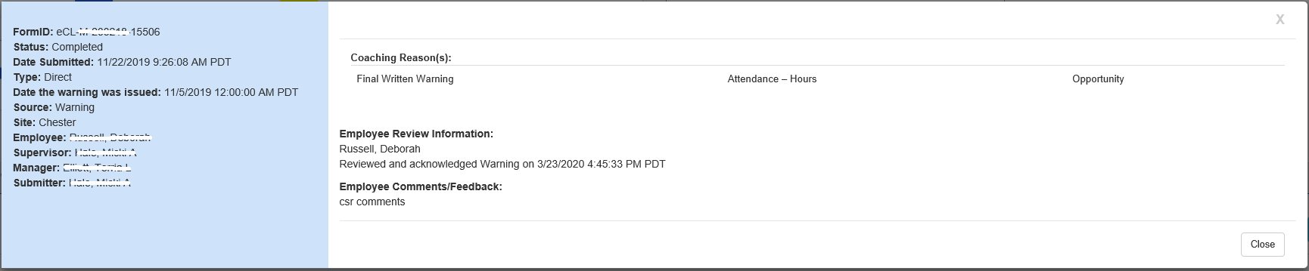

**Review – Regular Review Pending Form (editable):**

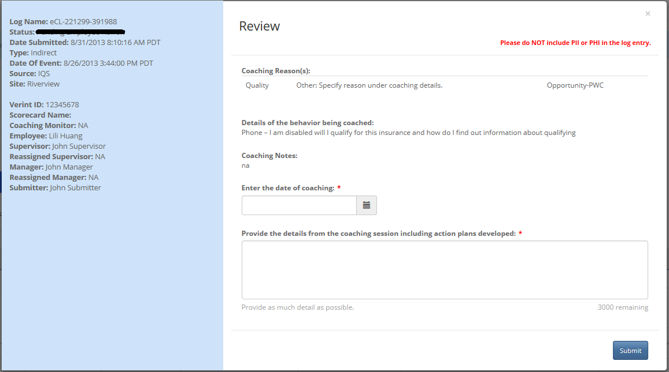

**Review - Acknowledge Pending Form (editable) – User is the log’s employee, and the log is reinforcement:**

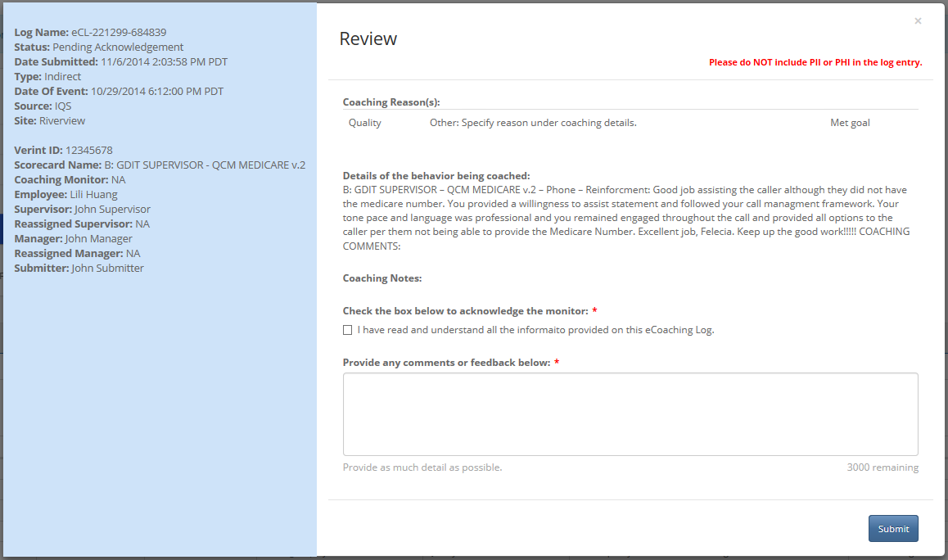

**Review - Acknowledge Pending Form (editable) – User is the log’s employee, and the log is opportunity:**

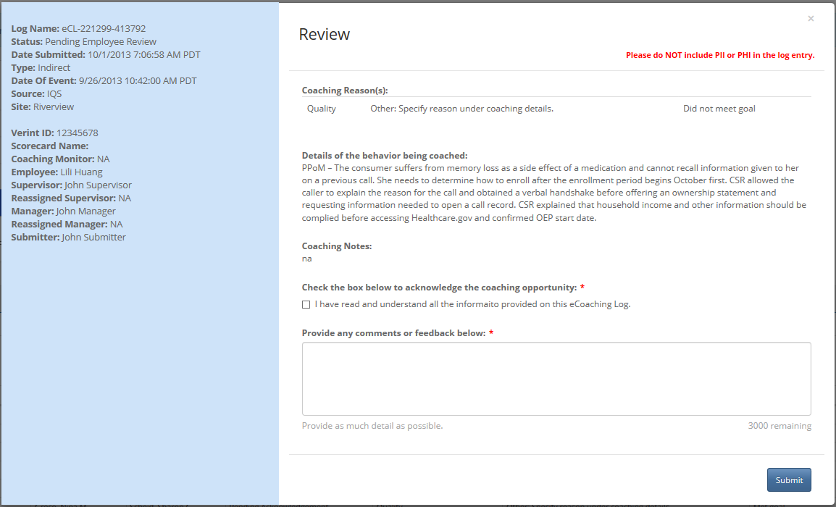

**Review - Acknowledge Pending Form (editable) – User is the supervisoropportunity:**

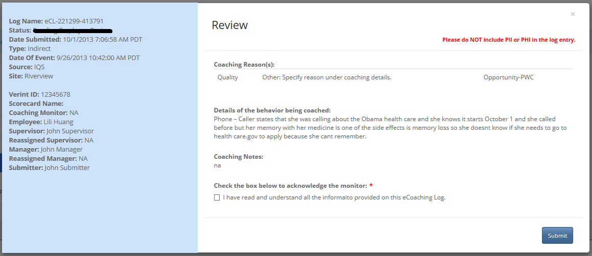

**Review – Acknowledge Pending Form (editable) – User is the supervisor, and the log is OTA (OverTurned Appeal):**

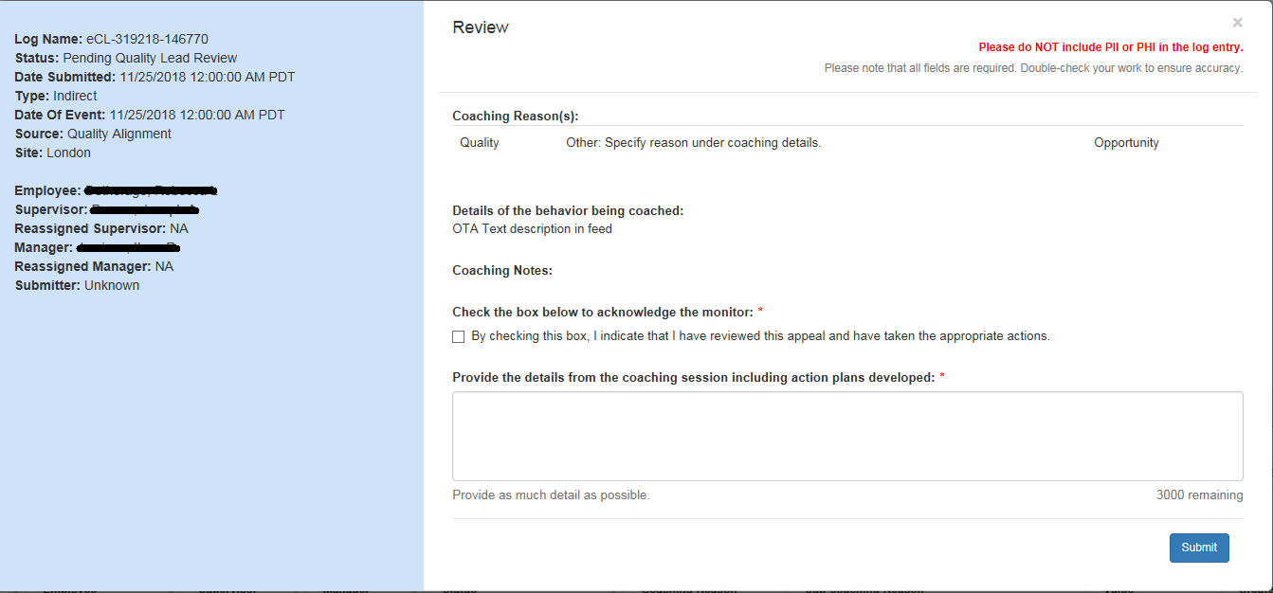

**Review – Research Review Pending Form (editable) – Coaching not required:**

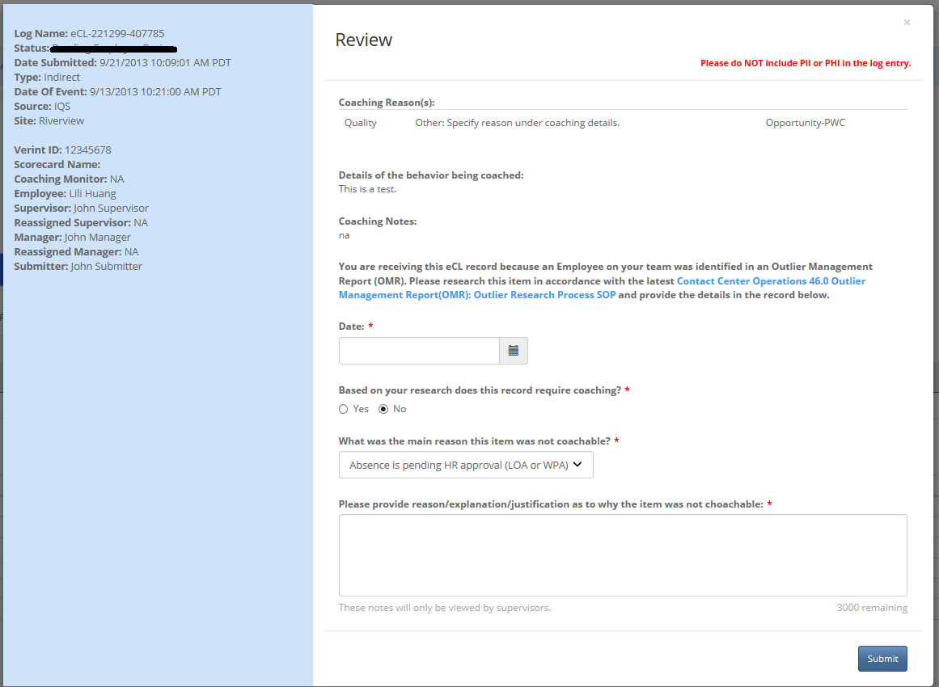

**Review – Research Review Pending Form (editable) – Coaching required:**

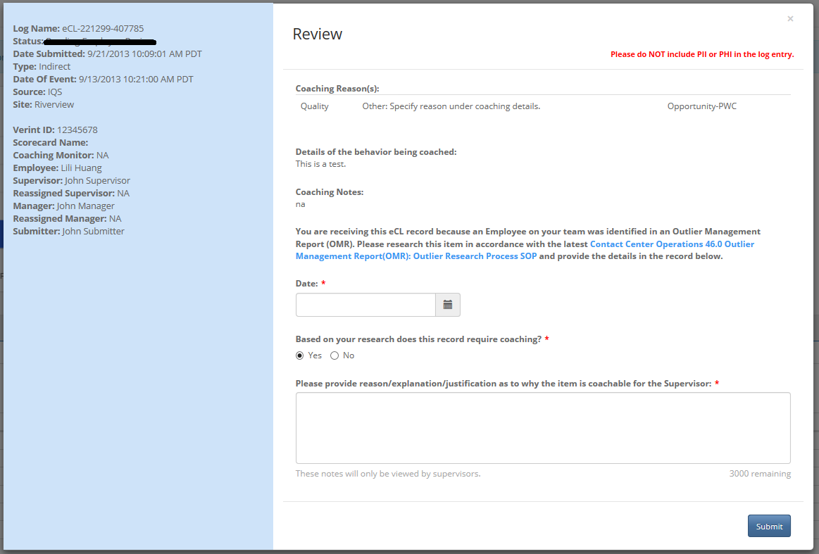

**Review – CSE Review Pending Form (editable) – Not CSE:**

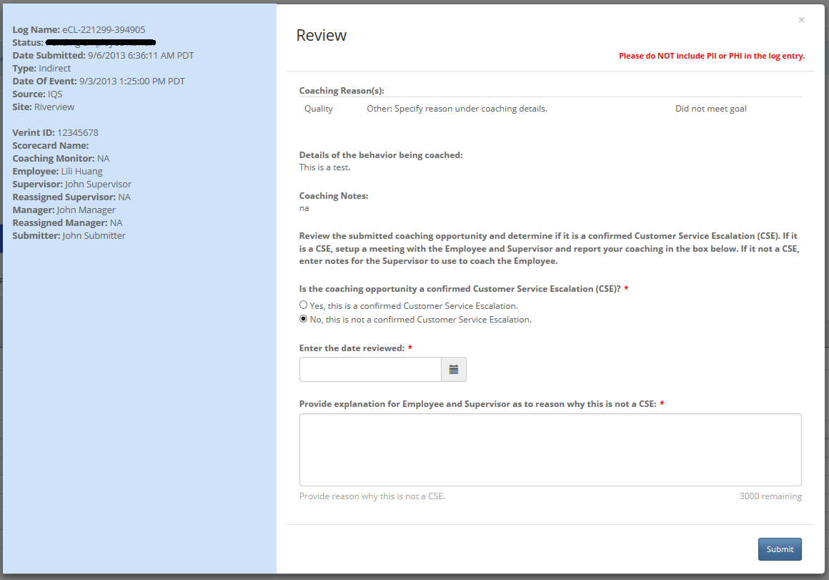

**Review – CSE Review Pending Form (editable) – Yes, CSE:**

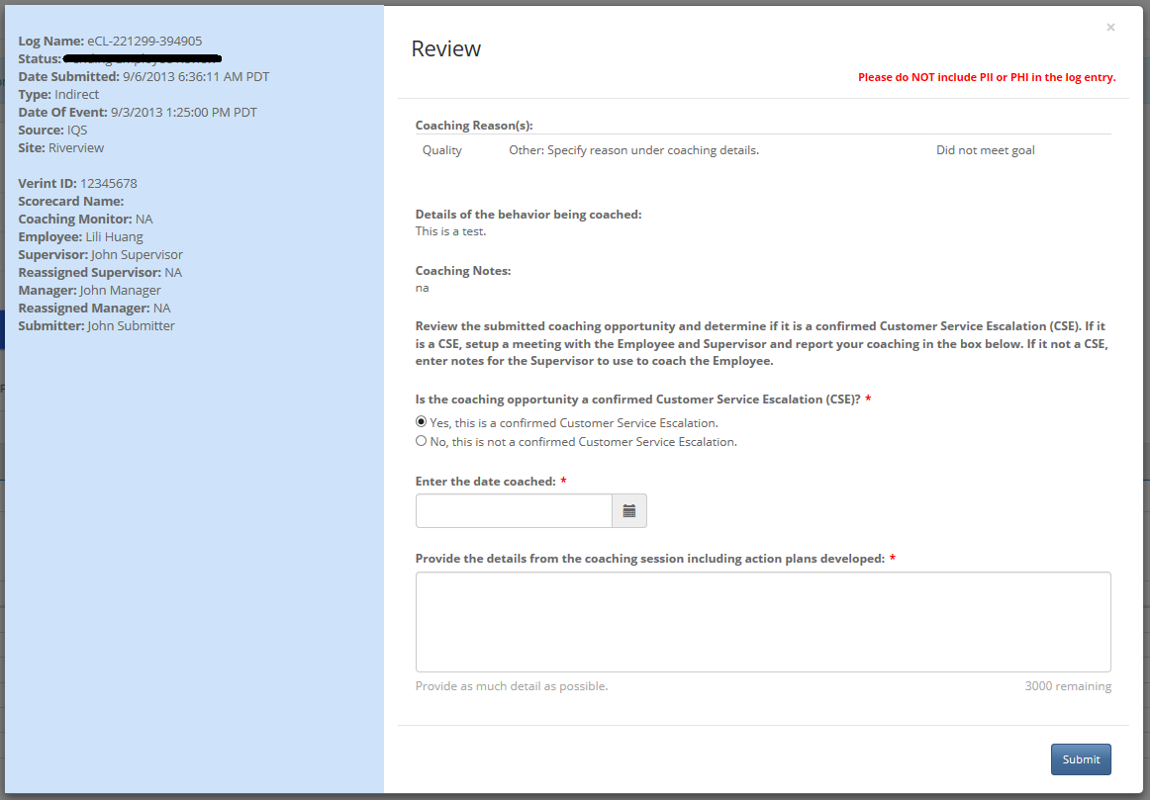

**Review – Quality Now – CSR Review Pending Form (editable) – User is the CSR of the log**

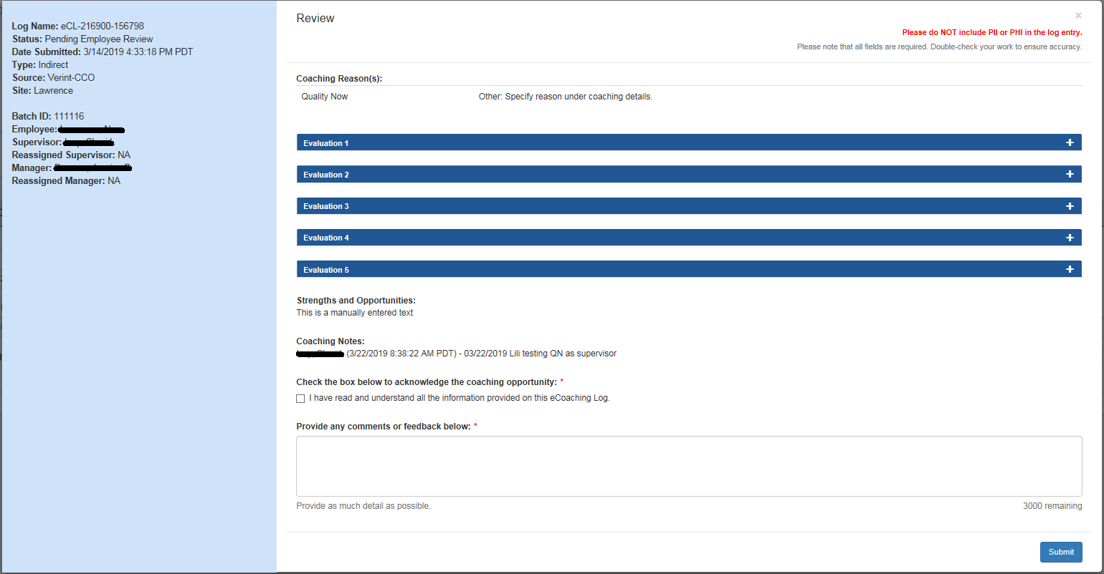

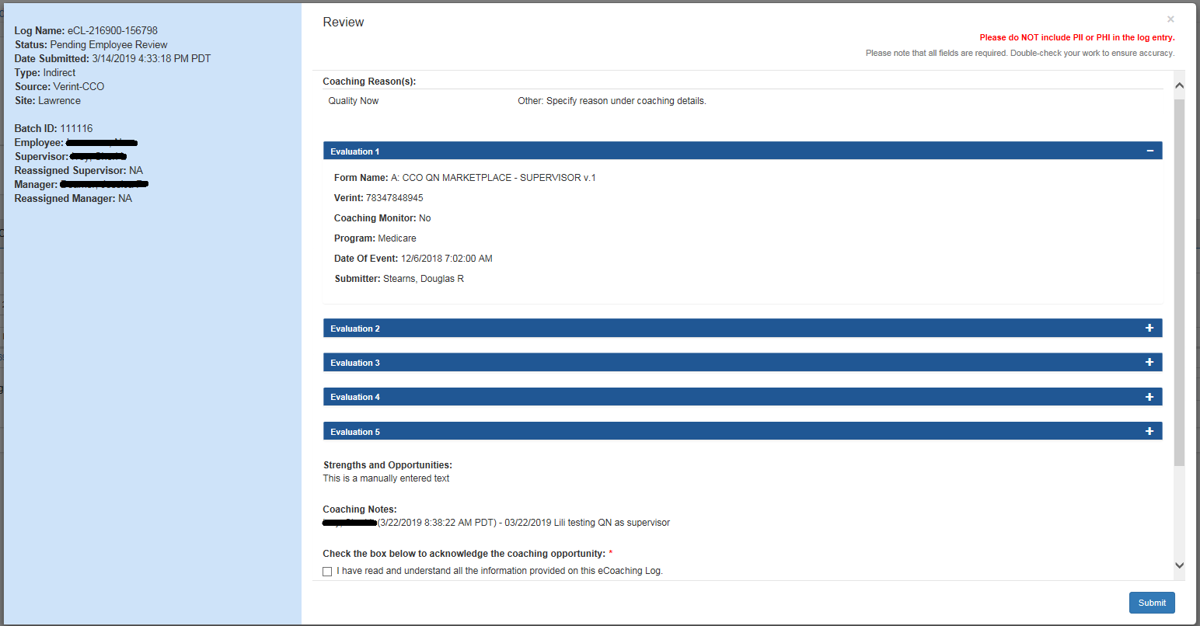

**Review – Quality Now – Supervisor Review Pending Form (editable) – User is the Supervisor**

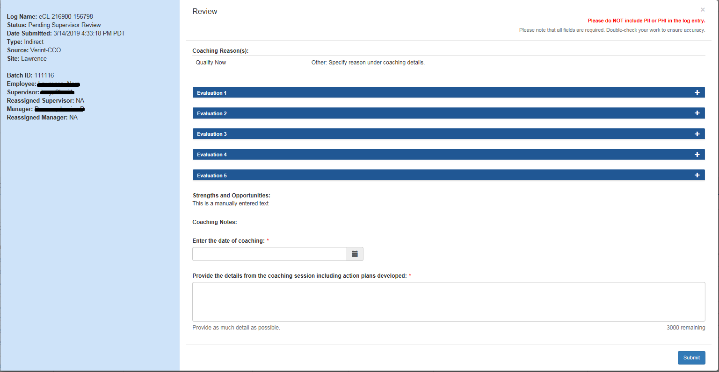

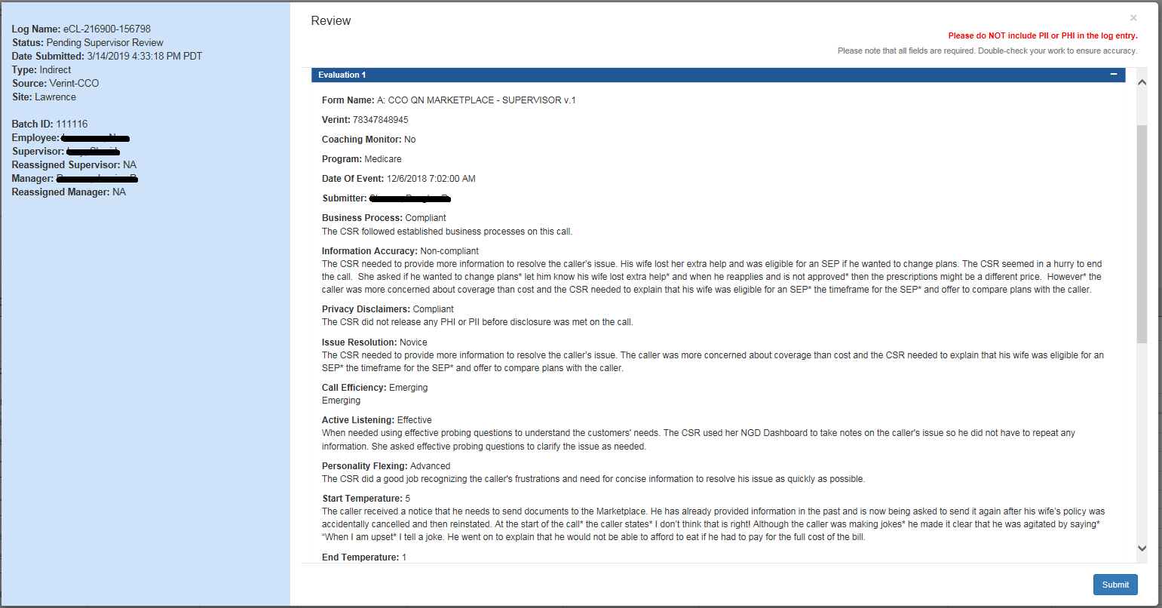

**Review – Quality Now – Manager View (Read Only)**

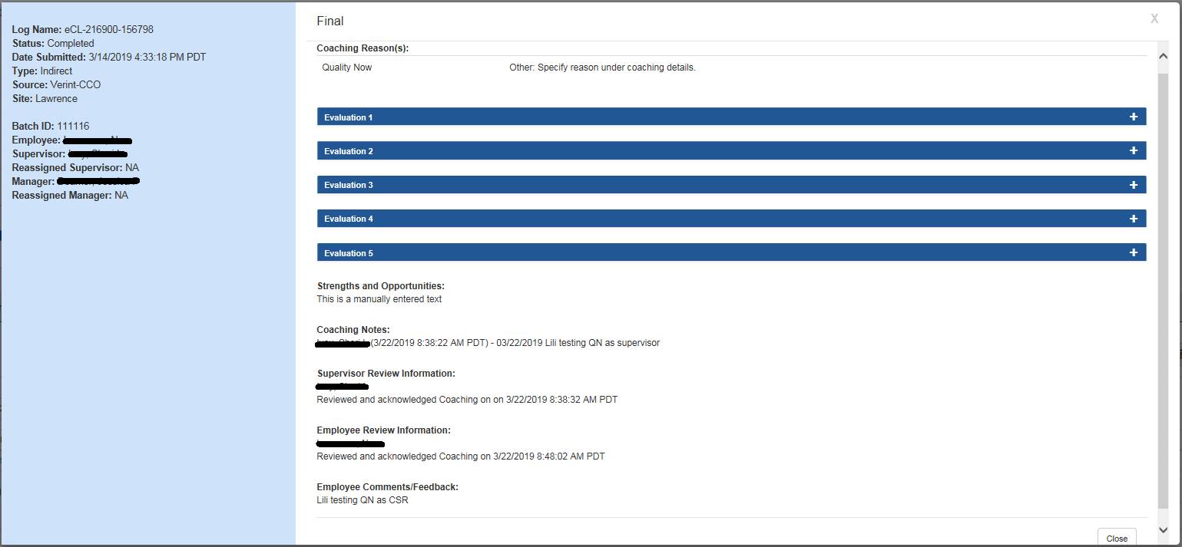

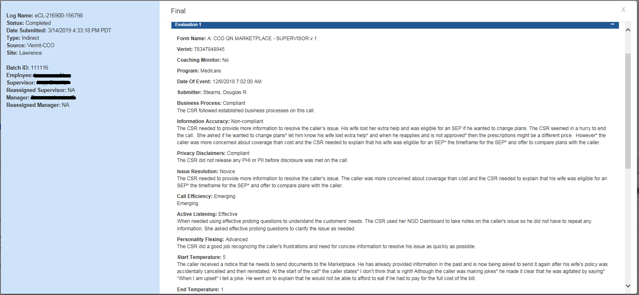

**Review – Short Call – Supervisor form**

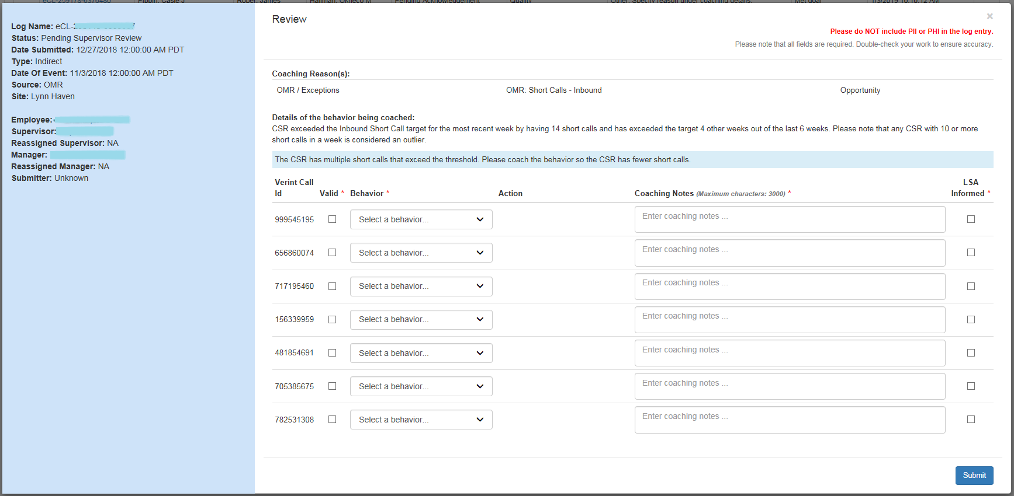

**Review – Short Call – Manager form**

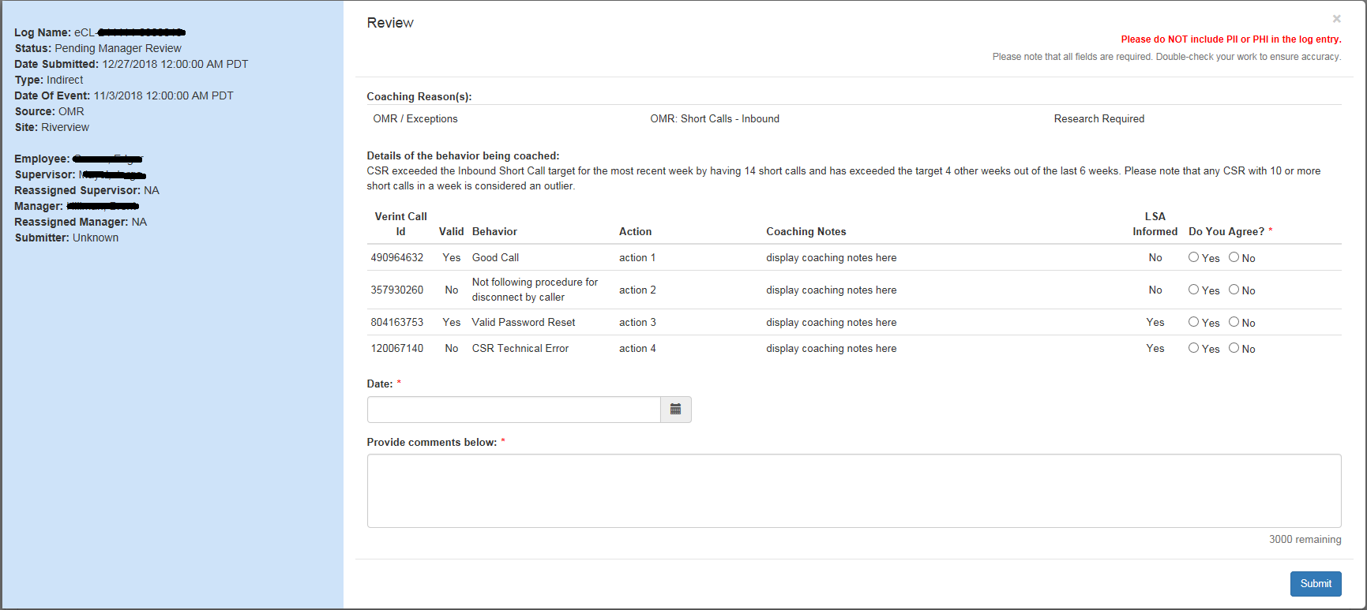

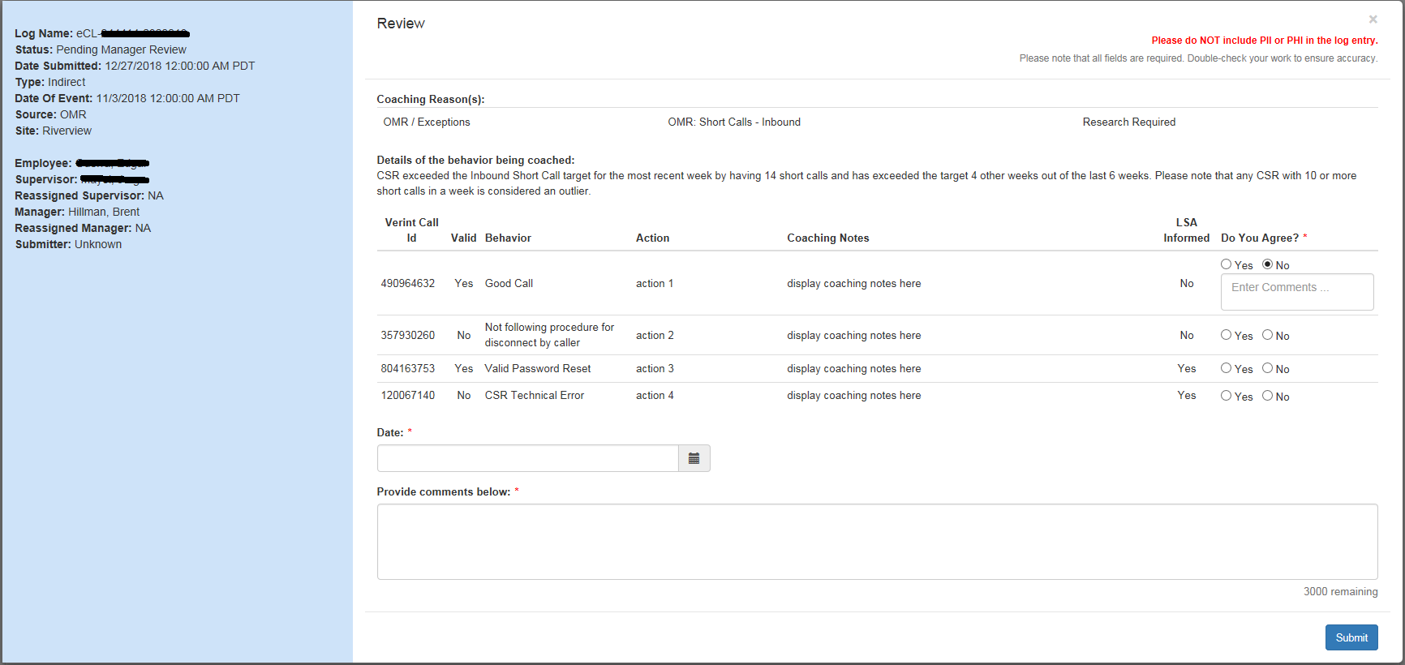

**Review – Follow-up is required - Pending Supervisor Review –Supervisor View**

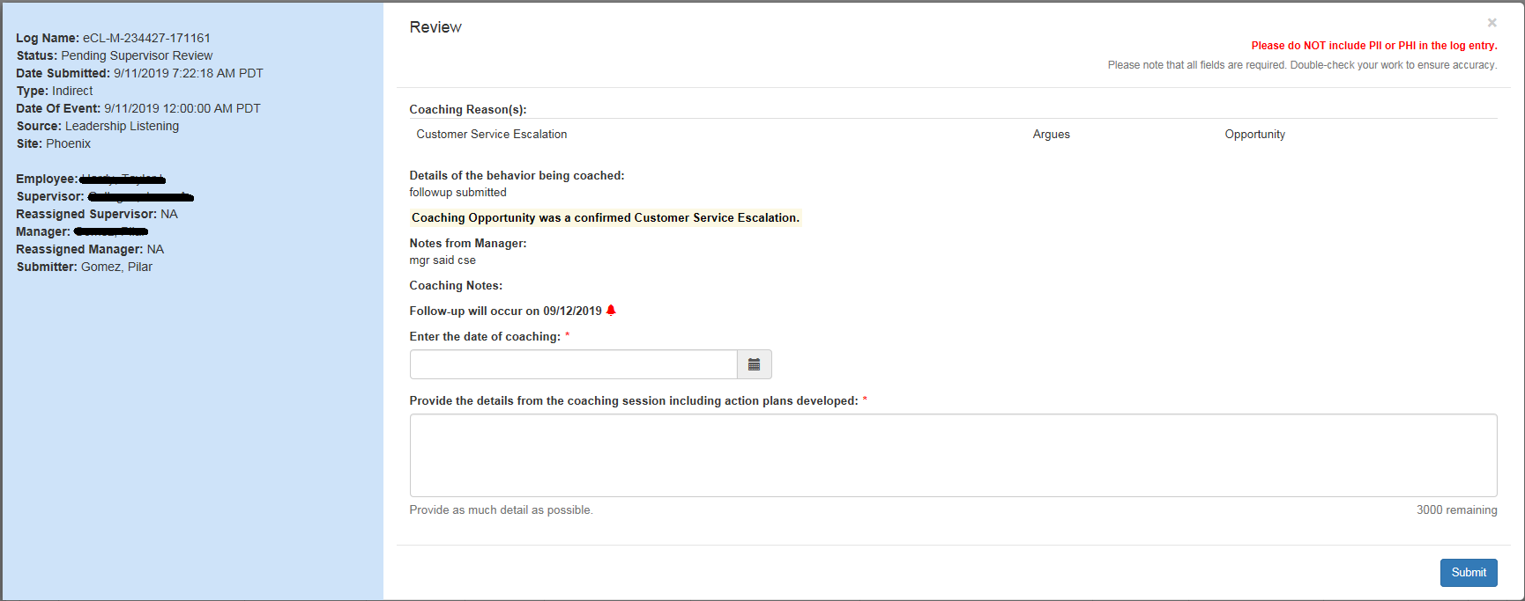

**Review – Follow-up is required - Pending Supervisor Review –Manager and Director View**

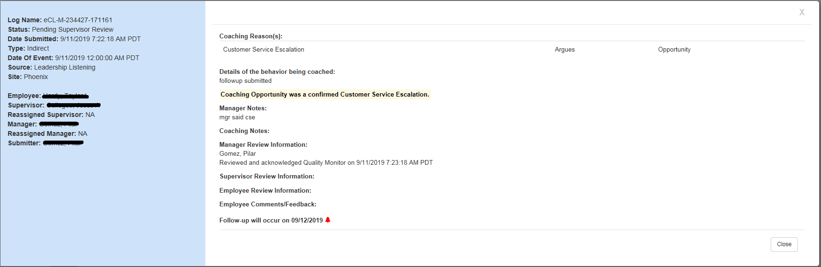

**Review – Follow-up is required - Pending Employee Review (before follow-up) – Employee View**

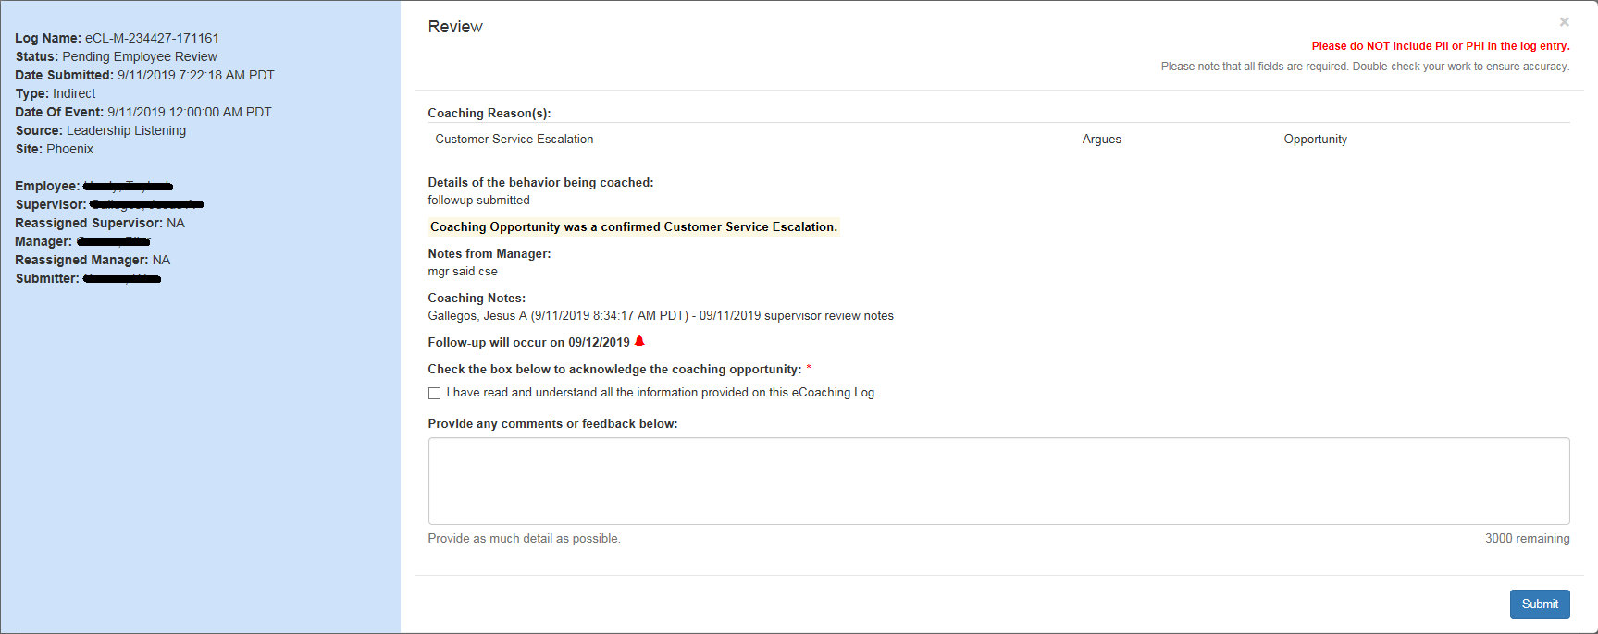

**Review – Follow-up is required - Pending Employee Review (before follow-up) –Supervisor, Manager, and Director View**

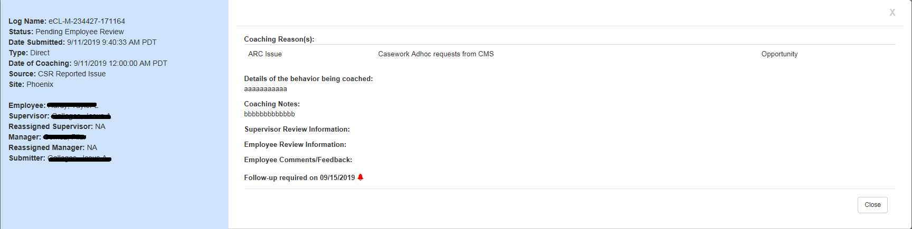

**Review – Follow-up is required – Pending Follow-up – Supervisor View**

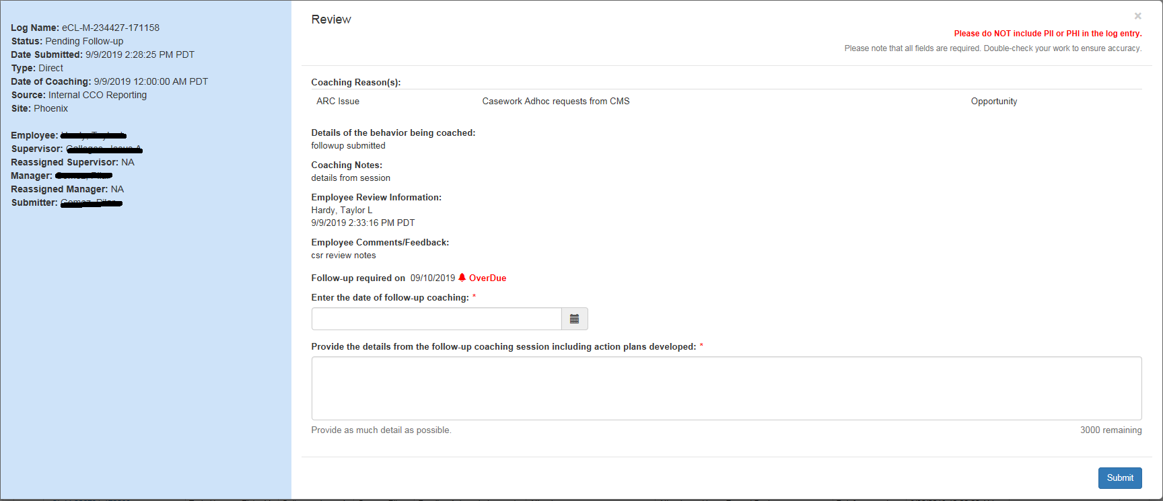

**Review – Follow-up is required – Pending Follow-up – Manager and Director View**

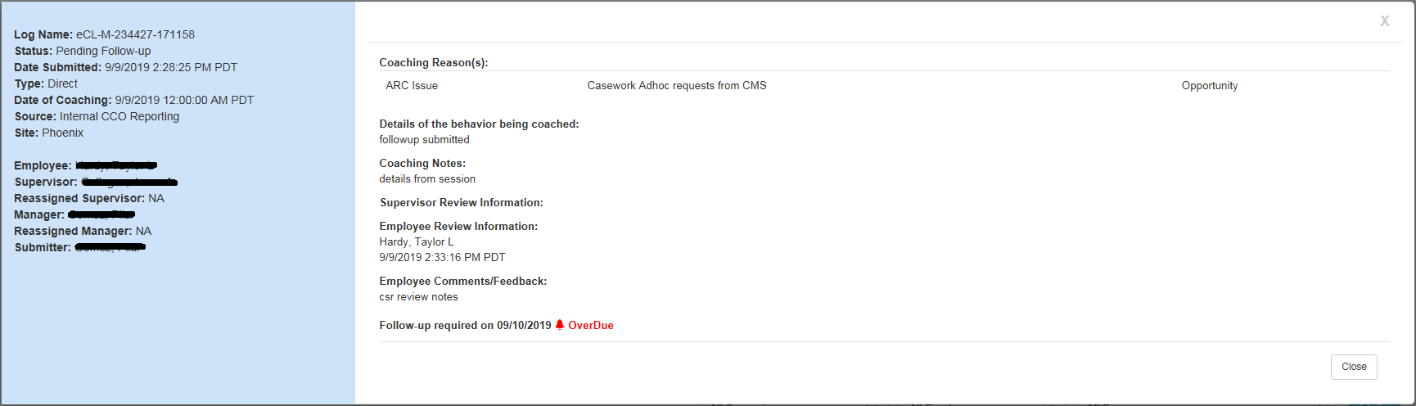

**Review - Follow-up is required – Pending Employee Review (after follow-up) – Employee View**

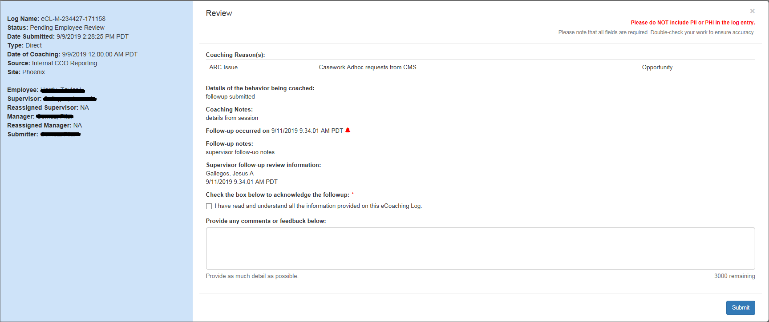

**Review - Follow-up is required – Pending Employee Review (after follow-up) – Supervisor, Manager, and Director View**

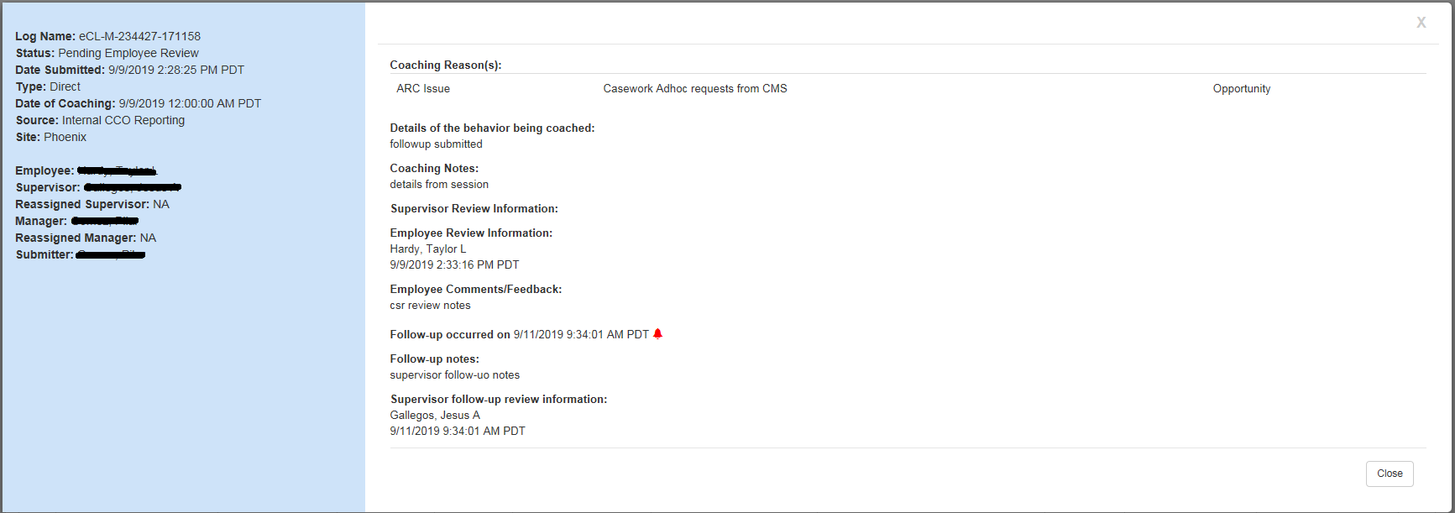

**Review - Follow-up is required – Completed**

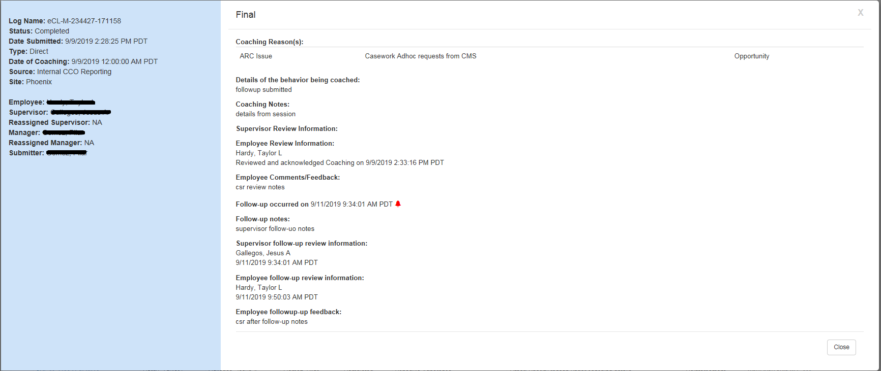

**Review – read only – Coaching Log:**

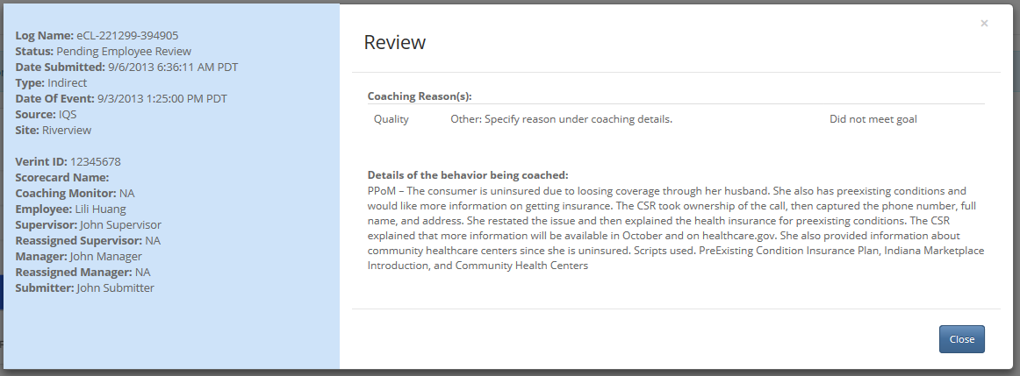

**Review – read only – Warning Log:**

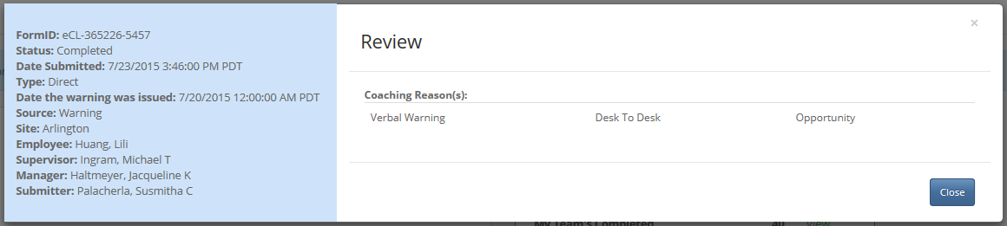

**Unauthorized to view log detail:**

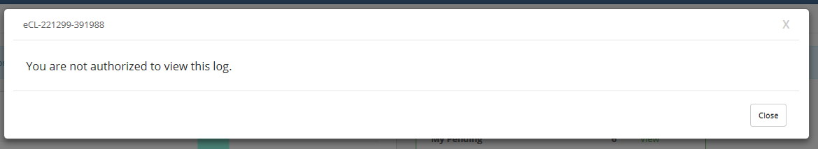

* + 1. Web Page Invoked Events

| Action | Processing & Result |
| --- | --- |
| Click Submit button | Controller: Review  Action: Save  Validates all form fields;  If valid, Save to database; Close Review Modal dialog; Refresh log list;  Else, display validation error message; |

* + 1. Web Page Fields

|  |  |  |  |
| --- | --- | --- | --- |
| Type | Display Text | Data Source | Validation (Show/Hide) |
| **Coaching Information displayed on left (non-editable) - _CoachingLogInfo.cshtml:** | | | |
| Label | Log Name: |  |  |
| Text |  | Coaching_Log |  |
| Label | Status: |  |  |
| Text |  | Coaching_Log |  |
| Label | Date Submitted: |  |  |
| Text |  | Coaching_Log |  |
| Label | Type: |  |  |
| Text |  | Coaching_Log |  |
| Label | Date of Coaching: |  | Display if log type is “Direct” and none Quality Now |
| Text |  | Coaching_Log |
| Label | Date of Event: |  | Display if log type is “Indirect” and none Quality Now |
| Text |  | Coaching_Log |
| Label | Source: |  |  |
| Text |  | Coaching_Log |  |
| Label | Site: |  |  |
| Text |  | Coaching_Log  Dim_Site |  |
| Start - Display for none Quality Now log | | | |
| Label | Verint ID: |  | Display if from verint |
| Text |  | Coaching_Log |
| Label | Scorecard Name: |  |
| Text |  | Coaching_Log |
| Label | Coaching Monitor: | Coaching_Log |
| Text |  | Coaching_Log |
| Label | Avoke ID: |  | Display if from analytics |
| Text |  | Coaching_Log |  |
| Label | NGD Activity ID: |  | Display if from NGD |
| Text |  | Coaching_Log |
| Label | Universal CallID: |  | Display if it has UC ID |
| Text |  | Coaching_Log |
| End – Display for none Quality Now log | | | |
| Label | Batch ID: |  | Display ONLY if Quality Now log |
| Text |  | Coaching_Log |  |
| Label | Employee: |  |  |
| Text |  | Coaching_Log |  |
| Label | Supervisor: |  |  |
| Text |  | Coaching_Log |  |
| Label | Reassigned Supervisor: |  |  |
| Text |  | Coaching_Log |  |
| Label | Manager: |  |  |
| Text |  | Coaching_Log |  |
| Label | Reassigned Manager |  |  |
| Text |  | Coaching_Log |  |
| Label | Submitter: |  |  |
| Text |  | Coaching_Log |  |
| **End – Coaching Information displayed on left** | | | |
| **Coaching Information displayed on right:** | | | |
| Label | Final |  | Display if log is completed |
| Label | Review |  | Display if log is pending |
| Label | Please do NOT include PII or PHI in the log entery. |  | Display if log is editable (User is supervisor or employee of the log) and display in red |
| Label: | Coaching Reason(s): |  |  |
| Text |  | Coaching_Log | Non-editable |
| Label: | Details of the behavior being coached: |  | Display for non-Quality Now log |
| Start – Short Calls | | | |
| Label: | The CSR has multiple short calls that exceed the threshold. Please coach the behavior so the CSR has fewer short calls. |  | Supervisors Only |
| Column Header | Verint Call Id |  |  |
| Valid |  |  |
| Behavior |  |  |
| Action |  |  |
| Coaching Notes |  | Display “Maximu characters: 3000” for Supervisors. |
| LSA Informed |  |  |
| Do You Agree? |  | Managers Only |
| Loop for each short call in this log | | | |
| Text | Verint Id in db |  |  |
| Checkbox |  |  | Supervisors Only |
| Text | Yes or No in db |  | Managers Only;  Non editable |
| Text | Action stored in database |  | Non editable;  For how to determine what action to display, reference DB DD. |
| Text Area |  |  | Supervisors Only |
| Text | Coaching Notes in db |  | Managers Only;  Non editable |
| Checkbox |  |  | Supervisors Only |
| Text | Yes or No in db |  | Managers Only;  Non editable |
| Radio button | Yes  No |  | Managers Only |
| Text Area | Enter Comments… |  | Managers Only;  And  If “No” is selected;  Required if “No” is selected. |
| Label | Dates: |  | Managers Only;  Required |
| Label | Provide comments below: |  | Managers Only;  Required |
| Label | 3000 remaining. |  | Managers Only; |
| Button | Submit |  |  |
| End - Loop for each short call in this log | | | |
| End – Short Calls | | | |
| Start - Quality Now log | | | |
| Loop for each evaluation contained in this log | | | |
| Label | Form Name: |  |  |
| Text |  | Coaching_Log_Quality_Now_Evaluations |  |
| Label | Verint: |  |  |
| Text |  | Coaching_Log_Quality_Now_Evaluations |  |
| Label | Coaching Monitor: |  |  |
| Text |  | Coaching_Log_Quality_Now_Evaluations |
| Label | Program: |  |  |
| Text |  | Coaching_Log_Quality_Now_Evaluations |  |
| Label | Submitter: |  |  |
| Text |  | Coaching_Log_Quality_Now_Evaluations |
| Label | Business Process: |  | Display ONLY for Submitters, Supervisors, and above |
| Text |  | Coaching_Log_Quality_Now_Evaluations |
| Label | Information Accuracy: |  |
| Text |  | Coaching_Log_Quality_Now_Evaluations |
| Label | Privacy Disclaimers: |  |
| Text |  | Coaching_Log_Quality_Now_Evaluations |
| Label | Issue Resolution: |  |
| Text |  | Coaching_Log_Quality_Now_Evaluations |
| Label | Call Efficiency: |  |
| Text |  | Coaching_Log_Quality_Now_Evaluations |
| Label | Active Listening: |  |
| Text |  | Coaching_Log_Quality_Now_Evaluations |
| Label | Personality Flexing: |  |
| Text |  | Coaching_Log_Quality_Now_Evaluations |
| Label | Start Temperature: |  |
| Text |  | Coaching_Log_Quality_Now_Evaluations |
| Label | End Temperature: |  |
| Text |  | Coaching_Log_Quality_Now_Evaluations |
| End - Loop for each evaluation contained in this log | | | |
|  | Strengths and Opportunities: | Coaching_Log |  |
| End – Quality Now log | | | |
| Text |  | Coaching_Log | Non-editable |
| Label | Notes from Manager: |  |  |
| Text |  | Coaching_Log | Non-editable |
| Label | Coaching Notes: |  |  |
| Text |  | Coaching_Log | Non-editable |
|  | | | |
| ***Start - Acknowledge Pending Form*** | | | |
| Hidden | LogId |  |  |
| Hidden | IsAcknowledgeForm |  |  |
| Label | Check the box below to acknowledge the monitor: |  | Display if log is reinforcement OR OTA (OverTurned Appeal) |
| Label | Check the box below to acknowledge the coaching opportunity: |  | Display if log is opportunity |
| Label | Check the box below to acknowledge the follow-up: |  | Display follow-up is required and completed by Supervisor |
| Label | I have read and understand all the information provided on this eCoaching Log. |  |  |
| Label | By checking this box, I indicate that I have reviewed this appeal and have taken the appropriate actions. |  | Display if log is OTA (OverTurned Appeal) |
| Checkbox |  |  | Required |
| Label | Please select one of the comments below for the log: |  | Display if user is the employee and acknowledges a DTT log |
| Dropdown | ATT Updated - with Approved Absence  ATT Updated - with Unapproved Absence  ATT Not Updated - SWP notified that Empower is inaccurate  ATT Not Updated and Empower will not be updated  ATT Not Updated - CSR Termed  CSR on a Leave of Absence  Absence is pending HR approval (LOA or WPA) | Reasons_By_ReportCode |
| Label | Provide any comments or feedback below: |  | Display if user is the employee and acknowledges a non DTT log.  Maximum 3000 |
| Input textarea |  |  |
| Label | Provide the details from the coaching session including action plans developed: |  | Display if OTA (OverTurned Appeal) log. |
| Input textarea |  |  |
| Label | Provide as much detail as possible. |  |  |
| Label | 3000 remaining |  | As user types, the number of remaining dynamically changes |
| Button | Submit |  |  |
| ***End – Acknowledge Pending Form*** | | | |
| ***Start - Review Pending Form*** | | | |
| Text |  |  | Instruction text, see section “8. Instruction Text” for details. |
| Hidden | LogId |  |  |
| Hidden | FormName |  |  |
| Hidden | ModuleName |  |  |
| Hidden | StatusId |  |  |
| Hidden | SupervisorEmail |  |  |
| Hidden | ManagerEmail |  |  |
| Hidden | SupervisorEmpId |  |  |
| Hidden | ManagerEmpId |  |  |
| Hidden | IsRegularPendingForm |  |  |
| If follow up is required: | | | |
| Label | Employee Review Information: |  | Display if the log is “Pending Follow-up” |
| Text |  | Coaching_Log | Display if the log is “Pending Follow-up”  Display employee name and the date time when the employee reviewed the log |
| Label | Employee Comments/Feedback: |  | Display if the log is “Pending Follow-up” |
| Text |  | Coaching_Log | Display if the log is “Pending Follow-up” |
| Label + Text | Follow-up required on [follow-up due date] | Coaching_Log | Display if follow-up has not happened yet. |
| Label + Text | Follow-up occurred on [follow-up actual date] |  | Display if Follow-up has happened. |
| L:abel | Follow-up Notes: |  | Display if Follow-up has happened. |
| Text |  | Coaching_Log | Display if Follow-up has happened.  Notes from Supervisor Follow-up |
| Label | Supervisor follow-up review information: |  | Display if Follow-up has happened.  Supervisor Name and Followup Timestamp |
| Text |  | Coaching_Log | Display if Follow-up has happened. |
| Text | Your will be able to enter follow-up date/notes on the follow-up day or after. |  | Display if today is before follow-up due date and User is the Supervisor |
|  |  |  |  |
| Label | Enter the date of follow-up coaching: |  | Display if Pending Follow-up and User is the Supervisor |
| Textbox + Calendar |  |  | Display if User is the Supervisor;  Disabled if today is before follow-up due date |
| Label | Provide the details from the follow-up coaching session including action plans developed: |  | If Pending Follow-up and User is the Supervisor |
| Textarea |  |  | Display if User is the Supervisor;  Disabled if today is before follow-up due date |
| End – if follow up is required | | | |
| Label | Enter the date of coaching: |  | If status is NOT Pending Follow-up |
| Input text |  |  | If status is NOT Pending Follow-up  Must be a valid past or current date. |
| Icon | Glyphicon-calendar |  |  |
| Label | Provide the details from the coaching session including action plans developed: |  | If status is NOT Pending Follow-up |
| Input textarea |  |  | Required  Maximum 3000 |
| Label | Provide as much detail as possible. |  |  |
| Label | 3000 remaining |  | As user types, the number of remaining dynamically changes |
| Button | Submit |  |  |
| ***End - Review Pending Form*** | | | |
| ***Start – Research Pending Form*** | | | |
| Hidden | IsResearchPendingForm |  |  |
| Hidden | LogId |  |  |
| Label | You are receiving this eCL record because an Employee on your team was identified in an Outlier Management Report (OMR). Please research this item in accordance with the latest Contact Center Operations 46.0 Outlier Management Report(OMR): Outlier Research Process SOP and provide the details in the record below."; |  | “Contact Center Operations 46.0 Outlier Management Report(OMR): Outlier Research Process SOP” will be the following hyperlink:  https://maximus365.sharepoint.com/sites/CCO/Resources/SOP/Contact%20Center%20Operations/Forms/AllItems.aspx |
| Label | Date: |  |  |
| Input text |  |  | Must be a valid past or current date. |
| Label | Based on your research does this record require coaching? |  |  |
| Radio Button | Yes  No |  | Default to “No” |
| Label | What was the main reason this item was not coachable? |  | Display if “No” is selected;  Dropdown:  Required  Input textarea:  maximum characters: 3000  Required |
| Dropdown | **If OMR/BRL or OMR/BRN:**  Approved accommodation on file  Other  **If OMR/IAE:**  Agent no longer employed or on LOA  Escalation was appropriate  ISG or Supervisor told agent to escalate  Not enough information to coach  Other  **Otherwise:**  Other | Reasons_By_ReportCode |
| Label | Please provide reason/explanation/justification as to why the item was not coachable: |  |
| Input textarea |  |  |
| Label | Please provide reason/explanation/justification as to why the item is coachable for the Supervisor: |  | If “Yes” is selected.  Dropdown:  Required  Input textarea:  maximum characters: 3000  Required |
| Input textarea |  |  |
| Label | These notes will only be viewed by supervisors. |  |  |
| Label | 3000 remaining |  | As user types, the number of remaining dynamically changes |
| Button | Submit |  |  |
| ***End – Research Pending Form*** | | | |
| ***Start – CSE Pending Form*** | | | |
| Hidden | IsCsePendingForm |  |  |
| Hidden | LogId |  |  |
| Hidden | ModuleId |  |  |
| Label | Review the submitted coaching opportunity and determine if it is a confirmed Customer Service Escalation (CSE). If it is a CSE, setup a meeting with the Employee and Supervisor and report your coaching in the box below. If it not a CSE, enter notes for the Supervisor to use to coach the Employee. |  |  |
| Label | Is the coaching opportunity a confirmed Customer Service Escalation (CSE)? |  |  |
| Radio Button | Yes, this is a confirmed Customer Service Escalation.  No, this is not a confirmed Customer Service Escalation. |  |  |
| Label | Enter the date coached: |  | Display if “Yes” is selected.  Date must be a valid past or current date.  Required.  Input area:  Maximum characters: 3000  Required |
| Input text |  |  |
| Icon | Glyphicon-calendar |  |
| Label | Provide the details from the coaching session including action plans developed: |  |
| Input textarea |  |  |
| Label | Enter the date reviewed: |  | Display if “No” is selected.  Date must be a valid past or current date.  Required.  Input area:  Maximum characters: 3000  Required |
| Input text |  |  |
| Icon | Glyphicon-calendar |  |
| Label | Provide explanation for Employee and Supervisor as to reason why this is not a CSE: |  |
| Input textarea |  |  |
| Label | Provide as much detail as possible. |  |  |
| Label | 3000 remaining |  | As user types, the number of remaining dynamically changes |
| Label | Follow-up required on [follow-up due date] | Coaching_Log | Display if follow-up is required. |
| Button | Submit |  |  |
| ***End – CSE Pending Form*** | | | |
| ***Start – View Coaching (read only)*** | | | |
| Label | Final |  | Display if log is completed |
| Label | Review |  | Display if log is pending |
| Label: | Coaching Reason(s): |  |  |
| Text |  | Coaching_Log | Non-editable |
| Label: | Details of the behavior being coached: |  |  |
| Text |  | Coaching_Log | Non-editable |
| Label | Coaching Opportunity was a confirmed Customer Service Escalation. |  | Display if confirmed CSE. |
| Label | Coaching Opportunity was not a confirmed Customer Service Escalation. |  | Display if confirmed NOT CSE. |
| Label | Manager Notes: |  |  |
| Text |  | Coaching_Log |  |
| Label | Manager Review Information: |  |  |
| Label | Reviewd and acknowledged Quality Monitor on |  |  |
| Text |  | MgrReviewAutoDate |  |
| Label | Coaching Notes: |  |  |
| Text |  | Coaching_Log |  |
| Label | Supervisor Reviw Information: |  |  |
| Label | Reviewed and acknowledged Quality Monitor on |  |  |
| Text |  | SupReviewedAutoDate |  |
| Label | Employee Review Information: |  |  |
| Text |  | EmployeeName |  |
| Label | Employee Comments/Feedback: |  |  |
| Text |  |  |  |
| Label | Reviewed and acknowledged Quality Monitor On |  | Display if IQS and Completed |
| Label | Reviewed and acknowledged Coaching On |  | Display if Not IQS and Not Completed |
| Text |  | EmloyeeReviewDate |  |
| Start – Follow up is required | | | |
| Label | Follow-up required on [follow-up actual date] |  | Display if Follow-up has not happened yet. |
| Label | Follow-up occurred on [follow-up actual date] |  | Display if Follow-up has happened. |
| L:abel | Follow-up Notes: |  | Display if Follow-up has happened. |
| Text |  |  | Display if Follow-up has happened.  Notes from Supervisor Follow-up |
| Label | Supervisor follow-up review information: |  | Display if Follow-up has happened.  Supervisor Name and Followup Timestamp |
| Text |  |  | Display if Follow-up has happened. |
| Label | Employee follow-up review information: |  | Display if log is completed.  Employee Name and Timestamp |
| Text |  |  | Display if log is completed. |
| Label | Employee follow-up feedback: |  | Display if log is completed. |
| Text |  |  | Notes from Employee after follow-up |
| End – Follow up is required | | | |
| Button | Close |  |  |
| ***End – View Coaching (read only)*** | | | |
| **End – Coaching Information displayed on right.** | | | |
| **Warning Information displayed on left (non-editable) - _WarningLogInfo.cshtml:** | | | |
| Label | FormID: | Warning_Log |  |
| Text |  | Warning_Log |  |
| Label | Status: |  |  |
| Text |  | Warning_Log |  |
| Label | Date Submitted: |  |  |
| Text |  | Warning_Log |  |
| Label | Type: |  |  |
| Text |  | Warning_Log |  |
| Label | Date the warning was issued: |  |  |
| Text |  | Warning_Log |  |
| Label | Source: |  |  |
| Text |  | Warning_Log |  |
| Label | Site: |  |  |
| Text |  | Warning_Log |  |
| Label | Employee: |  |  |
| Text |  | Warning_Log |  |
| Label | Supervisor: |  |  |
| Text |  | Warning_Log |  |
| Label | Manager: |  |  |
| Text |  | Warning_Log |  |
| Label | Submitter: |  |  |
| Text |  | Warning_Log |  |
| **End – Warning Information displayed on left (non-editable) - _ViewWarningLog.cshtml.** | | | |
| ***Warning Information displayed on right:*** | | | |
| Label: | Coaching Reason(s): |  |  |
| Text |  | Warning_Log | Non-editable |
| Text |  | Warning_Log_StaticText |  |
| Lable | Check the box below to acknowledge the warning opportunity: |  | Display only when:   1. User is the employee of the log, AND 2. Pending Employee Review |
| checkbox |  |  |
| Label | I have read and understand all the information provided on this warning log. |  |
| Label | Provide any comments or feedback below: |  |
| Input textarea |  |  |
| Button | Submit |  |
| Label | Employee Review Information: |  | Display Employee Review information and Employee Comments/Feedback when:  User is the supervisor or manager of the employee and the warning log is completed.  Display “Close” button when:  User is the supervisor or manager of the employee |
| Text |  | Warning_Log.CSRReviewDate |
| Label | Employee Comments/Feedback: |  |
| Text |  | Warning_Log.CSRComments |
| Button | Close |  |
| ***End – Warning Information displayed on right.*** | | | |

1. **Stored Procedures**
   1. sp_SelectReviewFrom_Coaching_Log
   2. sp_SelectReviewFrom_Coaching_Log_Reasons
   3. sp_SelectReviewFrom_Warning_Log_Reasons
   4. sp_Update_Review_Coaching_Log_Suerpvisor_Pending
   5. sp_Update_Review_Coaching_Log_Supervisor_Acknowledge
   6. sp_Update_Review_Coaching_Log_Employee_Pending
   7. sp_Update_Review_Coaching_Log_Employee_Acknowledge
   8. sp_Update_Review_Coaching_Log_Manager_Pending_Research
   9. sp_Update_Review_Coaching_Log_Manager_Pending_CSE
   10. sp_SelectReviewFrom_Coaching_Log_Quality_Now
   11. sp_ShortCalls_Get_BehaviorList
   12. sp_ShortCalls_Get_Actions
   13. sp_ShortCalls_Get_CallList
   14. sp_ShortCalls_Get_SupReivewDetails
   15. sp_ShortCalls_SupReview_Submit
   16. sp_ShortCalls_MgrReivew_Submit
   17. sp_ShortCalls_getMgrReviewDetails
   18. sp_Update_Review_Caoching_Log_Supervisor_Pending_Followup
   19. sp_Update_Review_Caoching_Log_Employee_Pending_Followup

Refer CCO_eCoaching_Log_Database_DD.docx for details.

1. **Logic to determine pending form type**
   1. Pending Acknowledgement

User is Manager

* Pending acknowledgement

User is the Supervisor or reassigned to

* Pending supervisor review and the employee has acknowledged, OR
* Pending acknowledgement, OR
* OverTurned Appeal (OTA) log, Pending Quality Lead Review

User is the employee

* Pending employee review, OR
* Pending acknowledgement
  1. Pending Research
* If Coaching Value is “Research Required” ” and the log is ACTIVE and not COMPLETED.

User is the Manager, or Manager when this low CSAT log was submitted, or reassigned to

* Pending manager review, and one of the following condition is met:
  + Current Coaching Initiative
  + OMR Exception but NOT Short Calls
  + Low CSAT
  1. Pending CSE

If Coaching Reason is “Customer Service Escalation” and the log is ACTIVE and not COMPLETED.

* 1. Pending Short Call Review (Supervisor)

If coaching log is Short Call and status is “Pending Supervisor Review”.

* 1. Pending Short Call Confirm (Manager)

If Coaching Log is Short Call and status is “Pending Manager Review”.

* 1. Pending Follow-Up (Supervisor)

If coaching log requires follow-up and status is “Pending Follow-Up”.

* 1. Pending Regular Review

None of the above.

1. **Logic to determine Review Page display mode (Ready Only vs Editable)**

|  |  |
| --- | --- |
| **Short Call - Pending Manager Review** | **If user is the manager or reassigned to, then Editable; Otherwise Read Only** |
| **Short Call – Pending Supervisor Review** | **If user is the supervisor or reassigned to, then Editable; Otherwise Read Only** |
| **Customer Service Escalation – Pending determination** | **If Pending Manager Review;**  **If user is the manager (or reassigned to), hen Editable;**  **Else Read Only** |
| **Research Required** | **If Pending Supervisor Review;**  **If user is the supervisor (or reassigned to), then Editable;**  **Else Read Only;**  **If Pending Manager Review;**  **If user is the manager (or reassigned to) or (the log is low CSAT and user was the manager when this log was entered), then Editable;**  **Else Read Only** |
| **Acknowledge – Pending Acknowlegement** | **Editable if:**   1. **User is the Employee of the log; OR** 2. **User is the Supervisor (or reassigned to) and the log is not Quality Bingo.**   **Otherwise Read Only** |
| **For all other logs** | **If Pending Supervisor Review;**  **If user is the supervisor (or reassigned to), then Editable;**  **Else Read Only;**  **If Pending Employee Review;**  **If user is the employee, then Editable;**  **Else Read Only;**  **For all other Pending Statuses, Read Only** |

1. **Logic to determine next status**
   1. Pending Acknowledgement

If the log is a warning log, next status will be “Completed”;

Otherwise:

For OverTurned Appeal (OTA) logs, next status will be “Completed”;

If no more reviews needed, next status will be “Completed”;

*(Note: logic for more reviews needed:*

* *BQNS (quality bingo), BQMS, or*
* *User is the supervisor and employee has acknowledged, or*
* *User is the employee and Pending Acknowledgement, or*
* *User is the employee and Pending Employee Review*
* *Supervisor has reviewed the log, and*
* *The log is IQS, or CTC, or High5Club, or Kudo, or Attendance, or MSR, or MSRS*

*)*

Otherwise :

* If user is the employee of the log,
* If follow-up is required,
* If follow-up has happened, then next status will be “Completed”;
* Otherwise, next status will be “Pending Follow-up”;
* If supervisor has acknowledged and NO follow-up required, then next status will be “Completed”;
* If supervisor has not acknowledged and NO follow-up required, then next status will be:
* “Pending Supervisor Review” for CSR and TRAINING modules;
* “Completed” for SUPERVISOR module (bingo log);
* “Pending Manager Review” for SUPERVISOR module (non bingo log);
* “Pending Quality Lead Review” for QUALITY module.
* If user is NOT the employee of the log,
* If current status is “Pending Acknowledgement”, then next status will be “Pending Employee Review”;
* Otherwise, next status will be “Completed”.
  1. Pending Research
* If Coaching is NOT required, then next status will be “Inactive”;
* Otherwise:
* If CSR or TRAINING module, next status will be
* “Pending Supervisor Review” if the log is Current Coaching Initiative or OMR Exception or Low CSAT;
* “Pending Employee Review” if the log is IAE or IAEF or IAT or OAE or Training Short Duration or Training Overdue or BRL or BRN;
* “Pending Employee Review” if user is the Supervisor or reassigned to;
* If SUPERVISOR module, next status will be
* “Pending Manager Review” if the log is Current Coaching Initiative or OMR Exception;
* “Pending Employee Review” otherwise;
* If QUALITY module, next status will be
* “Pending Quality Lead Review” if the log is Current Coaching Initiative or OMR Exception;
* “Pending Employee Review” otherwise;
* For all other modules, next status will be “Pending Employee Review”
  1. Pending CSE

Next status will be:

* “Pending Supervisor Review” for CSR, TRAINING modules;
* “Pending Manager Review” for SUPERVISOR module;
* “Pending Quality Lead Review” for QUALITY module.
  1. Pending Short Call Review (Supervisor)

Next status will be “Pending Manager Review”.

* 1. Pending Short Call Confirm (Manager)

Next status will be “Completed”.

* 1. Pending Regular Review

Next status will be “Pending Employee Review”.

* 1. Pending Follow-Up

Next status will be “Pending Employee Review”

1. **Instruction text**
   1. Pending CSE – user is the manager or reassigned to, Pending Manager Review (Note: when a log is added as CSE, it goes to Pending Manager Review)

Review the submitted coaching opportunity and determine if it is a confirmed Customer Service Escalation (CSE). If it is a CSE, setup a meeting with the Employee and Supervisor and report your coaching in the box below. If it not a CSE, enter notes for the Supervisor to use to coach the Employee.

* 1. Pending Research – user is the manager or reassigned to, Pending Manager Review, log is Current Coaching Initiative.

You are receiving this eCL record because an Employee on your team was identified in an Outlier Management Report (OMR). Please research this item in accordance with the latest <a href='https://maximus365.sharepoint.com/sites/CCO/Resources/SOP/Contact%20Center%20Operations/Forms/AllItems.aspx' target='_blank'>" +

Contact Center Operations 46.0 Outlier Management Report (OMR): Outlier Research Process SOP</a> and provide the details in the record below.

* 1. Pending Review
* **OMR Short Call – user is the supervisor or reassigned to, Pending Supervisor Review, log is short call.**

The CSR has multiple short calls that exceed the threshold. Please coach the behavior so the CSR has fewer short calls.

* **Low CSAT – user is the manager or reassigned to, Pending Manager Review, log is low CSAT.**

You are receiving this eCL because you have been assigned to listen to and provide feedback on a call that was identified as having low customer satisfaction. Please review the call from a PPoM perspective and provide details on the specific opportunities requiring coaching in the record below.

* **Training Short Duration – user is the supervisor or reassigned to, Pending Supervisor Review, log is “Training Short Duration”.**

CSRs are scheduled for specific times in Empower to ensure understanding of training materials presented. It is important to utilize the timeframe allotted to successfully understand the training content. Please be aware that the scheduled timeframe is a metric which has been agreed upon by CCO and CMS. You should use all or the majority of the scheduled time to review each eLearning module assigned.

* **Training Overdue – user is the supervisor or reassigned to, Pending Supervisor Review, log is “Training Overdue”.**

The above training is now overdue. Please have the training completed and provide coaching on the specific reasons it was overdue.

* **Quality High 5 Club – log is “High 5 Club”**

Customer satisfaction is critical to our success; therefore, to help gauge our performance, every caller is offered the option to complete a Customer Satisfaction (CSAT) survey. Using a scale from one to five, callers are able to rate their overall satisfaction. Top box, or a rating of 5, indicates the caller was extremely satisfied! Thank you for taking good care of your callers; you make a difference for each caller AND for the CCO!

* **Quality KUDO CSR – user is the CSR, log is “Kudo”**

Congratulations - you received a Kudos! Click <a href='https://maximus365.sharepoint.com/sites/CCO/Connection/Pages/KudosCentral.aspx' target='_blank'>here</a> to take a listen to what a recent caller had to say about your customer service.

* **Quality KUDO Supervisor – user is the supervisor, log is “Kudo”**

Click <a href='https://maximus365.sharepoint.com/sites/CCO/Connection/Pages/KudosCentral.aspx' target='_blank'>here</a> to listen to CSR kudos.

* **OMR Break Time Exceeded – user is the Supervisor, Pending Supervisor Review, log is “BRL” or “BRN”**

You are receiving this eCL record because an Employee on your team was identified in a Break Outlier Report. Please review the <b><a href='https://maximus365.sharepoint.com/sites/CCO/bi/ReportsCatalog/CSRDashboard/Forms/AllItems.aspx' target='_blank'>ETS Breaks Outlier Report</a>,

the ETS entries</b>, and refer to HCSD-POL-HR-MISC-08 Break Time Policy and Break Policy Reference guide for additional information and provide the details in the record below.

* **Scorecard MSR - Source is Performance Scorecard, log is “MSR”**

To review your full details, please visit the <a href='https://f3420-mwbp11.vangent.local/scorecard/csrscorecard.aspx' target='_blank'>CCO Performance Scorecard</a>.

If you have any questions, please see your supervisor.

* **Scorecard MSR - Source is Internal CCO Reporting, log is “MSR”**

To view in full detail, your Supervisor will review your Performance Dashboard with you during your next coaching session. An overview of your scores is also contained within the eCL.

* **Scorecard MSRS – log is “MSRS”**

To review your full details, please visit the <a href='https://f3420-mwbp11.vangent.local/scorecard/csrscorecard.aspx' target='_blank'>CCO Performance Scorecard</a>.

If you have any questions, please <a href='https://maximus365.sharepoint.com/sites/CCO/Reports/Performance_Scorecard/Lists/Scorecard_Escalated_Issues_Log/NewIssue.aspx' target='_blank'>submit an escalation</a> via the

<a href='https://maximus365.sharepoint.com/sites/CCO/Reports/Performance_Scorecard/default.aspx' target='_blank'>CCO Performance Scorecard Information Station</a>

SharePoint site.

* **ETS/HNC, ETS/ICC – Pending Supervisor Review, log is “ETS/HNC” or “ETSICC”.**

Click <a href='https://maximus365.sharepoint.com/sites/CCO/Initiatives/floorcheck/Timecard_Compliance_Reporting/Timcard%20Changes%20Reports/Forms/AllItems.aspx' target='_blank'>here</a>

to view the report containing the details of these changes.

* **ETS/OAE – user is the supervisor or reassigned to, Pending Supervisor Review, log is “ETS/OAE”**

You are receiving this eCL record because an Employee on your team was identified on the CCO TC Outstanding Actions report (also known as the TC Compliance Action report). Please research why the employee did not complete their timecard before the deadline laid out in the latest

<a href='https://maximus365.sharepoint.com/sites/CCO/Resources/SOP/Contact%20Center%20Operations/Forms/AllItems.aspx' target='_blank'>CCO Performance Scorecard</a>. Contact Center Operations 3.06 Timecard Audit SOP

* **ETS/OAS– user is the supervisor or reassigned to, Pending Supervisor Review, log is “ETS/OAS”**

You are receiving this eCL record because a Supervisor on your team was identified on the CCO TC Outstanding Actions report (also known as the TC Compliance Action report). Please research why the supervisor did not approve or reject their CSR’s timecard before the deadline laid out in the latest

<a href='https://maximus365.sharepoint.com/sites/CCO/Resources/SOP/Contact%20Center%20Operations/Forms/AllItems.aspx' target='_blank'>CCO Performance Scorecard</a>. Contact Center Operations 3.06 Timecard Audit SOP.

* **OMR/PBH – user is the CSR or Supervisor, log is “PBH”**

Be sure to check the Beneficiary Indicators applet on every call. If a message is on file, the CSR must follow protocol and review it to determine whether the information is applicable to the beneficiary’s reason for calling. However, the CSR must read and follow any messages related to the new Medicare card, regardless of the reason for the call. In addition to reading such messages, the CSR must be sure to log them as “read” to document that the information has been relayed to the caller.

Remember, it is critical that we follow through with the appropriate action(s) outlined in the CSR Notes portion of the Message Details applet. This includes checking and confirming whether the beneficiary’s correct mailing address is on file. Depending on whether the address is correct, the CSR will take one of the two following actions:

-If the address is correct, you must order a replacement card for the beneficiary using the “Medicare Card” button (even if they don’t think they need one).

-If the address is incorrect, you must refer the beneficiary to the Social Security Administration (SSA) using information in Agent Partner Search.

When reviewing this type of message, always take the appropriate steps as directed, regardless of the reason for the call. Failing to do so in these cases will result in the beneficiary not receiving his/her new Medicare card.

* **OTH/APS – user the supervisor, Pending Acknowledgement or Pending Supervisor Review, log is OTH/APS**

*Your CSR has reached a major attendance milestone with 22 perfect shifts. You are encouraged to validate that the CSR indeed earned perfect attendance and verify that the hours have been removed in the Attendance Tracking Tool. And of course, please say thank you to your CSR for a job well done. This notification is for your CSR and does not apply to your personal attendance. Please refer to the name listed beside the 'employee' field to determine the employee who is receiving this message.*

* **OTH/APW user the supervisor, Pending Acknowledgement or Pending Supervisor Review, log is OTH/APW**

*Your CSR had perfect attendance during a recent critical week. You are encouraged to validate that the CSR indeed earned perfect attendance and verify that the hours have been removed in the Attendance Tracking Tool. And of course, please say thank you to your CSR for a job well done. This notification is for your CSR and does not apply to your personal attendance. Please refer to the name listed beside the 'employee' field to determine the employee who is receiving this message.*

* **FC/ATTH (warning log)**

*The Attendance Policy states employees that reach or exceed 16 hours of unexcused/unapproved absences in a rolling 12 month period will receive a Formal Coaching. You have exceeded 16 hours of unexcused / unapproved hours, and as a result you are receiving a Formal Coaching. Your supervisor will provide a detailed attendance report of hours missed.*

*You completed Attendance Policy training and signed an acknowledgement form stating you understood the policies.*

*Reliable and punctual attendance is a requirement of the position you hold. You must improve your attendance immediately. It is an expectation that you:*

1. *Report to work as scheduled to maintain regular and predictable attendance.*
2. *If you are unable to come to work due to unexpected illness or other emergency, you must comply with notification guidelines outlined in the above attendance policy.*
3. *Provide management as much notice as possible prior to requesting an absence. Certain types of absences may be considered approved and will not count as missed time. In these circumstances the approval process for such time off must be followed.*

*You may improve your attendance record by using the “Earn Back” process, approved PTO, or other forms of time off as designated by your project.*

* **FC/ATTT (warning log)**

*Trends are patterns of behavior and include documented unexcused/unapproved instances of being out of compliance from their assigned work schedule for a minimum of 1 consecutive hour. Trend examples include; late arrival or early departure to/from work, missing a portion or all of 3 scheduled weekend days, a portion or all of 3 scheduled pay days, a portion or all of 3 scheduled Mondays or a portion or all of 3 scheduled Fridays*. You have accumulated three or more unexcused/unapproved patterned absences, and as a result you are receiving a Formal Coaching. Your supervisor will provide a detailed attendance report of your patterned absences.*

*You completed Attendance Policy training and signed an acknowledgement form stating you understood the policies.*

*Reliable and punctual attendance is a requirement of the position you hold. Your current pattern of unexcused/unapproved absences is unacceptable per the HC Attendance Policy. It is an expectation that you immediately:*

1. *Correct your behavior of repeated unexcused/unapproved absences.*
2. *Work your shift as scheduled.*

*You may improve your attendance record by enrolling or using the “Earn Back” process, PTO, or other forms of time off as designated by your project.*

*You must demonstrate immediate and sustained improvement in the areas noted above.*

*If you accrue 3 or more patterned absences in a 60 day rolling period over 13 weeks for limited service employees or 12 months for regular service employees you will be subject to additional progressive discipline up to and including termination.*

|  |  |  |
| --- | --- | --- |
| ***Pattern Occurrences*** | ***Level of Disciplinary*** | ***Action*** |
| *3 Occurrences* | *Formal Coaching* |  |
| *6 Occurrences* | *Verbal Warning* |  |
| *9 Occurrences* | *Written Warning* |  |
| *12 Occurrences* | *Termination* |  |

*For the purposes of this policy the level of progressive discipline will roll off after 13 weeks for limited service or 12 months regular service.*

*This Formal Coaching may not impact your ability to be considered for in-staff transfers or promotional opportunities.*