________________________

[MAXIMUS logo](https://www.maximus.com/)

Detail Design: CCO eCoaching Log – Review

Quality Now

________________________

Prepared by: Lili Huang Date: 08/06/2021

Department:

Change History Log

| Date | Change Description | Author |
| --- | --- | --- |
| 08/06/2021 | Initial Revision – TFS 22256 Quality Now Logs Enhancement | Lili Huang |
| 09/28/2021 | TFS 22256 Quality Now Logs Enhancement  Removed QNS log related, since they are loaded to database as Completed. | Lili Huang |
| 03/10/2022 | TFS 24326 – eCL logs not displaying fields properly.  Updated screenshots | Lili Huang |
| 02/06/2023 | TFS 26095 – QNS log workflow change.  Pending Supervisor Review -> Pending Employee Review -> Completed.  Added 3.2 and 6.2 | Lili Huang |
| 05/09/2023 | TFS 26568 - Add a link on the Quality Now eCLs to the Quality Now Feedback Form.  Updated 3.1 Quality Now (Screenshot)  Added 5. When to display the following text | Lili Huang |
| 02/16/2024 | TFS 27695 – Subcontractor;  Removed feedback text and url | Lili Huang |
| 05/15/2024 | TFS 28208 – Add ISG | Lili Huang |

**Table of Contents**

1. Description 4

2. Business Logic 4

3. Screenshot 4

3.1. Quality Now 4

3.2. Quality Now Supervisor 10

3.3. Unauthorized View 11

4. Logic to determine who can view Log Details 11

5. When to display feedback text and url 11

6. Logic to determine Review Page display mode (Ready Only vs Editable) 11

7. Workflow 12

6.1. Quality Now 12

6.2. Quality Now Supervisor 12

1. Description

This module allows authorized users to view or complete individual or team quality now logs. It also allows the authorized users to view their submitted quality now logs.

Display Review form as read only if:

1. Historical Dashboard:

User submitted the log, OR

User is the log’s employee, OR

User is the supervisor, OR

User is the manager, OR

User has a role as “ECL” in Historical_Dashboard_ACL table (for coaching logs only), OR

User has a role as Senior Manager, OR

User is from Human Resource (with job code starting with WHHR or WHER or WHRC);

1. My Dashboard:

My Submission section: users who submitted the log, OR

Warning Logs section: same as Historical Dashboard, OR

The log is Pending Supervisor Review, and user is not the supervisor or re-assigned to, OR

The log is Pending Employee Review, and user is not the log’s employee, OR

The log is neither Pending Supervisor Review nor Pending Employee Review, OR

The log doesn’t require research or CSE determination, OR

Completed logs

Display Review form as editable if:

1. My Dashboard:

Pending Coaching Logs, and user is the supervisor or re-assigned to or the log’s employee

Authorized users enter Review page by clicking the action link(s) in the log list from My Dashboard or by clicking [Log Name] from Historical Dashboard.

1. Business Logic

Upon entering Review page:

* Check if the user has access to view the selected log details.

If user is not authorized, redirect user to unauthorized page.

Else call stored procedure sp_SelectReviewFrom_Coaching_Log to get log details

* If current page is Historical Dashboard

Display Review page as Read Only.

* If current page is My Dashboard

Determine Pending Form Type (See section 5 for details);

Determine Review Page display mode (Read Only vs Editable);

Display Review Page.

User clicks Submit button:

* Validate form fields; See section 3.1.5 Web Page Fields for details.

If validation passes,

Update the reviewed log in database.

Refresh log list section on My Dashboard page.

Else display validation error

User clicks Close button:

* Close log detail modal dialog.

1. Screenshot
   1. Quality Now

Supervisor Prepares Log Summary (triggered by clicking “Prepare” link from log list on My Dashboard Review):

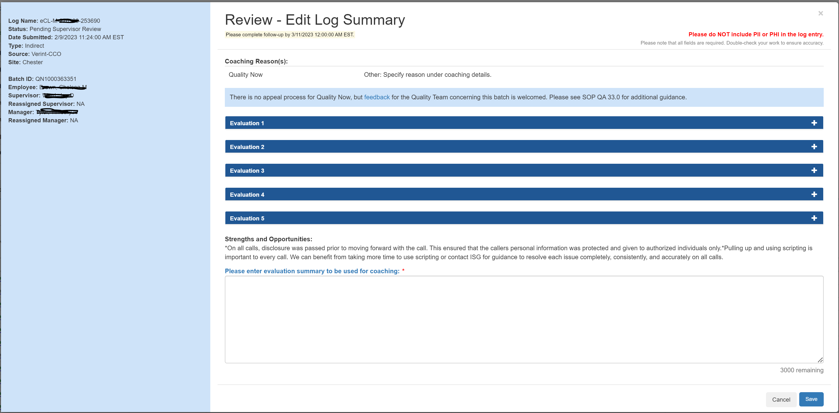

Supervisor Coaches CSR or ISG (triggered by clicking “Coach” link from log list on My Dashboard – My Pending Review):

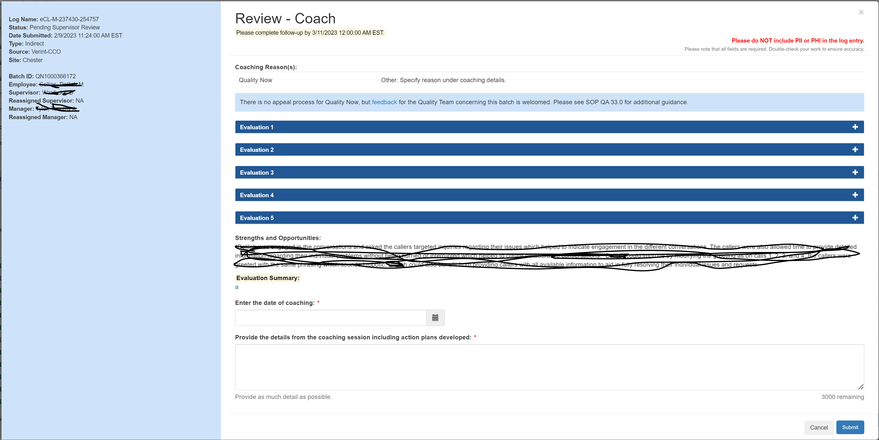

CSR or ISG Reviews/Acks (triggered by clicking “Review” link from log list on My Dashboard – My Pending Review):

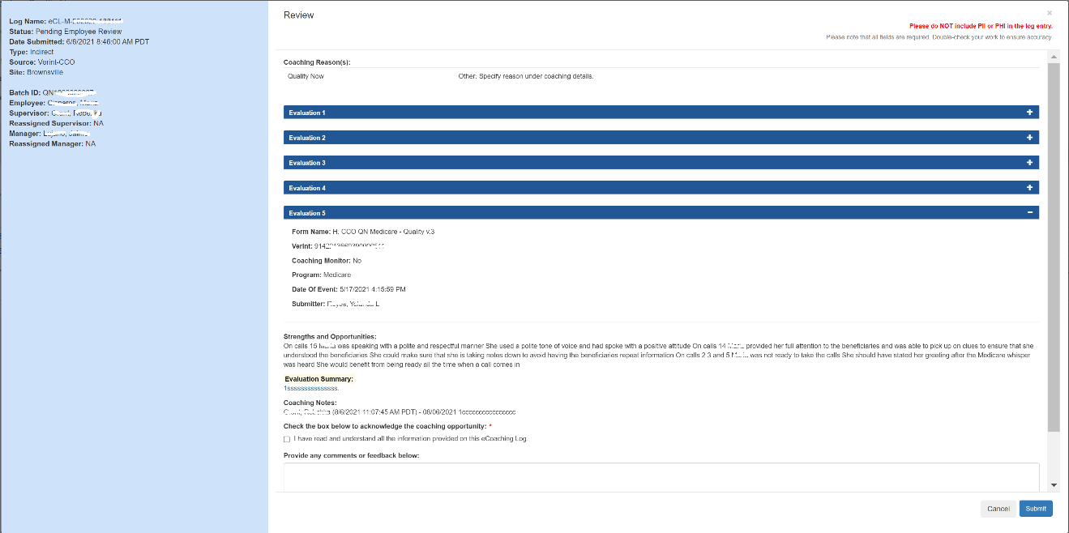

Supervisor Works on Follow-up Review (triggered by clicking “Review” link from log list on My Dashboard – My Pending Follow-up Preparation):

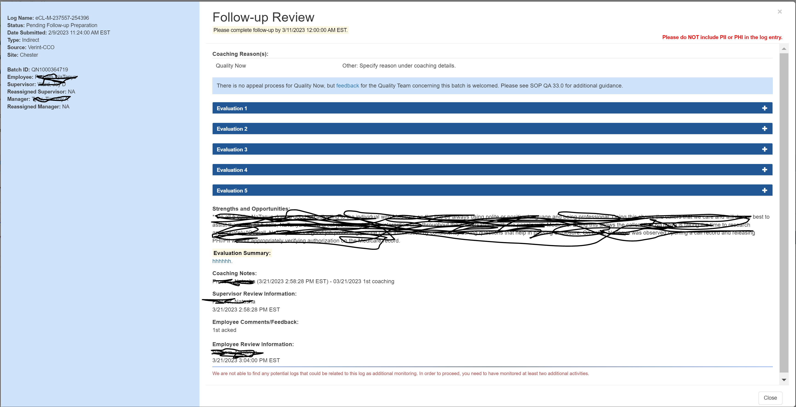

Supervisor Works on Follow-up Coaching (prepare log summary) (triggered by clicking “Prepare” link from log list on My Dashboard – My Pending Follow-up Coaching):

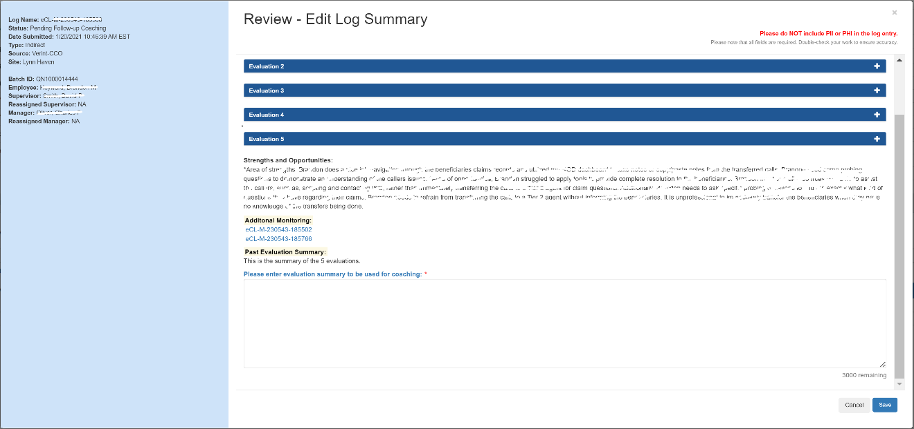

Supervisor Works on Follow-up Coaching (coaches CSR or ISG) (triggered by clicking “Coach” link from log list on My Dashboard – My Pending Follow-up Coaching):

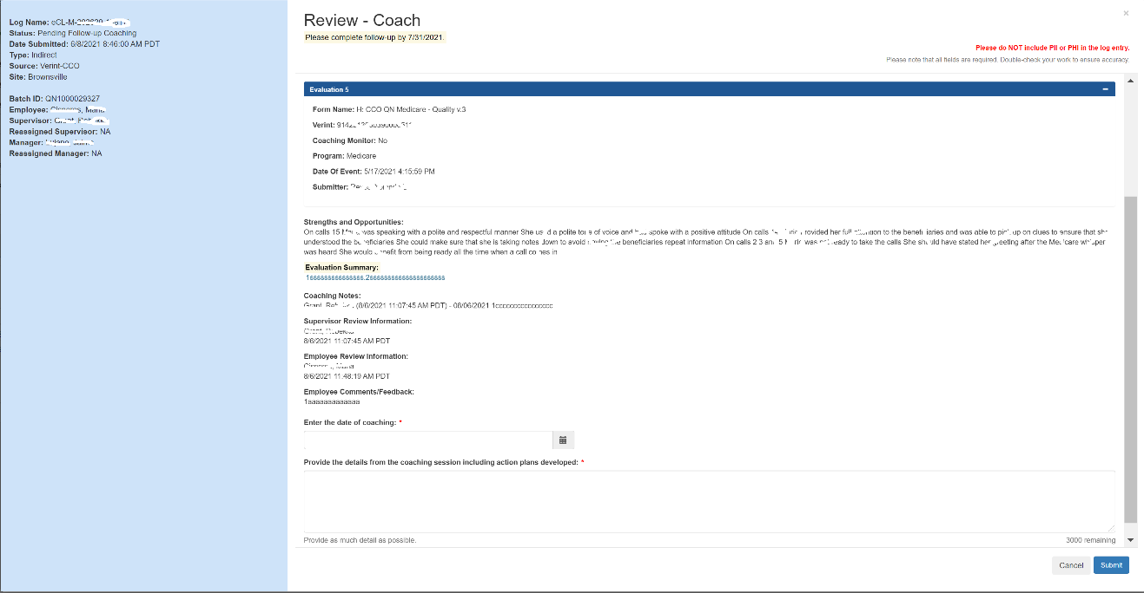

CSR or ISG Reviews/Acks (reviews/acks after follow-up coaching) (triggered by clicking “Review” link from log list on My Dashboard – My Pending Review):

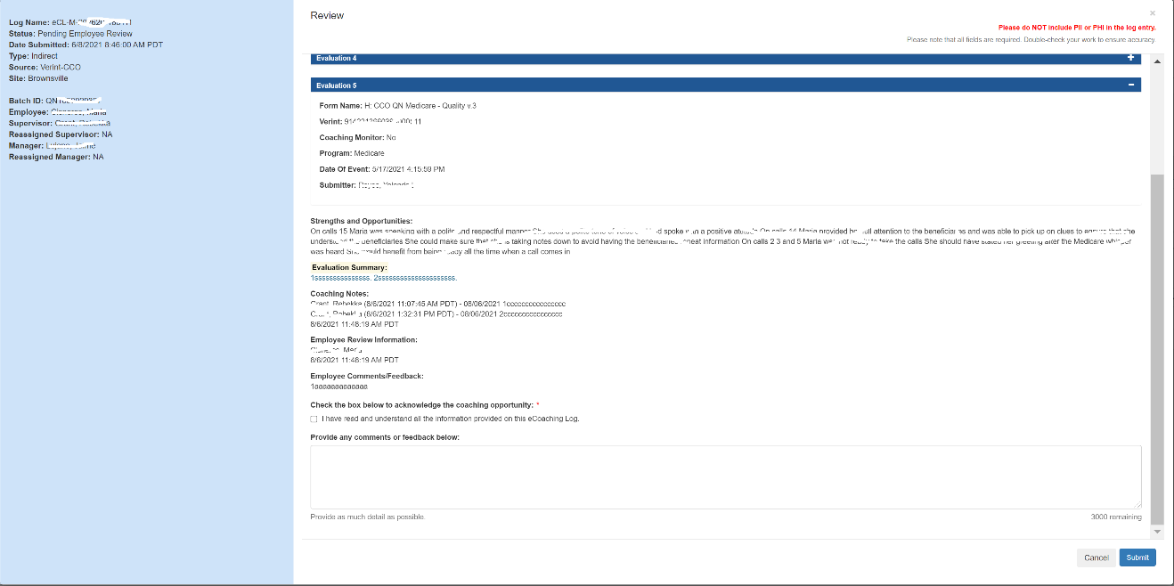

CSR or ISG views completed log (triggered by clicking “View” link from log list on My Dashboard – My Completed):

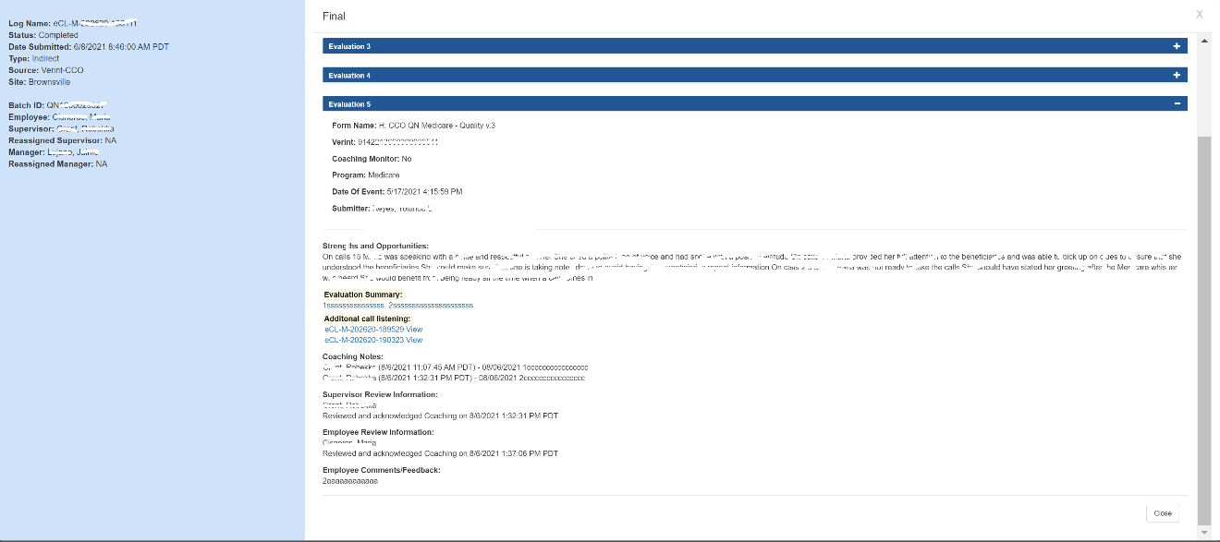

Supervisor views completed log (triggered by clicking “View” link from log list on My Dashboard – My Team’s Completed):

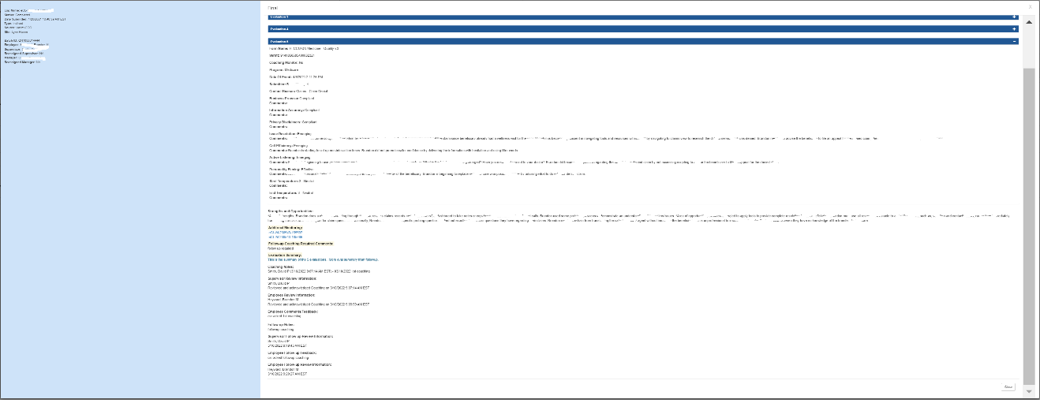

Manager views completed log (triggered by clicking “View” link from log list on My Dashboard – My Team’s Completed):

Same as Supervisor view.

Manager views pending log (triggered by clicking “View” link from log list on My Dashboard – My Team’s Pending):

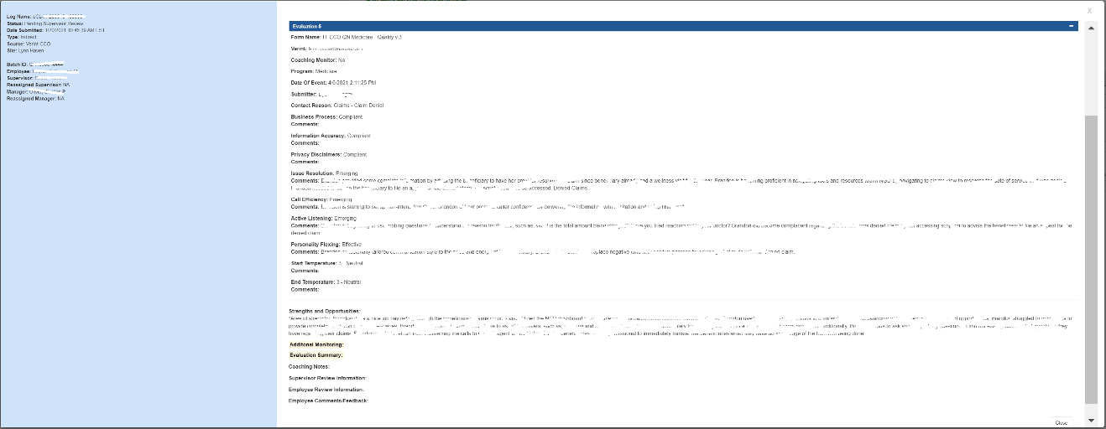

Authorized users view on Historical Dashboard:



* 1. Quality Now Supervisor

Supervisor Coaches CSR or ISG (triggered by clicking “Coach” link from log list on My Dashboard – My Pending Review):

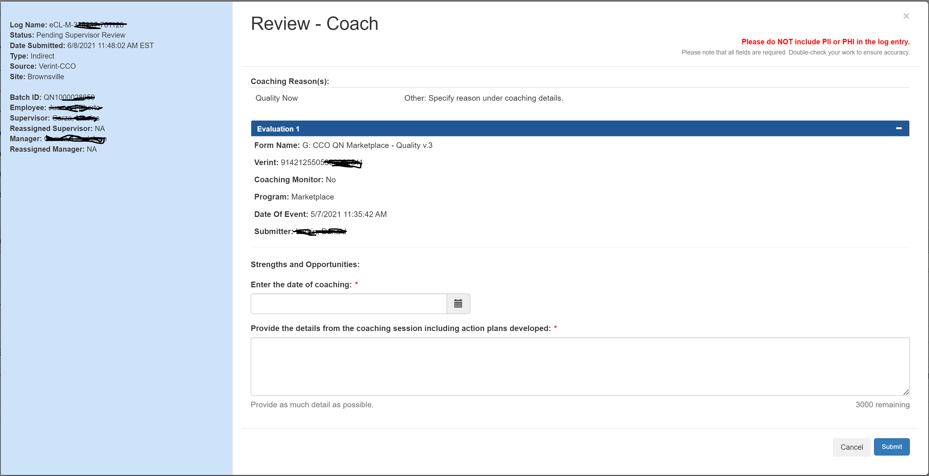

CSR or ISG Reviews/Acks (triggered by clicking “Review” link from log list on My Dashboard – My Pending Review):

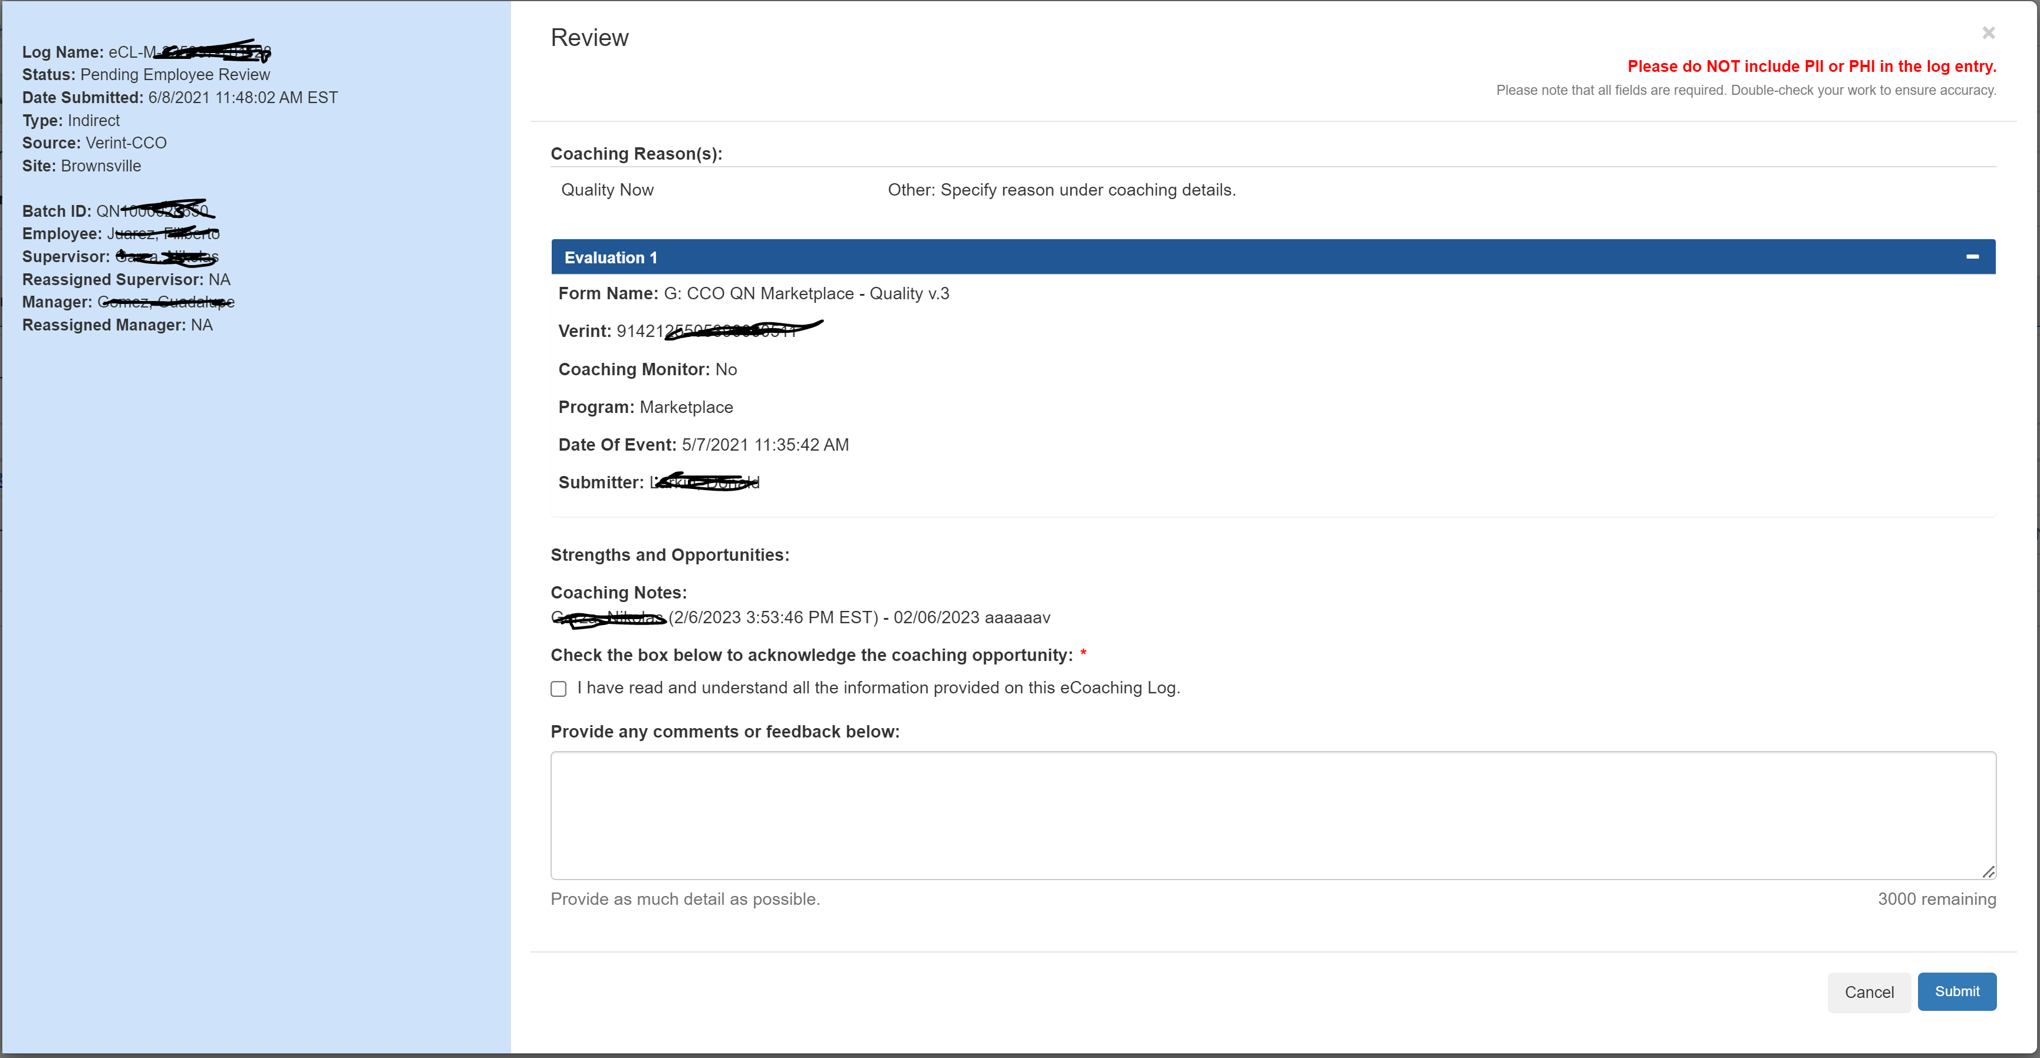

CSR or ISG views completed log (triggered by clicking “View” link from log list on My Dashboard – My Completed):

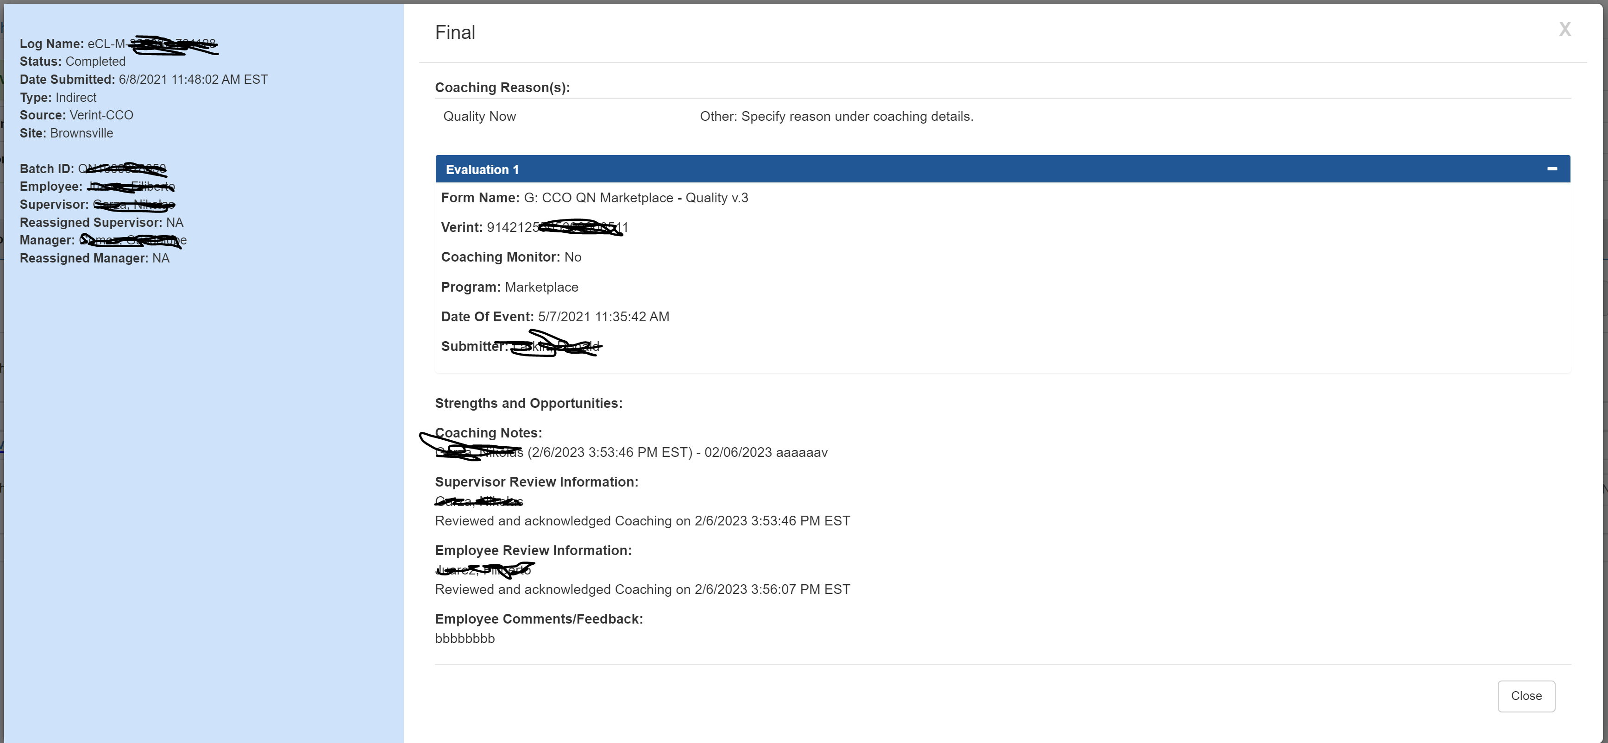

* 1. Unauthorized View

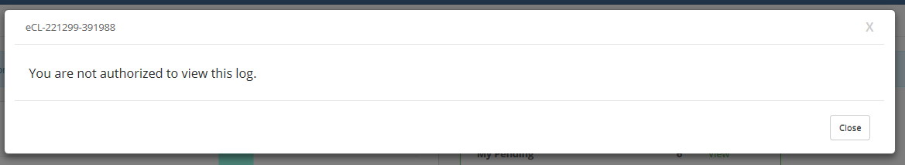

1. Logic to determine who can view Log Details

|  |  |
| --- | --- |
| My Dashboard – My Submission | Submitter only |
| My Dashboard – other than “My Submission”; | Employee;  Supervisor;  Manager;  Reassigned user; |
| Historical Dashboard | ARC;  ECL;  Employee;  Supervisor;  Manager;  Reassigned user; |

1. When to display feedback text and url

|  |  |
| --- | --- |
| Pending Supervisor Review | Prepare  Coach |
| Pending Follow-up Preparation | Review |

1. Logic to determine Review Page display mode (Ready Only vs Editable)

|  |  |
| --- | --- |
| Pending Supervisor Review | If user is the supervisor (or reassigned to), then Editable.  Else Read Only; |
| Pending Employee Review | If user is the employee, then Editable.  Else Read Only; |
| Pending Follow-up Preparation | If user is the supervisor (or reassigned to), then Editable.  Else Read Only; |
| Pending Follow-up Coaching | If user is the supervisor (or reassigned to), then Editable.  Else Read Only; |

1. Workflow
   1. Quality Now

Quality Specialist Form (5 evaluations per batch; one batch per log) – submitted by quality specialist:

Pending Supervisor Review 🡪 Pending Employee Review 🡪 Pending Follow-up Preparation;

*Supervisor checks two more activities (phone, webchat, or written correspondence) and decide if follow-up coaching is needed;*

If follow-up coaching is needed 🡪 Pending Follow-up Coaching 🡪 Pending Follow-up Employee Review 🡪 Completed.

If follow-up coaching is not needed 🡪 Pending Follow-up Employee Review 🡪 Completed.

* 1. Quality Now Supervisor

Quality Now Supervisor Form (1 evaluation per batch; one batch per log) – submitted by supervisor:

Pending Supervisor Review 🡪 Pending Employee Review 🡪 Completed.