________________________



Detail Design: CCO eCoaching Log - Survey

________________________

Prepared by: Lili Huang Date: 05/21/2018

Department: FCD

Change History Log

| Date | Change Description | Author |
| --- | --- | --- |
| 05/21/2018 | Initial Revision – TFS 10972 | Lili Huang |
| 08/31/2018 | TFS11984 – Include a link to ecl sharepoint site to report issues;  Updated 3.1.4 Web Page Invoked Events | Lili Huang |
| 09/04/2018 | TFS11984 – Include a link to ecl sharepoint site to report issues;  Moved the change to Common DD | Lili Huang |
| 09/25/2018 | TFS 12183 – Surveys submissions duplicate key error;  Updated 2. Business logic; 3.2.3 Screenshot | Lili Huang |
| 04/19/2019 | TFS 14227 – Add Hot Topic question on Survey Page; | Lili Huang |
| 04/22/2019 | TFS 14227 – Add Hot Topic question on Survey Page;  Updated screenshot | Lili Huang |
|  |  |  |

Table of Contents

**1.** **Description** 4

**2.** **Business Logic – SurveyController.cs** 4

Else Redirect user to the result page with “You have already submitted this survey [survey_id].” 4

**3.** **Page details** 4

**3.1** **Views\Survey\Index.cshtml** 4

3.1.1 Razor pages comprising Web Page 4

3.1.2 Layout Page 4

3.1.3 Screenshot 4

Note: Only displays question #7 for CSRs working at London site. 4

3.1.4 Web Page Invoked Events 5

**3.2** **Views\Survey\_Result.cshtml** 5

3.2.1 Razor pages comprising Web Page 5

3.2.2 Layout Page 6

3.2.3 Screenshot 6

3.2.4 Web Page Invoked Events 6

**4.** **Stored Procedures** 7

4.1. sp_select_surveydetails_by_surveyid 7

4.2. sp_select_questions_for_survey 7

4.3. sp_select_responses_by_question 7

4.4. sp_update_survey_response 7

4.5. sp_selectreviewfrom_coaching_log 7

4.6. sp_selectreviewfrom_coaching_log_reasons 7

1. **Description**

The eCoaching Log Survey provides a way to collect CSRs feedback about coaching experience. Every month, any CSR who has acknowledged and completed at least one eCoaching log and has not been chosen to do the survey for that month may receive a survey notification email, which has a link that takes the CSR to the Survey page.

The survey has five required questions, one required hot topic question if enabled, and one optional question for any additional comment.

1. **Business Logic – SurveyController.cs**

Upon user clicks the link in the survey notification email, it checks if the user’s employee ID matches the survey’ employee ID. Display unauthorized message if not matched; Check if the survey has been either inactivated or completed otherwise. If the survey is open, display survey page; Display appropriate message instead of survey page otherwise.

* Get the survey by calling stored procedures sp_select_surveydetails_by_surveyid, sp_select_questions_for_survey, and sp_select_responses_by_question;
* Check if the user’s employee ID matches the survey’s employee ID.
* If not matched, redirect user to the unauthorized page;
* If matched,
  + Redirect user to the result page with inactivated message if inactivated;
  + Redirect user to the result page with completed message if completed;
  + Otherwise, display the survey page.

* Upon user clicks Submit button, check if all questions are answered. If not, keep user on the survey page with validation error message displayed.

Otherwise, check if the survey form has already been submitted within the current HTTP session, if not, save the survey to database by calling stored procedure sp_update_survey_response

* + Redirect user to the result page with success message if the survey has been successfully saved;
  + Redirect user to the result page with fail message if the survey was not saved.

Else Redirect user to the result page with “You have already submitted this survey [survey_id].”

1. **Page details**
   1. **Views\Survey\Index.cshtml**
      1. Razor pages comprising Web Page

None

* + 1. Layout Page

Views\Shared\_Layout.cshtml

* + 1. Screenshot

Note: Only display question “Quality Now has improved my experience working on the CCO.” for CSRs working at London site.

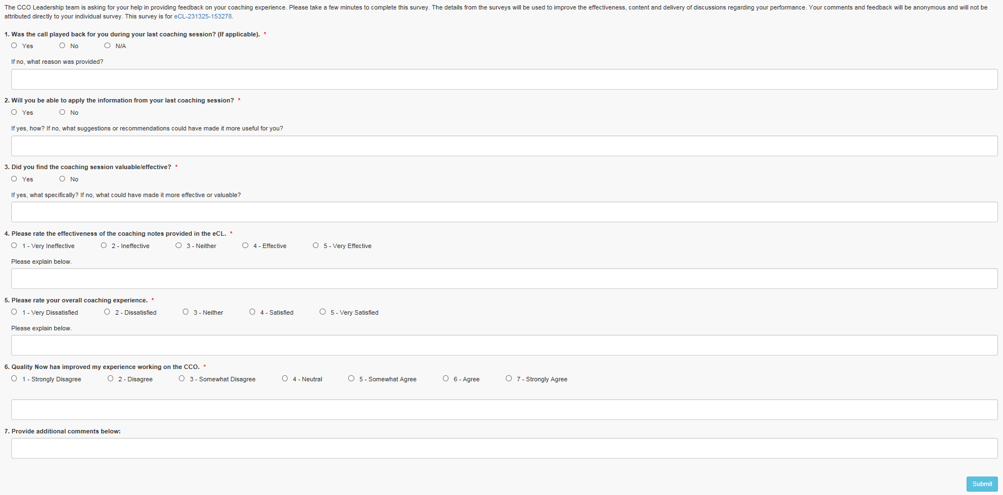

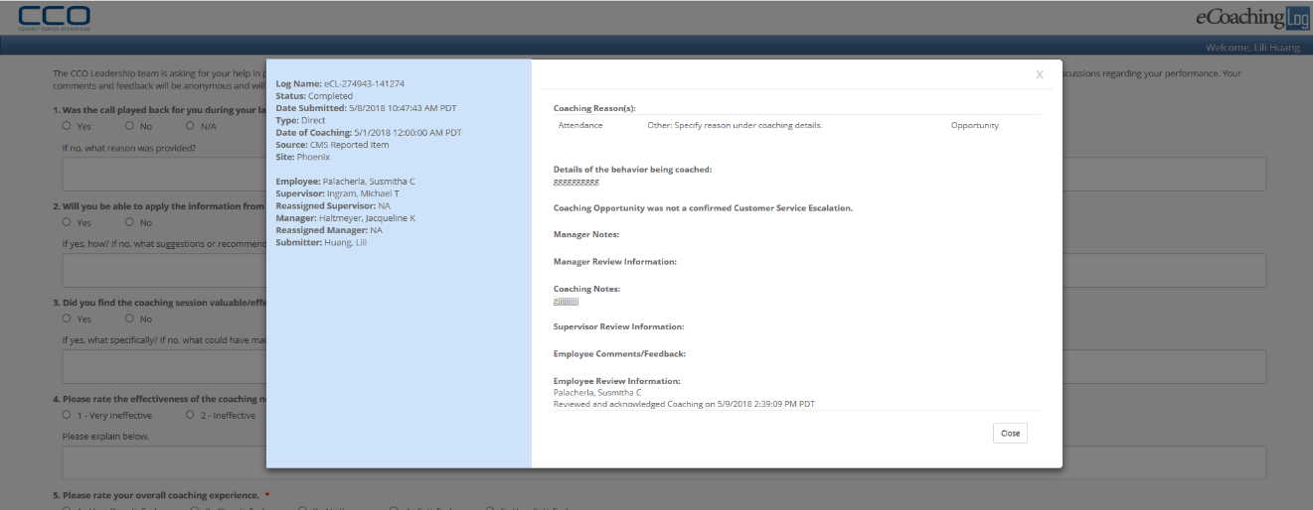

* + 1. Web Page Invoked Events

| Action | Processing & Result |
| --- | --- |
| Click the log name link | Controller: LogBase  Action: GetLogDetail  Display log details. |
| Click Submit button | Controller: Survey  Action: Save  Save survey to database. |

* 1. **Views\Survey\_Result.cshtml**
     1. Razor pages comprising Web Page

None

* + 1. Layout Page

Views\Shared\_Layout.cshtml

* + 1. Screenshot

You are not authorized.



Survey has already been completed.



Survey has expired.



Survey has been completed successfully.



You have already submitted this survey [survey_id].



* + 1. Web Page Invoked Events

| Action | Processing & Result |
| --- | --- |
| None | None |

1. **Stored Procedures**
   1. sp_select_surveydetails_by_surveyid
   2. sp_select_questions_for_survey
   3. sp_select_responses_by_question
   4. sp_update_survey_response
   5. sp_selectreviewfrom_coaching_log
   6. sp_selectreviewfrom_coaching_log_reasons

Refer CCO_eCoaching_Log_Database_DD.docx for details.