________________________



Detail Design: eCoaching Survey

eCoaching_Survey_DD

________________________

Prepared by: Lili Huang Date: 09/23/2015

Department: HCSD

Change History Log

| Date | Change Description | Author |
| --- | --- | --- |
| 09/23/2015  10/09/2015  03/22/2015 | Initial Revision – TFS 594  TFS 594 –  Updated 6.1.3 Screen shot  Updated 6.1.3 Screen shot | Lili Huang  Lili Huang  Lili Huang |
|  |  |  |

Table of Contents

1. Description 4

2. Presentation Layer 4

2.1. MySurvey.aspx.vb 4

2.1.1. Business Logic 4

2.2. MySurveyLogDetailView.aspx.vb 4

2.2.1. Business Logic 4

3. Business Layer 4

3.1. MySurveyHandler.vb 4

3.1.1. IsAccessAllowed 4

3.1.2. IsSurveyCompleted 4

3.1.3. ShowHotTopic 4

3.1.4. GetSurvey 5

3.1.5. SaveSurvey 5

3.1.6. GetQuestion 5

3.2. MySurveyLogDetailViewHandler.vb 5

3.2.1. GetLogReasons 5

3.2.2. GetLogDetail 5

4. Data Access Layer 5

4.1. MySurveyDBAccess.vb 5

4.1.1. GetSurvey 5

4.1.2. GetSurveyInfo 5

4.1.3. GetSurveyQuestions 5

4.1.4. GetSingleChoices 5

4.1.5. SaveSurvey 5

4.2. MySurveyLogDetailDBAccess.vb 5

4.2.1. GetLogReasons 5

4.2.2. GetLogDetail 5

5. Stored Procedures 5

5.1. Sp_Select_SurveyDetails_By_SurveyID 6

5.2. sp_Select_Questions_For_Survey 6

5.3. sp_Select_Responses_By_Question 6

5.4. sp_Update_Survey_Response 7

6. Page details 7

6.1. Survey Page (MySurvey.aspx) 7

6.1.1. ASPX pages comprising Web Page 7

6.1.2. Master Page 7

6.1.3. Screen Shot 7

6.1.4. Links 8

6.1.5. Web Page Invoked Events 8

6.1.6. Form Fields 10

6.2. Survey Log Detail Page (MySurveyLogDetailView.aspx) 12

6.2.1. Master Page 12

6.2.2. Screen Shot 12

6.2.3. Links 12

6.2.4. Web Page Invoked Events 12

6.2.5. Form Fields 13

1. Description

The eCoaching Survey provides a way to collect employees’ feedback about their coaching experience.

The survey takes place three times a month. Any employees who have acknowledged and completed at least one eCoaching Log in the survey month and have not been chosen to do the survey for the survey month might receive a survey notification email. The email will have a link that will take the employee to the Survey page.

1. Presentation Layer
   1. MySurvey.aspx.vb
      1. Business Logic

When the page displays for the first time (not post back):

Get the survey id request parameter;

Get the surveyfrom database

If the user is not authorized for the survey

Display not authorized message

Else

If the survey is completed

Display survey completed message

Else

Bind survey questions to the page

When Submit button is clicked:

If page validation fails,

Display error message

Else

Load the data entered on the page to survey object

Save the survey to database

If the survey is successfully saved

Display success message

Else

Display error message on the top of the page

* 1. MySurveyLogDetailView.aspx.vb
     1. Business Logic

When the page displays for the first time (not post back), the user is authorized for the survey,

And the survey has not been completed yet:

Get the survey log name from session

Get survey log details

Get survey log coaching reasons/subreasons

Bind survey details and survey reasons to the page

1. Business Layer
   1. MySurveyHandler.vb
      1. IsAccessAllowed

Check if the user’s employee ID matches the survey’s employee ID

* + 1. IsSurveyCompleted

Check if the survey has been completed

* + 1. ShowHotTopic

Checks whether to show Hot Topic question or not

* + 1. GetSurvey

Get the survey by calling GetSurvey method in business layer

* + 1. SaveSurvey

Save the survey to database

* + 1. GetQuestion

Get question by question display order

* 1. MySurveyLogDetailViewHandler.vb
     1. GetLogReasons

Get coaching reasons and sub reasons for the survey log

Bind to the page

Get details of the survey log

Bind to the page

* + 1. GetLogDetail

Get the details of the log

1. Data Access Layer
   1. MySurveyDBAccess.vb
      1. GetSurvey

Get survey general information (employee ID, survey log name, survey status, and if the survey contains hot topic for the month) by calling GetSurveyInfo

Get survey questions by calling GetSurveyQuetions

Get single choices data by calling GetSingleChoices

* + 1. GetSurveyInfo

Get survey general information (employee ID, survey log name, survey status, and if the survey contains hot topic for the month) by calling stored procedure sp_Select_SurveyDetails_By_SurveyID

* + 1. GetSurveyQuestions

Get survey questions by calling stored procedure sp_Select_Questions_For_Survey

* + 1. GetSingleChoices

Get single choices by calling stored procedure sp_Select_Responses_For_Survey

* + 1. SaveSurvey

Save survey to database by calling stored procedure sp_Update_Survey_Response

* 1. MySurveyLogDetailDBAccess.vb
     1. GetLogReasons

Get coaching reasons and sub reasons by calling stored procedure sp_SelectReviewFrom_Coaching_Log_Reasons

* + 1. GetLogDetail

Get details of the log by calling stored procedure sp_SelectReviewFrom_Coaching_Log

1. Stored Procedures
   1. Sp_Select_SurveyDetails_By_SurveyID

/*****************************************************************

Description:

Returns Employee ID, eCL Form Name, and if the survey contains a Hot Topic question for a given survey ID.

Tables:

Survey_Response_Header

Survey_DIM_QAnswer

Input Parameters:

surveyID

Resultset:

Survey_Response_Header.EmployeeID

Survey_Response_Header.FormName

Survey_DIM_QAnswer.isHotTopic

*****************************************************************/

* 1. sp_Select_Questions_For_Survey

/*****************************************************************

Description:

Returns all the questions’ display text and display order for a given survey.

Tables:

Survey_DIM_Question

Survey_DIM_QAnswer

Input Parameters:

surveyID

Resultset:

Survey_DIM_Question.QuestionID

Survey_DIM_Question.Description

Survey_DIM_Question.DisplayOrder

Survey_DIM_QAnswer.isHotTopic

*****************************************************************/

* 1. sp_Select_Responses_By_Question

/*****************************************************************

Description:

Returns all the active singlechoices.

Tables:

Survey_DIM_Response

Input Parameters:

None

Resultset:

Survey_DIM_Response.QuestionID

Survey_DIM_Response.ResponseID

Survey_DIM_Response.ResponseValue

*****************************************************************/

* 1. sp_Update_Survey_Response

/*****************************************************************

Description:

Updates Survey_response_header.CSRComments with the comments passed in;

Updates Survey_response_header.Status to “Completed”;

Updates Survey_response_header.CompletedDate to current timestamp;

Inserts all records from User-Defined Table ResponsesTableType into table Survey_response_detail.

Tables:

Survey_response_header

Survey_response_detail

Input Parameters:

surveyID

ResponsesTableType

userComments

Resultset:

None

Output Parameters:

returnCode

returnMessage

*****************************************************************/

1. Page details
   1. Survey Page (MySurvey.aspx)
      1. ASPX pages comprising Web Page

MySurvey.aspx

* + 1. Master Page

Site4.Master

* + 1. Screen Shot

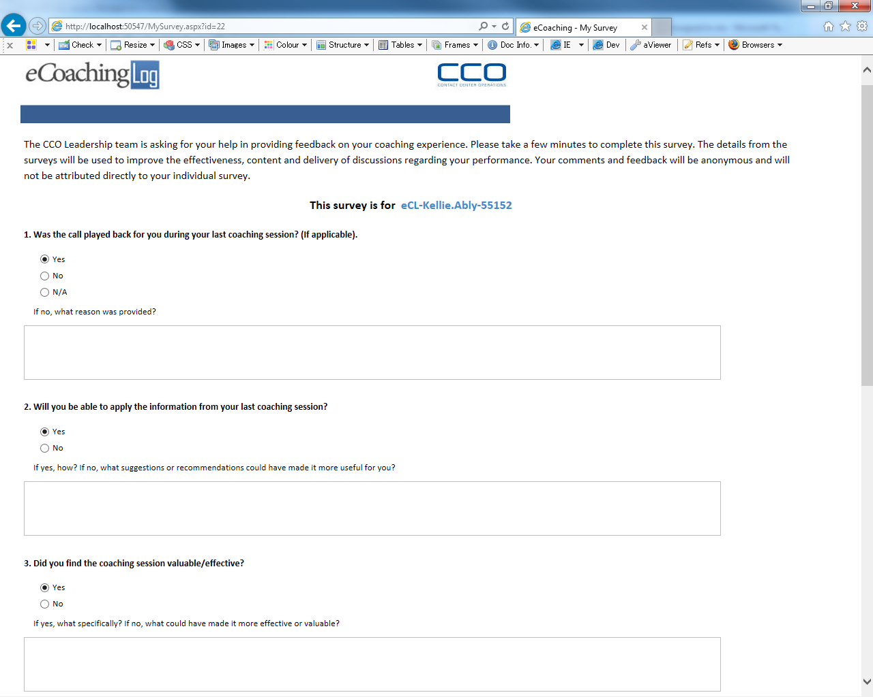

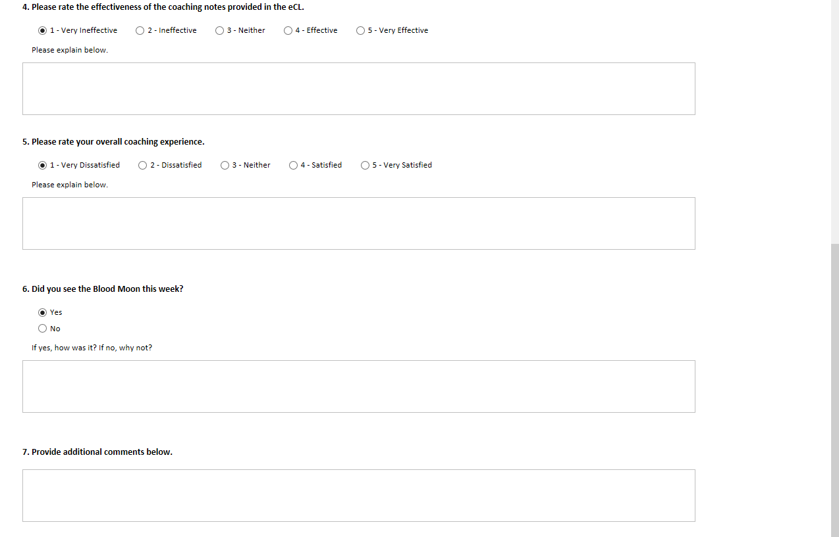



* + 1. Links

|  |  |
| --- | --- |
| Link Link Name | Destination |
| ecl-xxx-xxxx-123456 | My Survey Log Detail page (MySurveyLogDetailView.aspx |

* + 1. Web Page Invoked Events

| Action | Processing & Result |
| --- | --- |
| OnPageLoad | MySurvey.aspx is loaded. |
| Click on “ecl-xxx-xxxx-123456” link | Javascript displayDetailModal() is called to pop up Log Detail modal dialog |
| Click on “Submit” button | The form is submitted. |

* + 1. Form Fields

| **Page Name** | **Field Type** | **Field Name** | **Default Value** | **Data Element Source** | **Validation** |
| --- | --- | --- | --- | --- | --- |
| MySurvey.aspx | Label |  | The Quality team is asking for your help in providing feedback on your coaching experience with your supervisor. Please take a few minutes to complete this survey. The details from this survey will be used to improve the effectiveness, content and delivery of discussions regarding your performance. |  |  |
| MySurvey.aspx | Label |  | This survey is for |  |  |
| MySurvey.aspx | Link |  | ecl-xxx.xxxx-123456 | Survey_Response_Header.FormName |  |
| MySurvey.aspx | Label |  | 1.Was the call played back for you during your last coaching session? (If applicable). | Survey_DIM_Question.Description |  |
| MySurvey.aspx | RadioButtonList | Question1RadioButtonList |  | Survey_DIM_QAnswer.ResponseID  Survey_DIM_QAnswer.ResponseValue | required |
| MySurvey.aspx | RadioButton |  | Yes |  |  |
| MySurvey.aspx | RadioButton |  | No |  |  |
| MySurvey.aspx | RadioButton |  | N/A |  |  |
| End of RadioButtonList | | | | | |
| MySurvey.aspx | Label |  | If no, what reason was provided? | Survey_DIM_Question.Description |  |
| MySurvey.aspx | Text Box | Question1TextBox |  |  | optional |
| MySurvey.aspx | Label |  | 2.Will you be able to apply the information from your last coaching session? | Survey_DIM_Question.Description |  |
| MySurvey.aspx | RadioButtonList | Question2RadioButtonList |  | Survey_DIM_QAnswer.ResponseID  Survey_DIM_QAnswer.ResponseValue | required |
| MySurvey.aspx | RadioButton |  | Yes |  |  |
| MySurvey.aspx | RadioButton |  | No |  |  |
| End of RadioButtonList | | | | | |
| MySurvey.aspx | Label |  | If yes, how? If no, why not? | Survey_DIM_Question.Description |  |
| MySurvey.aspx | TextBox | Question2TextBox |  |  | optional |
| MySurvey.aspx | Label |  | 3.Did you find the coaching sesson valuable/effective? | Survey_DIM_Question.Description |  |
| MySurvey.aspx | RadioButtonList | Question3RadioButtonList |  | Survey_DIM_QAnswer.ResponseID  Survey_DIM_QAnswer.ResponseValue | required |
| MySurvey.aspx | RadioButton |  | Yes |  |  |
| MySurvey.aspx | RadioButton |  | No |  |  |
| End of RadioButtonList | | | | | |
| MySurvey.aspx | Label |  | If yes, what specifically? If no, why not? | Survey_DIM_Question.Description |  |
| MySurvey.aspx | TextBox | Question3TextBox |  |  | optional |
| MySurvey.aspx | Label |  | 4.Please rate the effectiveness of the coaching notes provided in the eCL. | Survey_DIM_Question.Description |  |
| MySurvey.aspx | RadioButtonList | Question4RadioButtonList |  | Survey_DIM_QAnswer.ResponseID  Survey_DIM_QAnswer.ResponseValue | required |
| MySurvey.aspx | RadioButton |  | 1-Very Ineffective |  |  |
| MySurvey.aspx | RadioButton |  | 2-Ineffective |  |  |
| MySurvey.aspx | RadioButton |  | 3-Neither |  |  |
| MySurvey.aspx | RadioButton |  | 4-Effective |  |  |
| MySurvey.aspx | RadioButton |  | 5-Very Effective |  |  |
| End of RadioButtonList | | | | | |
| MySurvey.aspx | Label |  | Please explain below. | Survey_DIM_Question.Description |  |
| MySurvey.aspx | TextBox | Question4TextBox |  |  | optional |
| MySurvey.aspx | Label |  | 5.Please rate your overall coaching experience. | Survey_DIM_Question.Description |  |
| MySurvey.aspx | RadioButtonList | Question5RadioButtonList |  | Survey_DIM_QAnswer.ResponseID  Survey_DIM_QAnswer.ResponseValue | required |
| MySurvey.aspx | RadioButton |  | 1-Very Dissatisfied |  |  |
| MySurvey.aspx | RadioButton |  | 2-Dissatisfied |  |  |
| MySurvey.aspx | RadioButton |  | 3-Neither |  |  |
| MySurvey.aspx | RadioButton |  | 4-Satisfied |  |  |
| MySurvey.aspx | RadioButton |  | 5-Very Satisfied |  |  |
| End of RadioButtonList | | | | | |
| MySurvey.aspx | Label |  | Please explain below. | Survey_DIM_Question.Description |  |
| MySurvey.aspx | TextBox | Question5TextBox |  |  | optional |
| MySurvey.aspx | Label |  | 6.Provide additional comments below. |  |  |
| MySurvey.aspx | TextBox | CommentTextBox |  |  | optional |

* 1. Survey Log Detail Page (MySurveyLogDetailView.aspx)

This page displays as a modal dialog on the Survey Page.

* + 1. Master Page

Site3.Master

* + 1. Screen Shot

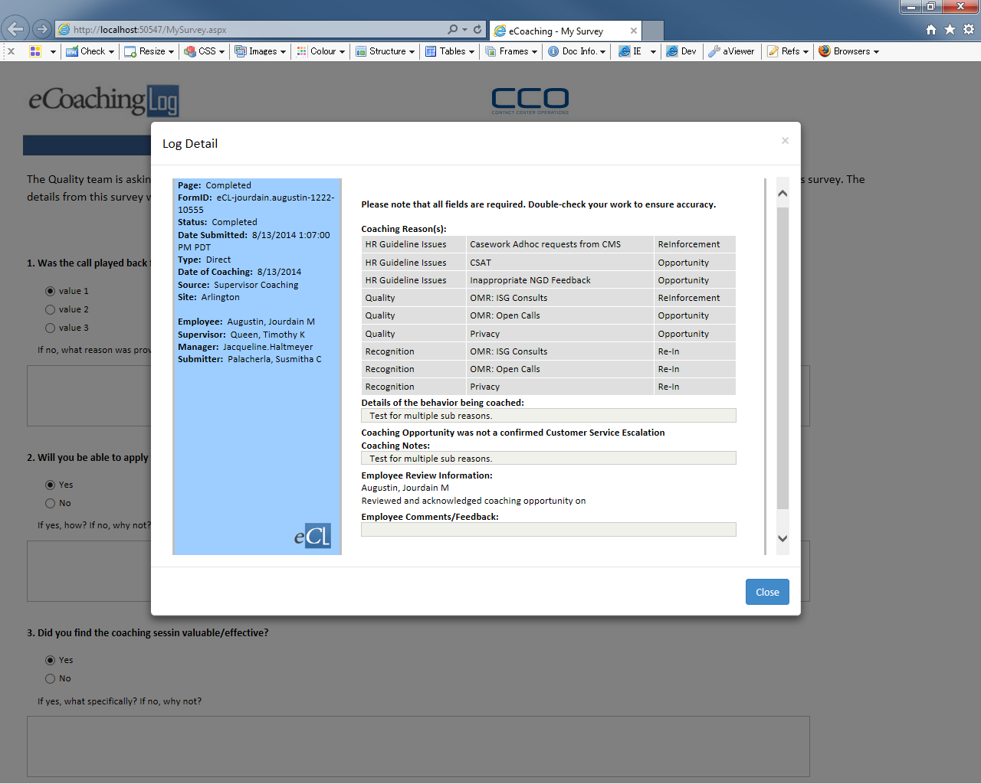

* + 1. Links

None

* + 1. Web Page Invoked Events

None

* + 1. Form Fields

|  |  |  |  |  |  |
| --- | --- | --- | --- | --- | --- |
| **Page Name** | **Field Type** | **Field Name** | **Default Value** | **Data Element Source** | **Display** |
| Left Side Content: | | | | | |
| MySurveyLogDetailView.aspx | Label |  | Page: |  |  |
| Label |  |  | Dim_Status.Status |  |
| Label |  | FormID: |  |  |
| Label |  |  | Coaching_Log.FormName |  |
| Label |  | Status: |  |  |
| Label |  |  | Dim_Status.Status |  |
| Label |  | Date Submitted: |  |  |
| Label |  |  | Coaching_log.SubmittedDate |  |
| Label |  | Type: |  |  |
| Label |  |  | Dim_Source.CoachingSource |  |
| Label |  | Date of Coaching: |  | Displays if the log is “direct”. |
| Label |  |  |  |
| Label |  | Date of Event: |  | Displays if the log is “indirect” |
| Label |  |  |  |
| Label |  | Source: |  |  |
| Label |  |  |  |  |
| Label |  | Site: |  |  |
| Label |  |  |  |  |
| Label |  | Verint ID: |  | Displays if it’s Verint monitor. |
| Label |  |  | Coaching_log.verintID |
| Label |  | Scorecard Name: |  |  |
| Label |  |  |  |  |
| Label |  | Avoke ID: |  | Displays if it’s behavior analytics monitor. |
| Label |  |  | Coaching_log.AvokeID |
| Label |  | NGD Activity ID: |  | Displays if it’s NGD Activity monitor. |
| Label |  |  | Coaching_log.NGDActivityID |
| Label |  | Universal Call ID: |  | Displays if it’s Universal call monitor |
| Label |  |  | Coaching_log.UCID |
| Label |  | Employee : |  |  |
| Label |  |  | Employee_Hierarchy.Emp_Name |  |
| Label |  | Supervisor: |  |  |
| Label |  |  | Employee_Hierarchy.Sup_Name |  |
| Label |  | Manager: |  |  |
| Label |  |  | Employee_Hierarchy.Mgr_LandID |  |
| Label |  | Submitter: |  |  |
| Label |  |  | Employee_Hierarchy.Emp_Name |  |
| Image |  | eclogo.png |  |  |
| Right Side Content: | | | | | |
| MySurveyLogDetailView.aspx | Label |  | Please note that all fields are required. Double-check your work to ensure accuracy. |  |  |
| Label |  | Coaching Reason(s): |  |  |
| GridView |  |  | Stored procedure  sp_SelectReviewFrom_Coaching_Log_Reasons |  |
|  |  | Details of the behavior being coached: |  |  |
| Table |  |  | Coaching_log.Description |  |
|  |  | Coaching Opportunity was a confirmed Customer Service Escalation |  | Displays if Coaching Reason is “Customer Service Escalation” |
| Label |  | Management Notes: |  | Displays if Coaching Reason is NOT “Customer Service Escalation” |
| Label |  |  | Coaching_Log.MgrNotes |
| Label |  | Coaching Opportunity was not a confirmed Customer Service Escalation |  | Displays if Coaching Reason is NOT “Customer Service Escalation” |
| Label |  | Coaching Notes: |  |  |
| Label |  |  | Coaching_Log.CoachingNotes |  |
| Label |  | Employee Review Information: |  |  |
| Label |  |  | Employee_Hierarchy.Emp_Name |  |
| Label |  | Reviewed and acknowledged coaching opportunity on |  |  |
| Label |  |  | Coaching_Log.CSRReviewAutoDate |  |
| Label |  | Supervisor Review Information: |  | Displays if it’s IQS. |
| Label |  |  | Employee_Hierarchy.Sup_Name |
| Label |  | Reviewed and acknowledged Quality Monitor on |  |
|  |  |  | Coaching_Log.SupReviewedAutoDate |
| Label |  | Employee Comments/Feedback: |  | Displays if it’s NOT IQS. |
| Label |  |  | Coaching_Log.CSRComments |