________________________



Detail Design: eCoaching Admin

________________________

Prepared by: Lili Huang Date: 05/02/2016

Department: HCSD

Change History Log

| Date | Change Description | Author |
| --- | --- | --- |
| 05/02/2016 | Initial Revision – TFS 1709 | Lili Huang |
|  |  |  |

Table of Contents

**1.** **Description** 5

**2.** **Controllers** 5

2.1. BaseController.cs 5

2.1.1. OnException method 5

2.2. HomeController.cs 5

2.2.1. Index action – Http Get 5

2.3. EmployeeLogController.cs 5

2.3.1. SearchForInactivate action - HttpGet 5

2.3.2. SearchForInactivate action - HttpPost 6

2.3.3. Inactivate action - HttpPost 6

2.3.4. SearchForReassign action - HttpGet 6

2.3.5. SearchForReassign action - HttpPost 6

2.3.6. Reassign action - HttpPost 6

2.3.7. SearchForReactivate action - HttpGet 7

2.3.8. SearchForReactivate action - HttpPost 7

2.3.9. Reactivate action - HttpPost 7

**3.** **Services** 7

3.1. EmailService.cs 7

3.1.1. Send 7

3.2. EmployeeLogService.cs 7

3.2.1. GetModules 7

3.2.2. GetTypes 7

3.2.3. GetLogsByEmpIdAndAction 8

3.2.4. GetPendingLogsByReviewerEmpId 8

3.2.5. GetPendingStatusesForReassign 8

3.2.6. GetReasons 8

3.2.7. ProcessActivation 8

3.3. EmployeeService.cs 8

3.3.1. GetEmployee 8

3.3.2. GetEmployees 8

3.3.3. GetPendingReviewersByStatusId 8

3.4. UserService.cs 8

3.4.1. GetUserByLanId 8

3.4.2. UserIsEntitled 9

**4.** **Repository** 9

4.1. EmployeeLogRepository.cs 9

4.1.1. GetModules 9

4.1.2. GetLogsByEmpIdAndAction 9

4.1.3. GetPendingLogsByReviewerEmpId 9

4.1.4. GetReasons 9

4.1.5. ProcessActivation 9

4.2. EmployeeRepository.cs 9

4.2.1. GetEmployee 9

4.2.2. GetEmployees 9

4.2.3. GetPendingReviewers 10

4.2.4. GetAssignToList 10

4.3. UserRepository.cs 10

4.3.1. GetUserByLanId 10

**5.** **Stored Procedures** 10

**6.** **Page details** 10

6.1. Main Menu (Views\Home\Index.cshtml) 10

6.1.1. Razor pages comprising Web Page 10

6.1.2. Layout Page 10

6.1.3. Screen Shot 10

6.1.4. Links to Other Modules 11

6.1.5. Web Page Invoked Events 11

6.1.7. Form fields 11

6.2. Inactivate Employee Logs (Views\EmployeeLog\SearchForInactivate.cshtml) 11

6.2.1. Razor pages comprising Web Page 11

6.2.2. Layout Page 11

6.2.3. Screen Shot 11

6.2.4. Links 13

6.2.5. Web Page Invoked Events 13

6.2.6. Form Fields 16

6.3. Reassign Employee Logs (Views\EmployeeLog\SearchForReassign.cshtml) 18

6.3.1. Razor pages comprising Web Page 18

6.3.2. Layout Page 18

6.3.3. Screen Shot 18

6.3.4. Links 20

6.3.5. Web Page Invoked Events 20

6.3.6. Form Fields 22

6.4. Reactivate Employee Logs (Views\EmployeeLog\SearchForReactivate.cshtml) 24

6.4.1. Razor pages comprising Web Page 24

6.4.2. Layout Page 24

6.4.3. Screen Shot 24

6.4.4. Links 26

6.4.5. Web Page Invoked Events 26

6.4.6. Form Fields 28

1. **Description**

This intranet site provides functionalities for administrators and managers to manage eCoaching logs.

Active coaching logs and warning logs are allowed to be inactivated. Inactivated coaching logs and warning logs are allowed to be reactivated to their previous status. Users must provide a valid reason when inactivating and reactivating eCoaching logs.

Pending review coaching logs are allowed to be reassigned to a different reviewer at the same hierarchey level. Users must provide a valid reason when reassigning eCoaching logs.

Administrators are allowed to manage coaching logs and warning logs across all sites, while managers are allowed to manage coaching logs from their own sites.

**Login**

Users log in with Windows authentication. Users will be required to enter a valid user ID and password. Users will be forwarded to the main menu page upon successful authentication and authorization. Otherwise, users will be redirected to the unauthorized page.

Roles Based Access Control (RBAC) approach is used for authorization. Each user can be assigned zero, one or many roles based on their responsibilities. The permissions to perform certain operations are assigned to specific roles. Through role-permission assignments, users acquire application permissions to perform particular tasks.

**Logoff**

Users exit the system by closing the browser.

1. **Controllers**
   1. BaseController.cs
      1. OnException method

Use log4net to log any exceptions thrown in all controllers.

Display Error page.

* 1. HomeController.cs
     1. Index action – Http Get

Get the user LAN ID for the current HTTP request.

Call GetUserByLanId method in the UserService class.

If it returns null

Redirect the user to the unauthorized page.

Else

Store the user returned in Session.

Display the main menu page.

* 1. EmployeeLogController.cs
     1. SearchForInactivate action - HttpGet

Call GetModules method in the EmployeeLogService class to return modules.

Save the modules returned in ViewBag.Modules.

Call GetTypes method in the EmployeeLogService class to return log types (coaching or warning).

Save the types returned in ViewBag.Types.

Initialize employee list to only have one item “Please select an employee” with value -1.

Save employee list in ViewBag.Employees.

Return SearchForInactivate.cshtml view.

* + 1. SearchForInactivate action - HttpPost

Get the selected log type ID and the selected employee ID for the current request.

Call GetLogsByEmpIdAndAction method in EmployeeLogService class to return logs for the selected employee with the selected log type (coaching and/or warning).

Return _SearchEmployeeLogResultPartial.cshtml partial view with the logs returned from previous step.

* + 1. Inactivate action - HttpPost

Get the following information for the current request:

* The user LAN ID
* Selected Logs IDs
* Selected Reason ID
* Other Reason text
* Comment text

Call ProcessActivation method in EmployeeLogService class to inactivate the selected logs and save the result to database.

Return success or fail via JSON based on the result from the previous step.

* + 1. SearchForReassign action - HttpGet

Call GetModules method in the EmployeeLogService class to return modules.

Save the modules returned in ViewBag.Modules.

Call GetPendingStatusesForReassign method in the EmployeeLogService class to return log types (coaching and/or warning).

Save the pending statuses returned in ViewBag.Statuses.

Initialize reviewer list to only have one item “Please select a reviewer” with value -1.

Save reviewer list in ViewBag.Reviewers.

Return SearchForReassign view.

* + 1. SearchForReassign action - HttpPost

Get the selected Status ID and the selected reviewer ID for the current request.

Call GetPendingLogsByReviewerEmpId method in EmployeeLogService class to return logs for the selected reviewer with the selected status.

Return _SearchEmployeeLogResultPartial.cshtml partial view with the logs returned from previous step.

* + 1. Reassign action - HttpPost

Get the following information for the current request:

* The user LAN ID
* Selected Logs IDs
* Reviewer Reassigned To
* Selected Reason ID
* Other Reason text
* Comment text

Call ProcessReassign method in EmployeeLogService class to reassign the selected logs to the new reviewer and save the result to database.

If the previous step is successful, send email to the new reviewer.

Return success or fail via JSON based on the result from ProcessReassign call.

* + 1. SearchForReactivate action - HttpGet

Call GetModules method in the EmployeeLogService class to return modules.

Save the modules returned in ViewBag.Modules.

Call GetTypes method in the EmployeeLogService class to return log types (coaching and/or warning).

Save the types returned in ViewBag.Types.

Initialize employee list to have only one item “Please select an employee” with value -1.

Save employee list in ViewBag.Employees.

Return SearchForReactivate.cshtml view.

* + 1. SearchForReactivate action - HttpPost

Get the selected log type ID and the selected employee ID for the current request.

Call GetLogsByEmpIdAndAction method in EmployeeLogService class to return logs for the selected employee with the selected log type (coaching or warning).

Return _SearchEmployeeLogResultPartial.cshtml partial view with the logs returned from previous step.

* + 1. Reactivate action - HttpPost

Get the following information for the current request:

* The user LAN ID
* Selected Logs IDs
* Selected Reason ID
* Other Reason text
* Comment text

Call ProcessActivation method in EmployeeLogService class to reactivate the selected logs and save the result to database.

If the previous step is successful, send email to the logs’ employee, supervisor or manager in the current hierarchy based on the logs’ previous status (before being inactivated).

Return success or fail via JSON based on the result from ProcessActivation call.

1. **Services**
   1. EmailService.cs
      1. Send

Send email based on the Email model passed in.

* 1. EmployeeLogService.cs
     1. GetModules

Call GetModules method in EmployeeLogRepository to return modules based on the user LAN ID.

* + 1. GetTypes

Return log types based on the user’s entitlements.

* + 1. GetLogsByEmpIdAndAction

Call GetLogsByEmpIdAndAction method in EmployeeLogRepository class to return logs of the employee for the action (either inactivate or reactivate).

Return logs.

* + 1. GetPendingLogsByReviewerEmpId

Call GetPendingLogsByReviewerEmpId method in EmployeeLogRepository class to return logs that are pending review for the specified reviewer.

Return the logs.

* + 1. GetPendingStatusesForReassign

Call GetPendingStatusesForReassign method in EmployeeLogRepository class to return pending statuses for the specified module.

Return the statuses.

* + 1. GetReasons

Call GetReasons method in EmployeeLogRepository class to return the reasons for the specified log type and action (inactivate or reactivate or reassign).

Return the reasons from the previous call.

* + 1. ProcessActivation

Call ProcessActivation method in EmployeeLogRepository class to either inactivate or reactivate the selected logs based on the action passed in.

Return true if success, false otherwise.

* 1. EmployeeService.cs
     1. GetEmployee

Call GetEmployee method in EmployeeRepository class to get the employee information for the specified employee ID.

Return the employee.

* + 1. GetEmployees

Call GetEmployees method in EmployeeRepository class to get all the employees for the specified user LAN ID, log type ID, module ID, and action (either inactivate or reactivate).

Return the employees from previous call.

* + 1. GetPendingReviewersByStatusId

Call GetPendingReviewersByStatusId method in EmployeeRepository class.

Return the reviewers.

* 1. UserService.cs
     1. GetUserByLanId

Call GetUserByLanId method in UserRepository class to get the user object populated with EmployeeId, LanId, Name, and JobCode.

If the user returned from previous call is not null

Call GetEntitlementsByUserLanId in UserRepository class to get all the entitlements for the specified user.

Set the user’s entitlements.

Return user

* + 1. UserIsEntitled

Return true if the user has the specified entitlement, false otherwise.

1. **Repository**
   1. EmployeeLogRepository.cs
      1. GetModules

Call stored procedure sp_AT_Select_Modules_By_LanID to return the modules for the specified user LAN ID.

Return the modules from previous call.

* + 1. GetLogsByEmpIdAndAction

Call stored procedure sp_AT_Select_Logs_Inactivation_Reactivation to return the logs of the specified employee and action (either inactivate or reactivate).

Return the logs from previous call.

* + 1. GetPendingLogsByReviewerEmpId

Call stored procedure sp_AT_Select_Logs_Reassign to return the logs that are pending review for the specified reviewer.

Return the logs from previous call.

* + 1. GetReasons

Call stored procedure sp_AT_Select_Action_Reasons to return the reasons for the specified log type and action (either inactivate or reactivate or reassign).

Return the reasons from previous call.

* + 1. ProcessActivation

Call stored procedure sp_AT_Coaching_Inactivation_Reactivation to either inactivate or reactivate (based on the specified action) the specified logs.

Return true if success, false otherwise.

* 1. EmployeeRepository.cs
     1. GetEmployee

Return the employee for the specified employee ID.

* + 1. GetEmployees

Calls stored procedure sp_AT_Select_Employees_Inactivation_Reactivation to return the employees for the specified user LAN ID, log type ID, module ID, and action.

Return the employees from previous call.

* + 1. GetPendingReviewers

Calls stored procedure sp_AT_Select_ReassignFrom_Users to return all the reviewers who have pending logs with the specified log status id.

Return the reviewers.

* + 1. GetAssignToList

Calls stored procedure sp_AT_Select_ReassignTo_Users to return all eligible reviewers to whom to assign the log(s) to.

Return the reviewers..

* 1. UserRepository.cs
     1. GetUserByLanId

Return the user for the specified user LAN ID.

1. **Stored Procedures**
   1. sp_AT_Check_Entitlements
   2. sp_AT_Select_Employees_Inactivation_Reactivation
   3. sp_AT_Select_Modules_By_LanID
   4. sp_AT_Select_Logs_Inactivation_Reactivation
   5. sp_AT_Select_Action_Reasons
   6. sp_AT_Coaching_Inactivation_Reactivation
   7. sp_AT_Select_Status_By_Module
   8. sp_AT_Select_Logs_Reassign
   9. sp_AT_Select_Warning_Inactivation_Reactivation
   10. sp_AT_Coaching_Reassignment
   11. sp_AT_Select_ReassignFrom_Users
   12. sp_AT_Select_ReassignTo_Users

Please refer to CCO_eCoaching_Database_DD for details.

1. **Page details**
   1. Main Menu (Views\Home\Index.cshtml)
      1. Razor pages comprising Web Page

None

* + 1. Layout Page

Views\Shared\_Layoutcshtml

* + 1. Screen Shot

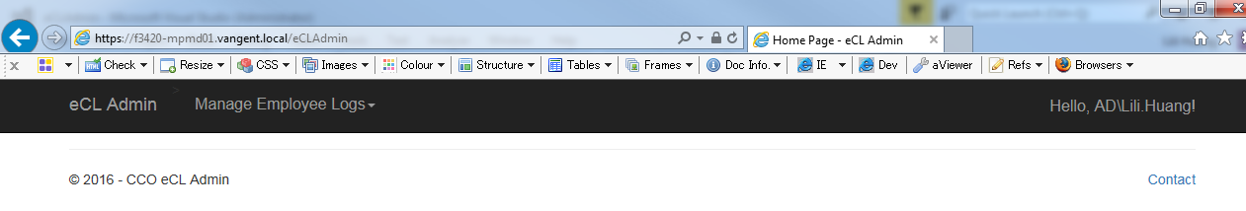

* + 1. Links to Other Modules

|  |  |
| --- | --- |
| Link Link Name | Destination |
| Manage Employee Logs | Dropdown menu display with the following links based on the user Role(s):  Inactivate Employee Logs (Admin and manager roles)  Reassign Employee Logs (Admin and manager roles)  Reactivate Employee Logs (Admin role) |
| Inactivate Employee Logs | Inactivate Employee Logs page  Views\EmployeeLogs\SearchForInactivate.cshtml |
| Reassign Employee Logs | Reassign Employee Logs page  Views\EmployeeLogs\SearchForReassign.cshtml |
| Reactivate Employee Logs | Reactivate Employee Logs page  Views\EmployeeLogs\SearchForReactivate.cshtml |

* + 1. Web Page Invoked Events

None.

6. 1. 7. Form fields

None.

* 1. Inactivate Employee Logs (Views\EmployeeLog\SearchForInactivate.cshtml)
     1. Razor pages comprising Web Page

EmployeeLogSelectEditorViewModel.cshtml

_SearchEmployeeLogResultPartial.cshtml

_InactivatePartial.cshtml

_ReasonPartial.cshtml

_CommentPartial.cshtml

* + 1. Layout Page

Views\Shared\_Layoutcshtml

* + 1. Screen Shot

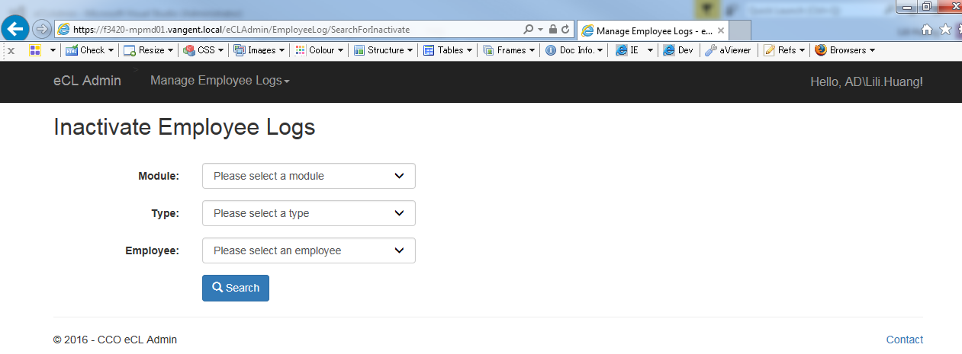

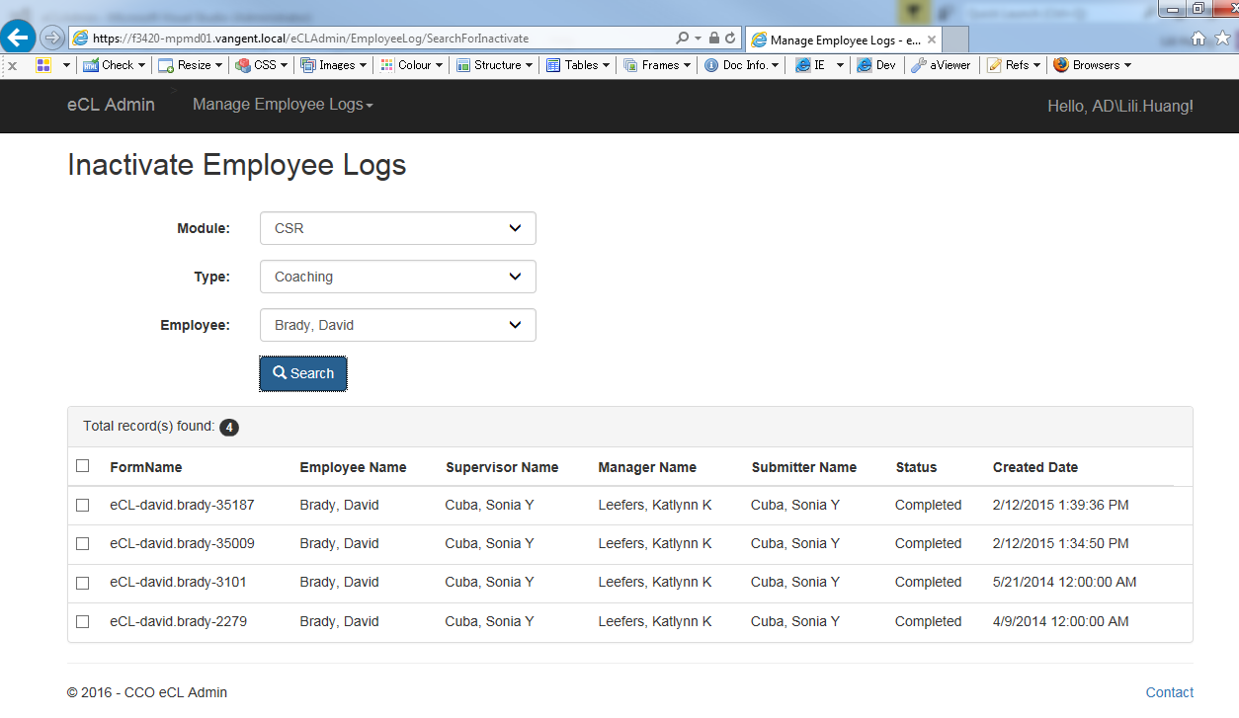

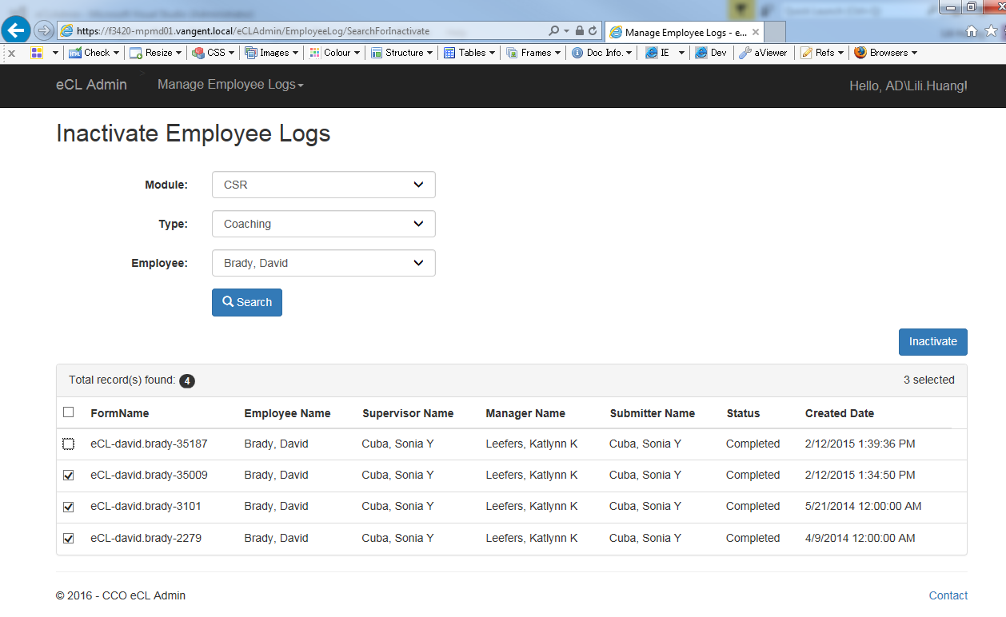

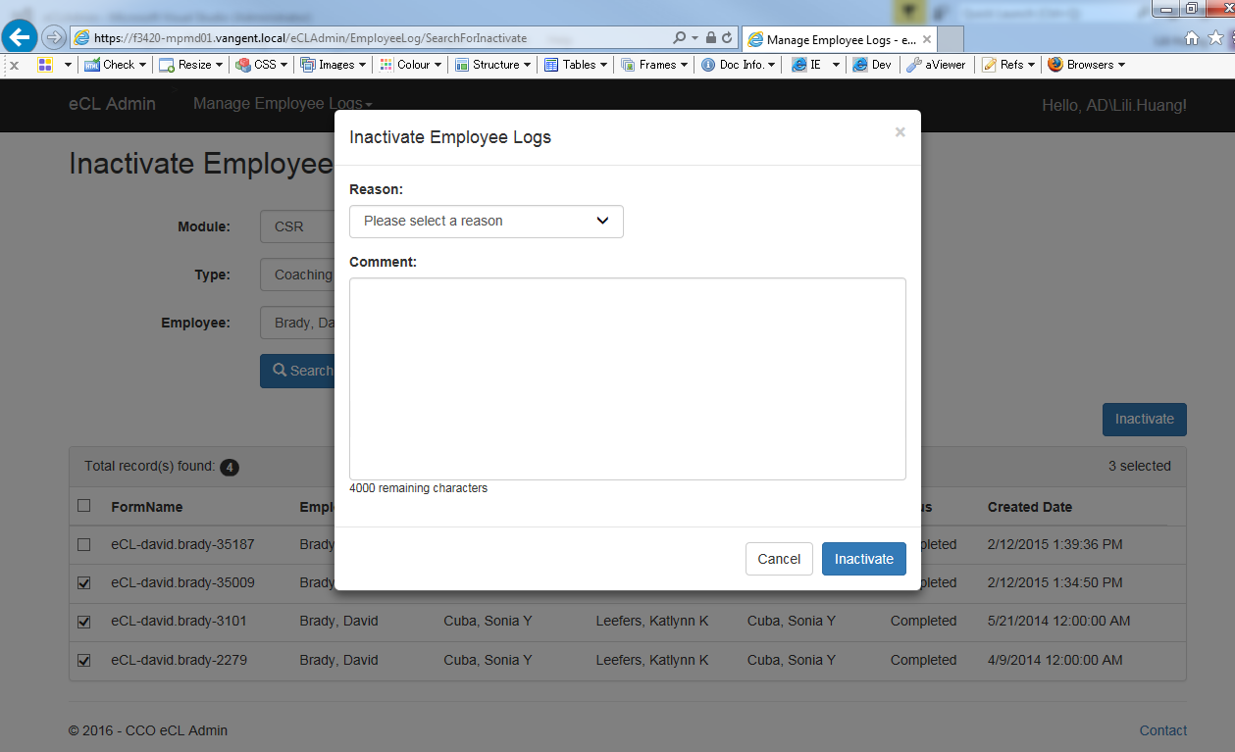

* + 1. Links

None

* + 1. Web Page Invoked Events

| Action | Processing & Result |
| --- | --- |
| Select a module from “Module:” dropdown list | If a type is already selected, an ajax call is made to get all the employees having active logs with the selected module and log type.  Controller: EmployeeLog  Action: GetEmployees  “Employee:” dropdown will be populated with the employees returned from the above ajax call. |
| Select a type from “Type:” dropdown list | If a type is already selected, an ajax call is made to get all the employees having active logs with the selected module and log type.  Controller: EmployeeLog;  Action: GetEmployees  “Employee:” dropdown will be populated with the employees returned from the above ajax call. |
| Select an employee from “Employee” dropdown  Click on “Search” button | An ajax call is posted back with selected module, type, and employee:  Controller: EmployeeLog  Action: SearchForInactivate [HttpPost] |
| Check/Uncheck any log(s) from the search result. | Javascript hideShowInactivateLink() is called to show/hide “Inactivate” link button.  If more than one log selected, “Inactivate” link button displays. Otherwise, “Inactivate” link button hides. |
| Click on “Inactivate” link button | jQuery $(‘body’).on(‘click’, ‘.modal-link’) function is called.  “Inactivate Employee Log” modal dialog displays. |
| Select a reason from “Reason:” dropdown list | If the selected reason is “Other”, a text box displays. |
| Click on “Inactivate” button (modal dialog). | An ajax call is posted back with the following data:  Selected Log Ids;  Selected reason id;  Other reason text entered;  Comment entered.  Controller: EmployeeLog  Action: Inactivate [HttpPost]  “Inactivate Employee Log” modal dialog closes.  A message will display to indicate the inactivation process whether the inactivation process is successful.  If success:  Success message (“The selected logs have been successfully inactivated.”) will be displayed. Searched result will hide and all the three dropdowns (Module, Type, and Employee) will be reset to default values.  Otherwise:  Fail message (“Failed to inactivate the selected logs.”) will display. |

* + 1. Form Fields

|  |  |  |  |  |  |
| --- | --- | --- | --- | --- | --- |
| **Page Name** | **Field Type** | **Field Name** | **Default Value** | **Data Element Source** | **Validation** |
| SearchForInactivate.cshtml | Label |  | Module: |  |  |
| DropDownList | module | -1 | AT_Module_Access |  |
| Label |  | Type: |  |  |
| DropDownList | logType | -1 |  |  |
| Label |  | Employee: |  |  |
| DropDownList | employee | -1 | Employee_Hierarchy |  |
| Start display Search Result: | | | | | |
| _SearchEmployeeLogResultPartial.cshtml | Label |  | Total record(s) found: |  |  |
| Label |  |  | EmployeeLogSelectViewModel.EmployeeLogs.Count |  |
| Checkbox | checkall | unchecked |  |  |
| Label |  | FormName |  |  |
| Label |  | Employee Name |  |  |
| Label |  | Supervisor Name |  |  |
| Label |  | Manager Name |  |  |
| Label |  | Submitter Name |  |  |
| Label |  | Status |  |  |
| Label |  | Created Date |  |  |
| Repeat for each log returned: |  |  |  |  |  |
| EmployeeLogSelectEditorViewModel.cshtml | Checkbox | EmployeeLogs[i].Selected | unchecked |  |  |
| Text |  |  | Coaching_Log.FormName if selected Type is “Coaching”  Or  Warning_Log.FormName if selected Type is “Warning” |  |
| Text |  |  | Employee_Hierarchy.Emp_Name |  |
| Text |  |  | Employee_Hierarchy.Sup_Name |  |
| Text |  |  | Employee_Hierarchy.Mgr_Name |  |
| Text |  |  | Employee_Hierarchy.Mgr_Name |  |
| Text |  |  | Employee_Hierarchy.Emp_Name  (Employee_Hierarchy.Emp_ID = Coaching_log.SubmitterID or Warning_Log.SubmitterID) |  |
| Text |  |  | DIM_Status.Status |  |
| Text |  |  | Coaching_Log.SubmittedDate if selected Type is “Coaching”  Or  Warning_Log.SubmittedDate |  |
| Hidden | EmployeeLogs[i].ID |  | Coaching_Log.CoachingID if selected Type is “Coaching”  Or  Warning_Log.WarningID if selected Type is “Warning” |  |
| Hidden | EmployeeLogs[i].FormName |  | Coaching_Log.FormName if selected Type is “Coaching”  Or  Warning_Log.FormName if selected Type is “Warning” |  |
| Hidden | EmployeeLogs[i].StatusId |  | Coaching_Log.StatusId if selected Type is “Coaching”  Or  Warning_Log.StatusId if selected Type is “Warning” |  |
| Hidden | EmployeeLogs[i].PreviousStatusId |  | AT_Coaching_Inactivate_Reactivate_Audit.LastKnownStatus |  |
| End of “Repeat for each log returned:” |  |  |  |  |  |
| End of “Start display Search Result:” | | | | | |
| _InactivatePartial.cshtml | Label |  | Reason: |  |  |
| DropDownList | reason | -1 | AT_Action_Reasons |  |
| Label |  | Comment: |  |  |
| TextArea | comment |  |  |  |

* 1. Reassign Employee Logs (Views\EmployeeLog\SearchForReassign.cshtml)
     1. Razor pages comprising Web Page

EmployeeLogSelectEditorViewModel.cshtml

_SearchEmployeeLogResultPartial.cshtml

_ReassignPartial.cshtml

_ReasonPartial.cshtml

_CommentPartial.cshtml

* + 1. Layout Page

Views\Shared\_Layoutcshtml

* + 1. Screen Shot

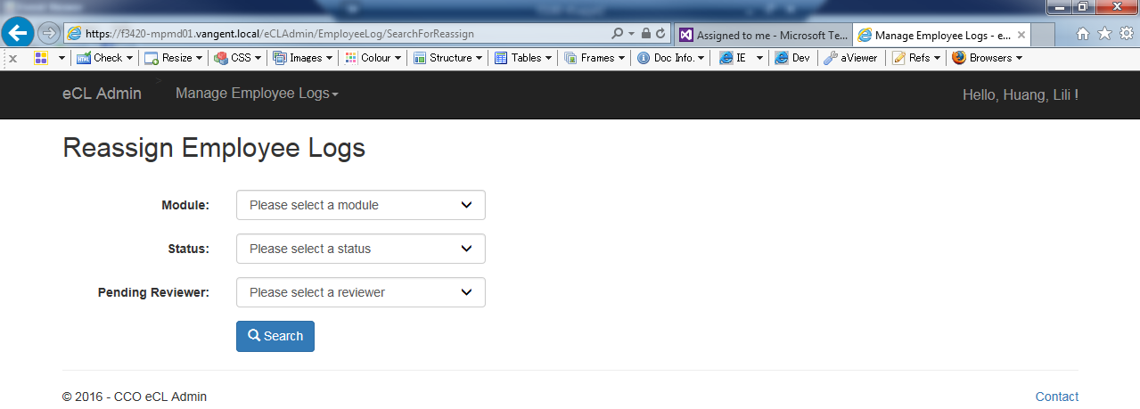

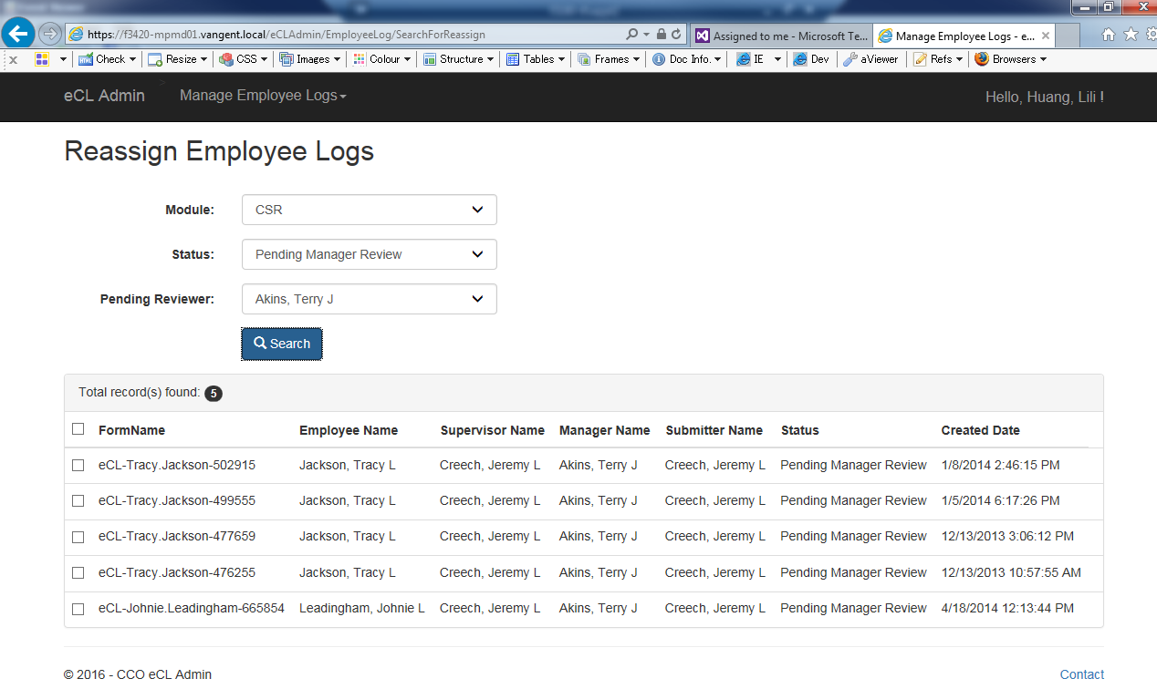

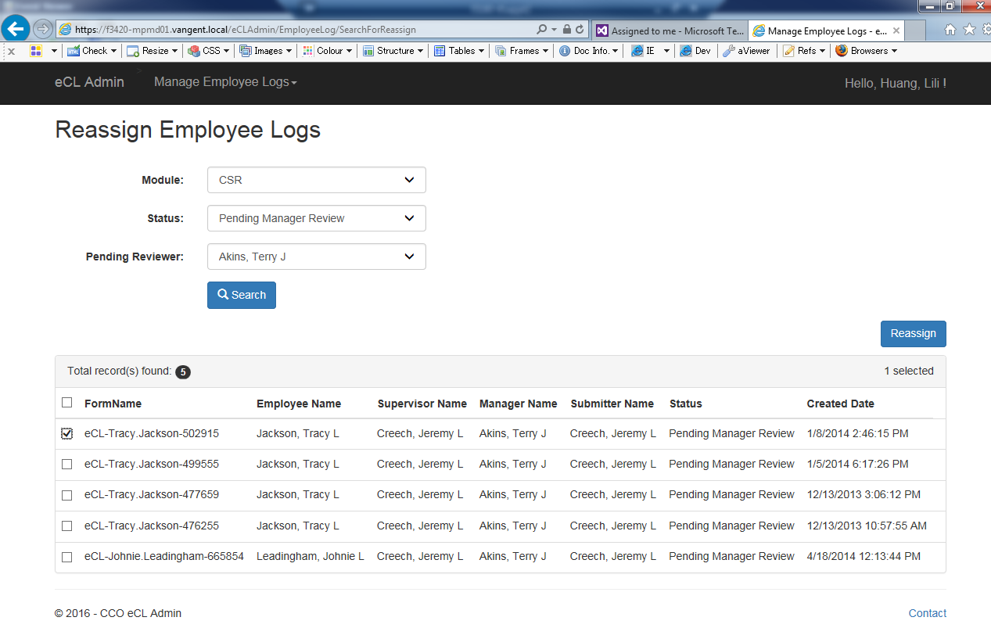

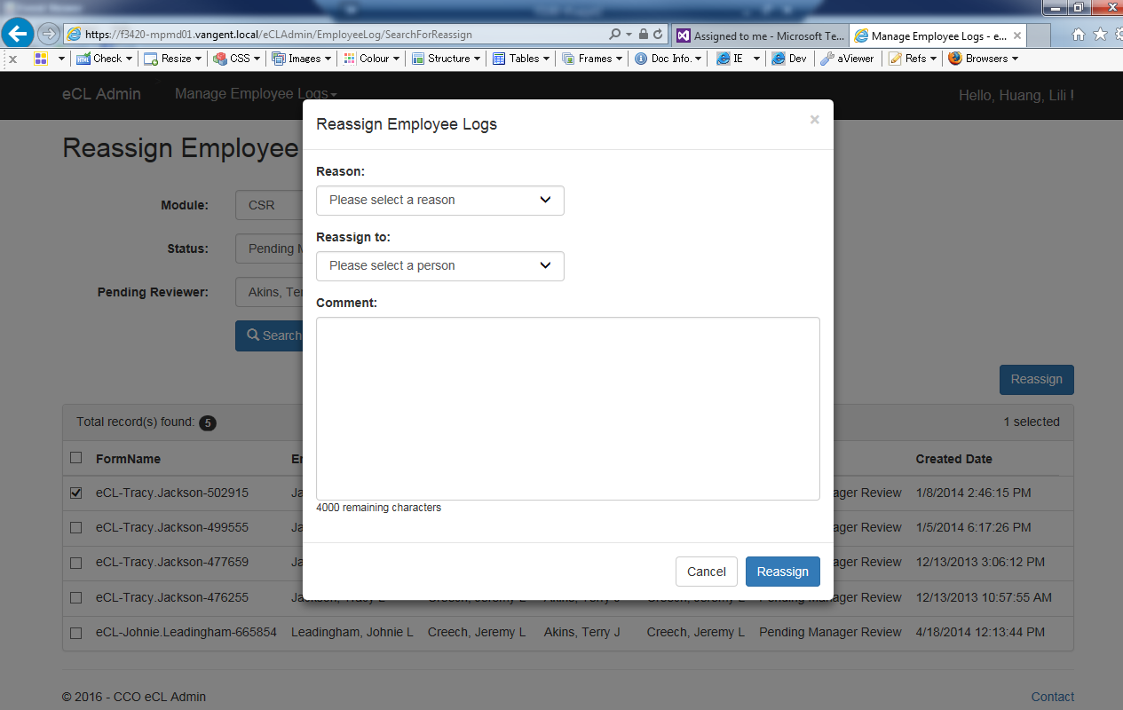

* + 1. Links

None

* + 1. Web Page Invoked Events

| Action | Processing & Result |
| --- | --- |
| Select a module from “Module:” dropdown list | An ajax call is made to get all pending statuses for the selected module.  Controller: EmployeeLog  Action: GetPendingStatuses |
| Select a status from “Status:” dropdown list | An ajax call is made to get all pending reviewers for the selected module and status.  Controller: EmployeeLog;  Action: GetPendingReviewers  “Pending Reviewer:” dropdownlist will be populated with the result from the ajax call. |
| Select a reviewer from “Pending Reviewer:” dropdown  Click on “Search” button | An ajax call is posted back with selected module, status, and reviewer:  Controller: EmployeeLog  Action: SearchForReassign [HttpPost] |
| Check/Uncheck any log(s) from the search result. | Javascript hideShowReassignLink() is called to show/hide “Reassign” link button.  If more than one log selected, “Reassign” link button displays. Otherwise, “Reassign” link button hides. |
| Click on “Reassign” link button | jQuery $(‘body’).on(‘click’, ‘.modal-link’) function is called.  “Reassign Employee Logs” modal dialog displays. |
| Select a reason from “Reason:” dropdown list | If the selected reason is “Other”, a text box displays. |
| Click on “Reassign” button (modal dialog). | An ajax call is posted back with the following data:  Selected Log Ids;  Selected reason id;  Other reason text entered;  Employee Id assigned to;  Comment entered.  Controller: EmployeeLog  Action: Reassign [HttpPost]  “Reassign Employee Logs” modal dialog closes.  A message will display to indicate if the reassignment is successful.  If success:  Success message (“The selected logs have been successfully reassigned.”) will be displayed. Searched result will hide and all the three dropdowns (Module, Status, and Pending Reviewer) will reset to default values.  Otherwise:  Fail message (“Failed to reassign the selected logs.”) will display. |

* + 1. Form Fields

|  |  |  |  |  |  |
| --- | --- | --- | --- | --- | --- |
| **Page Name** | **Field Type** | **Field Name** | **Default Value** | **Data Element Source** | **Validation** |
| SearchForReassign.cshtml | Label |  | Module: |  |  |
| DropDownList | module | -1 | AT_Module_Access |  |
| Label |  | Status: |  |  |
| DropDownList | employeeLogStatus | -1 | AT_Reassign_Status_For_Module |  |
| Label |  | Pending Reviewer: |  |  |
| DropDownList | employee | -1 | Employee_Hierarchy |  |
| Start display Search Result: | | | | | |
| _SearchEmployeeLogResultPartial.cshtml | Label |  | Total record(s) found: |  |  |
| Label |  |  | EmployeeLogSelectViewModel.EmployeeLogs.Count |  |
| Checkbox | checkall | unchecked |  |  |
| Label |  | FormName |  |  |
| Label |  | Employee Name |  |  |
| Label |  | Supervisor Name |  |  |
| Label |  | Manager Name |  |  |
| Label |  | Submitter Name |  |  |
| Label |  | Status |  |  |
| Label |  | Created Date |  |  |
| Repeat for each log returned: |  |  |  |  |  |
| EmployeeLogSelectEditorViewModel.cshtml | Checkbox | EmployeeLogs[i].Selected | unchecked |  |  |
| Text |  |  | Coaching_Log.FormName if selected Type is “Coaching”  Or  Warning_Log.FormName if selected Type is “Warning” |  |
| Text |  |  | Employee_Hierarchy.Emp_Name |  |
| Text |  |  | Employee_Hierarchy.Sup_Name |  |
| Text |  |  | Employee_Hierarchy.Mgr_Name |  |
| Text |  |  | Employee_Hierarchy.Mgr_Name |  |
| Text |  |  | Employee_Hierarchy.Emp_Name  (Employee_Hierarchy.Emp_ID = Coaching_log.SubmitterID or Warning_Log.SubmitterID) |  |
| Text |  |  | DIM_Status.Status |  |
| Text |  |  | Coaching_Log.SubmittedDate if selected Type is “Coaching”  Or  Warning_Log.SubmittedDate |  |
| Hidden | EmployeeLogs[i].ID |  | Coaching_Log.CoachingID if selected Type is “Coaching”  Or  Warning_Log.WarningID if selected Type is “Warning” |  |
| Hidden | EmployeeLogs[i].FormName |  | Coaching_Log.FormName if selected Type is “Coaching”  Or  Warning_Log.FormName if selected Type is “Warning” |  |
| Hidden | EmployeeLogs[i].StatusId |  | Coaching_Log.StatusId if selected Type is “Coaching”  Or  Warning_Log.StatusId if selected Type is “Warning” |  |
| Hidden | EmployeeLogs[i].PreviousStatusId |  | AT_Coaching_Inactivate_Reactivate_Audit.LastKnownStatus |  |
| End of “Repeat for each log returned:” |  |  |  |  |  |
| End of “Start display Search Result:” | | | | | |
| _ReassignPartial.cshtml | Label |  | Reason: |  |  |
| DropDownList | reason | -1 | AT_Action_Reasons |  |
| TextArea |  | otherreason |  |  |
| Label |  | Reassign to: |  |  |
| DropDownList | assignTo | -1 | Employee_Hierarchy |  |
| Label |  | Comment: |  |  |
| TextArea | comment |  |  |  |

* 1. Reactivate Employee Logs (Views\EmployeeLog\SearchForReactivate.cshtml)
     1. Razor pages comprising Web Page

EmployeeLogSelectEditorViewModel.cshtml

_SearchEmployeeLogResultPartial.cshtml

_ReactivatePartial.cshtml

_ReasonPartial.cshtml

_CommentPartial.cshtml

* + 1. Layout Page

Views\Shared\_Layoutcshtml

* + 1. Screen Shot

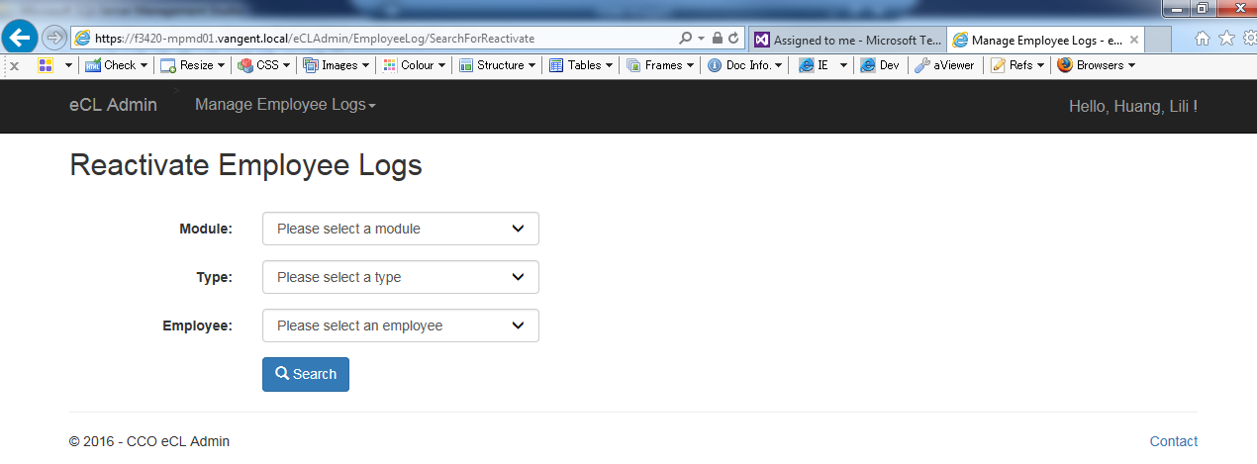

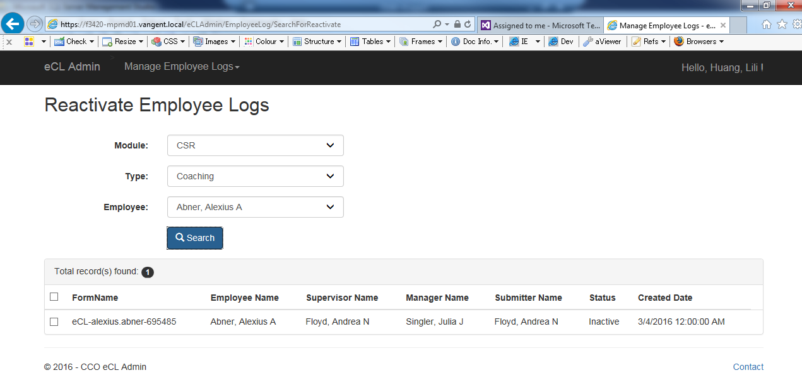

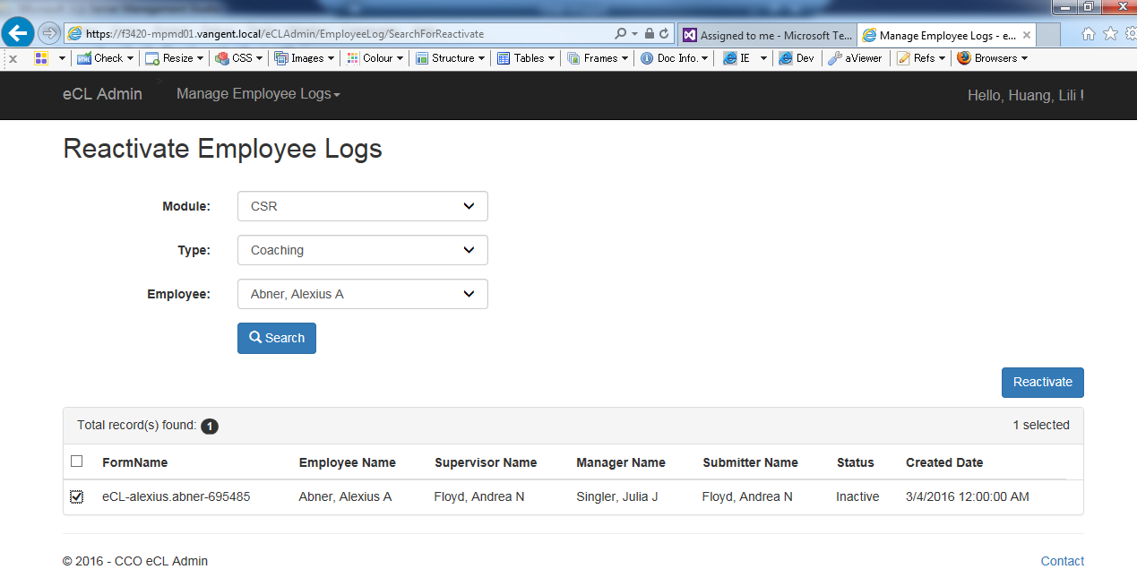

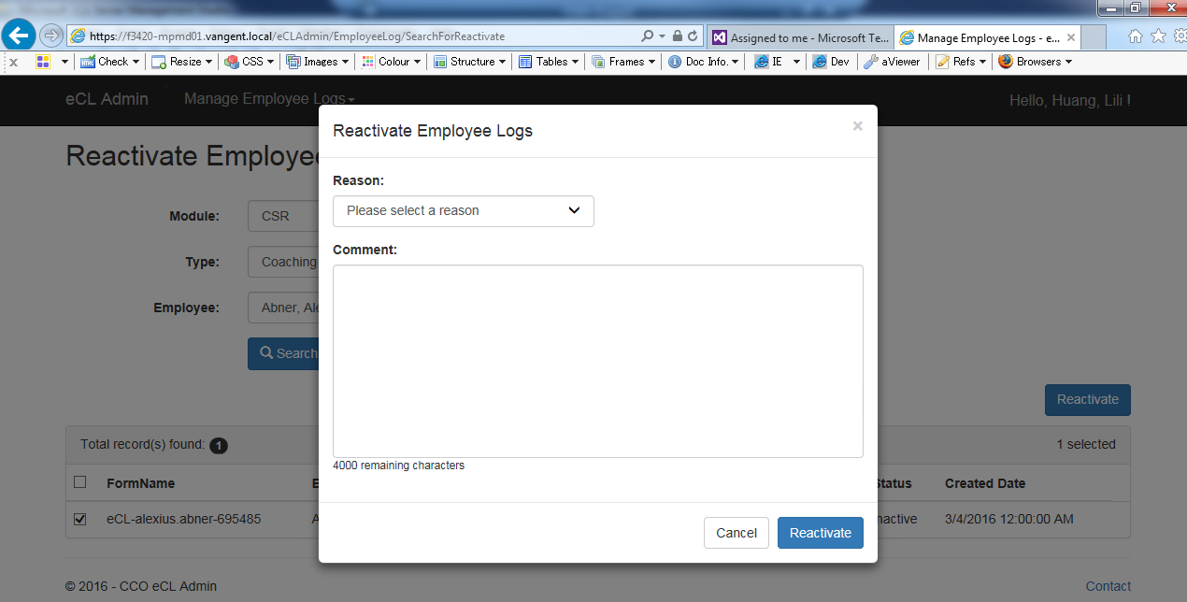

* + 1. Links

None

* + 1. Web Page Invoked Events

| Action | Processing & Result |
| --- | --- |
| Select a module from “Module:” dropdown list | If a type is already selected, an ajax call is made to get all the employees having active logs with the selected module and log type.  Controller: EmployeeLog  Action: GetEmployees  “Employee:” dropdown will be populated with the employees returned from the above ajax call. |
| Select a type from “Type:” dropdown list | If a type is already selected, an ajax call is made to get all the employees having active logs with the selected module and log type.  Controller: EmployeeLog;  Action: GetEmployees  “Employee:” dropdown will be populated with the employees returned from the above ajax call. |
| Select an employee from “Employee” dropdown  Click on “Search” button | An ajax call is posted back with selected module, type, and employee:  Controller: EmployeeLog  Action: SearchForReactivate [HttpPost] |
| Check/Uncheck any log(s) from the search result. | Javascript hideShowInactivateLink() is called to show/hide “Inactivate” link button.  If more than one log selected, “Reactivate” link button displays. Otherwise, “Reactivate” link button hides. |
| Click on “Reactivate” link button | jQuery $(‘body’).on(‘click’, ‘.modal-link’) function is called.  “Reactivate Employee Logs” modal dialog displays. |
| Select a reason from “Reason:” dropdown list | If the selected reason is “Other”, a text box displays. |
| Click on “Reactivate” button (modal dialog). | An ajax call is posted back with the following data:  Selected Log Ids;  Selected reason id;  Other reason text entered;  Comment entered.  Controller: EmployeeLog  Action: Reactivate [HttpPost]  “Reactivate Employee Logs” modal dialog closes.  A message will display to indicate if the reactivation is successful.  If success:  Success message (“The selected logs have been successfully reactivated.”) will be displayed. Searched result will hide and all the three dropdowns (Module, Type, and Employee) will be reset to default values.  Otherwise:  Fail message (“Failed to reactivate the selected logs.”) will display. |

* + 1. Form Fields

|  |  |  |  |  |  |
| --- | --- | --- | --- | --- | --- |
| **Page Name** | **Field Type** | **Field Name** | **Default Value** | **Data Element Source** | **Validation** |
| SearchForReactivate.cshtml | Label |  | Module: |  |  |
| DropDownList | module | -1 | AT_Module_Access |  |
| Label |  | Type: |  |  |
| DropDownList | logType | -1 |  |  |
| Label |  | Employee: |  |  |
| DropDownList | employee | -1 | Employee_Hierarchy |  |
| Start display Search Result: | | | | | |
| _SearchEmployeeLogResultPartial.cshtml | Label |  | Total record(s) found: |  |  |
| Label |  |  | EmployeeLogSelectViewModel.EmployeeLogs.Count |  |
| Checkbox | checkall | unchecked |  |  |
| Label |  | FormName |  |  |
| Label |  | Employee Name |  |  |
| Label |  | Supervisor Name |  |  |
| Label |  | Manager Name |  |  |
| Label |  | Submitter Name |  |  |
| Label |  | Status |  |  |
| Label |  | Created Date |  |  |
| Repeat for each log returned: |  |  |  |  |  |
| EmployeeLogSelectEditorViewModel.cshtml | Checkbox | EmployeeLogs[i].Selected | unchecked |  |  |
| Text |  |  | Coaching_Log.FormName if selected Type is “Coaching”  Or  Warning_Log.FormName if selected Type is “Warning” |  |
| Text |  |  | Employee_Hierarchy.Emp_Name |  |
| Text |  |  | Employee_Hierarchy.Sup_Name |  |
| Text |  |  | Employee_Hierarchy.Mgr_Name |  |
| Text |  |  | Employee_Hierarchy.Mgr_Name |  |
| Text |  |  | Employee_Hierarchy.Emp_Name  (Employee_Hierarchy.Emp_ID = Coaching_log.SubmitterID or Warning_Log.SubmitterID) |  |
| Text |  |  | DIM_Status.Status |  |
| Text |  |  | Coaching_Log.SubmittedDate if selected Type is “Coaching”  Or  Warning_Log.SubmittedDate |  |
| Hidden | EmployeeLogs[i].ID |  | Coaching_Log.CoachingID if selected Type is “Coaching”  Or  Warning_Log.WarningID if selected Type is “Warning” |  |
| Hidden | EmployeeLogs[i].FormName |  | Coaching_Log.FormName if selected Type is “Coaching”  Or  Warning_Log.FormName if selected Type is “Warning” |  |
| Hidden | EmployeeLogs[i].StatusId |  | Coaching_Log.StatusId if selected Type is “Coaching”  Or  Warning_Log.StatusId if selected Type is “Warning” |  |
| Hidden | EmployeeLogs[i].PreviousStatusId |  | AT_Coaching_Inactivate_Reactivate_Audit.LastKnownStatus |  |
| End of “Repeat for each log returned:” |  |  |  |  |  |
| End of “Start display Search Result:” | | | | | |
| _ReactivatePartial.cshtml | Label |  | Reason: |  |  |
| DropDownList | reason | -1 | AT_Action_Reasons |  |
| Label |  | Comment: |  |  |
| TextArea | comment |  |  |  |