_______________________



eCoaching Log Application

High Level Design

_______________________

|  |  |  |
| --- | --- | --- |
| Last Revision | Last Review | Description |
|  | Lili Huang | Updated for Option Year4. |

Prepared by: Jourdain Augustin Date: August 15, 2014

Department, Location: Engineering, Arlington

**Approved by: Date:**

Change History Log

| Date | Change Description | Author |
| --- | --- | --- |
| 08/15/2014  06/27/2016 | Initial Draft  Updated for Y4 | Jourdain Augustin  Lili Huang |
|  |  |  |

1 eCoaching Log Application 5

1.1 Purpose 5

1.2 Assumptions 5

1.3 Users 5

1.4 Application Technologies 5

1.5 Supported User Interface Presentation 5

1.6 Database 6

2 Design Criteria 6

2.1 Page Layout 6

2.1.1 App Title 9

2.1.2 Application Tab Navigation 10

2.1.3 Information Gathering 10

2.1.4 Status Display 10

2.2 Software Features 10

2.2.1 Interface Relationships 10

2.2.2 Aspect - eWFM 11

2.2.3 GDIT HR - PeopleSoft 12

2.2.4 External Feeds – Verint/Performance Management 12

2.2.5 Email Notifications 12

2.3 Application Modules 12

2.3.1 CSR 12

2.3.2 Supervisor 12

2.3.3 Quality 12

2.4 Application Functionality 13

2.4.1 Master Files and Styles 13

2.4.2 Home Page 13

2.4.3 Submissions 14

2.4.4 Dashboards 15

*2.4.4.1* My Dashboard 15

*2.4.4.2* My Submissions 17

*2.4.4.3* Historical 18

2.4.5 Reviews 19

*2.4.5.1* Main Review 19

*2.4.5.2* Historical Review 20

2.4.6 Errors 21

*2.4.6.1* Unauthorized Application Access 21

*2.4.6.2* Unauthorized Record Access 22

*2.4.6.3* Unauthorized Submission Access 23

*2.4.6.4* System Error 23

2.4.7 Data Flow Diagram 24

*2.4.7.1* Submission 24

*2.4.7.2* Review 25

# 

# eCoaching Log Application

## Purpose

The eCoaching Log application will be a modular intranet web application used to document and track coaching information.

## Assumptions

* The eCoaching Log application will not be 508 compliant
* All CCO employees and authorized HR will have access to the eCoaching Log application.
* All CSRS (except for ARC CSRs) will not be allowed to submit eCoaching records.
* Access to the eCoaching Log Control web page will be authenticated via the GDIT LAN Identification.

## Users

Users of the eCoaching Log application will include the following:

* All CCO employees
* Authorized HR

## Application Technologies

The eCoaching Log application will be designed using the below technologies:

* .NET framework 4, VB.NET
* SQL Server Database Server

## Supported User Interface Presentation

The eCoaching Log application will be designed to be viewed and used with the following browser applications:

* Microsoft Internet Explorer 8.0 and higher
* Firefox 31.0

## Database

The eCoaching Log application will consist of a SQL Server database containing tables for storing:

* Dimensional tables supporting functionality settings and values
* Coaching and warning records submitted via the user interface or via external feeds
* Hierarchal tables supporting user profiles and organizational relationships updated daily via external feed from GDIT Human Resource People Soft system and CCO Aspect system.

# Design Criteria

## Page Layout

Page layouts are shown in the following figures. Information on each region is given in the following sections.

Master Page Layout -



My Dashboard, My Submissions, Historical Dashboard Layouts –



New Submission Layout –



Main Review Page, Historical Review Page Layouts –



### App Title

The eCoaching Application will include the CCO logo image at the top of the page. The title shall not have a hyperlink.

### Application Tab Navigation

The application will include tabbed ifram structure containing application pages for completion of application functionality. The functionality potentially available for application use requiring tabs include “New Submissions”, “My Dashboard”, “My Submissions” and “Historical Dashboard”. The tabs will display according to user job code as determined by module.

### Information Gathering

The Infromation Gathering section of the page will be the iframe part of the page containing the selected tab’s functionality.

### Status Display

The Status Display section of the page will be a section displayed on the side of the page showing a summary of the current record’s information.

## Software Features

The below flow reflects the expected software features.

### Interface Relationships



### Aspect - eWFM

The Aspect eWFM system will support application functionality by providing an external feed of data containing CSR employee to supervisor relationship hierarchy.

### GDIT HR - PeopleSoft

The GDIT Human Resource PeopleSoft system will support application functionality by providing an external feed of data containing Non-CSR employee to supervisor relationship hierarchy.

### External Feeds – Verint/Performance Management

The Verint IQS system and Performance Management Outliers will support application functionality by providing an external feed of quality data containing externally created coaching record information.

### ETS – Electronic Keeping System

ETS will support application functionality by providing a data feed containing non-compliance time keeping activities.

### Email Notifications

The eCoaching application will trigger notifications by e-mailing employees when they are intially the subject of a coaching record or initially the person responsible for coaching updates.

## Application Modules

The eCoaching application will contain 5 modules to be accessible by user groups.

### CSR

The CSR module will allow users to capture, report and update information pertaining to Call Center Operations regarding CSR activities.

### Supervisor

The Supervisor module will allow users to capture, report and update information pertaining to Call Center Operations regarding Supervisor activities.

### Quality

The Quality module will allow users to capture, report and update information pertaining to Call Center Operations regarding Quality Assurance activities.

### LocalSysetm Administrator (LSA)

The LSA module will allow users to capture, report and update information pertaining to Call Center Operations regarding Local System Adminstrator activities.

### Training

The Training module will allow users to capture, report and update information pertaining to Call Center Operations regarding Trainer and Instructor activities.

## Application Functionality

The eCoaching application will contain the below functionality.

### Master Files and Styles

The eCoaching application will use a single style sheet. The style sheet will be used to access common formatting definitions across all web pages. The eCoaching application will use 4 master files controlling page layout structure.

### Home Page

The eCoaching application will use Windows Authentication to authenticate users. The system will accept accounts from AD.Local active directory networks. Access rights (user authorization) within the application will be based on the authenticated user’s profile in the application database incorporating a user’s employee job code, application module and additional job approvals (e.g. ARC CSRs). Users who do not sucessfully authenticate will be redirected to the authentication error page.

The eCoaching home page will host application functionality configured by displaying tabs on a navigation menu with the tab body containing an iframe of functionality page. The tab(s) that will display for a user will be determined by the user’s profile and that profile’s corresponding access levels by module. Below outlines tab visibility for module users :

Module tab acccess:

* New Submissions
  + ARC CSRs
  + All other users (excluding non ARC CSRs and HR)
* My Dashboard
  + All users (excluding HR)
* My Submissions
  + ARC CSRs
  + All other users (excluding non-ARC CSRs and HR)
* Historical Dashboard
  + All non-CSRs

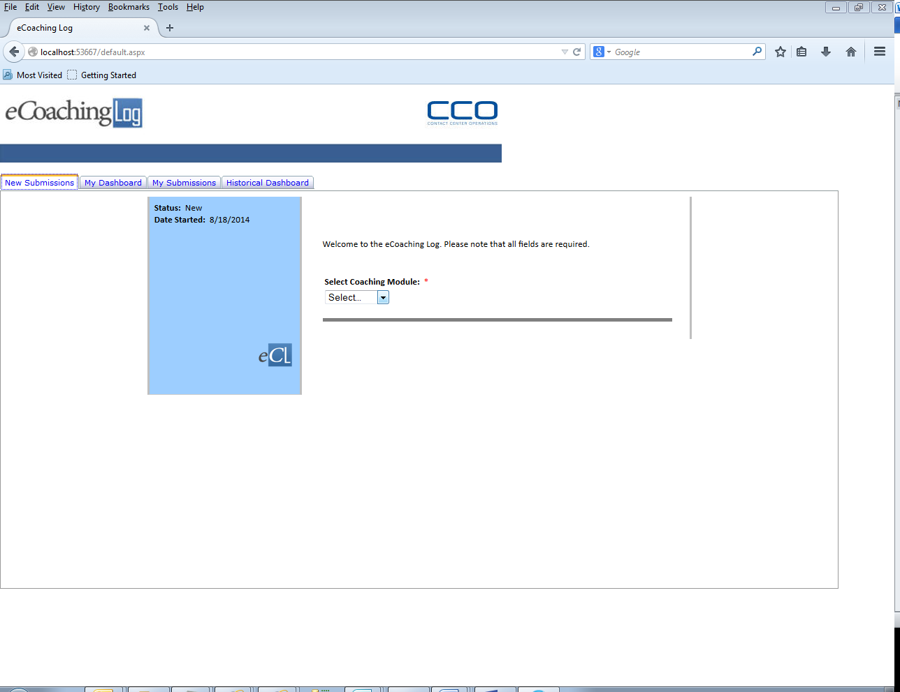

### Submissions

The New Submissions section will allow users to submit coaching information pertaining to the module that the user has access to use. The usable modules will display in a selectable menu on the submission page.

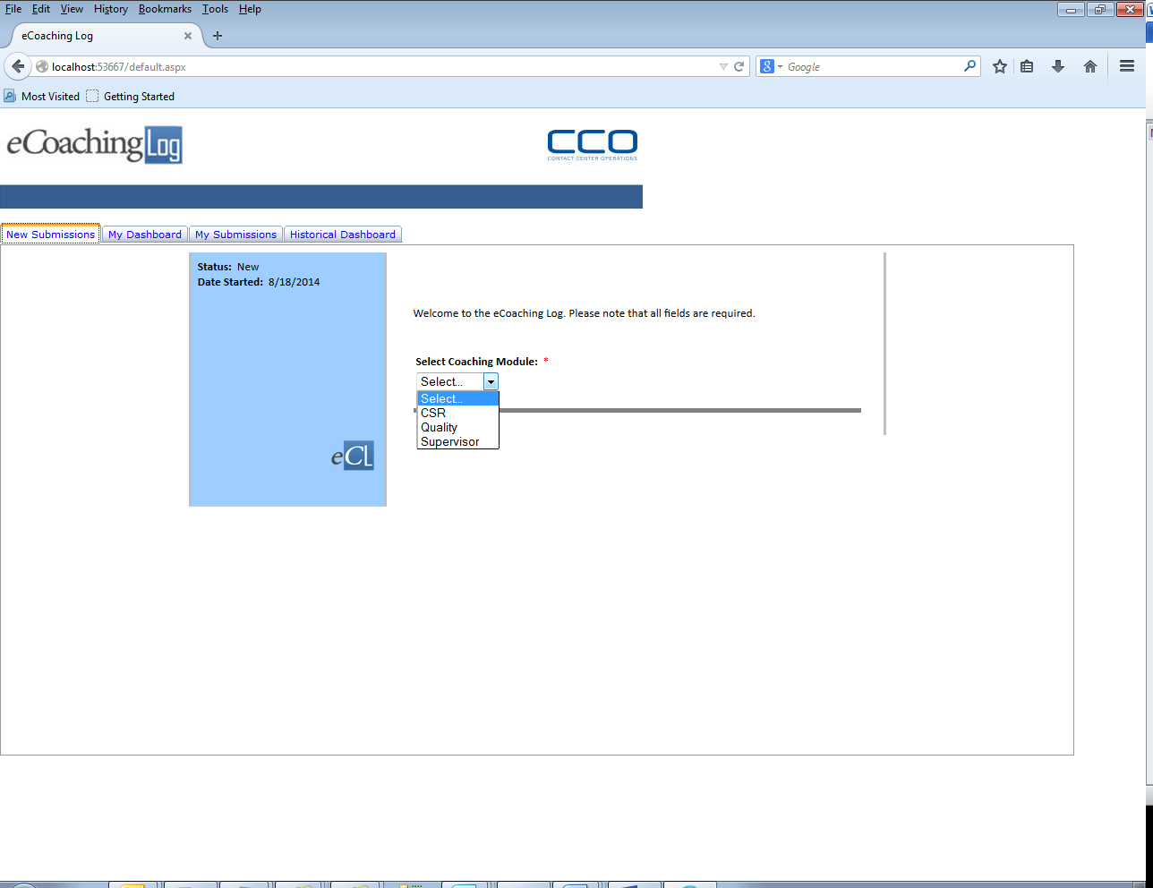

### Dashboards

#### My Dashboard

The eCoaching application will allow all users (except HR users) to view and update information pertaining to a coaching record that they are responsible for or have access to view.

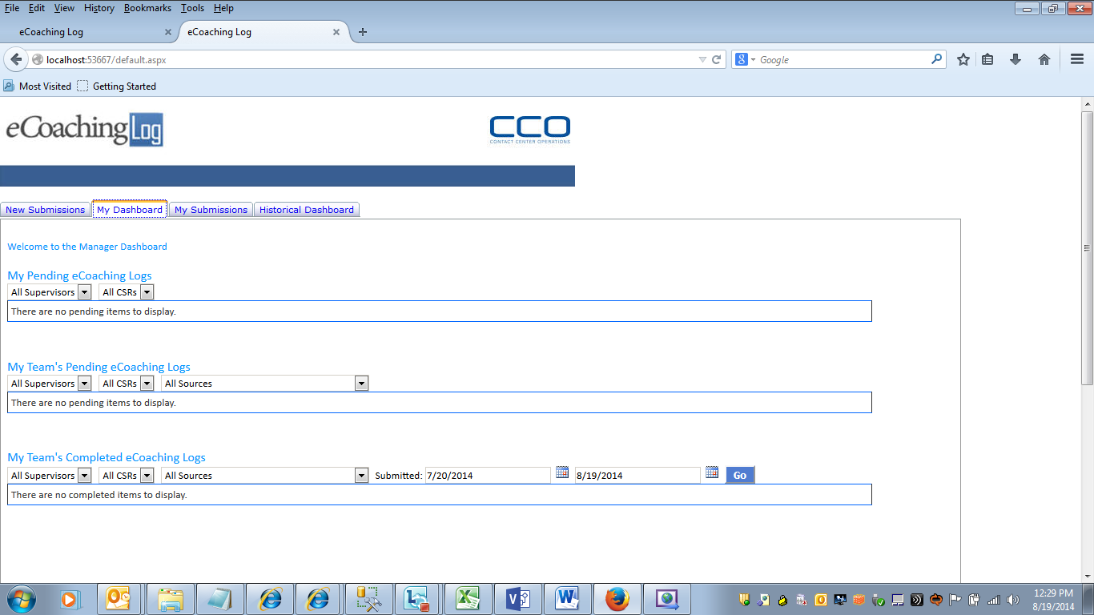

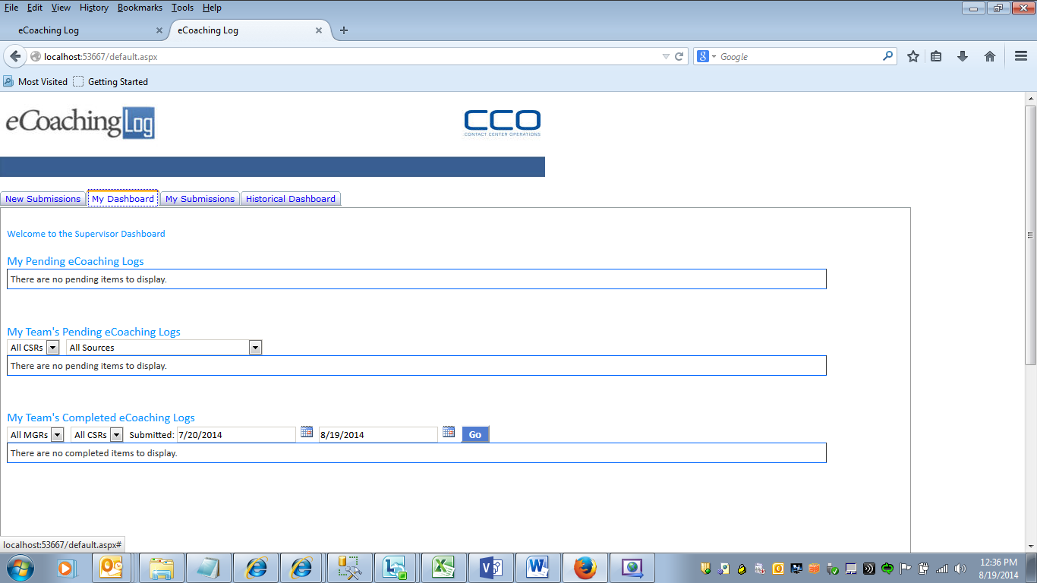

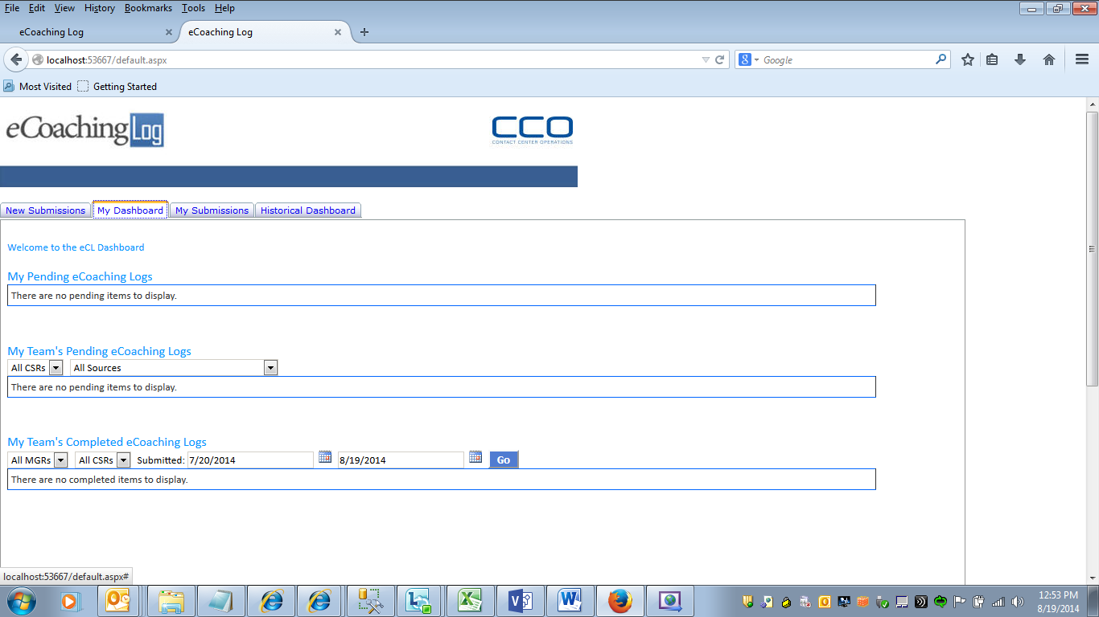

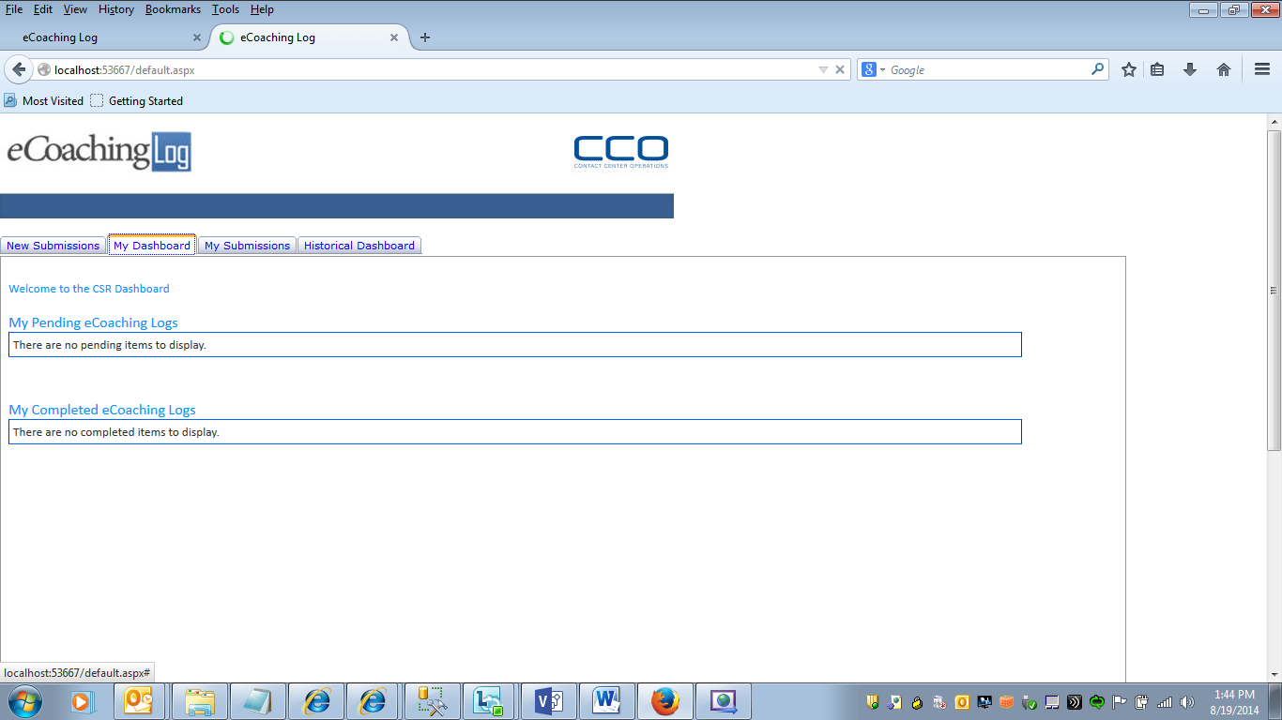

#### My Submissions

The eCoaching application will allow authorized users who have access to submit coaching to view and update information pertaining to a coaching record that they have submitted.

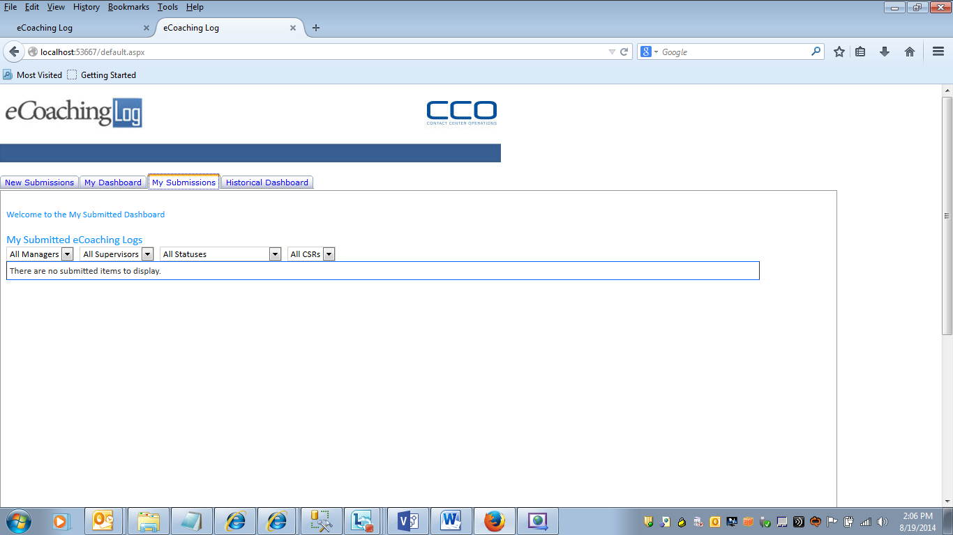

#### Historical

The eCoaching application will allow authorized users to generate reports on and view information pertaining to a any record in the database. Authorized users will be able to open the record to view detail information.

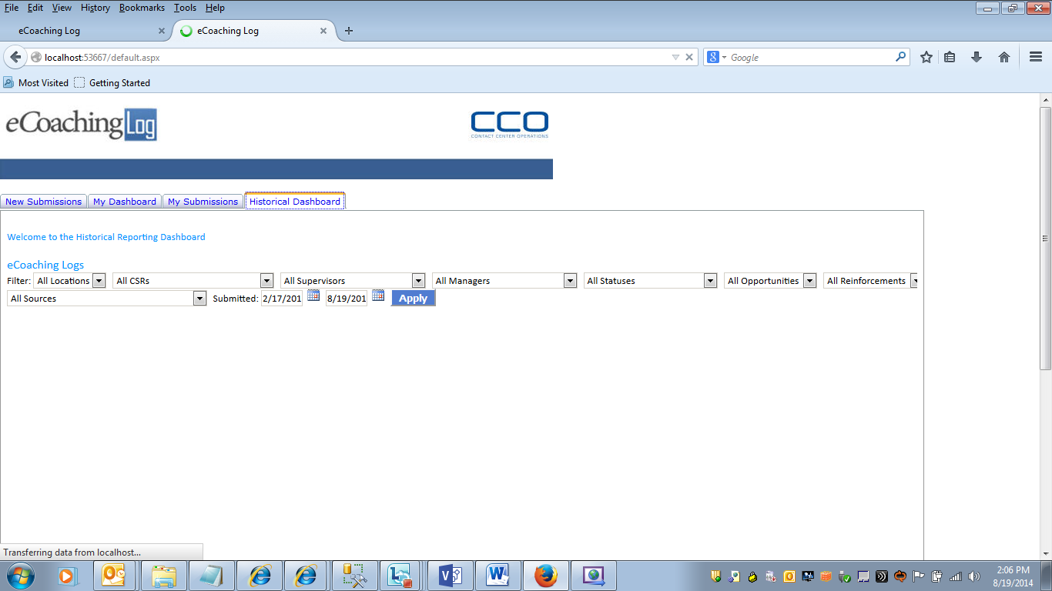

### Reviews

#### Main Review

The eCoaching application will allow authorized users to open records that they are associated with (as a recipient, supervisor, manager or submitter) for review and update (where applicable) according to the record’s status.

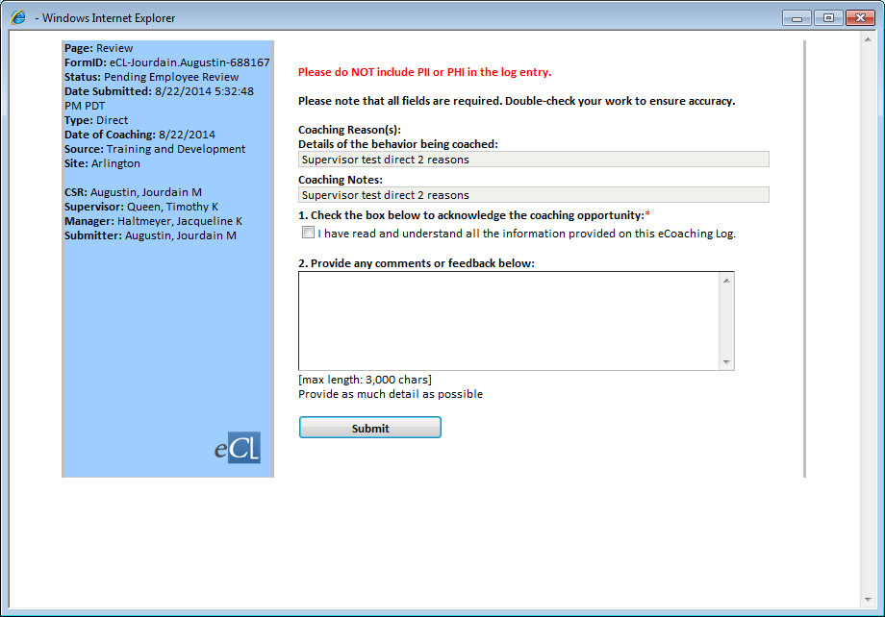

#### Historical Review

The eCoaching application will allow authorized users to open records for viewing only.

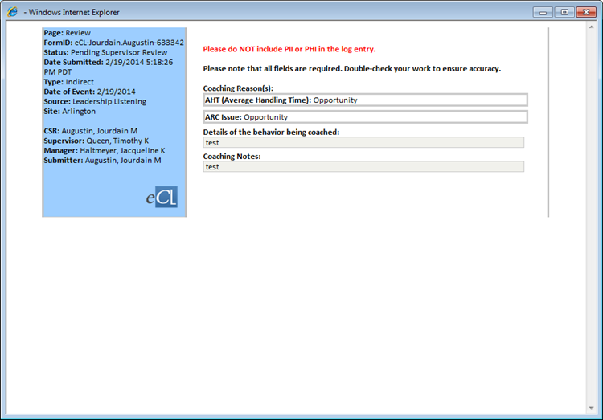

### Errors

The eCoaching application will redirect users to the error pagewhen error occurs.

#### Unauthorized Application Access

The eCoaching application will redirect users to an unauthorized application access page if the user’s profile is not found in the hirearchy tables of the application database.

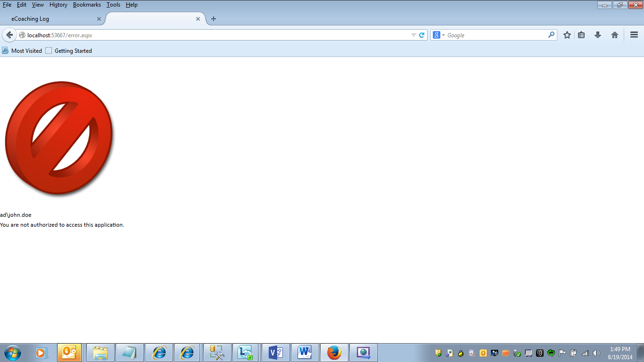

#### Unauthorized Record Access

The eCoaching application will redirect users to an unauthorized record access page if the user attempts to open for viewing a record that they are not associated with.

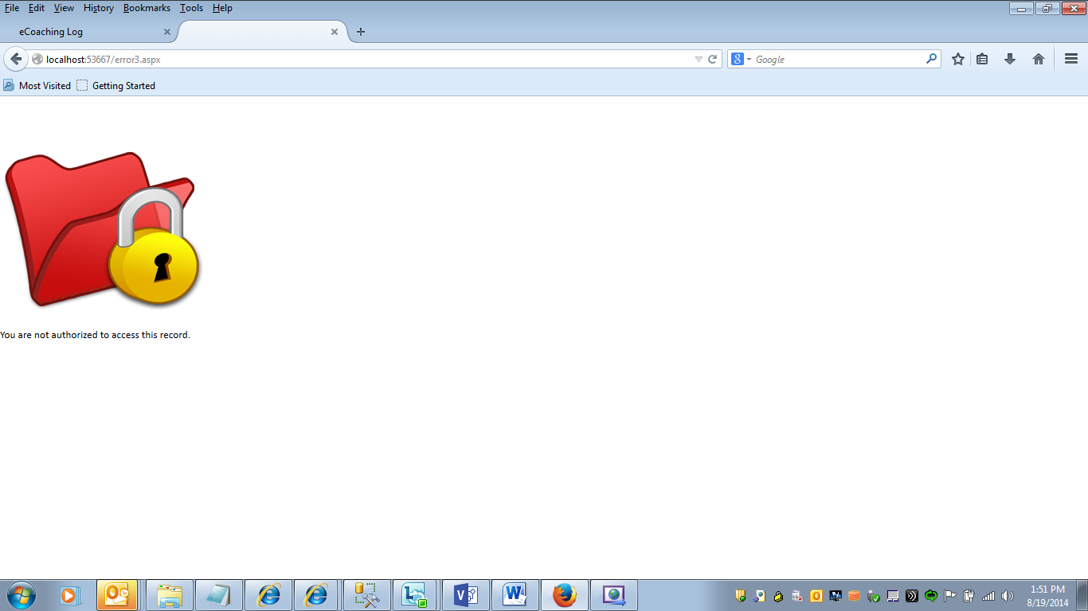

#### Unauthorized Submission Access

The eCoaching application will redirect users to an unauthorized submission access page if the user’s profile in the database is associated with one that is not approved for submitting coaching for any modules (e.g. CSRs who are not ARC CSRs)

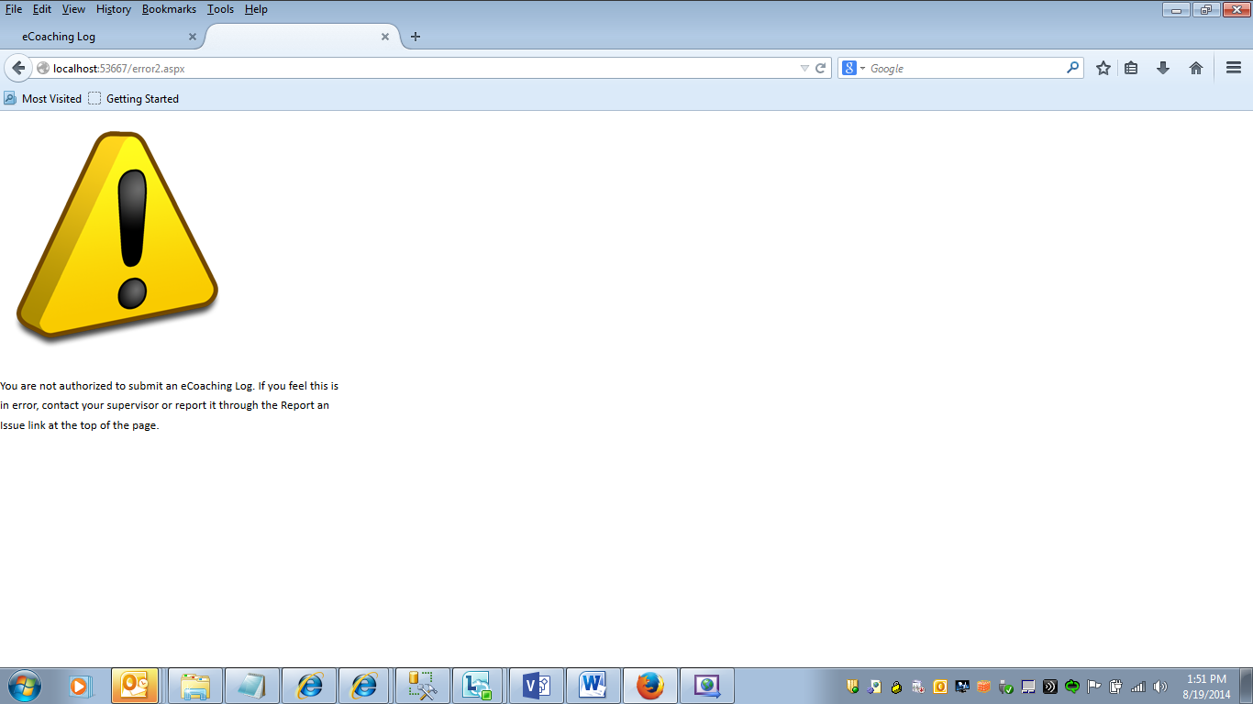

#### System Error

The eCoaching application will redirect users to a system error page if a code or database error occurs while attempting to use the application.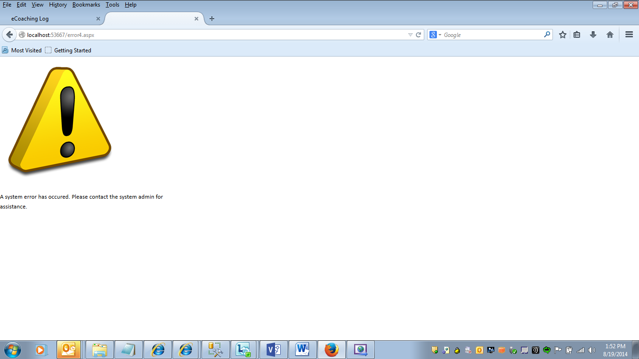

### Data Flow Diagram

#### Submission

For submission work flow, refer to the following documents for details

eCoaching\Requirements\Diagrams\CSR_Submission.vsd

eCoaching\Requirements\Diagrams\LSA_Submission.vsd

eCoaching\Requirements\Diagrams\Quality_Submission.vsd

eCoaching\Requirements\Diagrams\Supervisor_Submission.vsd

eCoaching\Requirements\Diagrams\Training_Submission.vsd

#### Review

