***Contact Center Operations***

eCL AdminWeb Application

Implementation Run Book

|  |  |
| --- | --- |
| Description | **TFS 3841 (Parent 3027) – Added Sr Mgr Dashboard** |

##### Contents

Overview 1

Implementation Steps 1

Important Notes 2

Appendix: 3

##### Revision History

|  |  |  |
| --- | --- | --- |
| Date | Change Description | Author |
| 06/06/2016 | TFS 2527 - eCL Admin Tool.  (Inactivate/Reactivate/Reassign logs) | Lili Huang |
| 12/02/2016 | TFS 3841 (Parent 3027) – Added Sr. Mgr. Dashboard | Lili Huang |

|  |
| --- |
| Overview |

|  |  |
| --- | --- |
| Purpose: | The purpose of this run book is to provide a documented process and instruction on how authorized CCO Engineers should implement GDIT-developed changes for eCL Admin Web Application per TFS 3841 (Parent 3027). |
| Change Summary: |  |
| Dependencies: | None |
| Affected Server(s): | PROD SERVER: f3420-mwbp11.vangent.local |
| Security Impact: | None |
| Access Level Needed: | Implementer needs:   * TFS access |

|  |
| --- |
| Implementation Steps |

|  |  |
| --- | --- |
| Purpose/Scope: | This process describes the steps taken to implement changes to eCL Admin Web Application in the production environment for TFS 3841 (Parent 3027). |
| Responsibility: |  |
| References / forms/ documents: |  |
| Preconditions: | None |
| Procedure: |  |
| Step 1: | Get the following file from TFS :  $/eCoaching_V2/UI Code/eCLAdmin_publish.zip (**36154**) |
| Step 2: | **For Production implementation only:**  RDC to Production server: f3420-mwbp11.vangent.local;  Go to the IIS application server and filter access to prevent any user access except for the tester’s IP address;  *See Appendix on “How to add IP restrictions to deny access to eCL Admin site”* |
| Step 3: | **For Production implementation only:**  Backup folder D:\inetpub\wwwroot\eCLAdmin;  Delete all files under D:\inetpub\wwwroot\eCLAdmin except:   * web.config   Unzip the file from Step 1 to folder D:\inetpub\wwwroot\eCLAdmin, **do not overwrite web.config**. |
| Step 4: | **For Production implementation only:**  Notify tester to test. |
| Step 5: | **For Production implementation only:**  Once tester has given approval, go to the IIS application server and update filter to allow all user access.  *See Appendix on “How to remove IP restrictions”* |
| Step 6: | Notify program. |
|  |  |
|  |  |
| Post-conditions: | None |
|  |  |

|  |
| --- |
| Important Notes |

|  |  |
| --- | --- |
| Purpose/Scope: | This section lists any other items of note for the implementation. |
| Note 1: |  |
| Note 2: |  |
|  |  |

# Appendix:

**How to add IP restrictions to deny access to eCL Admin site**

1. Remote Desktop Connect to production web server.
2. Open **Internet Information Services (IIS) Manager**:

* On the taskbar, click **Server Manager**, click **Tools**, and then click **Internet Information Services (IIS) Manager**.

1. In the **Connections** pane, expand the server name, expand **Sites**, and then **Quality Web Site**, **eCLAdmin**.

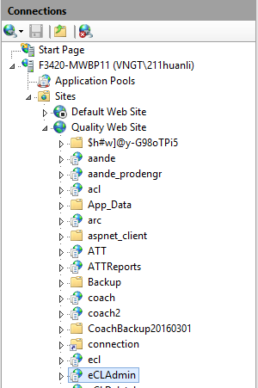

1. In the **Home** pane, double-click the **IP Address and Domain Restrictions** feature.

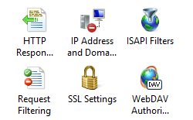

1. In the **IP Address and Domain Restrictions** feature, click **Edit Feature Settings…** in the **Actions** pane. Select **Deny** for **Access for unspecified clients:** dropdown, click OK.

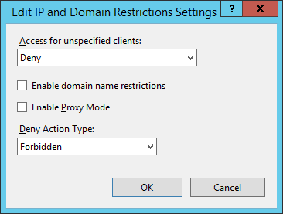

1. Click **Add Allow Entry…** in the **Actions** pane, enter the **IP** address that you wish to allow, and then click OK.

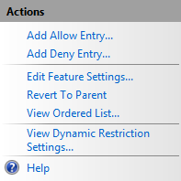

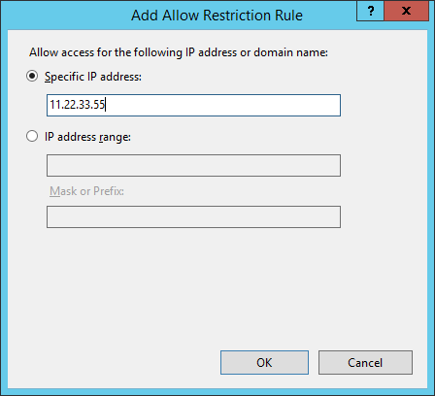

**How to remove IP restrictions**

1. In the **IP Address and Domain Restrictions** feature, click **Edit Feature Settings…** in the **Actions** pane. Select **Allow** for **Access for unspecified clients:** dropdown, click OK.

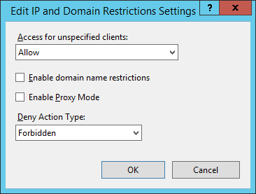

1. In the **IP Address and Domain Restrictions feature**, select the IP address added in step 6, and click **Remove** in the Actions pane.

