***Contact Center Operations***

eCoaching Log Web Application

Implementation Run Book

|  |  |
| --- | --- |
| Description | **TFS 6187 – New data feed through OMR for exceeding Break Length & Break Number** |

##### Contents

Overview 1

Implementation Steps 1

Important Notes 2

Appendix: 3

##### Revision History

|  |  |  |
| --- | --- | --- |
| Date | Change Description | Author |
| 7/24/2015 | TFS124 (P14676) – Historical Dashboard Export to Excel;  TFS130 (P14881) – Authenticate only on page non post back;  TFS136 (P14893) – Round 2 Performance improvements for Historical Dashboard;  TFS144 (P14916) – Additional HR access; | Lili Huang |
| 8/20/2015 | TFS115 - ecl coaching notes overwritten  TFS153 - ecl duplicate lanids all reviewing details  TFS175 - ecl lcsat display assigned reviewer  TFS363 - ecl duplicate form names  TFS481 - ecl display reasons, sub-reasons values | Lili Huang |
| 9/30//2015 | TFS632 – Disable Historical Dashboard Extract to Excel for Supervisors  TFS686 – Inappropriate ARC escalation feed | Lili Huang |
| 10/22/2015 | TFS974 – Add Warning Section to All eCoaching Modules | Lili Huang |
| 11/05/2015 | TFS1088 – Open CSR Comments field | Lili Huang |
| 12/10/2015 | TFS 1421 – Warning section display on My Dashboard | Lili Huang |
| 12/15/2015 | TFS 1423 – Add job code WHHR70 | Lili Huang |
| 02/17/2016 | TFS 1991 – OMR Short Calls fee with Manager Review | Lili Huang |
| 02/22/2016 | TFS 1925 – LCS: allow hierarchy managers to review (read-only) | Lili Huang |
| 03/04/2016 | TFS 1881 – Add Short Duration Reporting (Training SDR) records to eCoaching | Lili Huang |
| 03/09/2016 | TFS 2196 – CSR Comments not appearing in completed logs from IQS | Lili Huang |
| 03/22/2016 | TFS 2301 – Update Survey text. | Lili Huang |
| 03/24/2016 | TFS 2308 – Added Overdue Training. | Lili Huang |
| 04/08/2016 | TFS 2429 - Unknown user should not be able to access;  TFS 2432 - Separate solution for HR access; | Lili Huang |
| 06/06/2016 | TFS 2429 - Unknown user should not be able to access;  TFS 2432 - Separate solution for HR access; | Lili Huang |
| 06/08/2016 | TFS 2907 - eCL survey can be completed after being inactivated | Lili Huang |
| 06/29/2016 | TFS 2826 – CTC data feed | Lili Huang |
| 07/25/2016 | TFS 3252 – HFC (High CSAT 5) data feed | Lili Huang |
| 08/24/2016 | TFS 3622 – “My Dashboard” over 100 db connections within 1 db session | Lili Huang |
| 09/19/2016 | TFS 3991 – Attendance data feed. | Lili Huang |
| 10/27/2016 | TFS 4102 - Include Yes/No value to coaching monitor question | Lili Huang |
| 11/09/2016 | TFS 4102 - Include Yes/No value to coaching monitor question | Lili Huang |
| 11/15/2016 | TFS 3622 – “My Dashboard” over 100 db connections within 1 db session  Note: Re-Implement since 8/24/2016 implementation was rolled back. | Lili Huang |
| 11/17/2016 | TFS 4743 – Survey: Don’t set default values to all questions | Lili Huang |
| 12/06/2016 | TFS 3878 – Email CSR comments to supervisor/manager when CSR logs are completed. | Lili Huang |
| 2/1/2017 | TFS 5404 – Allow users with job codes starting “WPOP” to access Historical Dashboard | Lili Huang |
| 2/22/2017 | TFS 5661 - Opportun!ty, Re!nforcement issue | Lili Huang |
| 4/19/2017 | TFS 6187 – New data feed through OMR for exceeding Break Length & Break Number | Lili Huang |

|  |
| --- |
| Overview |

|  |  |
| --- | --- |
| Purpose: | The purpose of this run book is to provide a documented process and instruction on how authorized CCO Engineers should implement GDIT-developed changes for eCoaching Log Web Application per TFS 6187. |
| Change Summary: |  |
| Dependencies: | None |
| Affected Server(s): | PROD SERVER: f3420-mwbp11.vangent.local |
| Security Impact: | None |
| Access Level Needed: | Implementer needs:   * TFS access |

|  |
| --- |
| Implementation Steps |

|  |  |
| --- | --- |
| Purpose/Scope: | This process describes the steps taken to implement changes to eCoaching Log Web Application in the production environment for TFS 6187. |
| Responsibility: |  |
| References / forms/ documents: |  |
| Preconditions: | None |
| Procedure: |  |
| Step 1: | Get the following file from TFS :  $/eCoaching_V2/UI Code/eCoaching.zip (**C37104**) |
| Step 2: | **For Production implementation only:**  RDC to Production server: f3420-mwbp11.vangent.local;  Go to the IIS application server and filter access to prevent any user access except for the tester’s IP address;  *See Appendix on “How to add IP restrictions to deny access to eCoaching site”* |
| Step 3: | **For Production implementation only:**  Backup folder D:\inetpub\wwwroot\coach;  Delete all files under D:\inetpub\wwwroot\coach except:   * web.config   Unzip the file from Step 1 to folder D:\inetpub\wwwroot\coach, **do not overwrite web.config**. |
| Step 4: | **For Production implementation only:**  Notify tester to test. |
| Step 5: | **For Production implementation only:**  Once tester has given approval, go to the IIS application server and update filter to allow all user access.  *See Appendix on “How to remove IP restrictions”* |
| Step 6: | Notify program. |
|  |  |
|  |  |
| Post-conditions: | None |
|  |  |

|  |
| --- |
| Important Notes |

|  |  |
| --- | --- |
| Purpose/Scope: | This section lists any other items of note for the implementation. |
| Note 1: |  |
| Note 2: |  |
|  |  |

# Appendix:

**How to add IP restrictions to deny access to eCoaching site**

1. Remote Desktop Connect to production web server.
2. Open **Internet Information Services (IIS) Manager**:

* On the taskbar, click **Server Manager**, click **Tools**, and then click **Internet Information Services (IIS) Manager**.

1. In the **Connections** pane, expand the server name, expand **Sites**, and then **Quality Web Site**, **coach**.

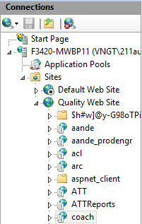

1. In the **Home** pane, double-click the **IP Address and Domain Restrictions** feature.

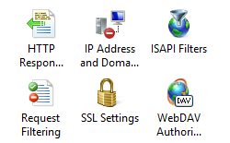

1. In the **IP Address and Domain Restrictions** feature, click **Edit Feature Settings…** in the **Actions** pane. Select **Deny** for **Access for unspecified clients:** dropdown, click OK.

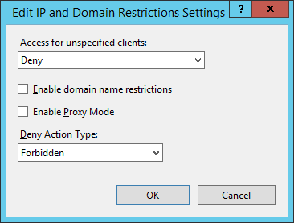

1. Click **Add Allow Entry…** in the **Actions** pane, enter the **IP** address that you wish to allow, and then click OK.

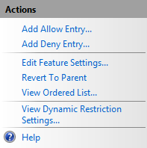

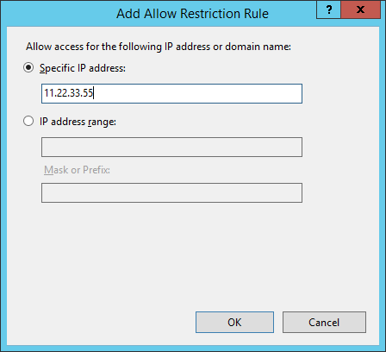

**How to remove IP restrictions**

1. In the **IP Address and Domain Restrictions** feature, click **Edit Feature Settings…** in the **Actions** pane. Select **Allow** for **Access for unspecified clients:** dropdown, click OK.

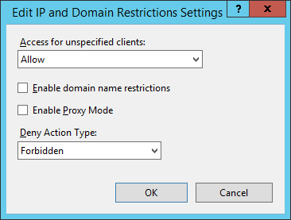

1. In the **IP Address and Domain Restrictions feature**, select the IP address added in step 6, and click **Remove** in the Actions pane.

