

Use Case Specification: SDR eCL Feed
For

eCoaching Log

Change History Log

Date | Version | Description | Author
03/10/2014 | 1.0 | CR1732 eCL - Short Duration Reporting Automation  Initial Document | Lisa Stein

Table of Contents

1. Brief Description 6
2. Participating Actors 6
2.1 Primary 6
2.2 Secondary 6
3. Basic Flow of Events 7
3.1 System process executes at the scheduled time. 7
3.2 Input file accessed from appropriate folder. 7
3.3 eCoaching Log information is read from the input file. 7
3.4 Assign the coaching log Program from the input Program. 7
3.5 Assign 232 as the value of the coaching log source id. 7
3.6 Assign the coaching log status from the input Form Status. 7
3.7 Assign the coaching log Site ID from the Employee record Site ID. 7
3.8 Assign the coaching log Employee LAN ID from the input CSR (LAN ID). 7
3.9 Assign the coaching log Employee ID from the Employee record Employee ID when a match is found with the input CSR (LAN ID). 7
3.10 Assign 999999 as the value of the coaching log Submitter ID. 7
3.11 Assign the coaching log Event Date from the input EventDate. 7
3.12 Assign 0 as the value for whether an Avoke ID is associated with the input record. 7
3.13 Assign 0 as the value for whether a NGD Activity ID is associated with the input record. 7
3.14 Assign 0 as the value for whether an UCID is associated with the input record. 7
3.15 Assign 0 as the value for whether a Verint ID is associated with the input record. 7
3.16 Assign the coaching log Description from the input txtDescription. 7
3.17 Assign the coaching log Submitted Date from the input Submitted Date. 8
3.18 Assign the coaching log Start Date from the input Evaluation Date. 8
3.19 Assign 0 as the value of whether this coaching log is Acknowledged. 8
3.20 Assign 0 as the value of whether this is a Customer Service Escalation. 8
3.21 Assign the coaching log Report ID from the input numReportID. 8
3.22 Assign the coaching log Report Code from the input strReportCode. 8
3.23 Assign 1 as the value of the coaching log Module ID. 8
3.24 Assign Current Coaching Initiatives – Research Required as the value of the coaching log and Short Duration Reporting as the value of the coaching log sub-reason. 8
3.25 Assign value of employee’s supervisor 8
3.26 Assign value of employee’s manager 8
3.27 Submit the Short Duration Reporting eCoaching Log 8
4. Alternative Flows 9
4.1 Employee Not Found. [Step 3.9, 4.4.2] 9
4.2 Duplicate eCoaching Logs. [Step 3.21, 3.22] 9
4.3 Employee ID/LAN ID. [Step 3.8, 3.9] 9
4.4 Supervisor Review Description. [Step 3.16] 9
5. Preconditions 10
5.1 Short Duration Reporting eCoaching Log input file exists and is available. 10
5.2 eCoaching Log database available. 10
5.3 eCoaching Log database populated with correct and current hierarchy information for CSR, Supervisors, Managers. 10
6. Postconditions 10
6.1 eCoaching Log submitted. 10
7. Assumptions and Dependencies 10
7.1 Input file is processed every day. 10
8. Business Rules 10
8.1 none 10
9. Technical Requirements 10
9.1 none 10
10. Activity Diagrams 11

Table of Figures
Figure 1 – CSR Outlier Management Report eCL Submission 13

Brief Description
Allow eCoaching Logs for call center Customer Service Representatives to be submitted through Short Duration Reporting data feed.

Participating Actors

Primary

System process

Customer Service Representatives

Supervisors

Secondary

Managers

Basic Flow of Events

System process executes at the scheduled time.

Input file accessed from appropriate folder.

eCoaching Log information is read from the input file.

Assign the coaching log Program from the input Program.

Assign 232 as the value of the coaching log source id.

Assign the coaching log status from the input Form Status.

Assign the coaching log Site ID from the Employee record Site ID.

Assign the coaching log Employee LAN ID from the input CSR (LAN ID).

Assign the coaching log Employee ID from the Employee record Employee ID when a match is found with the input CSR (LAN ID).

Assign 999999 as the value of the coaching log Submitter ID.

Assign the coaching log Event Date from the input EventDate.

Assign 0 as the value for whether an Avoke ID is associated with the input record.

Assign 0 as the value for whether a NGD Activity ID is associated with the input record.

Assign 0 as the value for whether an UCID is associated with the input record.

Assign 0 as the value for whether a Verint ID is associated with the input record.

Assign the coaching log Description from the input txtDescription.

The following characters from the input record will be replaced with the corresponding string of characters:
& | &amp;
< | &lt;
> | &gt;
` | &#39;
" | &quot;
‘ | &lsquo;
’ | &rsquo;
’ | &prime;
? | &Prime;
“ | &ldquo;
” | &rdquo;
- | &ndash;

Assign the coaching log Submitted Date from the input Submitted Date.

Assign the coaching log Start Date from the input Evaluation Date.

Assign 0 as the value of whether this coaching log is Acknowledged.

Assign 0 as the value of whether this is a Customer Service Escalation.

Assign the coaching log Report ID from the input numReportID.

Assign the coaching log Report Code from the input strReportCode.

Assign 1 as the value of the coaching log Module ID.

Assign Current Coaching Initiatives – Research Required as the value of the coaching log and Short Duration Reporting as the value of the coaching log sub-reason.

Assign value of employee’s supervisor

Assign value of employee’s manager

Submit the Short Duration Reporting eCoaching Log

Alternative Flows

Employee Not Found. [Step 3.9, 4.4.2]

When input Employee LAN ID match is not found in the Employee records reject the input record.

Continue with Step 3.10 above.

Duplicate eCoaching Logs. [Step 3.21, 3.22]

When input Report ID and Report Code match an existing coaching log’s Report ID and Report Code reject the input record.

Continue with Step 3.23 above.

Employee ID/LAN ID. [Step 3.8, 3.9]

Assign the coaching log Employee LAN ID from the Employee record LAN ID when a match is found with the input Employee ID.

Continue with Step 3.10 above.

Supervisor Review Description. [Step 3.16]

Assign the coaching log description
From feed | Concatenated text from feed <txtDescription>
Static Text | CSRs are scheduled for specific times in Empower to ensure understanding of training materials presented. It is important to utilize the timeframe allotted to successfully understand the training content. Please be aware that the scheduled timeframe is a metric which has been agreed upon by CCO and CMS. You should use all or the majority of the scheduled time to review each eLearning module assigned.

The following characters from the input record will be replaced with the corresponding string of characters:
& | &amp;
< | &lt;
> | &gt;
` | &#39;
" | &quot;
‘ | &lsquo;
’ | &rsquo;
’ | &prime;
? | &Prime;
“ | &ldquo;
” | &rdquo;

Continue with Step 3.17 above.

Preconditions

Short Duration Reporting eCoaching Log input file exists and is available.

eCoaching Log database available.

eCoaching Log database populated with correct and current hierarchy information for CSR, Supervisors, Managers.

Postconditions

eCoaching Log submitted.

Assumptions and Dependencies

Input file is processed every day.

Business Rules

none

Technical Requirements

none

Activity Diagrams
Below is the activity diagram for the use case that provides a visual depiction of the flow of events.

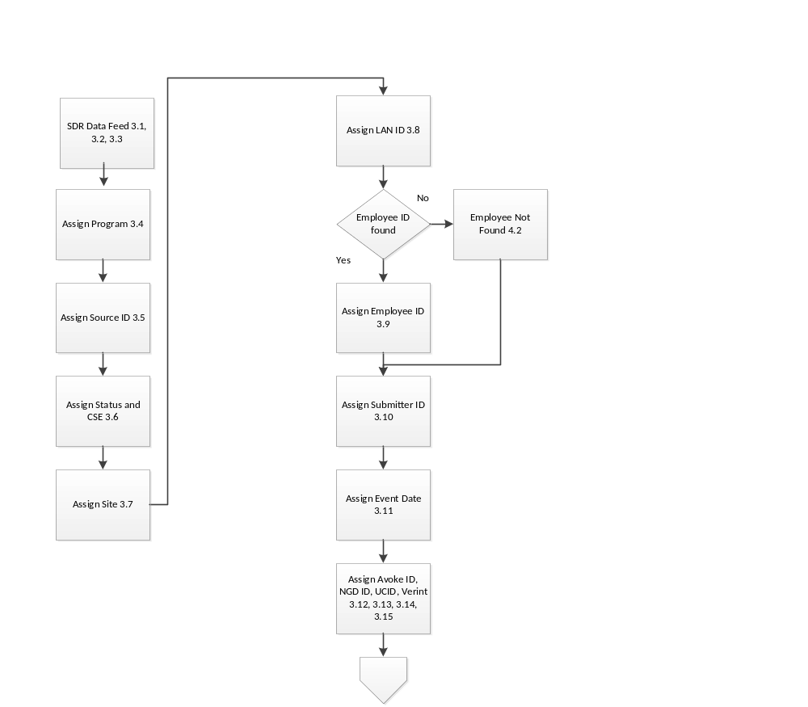

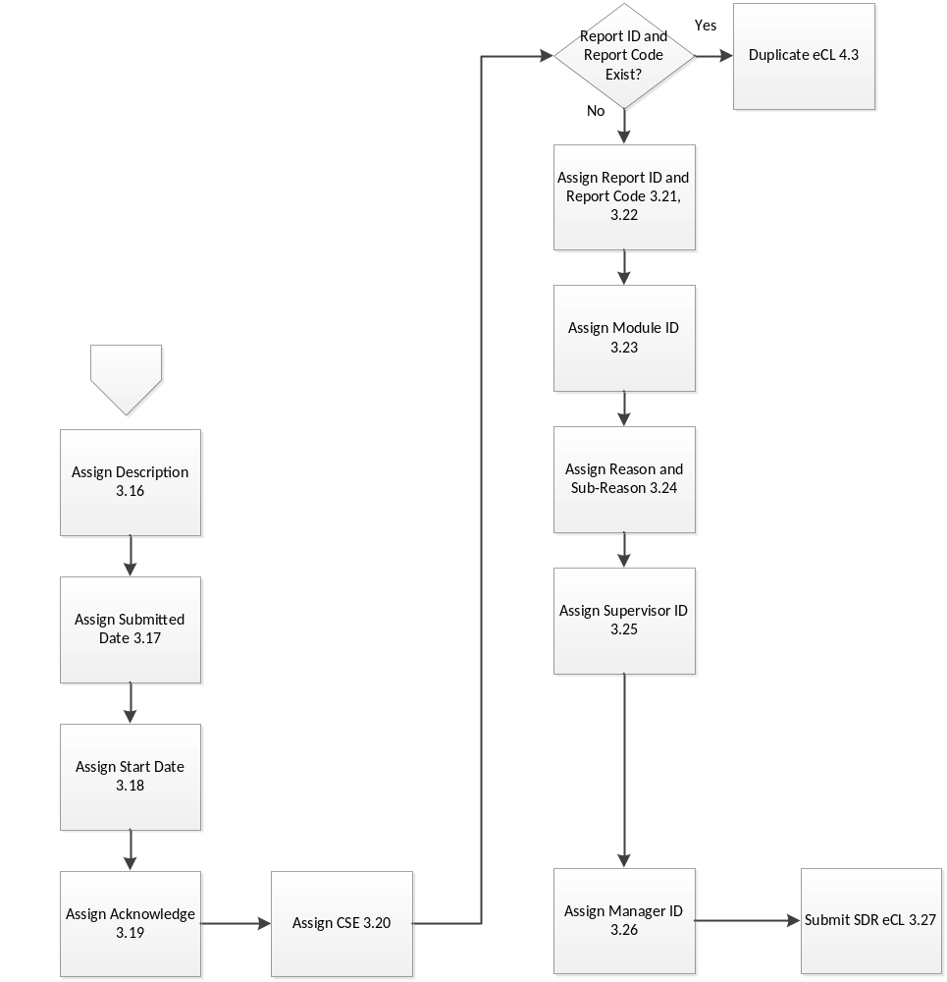

Figure 1 – CSR Outlier Management Report eCL Submission

