________________________


Detail Design: eCoaching Survey
eCoaching_Survey_DD
________________________

Prepared by: Lili Huang Date: 09/23/2015

Department: HCSD

Change History Log

Date | Change Description | Author
09/23/2015 | Initial Revision | Lili Huang

Table of Contents

1. Description 4
2. Presentation Layer 4
2.1. MySurvey.aspx.vb 4
2.1.1. Business Logic 4
2.2. MySurveyLogDetailView.aspx.vb 4
2.2.1. Business Logic 4
3. Business Layer 4
3.1. MySurveyHandler.vb 4
3.1.1. IsAccessAllowed 4
3.1.2. IsSurveyCompleted 4
3.1.3. ShowHotTopic 4
3.1.4. GetSurvey 5
3.1.5. SaveSurvey 5
3.1.6. GetQuestion 5
3.2. MySurveyLogDetailViewHandler.vb 5
3.2.1. GetLogReasons 5
3.2.2. GetLogDetail 5
4. Data Access Layer 5
4.1. MySurveyDBAccess.vb 5
4.1.1. GetSurvey 5
4.1.2. GetSurveyInfo 5
4.1.3. GetSurveyQuestions 5
4.1.4. GetSingleChoices 5
4.1.5. SaveSurvey 5
4.2. MySurveyLogDetailDBAccess.vb 5
4.2.1. GetLogReasons 5
4.2.2. GetLogDetail 5
5. Stored Procedures 5
5.1. Sp_Select_SurveyDetails_By_SurveyID 6
5.2. sp_Select_Questions_For_Survey 6
5.3. sp_Select_Responses_By_Question 6
5.4. sp_Update_Survey_Response 7
6. Page details 7
6.1. Survey Page (MySurvey.aspx) 7
6.1.1. ASPX pages comprising Web Page 7
6.1.2. Master Page 7
6.1.3. Screen Shot 7
6.1.4. Links 8
6.1.5. Web Page Invoked Events 8
6.1.6. Form Fields 10
6.2. Survey Log Detail Page (MySurveyLogDetailView.aspx) 12
6.2.1. Master Page 12
6.2.2. Screen Shot 12
6.2.3. Links 12
6.2.4. Web Page Invoked Events 12
6.2.5. Form Fields 13

- Description

The eCoaching Survey provides a way to collect employees’ feedback about their coaching experience.

The survey takes place three times a month. Any employees who have acknowledged and completed at least one eCoaching Log in the survey month and have not been chosen to do the survey for the survey month might receive a survey notification email. The email will have a link that will take the employee to the Survey page.

- Presentation Layer
  - MySurvey.aspx.vb
    - Business Logic

When the page displays for the first time (not post back):
Get the survey id request parameter;
Get the surveyfrom database
If the user is not authorized for the survey
Display not authorized message
Else
If the survey is completed
Display survey completed message
Else
Bind survey questions to the page

When Submit button is clicked:
If page validation fails,
Display error message
Else
Load the data entered on the page to survey object
Save the survey to database
If the survey is successfully saved
Display success message
Else
Display error message on the top of the page

  - MySurveyLogDetailView.aspx.vb
    - Business Logic

When the page displays for the first time (not post back), the user is authorized for the survey,
And the survey has not been completed yet:

Get the survey log name from session
Get survey log details
Get survey log coaching reasons/subreasons
Bind survey details and survey reasons to the page

- Business Layer
  - MySurveyHandler.vb
    - IsAccessAllowed
Check if the user’s employee ID matches the survey’s employee ID

    - IsSurveyCompleted
Check if the survey has been completed

    - ShowHotTopic
Checks whether to show Hot Topic question or not

    - GetSurvey
Get the survey by calling GetSurvey method in business layer

    - SaveSurvey
Save the survey to database

    - GetQuestion
Get question by question display order

  - MySurveyLogDetailViewHandler.vb
    - GetLogReasons
Get coaching reasons and sub reasons for the survey log
Bind to the page

Get details of the survey log
Bind to the page

    - GetLogDetail
Get the details of the log

- Data Access Layer
  - MySurveyDBAccess.vb
    - GetSurvey
Get survey general information (employee ID, survey log name, survey status, and if the survey contains hot topic for the month) by calling GetSurveyInfo

Get survey questions by calling GetSurveyQuetions

Get single choices data by calling GetSingleChoices

    - GetSurveyInfo
Get survey general information (employee ID, survey log name, survey status, and if the survey contains hot topic for the month) by calling stored procedure sp_Select_SurveyDetails_By_SurveyID

    - GetSurveyQuestions
Get survey questions by calling stored procedure sp_Select_Questions_For_Survey

    - GetSingleChoices
Get single choices by calling stored procedure sp_Select_Responses_For_Survey

    - SaveSurvey
Save survey to database by calling stored procedure sp_Update_Survey_Response

  - MySurveyLogDetailDBAccess.vb
    - GetLogReasons
Get coaching reasons and sub reasons by calling stored procedure sp_SelectReviewFrom_Coaching_Log_Reasons

    - GetLogDetail
Get details of the log by calling stored procedure sp_SelectReviewFrom_Coaching_Log

- Stored Procedures

  - Sp_Select_SurveyDetails_By_SurveyID
/*****************************************************************
Description:
Returns Employee ID, eCL Form Name, and if the survey contains a Hot Topic question for a given survey ID.

Tables:
Survey_Response_Header
Survey_DIM_QAnswer

Input Parameters:
surveyID

Resultset:
Survey_Response_Header.EmployeeID
Survey_Response_Header.FormName
Survey_DIM_QAnswer.isHotTopic

*****************************************************************/

  - sp_Select_Questions_For_Survey

/*****************************************************************

Description:
Returns all the questions’ display text and display order for a given survey.

Tables:
Survey_DIM_Question
Survey_DIM_QAnswer

Input Parameters:
surveyID

Resultset:
Survey_DIM_Question.QuestionID
Survey_DIM_Question.Description
Survey_DIM_Question.DisplayOrder
Survey_DIM_QAnswer.isHotTopic

*****************************************************************/

  - sp_Select_Responses_By_Question

/*****************************************************************

Description:
Returns all the active singlechoices.

Tables:
Survey_DIM_Response

Input Parameters:
None

Resultset:
Survey_DIM_Response.QuestionID
Survey_DIM_Response.ResponseID
Survey_DIM_Response.ResponseValue

*****************************************************************/

  - sp_Update_Survey_Response

/*****************************************************************
Description:
Updates Survey_response_header.CSRComments with the comments passed in;
Updates Survey_response_header.Status to “Completed”;
Updates Survey_response_header.CompletedDate to current timestamp;
Inserts all records from User-Defined Table ResponsesTableType into table Survey_response_detail.

Tables:
Survey_response_header
Survey_response_detail

Input Parameters:
surveyID
ResponsesTableType
userComments

Resultset:
None

Output Parameters:
returnCode
returnMessage

*****************************************************************/

- Page details

  - Survey Page (MySurvey.aspx)

    - ASPX pages comprising Web Page
MySurvey.aspx

    - Master Page
Site4.Master

    - Screen Shot

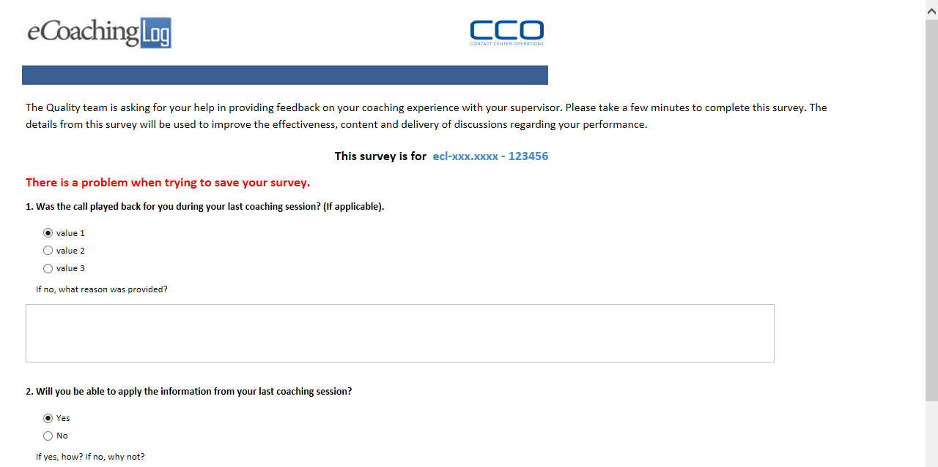
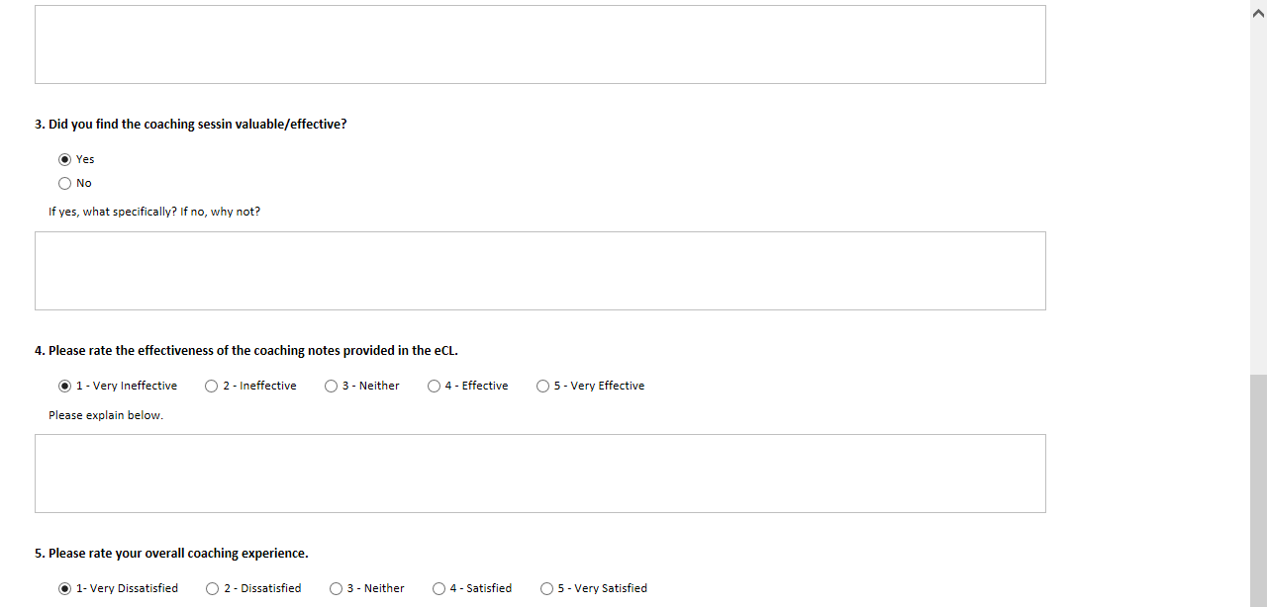
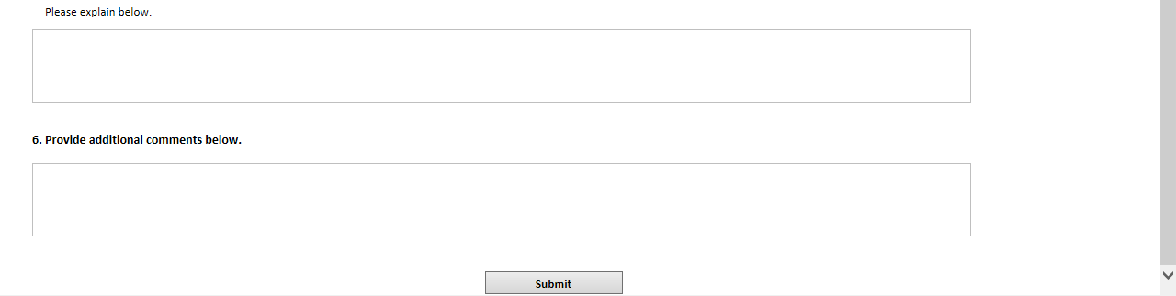

    - Links
Link Link Name | Destination
ecl-xxx-xxxx-123456 | My Survey Log Detail page (MySurveyLogDetailView.aspx

    - Web Page Invoked Events

Action | Processing & Result
OnPageLoad | MySurvey.aspx is loaded.
Click on “ecl-xxx-xxxx-123456” link | Javascript displayDetailModal() is called to pop up Log Detail modal dialog
Click on “Submit” button | The form is submitted.

    - Form Fields

Page Name | Field Type | Field Name | Default Value | Data Element Source | Validation
MySurvey.aspx | Label |  | The Quality team is asking for your help in providing feedback on your coaching experience with your supervisor. Please take a few minutes to complete this survey. The details from this survey will be used to improve the effectiveness, content and delivery of discussions regarding your performance.
MySurvey.aspx | Label |  | This survey is for
MySurvey.aspx | Link |  | ecl-xxx.xxxx-123456 | Survey_Response_Header.FormName
MySurvey.aspx | Label |  | 1.Was the call played back for you during your last coaching session? (If applicable). | Survey_DIM_Question.Description
MySurvey.aspx | RadioButtonList | Question1RadioButtonList |  | Survey_DIM_QAnswer.ResponseID  Survey_DIM_QAnswer.ResponseValue | required
MySurvey.aspx | RadioButton |  | Yes
MySurvey.aspx | RadioButton |  | No
MySurvey.aspx | RadioButton |  | N/A
End of RadioButtonList
MySurvey.aspx | Label |  | If no, what reason was provided? | Survey_DIM_Question.Description
MySurvey.aspx | Text Box | Question1TextBox |  |  | optional
MySurvey.aspx | Label |  | 2.Will you be able to apply the information from your last coaching session? | Survey_DIM_Question.Description
MySurvey.aspx | RadioButtonList | Question2RadioButtonList |  | Survey_DIM_QAnswer.ResponseID  Survey_DIM_QAnswer.ResponseValue | required
MySurvey.aspx | RadioButton |  | Yes
MySurvey.aspx | RadioButton |  | No
End of RadioButtonList
MySurvey.aspx | Label |  | If yes, how? If no, why not? | Survey_DIM_Question.Description
MySurvey.aspx | TextBox | Question2TextBox |  |  | optional
MySurvey.aspx | Label |  | 3.Did you find the coaching sesson valuable/effective? | Survey_DIM_Question.Description
MySurvey.aspx | RadioButtonList | Question3RadioButtonList |  | Survey_DIM_QAnswer.ResponseID  Survey_DIM_QAnswer.ResponseValue | required
MySurvey.aspx | RadioButton |  | Yes
MySurvey.aspx | RadioButton |  | No
End of RadioButtonList
MySurvey.aspx | Label |  | If yes, what specifically? If no, why not? | Survey_DIM_Question.Description
MySurvey.aspx | TextBox | Question3TextBox |  |  | optional
MySurvey.aspx | Label |  | 4.Please rate the effectiveness of the coaching notes provided in the eCL. | Survey_DIM_Question.Description
MySurvey.aspx | RadioButtonList | Question4RadioButtonList |  | Survey_DIM_QAnswer.ResponseID  Survey_DIM_QAnswer.ResponseValue | required
MySurvey.aspx | RadioButton |  | 1-Very Ineffective
MySurvey.aspx | RadioButton |  | 2-Ineffective
MySurvey.aspx | RadioButton |  | 3-Neither
MySurvey.aspx | RadioButton |  | 4-Effective
MySurvey.aspx | RadioButton |  | 5-Very Effective
End of RadioButtonList
MySurvey.aspx | Label |  | Please explain below. | Survey_DIM_Question.Description
MySurvey.aspx | TextBox | Question4TextBox |  |  | optional
MySurvey.aspx | Label |  | 5.Please rate your overall coaching experience. | Survey_DIM_Question.Description
MySurvey.aspx | RadioButtonList | Question5RadioButtonList |  | Survey_DIM_QAnswer.ResponseID  Survey_DIM_QAnswer.ResponseValue | required
MySurvey.aspx | RadioButton |  | 1-Very Dissatisfied
MySurvey.aspx | RadioButton |  | 2-Dissatisfied
MySurvey.aspx | RadioButton |  | 3-Neither
MySurvey.aspx | RadioButton |  | 4-Satisfied
MySurvey.aspx | RadioButton |  | 5-Very Satisfied
End of RadioButtonList
MySurvey.aspx | Label |  | Please explain below. | Survey_DIM_Question.Description
MySurvey.aspx | TextBox | Question5TextBox |  |  | optional
MySurvey.aspx | Label |  | 6.Provide additional comments below.
MySurvey.aspx | TextBox | CommentTextBox |  |  | optional

  - Survey Log Detail Page (MySurveyLogDetailView.aspx)

This page displays as a modal dialog on the Survey Page.

    - Master Page
Site3.Master

    - Screen Shot

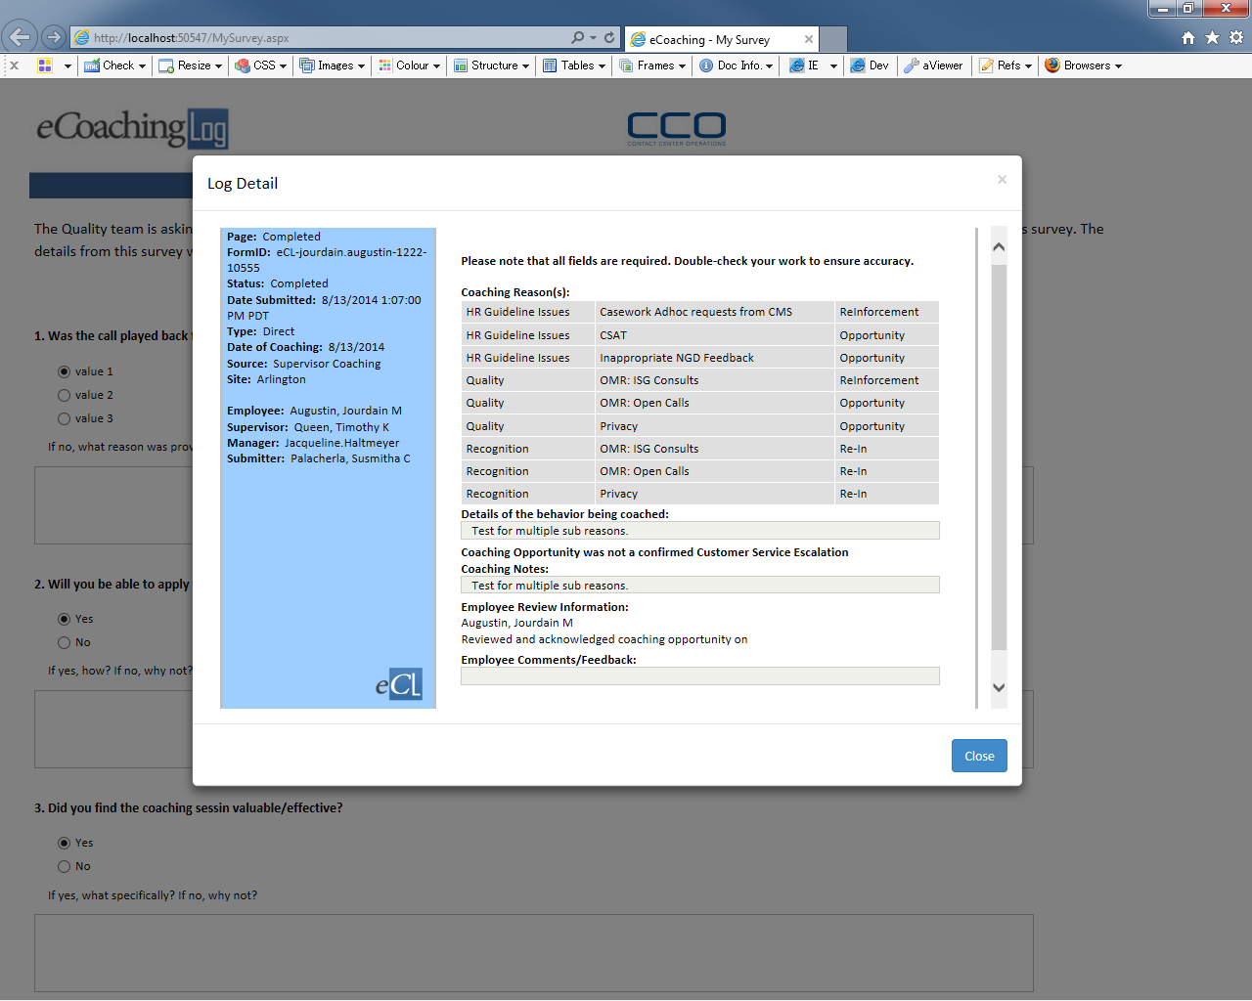

    - Links

None

    - Web Page Invoked Events

None
    - Form Fields

Page Name | Field Type | Field Name | Default Value | Data Element Source | Display
Left Side Content:
MySurveyLogDetailView.aspx | Label |  | Page:
MySurveyLogDetailView.aspx | Label |  |  | Dim_Status.Status
MySurveyLogDetailView.aspx | Label |  | FormID:
MySurveyLogDetailView.aspx | Label |  |  | Coaching_Log.FormName
MySurveyLogDetailView.aspx | Label |  | Status:
MySurveyLogDetailView.aspx | Label |  |  | Dim_Status.Status
MySurveyLogDetailView.aspx | Label |  | Date Submitted:
MySurveyLogDetailView.aspx | Label |  |  | Coaching_log.SubmittedDate
MySurveyLogDetailView.aspx | Label |  | Type:
MySurveyLogDetailView.aspx | Label |  |  | Dim_Source.CoachingSource
MySurveyLogDetailView.aspx | Label |  | Date of Coaching: |  | Displays if the log is “direct”.
MySurveyLogDetailView.aspx | Label |  |  |  | Displays if the log is “direct”.
MySurveyLogDetailView.aspx | Label |  | Date of Event: |  | Displays if the log is “indirect”
MySurveyLogDetailView.aspx | Label |  |  |  | Displays if the log is “indirect”
MySurveyLogDetailView.aspx | Label |  | Source:
MySurveyLogDetailView.aspx | Label
MySurveyLogDetailView.aspx | Label |  | Site:
MySurveyLogDetailView.aspx | Label
MySurveyLogDetailView.aspx | Label |  | Verint ID: |  | Displays if it’s Verint monitor.
MySurveyLogDetailView.aspx | Label |  |  | Coaching_log.verintID | Displays if it’s Verint monitor.
MySurveyLogDetailView.aspx | Label |  | Scorecard Name:
MySurveyLogDetailView.aspx | Label
MySurveyLogDetailView.aspx | Label |  | Avoke ID: |  | Displays if it’s behavior analytics monitor.
MySurveyLogDetailView.aspx | Label |  |  | Coaching_log.AvokeID | Displays if it’s behavior analytics monitor.
MySurveyLogDetailView.aspx | Label |  | NGD Activity ID: |  | Displays if it’s NGD Activity monitor.
MySurveyLogDetailView.aspx | Label |  |  | Coaching_log.NGDActivityID | Displays if it’s NGD Activity monitor.
MySurveyLogDetailView.aspx | Label |  | Universal Call ID: |  | Displays if it’s Universal call monitor
MySurveyLogDetailView.aspx | Label |  |  | Coaching_log.UCID | Displays if it’s Universal call monitor
MySurveyLogDetailView.aspx | Label |  | Employee :
MySurveyLogDetailView.aspx | Label |  |  | Employee_Hierarchy.Emp_Name
MySurveyLogDetailView.aspx | Label |  | Supervisor:
MySurveyLogDetailView.aspx | Label |  |  | Employee_Hierarchy.Sup_Name
MySurveyLogDetailView.aspx | Label |  | Manager:
MySurveyLogDetailView.aspx | Label |  |  | Employee_Hierarchy.Mgr_LandID
MySurveyLogDetailView.aspx | Label |  | Submitter:
MySurveyLogDetailView.aspx | Label |  |  | Employee_Hierarchy.Emp_Name
MySurveyLogDetailView.aspx | Image |  | eclogo.png
Right Side Content:
MySurveyLogDetailView.aspx | Label |  | Please note that all fields are required. Double-check your work to ensure accuracy.
MySurveyLogDetailView.aspx | Label |  | Coaching Reason(s):
MySurveyLogDetailView.aspx | GridView |  |  | Stored procedure  sp_SelectReviewFrom_Coaching_Log_Reasons
MySurveyLogDetailView.aspx |  |  | Details of the behavior being coached:
MySurveyLogDetailView.aspx | Table |  |  | Coaching_log.Description
MySurveyLogDetailView.aspx |  |  | Coaching Opportunity was a confirmed Customer Service Escalation |  | Displays if Coaching Reason is “Customer Service Escalation”
MySurveyLogDetailView.aspx | Label |  | Management Notes: |  | Displays if Coaching Reason is NOT “Customer Service Escalation”
MySurveyLogDetailView.aspx | Label |  |  | Coaching_Log.MgrNotes
MySurveyLogDetailView.aspx | Label |  | Coaching Opportunity was not a confirmed Customer Service Escalation |  | Displays if Coaching Reason is NOT “Customer Service Escalation”
MySurveyLogDetailView.aspx | Label |  | Coaching Notes:
MySurveyLogDetailView.aspx | Label |  |  | Coaching_Log.CoachingNotes
MySurveyLogDetailView.aspx | Label |  | Employee Review Information:
MySurveyLogDetailView.aspx | Label |  |  | Employee_Hierarchy.Emp_Name
MySurveyLogDetailView.aspx | Label |  | Reviewed and acknowledged coaching opportunity on
MySurveyLogDetailView.aspx | Label |  |  | Coaching_Log.CSRReviewAutoDate
MySurveyLogDetailView.aspx | Label |  | Supervisor Review Information: |  | Displays if it’s IQS.
MySurveyLogDetailView.aspx | Label |  |  | Employee_Hierarchy.Sup_Name | Displays if it’s IQS.
MySurveyLogDetailView.aspx | Label |  | Reviewed and acknowledged Quality Monitor on |  | Displays if it’s IQS.
MySurveyLogDetailView.aspx |  |  |  | Coaching_Log.SupReviewedAutoDate | Displays if it’s IQS.
MySurveyLogDetailView.aspx | Label |  | Employee Comments/Feedback: |  | Displays if it’s NOT IQS.
MySurveyLogDetailView.aspx | Label |  |  | Coaching_Log.CSRComments | Displays if it’s NOT IQS.

