The document lists down the areas that caused delays in successful deployment of ETL Job Management module on CADIR production environment. Deployment ticket for reference – [PAXTECH-2201](https://jira.maximus.com/browse/PAXTECH-2201)

1. Due to sql client on appserver and database server running on different versions, version numbers should be explicitly configured on database server. Since DB is migrated to AWS environment, DBA took a while to find out AWS account number and a way to login to it during deployment.

AWS account details can be found from Splunk. It can be accessed from below URL. Only DBAs would have access to it.

<https://splunk-us-east-1.logging.maximus.com/en-US/app/dba/search>

Client/server versions should be explicitly defined from AWS console. This setting is only needed when sql client is running on a different version from db server. Below the screenshots of settings made.

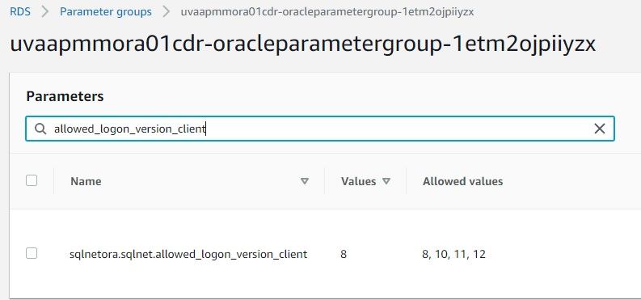

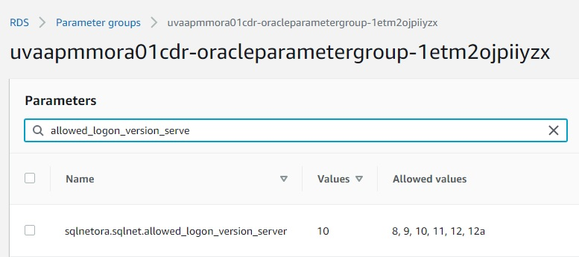

1. Separate directory for ETL Job Control (EJC) is deployed in Prod that would contain subfolders for scripts & logs (/u01/maximus/maxdat-prd/CADIR8/ETLJobControl/). In lower environments all EJC scripts and logs are merged into kettle scripts & logs locations. Due to the above, paths defined in EJC crons & in .set_env file would differ between lower & prod environments.

EJC logs aren’t detailed enough to help figure out the needed fixes in .set_env file path. Needed fixes to paths in .set_env were identified from deployment of below debug script under /u01/maximus/maxdat-prd/CADIR8/ETLJobControl/scripts/ and executing it by appadmin.

The script was later removed after fixes are applied.

svn://svn-staging.maximus.com/dev1d/maxdat/trunk/ETL_Job_Control/ETL/scripts/etl_job_control_debug.bash

1. Encryption of Maxdat password in kettle.properties failed both sql client (from EJC) and kettle scripts to establish connection to MAXDAT database. Both connected fine after password is decrypted back to plain text file.