MAXDat V2 History for UK HWS

Developer’s Guide

Randall Kolb

December 4, 2014

# Table of Contents

Table of Contents 2

1 Overview 3

2 Data Model 3

2.1 Manage Work V2 Data Model Diagram 4

2.2 Process Incidents (V2) Data Model Diagram 5

2.3 BPM Semantic V2 Data Model Structure 6

2.4 Data Model Population Example 7

3 Install 9

4 Glossary 9

# Overview

This is a developer’s guide for writing code to populate the MAXDat V2 History data models for the UK HWS project.

# Data Model

The MAXDat V2 History data model is a star schema dimensional model that contains a record of current and some historical info on the attributes values of the processes monitored. MicroStrategy reports use views of these tables. The V2 model is different than the original model in that it uses a history table rather than a fact table and uses different views.

MAXDat has two processes that use the V2 History data model.

DDL scripts and data models can be found for each at SVN URLs listed below:

Manage Work V2: svn://rcmxapp1d.maximus.com/maxdat/BPM/Corp/MW_V2/*/mssql/*

Process Incidents (V2): svn://rcmxapp1d.maximus.com/maxdat/BPM/Corp/ProcessIncidents/*/mssql/*

## Manage Work V2 Data Model Diagram

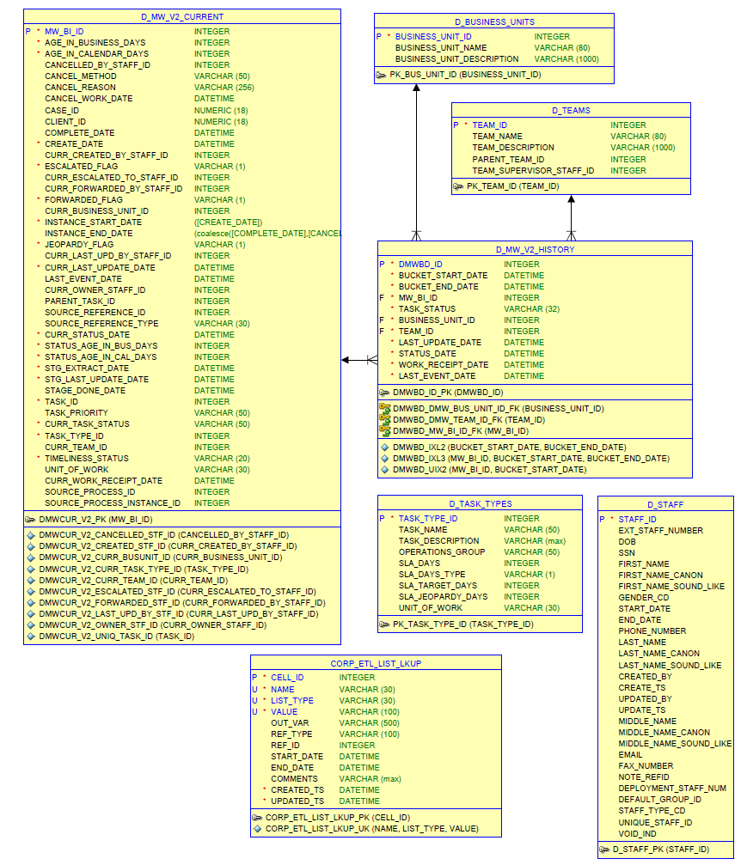

## Process Incidents (V2) Data Model Diagram

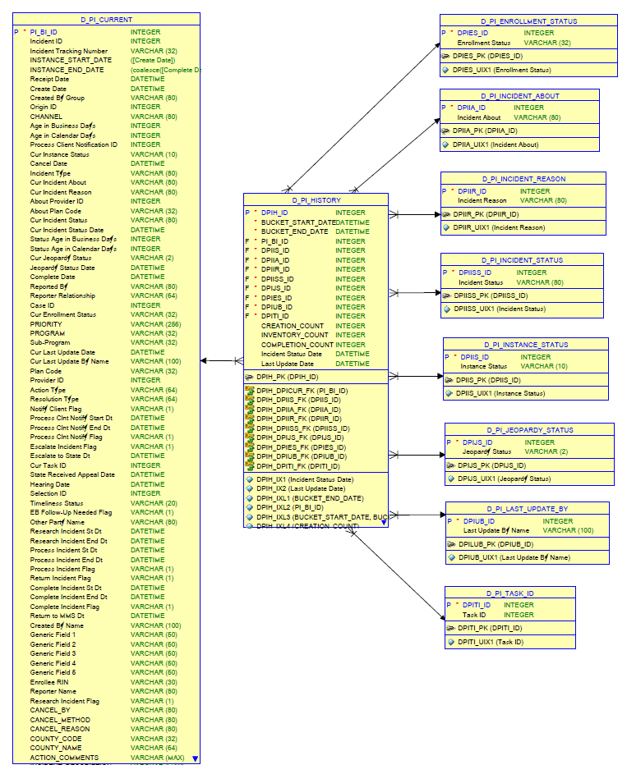

## V2 History Data Model Structure

Each process has a data model diagram that can be found here in SVN:

Example: svn://rcmxapp1d.maximus.com/maxdat/BPM/Corp/MW_V2/doc/mssql/*

Each process has at least two tables

1 - The current dimension. Contains one row per instance containing the current values of each instance. Some of the columns in the current dimension should be calculated by the ETL when inserting or updating using functions provided for each process. Many of these calculation columns are current date dependent (Example: calculated column AGE_IN_BUSINESS_DAYS uses MV_V2_GET_AGE_IN_BUSINESS_DAYS function) and so are also updated by a job that runs every day at midnight. Only active current (not completed) dimension rows are updated.

Example table: MW_V2_CURRENT

Example functions: svn://rcmxapp1d.maximus.com/maxdat/BPM/Corp/MW_V2/createdb/mssql/MW_V2_pkg.sql

2 - The history table. Contains one row per bucket (day) in which an event (change) occurred per instance.

Example table: D_MW_V2_HISTORY

Additionally there are usually several dimension tables that contain the unique values that are used by several instances. Each history table (Example: D_MW_V2_HISTORY) row has IDs that point to rows in these tables.

Example tables:

D_BUSINESS_UNITS

D_STAFF

D_TASK_TYPES

D_TEAMS

## Data Model Population Example

MW V2 (Manage Work V2) table names are used in the examples on the next page.

Values that are in green must be inserted or updated by ETL.

{value} below is an example ID pointing to a ID in a dimension table.

Numbers are just made-up examples to show when they change.

Dates below are formatted as:

yyyy-mm-dd hh:mm:ss (MS SQL Server)

YYYY-MM-DD HH24:MI:SS (Oracle)

Each example below is based on one instance (unique MW_BI_ID in the where clause of the table).

**Event at 2014-11-06 13:00:04 – New Manage Work Instance.**

Insert new **D_MW_V2_HISTORY** table row:

**BUCKET_START_DATE  BUCKET_END_DATE LAST_UPDATE_DATE {value}**

0001-01-01 00:00:00 9999-12-31 00:00:00 2014-11-06 13:00:04 1234561

**Event at 2014-11-08 02:50:34 – Change status**

Update old and insert new **D_MW_V2_HISTORY** table rows:

**BUCKET_START_DATE  BUCKET_END_DATE LAST_UPDATE_DATE {value}**

0001-01-01 00:00:00 2014-11:07 00:00:00 2014-11-06 13:00:04 1234561

2014-11-08 00:00:00 9999-12-31 00:00:00 2014-11-08 02:50:34 1234577

**Event at 2014-11-10 12:20:08 – Change status again**

Update old and insert new **D_MW_V2_HISTORY** table rows:

**BUCKET_START_DATE  BUCKET_END_DATE LAST_UPDATE_DATE {value}**

0001-01-01 00:00:00 2014-11:07 00:00:00 2014-11-06 13:00:04 1234561

2014-11-08 00:00:00 2014-11-09 00:00:00 2014-11-08 02:50:34 1234577

2014-11-10 00:00:00 9999-12-31 00:00:00 2014-11-10 12:20:08 1234598

**Event at 2014-11-10 14:30:19 – Change status again on the same day.**

Events later in the day (where bucket interval = 1 day) overwrite the previous events during that same day.

Update **D_MW_V2_HISTORY** table row:

**BUCKET_START_DATE  BUCKET_END_DATE LAST_UPDATE_DATE {value}**

0001-01-01 00:00:00 2014-11:07 00:00:00 2014-11-06 13:00:04 1234561

2014-11-08 00:00:00 2014-11-09 00:00:00 2014-11-08 02:50:34 1234577

2014-11-10 00:00:00 9999-12-31 00:00:00 2014-11-10 14:30:19 1234623

**Event at 2014-11-12 09:20:22 – Change status and complete.**

Update old and insert new **D_MW_V2_HISTORY** table rows:

**BUCKET_START_DATE  BUCKET_END_DATE LAST_UPDATE_DATE {value}**

0001-01-01 00:00:00 2014-11:07 00:00:00 2014-11-06 13:00:04 1234561

2014-11-08 00:00:00 2014-11-09 00:00:00 2014-11-08 02:50:34 1234577

2014-11-10 00:00:00 2014-11-12 00:00:00 2014-11-10 14:30:19 1234623

2014-11-12 00:00:00 9999-12-31 00:00:00 2014-11-12 09:20:22 1234752

# Install

Every project has an install guide that describes the steps and files need to install the MAXDat schema.

Example: svn://rcmxapp1d.maximus.com/maxdat/BPM/UK_HWS/doc/mssql/DB_install_UK_HWS_README.txt

# Glossary

**BPM** – Business Process Management

**Instance** – In MAXDat an instance is a path through a business process flow chart, made by a particular client, such as one client applying for benefits. This translates into one row in the current dimension table in the data model that describes the detailed state of that process for the client

**MicroStrategy** – Business intelligence and reporting software.

**Process** – A business process described by a requirement spreadsheet. Example: Manage Work

**Project** – A set of business processes used to fulfill contractual obligations for BPM for an entity such as a state benefit program. Example: UK Health for Work Service (UK-HWS)

**SVN** – Subversion – Software revision control system.