1.You have to create JNDI entries for the BPMSourceDD, BPMSourceUAT, BPMSourcePRD, OLTPSourceDEV, OLTPSourceUAT and OLTPSourcePRD. Example of the entry is shown below.

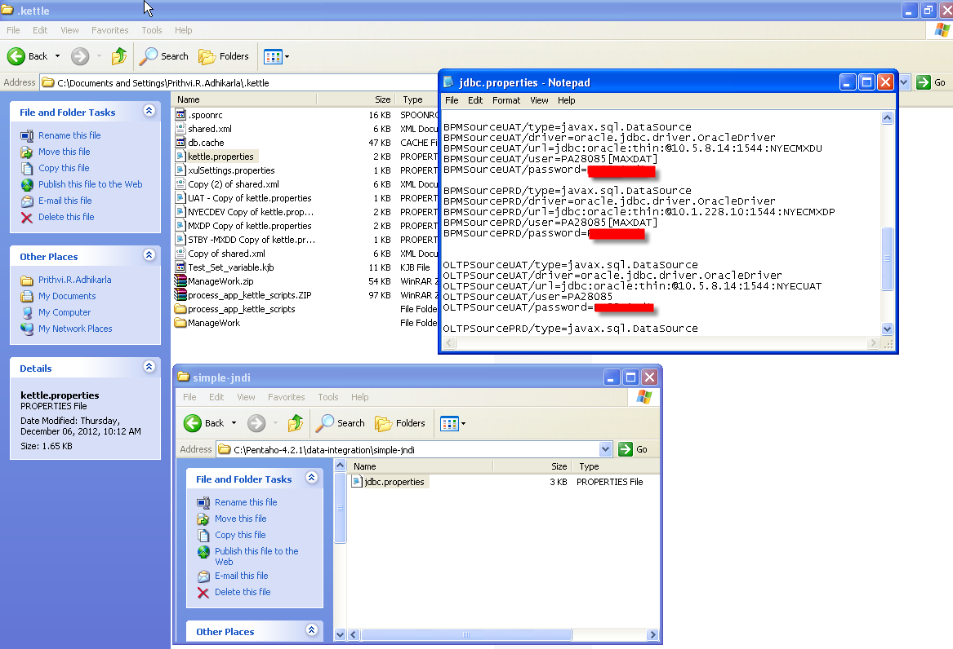

2. Setup the kettle properties file with the above created entries. Example of this entry is shown below.
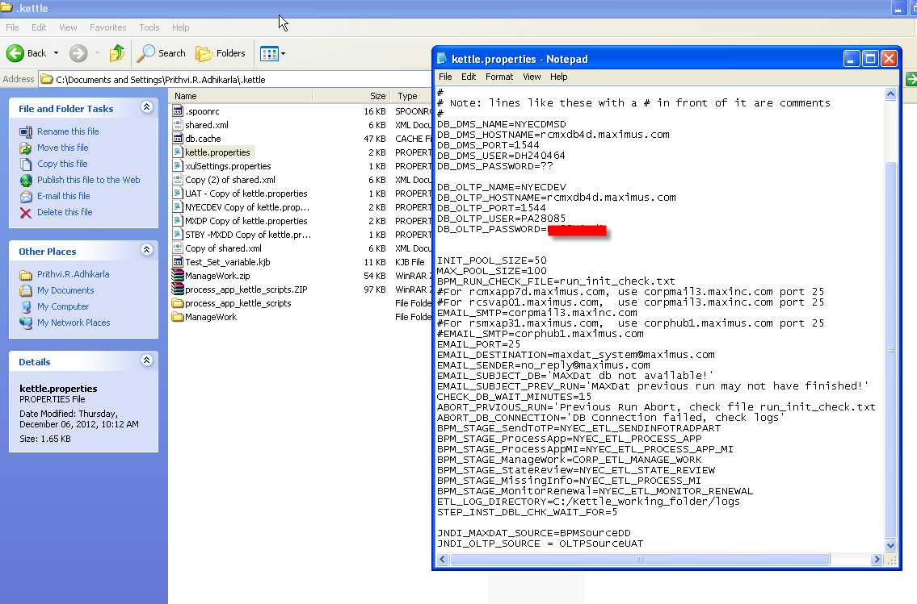

3. Now, use the above entries in the spoon transformation.
