Enrollment Management Reporting Solution (EMRS)
Data Mart
Installation Guide

December 02, 2009
- Table of Contents
1. Table of Contents 2
2. Table of Figures 2
3. Introduction 3
4. Database Installation 3
4.1. Release Script Location 3
4.2. Designer Repository 3
4.3. Script Types 4
4.4. Script Order 5
4.5. Script Execution 5
4.6. Stored Procedure Execution 5
4.6.1. Date Period Procedure 6
4.6.2. Time Period Procedure 6
5. ETL Installation 6
5.1. Jobs and Transformations 6
5.2. ETL Files 9
5.3. ETL Deployment 10
5.4. BI Deployment 10

- Table of Figures

Figure 1 - Designer Connectivity 3
Figure 2 - Designer Authorization Authorities 4
Figure 3 – DBA & Developer Script Names 4
Figure 4 – Installation Script Name, Type, and Order 5
Figure 5 - Job Execution 7
Figure 6 - Dimension Transformation 7
Figure 7 - Fact Transformation 8
Figure 8 – Pentaho Transformations and Jobs 9

- Introduction
There are two parts to the installation of the EMRS data-mart:

- Database Installation
- ETL Installation

The Database Installation creates all the EMRS database objects and initializes the data-mart. The ETL installation initializes the scheduled workflow job system which in turn executes each individual ETL transformation in sequential order.

The Database Installation procedure should not be used for any subsequent maintenance after the data-mart has been put into operation. Doing so would delete any historical record. Use regular database migration procedures in the future to move a production installation and maintain its integrity.

- Database Installation
  - Release Script Location
The EMRS data-mart is installed using a set of SQL scripts. These scripts are located on the share-drive at:

S:\Texas IEE Project\MAXIMUS\CHIP\TX_CHIP_REPORTING\EMRS\Release

There are a series of folders located here, and each folder is given a date-name, e.g. 091030 which represents the date Friday, October 30, 2009. The latest date represents the latest release.
  - Designer Repository
The design database is an Oracle Designer Repository used to design and generate the project DDL scripts. It is hosted on servers located in Sacramento, CA. Figure-1 shows the Repository connection details for the EMRS project design work.

Figure 1 - Designer Connectivity

# | System | Detail
1 | Instance | MAXEREP
2 | Work Area | TX_DATAMART
3 | Application System | EMRS
4 | Owner | DES
5 | User | IW39610

The user IW39610 is the only current user-account with full developer privileges to this work-area, and belongs to the data-architect consultant. After the consultant is gone, subsequent authorized developers may obtain their own user-account by sending an email to the following MAXIMUS email addresses requesting development privileges in the EMRS Application System.

Figure 2 - Designer Authorization Authorities

# | Authority | Email Address | Purpose
1 | Local DBA Support | TXCHIPDBAs | Notify Local DBA Group who will verify authorization of the user-account.
2 | Designer Support | System Group Div19-7 | Sacramento DBAs who will create the Designer user-account, and grant access to the EMRS project Application System.
3 | Citrix Support | OIS-Rancho | System Administration Group who will grant Citrix Virtual access to the remote Designer environment for the user-account, from the Austin location.

  - Script Types
All the scripts in the Release Location are SQL or PL/SQL scripts. Some are DDL and some are DML. Together, these scripts create all the database objects that make up the data mart. The DML scripts pre-populate some tables with necessary default data. The execution of the scripts initiates the operation of the data-mart with Day-1 transaction data. After that, ETL operations accumulate transaction histories.

This procedure should only be used to create a new initial installation. After initiation, the data-mart will maintain a historical record of all data coming from its source systems. Subsequent execution of this installation procedure would cause the loss of all historical records. Therefore, this procedure should never be executed on a Production server. In order to create a fresh installation on a server, DROP scripts are included that clean out any previous installation on the server. For example, if there is a desire to update a DEV or TEST environment to the latest release, and there is no concern for maintaining historical data.

Certain scripts must be executed with DBA privilege by the MAXIMUS DBA Department. The remaining scripts must be executed by the developer using the EMRS_OWNER login, whose creation is described in the EMRS Capacity Plan document. The script name convention shown in Figure 3 depicts what script must be executed by whom. The developer must email the DBA scripts to the Local DBA Support group for them to execute. After the developer receives notification that the DBA scripts have been executed [by the DBA Group], the developer can proceed to execute the remaining scripts while logged in as EMRS_OWNER.

Figure 3 – DBA & Developer Script Names

Script  Naming Convention | Purpose
EMRS_DBA | Scripts that must be emailed to the Local DBA to be executed.
EMRS_Owner | Scripts that can be executed by the Developer.
  - Script Order
The database installation scripts must be executed in the sequential order specified, or else subsequent scripts will fail. Figure-4 is a list of each script type, in the order of execution, and a general description of what the script does.

Figure 4 – Installation Script Name, Type, and Order

Sequence | Script Name | Privilege | Type | Description
1 | drop_EMRS_tables.tab | Developer | DDL | Remove previous EMRS tables
2 | drop_EMRS_sequences.sqs | Developer | DDL | Remove previous EMRS sequences
3 | drop_EMRS_pub_synonym.syn | DBA | DDL | Remove previous EMRS synonyms
4. | EMRS_DBA.tbs | DBA | DDL | Create EMRS tablespaces
5 | EMRS_DBA.rle | DBA | DDL | Create EMRS roles
6 | EMRS_DBA.usr | DBA | DDL | Create EMRS users
7 | EMRS_DBA.syn | DBA | DDL | Create EMRS synonyms
8 | EMRS_Owner.tab | Developer | DDL | Create EMRS tables
9 | EMRS_Owner.ind | Developer | DDL | Create EMRS indexes
10 | EMRS_Owner.con | Developer | DDL | Create EMRS constraints
11 | EMRS_Owner.sqs | Developer | DDL | Create EMRS sequences
12 | EMRS_Owner.syn | Developer | DDL | Create EMRS synonyms
13 | EMRS_Owner.grt | Developer | DDL | Create EMRS grants
14 | ins_Z_emrs_d_comm_types.sql | Developer | DML | Create Zero Record for Dimension
15 | ins_Z_emrs_d_counties.sql | Developer | DML | Create Zero Record for Dimension
16 | ins_Z_emrs_d_date_periods.sql | Developer | DML | Create Zero Record for Dimension
17 | ins_Z_emrs_d_languages.sql | Developer | DML | Create Zero Record for Dimension
18 | ins_Z_emrs_d_oaction_types.sql | Developer | DML | Create Zero Record for Dimension
19 | ins_Z_emrs_d_oactivities.sql | Developer | DML | Create Zero Record for Dimension
20 | ins_Z_emrs_d_otarget_group_actv.sql | Developer | DML | Create Zero Record for Dimension
21 | ins_Z_emrs_d_otarget_group_typs.sql | Developer | DML | Create Zero Record for Dimension
22 | ins_Z_emrs_d_plans.sql | Developer | DML | Create Zero Record for Dimension
23 | ins_Z_emrs_d_programs.sql | Developer | DML | Create Zero Record for Dimension
24 | ins_Z_emrs_d_providers.sql | Developer | DML | Create Zero Record for Dimension
25 | ins_Z_emrs_d_school_dists.sql | Developer | DML | Create Zero Record for Dimension
26 | ins_Z_emrs_d_staff_persons.sql | Developer | DML | Create Zero Record for Dimension
27 | ins_Z_emrs_d_time_periods.sql | Developer | DML | Create Zero Record for Dimension
28 | period_pop.pks | Developer | PL/SQL | Create the Date Dimension Stored Procedure Package
29 | period_pop.pkb | Developer | PL/SQL | Create the Date Dimension Stored Procedure Body
30 | time_period_pop.pks | Developer | PL/SQL | Create the Time Dimension Stored Procedure Package
31 | time_period_pop.pkb | Developer | PL/SQL | Create the Time Dimension Stored Procedure Body

  - Script Execution
It should be evident that the scripts above can be enclosed in a SQL script and executed as a single unit. Begin the execution script with a SPOOL command, so you can log the entire dialog from the individual executions. If one fails, you can iteratively make corrections and restart until you have a clean run. EMRS develop has continued during the writing of this document. And while every effort was made to keep this document in sync with item changes, it’s possible that some item could need an edit adjustment.
  - Stored Procedure Execution
The final database installation step is to initialize the EMRS_D_DATE_PERIODS and EMRS_D_TIME_PERIODS dimension tables, i.e. pre-populate the tables with the EMRS date and time ranges respectively. The stored procedures required for this were created in the Figure-4 set of scripts (steps 28 - 31).
    - Date Period Procedure
While logged into SQL*Plus as EMRS_OWNER, execute the following command line:

SQL> exec period_pop.loop_period_row('01-JAN-1995', '31-DEC-2050')

This will pre-populate the EMRS_D_DATE_PERIODS table with a row for each day between years 1995 and 2050 yielding an effective EMRS application lifespan of 55 years. This span can be extended now at the time of installation if desired by changing the end-date in the statement above. Section 10.4 of the EMRS Architecture and System Design document describes a procedure to extend the lifespan after the project is in Production if necessary. No other procedures are allowed on this table, or with this stored-procedure. It may be a good idea to drop this stored procedure after installation.

    - Time Period Procedure
While logged into SQL*Plus as EMRS_OWNER, execute the following command line:

SQL> exec period_time_pop.loop_time_period_row

This will pre-populate the EMRS_D_TIME_PERIODS table with a row for each minute of the day for 24 hours. No other procedures are allowed on this table, or with this stored-procedure. It may be a good idea to drop this stored procedure after installation.
- ETL Installation
At the time of writing, neither host servers, nor Pentaho licenses have been procured. Hence, no ETL repository has been configured or tested. Without these, only the Outreach mart development has been fully achievable. Outreach has a complete set of ETL transformations for each of its facts and dimensions. Only a few of the Enrollment and Communications transformations have been developed. When all three data-marts are completed, the Jobs workflow should include all data-marts, i.e. Enrollment, Outreach, and Communications, and all three should be executed sequentially each night. For now, only the Outreach transformations are included in the Jobs workflow. At some future date, the remaining transformations should be added to the Jobs workflow.
  - Jobs and Transformations
The basic rule for ETL Job execution is that all dimensions must be loaded before any fact table is loaded. This will ensure that all the conformed dimensions have the latest related data for all marts. Then when the fact tables are loaded, there will be no chance of constraint failure resulting in the error message “no matching record in master table”.

Also, all dimensions must have at least 1 row present in the dimension table prior to the execution of the dimension transformation. The Pentaho Type-2 dimension function will fail if executed on an empty table. The possibility of this happening is eliminated in Section 4.4 above during the database installation process. The ins_Z_* scripts in Figure-4 are executed during initial installation, and populate each dimension. Please refer to the ETL Process section of the EMRS Data Mart Architecture and System Design document for additional ETL details.

Pentaho Kettle produces .ktr Transformation-Files in XML format. Pentaho Workflow produces .kjb Job-Files, also in XML format. The Jobs file executes and orchestrates the transformation files in designated order (Figure 5). Dimensions must be loaded before Facts. The job files ensure that the transformations are executed in the right order. Pentaho recommends that files should only be opened and executed using the Pentaho product! The Job Workflow shown in Figure-5 first executes each Outreach dimension- transformation sequentially. And lastly executes its two fact-transformations.

Figure 5 - Job Execution
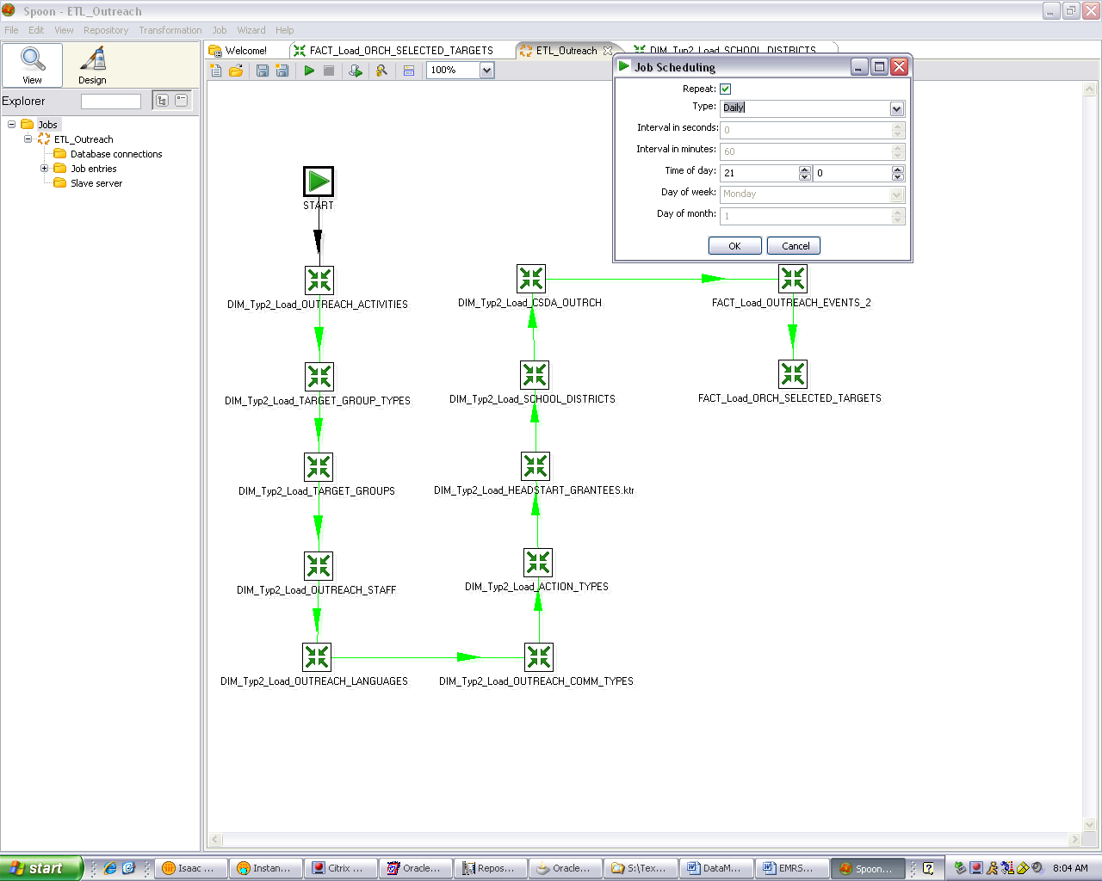

A typical dimension transformation (Figure-6) connects to a source-system, extracts data using SQL logic, adds system and constant information for auditing, then filters and delivers the final product to a target Kimball Type-2 dimension table.

Figure 6 - Dimension Transformation
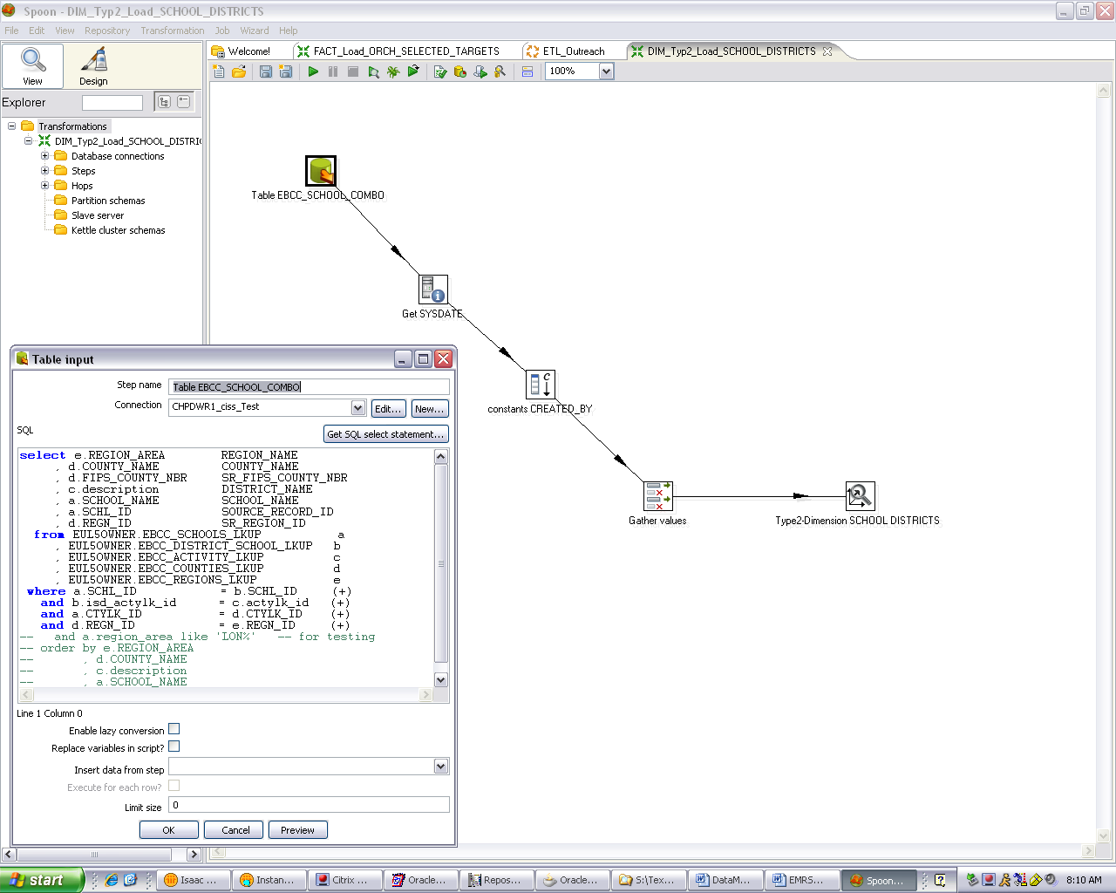

A typical fact transformation (Figure-7) connects to a source, extracts the data using SQL logic, looks up the proper target foreign-key for a given source record’s primary-key [for each dimension], adds sequence, system and constant information for auditing, then filters and delivers the final product to the target fact table.

Figure 7 - Fact Transformation

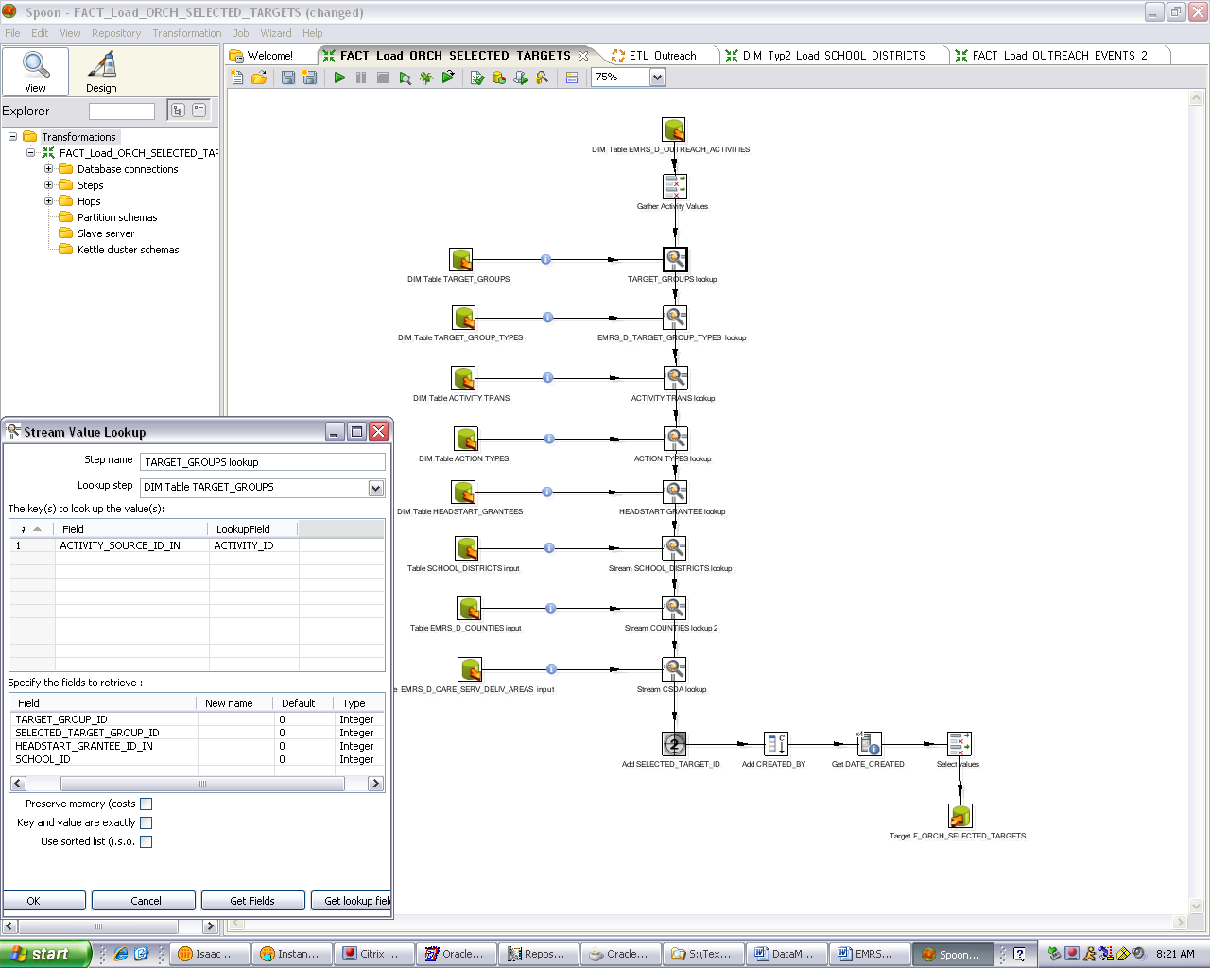

Since the dimension-transformations are executed prior to the fact-transformations, all the necessary lookup source keys are already stored in the first-step of the fact-transformation. The fact-transformation is then able to convert the source-keys to the target-keys making the dimension model operational. At the time of writing, more testing on the dimension-transformations was necessary.

NOTE: First time execution of the Type-2 dimension step-functions would correctly store data in the dimension tables as expected. However, subsequent execution of the Pentaho Type-2 functions did not properly insert new or updated source-system rows into the fact-tables. Nor did those functions properly version those rows after the initial execution. Pentaho consulting may be required to resolve the problem. Otherwise, I believe the basic logic of the transformations to be correct.

  - ETL Files
The naming convention established for the Pentaho .ktr files reflects their purpose. Files that begin with the prefixes DIM, FACT, STAGE, or MART load a dimension, fact, staging table, or the entire mart respectively (Figure 8). The prefix DIM is followed by the letters Typ2 indicating it is a Kimball Type-2 Dimension loading script. Some names may contain either MAXSTAR or OUTREACH, designating the source-system is one of those two legacy systems. If there is no system designation, then it is the MAXSTAR Medicaid enrollment source. The SOURCE_RECORD_ID field will contain the word Medicaid as its value for all records that have MaxStar as its source.
The remaining letters spell out the name of the dimension, fact, staging table, or mart being loaded.

Figure 8 – Pentaho Transformations and Jobs

# | Transformation | Type | Mart
1 | MART_Load_Outreach.kjb | Job Workflow | Presently only Outreach
2 | DIM_Typ2_Load_ACTION_TYPES.ktr | Dimension Transformation | Outreach
3 | DIM_Typ2_Load_Change_Codes.ktr | Dimension Transformation | Enrollment
4 | DIM_Typ2_Load_COMM_TYPES.ktr | Dimension Transformation | Enrollment
5 | DIM_Typ2_Load_COUNTIES.ktr | Dimension Transformation | Conformed for All
6 | DIM_Typ2_Load_CSDA_MAXS.ktr | Dimension Transformation | Enrollment
7 | DIM_Typ2_Load_CSDA_OUTRCH.ktr | Dimension Transformation | Outreach
8 | DIM_Typ2_Load_HEADSTART_GRANTEES.ktr | Dimension Transformation | Outreach
9 | DIM_Typ2_Load_MAXSTAR_LANGUAGES.ktr | Dimension Transformation | Enrollment
10 | DIM_Typ2_Load_OUTREACH_ACTIVITIES.ktr | Dimension Transformation | Outreach
11 | DIM_Typ2_Load_OUTREACH_COMM_TYPES.ktr | Dimension Transformation | Outreach
12 | DIM_Typ2_Load_OUTREACH_LANGUAGES.ktr | Dimension Transformation | Outreach
13 | DIM_Typ2_Load_OUTREACH_STAFF.ktr | Dimension Transformation | Outreach
14 | DIM_Typ2_Load_PLANS.ktr | Dimension Transformation | Enrollment
15 | DIM_Typ2_Load_PROVIDERS.ktr | Dimension Transformation | Enrollment
16 | DIM_Typ2_Load_Risk_Group_Codes.ktr | Dimension Transformation | Enrollment
17 | DIM_Typ2_Load_SCHOOL_DIST.ktr | Dimension Transformation | Outreach
18 | DIM_Typ2_Load_STAFF.ktr | Dimension Transformation | Enrollment
19 | DIM_Typ2_Load_TARGET_GROUP_ACTIVITIES.ktr | Dimension Transformation | Outreach
20 | DIM_Typ2_Load_TARGET_GROUP_TYPES.ktr | Dimension Transformation | Outreach
21 | FACT_Load_F_OUTREACH_EVENTS.ktr | Fact Transformation | Outreach
22 | FACT_Load_OUTREACH_SELECTED_TRGS.ktr | Fact Transformation | Outreach

  - ETL Deployment
When server capacity is available, ETL deployment will be possible. As of now, ETL was practiced using a combination of personal desktop installations, and the DEV database-server; neither of which had enough storage nor processing capacity to contain all the data-mart data. But when servers and storage capacity become available, the plan is to create a Pentaho Repository on a server as described in the Capacity Plan Estimate for the EMRS Data Mart document, and deploy the above named jobs and transformations on those resources.
  - BI Deployment
As with the ETL Deployment section above, the Business Intelligence (BI) tier can be installed and configured when the servers have been procured, as described in the document Capacity Plan Estimate for the EMRS Data Mart. No other BI development has been done.

Existing MAXIMUS Oracle Discoverer installations can be used to access the data-mart even if no other BI products are procured. All the necessary constraints are created during database installation to establish the correct relationships in Discoverer.

