Here are the steps for setting up Streamsets ingestion for a new project.

1. Log in to Streamsets DEV <https://uoradmmapp01soa.maxcorp.maximus:18630/>
2. Duplicate an existing pipeline
3. Do not use the pipeline that is in Running state. For example, there should not be the SCH label.

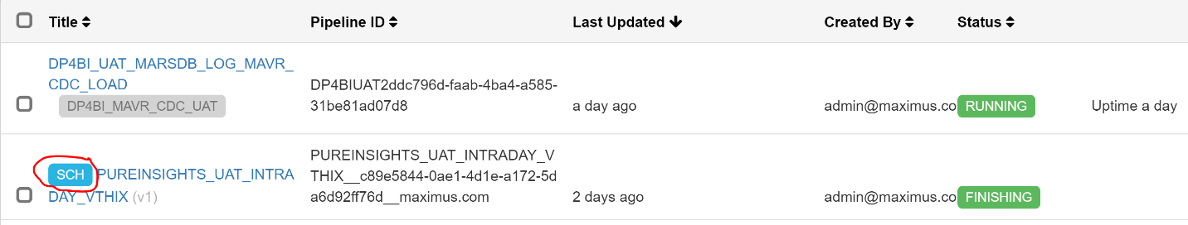

1. Rename the pipeline name to the appropriate project
2. Open the pipeline, click the first stage JDBC Query Consumer 🡪 Configuration 🡪 Credentials 🡪 Enter the ID/Password for that project

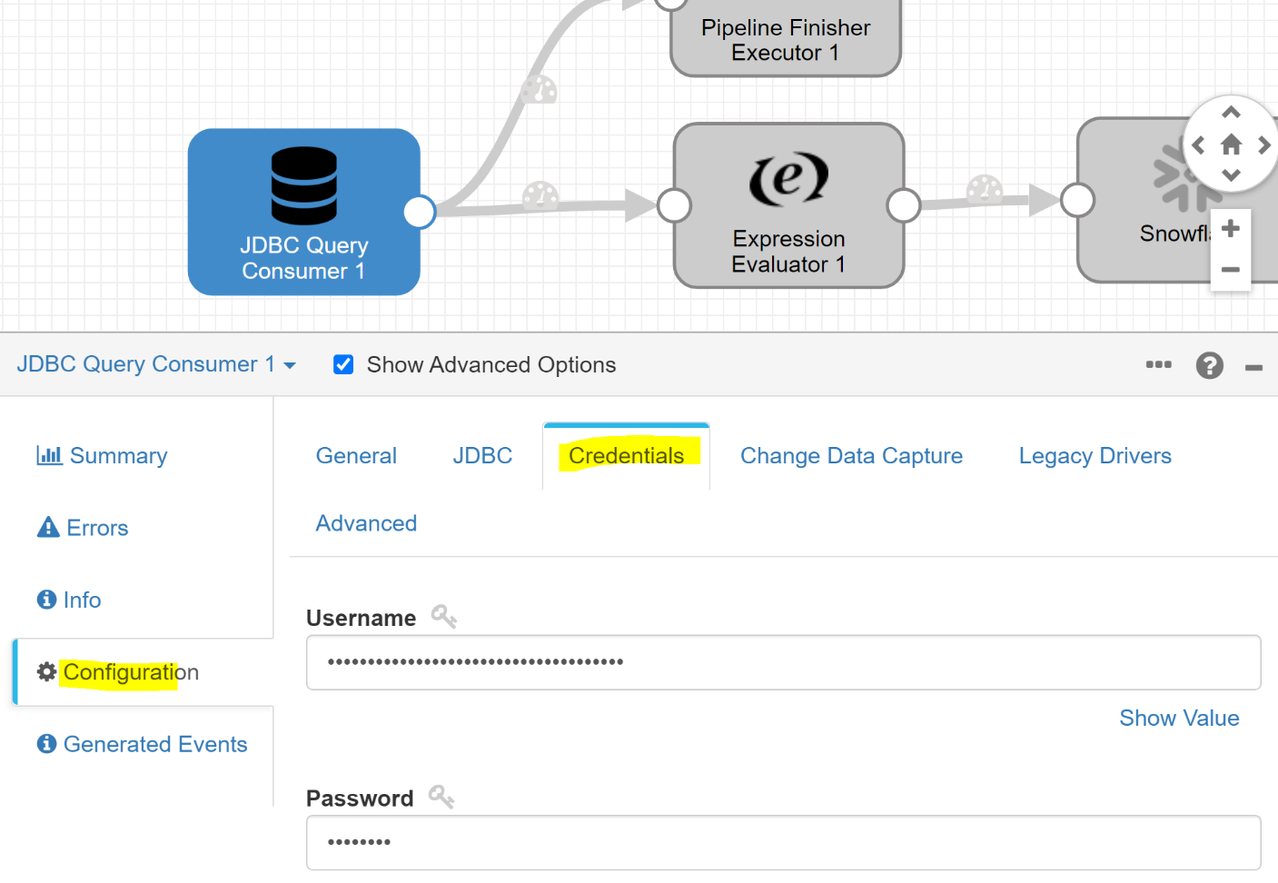

1. Click the 2nd stage Expression Evaluator 🡪 Configuration

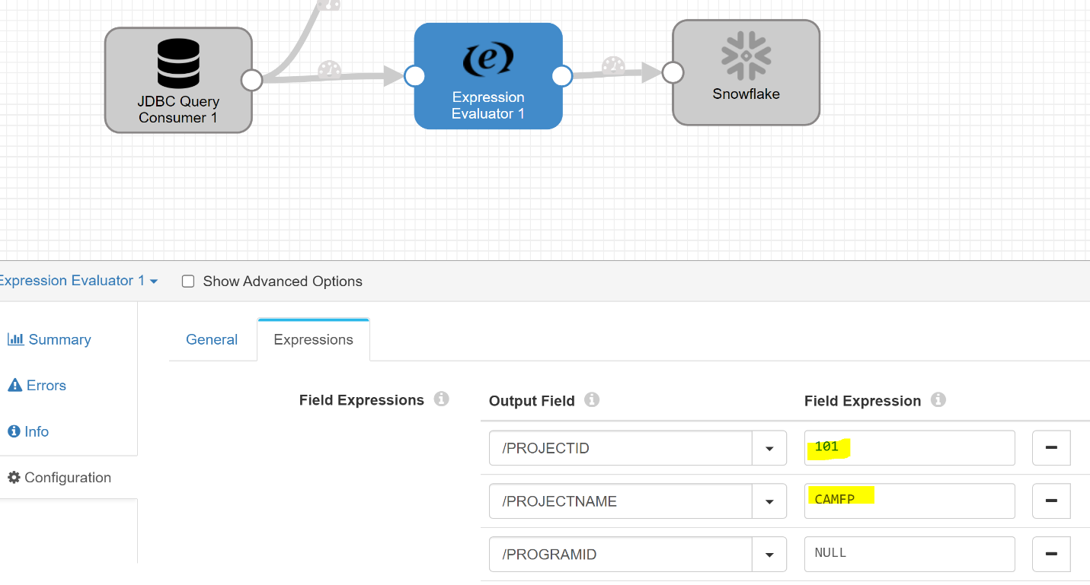

1. Click the preview button on the top right corner of the screen. An eye icon will be there.

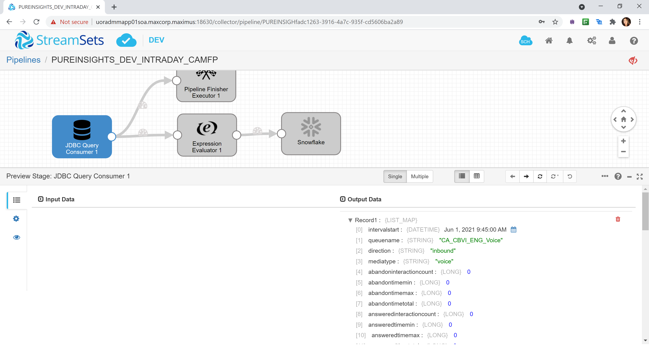

1. Verify the output data columns. Click on Expressions Evaluator stage to see the project ID , Project Name additions to the data

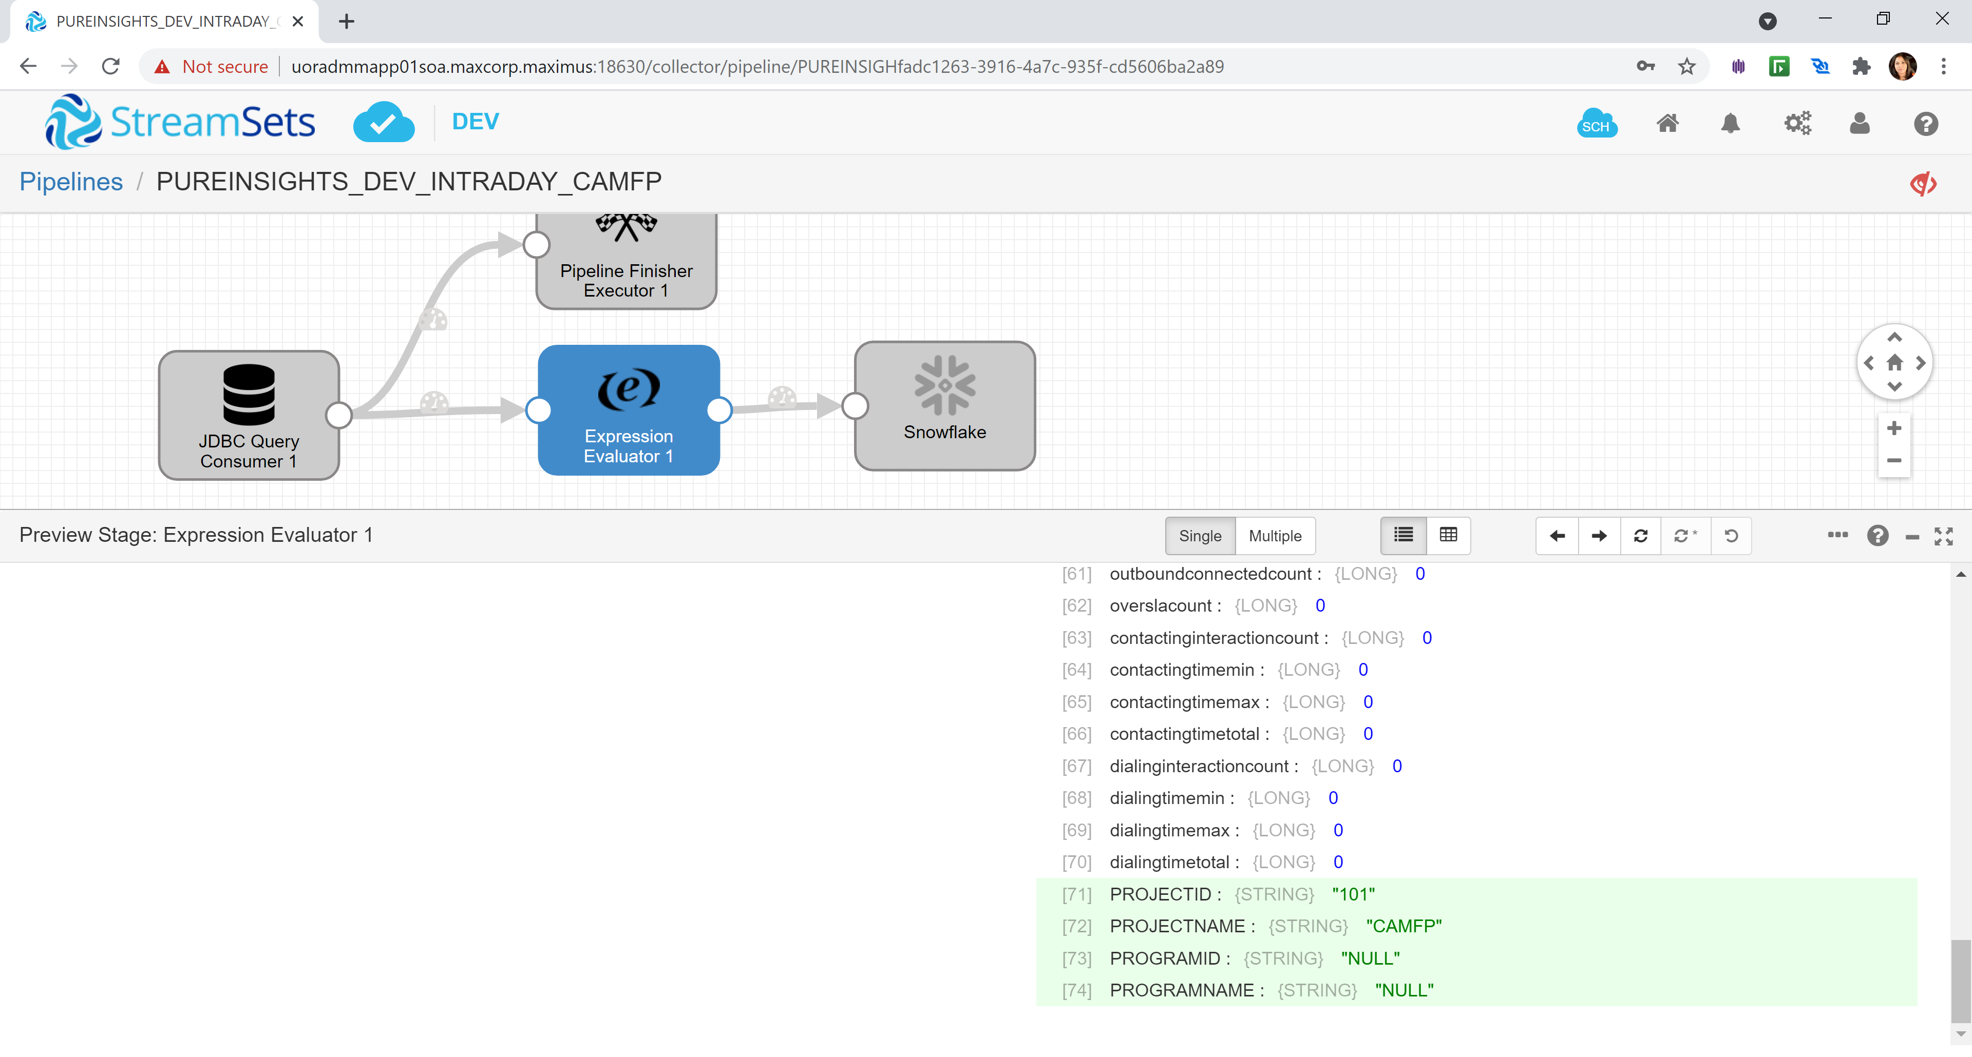

1. Once the preview looks good, it can be stopped

**Publish the Pipeline and Control Hub Job:**

1. To publish pipeline, go to the main page, select your Pipeline and then click on the Publish Pipeline icon on top right corner

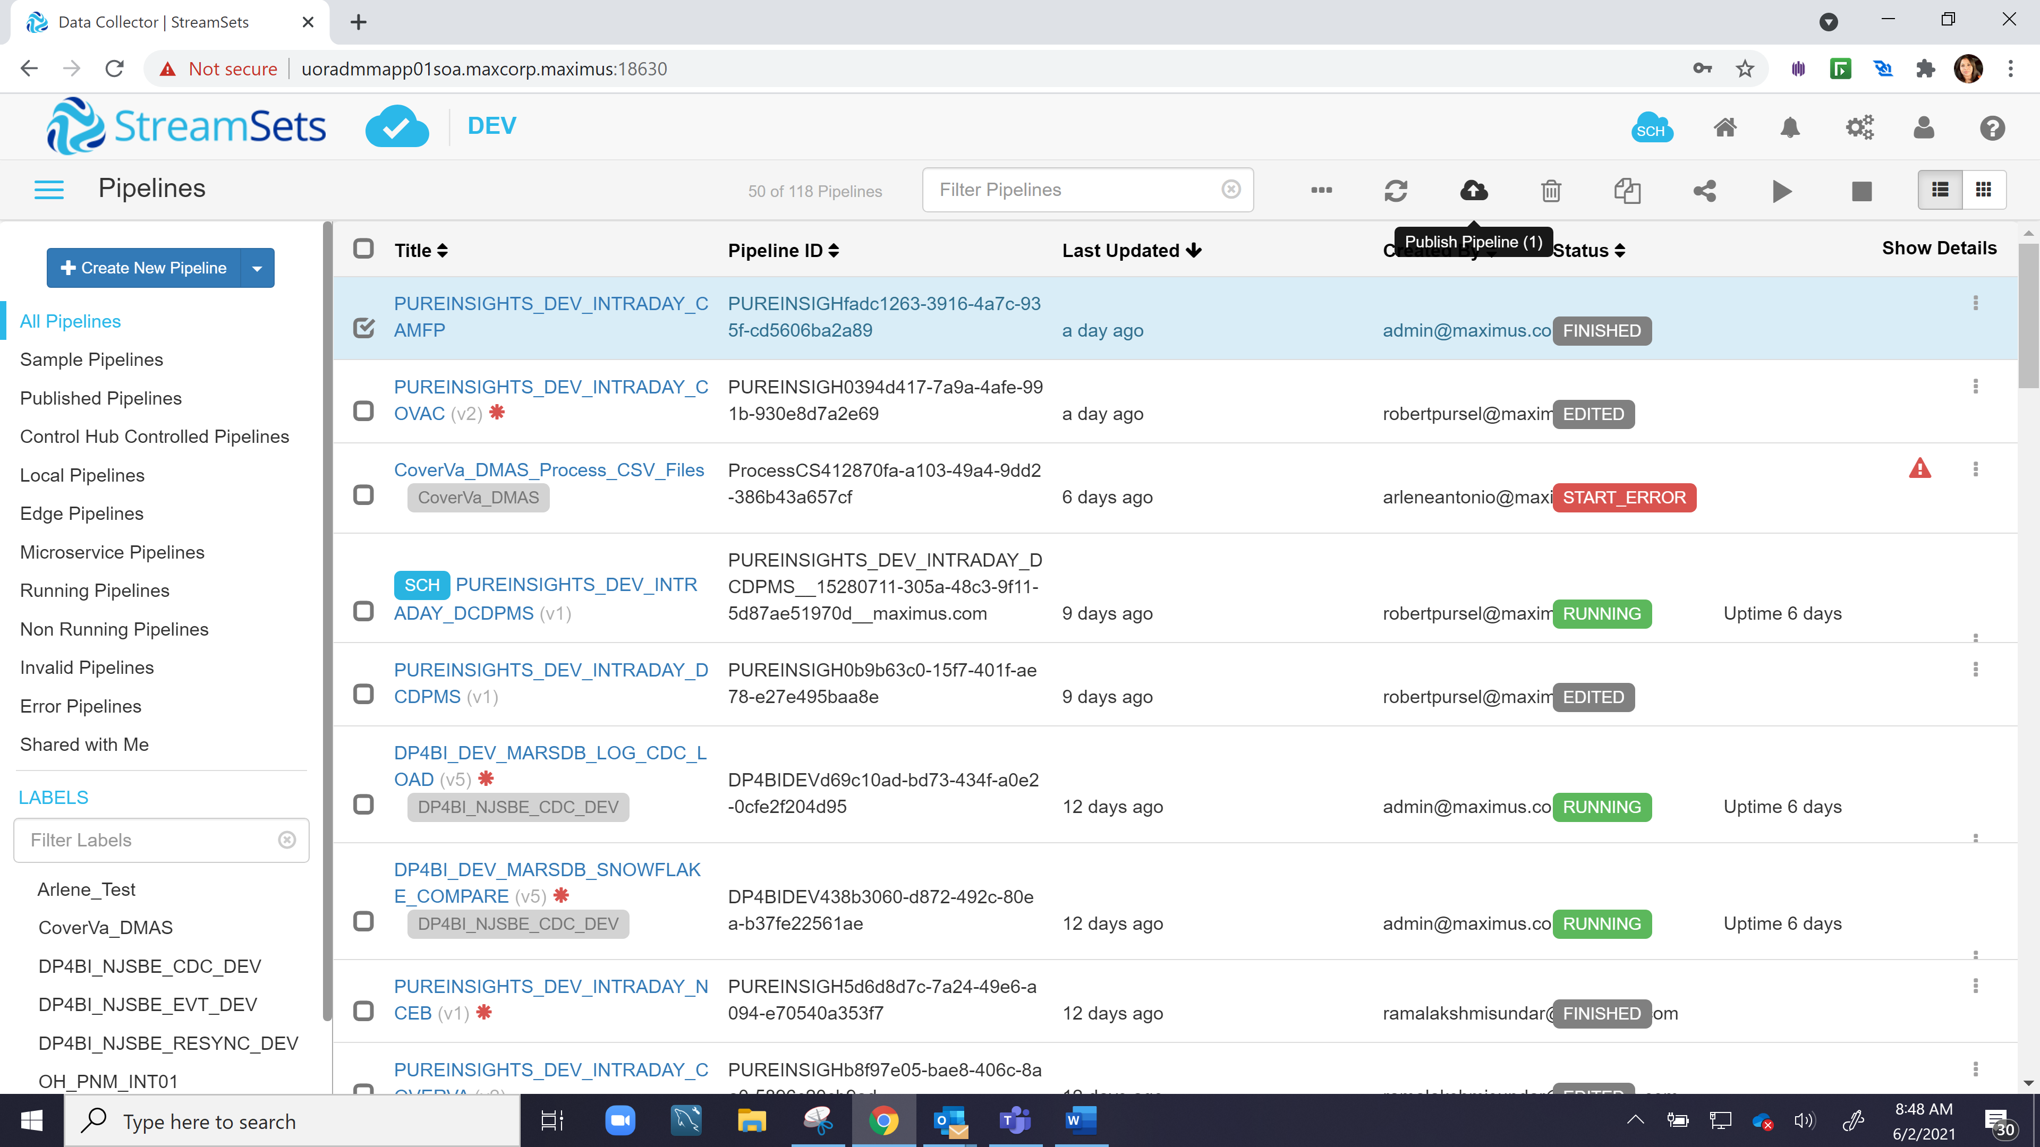

1. Enter a message to publish the Pipeline to the control hub

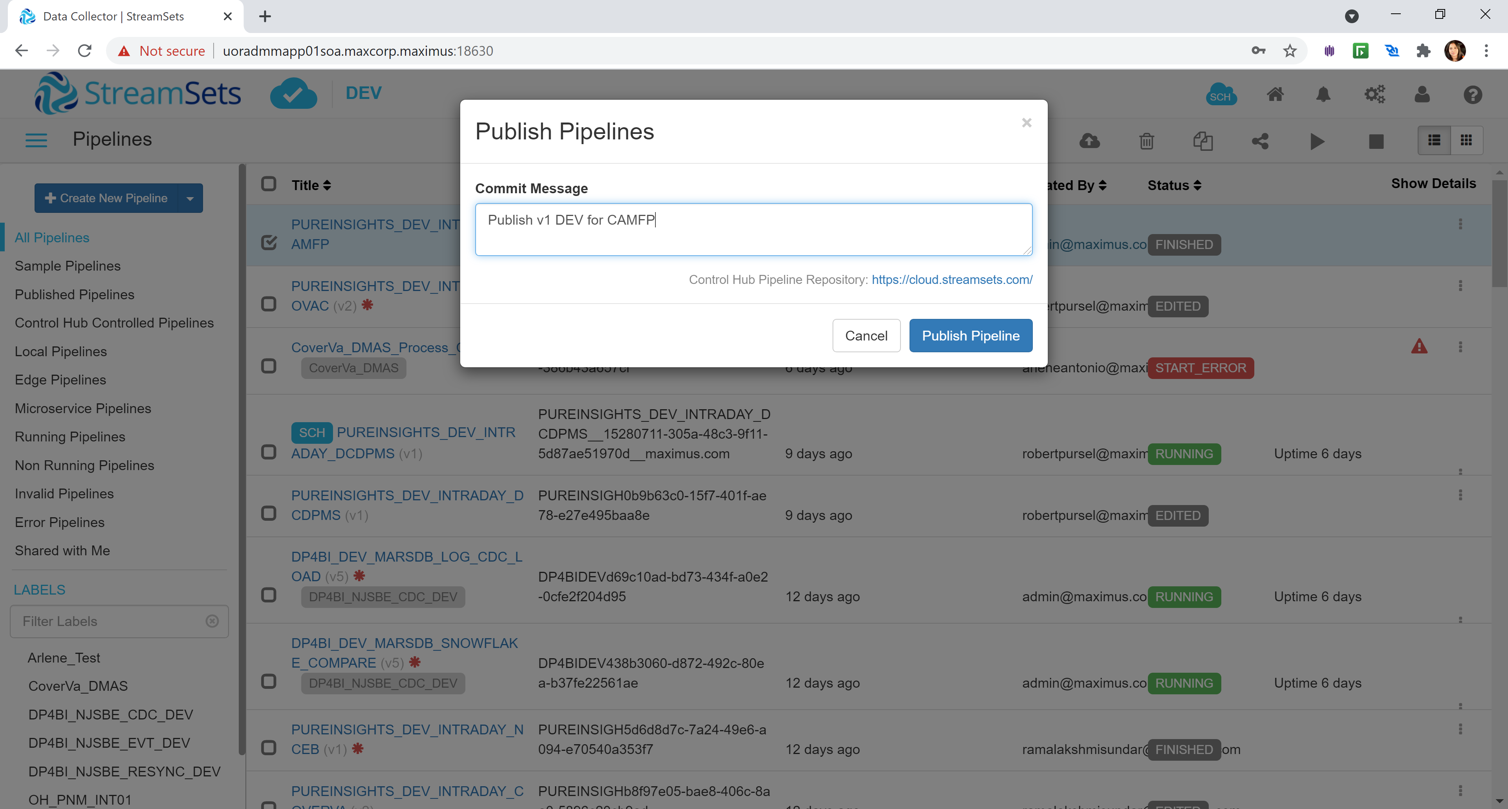

1. Goto the Control Hub. Click on the SCH symbol on the topmost right corner of screen. It will be like a cloud icon

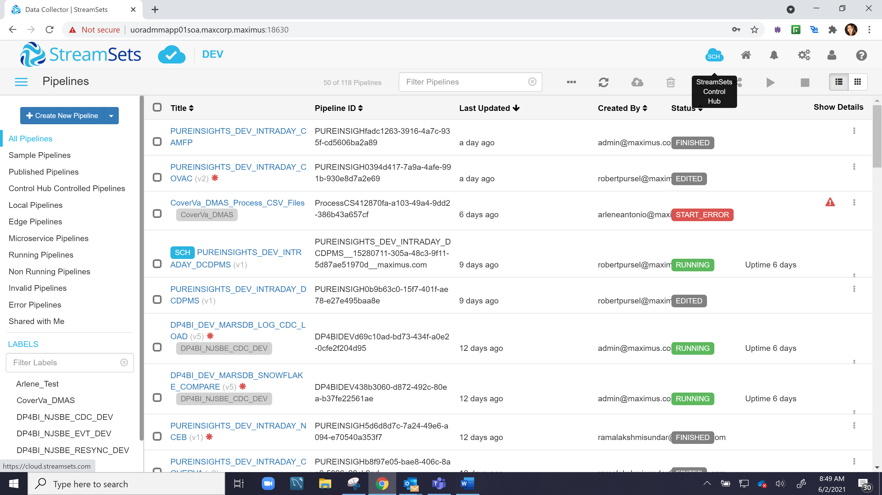

1. Create Jobs for each published pipeline.

* Runs every 15mins
* Select Prodvpc as environment
* Select the project timezone
* Click Start to enable it