1. Attributes for pooling has to be defined with value instead of variable in /config/.kettle/shared.xml file.

Old:

<attribute><code>POOLING_initialSize</code><attribute>${INIT_POOL_SIZE}</attribute></attribute>

<attribute><code>POOLING_maxActive</code><attribute>${MAX_POOL_SIZE}</attribute></attribute>

New:

<attribute><code>POOLING_initialSize</code><attribute>20</attribute></attribute>

<attribute><code>POOLING_maxActive</code><attribute>100</attribute></attribute>

1. Kettle uses timezone of its host as default. When a string has to be converted to datetime that falls during 2am-3am on a daylight saving date in March, all timestamps between 2am and 3am get shifted by an hour. This works well for all times that are in timezones where daylight conversion happens. But when a string with time in UTC timezone (where daylight savings don’t apply) has to be converted to datetime/timestamp, its not accurate to shift time by an hour. This effects Agent Activity Detail load as it contains columns for UTC datetime.

To remediate, last 2 steps in below screenshot can be replaced with execute sql script, where string to datetime/timestamp conversion will be done in DB instead of kettle. But the logs generated through this step grow large as log gets generated for each record passing through the script. Hence usage of Execute SQL script is not implemented.

Old/New:

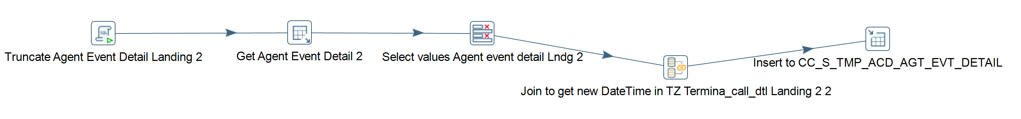

With Execute SQL Script:

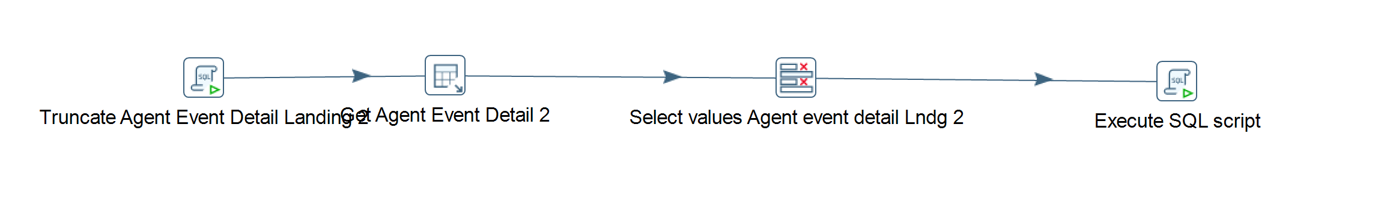

1. When DB data type NUM(n,0) has to be converted to string in kettle, it does the conversion with zero after decimal included. Eg: A value of 1234.0 gets converted to string as ‘1234.0’ in 8.3version where as 4.2 version would implicitly convert to ‘1234’ when a comparison against a string value has to be done. Hence source query in 8.3 version load_cc_s_agent.ktr is updated where a column with NUM(n,0) datatype is cast as integer.

Old:

New:

1. When a source(stream) field with string type has to be inserted into DB Number type column (via Insert/Update step), 4.2 version would implicitly remove any spaces in the string and convert to number type before insert. 8.3 wouldn’t remove spaces and hence source query should be explicitly updated with trim function. Source query in load_cc_s_call_back.ktr is updated as below.

Old:

New:

1. 4.2version would successfully assign BigNumber type value to Integer type field, but the assignment would fail in 8.3version. In such cases, Integer type field should be converted to BigNumber and then assigned. Load_cc_s_contact_queue.ktr is updated by adding an additional step to convert queue_number from int (as derived from source) to BigNumber as below.

1. For Insert/Table Output steps that are defined to run with multiple instances parallely, ‘ Truncate table’ checkbox should be unchecked and a separate step should be configured to truncate the table before the step. No ktrs in shared CC have this scenario, so no updates are done.