**PureInsights – Snowflake Integration for specific project/state**

1. Create **C:\Maximus\Reports** directory
2. Create **C:\Temp** directory
3. **Create, specific to project, MySQl connection.**

Note: Email from Rama sent on 1/29/2021

Subject: NCEB Pureinsights Access for Service Account

**STEPS TO CREATE PUREINSIGHTS PASSWORD:**

1. Log in to Genesys US West URL

<https://login.usw2.pure.cloud/?rid=Z3akA3XohzOetxk_MZUn1k58p49UfYvTzhRf4R5BiXY#/authenticate-adv/org/NCEB>

1. Enter Organization Name: NCEB
2. Enter the NCEB Service account UserID & Password. Click Login.
3. In a different TAB, open PureInsights URL

<https://mysql.pureclouddatabase.com/>

1. Select the region Americas (US/West)
2. The service account information will be displayed in the Page.
3. Enter a password and click Update.

Share recording with viewers:  
<https://maximus.zoom.us/rec/share/cjkEGkqwqKNmwIm8dEgUKduxyOLqBnv7ZA1aL4yTmtZs2w_x_JNJZFbjnf224iFz.7S2rjj_w6bHhgOlo> Passcode: 4yDwL$LP

Thanks,

Rama

1. **Create MySQL ODBC connection specific to project.**

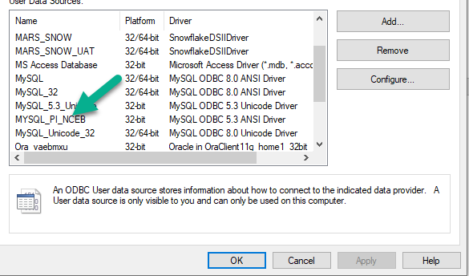

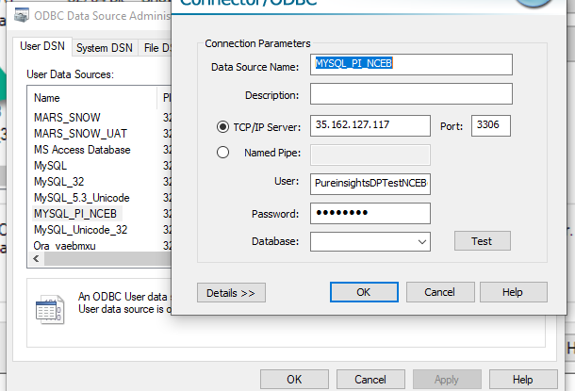

1. **Create Snowflake ODBC connection separately for each environment.**

Snow Flake

https://fu30703.us-east-1.snowflakecomputing.com/console#/internal/worksheet

User: SVC_UFT_DEV_USER

Pass: ^N4]8TmUnL?%7e}]

SVC_UFT_DEV_USER

fu30703.us-east-1.snowflakecomputing.com

PUREINSIGHTS_DEV

PUBLIC

6

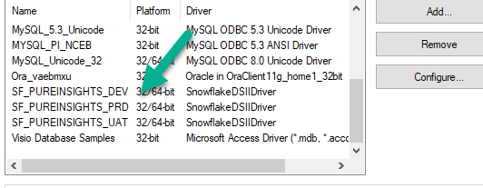

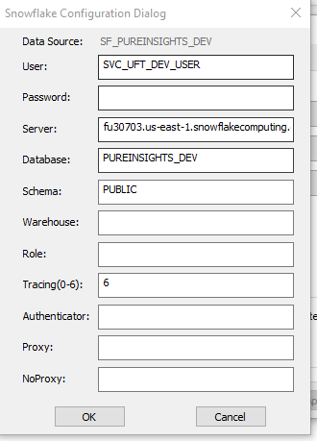

1. **Create new project automation directory.**

Example:

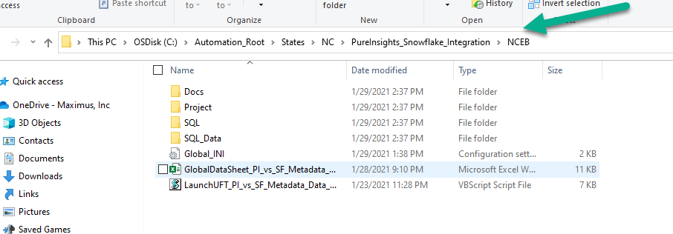

1. Open **GlobalDataSheet_PI_vs_SF_Metadata_Data_Verification** and update data (URLs) specific for current project.
2. Edit **LaunchUFT_PI_vs_SF_Metadata_Data_Verification.vbs** file and update first line (specific to the project)

Example: strFilePath = "C:\Automation_Root\States\Stateless\PureInsights_Snowflake_Integration\**NCEB**\GlobalDataSheet_PI_vs_SF_Metadata_Data_Verification.xlsx"

1. Open Global_INI.ini file and update:
   1. **[ENV]** – value relevant to Snowflake environment you are testing right now.
   2. [ENV_DEV], [ENV_UAT], [ENV_PRD]

* Enter correct DB connection information.
* Example: value = Provider=MSDASQL.1;DSN=**SF_PUREINSIGHTS_DEV**;;HDR=Yes';Password=^N4]8TmUnL?%7e}];Warehouse=QA_WH

Note: **SF_PUREINSIGHTS_DEV** is name of ODBC connection for specific environment.

* 1. **[ENV_MySQL]** - Set MySQL DB connection.

**Example**: value = Driver={MySQL ODBC 5.3 Unicode Driver};Server=35.162.127.117;Database=PureCloud;User=PureinsightsDPTestNCEB@maximus.com;Password=fM0(xghu;

* 1. **[varchar] –** Set standard MySQL – Snowflake datatype conversions

